OCTOBER 2025
Sun | Mon | Tue | Wed | Thu | Fri | Sat
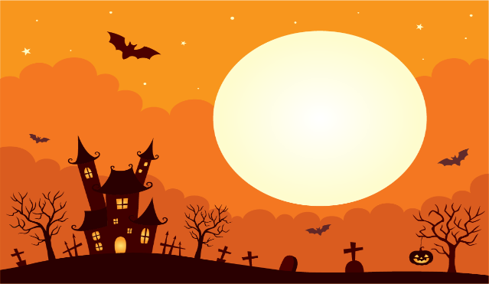

 |  |  | 1  Pool Exercise 10am  Bridge 1pm  Poker 6pm | 2  Shuffleboard 10am  Canasta 1pm  Shuffleboard 1pm  Bingo 6:30 pm | 3  Pool Exercise 10am  Potluck 5-7pm | 4
5  Dominos 2pm | 6  Pool Exercise 10am  Bowling 11am  Bunco 6pm | 7  Shuffleboard 10am  Mahjong 11am  Shuffleboard 1pm  Nimble Fingers 2pm  Ice Cream Social 3pm  Poker 6pm | 8  Pool Exercise 10am  Bridge 1pm  Poker 6pm | 9  Shuffleboard 10am  Ceramics 10am  Canasta 1pm  Shuffleboard 1pm  Halloween Ticket Sales 4-6pm  Bingo 6:30 pm | 10  Pool Exercise 10am  Potluck 5-7pm | 11  Halloween Ticket Sales 10am-noon
12  Dominos 2pm | 13  Pool Exercise 10am  Bowling 11am  Bunco 6pm | 14  Shuffleboard 10am  Mahjong 11am  Shuffleboard 1pm  Nimble Fingers 2pm  Poker 6pm | 15  Pool Exercise 10am  Circle of Friends 11am  Bridge 1pm  Poker 6pm | 16  Shuffleboard 10am  Ladies Lunch 1pm  Canasta 1pm  Shuffleboard 1pm  Halloween Ticket Sales 4-6pm  Bingo 6:30 pm | 17  Pool Exercise 10am  Potluck 5-7pm | 18  Halloween Ticket Sales 10am-noon
19  Dominos 2pm | 20  Pool Exercise 10am  Bowling 11am  Bunco 6pm | 21  Shuffleboard 10am  Mahjong 11am  Shuffleboard 1pm  Nimble Fingers 2pm  Poker 6pm | 22  Pool Exercise 10am  Bridge1pm  Social Committee 2pm  Poker 6pm | 23  Shuffleboard 10am  Ceramics 10am  Canasta 1pm  Shuffleboard 1pm  Halloween Ticket Sales 4-6pm  Bingo 6:30 pm | 24  Pool Exercise 10am  Potluck 5-7pm | 25  Halloween Ticket Sales 10am-noon
26  Dominos 2pm | 27  Pool Exercise 10am  Bowling 11am  Bunco 6pm | 28  Shuffleboard 10am  Mahjong 11am  Shuffleboard 1pm  Nimble Fingers 2pm  Poker 6pm | 29  Pool Exercise 10am  Golf Cart Parade Meeting 11am  Bridge 1pm  Poker 6pm | 30  Shuffleboard 10am  Canasta 1pm  Shuffleboard 1pm  Bingo 6:30 pm | 31  Pool Exercise 10am  HALLOWEEN PARTY 6-10PM

