MAY 2026
Sun | Mon | Tue | Wed |  | Thu | Fri | Sat
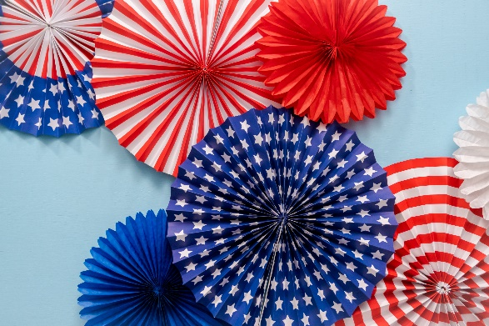 |  |  |  |  |  | 1  Tennis 8:15am  Pool Exercise 10am  Billiards 4 pm  Potluck 5-7pm | 2  FLEA MARKET 8AM-2PM  Pickleball 8:30  Canasta 1pm
3  Dominos 2pm | 4  Tennis 8:15am  Pool Exercise 10am  Ping Pong 2pm  Bunco 6pm | 5  Shuffleboard 10am  Mahjong 11am  Shuffleboard 1pm  Nimble Fingers 2pm  Pool Volleyball 4pm  Poker 6pm | 6  Tennis 8:15am  Pool Exercise 10am  Bridge 1pm  Ping Pong 2pm. |  | 7  Shuffleboard 10am  Canasta 1pm  Shuffleboard 1pm  Pool Volleyball 4pm  Bingo 6:30 pm | 8  Tennis 8:15am  Pool Exercise 10am | 9  Pickleball 8:30  Canasta 2pm
10  Dominos 2pm | 11  Tennis 8:15am  Pool Exercise 10am  Ping Pong 2pm  Bunco 6pm | 12  Pickleball 8:30 am  Shuffleboard 10am  Mahjong 11am  Shuffleboard 1pm  Nimble Fingers 2pm  Pool Volleyball 4pm  Poker 6pm | 13  Tennis 8:15am  Pool Exercise 10am  Circle of Friends 11 am  Bridge 1pm  Ping Pong 2pm |  | 14  Pickleball 8:30 am Ceramics 10am  Shuffleboard 10am  Ladies Lunch 1pm  Canasta 1pm  Shuffleboard 1pm  Bingo 6:30 pm | 15  Tennis 8:15am  Pool Exercise 10am  Potluck 5-7pm | 16  Pickleball 8:30  Canasta 2pm
17  Dominos 2pm | 18  Tennis 8:15am  Pool Exercise 10am  Ping Pong 2pm  Bunco 6pm  Board Meeting 6pm | 19  Pickleball 8:30 am  Shuffleboard 10am  Mahjong 11am  Shuffleboard 1pm  Nimble Fingers 2pm Pool Volleyball 4pm  Poker 6pm | 20  Tennis 8:15am  Pool Exercise 10am  Bridge 1pm  Ping Pong 2pm |  | 21  Pickleball 8:30 am  Shuffleboard 10am  Canasta 1pm  Shuffleboard 1pm  Bingo 6:30 pm | 22  Tennis 8:15am  Pool Exercise 10am  Potluck 5-7pm | 23  Breakfast 8-10am  Pickleball 8:30  Canasta 2pm  Dance 5-9pm
24  Dominos 2pm | 25  Tennis 8:15am  Pool Exercise 10am  Ping Pong 2pm  Bunco 6pm  Office is closed | 26  Pickleball 8:30 am  Shuffleboard 10am  Mahjong 11am  Shuffleboard 1pm  Nimble Fingers 2pm  Pool Volleyball 4pm  Poker 6pm | 27  Tennis 8:15am  Pool Exercise 10am  Bridge1pm  Ping Pong 2pm |  | 28  Pickleball 8:30 Ceramics 10am  Shuffleboard 10am  Canasta 2pm  Shuffleboard 1pm | 29  Tennis 8:15  Pool exercise 10am | 30  Pickleball 8:30  Canasta 2pm
31
Dominos 2pm

