**DRESSAGE & COMBINED TESTS**

**NCDCTA recognized** [**www.ncsandboxseries.com**](http://www.ncsandboxseries.com)

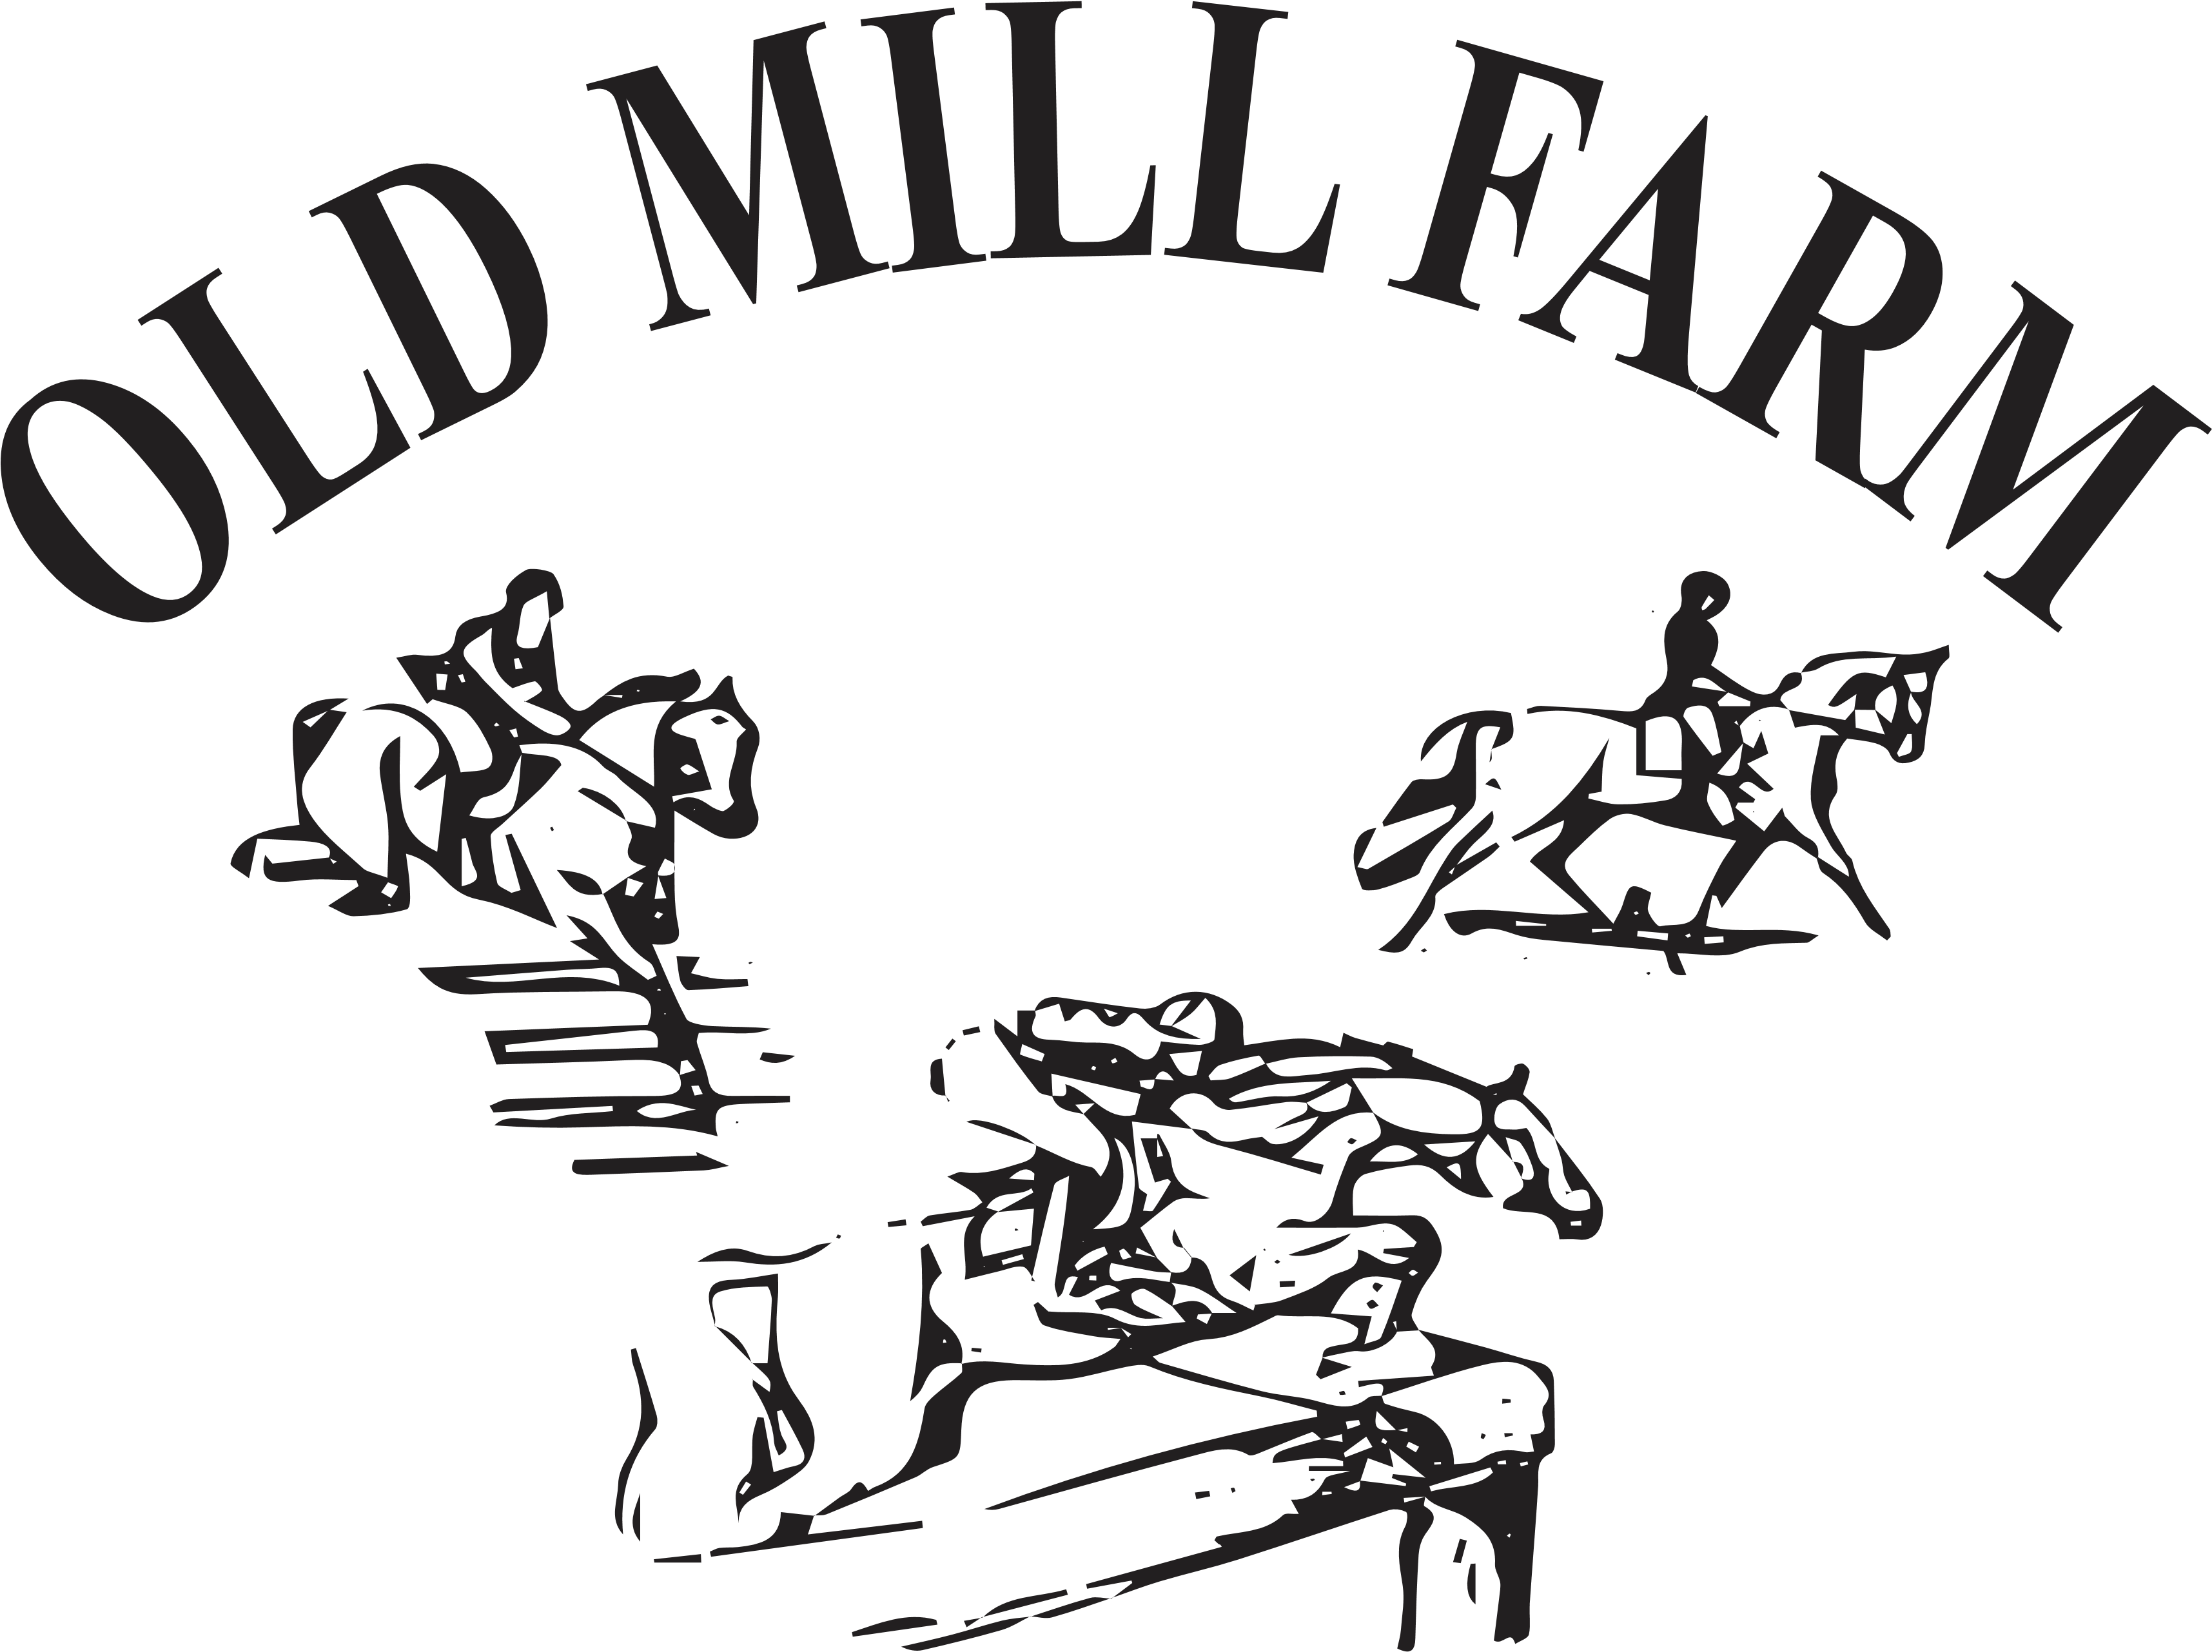

**JUDGE: DONNA KELLY ‘r’**

**Intro – 4th level and Western Dressage! 😊**

**DRESSAGE ONLY:** $50

**Test#1:__________________________Test #2: _________________________**

**Test #3: _________________________ Test #4: ________________________**

**COMBINED TEST DIVISIONS:**

TRAINING: USEF Training Test A Fences 3’3”

NOVICE: USEF NoviceTest A Fences 2’11”

BEGINNER NOVICE: USEF BNTest A Fences 2’7”

STARTER: USEF Starter test Fences 2’3”

**PRE-STARTER** DIVISION: USDF INTRO C FENCES **2’**

GREEN AS GRASS: USDF Intro B Fences 18”

TADPOLE: USDF Intro A Fences 6” ground poles

**CT DIVISION:** (Dressage + Stadium):_$75**_______________________________________**

**Limited Entries**: Entries must be paid to schedule. Late entries / changes $15

No Refunds after closing date.

Online entries are encouraged (no fee) at: [www.OldMillFarmStables.com](http://www.oldmillfarmstables.com) 🡪Calendar

RIDER:________________________Jr / Sr_HORSE:________________________

Address:__________________________________________________________

Email: _____________________________Phone#:________________________

All entries are made at the rider’s own risk. 2025 Release and Coggins must accompany entries.

Release Form available on website. **Enter online** @ [www.oldmillfarmstables.com](http://www.oldmillfarmstables.com) or

Mail entries to: Old Mill Farm, Inc 456 Clapp Farm road Lexington, NC 27295

Checks payable to : Old Mill Farm, Inc Email: [OLDMILLFARMINC@gmail.com](mailto:OLDMILLFARMINC@gmail.com)

**EQUINE ACTIVITY LIABILITY ACT WARNING:**

**Under NC Law, an equine activity sponsor or equine professional is not liable for any injury to or the death of the participant**

**in equine activities resulting exclusively from the inherent risks of equine activities. (N.C.General Statute §99E-1-3)**

Signature: ________________________________(parent if under 18) Date:_____________