**2025**

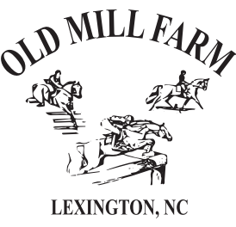

More Info at: [www.OldMillFarmStables.com](http://www.OldMillFarmStables.com) 336-764-4628 / 336-416-0201

**APRIL 12TH**  **DRESSAGE & COMBINED TESTS**

* Intro – 4th Level Including WDAA Western Dressage!
* T, N, BN, Starter, PRE-starter, Green as Grass, Tadpole
* X-C Schooling

**MAY 17TH HORSE TRIAL / DRESSAGE & COMBINED TESTS**

* Intro – 4th Level Including WDAA Western Dressage!
* N, BN, Starter, PRE-starter, Green as Grass, Tadpole

**AUGUST 16TH DRESSAGE & COMBINED TESTS**

* Intro – 4th Level Including WDAA Western Dressage!
* T, N, BN, Starter, PRE-starter, Green as Grass, Tadpole
* X-C Schooling

**SEPTEMBER 20TH**

**HORSE TRIAL / DRESSAGE & COMBINED TESTS**

* Intro – 4th Level Including WDAA Western Dressage!
* N, BN, Starter, PRE-starter, Green as Grass, Tadpole