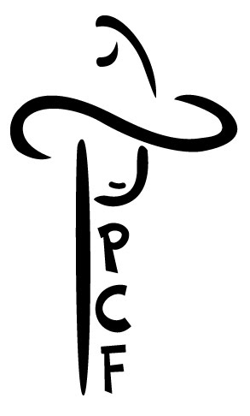
Food and Beverage Vendor Contract
PLATTE COUNTY FAIR BOARD
59 Antelope Gap Rd Wheatland, WY 82201 (307) 322-9504
Fax: (307) 366-9403 plattecofair8@gmail.com
Plattecountyfair.org
OGANIZATION NAME:________________________________________________________________
CONTACT PERSON: __________________________________________________________________
ADDRESS:__________________________________________________________________________
TELEPHONE:________________________________________________________________________
EMAIL:_____________________________________________________________________________
This agreement is made between the Platte County Fair and (Renter)
TERMS OF RENT:
- That in consideration of the mutual agreement herein contained, the Platte County Fair Board grants permission to above renter to occupy and use space assigned as indicated.
- Upon approval, receipt, and payment of this agreement a space will be reserved.
- Space is available on a first come first serve basis.
- Cancellations must be received at the Fair office no later than one week before the first day of Fair.
- Renter agrees to pay the association the total sum of:
Food and Non-Alcoholic Beverage Full Menu:
$500 for the week Saturday through Saturday
Food and Non-Alcoholic Beverage Full Menu:
$100 a day
Carnival Food or Beverage (Sno cones, coffee, funnel cake, cotton candy, popcorn etc.):
$250 for the week Saturday to Saturday
Carnival Food or Beverage (Sno cones, coffee, funnel cake, cotton candy, popcorn etc.):
$50 a day
- Care and Maintenance of premises: The Platte County Fair will maintain the grounds. Renter is responsible for the maintenance of the leased property. Renter is responsible for the cleanup around their location if waste materials are derived from their location. Association will not provide storage of any renter property. Renter must keep space clean, orderly, safe, and presentable to the public.
- Indemnification of Association: Association shall not be liable for any damages or injury to renter or renter’s property. Renter agrees to hold the association harmless from all claims for damages, no matter how caused.
- All health, food and safety regulations must be followed, and a current concession/food license must be posted. If public safety is compromised, contract will be void and fees will be retained by the Platte County Fairboard.
- If applicable, decorate your area according to the year’s fair theme to encourage a festive look throughout the Fair Grounds.
- The following signatures make this a legal and binding agreement.
- Renter will provide all their own materials, supplies, and equipment for operation.
- Please attach a full menu. Items will be approved by Fair Staff. It is our goal for all vendors to make a profit so some menu items may not be approved dependent on other approved vendors and menu items being offered. Once approved you may ONLY sell approved menu items.
BY SIGNING BELOW, YOU AGREE TO ALL TERMS LISTED IN CONTRACT
Date: ____________________ Date: ________________________

___________________________________ ____________________________________
Renter Signature PCFB Signature

FOR OFFICE USE ONLY

Date Received _____________________ Dates ______________________

Check Number _____________________ Total Due $_____________________

Cash _____________________

PCF Staff Approval _____________________________________________

