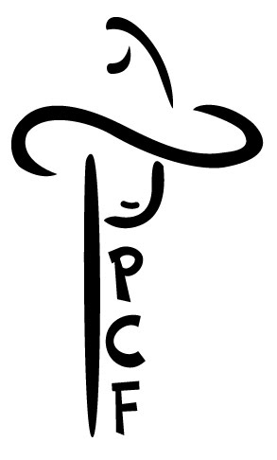
PLATTE COUNTY FAIR BOARD
59 Antelope Gap Rd Wheatland, WY 82201 (307) 322-9504
Fax: (307) 366-9403 plattecofair8@gmail.com
Plattecountyfair.org
Non-Food Vendor Contract

OGANIZATION NAME:________________________________________________________________
CONTACT PERSON: __________________________________________________________________
ADDRESS:__________________________________________________________________________
TELEPHONE:________________________________________________________________________
EMAIL:_____________________________________________________________________________
This agreement is made between the Platte County Fair Grounds and (Renter)
TERMS OF RENT:
- That in consideration of the mutual agreement herein contained, the Platte County Fair Board grants permission to above renter to occupy and use space assigned as indicated.
- Upon receipt and payment of this agreement a space will be reserved.
- Space is available on a first come first serve basis.
- Cancellations must be received at the Fair office no later than one week before the first day of Fair.
- Renter agrees to pay the association the total sum of:
With electricity:
$150 for the week
Without electricity:
$100 for the week
- Please list merchandise selling:
__________________________________________________________________________________________________________________________________________________________________________________________________________________________________________
- Please list all items/utilities needed for operation: __________________________________________________________________________________________________________________________________________________________________________________________________________________________________________
- Care and Maintenance of premises: The Platte County Fair will maintain the grounds. Renter is responsible for the maintenance of the leased property. Renter is responsible for the cleanup around their location if waste materials are derived from their location. Association will not provide storage of any renter property. Renter must keep space clean, orderly, safe, and presentable to the public.
- Indemnification of Association: Association shall not be liable for any damages or injury to renter or renter’s property. Renter agrees to hold the association harmless from all claims for damages, no matter how caused.
- If applicable, decorate your area according to the year’s fair theme to encourage a festive look throughout the Fair Grounds.
- The following signatures make this a legal and binding agreement.
BY SIGNING BELOW, YOU AGREE TO ALL TERMS LISTED IN CONTRACT
Date: ____________________ Date: ________________________

___________________________________ ____________________________________
Renter Signature PCFB Signature

FOR OFFICE USE ONLY

Date Received _____________________ Dates ______________________

Check Number _____________________ Total Due $_____________________

Cash _____________________

PCF Staff Approval _____________________________________________

