ALTOONA REGIONAL 2026 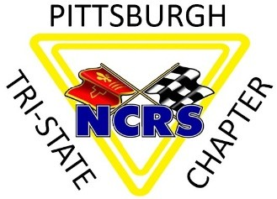
We as a team accomplished at lot with the conclusion of our Altoona Regional Judging event at the Blair County Convention Center this past weekend. It all started in May of 2024 when Dave Kitch proposed that we host another Regional in 2026. At that time, we investigated and secured the Convention Center contract, and the contract with the Country Inn and Suites for hosting the event. We also had to negotiate with the NCRS and other chapters to keep our regional alone in the northeast US for 2026. We wanted to be in a position to make our regional a stepping stone for the NCRS National in Charleston, SC in 2026.
Fast forward to November 2025 when we published the registration form in the Driveline and opened registrations online for the event. We had a team of our members taking shape and over the next few months, built a group of 29 people to manage the event. Fundraising was an important ingredient of the early work, securing multiple sponsors for our event. I would like to recognize Mike Bucheit for securing the following sponsors:
- Mirrock Corvette in Saltsburg, PA sponsored the Reception.
- All Collector Autos in Bedford, PA sponsored the Judges shirts.
- Zippo/Case knives in Bradford, PA gifts for the Banquet.
- Howard’s Auto Body in Greensburg, PA sponsored a judges meal.
- Bair’s Corvettes in Linesville, PA sponsored our Registration.
- Two members of our chapter sponsored a judges meal:
  - Mike Bucheit
  - Bill Bryan

So now after 2 years of planning, the event took place and here are the numbers for the event:
192 Registrations with 267 attendees
46 Flight car registrations
12 PV car registrations
6 Open Class car registration
6 Sportsman cars
4 Bowtie Signoffs
3 American Heritage
54 Car Trailers for parking
218 Reception attendees signed up
116 Banquet attendees
It was a lot of hard work for all our chapter members involved and I want to thank each and every one of them for the extra effort they gave to make this event a success. It really takes a team of good individuals to make an event like this work. I will say that even after 8 regionals, we are still learning how to fine tune our efforts, but I consider this a great accomplishment for a group of volunteers. I have heard so many good comments from the NCRS leaders, judges and car owners and I am proud to be part of this group. Thank you.
Respectfully,
Don Geary

