Block of the Month – Appliqué Garden

Rules:

Size: 10 ½” unfinished square – any shade of Green
Circle applique - at least one 4” circle; plus additional sizes if desired
At least one design should be fussy-cut

Video tutorial: https://www.youtube.com/watch?v=odtUb58CTM0 (Fons and Porter)

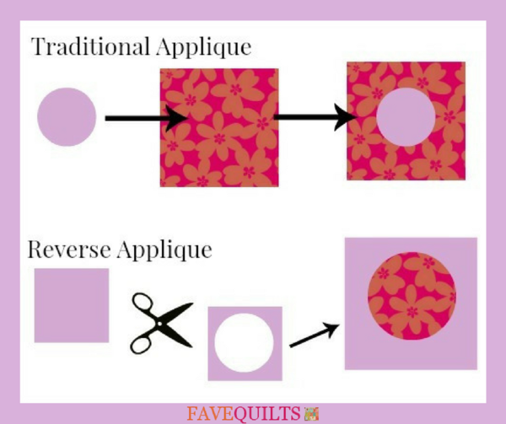
Possibilities:

Traditional appliqué / Reverse Appliqué

Turned under edges / exposed edges

Invisible stitching / visible stitching

Machine-stitched / by hand

Functional stitches / Embroidered

Multi layered

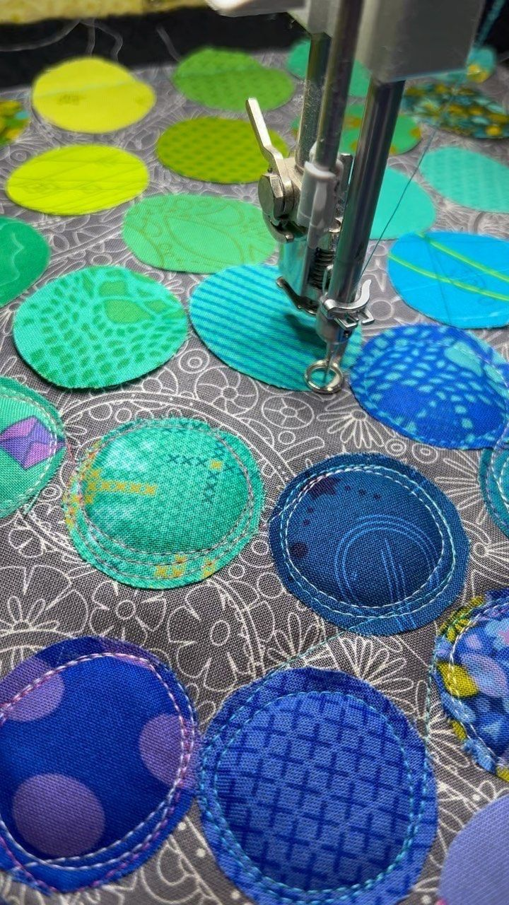 | 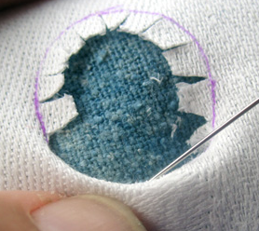 | 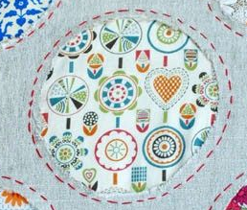

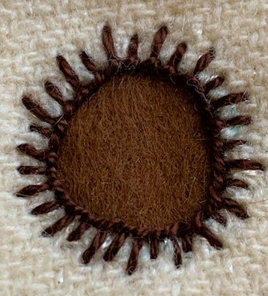 | 