2028 A.D. THE YEAR OF HIS RETURN?

FOREWARD
This article is about the year of the Lord’s return. Anyone who has studied end times prophecy is familiar with the verse,
“Watch therefore, for ye know neither the day nor the hour wherein the Son of man cometh.” Matt 25:13 KJV
This saying does not mean you can’t know the year, or even the month of his return. Jesus rebuked the Pharisees when he told them;
"When it is evening you say, 'It will be fair weather, for the sky is red'; and in the morning, 'It will be foul weather today, for the sky is red and threatening.' Hypocrites! You know how to discern the face of the sky, but you cannot discern the signs of the times. Matt 16:2-4 NKJV
He obviously meant that the signs of his first coming were readily discernable. This is also true of his second coming. Jesus told the apostles that “knowledge of the secrets of the kingdom of heaven has been given to you” (the believer). [Matt 13:11]. Jesus is not referring to knowledge that comes from the mind of man. He is referring to a deeper understanding of things that can only be revealed by the Holy Spirit, which are hidden beneath the surface of the stories found in the Old and New Testament This is why the Apostle John wrote;
“…the anointing which you have received from Him abides in you, and you do not need that anyone teach you;” 1 John 2:27 NKJV
Him who abides in you is the spirit of truth who leads you into all truth;
“…and the sheep follow him: for they know his voice.” John 10:4.
In order to explain what will happen to believers in the last days, especially during the seven-year tribulation period, most Christian denominations have adopted one of several “rapture” theories. These theories, which are based primarily upon 1 Thessalonians 4:16-17, usually state that either a pre, mid, or post tribulation removal of the church will take place. The theory you’re about to read is based on a conclusion arrived at by what is called in legal terms, “a preponderance of the evidence.” In other words, the significance of certain facts related to a set of particular circumstances is so convincing - that it can lead to only one conclusion. This writing explores a reoccurring theme found throughout the scriptures that points to the following conclusion;
The Church at Philadelphia, found in the Book of Revelation, will secretly leave this plane of existence at the start of the tribulation, in the same way that Enoch was taken by God. (Genesis 5:24). They will be hidden during the first 3 ½ years of the tribulation. [Study Note 6] At the mid-point of the seven-year tribulation, in full view of everyone on earth, the rest of the saints will leave this earth in the same manner that Elijah was taken up to heaven. (2 Kings 2:11)
“These are the ones who have come out of the great tribulation; Rev 7:13

CHAPTER 1

The timing of certain events found in this account are directly linked to the date of Jesus’ birth and John’s Gospel Chapter 12. Although Matthew does not say Jesus was born on a certain day, he dates his birth to the reign of King Herod the Great of Judea. By examining certain historical records of the time, along with the scriptures, we can find the time of his birth with some degree of certainty.
“Now when Jesus was born in Bethlehem of Judaea in the days of Herod the king, behold, there came wise men from the east to Jerusalem,” Matthew Chapter 2:1.
Who was Herod the Great?
The country of Judea was under Persian rule until the Greek army took control in 332 B.C., under the command of Alexander the Great. In 167 B.C., a Hebrew man by the name of Mattathias ben Johanan led a successful revolt against the Greeks. The family of Mattathias became known as the Maccabees (or “The Hammer”), and ruled in Judea as the Hasmonean Dynasty. However, in 63 B.C. the Roman ruler Pompey the Great took control of Judea. Then, in 40 B.C., another Hasmonean by the name of Mattathias Antigonus fought against the occupying Roman Army and with the help of the Parthian Army took back control of Judea. Antigonus was the Ninth King and High Priest of Judea, but his victory was short lived. Rome regrouped and combined its forces with those led by Herod to re-conquer Jerusalem in 37 B.C. Herod was an Edomite, a descendant of Esau. After he fought to re-capture Jerusalem, he was granted the title "King of Judea" by the Roman Senate. According to the writings of the Hebrew historian Flavius Josephus, Herod ruled for 34 years after capturing Jerusalem, placing his death sometime between 3-1 B.C. But the exact date of when Herod died is not critical in determining the birth date of Christ. What we do know from Matthew’s gospel is that Herod was alive when the Magi arrived in Jerusalem and told him of the birth of Jesus.

Who were the “Magi?”
The Greek word translated “wise men” is “magian,” and literally means “Persian astronomer or priest.” After the Hebrew prophet Daniel interpreted King Nebuchadnezzar’s dream (Daniel 2:24), he was given the title “Rab-mag,” meaning Chief of the Magi. Daniel must have told the Persian Magi that the birth of the messiah Jesus would be announced by the appearance of a "star." In fact, the Magi told Herod, “we have seen HIS star,” obviously meaning they knew about the prophecy.
The Magi were priests and government officials that were composed of the upper house of the Council of the Megistanes, whose duties included choosing the king of Persia. Therefore, when the ruling class of Persian/Parthian nobles known as Magi entered Jerusalem around 3 B.C., King Herod's reaction was understandably one of fear.
“When Herod the king had heard these things, he was troubled, and all Jerusalem with him.” Matthew 2:3
Our Christmas tradition tells the story of three wise men coming to Jerusalem bearing costly gifts for Jesus. However, the gospel of Matthew does not specifically state the number of wise men. Ask yourself, why would all of Jerusalem be troubled by the appearance of only three Magi from Persia? The Hebrew historian Josephus wrote two books during the first century A.D.¹ He stated that during the time of Christ, caravans came to Jerusalem from Persia carrying precious treasures accompanied by “ten thousand” Parthian soldiers. This is significant because 53 years before the birth of Christ, the Parthian Army nearly destroyed the entire Roman army deployed at the Battle of Carrhae (modern day Turkey). The Parthians killed 20,000 Roman soldiers, took 10,000 soldiers’ captive, allowing only 10,000 Romans to escape. So, in 3 B.C. when Herod the Great had a small army of Judeans accompanied by an additional 500-600 Roman soldiers, the appearance in Jerusalem of 10,000 Parthian soldiers guarding a caravan of royalty and treasure from Persia was enough to make “all of Jerusalem troubled.” [Study Note 1]
Was the star of Bethlehem a Comet?
The Magi informed King Herod that the star appeared, which indicates that the star was not a customary sight in the evening sky over Persia. Even Herod had to inquire of the Magi to find out when “the star” appeared, indicating that no one in Judea (1000 miles away) was aware of the “star.”
______________________________
¹ Flavius Josephus was born “Yoseph Ben Matthias” in Jerusalem in AD 37/38. He fought in the Hebrew revolt against Roman occupation beginning in 66 A.D., that ended in the destruction of Jerusalem in 70 A.D. He wrote the books “Antiquities,” and “The Jewish Wars.”
Shown below are several excerpts of articles taken from Bulletins written by Tyndale House (Christian Publishers) that may explain what happened.
THE STAR OF BETHLEHEM, A COMET IN 5 BC
AND THE DATE OF CHRIST’S BIRTH
Author - Colin J. Humphreys [Tyndale Bulletin 43.1 (1992)
The Chinese kept careful astronomical records of visible comets and used different terms to describe them. A tailed comet was called a sui–hsing, meaning a broom star, the ‘broom’ referring to the tail of the comet. The chronicle entitled, the “Ch'ien-han-shu” states that:
"In the second year of the period of Ch'ien-p'ing, second month, a hui-hsing appeared in Ch'ien-niu for more than 70 days"
This record can be translated as:
“During the interval between March 10th and April 7th of 5 BC, a comet that was visible for more than 70 days appeared close to Alpha and Beta Capricornii”
In his book, “Chinese Mathematical Astrology,”(2002) Ho Peng–Yoke lists and translates ancient Chinese records of comets and novae. From these records, the comet of 5 BC, appearing in the east in the constellation Capricornus, may uniquely be identified as the star of Bethlehem. According to the Chinese description of this comet, it was visible for over 70 days. Further analysis suggests that the birth of Christ was in the Spring, in the period between March 9 – May 4, 5 BC. [http://fliphtml5.com/blbz/edum/basic]
This time frame would fit with the birth of Christ, according to the Hebrew Calendar. Attesting to this time period, Luke states in his gospel that on the night of Jesus’ birth;
“…there were in the same country shepherds living out in the fields, keeping watch over their flock by night. Suddenly, an angel of the Lord appeared among them, and the radiance of the Lord’s glory surrounded them, and they were terrified. But the angel said to them, “Do not be afraid. I bring you good news that will cause great joy for all the people. Today in the town of David a Savior has been born to you; he is the Messiah, the Lord.” (Luke 2:8)
The most natural time for sheep to breed is in the fall (Oct-Nov). They give birth between the last two weeks of March up until the first two weeks in April. Sheep are known to experience problems while giving birth, so the Shepherds would stay out in the fields at night keeping watch over the pregnant ewes. For this reason, the shepherds happened to be out in the fields during the night Jesus was born.

The Lord’s Passover
In Exodus Chapter 12: God tells the Hebrew people that “Nisan,” which is our month of April, is the first month of the year. God said to Moses and Aaron just before the Exodus from Egypt,
“This month is to be for you … the first month of your year. Tell the whole community of Israel that on the tenth day of this month each man is to take a lamb for his family, one for each household….take care of them until the fourteenth day of the month, when all the members of the community of Israel must slaughter them at twilight. Then they are to take some of the blood and put it on the sides and tops of the doorframes of the houses where they eat the lambs… it is the Lord’s Passover.”
The Passover lamb of Exodus 12 is a picture of Christ. John the Baptist understood this when he proclaimed, “Behold, the Lamb of God, who takes away the sin of the world! (John 1:29). Because Jesus is the Passover lamb, it is reasonable to conclude that Jesus was born on the tenth day of Nisan (April). If the comet that appeared in the eastern sky over Persia was the one that announced his birth, then he was born on April 10, 5 B.C.

CHAPTER 2

Often times the scriptures will apply a dual (or parallel) meaning to an event. One is relevant at the time it is given, while the other applies to a future event (usually concerning the end times). For example, during the impending invasion of northern Israel by the Assyrians (around 721 B.C.) the Prophet Isaiah proclaims the word of God by stating;
Come, my people, enter thou into thy (secret) chambers, and shut thy doors about thee: hide thyself as it were for a little moment, until the indignation be overpast. 26:20

This verse applied to a certain number of Hebrews living in Galilee at that time, but it also has a prophetic meaning for the last days, which is verified in the next verse;
For behold, the LORD comes out of His place. To punish the inhabitants of the earth for their iniquity; The earth will also disclose her blood, and will no more cover her slain. Isa 26:21
The Lord GOD “coming out of His place” means God Almighty is leaving the heavens and coming to earth – in judgment. The secret chamber referred to in Isaiah verse 20, also relates to Rev 3:8, when Jesus tells the church at Philadelphia;
“I have set before thee an open door…”
This “open door” is literally translated as “a portal” that leads to a place to hide; where God will keep them from the hour (or season) of temptation; which is more fully translated to mean, “to keep you from the experience of evil,”
“…which shall come upon all the world,” (Rev 3:8-10)
The hour of temptation is the great tribulation, leading up to the time described by Isaiah, when God comes “out of His place” to punish the wicked.
Just as events can have a dual meaning, certain characters can serve a dual purpose by representing, or being emblematic of a particular concept being illustrated. For example, the prophet Daniel was preserved in the lions’ den by the “angel of God.” In Rev 3:8, the “angel of God” is sent to the Philadelphia believers, to provide a way of escape from the adversary, “who walks about like a lion seeking whom he may devour.” (1 Peter 5:8). The name Daniel is derived from the Hebrew word “Dan,” who was one of the sons of Jacob and means “Judge.” In Genesis chapter 49, Jacob prophesized over Dan by saying;
“Dan shall judge his people, as one of the tribes of Israel.”
This verse does not mean that Dan will sit in judgment of his fellow tribes, but rather, he will plead their cause from another place, as one of them. Dan is a friend of his brethren (the other eleven tribes of Israel), just as the word Philadelphia means in the Greek, “fond of brethren.” This “other place” will not be of this world. Look and see. At the start of the tribulation, when the angels put the seal of God upon the tribes of Israel, the tribe of Dan is already missing from the list, for the simple reason that the tribe of Dan is missing from the face of the earth. (See Rev 7:5-8) Therefore, the Patriarch Dan, the tribe of Dan, the Prophet Daniel, and the Church at Philadelphia are all emblematic (or symbolic) of a group of believers who will leave this plane of existence within the physical realm – at the start of the tribulation. Those believers who remain are represented by the Church of the Laodiceans, which is still present on the earth after the Church at Philadelphia has left (according to the chronological account found in the Book of Revelation). [Study Note 2 and 3] At this same time, when all of the remaining believers are taken from the earth, Satan is thrown down to the earth. (Rev 12:9). [Study Note 4]

CHAPTER 3
THE 35th MERIDIAN (approximately 30’ 20” east)
The 35th Meridian, shown on the map below as a dark black line, has a special significance. It travels directly over the middle of the Sea of Galilee, right above the Jordon River, bisects the Dead Sea, and continues 200 miles south directly over the spot where Moses parted the Red Sea and the Israelites crossed over during the Exodus (the dotted black line represents the Exodus from Egypt)
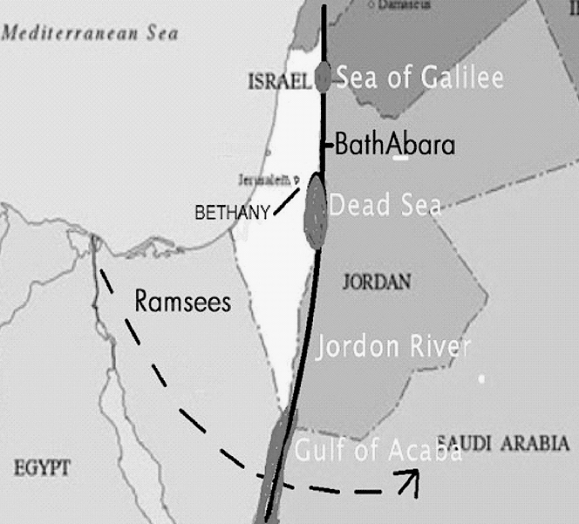
[Keep this in mind – extraordinary and supernatural events have occurred under and directly around the 35th meridian.]
For example, when the Hebrews left Goshen-Egypt on the Exodus, they headed east toward Sheba in modern Saudi Arabia. When God parted the Red Sea, the Hebrews crossed over (or under) the 35th meridian and the laws of physics were suspended (in part). On the east side of the 35th meridian, their clothes and their shoes did not wear out. (Deuteronomy 29:5) They ate bread that came down from heaven. Caleb, who along with Joshua believed that God would destroy the Anakim (Giants) living in Canaan, did not age during the forty years they wandered in the desert (Joshua 14:7). After Moses died, Joshua led the Hebrews in battle to take the city of Jericho, which is 4-5 miles west of the 35th meridian. Once the Hebrews crossed the 35th meridian from the east, their clothes and shoes began to wear out, the manna from heaven ceased, and they ate the corn of Jericho (Joshua 5:12).
In John’s gospel chapter 6:18-21, the disciples set off across the Sea of Galilee to the town of Capernaum. When they had rowed about three of four miles, (or half way) they saw Jesus walking on the sea toward them. Once they took him into the boat, they went immediately; or “at once” to the other side of the lake. This accelerated speed of travel also occurred at the 35th meridian.
In Genesis 18:2, Abraham was sitting at the door of his tent looking across the plains of Mamre, toward the 35th meridian. He lifted up his eyes and saw that three men stood by him: and when he saw them, he ran from the tent door to meet them, and bowed himself toward the ground. Ask yourself this question, if the three men stood by him, why did Abraham run out to meet them? The Hebrew word “’al” which is being translated as “by,” actually means “above,” and is always related to a “downward” aspect or movement. In other words, the three men were descending from the sky above Abraham when he ran out to meet them, which is why he lifted up his eyes to see them. It appears there is some type of dimensional anomaly that occurs around the the 35th meridian. Whatever it is, the Jordan River has always been known to the Hebrews as a place “to cross over,” and not just from one side of the river to other. [Study Note 5]

“Crossing Over”

After Jesus gives the “Good Shepherd” discourse he; “went away again beyond Jordan into the place where John at first baptized; and there he abode.” John 10:40. The place where John baptized was called Bethabara. (John 1:18). There was a ferryhouse located there on the eastern shoreline of the Jordan River. During the rainy season, when the current was turbulent, people and goods were ferried across the river at Bethabara. For this reason, Bethabara meant two things in the Hebrew language, (1) a ferryhouse, and (2) a place beyond the Jordan. The idea of “a place beyond the Jordan” comes from the word “Hebrew” itself, which is derived from the root word “Ibree” meaning “to cross over” (especially to the east side of the Jordan River). In a spiritual sense, to cross over the Jordan is to leave this physical plane of existence and journey into the spirit realm (or heaven). In the Hebrew mind, going over the Jordan meant going back home.²

CHAPTER 4

Also keep in mind when reading what follows, the dual or parallel nature of the narrative found in John chapter 12. There is the Historical account we all know that took place in John’s day and time. However, there is also an implied prophetic meaning. In the historic account, Jesus leaves Bethabara to raise Lazarus from the dead. Later he has supper with Martha, Mary, and Lazarus at their house in Bethany. The following implied meaning is a prophetic overlay given to the historic account of John 12. At some future time, when Jesus leaves Bethabara and crosses over the Jordan River, he is leaving heaven to gather the saints of God. This marks the beginning of the Tribulation. Shown on the chart on the next page, when He arrives in Bethany, Martha and Mary are preparing a meal; which is, for the purposes of this prophecy, the marriage supper of the lamb (Revelation 19:6-9).
______________________________
² This very idea is expressed in a hymn dated 1784, entitled “Wayfaring Stranger,” I'm just a-goin' over Jordan, I'm just a-goin' over home.” (Emmylou Harris does the best rendition of this song.)
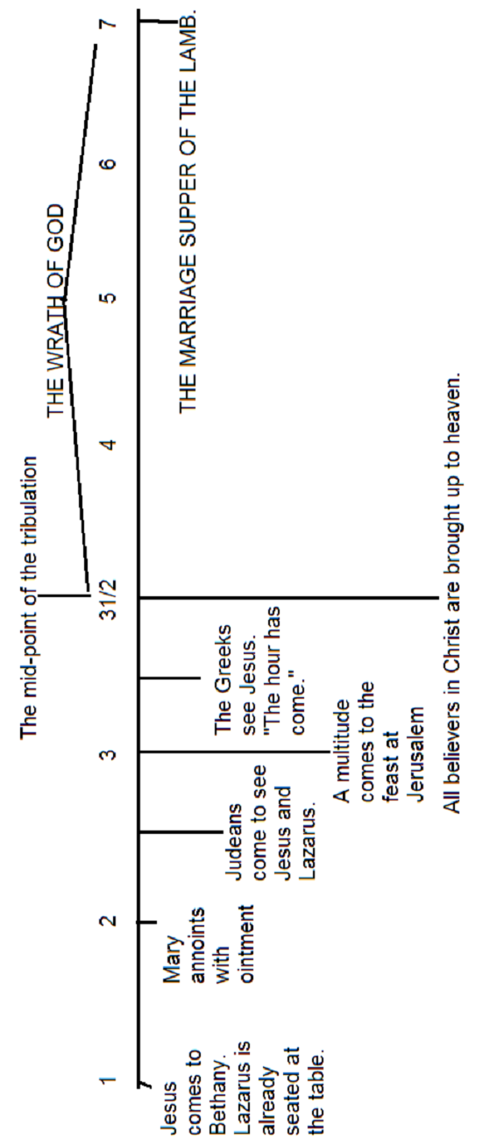
Lazarus is already seated at the table, because Lazarus is a picture of the Church at Philadelphia which has already left this plane of existence at the start of the tribulation. Jesus then gathers all those who believe in His name, beginning with the Judeans (or Hebrews), followed shortly thereafter by all other believers, who are represented by the Greeks. What follows immediately afterwards is the wrath of God. (John 12:20)

Chapter 5

In the historical account, while Jesus is at Bethabara, Martha and Mary sent unto him saying, “Lord, behold, he whom thou lovest is sick.” Jesus assures Martha and Mary that the sickness is not unto death. However, Lazarus does in fact - die. So, what did Jesus mean? In Hebrew, the name Lazarus is El`azar and means “God (is) helper.” The word “Bethany” means “House of Figs,” and relates back to Genesis chapter 3, and the Garden of Eden. When Adam and his wife sinned, they became mortal beings and covered their nakedness with fig leaves. [“…sin entered the world through one man, and death through sin…Romans 5:12] In the prophetic interpretation of this account, Jesus is the helper coming to the “House of Figs” (the children of God) to save us from the sickness of mortality passed down from our first parents. Jesus said the sickness is not unto death because;
“everyone who lives and believes in Me will never die.” John 11:26
Notice in the historic account, when Jesus receives the news about Lazarus being sick, he “abode two days still in the same place where he was.” (John 11:5-6) Jesus waited TWO DAYS before leaving Bethabara to raise Lazarus from the dead. This two-day period of time has a special significance in the prophetic version of this account.

[In the study shown below, a numbered day appears next to each verse that correlates to the 7-day [7-year] timeline shown on page 17.]

John’s Gospel Chapter 12

In John 12, after Lazarus is raised from the dead, the first verse states (DAY 1 of the timeline);
“Then Jesus six days before the passover came to Bethany, where Lazarus was which had been dead, whom he raised from the dead.”
The first thing to recognize in this verse is the time period of “six days before Passover,” which has no special meaning in the Hebrew culture. Therefore, by referring to the six days before Passover, the author is alerting the reader to a parallel meaning. The six days before Passover, plus the Passover day itself, equals seven days. Let’s suppose that this seven-day time frame is also meant to be a picture of the seven-year tribulation. According to Exodus Chapter 12, Passover occurs on the first day of the Feast of Unleavened Bread. During the six days following Passover the Hebrews ate no leaven (or yeast). Since leaven represents sin, the feast of unleavened bread is meant to convey the idea that once the lamb is offered as the penalty for sin (on the day of Passover), all sin is COMPLETELY erased from the believer’s life. (Romans 4:8). Let’s say for the sake of this allegory, that the six days before Passover is actually marking the six days leading up to the final Passover, which is the Marriage supper of the lamb coming at the end of the seven-year tribulation. [Rev 19:9] Jesus spoke of the marriage supper of the lamb at his last Passover when he said; “But I say unto you, I will not drink henceforth of this fruit of the vine, until that day when I drink it new with you in my Father's kingdom (Matt 26:29). The time of “that day” occurs at the end of all things, when the marriage supper of the lamb takes place.
The second thing to notice is that Lazarus, who is a picture of the “Philadelphia” believers who have already left this world at the beginning of the tribulation, is seated at the table. The believers who remain in this world notice that the “Philadelphia” believers are gone, in the same way that the people of Enoch’s day knew that Enoch had been taken by God. (Gen 5:21–24) This why in Verse 9, “a large crowd of Judeans come to Bethany, not only because of Jesus, “but also to see Lazarus.”
Verse 3 of John Chapter 12 (DAY 2 on the timeline), coincides with an event taking place in the spirit realm in Revelation Chapter 8, when seven angels are given seven trumpets, which represent the first of three woes that are about to come upon the earth. This signifies the beginning of the wrath of God. In the historic account of John 12:3;
“Then took Mary a pound of ointment of spikenard, very costly, and anointed the feet of Jesus, and wiped his feet with her hair: and the house was filled with the odor of the ointment.”
While in the spirit realm;
“..another angel came and stood at the altar, having a golden censer; and there was given unto him much incense, that he should offer it with the prayers of all saints upon the golden altar which was before the throne.” Rev 8:3
These two events most likely occur simultaneously. Mary offers incense at the preparation for the marriage supper of the lamb, while an angel offers incense with the prayers of the Saints at the altar of God. Immediately following the angel’s offering;
“…the [same] angel took the censer [that offered incense], and filled it with fire of the altar, and cast it into the earth: and there were voices, and thunderings, and lightnings, and an earthquake. Rev 8:5

[The thunderings stated here, are linked to another circumstance mentioned on page 28.]
Following these two offerings the rest of the believers are caught up to heaven. This signifies the start of the middle of the tribulation, and the beginning of the wrath of God.
In verse 12 (DAY 3 of the timeline), “The next day a great multitude had come to the feast, when they heard that Jesus was coming to Jerusalem,…” The term “great multitude” is used to describe all people, from all nations, who have believed in the Gospel of Jesus which has been preached for almost 2000 years. These people are symbolized by the Greeks (in verse 20) “…who came up to worship at the feast.” In verse 22, which is still day 3 of the timeline, “(the Greeks) came to Philip saying, "Sir, we wish to see Jesus." (v22) Philip then told Jesus (v23), and Jesus answered them, saying, "The hour has come that the Son of Man should be glorified. In the historic version of this account, Jesus is crucified. In this prophetic overlay, when Jesus says “the hour has come” he is referring to his second coming. In other words - Time’s Up. The number of all those who would believe in Christ is complete, according to the plan of God.
CONCLUSION
As previously mentioned, since Jesus is the prophesized Passover Lamb, he was most likely born on Passover, the tenth day of the month of Nisan (or April). Luke states in his gospel that Jesus began his ministry when he was about 30 years of age. (Luke 3:23). So then, sometime before April 10, 25 A. D., he began his ministry. How did Jesus begin his ministry? John answers this question in chapter 2 of his gospel when he describes the wedding at Cana in Galilee:
“This beginning of miracles did Jesus in Cana of Galilee, and manifested forth his glory; and his disciples believed on him.” V. 11-13:
John writes that after the marriage at Cana, Jesus “went down to Capernaum, he, and his mother, and his brethren, and his disciples: and they continued there not many days,” because the “Passover was at hand, and Jesus went up to Jerusalem.” (verse 13) Since Jesus is traveling to Jerusalem because the Passover is about to occur, this means the wedding at Cana occurred just before April 10, 25 A.D., when Jesus was “about (or almost) 30.”
The scriptures indicate that Lazarus was raised from the dead during the last four months of Jesus’ ministry, between the Feast of the Dedication, which occurred in December (John 10:22), and the Passover of John 13:1, in the year 28 A.D., as illustrated by the graph on the next page.
28 A.D.

28 A.D. is the prophesized year that Jesus was to be cut off and killed. In the Book of Daniel, Chapter 9, verse 24, the angel Gabriel tells Daniel the prophecy of the seventy weeks.
“Seventy weeks are determined upon thy people and upon thy holy city, to finish the transgression, and to make an end of sins, and to make reconciliation for iniquity, and to bring in everlasting righteousness, and to seal up the vision and prophecy, and to anoint the most Holy.”
The Hebrew idiom of “a week” equals seven years. Therefore, 7 times 70 equals 490 years, “…to bring in everlasting righteousness.” This occurs at the end of the tribulation, when God destroys the wicked and creates a new heaven and a new earth (Rev 21:1).

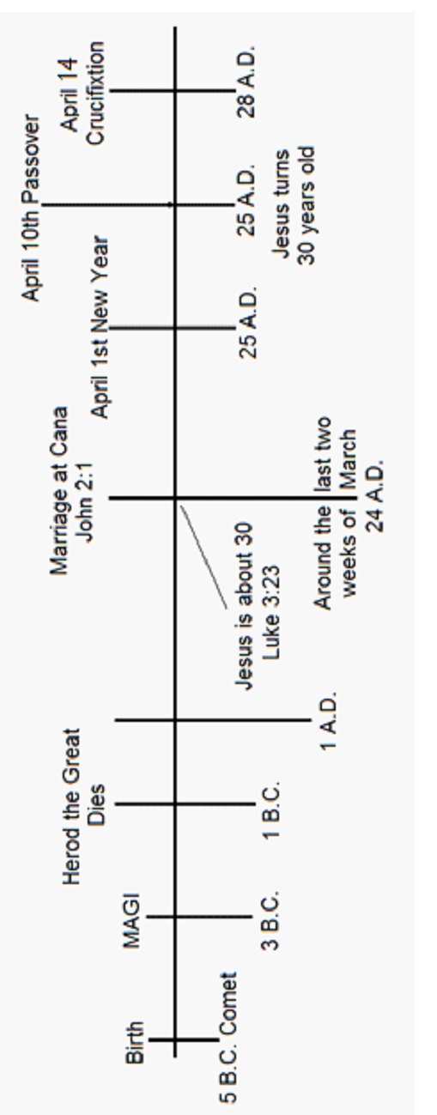
Yet, in Daniel 9:25, the angel Gabriel makes a very specific prediction about the 70-week prophecy:
“…that from the going forth of the commandment to restore and to build Jerusalem unto (until) the Messiah the Prince shall be; seven weeks [7 X 7 = 49 years], and threescore (60) and two (2) weeks: [7 X 62 = 434 years.] the street shall be built again, and the wall, even in troublous times.”
Taken together, 49 + 434 = 483 years.
It is a matter of historical record, the commandment to restore and rebuild Jerusalem was given by the Persian King Artaxerxes on March 14, 445 B.C. Subtract the year 455 B.C. from 483 to arrive at 28. A.D., the year that Gabriel said the Messiah would be cut off and killed. The remaining one week of the seventy-week prophecy, which has been left unfulfilled by the crucifixion, is a picture of the seven-year tribulation. In other words, the “70th week” of the prophecy has been “suspended” until the time Jesus leaves Betharbara to start the tribulation.
Herein lies the hidden meaning of John 12.
In the historical narrative, Jesus waits TWO DAYS at Bethabara before going to Bethany to raise Lazarus from the dead. In the prophetic overlay of the historical narrative, Bethabara symbolizes the spirit realm, the place where Jesus ascended to after the resurrection in 28 A.D. Let us suppose there is a parallel meaning behind the TWO DAYS, that applies to the prophetic overlay of the historical narrative; and Jesus has waited TWO DAYS since 28 A.D., for the time of the end, to leave for Bethany on his final mission to heal the saints of mortality, and rescue them from the great tribulation. The Apostle Peter stated in chapter 3, verse 8, of his second Epistle;
“…beloved, be not ignorant of this one thing, that one day is with the Lord as a thousand years, and a thousand years as one day.” KJV
Applying the Apostle Peter’s measurement of time to the prophetic version, Jesus will wait TWO THOUSAND YEARS before he leaves Bethabara to rescue the Saints. Just as Jesus began his ministry in 25 A.D., he will remove the Philadelphia believers in 2025 A.D., near or at the start of the tribulation. Then in 2028 A.D., the rest of the believers will leave this plane of existence at the mid-point of the tribulation, to be in the presence of God forevermore. [Study Note 7]
Thunderings
The events surrounding the third time Jesus appears to the disciples, found in John 21, is also symbolic of the same time frame:
“After these things Jesus shewed himself again to the disciples at the sea of Tiberias (Galilee); and on this wise shewed he himself,” Or in modern English, “in this way (or in a specific order) He showed Himself;” (to) Simon Peter, Thomas called the Twin, Nathanael of Cana in Galilee, the sons of Zebedee, and two others of His disciples were together.
Notice first, Jesus is at the Sea of Galilee under the 35th meridian. This is a picture of Jesus gathering all of the saints at the middle of the tribulation. Jesus didn’t just appear to everyone at the same time, and there is a symbolic reason for this. He appears first to Simon Peter, who was the first disciple to believe that Jesus was the Son of God (Matthew 16:16). Then he appears to Thomas called the twin, who was the last disciple to believe (John 20:24). These two disciples represent all of those who believe, from the first to the last. Then he appears to Nathanael of Cana in Galilee, who not only saw Jesus as the Son of God, but also as the King of Israel, and this is exactly what’s about to happen, it is time for Jesus to be crowned “King.” Next, he appears to the sons of Zebedee, who are James and his brother John, to which Jesus gave the name “sons of thunder.” (Mark 3:17). Scholars have always wondered what the meaning was behind this title. It relates to page 22, when an angel takes fire from the alter and throws it down into the earth, and there are…thunderings. This marks the beginning of the wrath of God, at the middle of the tribulation. What we are being shown in this illustration is that once all of the believers meet up with Jesus, the thunder starts just as the last “two-other of his disciples” join the rest of the believers. The reason why these two “other disciples” are nameless, is because they are the two witnesses that are killed in Jerusalem, at the middle of the tribulation. We are not given their names in advance. They lie in Jerusalem for three and one-half days (which symbolizes three and one-half years, or the middle of the tribulation). At which time they are resurrected in front of everyone on earth (Rev 11:8-10), in the same manner that Elijah was taken up to heaven in a chariot of fire.

The Hebrew Feast of Sukkot

The Hebrew feast of Sukkot, is called the Feast of Tabernacles in the New Testament (John 7:2). This seven-day feast commemorated the Exodus from Egypt. It is also a picture of the seven-year tribulation. A full explanation of John Chapter 7 would require an in-depth study, but just to scratch the surface, look at verse 10, when Jesus goes secretly to Jerusalem on the first day of the feast. (This is a picture of Jesus secretly coming to get the Philadelphia believers at the start of the tribulation). In verse 14, in the middle of the feast, Jesus appears openly, teaching in Jerusalem. Since this is a picture of the tribulation, the middle of the feast would be 3 1/2 years into the tribulation. Here is the interesting thing, the exact middle of the Hebrew Feast of Sukkot for the year 2028, occurs on October 8, 2028. Backing up three and one-half years from that date (on the Hebrew Calendar), you arrive at April 11, 2025,² which is the official day of Passover – exactly 2000 years since the day Jesus turned 30.³
The 153 Fish
One of the fall festivals that God commanded the Hebrews to celebrate was Yom Teruah, or the “Day of Shouting” (and blowing of trumpets). This is the only feast day in which the precise meaning is not explained in the Old Testament. When the Hebrew’s were living in the wilderness during the Exodus, a loud trumpet blast (Teruah) would sound to call the people to attention, to prepare them to meet God. (Exodus19:17). Most likely, the trumpet blast of Yom Teruah in 2028, will be the call of God to all believers on earth, to prepare to meet God! We know from the scriptures that the return of Jesus is preceded by a loud command, with the voice of an
_____________________________
2 The Hebrews still observe a 30-day calendar which requires a 5.25 day adjustment each year. That’s why Passover is on April 11 instead of April 10.
3 To look at the calendar see www.hebcal.com.
archangel, and with the trumpet of God. (1 Thessalonians 4:16)
In John Chapter 20, look at how John specifically counts the days to Yom Teruah:
Verse 18 - Mary Magdalene came and told the disciples that she had seen the Lord, and that he had spoken these things unto her. (The morning of the resurrection, Day 1)
19 - Then the same day at evening, being the first day of the week (Sunday), when the doors were shut where the disciples were assembled for fear of the Jews, came Jesus and stood in the midst, and saith unto them, Peace be unto you. (Still Day 1)
24 - But Thomas, one of the twelve, called Didymus, was not with them when Jesus came.
26 - And after eight days again his disciples were within, and Thomas with them: then came Jesus, the doors being shut, and stood in the midst, and said, Peace be unto you. (Day 9,a Monday)
Chapter 21
1 - After these things Jesus shewed himself again to the disciples at the sea of Tiberias (the Sea of Galilee); and on this wise shewed he himself. (Day 10, which was a Tuesday)
3 - Simon Peter saith unto them, I go a fishing. They say unto him, We also go with thee. They went forth, and entered into a ship immediately; and that night they caught nothing.
10 - Jesus saith unto them, Bring of the fish which ye have now caught.
11 - Simon Peter went up, and drew the net to land full of great fishes, an hundred and fifty and three: and for all there were so many, yet was not the net broken. John 20:18-21:25 KJV
Consider the following theory; the 153 great fish represent 153 days. John Chapter 20 marks out 10 specific days prior to catching the 153-great fish, and the 10th day was a Tuesday. Adding 10 days to the one hundred and fifty-three days, equals 163 days. If you look at the Hebrew calendar for the year 2028, Tuesday, April 11, 2028 is Passover, and 163 days later, on Thursday, September 21, 2028, is Yom Teruah, the day of shouting and the sounding of the trumpet. Get ready to meet God!
______________________________
The 153 great fish may not only represent 153 days (or one great fish per day), but it may also represents the provision of food needed for the saints to survive from the Passover of 2028, until Yom Teruah. It is possible that the mark of the beast was implemented just before or around the Passover of 2028, and all of the people on earth are required to receive the mark in order to purchase food. Of course, believers will not take this mark and will need this provision from the Lord.

STUDY NOTES
1. The Caravan’s route from Persia to Israel was most likely along what was known as “the fertile crescent” which curves north as you travel west. This was easier than going directly west from Persia and across the desert. (See Map on next page) Nothing indicates in the scriptures that the wise men followed the star from Persia to Jerusalem. Instead, Matthew infers that the star had disappeared and then reappeared after the Magi spoke to King Herod the second time. Matthew 2:7
“When they had heard the king, they departed; and, lo, the star, which they saw in the east, went before them, till it came and stood over where the young child was. When they saw the star, they rejoiced with exceeding great joy.” Matthew 2-10. The use of the word “lo” (or behold) indicates they were taken by surprise, not expecting to see the star. But when they did see it, they rejoiced because the star had reappeared and then moved to be over the house where Jesus lived (Matthew 2:10-11). Notice also, that the Magi see “the star,” the same one they saw in the east, and had recognized as “HIS star,” the one that was foretold to appear before the birth of the messiah. I have not seen in my studies, a scientific explanation of how the same star reappeared about two years later, I just believe it.
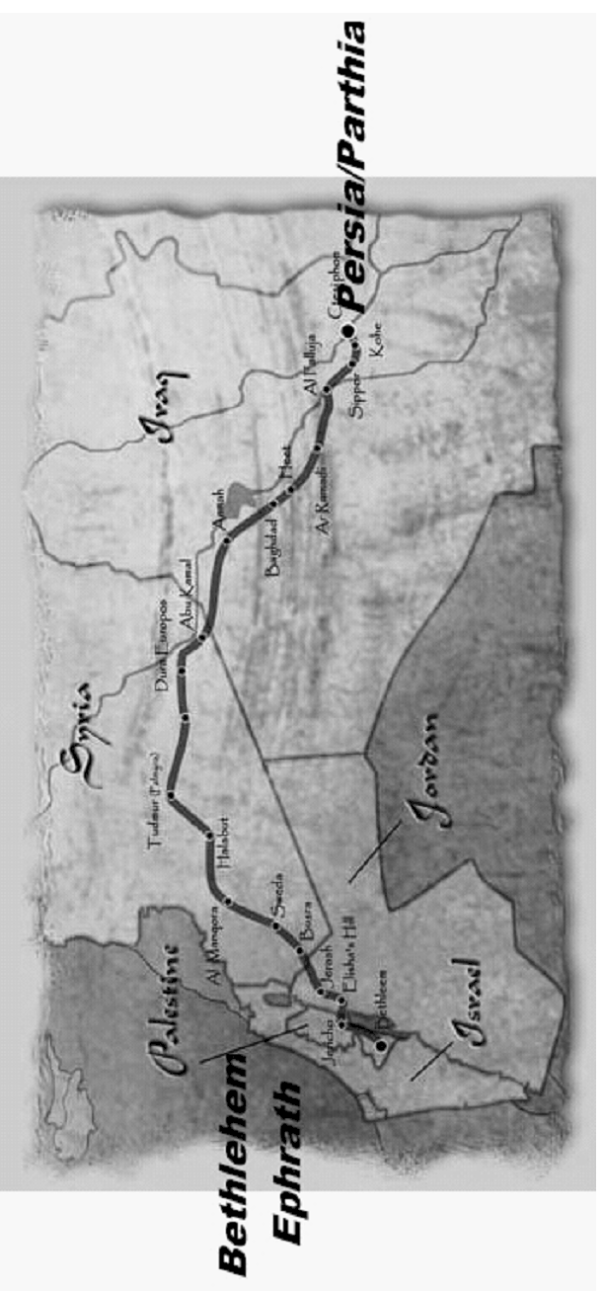
2. Jesus says to the church of the Laodiceans;
“Behold, I stand at the door, and knock: if any man hear my voice, and open the door, I will come in to him, and will sup with him, and he with me.” Rev 3:20
This saying poses the question, why is Jesus standing outside of the door of “His” church knocking to be let in? This verse also alludes to the fact that the church does not open the door so Christ must appeal to each individual in that church who might hear his voice, to come and “sup” with him. Make no mistake about this verse, it represents the final curtain call. The “supper” that Jesus is referring to is the marriage supper of the lamb. Once the door is shut to this supper, no one else will enter. [Study Note 3]
The believers who did not leave at the beginning of the tribulation were distracted by the things of this world found in the description of the Church of the Laodiceans. There is an important distinction made in the language itself concerning the seven churches of Revelation. Beginning in Rev. Chapter 2, Jesus instructs the Apostle John to send a letter to the angel of the church; of Ephesus, in Smyrna, in Pergamos, in Thyatira, in Sardis, and in Philadelphia. The use of the words “of” and “in” denote the geographic location where each church was started. However, the last letter is written to the angel of the church of the Laodiceans. The phrase “of the Laodiceans” is meant to indicate that this church may have been planted by the Holy Spirit in Laodicea, but the Laodiceans have supplanted the teachings of Christ with their own doctrine. Thus, Jesus’ church in Laodicea has become “the church of the Laodiceans.” In other words, it’s their church and not Jesus’ church anymore. That’s why Jesus is pictured standing at the door and knocking to be let in. Even so, anyone in this church who hears the voice of Christ and answers his call, will leave this earth about the middle of the seven-year tribulation.
3. In the parable of the 10 virgins, the five foolish virgins run out of oil just as the bridegroom approaches. They leave the wedding feast to buy oil from the merchants. However, the oil being referred to in this parable is the Holy Spirit, which cannot be purchased. The merchants are the teachers who sell the oil of religion, found in the church of the Laodiceans, who proclaim they are rich and in need of nothing, while Jesus sees them as poor, blind, and naked. Jesus sends them away.
4. Once the believers are brought up to be with the Father and his Son, an angel proclaims in verse 10 (part a);
“Now is come, salvation, and strength, and the kingdom of our God, and the power of His Christ,
This is very important. The Greek word being translated above as “Now,” is the word, “arti (ar'-tee).” This word denotes the idea of something “suspended,” that has just now come - this day and hour. The thing that was suspended in time was the fulfillment of God’s promise of salvation, which is now made manifest through the redemption of the body, into a state of immortal life. The “suspension” of salvation until this moment in time, is what the author of the Letter to the Hebrews described in chapter 11, verses 39-40. He wrote that all of the believers who have gone before us, even those who suffered as martyrs, would have to wait for the redemption of their bodies:
“And these all, having obtained a good report through faith, received not the promise: God having provided some better thing for us, that they without us should not be made perfect.” KJV
To be made perfect is to receive eternal life, which is the promise of Christ. Part b of Rev 12:10 declares;
“…for the accuser of our brethren, who accused them before our God day and night, has been cast down.”
Notice that Satan’s power to accuse is in the past tense. (Rev 6:11). Once the fulness of salvation has come, there is no room in heaven for the accuser. Satan is cast down to the earth and the three woes begin, signifying the start of the wrath of God against the godless inhabitants of the earth. The redeemed are not subjected to the wrath of God, therefore we cannot be here on earth after the mid-point of the tribulation.
“For God hath not appointed us to wrath, but to obtain salvation by our Lord Jesus Christ, 1 Thess 5:9 KJV
5. In the book of Joshua, Chapter 3, God holds back the turbulent Jordan River so the Hebrews can cross over on dry ground, on the 35th meridian.
6. Why is the Philadelphia church kept from the tribulation? They have kept (or guarded) his word, and not denied (refused or contradicted) his name, and also have a degree of miraculous power. In order to understand this more fully, you must first consider how John views Christ, when he sees him in his perfect form (Rev 1:12-16).
“I turned to see the voice of him that spoke with me…I saw seven golden candlesticks; And in the midst of the seven candlesticks one like unto the Son of man, clothed with a garment down to the foot, and gird about the chest with a golden girdle. His head and his hairs were white like wool, as white as snow; and his eyes were as a flame of fire; And his feet like unto fine brass, as if they burned in a furnace; and his voice as the sound of many waters. And he had in his right hand seven stars: and out of his mouth went a sharp two-edged sword: and his countenance was as the sun shineth in his strength.“ Jesus says to John, “I am he that liveth, and was dead; and, behold, I am alive for evermore,” (Rev 1:18).
Note that following this description of Jesus in his glorified body, each one of the churches beginning with Ephesus, see only a part of the full image of Christ (in his glorified form). For example, Ephesus sees only, “the seven stars in his right hand, who walketh in the midst of the seven golden candlesticks” (Rev 2:1). The church in Smyrna hears Jesus saying “These things saith the first and the last, which was dead, and is alive; they have no recorded vision (Rev 2:8) The church in Pergamos sees ”…he which hath the sharp sword with two edges; (Rev 2:12). The church in Thyatira see him “..who hath his eyes like unto a flame of fire, and his feet are like fine brass; (Rev 2:18). The church in Sardis sees “…he that hath the seven Spirits of God, and the seven stars; I (Rev 3:1). The church in Philadelphia sees “…he that is holy, he that is true, (Rev 3:7) In other words, the Philadelphia church not only sees the fullness of Christ who is holy (or complete), they also understand that he is the truth of God.
Lastly, to the church of the Laodiceans; Jesus must testify of himself, that he is “..the Amen (or the fulness of God), the faithful and true witness, the beginning of the creation of God; (Rev 3:14). How God began his creation with Jesus requires a fundamental understanding of the person of Christ, which is either misunderstood, completely forgotten, or disregarded by the Laodiceans.
7. Also Consider Martha’s statement made to Jesus when he arrived at the tomb of Lazarus (John 11:38-39).
“Jesus, once more deeply moved, came to the tomb. It was a cave with a stone laid across the entrance. “Take away the stone,” he said. “But, Lord,” said Martha, the sister of the dead man, “by this time there is a bad odor, for he has been there four days.”
It is 18-20 miles from Bethany to Bethabara, or a two-day journey on foot. Therefore, when Martha and Mary first tell Jesus that Lazarus is sick, two days have already passed. Jesus waits two more days in Bethabara, and then makes the two-day trip to Bethany for a total of six days. Applying 2 Peter 3:8 again, the six days symbolically equal six thousand years. According to the timeline of birth and death dates given in the book of Genesis, the flood actually occurred 1656 years after the creation of Adam. Compare this date to the year 2348 B.C., which is the best guess date agreed to by Bible scholars for Noah’s flood. If we add 1656, 2348, and 2028 together, we arrive at 6032 years. If we allow for a 32-year margin of error in the dating of Noah’s flood, it has been 6000 years since the creation of Adam, the fall of Adam, and the sickness (or curse) of mortality. The six days that occur between the sickness, death, and raising of Lazarus from the dead; symbolically coincide with the six thousand years that have passed since the creation of man, the fall of man, and the restoration of man at the return of Jesus.
ADDITIONAL STUDY ON YOM TERUAH
Yom Teruah begins a ten-day period leading up to the holiest day of YHWH's calendar, Yom Kippur -- the "Day Of Atonement." In modern Judaism, these ten days are called the 'Days of Awe.' Traditionally, the Baal Tekiah (shofar blower) begins with one held blast called Tekiah; followed by three broken blasts called Shevarim; followed by nine even faster broken blasts called Teruah. The traditional meanings are:
1. TEKIAH - A pure unbroken sound that calls man to search his heart, forsake his wrong ways, and seek forgiveness through repentance. The tekiah called the people to attention and to gather unto Moses; to listen to God, to receive from Him the orders for the day. The Tekiah blast is followed by:
2. SHEVARIM - Three broken, staccato, trembling sounds.
3. TERUAH - A wave-like sound of alarm calling upon man to stand by the banner of God. Teruah in Hebrew means not only a certain unique sound. It also connotes "to break", denoting breaking something and/or causing damage. It is the note for bustling, speedy activity, the signal for breaking up, for striking tents and breaking up camp.
The historic meaning of these blasts (from the Shofar) also point to the Great Tribulation and the rapture of the Saints. There is a special meaning within this Hebrew tradition that is meant for modern day believers. Just as the tribes of Israel numbered twelve, so are there twelve blasts from the Shofar (after the Tekiah). The Tekiah will sound first. It is the “Wake Up Call to Attention.” Believers in Messiah who have made themselves ready, will hear this blast! The next sound to follow will be the Shevarim, the first three short blasts (of the twelve) which signal the rapture of the Philadelphia believers. At the mid-point of the tribulation, the final nine blasts (3x3) will be heard and the remainder of the Saints will be raptured. This theme, the grouping together of “threes,” occurs several times in the New Testament. Have you ever wondered why Jesus, on three separate occasions, selected Peter, James, and John to accompany him while leaving out the other nine disciples? The first time occurred at the house of the ruler of the Synagogue:
And when he came into the house, he suffered no man to go in, save Peter, and James, and John, and the father and the mother of the maiden. Luke 8:51 KJV
Then at the Mount of Transfiguration;
And after six days Jesus taketh Peter, James, and John his brother, and bringeth them up into an high mountain apart, Matt 17:1 KJV
And at the Garden of Gethsemane.....
And he took with him Peter and the two sons of Zebedee (James and John), and began to be sorrowful and very heavy. Matt 26:37 KJV
In the historical narrative of Matthew 26; Jesus goes away three times to pray. When he returns the third time, he finds the disciples asleep, his betrayer in the Garden, and a small army ready to take him captive. In the parallel or end time version, we’re being shown that when he comes the third time (at the end of the tribulation); It is over - times up! Jesus is in the garden, not to surrender to the Army, or Satan and his Anti-Christ. He is there to destroy the Army of the Anti-Christ, and put away forever, the enemies of God.
What significance do these three events have in relation to the first departure of the Saints at the start of the Tribulation? Peter, James, and John are emblematic of the Philadelphia believers. They are represented by the first three (short) blasts from the shofar called the Shevarim. Pray that you are worthy to leave with this group. You may be wondering, how do I become worthy? The answer is found in what Jesus said to this group of believers (expanded translation of the Greek words appear in parenthesis); “I know thy works: behold, I have set before (in the presence of) thee an open door (portal), and no man can shut it: for thou hast a little strength (miraculous power), and hast kept (guarded) my word, and hast not denied (contradicted, disavowed, or rejected) my name (authority)…I also will keep thee from the hour of temptation (experience of evil) , which shall come upon all the world, to try them that dwell upon the earth. (Rev 3:8-10) Amos wrote (in 3:7), “Surely the Lord GOD will do nothing, unless He reveals His secret to His servants the prophets. I do not expect prophets to appear now as they did in the days of ancient Israel, because Jesus has come, and the scriptures say, 'For the Testimony of Jesus Is the Spirit of Prophecy' (Rev 19:10). We who have received Jesus, have received the spirit of prophecy, and we are more than capable of understanding the signs of his second coming. If you sense the end is near, even at the very door, you’re not paranoid, you are being shown something in the spirit that only the Holy Spirit can make you aware of. Afterall, he is coming back for those who are looking forward to his coming!

Copyright © 2019 Williamfkinney @gmail.com

