Torah or The Law
Written by William Kinney
Maryville, Tennessee 37803
Copyright 2014 © All Rights Reserved
Table of Contents
Chapter One – Page 8
Chapter Two – Page 24
Chapter Three – Page 30
Chapter Four – Page 43
Chapter Five – Page 48

Introduction
Our world is full of signs and symbols designed to manipulate our thoughts, and solicit a response. Thousands of years ago, the Egyptians worshipped the trinity of Osiris, Isis, and Horus. Osiris was the god of the afterlife, the underworld, and the dead. He was the brother and husband of Isis; and Horus was their son. Osiris was murdered by his brother Set (also considered a god) who then dismembered his brother’s body. His wife, Isis, searched for and discovered the pieces, which she then reassembled. With a little magic, she resurrected Osiris from the dead. With an added measure of magic, she conceived by Osiris and gave birth to Horus. Initiates into the mystery religion of Isis, worshipped her with dance, music, and the clash of cymbals.
This cymbal
Became a symbol;
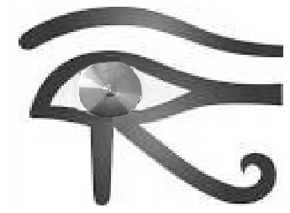
Of Royal power and authority. This image subconsciencely reminded the Egyptians that under the “Eye of Isis” (and Horus) they were being watched and evaluated for societal conformaty. Everyone was a serv-ant under Isis.
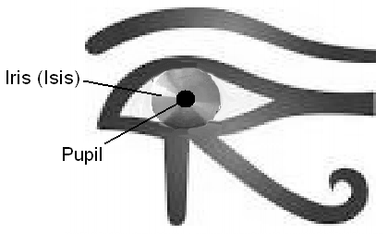The worship of Isis was brought to the Roman world by the Phoenicians, where she became the Goddess “Ceres.”
In the same way that a brick mason uses a mortarboard to hold cement,
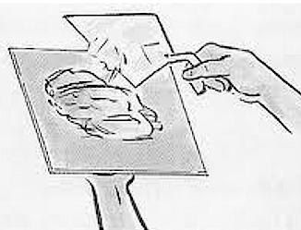
Graduates of schools and universities wear a mason’s mortarboard at their graduation - Cere(s)mony.
The pupil is the brick, the hidden knowledge that requires payment (in order to be received) is the mortar. The teacher is a priest, and in the perfect blend of Religion and State; he helps to assemble the bricks into a state sanctioned structure. In ancient Egypt, the structure is symbolized by the pyramid, the capstone symbolizes the Royalty that sits atop the common man (represented by the bricks). Even today, the “All Seeing Eye” is all around us, even on the US dollar bill.
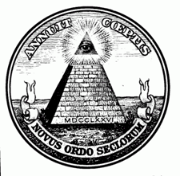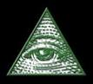
(There are many more symbols like these.)
So then, according to those who record history, was it God in the beginning, who caused the Genesis of creation? Or is it “Isis” who “generates.”
The greek philosopher Plato, in his book “The Republic,” envisioned the best form of government (for controlling the masses) to be structured like a beehive.
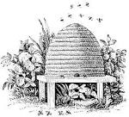
The drones are the royalty that serve the Queen. The Queen chooses from among the drones, who will be her mate. The worker bees fly back and forth between the flowers and the hive to bring in the honey (money). Picture Plato’s beehive in its naturally occurring spiral, colored in alternating black and yellow stripes. (This was Plaro’s logo). Think of the English word to exist, or;
TO
Unless you’re a King, Queen, Prince, Princess, Duke, Dutchess; or some other member of royalty, you’re the bee. If this picture were in color, you would see the happy little feller’s yellow and black stripes. That pattern is the same pattern we use on our Public School buses; where we send our children to learn from the “arch-hives,” how to stay biz-z-z-y in biz-z-z-iness; and bee-have in society. After a bizzy day of collecting honey for the hive, a bee might want to kick back and drink a bee-r; and watch something on the Tell-A-Vision. Afterall; both he and she (as well as me) can Bee-lieve with glee, what they see on Tee-Vee (for a fee). [That last sentence is proof positive of the damaging effects Dr. Zues can have on Early Childhood Development.]
Because there is so much information available on the Internet about secret societies and fraternal orders; conspiracies and conspirators; I didn’t plan to present a complete expose’ on the subject matter. I only wanted to make the point that things are not always the way they seem. There is an agenda in this world, aimed at projecting the image of a realty that is not based on truth but rather manipulation and control. The word “manipulation” (in Hebrew) carries the same connotation as witchcraft; to whisper a spell, to enchant or practice magic. Manipulation is a diametric contradition to God’s plan for man, which includes a free will combined with liberty and freedom of choice. However, there are many who live willingly under this system of manipulation and control (for several different reasons). Some do not even question the world they live in. Others realize the nature of the delusion; and to the best of their ability and circumstances, they do not participate. While others know fully well what is going on, but because they derive a benefit from the system – they choose to conform.
Chapter One
Jesus said; "for my yoke is easy, and my burden is light." Matt 11:30 KJV).
When he said that he was referring to God's Torah, which is simple and concise. He was not referring to the additional 603 laws of the "Talmud," or the "oral tradition" (that would become the Mishnah) which was imposed on the people by the "Religious authorities." He was not referring to the ceremonial and sacrificial system the Hebrews insisted upon keeping after they left Egypt during the Exodus, the same system that God rejected.
Thus says, YHWH the God of Israel: "Add your burnt offerings to your sacrifices and eat meat. For I did not speak to your fathers, or command them in the day that I brought them out of the land of Egypt, concerning burnt offerings or sacrifices. "But this is what I commanded them, saying, 'Obey My voice, and I will be your God , and you shall be My people. And walk in all the ways that I have commanded you that it may be well with you.'
The phrase; “walk in all the ways that I have commanded you” can also be translated as; “walk in all the way that I have commanded you.” The word being translated as “ways” is “haderek” (“ha” is the definite article, “the”); and means;
#1870, derek (deh'-rek); a road (as trodden); figuratively, a course of life or mode of action.
In Genesis 18:19 the same word, “haderek” is translated as;
“and they shall keep the way (haderek) of the Lord,…” KJV
In Judges 2:22;
“…whether they will keep the way (haderek) of the Lord to walk therein,…”KJV
[“Haderek” is also translated as “the way” in 2 Kings 21:21, 2 Kings 22:2, 2 Ch 20:32, 2 Ch 21:6, and other places in the scriptures.]
My point is, the singular term, “the way” is more appropriate because it is a reference to the Torah, which encompasses the totality of “His way” in ten words. By saying; “ways,” the translator is conveying the false idea that there are many different laws, statutes, and ordinances; that must be followed and obeyed. Whereas; the original Torah given to Moses was comprised of the following ten words;
YHWH (God) is First. Love YHWH with all your heart, and your neighbor as yourself.
(I will explain this in detail shortly). Continuing in Jeremiah (chapter seven), God is telling Israel (through the prophet) that He did not institute ritualistic sacrifices and burnt offerings. He (God) goes on to say;
“Yet they did not obey or incline their ear, but followed the counsels and the dictates of their evil hearts, and went backward and not forward. “Since the day that your fathers came out of the land of Egypt until this day, I have even sent to you all My servants the prophets, daily rising up early and sending them. “Yet they did not obey Me or incline their ear, but stiffened their neck. They did worse than their fathers. Jer 7:21-26 (NKJ)
Oh, what an indictment against them! They took the simplicity found in God’s Torah, and turned it back into the Religion of Cain, complete with grain and fruit offerings, water and wine oblations, animal sacrifices and burnt offerings; and hundreds of do’s and don’ts.
Jesus had this to say about the oral laws and tradition;
They (The Scribes and Pharisees) bind heavy burdens, hard to bear, and lay them on men’s shoulders; but they themselves will not move them with one of their fingers. Matt 23:3-5NKJV
The Hebrews were stiff necked, and of a hard heart; not willing to obey the spirit of the Torah; they were more concerned with the boundaries of compliance. This meant they had to be instructed and guided by Moses regarding how to interpret every aspect of the written law and how it applied to everyday life. These instructions eventually gained the same authority as the “Torah,” and became “The Law of Moses,” or “The Law.” (This is where the confusion begins). The Torah is now considered to be the first five books of the Bible. Jesus said;
“Do not think that I came to destroy the Law or the Prophets. I did not come to destroy but to fulfill. Matt 5:17 NKJV
Which law is Jesus referring to; the Torah, or the Law of Moses? Paul, in his discourse to the Romans (chapter 3, verse 28) about having faith in Jesus, wrote:
Where is boasting then? It is excluded. By what law? Of works? No, but by the law of faith. Therefore we conclude that a man is justified by faith apart from the deeds of the law.
Paul seems to say here that obedience to the law is of no consequence; because believers are justified by faith. When Paul appeared before Felix, Procurator of Judea; he said to him;
This I confess to you, that according to the Way (of the Messianic Hebrew believers) which they call a sect, so I worship the God of my fathers, believing all things which are written in the Law and in the Prophets. Acts 24:14-15 NKJV
If we go back to Paul’s discourse to the Romans in chapter 3, and go to verse 31 he says;
Do we then make void the law through faith? Certainly not! On the contrary, we establish the law. Rom 3:31 NKJV
This saying is more in agreement with what Jesus said about fulfilling the law. Why do these sayings (and others regarding the law) seem contradictory? I can assure they are not. This is all a matter of realizing a conceptual difference in terms.
The original Torah is comprised of 10 words.
“he declared unto you his covenant, which he commanded you to perform, even ten commandments; and he wrote them upon two tables of stone. Deut 4:13 KJV
The Hebrew word being translated as commandments; is Strong’s word #1697; dabar (daw-baw’), from #1696; a word; by implication, a matter (as spoken of). Word #1696 means; dabar (daw-bar’); to arrange; but used figuratively (of words). This word also means “utterances.”
What were the original Ten Words uttered by God and written on the two stone tablets?
They can be easily reconstructed. Over time, part of the ten words had become disassociated from the original Torah (this may have been part of an agenda). Jesus brought this to our attention when one of the scribes asked him;
Which is the first commandment of all? Mark 12:28 KJV
His answer was unusual, maybe even strange to those who heard it; but at the same time powerful because of the implications. Jesus was on a mission to restore all things to the Father, including every aspect of the truth.
Jesus answered him, The first of all the commandments is, Hear, O Israel; The Lord our God is one Lord: Mark 12:29 KJV
Where did that come from? I have never seen this sentence referred to as the first commandment. Usually the first commandment is said to be, "Love God with all your heart." Could the first commandment have been a two part sentence? When you look at the original Hebrew word being translated as "one" (in the phrase, The Lord our God is one Lord); that word is (#259) 'echad (ekh-awd'); a numeral from word #258; properly, united, one; or the ordinal (number) first. This is the same word used in Genesis 1:5 to say, "the evening and the morning were the first day (yom echad). So, let's suppose for a moment the first part of the first commandment is the (Hebrew) phrase;
YHWH Ulheynuw ‘echad.
God our Mighty One is First.
Ye are my witnesses, saith YHWH, and my servant whom I have chosen: that ye may know and believe me, and understand that I am he: before me there was no God formed, neither shall there be after me. I, even I, am YHWH; and beside me there is no saviour. Isa 43:10-11 KJV
“Before me there was no God formed.” In other words, I am The First. Secondly, since God has created his entire family to comprehend and enjoy his creation on the same level that he does; he has said;
“Ye are gods; and all of you are children of the most High.” Ps 82:6 KJV
The Hebrew word being translated as “gods,” in the phrase, “Ye are gods;” is (#430) 'elohiym (el-o-heem'); or properly “Ulheem,” (or “mighty ones”). This is the same word (Ulheem) that God uses as a title for himself (Gen 1:1). The difference is, YHWH is “The Mighty One.” Why is the recognition of his preeminence as “First” even a consideration? For one simple reason (as far as I can see); God is going to make us the same as he is, only he will always be the one who is First. God the Father is First, in the same way that Christ is;
"...the firstborn among many brethren." Rom 8:29 KJV
Christ himself considered God his Father, to be First (as we'll see shortly). In the next two verses Jesus adds the following to “God our Mighty One is First;”
Thou shalt love YHWH thy God (Mighty One) with all thy heart, .... (and) thy neighbour as thyself. (Mark 12:30-31)
There is none other commandment greater than these.
The original Ten Words, according to Jesus were;
YHWH Ulheynuw ‘echad,
God our mighty one is First.
Wa’awhabta YHWH bakal labawbka.
Love God with all your heart.
Wa’awhabta laraeka kamowka.
Love thy neighbor as thyself.
These Ten Words are The Torah (the Way of God). They have existed from the beginning, before there was a creation. They were later divided into Ten Commandments because the people of Israel could not receive (or live by) the Ten Words. It is easy to see that the 10 commandments fit ideologically right back into the 10 words.
- I Love God,
Therefore, He is first in my life. Because he is first; I do not believe in other gods, make images of false gods (in worship), or call myself a child of God in vain. My rest is in God.
- I love my neighbor (true brothers and sisters in YHWH (Matt 12:48-50);
Therefore; beginning with my parents (whom I honor for their love and service to me); I do not murder, adulterate, steal, give false testimony, or covet anything.
After Moses broke into pieces the first two tablets containing the Ten Words, God wrote the words again, on a second set of tablets. When Moses presented the second set of tablets, he said to the people of Israel;
These words the Lord spake unto all your assembly in the mount out of the midst of the fire, of the cloud, and of the thick darkness, with a great voice: and he added no more. And he wrote them in two tables of stone, and delivered them unto me. Deut 5:22 KJV
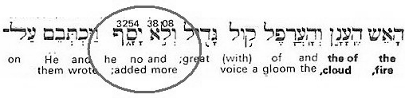
God added no more! The other laws, statutes and ordinances were added to the Ten Commandments by men. These additions gained in authority, eventually becoming equal in importance to the Ten Commandments. They became known as "The Law of Moses."
In opposition to the law of the flesh (contained in ordinances) stands – Jesus; who is “the Torah” made flesh. Jesus fulfilled all aspects of the Ten Words (Torah) in that he put God first; preferring the will of God before that of his own will. He demonstrated his love for God when he agreed to become the Messiah. In becoming the Savior, He proved that he loved His neighbor as himself. This is the fulfillment of the Torah.
Shown below is a simple illustration of Moses holding the Torah. The Ten Commandments are usually depicted with the words written only on the front side of the tablets. However, God wrote on both sides of the two tablets, making them three dimensional.
The two tablets were a representation of Adam and Eve, who were two - three dimensional beings. They were supposed to lead by example, by following the Ten Words of YHWH Torah.

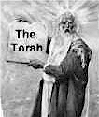

On the next page is an illustration of Moses holding the “Law of Moses” (approximately to scale). If I wrote all the words that appear in the Book of Leviticus, they would take up both sides of the two stones shown in the next drawing.

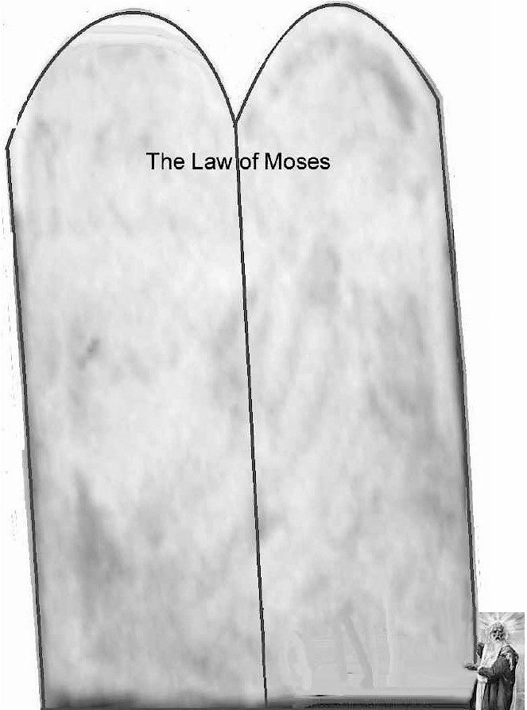
The 603 additional statutes and ordinances (besides the Ten Commandments) which were eventually codified in the Talmud/Torah - is not the Torah, neither was it the Law of Moses. The scriptures bear out this supposition, that it is indeed - true. Look at what took place in Joshua 8:30-32
"Then Joshua built an altar unto YHWH the God of Israel in mount Ebal, As Moses the servant of God commanded the children of Israel, as it is written in the book of the law of Moses, an altar of whole stones, over which no man hath lift up any iron: and they offered thereon burnt offerings unto God, and sacrificed peace offerings. And he (Joshua) wrote there upon the stones a copy of the law of Moses, which he wrote in the presence of the children of Israel." KJV
It says – that He (Joshua) wrote a copy of the Law of Moses while the children of Israel waited. I did a word count on the Book of Leviticus alone, which contains most of the sacrificial and ceremonial laws (and some of the societal laws). I did not include the Book of Numbers or Deuteronomy.
There are approximately 22,600+ words in the Book of Leviticus; which amounts to 92,500+ characters (letters). When writing the text, if I allow for a ½" of surface space for each character, I can fit four letters in a square inch. That means 92,500 characters divided by 4 equals 23,125 square inches. Divide that by 12 to determine the square footage and you have 1,927 square feet; or a surface area of 43.8 feet wide by 44 feet tall. That’s a big rock. Even if you divide that into several rocks (as the verse says) that’s several big rocks. I can write 50 letters in Paleo Hebrew per minute. That means it would take me 1850 minutes or about 31 non stop hours to write the entire Book of Leviticus.. Since the Hebrew word used in the text is "Kathab;" which means "to graven," and the medium being written upon is stone; the text supports the idea that Joshua carved the Law of Moses into the stone altar. I didn’t even try to calculate the time it would take me to carve the 22,500+ words (maybe months?). It stands to reason that the entire assembly of Israel could not have stood around for months (or longer) waiting for Joshua to carve the Law of Moses (and then read it).
"And he wrote there upon the stones a copy of the law of Moses, which he wrote in the presence of the children of Israel. And all Israel, and their elders, and officers, and their judges, stood on this side the ark and on that side before the priests the Levites, which bare the ark of the covenant of God, as well the stranger, as he that was born among them; half of them over against mount Gerizim, and half of them over against mount Ebal; as Moses the servant of God had commanded before, that they should bless the people of Israel. And afterward he read all the words of the law, the blessings and cursings, according to all that is written in the book of the law. There was not a word of all that Moses commanded, which Joshua read not before all the congregation of Israel, with the women, and the little ones, and the strangers that were conversant among them." Josh 8:32-35 KJV
Joshua carved into stone, the entire Law of Moses and then read it aloud to the people. According to the scene described in the scriptures; I believe he carved the Ten Commandments and not the 22,600+ words of the law.” Shown next is most likely what Joshua carved (in Ancient Hebrew);
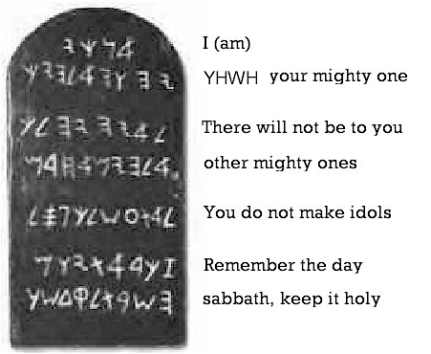

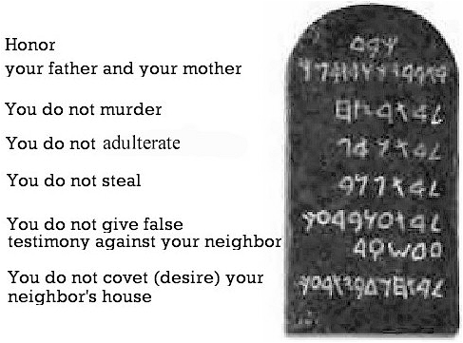
The sacrificial and ceremonial laws were added in by the Priests and scribes; and then falsely codified into law. This is specifically what Jeremiah the Prophet was referring to when he wrote:
"'How can you say, "We are wise, for we have the law of” (God) when actually the lying pen of the scribes has handled it falsely? Jer 8:8 (NIV)
One of the things they handled falsely was codifying the practice of redundant animal sacrifices.
"To what purpose is the multitude of your sacrifices to Me?" Says . "I have had enough of burnt offerings of rams and the fat of fed cattle. I do not delight in the blood of bulls, or of lambs or goats. "When you come to appear before Me, who has required this from your hand, to trample My courts?
Bring no more futile sacrifices; incense is an abomination to Me. The New Moons, the Sabbaths, and the calling of assemblies-- I cannot endure iniquity and the sacred meeting. Your New Moons and your appointed feasts my soul hates; they are a trouble to Me, I am weary of bearing them. When you spread out your hands, I will hide My eyes from you; even though you make many prayers, I will not hear. Your hands are full of blood. "Wash yourselves, make yourselves clean; put away the evil of your doings from before My eyes. Cease to do evil, Learn to do good; seek justice, rebuke the oppressor; defend the fatherless, plead for the widow. "Come now, and let us reason together," says, "Though your sins are like scarlet, they shall be as white as snow; though they are red like crimson, they shall be as wool. Isa 1:11-18 (NKJ)
God is reiterating to the House of Israel; that he does not require the blood of bulls, lambs, or goats; or sacrifices or burnt offerings. [This same message is expressed in Ps 40:6, Ps 51:15-17, Heb 10:5.]
If God didn’t command them in this matter, where did this form of worship come from? It belongs to the worship of the goddess Innana; which is actually a post flood religious practice that began with Cain. Archaeologists discovered the Vase of Urak during an dig in Shinar. The people of Uruk (founded by Nimrod, according to Gen 10:10) worshipped the Moon God Nanna (also known as Sin, as in Mount Sinai), the Moon Goddess Ningal, and her daughter Innana (also referred to as the Queen of Heaven or the Queen of the South). Depicted on the vase (1700 years before the Exodus) are the same offerings and sacrifices the Hebrews were allegedly commanded by God to perform. (Which we will explore shortly) Who was it that first offered sacrifices to "God" after the Exodus? It was not Moses, it was Jethro, the High Priest of Midian (a polytheistic pagan). Moses himself testified concerning the words written on the two tablets, that God added no more (Deut 5:22). Following that presentation, the adversary began a campaign to corrupt the Torah and create a religion.
Chapter Two
The Religion of Cain
It began in Bereshiyth (Genesis), with the first person to make an offering to God - Cain.
And in process of time it came to pass, that Cain brought of the fruit of the ground an offering unto the Lord. Gen 4:3 KJV
I believe Cain should be credited with starting the first religion. Why is it that the wicked one, Cain, was the first one to make an offering? Did he feel a certain detachment from God in their relationship; and thought he could mend it with an offering of produce? Or did Cain perceive that God favored Abel, and wanted to “out do” his brother?
And Abel, he also brought of the firstlings of his flock and of the fat thereof. And the Lord had respect unto Abel and to his offering: But unto Cain and to his offering he had not respect. Gen 4:3-5 KJV
The Hebrew word (#413), 'el (ale); is a primitive particle denoting motion towards, as in the English word, “unto.” It is used twice in the sentence above, which can also be written as;
“Unto Cain and unto his offering he (God) had no respect (regard, consideration, or compassion). God not only rejected Cain’s offering, but he also saw through Cain’s motives and rejected him personally. This is an important distinction made in the text. Since Abel was righteous before God, why didn’t he take the lead in this matter, and make the first offering? Perhaps as an outward sign of his love for God? The best answer I can think of is that Able didn’t feel detached in his relationship with God. He didn’t initiate the practice of sacrificial offerings because Able understood that God wants us to walk by faith. Carefully consider what the details of this text are saying.
And Abel, he also brought of the firstlings of his flock and of the fat thereof. And the Lord had respect unto Abel and to his offering. Gen 4:4
The Hebrew word for firstling is (#1062) bekowrah; which is from (#1060) bekowr; and means the first born of man or beast. (#1060) bekowr is from (#1069) bakar; which means to burst the womb (from #1061) to give the birthright (of the firstborn).
The Hebrew word translated as “the fat thereof” is (#2459) cheleb (kheh'-leb) and means “to be fat,” as in “the richest or (most) choice part.
Able brought to God - ALIVE - the choice lamb of his flock, the first born; as a symbol for the Messiah, who is the first born of God, the one who has been given the birth right. Abel did this because he believed by faith, the promise God made to Eve, that a savior would come from her lineage, who would redeem the fallen state of man. I realize that those who support animal sacrifices would have us believe that Abel slaughtered the lamb he brought to God, but this viewpoint is wrong for several reasons. The first one is; God did not approve of the slaughter (or eating) of animals prior to the flood. If Abel had slaughtered the lamb, it would not have been accepted by God. Secondly, if animal sacrifice was acceptable at this time, certainly bloodthirsty Cain would have offered a slaughtered animal to God instead of produce.
“And Cain talked with Abel his brother:…Gen 4:8
I can just imagine what the talk was about. Cain most likely said to Abel, ‘Why do you have to be different?’ ‘Why can’t you just make the same offering that I do?’ Cain, in his twisted narcissistic frame of mind probably thought that if Abel made the same offering he did, God would also have to accept Cain’s offering. Isn’t this the true nature of organized religion? A group of men interpret what God says; formulate a method of worship, and then expect everyone else to conform. In the not so distant past, non-conformists were often killed by the “religious authorities” in the same that Cain slew Able. This perverted view is what led the religious authorities in Israel to kill the Messiah they were supposedly waiting for. Is there a greater form of insanity? Since Abel was not willing to join in Cain’s form of religious worship, he had to be eliminated.
“and it came to pass, when they were in the field, that Cain rose up against Abel his brother, and slew him.” Gen 4:8 KJV
God did not instruct Adam, Abel, or Cain in the way of animal sacrifice. There is only one sacrifice that was acceptable before God - the death of Jesus Christ.
Therefore, when He came into the world, He said: "Sacrifice and offering You did not desire, But a body You have prepared for Me. In burnt offerings and sacrifices for sin You had no pleasure. Then I said, 'Behold, I have come — In the volume of the book it is written of Me — To do Your will, O God.'" Heb 10:5-7 NKJV
The scriptures say, “Abel, he also brought of the firstlings of his flock and of the fat thereof.” The original part of the text most likely ended with the word “flock,” and the post positional phrase, “and the fat thereof” was inserted much later by scribes for “clarification purposes,” obviously because the scripture must be in reference to an animal sacrifice. (I will list other occurrences of this very same thing.)
In the mindset of those who promote animal sacrifice; “And the fat thereof” is present to give the reader the impression that Abel is making a Levitical “peace offering,” even before such an offering became institutionalized.
“He shall offer of the sacrifice of the peace offering an offering made by fire unto the Lord; the fat thereof… Lev 3:9 KJV
“He shall take away all the fat thereof, as the fat is taken away from off the sacrifice of peace offerings; Lev 4:31KJV
“He shall take away all the fat thereof, as the fat of the lamb is taken away from the sacrifice of the peace offerings; Lev 4:35 KJV
“he shall offer of it all the fat thereof;…” Lev 7:3 KJV
A peace offering could be given any time a person wanted to celebrate the peace they enjoyed in their relationship with God. Usually these offerings were made in Thanksgiving, or in payment of a vow, or as an expression of goodwill from someone who worshipped God (Lev 7:11). Peace offerings were instituted during the Exodus; they were not in practice when Able brought a lamb to God.
In addition to this, I noticed when doing a search in Strong’s Concordance for the phrase “and of the fat thereof,” that this saying does not occur any where else in the scriptures as a post positional phrase (except in Genesis 4:4). It does occur as a noun clause, in the middle of a sentence, in the four places from Leviticus (listed above and on the previous page) by not as a noun clause added to the end of a sentence. This is just another indicator to me, that it was added in later on. Jesus said;
It is written, My house shall be called the house of prayer; but ye have made it a den of thieves Matt 21:17 KJV
He was quoting from Isaiah 56:7 (below);
Even them (The Gentiles) will I bring to my holy mountain, and make them joyful in my house of prayer: their burnt offerings and their sacrifices shall be accepted upon mine altar; for mine house shall be called an house of prayer for all people. KJV
Notice that Jesus left out the part about burnt offerings and sacrifices? If you delete that saying from the text, the verses flow perfectly well as a completed idea (seen below);
Even them (The Gentiles) will I bring to my holy mountain, and make them joyful in my house of prayer: for mine house shall be called an house of prayer for all people. KJV
Throughout the scriptures there are places where I see a post positional phrase that I suspect was a later addition, but there are also places when a false entry appears as a sentence inserted in a paragraph (as shown above).

Chapter Three
Early on in human history the system of sacrifices and offerings was imbedded in the minds of the people. “Religion and the State” has always co-existed in some form of co-operation. For the body politic, it was considered to be the best of both worlds. The State uses the threat of force to achieve its goal of societal compliance in this life, and the Religious authorities were there to threaten you with damnation in the next life. This was all for the sake of manipulating and controlling the masses.
I realize that even the thought of the scriptures being altered to adopt the pagan practice of animal sacrifice may be incredulous to many believers. I was taught to view the Bible as if God himself had written every word of it by his own hand. The fact is, the Bible is filled with the truthful word of God, and in that word, God himself testifies that the adversary has used his influence to distort the truth. Of course, this doesn’t mean the entire body of scripture has been tainted and should be discarded. The believer has not been set adrift in an ocean of lies to fend for themselves, or even fall into despair. Every believer has the Spirit of God and cannot be deceived. He is your truth filter, and by his power you can see right through the “wiles” of the devil (Eph 6:11). There is nothing that can separate us from the love of God in Christ Jesus. Likewise, there is no lie that can separate us from the truth that is in Christ Jesus.
After a thorough examination of the scriptures related to animal sacrifice, it became evident to me, that the Hebrews adopted the practice and the scribes altered the scriptures to make it appear to be the will of God. Shown below is one example taken from the original instructions given to Noah. There is a two fold message of great importance being brought forth in these verses. The first one to consider is the number of animals being brought into the ark, the second consideration (which we’ll take up shortly) is the type of animal being saved.
And of every living thing of all flesh you shall bring two of every sort into the ark, to keep them alive with you; they shall be male and female. Of the birds after their kind, of animals after their kind, and of every creeping thing of the earth after its kind, two of every kind will come to you to keep them alive. And you shall take for yourself of all food that is eaten, and you shall gather it to yourself; and it shall be food for you and for them." Gen 6:19-21 NKJV
God’s specific instructions are that two of each animal, one male and one female; be brought into the ark. After the flood waters subsided, and Noah had left the ark to live on dry land, the scribes added in a verse whereby Noah makes burnt offerings of every animal;
And Noah builded an altar unto the Lord; and took of every [clean] beast, and of every [clean] fowl, and offered burnt offerings on the altar. Gen 8:20 KJV
If there were only two of each kind of every animal, every species that God had just saved, was slaughtered by Noah. To avoid this mishap, we find these verses (which I believe were added later);
Of every clean beast thou shalt take to thee by sevens, the male and his female: and of beasts that are not clean by two, the male and his female. Gen 7:2 KJV
Now, if God had already (at this point in time) distinguished between clean and unclean animals, why doesn’t he mention it to Noah when giving him these instructions?
And the fear of you and the dread of you shall be on every beast of the earth, on every bird of the air, on all that move on the earth, and on all the fish of the sea. They are given into your hand. Every moving thing that lives shall be food for you. I have given you all things, even as the green herbs. Gen 9:2-4 NKJV
The Hebrew word being used for the English word, “every,” is (#3605) kol (kole); from (#3634); the whole; all, any or every. God gave to Noah, and causatively every person descended from him, the right to eat any and every animal, in the same way they had previously eaten the green herbs Something must have changed in the post flood environment that caused God to allow for this adaptation; or change from his original plan and economy. In his instructions to Noah, God made no distinction between clean and unclean animals; which is the basis for determining which animal can be eaten or sacrificed.
Jesus said:
When He had called all the multitude to Himself,… "Hear Me, everyone, and understand: There is nothing that enters a man from outside which can defile him; but the things which come out of him, those are the things that defile a man. If anyone has ears to hear, let him hear!" Mark 7:14-16 NKJV
The sacrifices and burnt offerings; the idea of clean and unclean animals, along with the dietary laws; were given added authority by the lying pen of the scribes.
How do you say: We are wise, and the (Torah) law of the Lord is with us? Indeed the lying pen of the scribes hath wrought falsehood. Jer 8:8 Douay-Rheims
They were instituted to control the people, to set up a division between the clergy and laity. And by doing so, subvert the true message of freedom and liberty found in the Ten Words of YHWH Torah.
Solomon’s temple, which he called “YHWH’s house,” was to be a house of prayer, especially prayers dedicated in expectation to the prophesied coming of the Messiah. This is what the true believers of this day and time were waiting for – a savior. In the same way that true believers in our day and time are waiting for the glorious return of our Savior. The Levitical Priesthood was originally tasked with collecting the offerings and distributing them among the widows and orphans. Their stated purpose was not to fulfill the bloodlust of a blood thirsty god. The only animal sacrifice accepted by God was the Passover lamb. It was to be eaten in its entirety by the family in each household. Any leftovers were to be burnt at the close of the Passover day. The true Passover celebration does not resemble in any way the sacrificial system imposed on the Hebrew people by the religious authorities.
God told the Hebrew people;
“Ye shall be holy unto me: for I YHWH am holy, and have severed you from other people, that ye should be mine.” Lev 20:26 KJV
To be holy or righteous before God has nothing to do with the pagan custom of sacrifices and burnt offerings. I have no doubt that many of the things Moses told the people (especially about sanitation) came from God; for the purpose of assisting Moses in establishing a healthy community. But these practices were not meant to be codified as law, equal in nature to the Ten Words, or the Ten Commandments. Paul put it this way:
For I am persuaded, that neither death, nor life, nor angels, nor principalities, nor powers, nor things present, nor things to come, Nor height, nor depth, nor any other creature, shall be able to separate us from the love of God, which is in Christ Jesus our Lord. Rom 8:38-39 KJV
Nothing can separate us from the love of God except-
a sausage biscuit
How can that be? God did not instruct Noah in any such prohibition. Yet, based on a persons background or personal understanding; the prohibition against eating swine might ring as true as any other scripture. It’s up to the individual, what to believe. Did God say to Noah;
Every moving thing that liveth shall be meat for you; even as the green herb have I given you all things. Gen 9:3-4 KJV
Or did he say to Moses;
“the swine, though it divides the hoof, having cloven hooves, yet does not chew the cud, is unclean to you. Their flesh you shall not eat, and their carcasses you shall not touch. They are unclean to you.” Lev 11:7-8 NKJV

Footnote #1
In my opinion, this is another example of placing the “adapted” Mosaic Law above the original ten word Torah. In the same way that the Pharisee thought he was more righteous than the tax collector (Luke 18:10); the son that stayed at home with the Father thought he should be favored above his brother. What is usually called the parable of the Prodigal Son is more of a story about the son that stayed at home than the one who left. This story is allegoric of the two houses of the Nation of Israel; the House of Joseph (Israel) and the House of Judah [my comments in brackets].
The Parable of The Son That Stayed Home-
Then He said: "A certain man had two sons [the House of Joseph, and the House of Judah].
The younger of them [the House of Joseph or Israel] said to his father, 'Father, give me the portion of goods that falls to me.' So he divided to them his livelihood.
[Notice here, the Father doesn’t just give the younger son a portion of his estate. The father gives his entire estate to his two sons. This is the idea being conveyed, according to numerous translations (shown below);
And he divided to them what he was possessed of. Luke 15:12 Darby
And he divided unto them his substance. Luke 15:12 Douay-Rheims
"So the father divided the property between them. Luke 15:12 (from THE MESSAGE: The Bible in Contemporary Language © 2002 by Eugene H. Peterson. All rights reserved.)
So his father agreed to divide his wealth between his sons. Luke 15:12 Holy Bible, New Living Translation ®, copyright © 1996, 2004 by Tyndale Charitable Trust. Used by permission of Tyndale House Publishers. All rights reserved.

So he divided his wealth between them. Luke 15:12 Weymouth]
Not many days after, the younger son gathered all together, journeyed to a far country, [the Gentile nations] and there wasted his possessions with prodigal living [idolatry]. But when he had spent all, there arose a severe famine in that land, and he began to be in want. Then he went and joined himself to a citizen of that country, and he sent him into his fields to feed swine. And he would gladly have filled his stomach with the pods that the swine ate, and no one gave him anything. "But when he came to himself, he said, 'How many of my father's hired servants have bread enough and to spare, and I perish with hunger! I will arise and go to my father, and will say to him, "Father, I have sinned against heaven and before you, and I am no longer worthy to be called your son. Make me like one of your hired servants."' [this son humbly repents]
"And he arose and came to his father. But when he was still a great way off, his father saw him and had compassion, and ran and fell on his neck and kissed him. And the son said to him, 'Father, I have sinned against heaven and in your sight, and am no longer worthy to be called your son.'
"But the father said to his servants, 'Bring out the best robe and put it on him, and put a ring on his hand and sandals on his feet. And bring the fatted calf here and kill it, and let us eat and be merry; for this my son was dead and is alive again; he was lost and is found.' And they began to be merry.
"Now his older son [Judah] was in the field. And as he came and drew near to the house, he heard music and dancing. So he called one of the servants and asked what these things meant. And he said to him, 'Your brother has come, and because he has received him safe and sound, your father has killed the fatted calf.'
"But he was angry and would not go in. Therefore his father came out and pleaded with him. So he answered and said to his father, 'Lo, these many years I have been serving you; I never transgressed your commandment at any time; and yet you never gave me a young goat that I might make merry with my friends. But as soon as this son of yours came, who has devoured your livelihood with harlots, you killed the fatted calf for him.'
"And he said to him, 'Son, you are always with me, and all that I have is yours. It was right that we should make merry and be glad, for your brother was dead and is alive again, and was lost and is found.'" Luke 15:11-32 NKJV
Notice the stay at home son says, "Lo, these many years I have been serving you..." I have to wonder, if he was truly serving his Father, why didn’t he know that his father was kind, merciful, loving and forgiving? If he had truly served his Father, and had a relationship with him; why was he surprised about how his Father reacted when the prodigal son returned? Also, why didn't the “stay at home” son know that everything the Father has belonged to him also? Don't get me wrong, the Father doesn’t disown the stay at home son. But at the same time he has to tell this son, all he has is his for the asking - but he never asked! Judah was so busy "serving the Father" in his own religious way, he didn't take the time to get to know his Father as a person. If you do not intimately know the Father, how can you truly love him? When his brother (the prodigal son) left home, why didn’t he go after him, to try and save him? He knew (according to the parable) that his brother was living a prodigal life. It appears to me, the stay at home son did not love his brother. Neither did he truly love his Father.
Here, in this simple parable, we have the antithesis of the Torah, in the life of the stay at home son. God is not first in his life; therefore he does not love God. Since he does not love God; then neither can he love his brother.
God "enjoined" Adam (tsavah) to eat from the tree of life (Gen 2:16) to become a "part of the whole," and join with God in his vision and plan for Creation. The 10 words are the everlasting Torah that will never pass away. They came out of infinity - even before there was an eternity!
In the end, as I wrote earlier, Cain was the first person to devise a religious system of sacrifice and offerings, which God has always rejected. Everything in the material world belongs to God and the only thing we really possess that we can call our own - is our free will. This is why he enjoins (asks) each one of us, as an act of our free will, to choose to walk in his Torah.

The second issue I wanted to bring to your attention (mentioned on page 31) has nothing to do with the point I’m trying to make about the Mosaic Law and the Torah; but it is important just for the sake of knowing the truth. The scriptures say that God decided to destroy the earth in a deluge, because it had become corrupt;
The earth also was corrupt before God, and the earth was filled with violence. And God looked upon the earth, and, behold, it was corrupt; for all flesh had corrupted his way upon the earth. Gen 6:11-12 KJV
The Hebrew word for “corrupt” is (#7843), shachath, and means; to decay, ruin, destroy, and waste.
The earth was “corrupt” in that it was in a state of decay and ruin. It was also filled with violence (unjust gain, oppression, and unrighteousness). All flesh, meaning both man and beast, .had corrupted “his way.” The Hebrew word being translated as “his way” is (#1870) derek (deh'-rek); and means, a course of life or mode of action. In other words, “all” among man and beast had been corrupted (in their way) with two exceptions. The first one was Noah;
But with thee (Noah) will I establish my covenant; and thou shalt come into the ark, thou, and thy sons, and thy wife, and thy sons' wives with thee. Gen 6:18 KJV
The second group was a collection of animals God had preserved in their original form since the Creation (some 1656 years earlier).
Of fowls after their kind, and of cattle after their kind, of every creeping thing of the earth after his kind, two of every sort shall come unto thee, to keep them alive. Gen 6:20 KJV
This reference made to “after their kind,” (and “after his kind”) is a throw back to the original creation story, when God made all creatures to reproduce, “after their kind.”
And God said, Let the earth bring forth the living creature after his kind, cattle, and creeping thing, and beast of the earth after his kind: and it was so. Gen 1:24 KJV
The Hebrew word being translated as, “kind” is #4327; miyn, and indicates - species.
God told Noah that he was a man,
“…righteous before (him) in this generation.” Gen 7:1 KJV
And furthermore;
Noah was a just man and perfect in his generations, and Noah walked with God. Gen 6:9 KJV
The terms “righteous in this generation,” and “perfect in his generations;” mean that Noah was a man “perfect in his pedigree (posterity).” He had not been genetically corrupted by the “Nephillim” (Fallen Angels) of Genesis Chapter Six. The same fallen angels that corrupted the entire earth;
“…who did not keep their proper domain, but left their own abode, He has reserved in everlasting chains under darkness for the judgment of the great day;..” Jude 6-7 NKJV
Not only was Noah perfect in his pedigree, but God had also kept to himself a group of animals that had reproduced according to “their own kind” and remained pure in their pedigree. The rest of all flesh, men and animals, had become genetically corrupt; as recorded in the Book of Enoch (the Apostle Jude refers to this in his letter).
The Dinosaurs were the giants of the animal kingdom, just as the Nephillim (and their children the Gibborim) were the giants among men. Both of these groups, because of their corrupted genome, were destroyed in the deluge of the flood. Contrary to the way some men teach; the Dinosaurs did not board the ark, neither did the Nephillim or their children.
_______________
Chapter Four
Let’s go back to the Exodus and see how the Religion of Cain, which was kept alive after the flood, crept into the Hebraic faith. It wasn’t Moses who first offered sacrifices to God after the Exodus, it was his father-in-law Jethro, the pagan priest of Midian.
And Jethro said, Blessed be "the Lord," who hath delivered you out of the hand of the Egyptians, and out of the hand of Pharaoh, who hath delivered the people from under the hand of the Egyptians. Now I know that "the Lord" is greater than all gods: for in the thing wherein they dealt proudly he was above them. And Jethro, Moses' father in law, took a burnt offering and sacrifices for God: and Aaron came, and all the elders of Israel, to eat bread with Moses' father in law before God. Ex 18:10-12 KJV
Notice first that Jethro believes in other gods.
His prayer (shown above) is in stark contrast to the one that Moses prayed after witnessing the miracle of the parting of the Red Sea;
Thus God saved Israel that day out of the hand of the Egyptians; and Israel saw the Egyptians dead upon the sea shore. And Israel saw that great work which God did upon the Egyptians: and the people feared God and believed YHWH, and his servant Moses.
Then sang Moses and the children of Israel this song unto YHWH and spake, saying, I will sing unto God, for he hath triumphed gloriously: the horse and his rider hath he thrown into the sea. Ex 14:30-15:1 KJV
Moses and the children of Israel sung a song of praise to God. They did not worship a “God greater than all other gods” as Jethro did. Moses did not erect an altar, and offer sacrifices and burnt offerings as a show of thanks (as Jethro did). Each man, Jethro and Moses; had a totally different understanding of who God is. The influence that Jethro had upon Moses and Israel cannot be understated. It is interesting to see that when I “reverse engineer” the founding of the Nation of Israel, Jethro's actions account for a large part of its corporate structure. If you look closely at his character, Jethro is a likeness of Satan, who is the spoiler of everything good. Just like the work he performed in the Garden of Eden, Satan was there during the Exodus working to curtail the victory just won by the Hebrew people. What follows next is the building of a nation (taken from Exodus Chapter eighteen).
[my comments appear in brackets]
And so it was, on the next day, that Moses sat to judge the people; and the people stood before Moses from morning until evening. So when Moses' father-in-law saw all that he did for the people, he said, "What is this thing that you are doing for the people? Why do you alone sit, and all the people stand before you from morning until evening?" And Moses said to his father-in-law, "Because the people come to me to inquire of God. When they have a difficulty, they come to me, and I judge between one and another; and I make known the statutes of God and His laws." So Moses' father-in-law said to him, "The thing that you do is not good. Ex 18:13-18 NKJV
[The thing Moses does, is not good? Here comes the serpent to present Moses with the "other option."]
Thou wilt surely wear away, both thou, and this people that is with thee: for this thing is too heavy for thee; thou art not able to perform it thyself alone.
[Since when was Moses ever alone? God was always with him, even speaking with him, face to face.]
Listen now to my voice; [Here it comes…] I will give you counsel, and God will be with you: Stand before God for the people, so that you may bring the difficulties to God. And you shall teach them the statutes and the laws, and show them the way in which they must walk and the work they must do.
[Here the pagan High Priest introduces the concept of additional laws, statutes, and ordinances; and "the works" that must follow to show that you are in compliance.]
Moreover you shall select from all the people able men, such as fear God, men of truth, hating covetousness; and place such over them to be rulers of thousands, rulers of hundreds, rulers of fifties, and rulers of tens. Ex 18:21 NKJV
[Jethro is laying out a structured system of oversight and enforcement.]
And let them judge the people at all times. Then it will be that every great matter they shall bring to you, but every small matter they themselves shall judge. So it will be easier for you, for they will bear the burden with you. If you do this thing, and God so commands you, then you will be able to endure, and all this people will also go to their place in peace." Ex 18:22-23 NKJV
[This is somewhat puzzling to me. I don’t see why God would give this revelation to the pagan High Priest of Midian, and not directly to Moses.]
So Moses heeded the voice of his father-in-law and did all that he had said. Ex 18:24-25 NKJV
[I don’t see an entry in the scriptures indicating that Moses took this matter up with God in prayer before making a decision. Instead we read;]
Moses heeded the voice of his father-in-law and did all that he had said.
In like manner;
Adam heeded the voice of his wife; (Gen 3:17);and
Abram heeded the voice of his wife (Gen 16:2); and
Samson heeded the voice of his wife, (Judges 16:16).
Each time someone has heeded the voice of another, in opposition to what God has said, or without first consulting God in prayer; it has proven to be disastrous.
Once Israel had their system of worship in place (the sacrifices and offerings of Inaana), the Political and Social system of laws, ordinances, statutes; Judges, Courts, and enforcement; what was the next logical step?
We need a King!
So God gave them- Shaw’ Uwl - (meaning) asked for, or requested of Ul (our Mighty One).
All of this took place through the help of one man – Jethro.

And the worship of Inannah
For thousands of years the descendants of Cain have worshipped the moon. Around 3000 B.C. Uruk was the largest settlement in southern Mesopotamia (Iraq/Babylon). It was most likely the largest settlement in the world at that time with around 80,000 people. It is believed to be the Biblical town of Erech (Gen 10:10), the second city founded by Nimrod in Shinar. The people of Uruk worshipped the Moon God Nanna (also known as Sin, as in Mount Sinai), the Moon Goddess Ningal, and her daughter Innana (the New Moon Goddess) also referred to as the Queen of Heaven (or the Queen of the South). Throughout other places in the near east she was called, Ishtar, Astarte, and Asherah.
A unique and one of kind picture into the ancient world that illustrates the religious practices and rituals of the people of Urak, is displayed on the 5000 year old vase of Uruk (shown on the next page, and at this web page):
http://www.ancientworlds.net/aw/Article/764564
Depicted on the vase is the Goddess Inanna, who was worshiped from Persia to Abraham’s home town of Haran.
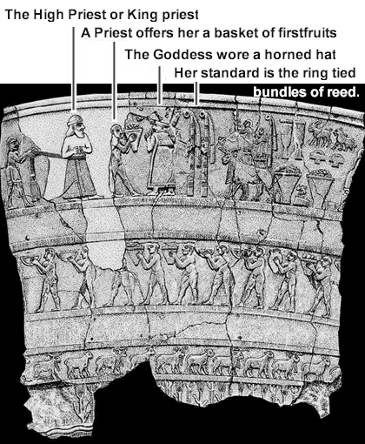
Also pictured is the High Priest (King) overseeing the rest of the clergy bringing up the animal sacrifices (ewes and lambs). The lead priest, who appears on the vase between the High Priest and the Goddess, is bringing the "first fruits" offering consisting of fruits, vegetables, and grains. This is reminiscent of the Hebrew feast of Shavuot, or the Festival of Weeks; celebrated fifty days after Passover.
And thou shalt observe the feast of weeks, of the firstfruits of wheat harvest, and the feast of ingathering at the year's end. Ex 34:22 KJV
'Also on the day of the firstfruits, when you bring a new grain offering to the Lord at your Feast of Weeks,…You shall present a burnt offering as a sweet aroma to the Lord: two young bulls, one ram, and seven lambs in their first year,... Num 28:26-31 NKJV
I don’t think of the putred smell of burning flesh, as a “sweet aroma” to the Lord. The “sweet perfume” that fumigated the temple with a pleasant aroma, was the incense, that was placed on the altar of gold, set before the ark of the testimony. This incense was not meant to be set on fire.
The “commandments” given to Israel during their forty four year sojourn in the desert, may appear to be the start of something new; an observance initiated by God. However, this form of sacrifice was well known all over the ancient world. The Hebrews were obviously well acquainted with the practice as well.
So all the people broke off the golden earrings which were in their ears, and brought them to Aaron. And he received the gold from their hand, and he fashioned it with an engraving tool, and made a molded calf. Then they said, "This is your god, O Israel, that brought you out of the land of Egypt!" So when Aaron saw it, he built an altar before it. And Aaron made a proclamation and said, "Tomorrow is a feast to the Lord." Then they rose early on the next day, offered burnt offerings, and brought peace offerings; and the people sat down to eat and drink, and rose up to play. Ex 32:3-6 NKJV
These ancient rituals and observances had their start in the offerings of Cain. They were reinstituted after the flood by Ham’s grandson, Nimrod, who built the city of Urak.
"To what purpose is the multitude of your sacrifices to Me?" Says the Lord." I have had enough of burnt offerings of rams And the fat of fed cattle. I do not delight in the blood of bulls, Or of lambs or goats. "When you come to appear before Me, Who has required this from your hand, To trample My courts? Bring no more futile sacrifices; Incense is an abomination to Me. Isaiah 1:11
Who has required this from their hand? Of course, that is a rhetorical question and God is saying that it was not He.
“,,,and the drink offering thereof shall be of wine, the fourth part of an hin.” Lev 23:13 KJV
The wine and water libations (drink offerings) made to Inannah (shown on the vase), is the same offering the Hebrews were supposedly commanded to offer God (YHWH) Lev 23:13. Looking at the scene depicted on the vase of Urak, it’s plain to see that it was the Goddess Inannah, the New Moon Goddess, who required and received those offerings.
I cannot endure iniquity and the sacred meeting. Your New Moons and your appointed feasts My soul hates; They are a trouble to Me, I am weary of bearing them. Isa 1 NKJV
The Hebrews were celebrating her monthly holiday with a sacred meeting, an appointed feast day. This system of offerings and sacrifices was practiced 1700 years before the Exodus in Urak; and eventually in all of Mesopotamia. Notice that the naked priests in the procession, almost looked bald, but in fact they seem to be wearing a flat headdress made up of a piece of cloth; sculpted to fit tightly to their scalp. In contrast, the Priest-King is wearing a “Kippah” on his head that distinguishes him from the rest of the priests. In a similar manner; the Hebrew High Priest wore a turban, while the rest of the men typically wore yarmulkes (after the Babylonian captivity). The beard of the High Priest of Inannah, has been trimmed around the edges to represent the shape of the moon.
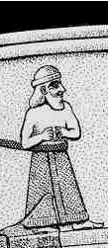
Behind Innana are the two ringed bundles of reeds. 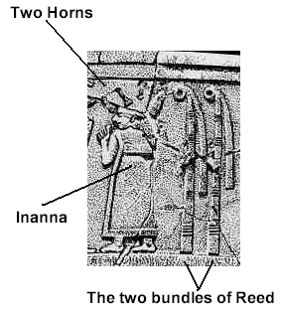
Inannah was not only the New Moon Goddess, she was also a fertility goddess. The bundles of reed were a common standard (or image) that represented her vulva. The scene on the vase is a fertility rite. This same design (two bundles of reeds) was a major part of Sumerian architecture. Not only were they placed in the front of private homes, but also on government storehouses. These houses had a “bulbous” shaped roof which symbolized the pregnant womb; and the reeds at the front door symbolized the entrance to the womb (as shown below). Taken together, these symbols meant fertility and plenty.
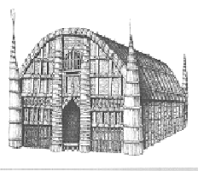
These same features can also be seen in the architecture of Solomon’s temple. The two pillars outside of the entrance to Solomon’s temple present the same imagery as the two bundles of reed (above). A review of the floor plan of Solomon’s temple also draws a certain parallel between the design of the temple, and the human female reproductive organs.
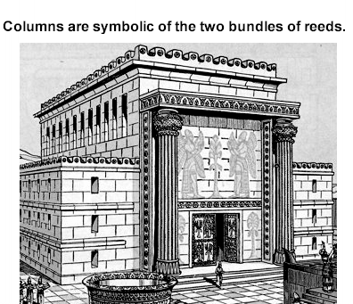
Notice from the floor plan of Solomon’s Temple (below), there are no windows or doors, except for the main entrance (doorway) located between the two pillars.
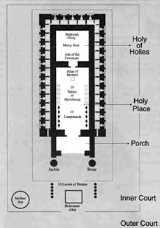
Compare the floor plan with human reproductive organs.
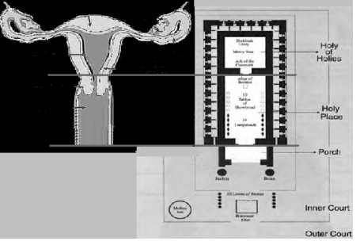
The similarity is unmistakable. Yet even though some of the symbolism found in the worship of Inannah, can also be found in Solomon’s temple; there are some important distinctions between the two. Solomon’s temple was designed to be a house of prayer; and the foremost prayer in the hearts of the people was for the coming (birth) of Messiah. Solomon’s temple actually speaks of the story of redemption. The High Priest was a likeness of Jesus Christ. Inside the ark of the testimony were the (two) three dimensional tablets containing the written Torah inscribed by the finger of God. These two tablets were a representation of the immortal bodies of Adam and Eve. Their bodies, made by the hand of God; were “broken into pieces” by sin - but not entirely lost. A picture of this is seen at Mount Sinai, when Moses finds the people of Israel engaged in idolatry, and throws down the two tablets breaking them into pieces. The second set of tablets; were preserved in the ark of the testimony, and guarded by two fifteen foot tall Cherubim. They represented the promise God made to Eve; that through her seed a redeemer would come. It was Jesus Christ who fulfilled that promise. He was the High Priest who went into the ark and “brought back to life” the immortal bodies of Adam and Eve symbolized by the two tablets. He made the choice that Adam and Eve failed to make; he committed no sin. Jesus then subjected his sinless immortal body to death, and reversed the curse of sin and death.
No one takes it (my life) from Me, but I lay it down of Myself. I have power to lay it down, and I have power to take it again. This command I have received from My Father." John 10:18 NKJV
This is why he was called the last (or second) Adam. I explain this symbolism in detail in the book, “A Beautiful Delusion.” Not only as it relates to Christ (and Solomon’s Temple), but also how the temple itself is a symbol of prophecy, declaring that one day another High Priest will re-create the immortal body. Only this High Priest will be a counterfeit known as the Anti-Christ. The temple he walks into will be in the likeness of man, but in reality, it will be an unnatural triple helix life form. By means of a genetic therapy, the Anti-Christ will have;
“power to give life unto the image of the beast, that the image of the beast should both speak, and cause that as many as would not worship the image of the beast should be killed. Rev 13:15 KJV
How does one worship the image of the beast? Simply by changing themselves into his image. Everyone who takes the immortal life gene therapy will have their genome irreversibly changed into the likeness of the beast (the Anti-Christ).
________________
Getting back to the worship of Inannah, and particularly the headdress worn by the priests and the High Priest;
"If there is found among you, within any of your gates which YHWH your Mighty One gives you, a man or a woman who has been wicked in the sight of YHWH your Mighty one, in transgressing His covenant, "who has gone and served other gods and worshiped them, either the sun or moon or any of the host of heaven, which I have not commanded, "and it is told you, and you hear of it, then you shall inquire diligently. And if it is indeed true and certain that such an abomination has been committed in Israel, "then you shall bring out to your gates that man or woman who has committed that wicked thing, and shall stone to death that man or woman with stones. Deut 17:2-5 (NKJ)
I’m sure everyone knows how to identify the full moon (shown below).
A new moon is the exact opposite in brilliance to a full moon, it shows no light. It's not to be mistaken for the waxing crescent.......
or the waning crescent......
The New Moon is black. This picture shows a slightly gray border around the circumference, to distinguish it from the black background.
When the Hebrews came out of Babylon and began to reacquaint themselves with the Scriptures, they must have come upon this verse;
Ye shall not round the corners of your heads, neither shalt thou mar the corners of thy beard. Lev 19:27 (KJV)
The meaning behind the phrase; “mar the corners” of the beard, meant much more than to ruin the natural look of a beard that grew to its own shape (untrimmed). It meant not to trim the corners of your beard into the shape of the moon, in the same manner as the High Priest of Inannah. The other term from the same verse is;
"You will not round the corners of your heads"
This refers to the practice of shaving your head into the shape of a circle or disk, to honor the moon (or in some cults, the sun). When the Hebrews came out of Babylon; evidently the Moon worshippers were reluctant to give up the practice of shaving their heads and clipping the corners of their beards. Instead they made yarmulkes, like the one shown below, in the shape and shade of a new moon.
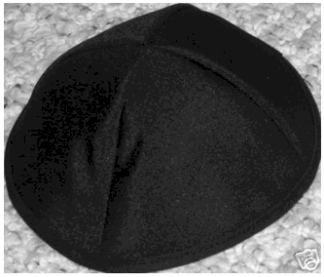
This was done under the pretense of honoring God by covering your head. However, to say you’re not violating the ordinance about shaving your head (into a new moon) by wearing a yarmulke is a rationalization. You may not be violating the letter of the law, but you are certainly violating the spirit of Torah. Many Hebrews and Messianic believers wear a black, white, or blue yarmulke as a matter of custom, not realizing it is an ancient form of worshipping the new moon. If you look at how a true orthodox yarmulke is made, there are strict standards in place to make sure that the thread used to stitch the hem around the outer edges of the circumference is the same shade of black as the fabric used to make the yarmulke. In other words, there should be no border colors or differentiation between the fabric and thread, to make the cap look like anything other than a perfect New Moon.
Cain’s offering of the produce of the ground has not changed in almost six thousand years; it has only become more elaborate.
_______________
In Closing;
I wanted to address the meaning of the Sabbath separately, because I have been asked at times; how does it fit into the ten words of the original Torah; especially since it appears in the Ten Commandments as a holy day of observance. First, let’s take another look at the original Ten Words;
YHWH our Mighty One is First Love YHWH with all your heart and your neighbor as yourself.
All of the subsequent divisions placed upon the original Ten Words; including the Ten Commandments, fit ideologically right back into the original ten words. If I love God, and he is first in my life; I do not offend him in any way; in my relationship with him or his children (my brothers and sisters). Shown below is an excerpt from the Book of Exodus, when Moses receives the second set of tables containing the ten words.
“And he was there with the Lord forty days and forty nights; he did neither eat bread, nor drink water. And he wrote upon the tables the words of the covenant, the ten commandments.” Ex 34:28 KJV
This is how it appears in the Sovereign Grace Interlinear Bible (Hebrew is read from right to left);
Shown below is the Hebrew root word used for the translation of the Hebrew words; “word” and “words.”
dabar (daw-baw'); (#1697) a word; by implication, a matter (as spoken of); from #1696, dabar (daw-bar'); to arrange (words). You can see in the following illustration the letters D-B-R, which spells “daw-bar;” makes up the root word.
I’ve placed the two different words on top of one another (in a dashed rectangle) to make an exact comparison;
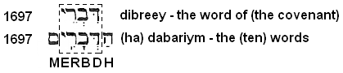
“Dibreey” (which is a phonetic spelling) is spelt with the consonants, D-B-R-E. The word underneath “dibreey” - “(ha) dabariym;” has the letter “h” added (in front of the D). This is the definite article, and means, “the.” At the end of the word appears the letter “m,” which adds the sound “eem” indicating that this word is in the plural tense.
In 1518, the New Testament was translated into Greek by a man named Desiderius Erasmus. His translation (called the Textus Receptus), was used to create English language Bibles by William Tyndale (1526), and the scholars that produced the King James Version (in 1611). In each one of the versions named above, the scholars recognized that “dibreey;” and “dabariym” came from the same root word of “dabar.” (Hebrew words #1697 and #1696.)
Notice that the Sovereign Grace Interlinear Bible’s version of Exodus 34:28 (on the previous page); places the reference number 6680 above the word “dabariym.” (This publisher uses the “Majority Text” translation and not the “Textus Receptus”). However, Hebrew word #6680 is actually the word; tsavah (tsaw-vaw'); to constitute (or enjoin, bade). This is the same word usually translated in English Bibles as, “commandment(s).” But “tsavah” is not the word that appears in the original Greek text. The Majority text is inferring that the ten words are the Ten Commandments. This is an interpolation (and inaccurate). The original Hebrew clearly states that God gave Moses the Ten Words for Israel to live by.
When the Pharisees questioned Jesus about whether it was lawful for a man to “put away his wife;”
He (Jesus) saith unto them, Moses because of the hardness of your hearts suffered you to put away your wives: but from the beginning it was not so. Matt 19:3-8 KJV
Jesus is saying (in these verses) that the children of Israel could not receive the higher calling of the true Torah; therefore Moses was compelled not only to elucidate the ten words into Ten Commandments, but also to make exceptions to God’s original plan behind the purpose of marriage.
_______________
Getting back to the Sabbath, how does taking one day off a week fulfill the first part of the Ten Words?
Let me just say first, I’m not advising anyone to stop celebrating the Sabbath. If you take one day of the week to honor God in a special way, to study his word, or join in with other believers in a worship service, you will receive a blessing from YHWH. I would only add to what ever you feel led to do, to view the Sabbath as not only a celebration, but a destination. Jesus repeatedly broke the Sabbath because it had turned into a mandatory observance stripped of most of its meaning. Here are some examples;
At that time Jesus went through the grainfields on the Sabbath. And His disciples were hungry, and began to pluck heads of grain and to eat. Matt 12:1 NKJV
...there was a man who had a withered hand. And they (the Pharisee) asked Him, saying, "Is it lawful to heal on the Sabbath?" — that they might accuse Him. (Jesus answered)..it is lawful to do good on the Sabbath." Matt 12:10-14
And behold, there was a woman who had a spirit of infirmity eighteen years, and was bent over and could in no way raise herself up. But when Jesus saw her, He called her to Him and said to her, "Woman, you are loosed from your infirmity." And He laid His hands on her, and immediately she was made straight, and glorified God. But the ruler of the synagogue answered with indignation, because Jesus had healed on the Sabbath; Luke 13:11-14 NKJV
And behold, there was a certain man before Him who had dropsy. And Jesus, answering, spoke to the lawyers and Pharisees, saying, "Is it lawful to heal on the Sabbath?" 4 But they kept silent. And He took him and healed him, and let him go. Luke 14:2-5 NKJV
The sick man answered Him, "Sir, I have no man to put me into the pool when the water is stirred up; but while I am coming, another steps down before me." Jesus said to him, "Rise, take up your bed and walk." And immediately the man was made well, took up his bed, and walked. And that day was the Sabbath. The Jews therefore said to him who was cured, "It is the Sabbath; it is not lawful for you to carry your bed." John 5:7-10 NKJV
They brought him who formerly was blind to the Pharisees. Now it was a Sabbath when Jesus made the clay and opened his eyes. Then the Pharisees also asked him again how he had received his sight. He said to them, "He put clay on my eyes, and I washed, and I see." Therefore some of the Pharisees said, "This Man is not from God, because He does not keep the Sabbath." John 9:13-16 NKJV
The Sabbath became a law unto itself, enforced by the religious authorities. Not because they were zealous for God; but rather they were motivated by self interest. They designed the rules by which the Sabbath would be observed, for the purpose of maintaining control over the people. They derive their power, and obtain their wealth, in the forced separation of clergy and laity. This is why Jesus called them a “generation of vipers,” a “brood” (the offspring) of snakes. (Matt 12:34). This same spirit can be found among the religious authorities of our day. The Sabbath that Jesus was announcing was not only the rest a believer finds in Christ himself, it is also a place.
It all started in the beginning – with the Hebrew word – Bereshyith
Shown above is the Hebrew letter “B” (or bayt), the first letter of the Bible. It begins the first word of the Bible, which is Bereshyith (seen below);
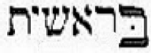
Notice above, the first letter “B” appears in the original text, larger than the rest of the letters. [Illustration taken from the Sovereign Grace Interlinear Bible) This was deliberate. The dot in the middle of the bayt is called a “dagesh forte,” and serves as a diacritical mark (a sort of shorthand) used to double the letter. Shown next is how “Bereshyith” is written without vowel points or diacritical marks; while maintaining the larger size of the first “bayt” present in the Masoretic text.
There are two letters, “B-b.” Now transcribe the Aramaic block print to ancient Hebrew letters (an alphabet chart is located in the back of the book). The first larger “B,” becomes the symbol for “house;” or in this case, “God’s house.”
God has always existed in this place as an infinite being; and from his house (Infinity), he made his everlasting Creation.

“In my Father's house are many mansions;” John 14:2 KJV
I have no doubt that the mansions being referred to are Galaxies located throughout his multiverse.
This order of events is uniquely included as a part of God’s very own name. Shown next is an explanation taken from my book, “You Have Not Denied My Name.”
God first revealed himself as, “Yahh.” This name is transliterated into English as, “Jah.” Bible scholar James Strong’s lists this name as Hebrew word #3050, Yahh; the Sacred Name. The Hebrew letter “H” receives a diacritical mark known as a “dagesh forte” which serves to double the letter; rendering the name, “Yahh.” (This mark is a small dot in the middle of the letter). This name also receives the vowel point “kaw-mates” which makes the “aw” vowel sound (shown in the illustration taken from Strong’s Concordance):
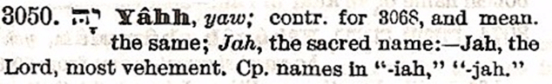
The kawmates is the reason why Strong’s Concordance renders the full sound of his name as, “Yaw.” [There is an important distinction to be made here. The “aw” sound disappeared from the Hebrew language after the Babylonian captivity. It was replaced with the Aramaic sound of “ah.”]
Strong (and other scholars) comment that Yahh (Yaw) is a contraction for the full sacred name, which is Yhwh (Yehovah). This is not entirely correct. The name Yhwh, was manifested later in time, as an added revelation to Yahh. This is how YawHH (#3050) is spelt in the ancient Hebrew alphabet (Hebrew is read from right to left)
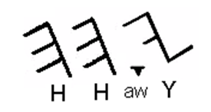
Every Hebrew letter has a name and a word meaning. The first letter in the name “Yahh” is “Y.” It bears the name, “Yawd” (#3027). The name “Yawd” is spelt; (consonant) Y, (Vowel) aw, (consonant) D, as shown below.
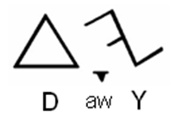
The letters used to spell “Yawd” have an individual word meaning of:
Y - the open (right) hand, indicating power, means, and direction.
Aw - The vowel point "kaw-mates" means to grasp with the (left) hand, in the sense of holding, preserving, and ownership.
D - The letter "d" means "door."
These letters [Y-aw-d] taken together have the additional meaning of: “Coming from a door (d) made in infinity was the left hand of “Yahh” in power (y) creating; while the left hand is holding (sustaining) His creation (aw).
The letter “H” means “life.” It appears twice (in Yahh) meaning, the power of God that came through the door created life in two places; the spirit realm (h), and the physical realm (h). This is the first witness of the nature of God as revealed through his name, at the beginning of Creation. When he created a door in infinity, He used his self existent nature (energy and power) to create eternity.
In Relativistic physics, the term “space-time” refers to a mathematical model that combines space and time into a single interwoven continuum. The space-time continuum consists of three (special) dimensions, and one dimension of time (often termed the fourth dimension). In this model, time cannot be separated from the three dimensions of space. To travel from one place to another (in the continuum) a co-ordinate grid system is required consisting of three spacial and one temporal co-ordinate. You must first locate your position within the grid, which is a fixed point in three dimensional space. This requires six grid co-ordinates. Once your relative position is established, all that is needed to travel to your destination is the seventh grid co-ordinate. In the next illustration, the six grid co-ordinates in the three dimensional cube, represents our location in three dimensional time. The seventh grid co-ordinate is our destination. It is the Garden of Eden, the New Jerusalem. The place where will be reunited with our Creator and enjoy his Sabbath rest, Jesus the Christ.
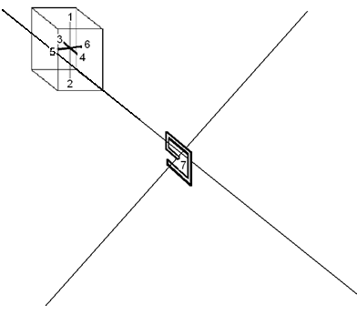
A likeness (or picture) of the seven grid co-ordinates can be seen in the seven day week.
- Sunday
- Monday
- Tuesday
- Wednesday
- Thursday
- Friday ---------------------------- 7. Saturday
Since a day (with YHWH) is like a thousand years; the seven day week is also a picture of the six thousand year lease given to man (to rule over the earth). Seven is the Hebrew number for “completion.” When the six thousand year lease expires; then comes the completion; the Sabbath rest of God.
When God created Adam of the dust of the world, he breathed into his nostrils, and Adam became a living being (Gen 2:7). Since God is a spirit, I take this to mean that the breath of life given to Adam was much more than a puff of air. God breathed into Adam his spirit, and his intellect. This same life became a part of the consciousness of Eve. Adam and Eve had a bond with their Creator, a spiritual connection. It was this “connection” with God; that was severed when Adam and Eve sinned. This connection also represented a bridge that existed between the three dimensional world and the timelessness of Infinity. Without God’s spirit present in their lives, Adam and Eve began to physically experience the unbalanced affects of time, which result in decay and eventually death.
_______________
Getting back to the first “B” and second “b” of the Bible;
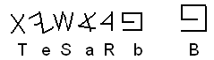
The second and smaller letter “b” begins the word, “bereshyith;” which is usually translated as “In the beginning.”
Bible scholars agree that this is an interpolation, since the definite article “the” is missing from the Hebrew text. Contemporary Bible scholar Arthur Custance, compared numerous translations, including those of; Martin Luther (leader of the Protestant Reformation), Peter Von Bohlen, Christian Dillman, Robert Young, John Smith, H.C. Leupold, E.A. Speiser, and concluded that;
“These renderings (“In the beginning”) point up several problems. There is a question as to the precise meaning of the first word (B'reshith,) which is not actually "in the beginning.... "but " In () beginning....”, the definite article being absent in the original.” Arthur Custance (www.custance.org)
However, it is not difficult to understanding the intended meaning by looking at the construct of the word. Primary Hebrew words are formed with a two and three letter root. Since each of the two or three letters has an individual word meaning, the full word always derives some (or most) of its meaning from the letters themselves. In other words, the definition of a compound or derivative word does not stray far from the meaning of its individual letters.
For example, look at the Hebrew words listed below;
#1537 – Gigal, a city (with a circular wall)
#1536 – gilgal, a wheel.
#1534 – galgal – a rolling thing (wheel).
#1544 – gilluwl – a log (as round).
#1550 – galiyl – a door (as truning); a ring (as round).
#1557 – Galiylah (Galilee) a circle, or circuit.
#1556 – galal – to roll.
#1581 – gamawl – a camel.
#1557 – galawl – camel dung (as in balls).
I had to put number 1557 in there just for a laugh. But just this one example will give you an idea of how the words used to describe roundness, rolling, and travel; contain the letter “g” or (gaw). The letter “l” which is also used in all of the words shown above; can be used as a preposition indicating “to;” as in “traveling to a place,” or “rolling for a distance,” and the “to and from” of a circular route. The letters used to form these words are not picked randomly, they are chosen in the construct of a word (by their individual meaning) to render a certain relative definition. We can apply this same technique, in order to discover a more accurate meaning of the first word of the Bible, by looking at the second word, “barah.” It is being used as a noun modifier to help define the first word (bereshiyth).
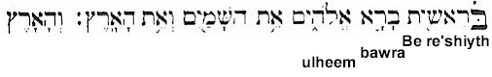
Baw-raw (or Barah); #1254, means to create; in the sense of something more than just a formation (of things that will continue to grow and develop). It is used decisively to indicate God’s capability to make something out of nothing. In the fifty seven times this word is used in the Old Testament, it is used fifty times to describe something that God has made. In the illustration on the previous page, “baw-raw” is conjugated in the third person singular, and should read, “created he.”
Listed below are words that begin with “baw,” that convey a similar idea as “baw-raw.”
Baw-naw (or banah); #1129, means to build, as in to form the foundation (of something that will grow and develop). This verb is used to describe Adam’s wife, who was made (“yiben”) by the hand of God himself. This verb is much different than (#6213) “asah;” the verb used to describe something (common) that was “made,” such as the beasts and creeping things that move upon the earth.
Baqar (or baw-kar), #1239; means to break (burst) forth.
Bakar (baw-kar'), 1069; means to burst the womb, (bear fruit of a woman or a tree); to give the birthright.
Looking back at “bereshiyth” (the noun being modified by “baw-raw”), it is constructed of the primary preposition “be” and the word “reshyith.” “Be,” as a prefix means in, at, or with. Re’shiyth (#7225) means; the first, in place, time, order or rank.
A more precise translation of these verses could easily read:
Bursting forth from His house (Infinity), in order to form a foundation, at this place and time, The First, created (he); “Ulheem,” the alphabet, heavens, and earth (itself).
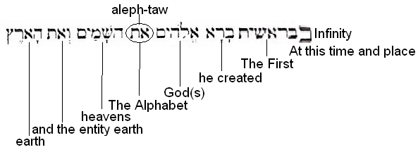
Is the phrase, “The First” (which is more of a title) a reasonable translation of the word “bereshiyth,” or is it a stretch? The answer to this question goes back to the word study on pages 12-13; and the answer that Jesus himself gave to a question;
The first of all the commandments is, Hear, O Israel; The Lord our God is one Lord: Mark 12:29 KJV
The original Hebrew word being translated as "one" is 'echad (ekh-awd'); a numeral from word #258; properly, united, one; or the ordinal (number) first. This is the same word used in Genesis 1:5 to say, "the first (echad) day (yom). The Lord our God is one, should actually read;
YHWH Ulheynuw ‘echad. (God our Mighty One is First).
Translating “echad,” “ri’shown” (#7223), and “re’shiyth” (#7225) as “First” and “The First” is compatible with the scriptures, and appears in numerous other places.
For example:
Who has performed and done it, Calling the generations from the beginning? 'I, the Lord, am the first; And with the last I am He.'" Isa 41:4 NKJV
The first shall say to Zion, Behold, behold them: and I will give to Jerusalem one that bringeth good tidings. Isa 41:27 KJV
"Thus says the Lord, the King of Israel, And his Redeemer, the Lord of hosts: 'I am the First and I am the Last; Besides Me there is no God. Isa 44:6 NKJV
Hearken unto me, O Jacob and Israel, my called; I am he; I am the first, I also am the last. Isa 48:12 KJV
Saying, I am Alpha and Omega, the first and the last: Rev 1:11 KJV
Two questions arise. Why translate “echad” as “first” instead of “one?” What is the significance of the title, “The First?”
In my mind, there is one answer to both questions. It has always been God’s intention for his children to be exactly like him; to fully share in his intellect, with complete knowledge and understanding of his creation; and most importantly, to share in his self existent nature. This was Jesus’ prayer (from John’s gospel) that we become one with him, just as he and the father are one.
I’m not saying that we will become Gods in our own right; in the sense that God is going to give us creative license to go out and make our own worlds complete with all sorts of new creatures. God has already rested from his completed work of creation. What he did for Adam and Eve, was to elevate them to his level, so they could enjoy all of creation in the exact same way that God is able to. They were meant to be his companions, in the same way that he should be ours. Adam and Eve became dissatisfied because they wanted something else – it’s as simple as that. They were not content with all that God had given them. But the true crux of the problem was this; they did not respect God in his position (place or rank) of being “First.” They put themselves before God, and they became first (in their own minds). This is exactly what Paul is referring to in his letter to the Romans, chapter one;
Because that, when they knew God (Adam and Eve), they glorified him not as God, neither were thankful; but became vain in their imaginations, and their foolish heart was darkened. Professing themselves to be wise (eating of the tree to make one wise), they became fools, And changed the glory of the incorruptible God (the covering of light that God gave to Adam and Eve) into an image made like to corruptible man (a terrestrial form), and to birds, and fourfooted beasts, and creeping things. Rom 1:21-23 KJV
There will always be one special distinguishing factor among all those who are like God, and comprise the family of God,
God is - The First
"You are My witnesses," says the Lord, "And My servant whom I have chosen, That you may know and believe Me, And understand that I am He. Before Me there was no God formed, Nor shall there be after Me. I, even I, am the Lord, And besides Me there is no savior. Isa 43:10-11 NKJV

Footnote –
Regarding the expanded version of Romans chapter one (shown on the previous page); The scriptures reveal that Adam and Eve were covered in light; just as God uses light as a garment (or covering) Psalm 104:2. When they sinned, their covering of light departed from them, and they found themselves nude, among the men and women of the garden. A deeper explanation of this event (according to the original Hebrew) can be found in my books, “A Beautiful Delusion” and “The Second Exodus.” It is also part of teaching referred to as, “The Two Seed Lines.” This concept, of two distinct genetic seed lines, Cain and then Abel; is usually discredited by mainstream theologians who prefer to think of the two seed lines as “spiritual,” having nothing to do with heredity. This is a topic that each believer should re-evaluate for themselves. The scriptures are replete with examples that lend itself to the interpretation that there are two seed lines present on this earth; those who belong to God, and those who belong to Satan.
_______________
The righteous perishes, And no man takes it to heart; Merciful men are taken away, While no one considers That the righteous is taken away from evil. He shall enter into peace; They shall rest in their beds, Each one walking in his uprightness. "But come here, You sons of the sorceress, You offspring of the adulterer and the harlot! Whom do you ridicule? Against whom do you make a wide mouth And stick out the tongue? Are you not children of transgression, Offspring of falsehood, Isa 57:1-4 NKJV
_______________
And he gave them another story, saying, The kingdom of heaven is like a man who put good seed in his field: But while men were sleeping, one who had hate for him came and put evil seeds among the grain, and went away. But when the green stem came up and gave fruit, the evil plants were seen at the same time. And the servants of the master of the house came and said to him, Sir, did you not put good seed in your field? how then has it evil plants? Matt 13:24-27 BBE
_______________

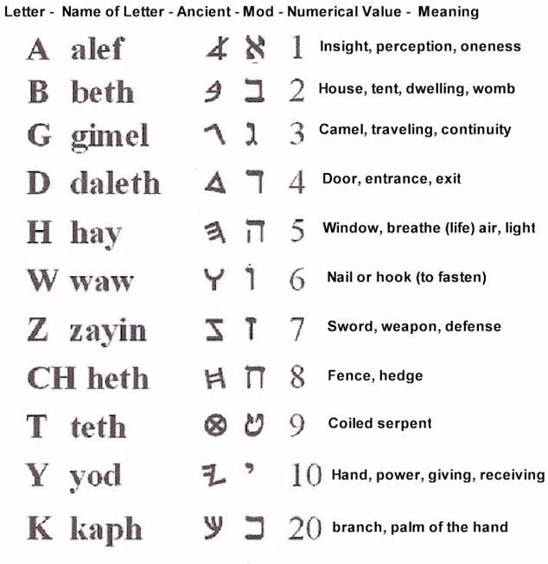

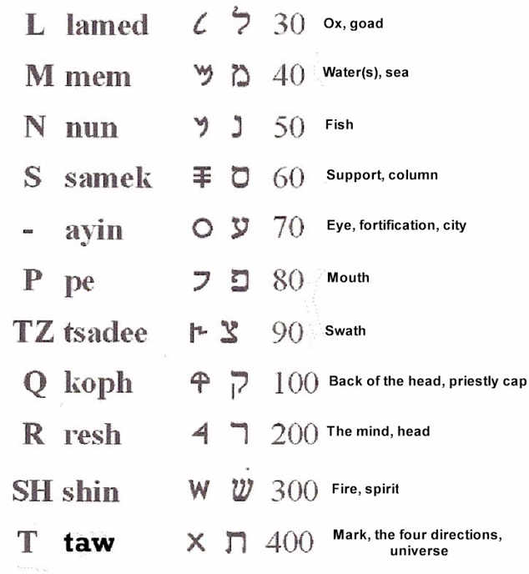

Credits -
(Biblesoft's New Exhaustive Strong's Numbers and Concordance with Expanded Greek-Hebrew Dictionary. Copyright © 1994, 2003, 2006 Biblesoft, Inc. and International Bible Translators, Inc.)

