You Have Not Denied My Name

.

By William Kinney

Maryville, Tn 37803

Copyright © 2014

[www.williamfkinney.com](http://www.williamfkinney.com)

(William f. Kinney)

Chapter One- Page 22

Chapter Two – Page 45

Chapter Three – Page 51

Chapter Four – Page 60

Chapter Five – Page 81

This is the Hebrew “Aleph-bet” (alphabet) showing the letter first, the name of the letter, its ancient form, modern form, numerical value, and the word meaning of each letter.  
  
The first eleven letters are:

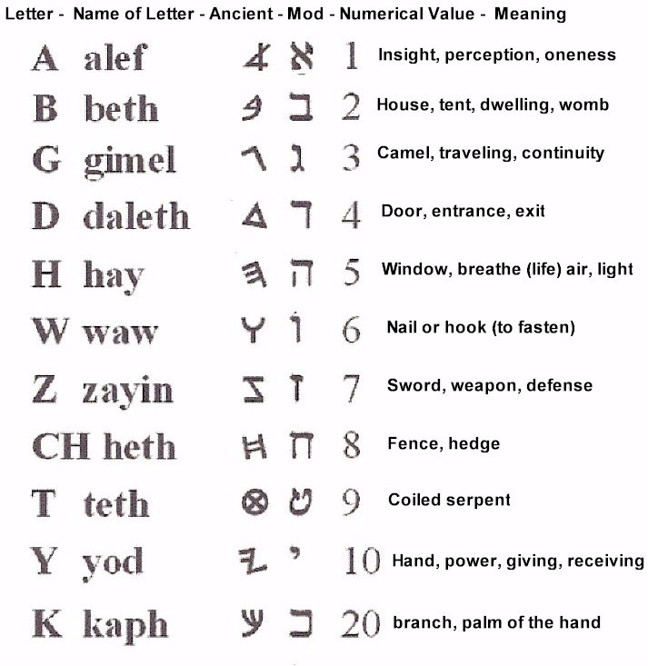

Letters 12 – 22:

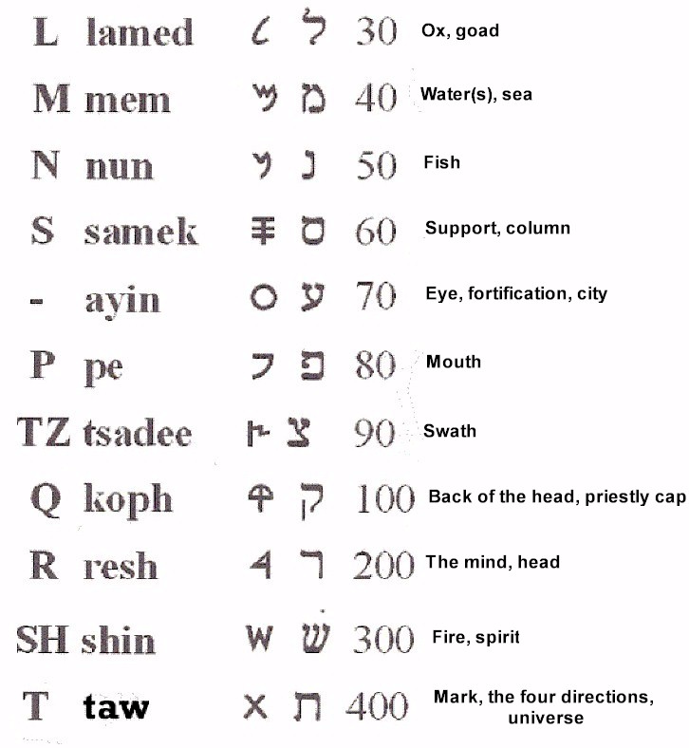

The illustration below is taken from the Dead Sea Scrolls.  
The name of God (YHWH) appears on the bottom line and is marked with an arrow. Although the body of the text is written in the Aramaic form of Hebrew (adopted after the Babylonian captivity); the scribe who wrote this text preserved God’s name in the ancient Hebrew letters.

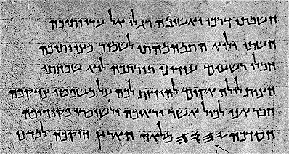



(Ancient Hebrew)



_______________



(Modern Hebrew)

Introduction

In the search for truth, especially when researching the scriptures for yourself in order to gain a better understanding; you will be met with a great deal of opposition just for attempting such a feat. But trust in God and believe what he has said regarding the new Covenant:

*No more shall every man teach his neighbor, and every man his brother, saying, 'Know the Lord,' for they all shall know Me, from the least of them to the greatest of them, says the Lord. Jer 31:33-34 NKJV*

There is information and disinformation; commentary and opinions, all meant to sway you from your own personal search. Never let someone else define the debate; or give you the results before the search begins. God will guide you in the truth.

Recently I was given a calendar that was printed by a certain Christian denomination that contained a statement (more of a disclaimer) about why they didn’t use a Hebrew name for God. I’ve heard it many times before in the past; it went something like this:

"No one can know for sure the true pronunciation of God’s name.”

“It has been lost in time."

“The Rabbis of old hid the name so it would not be blasphemed by the heathen (Gentiles). It has been guarded ever since.”

“Scholars have proposed a number of different names, but cannot agree for certain which one is correct.”

In other words; before you even begin your search, you are doomed to fail. This is what I meant by defining the debate.

God is of a different opinion: He told Moses;

This is My name forever (YHWH), and this is My memorial to all generations.' Ex 3:15 NKJV

By calling his name a "Memorial," God was telling Moses that He wanted his name to be spoken and written; and not to fall into disuse. (It actually became prohibited by the religious authorities).

In my research, I’ve found that indeed God’s name was hidden, but not lost. How could his name be deleted from among the twenty two letters used to bring his creation into existence? The thought of that alone is absurd. The reality is; the letters, words, and syntax of the Hebrew language all unmistakably point to one name. Believers should know the glorious name of our Creator - it means so much!

That being said I should warn you, I’ve had people in the past ask me if I was denouncing the names of God and Jesus, or trying to replace their names with a Hebrew version. This is also another attempt at defining the debate. It is meant to cast suspicion upon any research of the subject matter before it even begins; no matter how conclusive the research may be. To capitulate under that type of manipulation would amount to intellectual dishonesty. This book has nothing at all to do with denouncing the names we know as English speaking people. I was saved in the name of Jesus, as well as many that came before me; including many a God fearing ancestor that had a powerful testimony of Jesus Christ. The purpose behind presenting my findings is to enrich a persons understanding of the language God speaks. That’s right. God used the 22 letters of the Hebrew language to create everything. That prospect alone should compel believers to study this language; including the origin of the names that were transliterated from Hebrew into Latin and Greek; and then Anglicized into the English names that we know.

What was the Hebrew name that Jesus had when he was on earth? Was it Yeshua, which is a noun that means “salvation?” Or, Yehoshua, which is the proper name Joshua? Could Jesus have had a Hebrew name that incorporated the full name of God (YHWH); so that if someone called out his name, they would have to say the full name of God (in the process)? You may already know that in Jesus’ day, it was unlawful for anyone but the High Priest to pronounce the name of God (YHWH), under penalty of death. With that in mind, it is reasonable to think, he would not have used such a name in public. It is quite feasible though, that he used the name Yahushua (Joshua) until the end of his ministry, when he began to manifest his full name openly (putting him further at odds with the Chief Priests and the Pharisees). For him to use an abbreviated version of his full name, was not dishonest in any way; it was just a matter of timing.

Why did Jesus tell the leper; after he was healed,

*“See thou tell no man,…” Matt 8:4KJV*

Why did he tell his disciples that they should;

*“…tell no man that he was Jesus the Christ.” Matt 16:20 KJV*

When the unclean spirits saw him and cried out, saying, Thou art the Son of God, why did Jesus order them to;

*“…not make him known…” Mark 3:11-12 KJV*

He delayed the full revelation of who he was, until he had accomplished what he set out to do.

With only hours left before his death, Jesus prayed to the Father;

*"I have manifested Your name to the men whom You have given Me out of the world. John 17:6 NKJV*

The Greek word being translated as “manifested” is; phaneroo (#5319); to render apparent, declare, (make) manifest, and show forth.

There was something about God’s name that Jesus wanted to make apparent to the disciples, before he was crucified.

*Holy Father, keep them in your name which you have given to me, so that they may be one even as we are one. John 17:11 BBE*

Notice above that God gave Jesus, the same name that he has. (This will become apparent later).

You’ll see in this study, there is a progressive manifestation of the Father’s name, which coincides with an expanding revelation of who the Father is. This is turn leads to a further revelation found in the name of his son. This is all very important because;

**Who we are begins with - who He is.**

Finally, understanding the names of both God and his Messiah; brings about a unity that is based in love and harmony.

*And I have given to them knowledge of your name, and will give it, so that the love which you have for me may be in them and I in them. John 17:26 BBE*

God first revealed himself as, “Yahh.” This name is transliterated into English as, “Jah.”

Shown next is James Strong’s Hebrew word #3050, Yahh; the Sacred Name. The Hebrew letter “H” receives a diacritical mark known as a “dagesh forte” which serves to double the letter; rendering the name, “Yahh.” (This mark is a small dot in the middle of the letter). This name also receives the vowel point “kaw-mates” which makes the “aw” vowel sound (shown in the illustration):

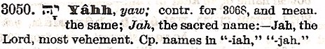

The kawmates is the reason why Strong’s Concordance renders the full sound of his name as, “Yaw.” [There is an important distinction to be made here that will be fully developed later. The “aw” sound disappeared from the Hebrew language after the Babylonian captivity. It was replaced with the Aramaic sound of “ah.”]

Strong (and other scholars) comment that Yahh (Yaw) is a contraction for the full sacred name, which is Yhwh (Yehovah). This is not entirely correct. The name Yhwh, was manifested later in time, as an added revelation to Yahh. This is how YawHH (#3050) is spelt in the ancient Hebrew alphabet (Hebrew is read from right to left)

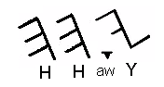

Every Hebrew letter has a name and a word meaning. The first letter in the name “Yahh” is “**Y.”** It bears the name, “Yawd” (#3027). The name “Yawd” is spelt; (consonant) Y, (Vowel) aw, (consonant) D, as shown below.

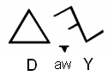

The first letter alone of God’s ancient name (“Yahh”) means:

Y - the open (right) hand, indicating power, means, and direction.

Aw - The vowel point "kaw-mates" means to grasp with the (left) hand, in the sense of holding, preserving, and ownership.

D - The letter "d" means "door."

These letters alone have the separate meaning of:

“Coming from a door (d) made in infinity was the left hand of “Yahh” in power (y) creating; and then the left hand holding (sustaining) His creation (aw).

The letter “H” means “life.” It appears twice (in Yahh) meaning, the power of God that came through the door created life in two places; the spirit realm (h), and life in the physical realm (h).

This is the first witness of the nature of God as revealed through his name, at the beginning of Creation. The second witness was given by God to Moses at the beginning of the Exodus. The children of Israel previously knew God by the name “Yahh.” When Moses said to God;

"…when I come to the children of Israel and say to them, 'The God of your fathers has sent me to you,' and they say to me, 'What is His name, what shall I say to them?" Ex 3:13 NKJV

God answered Moses;

"I AM WHO I AM."

‘EHaYaw aSHER EHaYaw

"Thus you shall say to the children of Israel, 'I AM has sent me to you.'" Ex 3:14 NKJV

EHaYaw is translated as “I AM” because it contains a present participle of the verb “HawYaw” (#1961) which means to exist.

This is the name God gave to Moses in response to his question because the children of Israel would know his name (Yaw) when they heard it.

You can see the sacred name (Yaw) appears below in the word “EhaYaw” (read right to left):



Moreover, God would now become known as, “YHWH;” the “self existent One,” who is able to grant eternal life. (Ex 3:14).

*(God said) I appeared unto Abraham, unto Isaac, and unto Jacob, by the name of God (Yahh) Almighty (Ul), but by my name YHWH was I not known to them. Ex 6:3 KJV*

Isaiah also points out in chapter 26, verse 4 (Majority text) that Yahh and YHWH are different names for one in the same person.

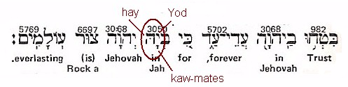

(Read from right to left)  
Jah and Jehovah are both transliterations from the Hebrew.

This progressive revelation of Yahh to YHWH is only the beginning. In the pages to come, I will go into further in detail about the name of God, and the correct pronunciation (which has been memorialized forever as YHWH). His name became the name of his son, as part of an expanding revelation. This happened when Jesus was made manifest in the physical realm. Finally, at the end of the Tribulation, when the enemies of God have been destroyed, there will be one more added manifestation to the name of Christ;

*His eyes were as a flame of fire, and on his head were many crowns; and he had a name written, that no man knew, but he himself. Rev 19:12 KJV*

What I’m going to lay out in the format of this book is a preponderance of the evidence. No one has ever found an ancient conversion manual, or top secret cipher written by some ancient Rabbis outlining the method used to hide God’s name. However, there is a landslide of incontrovertible evidence for you to consider; an overwhelming amount of semantic and syntactic evidence that all points in one direction. Beyond this claim, you should believe in your heart that it is God’s abiding will for you to know beyond a doubt his Memorial Name.

The Holy Spirit will guide you in all truth.

Preface

There are many transliterated names in the scriptures. I start out using those names because they are familiar. As we peel back the years by studying the etymology, the true form of each name will become apparent. All study material is shown in its original form; language and context. It is best for the reader to equip themselves with a copy of Wilhelm Gesenius' Hebrew-Chaldee Lexicon; and Strong's Expository Dictionary of Old and New Testament words. Strong's Dictionary is a little easier for the beginner to read. Whereas; Gesenius' book is geared toward the Hebrew and Greek language student, but that shouldn't discourage the beginner. Every individual Hebrew and Greek word has been assigned a single reference number, so the same reference number (for each word) appears in both books (Strong's and Gesenius). This makes it much easier to explore and understand each reference. Bible scholar Wilhelm Gesenius published his work first (beginning in 1818); which became the lead source material for scholarly works published by Strong, Brown, Griggs, and Driver (and many others).

Searching for the name of God is like piecing together a puzzle, when some of the pieces are missing. However, since the one who designed the puzzle is God; once the rest of the puzzle is assembled, even the missing pieces come into view, and the big picture can be seen.

Some of the missing pieces that need to be reconciled are:

1. The Disappearing Vowel Points –

Most Bible scholars contend that the true rendering of the sacred names can not be known, because the vowels points were left out of the Hebrew scriptures. Is this true?

1. Kawmates-

This one vowel point has mysteriously lost its sound. This makes for a good conspiracy.

1. The Archaic Hebrew Alphabet-

The oldest form of each letter, backs up to its archaic root of the “kawmates” (aw) sound.

1. Ancient Hebrew names-

There are many ancient proper names that include three of the four letters of the Father’s name. The Father’s name being YHWH, these names end in YWH (and are known as “Theophoric” names, or names that include God’s name. After the Babylonian captivity, it becomes apparent that some (not all) of these names underwent a vowel change, in order to hide the Creator’s true name. A close look at the etymology of the Hebrew name “Joshua” points to this very thing. In the Greek Septuagint text of the Old Testament, the name of Joshua was transliterated into Iesous (pronounced yay-soos). It was this Greek name (Iesous) that was Anglicized and became the English name, Jesus.

1. The oldest form of Hebrew is known as “archaic.”

Bible scholars like Gesenius and Strong, refer to the archaic form of many words as “a primitive root.” Biblical Hebrew (also called Classical Hebrew) is said to be a Caananite Semetic language spoken in the area known as Canaan. Most scholars believe that the Hebrews adopted the Phoenician script, which then developed into Paleo Hebrew. Recent discoveries indicate this view is incorrect. While the average person is familiar with the Dead Sea Scrolls found in the caves at Qumran; not many are familiar with one of the greatest archaeological finds of the 20th Century; the city of Ebla. The reason why this discovery has gone unpublicized is because many of the tablets found contain information that challenges some Academic and Theological doctrines. For example, there is a city recorded on the tablets, west of Ninevah and east of Haran called Ur of the Khaldis. This is believed by many to be the Ur that Abraham was from, rather than “Ur of the Chaldeans.”

The most telling information to be gleaned from the tablets were insights into the ancient Hebrew language. Rather than Hebrew being derived from the western Semitic language of the Phoenicians; in his article about Ebla Professor Pettinato describes certain Proto-Canaanite words that are very similar in form to Biblical Hebrew. He concludes that an interdependence existed between the two cultures. Scholars say that the Proto-Canaanite language proceeded Hebrew, based on the assumption that written forms of the language (and its alphabet) existed before Biblical Hebrew. However, tablets found at Ebla containing ancient Hebrew words akin to their Biblical Hebrew forms, existed in 2400 - 2250 B.C. or 1000 or more years before the Phoenician examples. Based on this find, it could be said that ancient Hebrew, the language of Noah and his family, remained pure in form; while the Western and Eastern branches (in Phoenicia and Assyria respectively) evolved into their own form of a Hebrew derivative (rather than the other way around).

Consider this; after the flood, one of Noah’s sons migrated south from Ararat and west to the Mediterranean Coast. He and his descendants founded the cities of Phoenicia, and eventually settled all of Canaan. Another son migrates south and eventually east, founding Sumer (Assyria and Babylon). All the while one son Shem (and his descendants) stayed in Asia minor, below the mountains of Ararat, migrating (at a slower pace) south to Haran, and Ur of the Khaldis; possibly even founding those two cities. If Shem and his descendants kept flocks, and lead a rural lifestyle, the language they spoke would not radically evolve primarily based on a lack of exposure to outside influences.

On the other hand, Cities like Tyre, Sidon, Byblos, and Ugarit (in Phoenicia) became there own Metropolis, and a dialect of the original language naturally evolved from its mother tongue (of ancient Hebrew). Exposure to other cultures and languages through trade also had an affect on the language. Ebla was known in the writings of Sumeria and Egypt, because they were most likely trading partners. It is a known fact that Irish tin has been found in Phoenicia, and Phoenician jewelry has been uncovered in Ireland. It’s easy to see in my hypothetical migration scenario how the ancient “Paleo-Canaanite” language may have developed in Canaan hundreds of years before the arrival Shem’s descendants. It should not be assumed that Shem’s descendants lacked their own Hebrew alphabet and unique spoken form of the language. In fact, they probably possessed the purist form of the language to be passed down (since Adam).

Listed below are excerpts from an article written about the Ebla tablets, by Dr. Clifford Wilson an archaeologist, linguist and Bible scholar [the article appeared at the Institute for Creation Research. http://www.icr.org/article/ebla-its-impact-bible-records/]

*Professor Paolo Matthiae of the Rome University has been excavating there since 1964, but his work was not spectacular until 1968 when his team produced a statue dedicated to the goddess Eshtar and bearing the name of Ibbit-Lim, a king of Ebla. This endorsed the positive identification of the city. The kingdom of Ebla had previously been known in Sumerian, Akkadian and Egyptian texts, and the excavators had good clues when they began digging in this 50-feet high mound. Now their hopes were bright for the future.*

*In the 1975 season some 15,000 tablets were recovered. To bring the report up to date, the excavators recently reported (with a smile!) that 1976 was a poor season -- only 1,600 tablets were found! One tablet stated that the city had a population of 260,000.*

*Vocabulary Lists in Two Languages*

*When the first tablets were found, it was soon realized that this city used a very ancient language in the North West Semitic group which was previously unknown. Professor Pettinato labeled this "Paleo-Canaanite." In layman's terms, this means "ancient Canaanite."*

*Pettinato tells us, The pronominal and verbal systems, in particular, are so clearly defined that one can properly speak of a Paleo-Canaanite language closely akin to Hebrew and Phoenician.*

*The vocabularies at Ebla were distinctively Semitic: the word "to write" is k-t-b (as in Hebrew), while that for "king" is "malikum," and that for "man" is "adamu." The closeness to Hebrew is surprising….about 17,000 tablets and significant fragments have been found at this site, and they date to approximately 2,400 B.C. to 2,250 B.C.*

*Personal Names and Places In the Tablets*

*A number of personal names in the Ebla documents are very similar to names used at later times in the Old Testament. One such name is Michael (mi-ka-ilu) which means, "Who is like El?" A related form, also in the Ebla texts, is mi-ka-ya which is well-known in the Bible, with the ya ending replacing the el. Other names are e-sa-um (Esau), da-'u-dum (David), sha-'u'-lum (Saul), and Ish-ma-ll (Ishmael), this last meaning "II (El -- God) has heard me."*

*Other examples given by Professor Pettinato are En-na-ni-ll which gave over to En-na-ni-Ya (II/Ya has mercy on me); A-dam-Malik (man of Milik); 'il-ha-il, II is strength; Eb-du-Ra-sa-ap, Servant of Rasaph; Ish-a-bu, A man is the father; Ish-i-lum, A man is the god; I-sa-Ya, Ya has gone forth; I-ad-Damu, The hand of Damu; and Ib-na-Malik, Milik has created.*

*Hebrew scholars recognize remarkable similarities to later Hebrew in the Old Testament, and Professor Pettinato himself states, "Many of these names occur in the same form in the Old Testament, so that a certain interdependence between the culture of Ebla and that of the Old Testament must be granted."*

*Hebrew Words Akin to Ebla Words*

*At Ebla, the king has the Sumerian title 'en,' and according to the vocabulary lists already referred to, the Paleo-Canaanite equivalent is "Malek." This is virtually the same as the Hebrew word for "king" in the Old Testament "melek." The elders of the kingdom were the "abbu," remarkably close to "abba" (father) of the Old Testament. At many points the similarity to Old Testament Hebrew is very close.*

*Man's search for the true God and for spiritual truth is shown by some of the personal names at Ebla. "Mi-ka-Ya," meaning "Who is like Ya?" replaced "Mi-Ka-ll," meaning "Who is like ll (El)?" "En-na-ni-Ya" meant, "Ya has mercy on me." Re-i-na-Adad," telling the world that "Adad (a god) is our shepherd," reminds the Christian of Psalm 23 where the ultimate of that searching for divine leading and protection is found as the psalmist exclaims, "The Lord is my shepherd."*

“A certain interdependence between the culture of Ebla and that of the Old Testament must be granted."

In other words, ancient Hebrew did not evolve from the Paleo Canaanite language and alphabet. Which brings me back to my original hypothesis; Shem migrated at a slower rate (from the Mountains of Ararat) then his brothers. Which means the original form of the language spoken by God, and known by Noah and his family; remained mostly intact – even until Abraham’s day.

_______________

Some Bible scholars have stated that Modern Hebrew cognates with eighty percent of Ancient Hebrew. While other say; Ancient Hebrew differs noticeably, though not drastically from Modern Hebrew. Most agree that the Yemenite dialect (that developed in the Middle Ages) is probably closest to the phonology of Ancient Hebrew. The differences in syntax or grammar between ancient and modern forms are based largely on influence from Ashkenazi (Eastern Turkish) Hebrew and Yiddish. [Phonology is the study of sounds and speech patterns in language]

The differences they speak of will become apparent when we study the original archaic roots of each relative word.

_______________

Chapter One

Who has ascended into heaven, or descended? Who has gathered the wind in His fists? Who has bound the waters in a garment? Who has established all the ends of the earth? What is His name, and what is His Son's name, if you know? Prov 30:4 (NKJ)

The prophet Isaiah (YashaYaHu) wrote in chapter 26, verse 8;

*O , we have waited for You; The desire of our soul is for Your name…for the remembrance of You. NKJV*

Whenever the four letters of the Creators name, "Yhwh" did appear in the manuscripts, the word "LORD" or "Lord God" was inserted and the word "ha shem" (meaning "the name") was spoken instead.  Whatever their intentions were behind not writing or speaking the name, it was (and is to this day) clearly a violation of God's will.

*".....this is my name for ever, and this is my memorial unto all generations." Exod 3:15 (KJV)*

The Hebrew root word "zakar (zaw-kar')" being translated as "memorial" means;

"to mark (so as to be recognized), to remember; by implication, to mention."

His name must be spoken (mentioned) in order to be remembered, and it must be written (marked out) in order to be recognized.

*"Woe to you lawyers! For you have taken away the key of knowledge. You did not enter in yourselves, and those who were entering in you hindered." Luke 11:52 (NKJ*

In the Hebrew language, a combination of two of three letters will form a root word, and the addition of one or several more letters will form a derivative (stem) or compound (dual) word. A stem or compound word will retain some (or even much) of the meaning of the original root word; and those words will retain part of the meaning of the individual letters themselves. This is one of the most remarkable things about the Hebrew language, which separates it from all other languages; and marks it as coming from heaven.

In the copy I used earlier of Isaiah 26; notice that Yahh (Gesenius/Strong's #3050) is pointed with the vowel "kaw-mates." This is why James Strong makes the pronunciation of this name; "Yaw." The kawmates is articulated with a soft aspiration, as opposed to hard abrupt (w) ending. Strong compares the sound made by “aw” to the sound made in the English word, “all.”

(as found in the Hebrew Articulation chart of Strong’s Concordance).

The articulation of the vowel “kaw-mates.” (also spelt qamets) is a foundational truth, that affects the entire Hebrew language and Bible interpretation.

Shown in the next diagram is Strong’s Hebrew word #3050, “Yaw.”

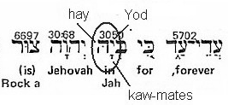

Scholars agree that the three letter version of the sacred name, Yhh, is a form of the four letter version of the sacred name given to Moses, "Yhwh."

[The Hebrew letter "Y" is transliterated by scholars into the English letter "J," which was the last letter added to the English alphabet. The letter “J” represents the Greek sound of “Ie,” or “Iesous” which became “Jesus;” and first appeared in print in the King James Bible, in 1611. ]

A)



From Gesenius' Hebrew - Chaldee Lexicon Baker Books Publishing

B)



From The Analytical Hebrew and Chaldee Lexicon by Davidson Hendrickson Publishing

C)



From, A Concise Hebrew and Aramaic Lexicon of the Old Testament by William Holladay Based upon the Lexical work of Ludwig Koehler and Walter Baumgartner Eerdmans Publishing Co.

D) Yhh, “n.pr.dei” (No image available)

From, Brown-Driver-Briggs lists Yhh as a proper name for the Creator. [“n.pr.dei” means name, proper, of God]

________________

Shown below is a few examples (taken directly from Gesenius and Strong’s dictionary) of how the root word Yaw, which is a proper name; appears in the construct of other (compound) proper names, always pointed by the kaw-mates ("aw" sound). These are ancient names that include the name of God, as the definition indicates (more examples to follow);

1. Yaw at the beginning of a proper name (formed around the sacred name).

#3199 Yakiyn (yaw-keen'); from 3559; he (Jah) will establish; Jakin, the name of three Israelites and of a temple pillar:

#3151 Yaziyz (yaw-zeez'); from the same as 2123; he (Jah) will make prominent; Jaziz, an Israelite:

1. Yaw in the middle of a name:

#3113 Yowyaqiym (yo-yaw-keem'); a form of 3079; Jah will raise, Jojakim, an Israelite: -Joiakim. Compare 3137.

#3114 Yowyariyb (yo-yaw-reeb'); a form of 3080; Jah will contend, Jojarib, the name of four Israelites:.

1. Yaw at the end of a name; forming a compound word that includes the sacred name:

3042 Yedayah (yed-aw-yaw'); from 3034 and 3050; praised of Jah; Jedajah, the name of two Israelites:

3156 Yizrachyah (yiz-rakh-yaw'); from 2224 and 3050; Jah will shine; Jizrachjah, the name of two Israelites.

What follows is a small list of the oldest Hebrew proper names dating back to the reign of David and earlier. This is an important because these names predate the Babylonian captivity; after which, the language underwent some significant changes. Each name incorporates the Sacred Name; by ending with three of the four letters found in the sacred name (Y, H, and W; or; yod, hay, and waw). The “Y” is always pointed by the vowel "kaw-mates (aw)." The “H” is always pointed by the vowel "shu-rake (u)." These two vowels also play an important role in pronouncing the Sacred Title of God; which is, “The Mighty One” (or Ul). (covered later).

The proper name, (#29) 'Abiyah (ab-ee-yaw');or prolonged ' Abiyahuw (ab-ee-yaw'-hoo); from 1 and 3050; father (i.e. worshipper) of Jah; Abijah, the name of several Israelite men and two Israelitesses. Shown next is how it is spelt in Hebrew;

[“n.pr.dei” 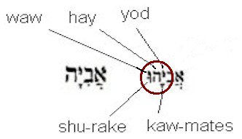

This name incorporates the root name of "Yaw." ( shown above) The h (hay), w (waw), and u (shurake) make up the pronunciation "hoo (hu)" (shown below):

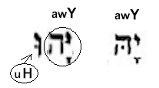

"Hoo" is the present consecutive conjugation of the verb "haw-yaw" which means "to exist." In this case, YawHu means, "Yaw, the self existent one." Or simply put, "Yaw (who forever) is."

138 'Adoniyah (ad-o-nee-yaw'); original (prolonged)- Adoniyahuw (ad-o-nee- yaw'-hoo); from 113 and 3050; lord (i.e. worshipper) of Jah; Adonijah, the name of three Israelites. (David’s 4rth son of Hebron).



_______________

223 'Uwriyah (oo-ree-yaw'); or (prolonged) - Uwriyahuw (oo-ree-yaw'-hoo); from 217 and 3050; flame of Jah; Urijah, the name of one Hittite and five Israelites: (Bathsheba’s husband).



_______________

274 'Achazyah (akh-az-yaw');or (prolonged) 'Achazyahuw (akh-az-yaw'-hoo); from 270 and 3050; Jah has seized; Achazjah, the name of a Jewish and an Israelite king: (Ahab’s son, King of Israel)



________________

Also:

452 - 'Eliyah (ay-lee-yaw');or prolonged ' Eliyahuw (ay-lee-yaw'-hoo); from 410 and 3050; God of Jehovah; Elijah, the name of the famous prophet and of two other Israelites: (1Kings) [ The Book of 1 Kings cover the time period of when the Kingdom was first divided in 921 B.C. until about 851 B.C.]



__________________

558 - 'Amatsyah (am-ats-yaw');or 'Amatsyahuw (am-ats-yaw'-hoo); from 553 and 3050; strength of Jah; Amatsjah, the name of four Israelites: (2Kings)

568 - 'Amaryah (am-ar-yaw');or prolonged ' Amaryahuw (am-ar-yaw'-hoo); from 559 and 3050; Jah has said (i.e. promised); Amarjah, the name of nine Israelites: (1Chronicles)

[ The Book of 1 Chronicles focuses on David’s rule from 1004 B.C. to 971 B.C., but includes info up to 500 B.C.]

683 - 'Atsalyahhuw (ats-al-yaw'-hoo); from 680 and 3050 prolonged; Jah has reserved; Atsaljah, an Israelite: (2Kings)

1141 - Benayah (ben-aw-yaw');or (prolonged) Benayahuw (ben-aw-yaw'-hoo); from 1129 and 3050; Jah has built; Benajah, the name of twelve Israelites: (2Samuel)

[The Book of 2nd Samuel was written sometime after Solomon’s death in 931 B.C. and before the Assyrian captivity of 722 B.C.]

1296 - Berekyah (beh-rek-yaw');or Berekyahuw (beh-rek-yaw'-hoo); from 1290 and 3050; knee (i.e. blessing) of Jah; Berekjah, the name of six Israelites: (1 Chronicles)

1436 - Gedalyah (ghed-al-yaw');or (prolonged) Gedalyahuw (ghed-al-yaw'-hoo); from 1431 and 3050; Jah has become great; Gedaljah, the name of five Israelites:

1587 - Gemaryah (ghem-ar-yaw');or Gemaryahuw (ghem-ar-yaw'-hoo); from 1584 and 3050; Jah has perfected; Gemarjah, the name of two Israelites: (Jeremiah 29)

1806 - Delayah (del-aw-yaw');or (prolonged) Delayahhuw (del-aw-yaw'-hoo); from 1802 and 3050; Jah has delivered; Delajah, the name of five Israelites: (1 Chronicles)

2069 - Zebadyah (zeb-ad-yaw');or Zebadyahuw (zeb-ad-yaw'-hoo); from 2064 and 3050; Jah has given; Zebadjah, the name of nine Israelites: (1 Chronicles)

2148 - Zekaryah (zek-ar-yaw');or Zekaryahuw (zek-ar-yaw'-hoo); from 2142 and 3050; Jah has remembered; Zecarjah, the name of twenty-nine Israelites: -Zachariah, Zechariah. (2 Kings)

2396 - Chizqiyah (khiz-kee-yaw');or Chizqiyahuw (khiz-kee-yaw'-hoo); also Yechizqiyah (yekh-iz-kee-yaw'); or Yechizqiyahuw (yekh-iz-kee-yaw'-hoo); from 2388 and 3050; strengthened of Jah; Chizkijah, a king of Judah, also the name of two other Israelites: (2Kings)

2518 - Chilqiyah (khil-kee-yaw');or Chilqiyahuw (khil-kee-yaw'-hoo)' from 2506 and 3050; portion of Jah; (Chilhijah, the name of eight Israelites: (2 Kings)

2811 - Chashabyah (khash-ab-yaw');or Chashabyahuw (khash-ab-yaw'-hoo); from 2803 and 3050; Jah has regarded; Chashabjah, the name of nine Israelites: -Hashabiah. (1Chron)

2900 - Towbiyah (to-bee-yaw');or Towbiyahuw (to-bee-yaw'-hoo); from 2896 and 3050; goodness of Jehovah; Tobijah, the name of three Israelites and of one Samaritan: (2 Chron)

2970 - Ya'azanyah (yah-az-an-yaw');or Ya'azanyahuw (yah-az-an-yaw'-hoo); from 238 and 3050; heard of Jah; Jaazanjah, the name of four Israelites: (2Kings)

2977 - Yo'shiyah (yo-shee-yaw');or Yo ‘shiyahuw (yo-she-yaw'-hoo); from the same root as 803 and 3050; founded of Jah; Joshijah, the name of two Israelites: (1Kings)

3404 - Yeriyah (yer-ee-yaw');or Yeriyahuw (yer-ee-yaw'-hoo); from 3384 and 3050; Jah will throw; Jerijah, an Israelite: (1Chr)

3414 - Yirmeyah (yir-meh-yaw');or Yirmeyahuw (yir-meh-yaw'-hoo); from 7311 and 3050; Jah will rise; Jirmejah, the name of eight or nine Israelites: Jeremiah (2Kings)

3449 - Yishshiyah (yish-shee-yaw');or Yishshiyahuw (yish-shee-yaw'-hoo); from 5383 and 3050; Jah will lend; Jishshijah, the name of five Israelites: (1Chr)

3460 - Yishma` yah (yish-mah-yaw');or Yishma` yahuw (yish-mah-yaw'-hoo); from 8085 and 3050; Jah will hear; Jishmajah, the name of two Israelites: -Ishmaiah. (1Chr)

3470 - Yesha` yah (yesh-ah-yaw');or Yesha` yahuw (yesh-ah-yaw'-hoo); from 3467 and 3050; Jah has saved; Jeshajah, the name of seven Israelites:

There are 72 of these names altogether (that end in Yaw-Hu). Many others start with “Yaw” or have “Yaw” in the middle of the name. The purpose of posting them here was not only to show the etymology, but also the time period they originated from. They comprise the oldest names in the scriptures.

The names constructed from Yahh (Yaw); such as YawHoo; must retain their original vowel pointing (aw) when indicating the creator's name (Yaw). This is why Yaw-hoo could not become Ye-ho. Here is where the deception of the scribes is revealed. Shown below is how the full (four lettered) Sacred Name is “officially” rendered.

Scribes changed the ancient vowel pointing of;

**"aw" and "u;" (as in Yaw-Hu)**

into

**“e,” and “o.” (as in Ye-Ho)**

They did this in order to form the name "Ye-ho-vah" and conceal the name; “Yaw- hu-ah.”

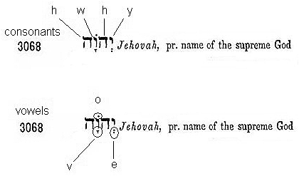

Bible Scholar Wilhelm Gesenius' commented about the name “Jehovah” in his Lexicon (see word #3068). He said, there was a long standing Jewish tradition that the vowel points for the sacred name were replaced with the vowels points from the word "Adonai" (Lord) so the reader would not say the sacred name, but would say instead, “Lord.”  However, Gesenius goes on to say that the vowels in place are not even the vowel points for Adonai! So where did these vowel points come from? Gesenius states,” It is thus evident that the word Jehovah does not stand with its own vowels, but those of another word, the inquiry arises, **what then are the true and genuine vowels?”**

This is exactly the place where the scribes want you to get stuck at, and remain. The name Jehovah was invented to conceal the true and ancient vowel pointing of kaw-mates and shu-rake, to hide the true pronunciation of the Creator's sacred name which is -Yaw-hu-ah.

Once Yaw-Hu was replaced by Ye-Ho, so were other "Theophoric" or "god- bearing" names, such as "Joshua," changed into Yehoshuah. (shown later).

_______________

How can we be sure that the vowel point kaw-mates originally articulated the sound "aw" as in the English word "all." The first (and simplest) answer is, the name for each primary vowel point gives away it unique sound, shown in the partial list below (pronunciation in brackets);

1. Kamets [kaw-mates] has the "aw" sound in its first syllable (kaw).

2. Chiyriq [kee-rik] has the (long) "e" sound of its first syllable (kee).

3. Cholem [kho-lem] has the (long) "o" sound of its first syllable (kho).

4. Tserey [tsay-ray] has the (long) "a" sound in each of its syllables.

5. Shurake [shoo-rake] has the (long) "oo" or "u" sound of its first syllable (shu); and so it is for each of the other vowel sounds (we’ll examine the others later).

Strong used the English word “all” (awl) as an example of the sound produced by the kaw-mates vowel; Gesenius used the word Psalm (Psawlm). Both of these words are used to express a vowel sound called a “diphthong” (which is from a Greek word meaning, “two sounds”). Other English words bearing this same diphthong are: cause (cawse), salt (sawlt), and law.

The most significant finding to corroborate this pronunciation is that each letter of the alphabet backs up to an archaic sound ending in "aw."

When studying Hebrew, I first noticed this in the sound of Hebrew letters "d," "w," and "t," which still retain their ancient pronunciation (in Biblical Hebrew).of; "daw-let," "waw," and "taw." In modern Hebrew (spoken in the State of Israel) “waw” and “taw” have evolved into the eastern European (or Yiddish) form of “Vav” and “Tav. “Daw-let” has taken on the Aramaic sound of “dah-let.”

Before the Babylonian Captivity, the "aw" vowel sound was prevalent, and can be seen in numerous names, such as the name David, pronounced Daw-veed.

[Strongs # 1732 David (daw-veed’); rarely (fully); Daviyd (daw-veed’); from the same as 1730; loving; David, the youngest son of Jesse].

Bible Translators softened the sound of the two double-u’s (ww) that appear next to each other in the pronunciation of this name; by giving the second double-u a “v” sound. However, even today this name is still pronounced in Arabic as “Daw-weed,” preserving the archaic pronunciation.

[Arabic is a language descended from Hebrew.]

The Hebrew language (and written alphabet) of King David's time; was still in use until the 8th Century B.C., and the invasion of Israel by the Assyrians. After 586 B.C., with the invasion of Judea and subsequent captivity by the Babylonians, the “aw” sound transitioned to the “ah” sound of the Aramaic language.

You can easily see (looking at each individual word) in the excerpt below; taken from the Book of Daniel, the Hebrew “aw” sound has been replaced with “ah” (and sometimes “eh”).

*"That they would desire mercies of the God of heaven concerning this secret; that Daniel and his fellows should not perish with the rest of the wise men of Babylon." Dan 2:18 (KJV)*

That - #7359 rechem (Aramaic) (rekh-ame'); corresponding to 7356; 7355 racham (**raw**-kham'); a primitive root. [Notice the primitive Hebrew root is "raw" instead of "re."]

they would desire - #1156 be` a' (Aramaic) (beh-aw'); or be` ah (Aramaic) (beh-aw'); corresponding to 1158; ba` ah (**baw-aw'**);a primitive (Hebrew) root

mercies - #7359, again.

of - #4481 min (Aramaic) (min); corresponding to 4480: min (min); for 4482 men (mane); from an unused root.

the God of - 426 'elahh (Aramaic) (el-aw'); corresponding to 433; God: 'elowahh (el-o'-ah; from 410; a deity or the Deity: 'el (ale); shortened from 352 'ayil (ah'-yil);; strength; as adjective, mighty; especially the Almighty (but used also of any deity): from the same as 193 'uwl (ool); from an unused root meaning to twist, i.e. (by implication) be strong; the body (as being rolled together); also powerful.

[While “uw” is obviously different from “aw,” it is yet another vowel sound that goes back to the archaic roots of the language.]

Before we look at the second half of this sentence from Daniel; consider this interesting example of the difference between Hebrew and Aramaic, found in 2 Kings 18:17-29; from the time period of 701 B.C. (and the invasion of Jerusalem by the Assyrians). Hebrew and Aramaic were two closely related Semitic languages, yet, one group could not understand the others language.

The King of Assyria sent an emissary to Jerusalem to demand the surrender of King Hezekiah. When they arrived at Jerusalem, the Assyrian Ambassador (The Rabshakeh) stood at the aqueduct by the city wall and called out to King Hezekiah. Eliakim, Hilkiah, and Shebna the Scribe came out and spoke for the King, Hezekiah.

*“Then the Rabshakeh said to them, "Say now to Hezekiah, 'Thus says the great king, the king of Assyria: "What confidence is this in which you trust? You speak of having plans and power for war; but they are mere words. … Now therefore, I urge you, give a pledge to my master the king of Assyria, and I will give you two thousand horses — if you are able on your part to put riders on them! How then will you repel one captain of the least of my master's servants, and put your trust in Egypt for chariots and horsemen? Have I now come up without the Lord against this place to destroy it? The Lord said to me, 'Go up against this land, and destroy it.'"*

Then Eliakim, Hilkiah, Shebna, and Joah said to the Rabshakeh,

*"Please speak to your servants (us) in Aramaic, for we understand it; and do not speak to us in Hebrew in the hearing of the people (the other Hebrews) who are on the wall."*

But the Rabshakeh said to them,

*"Has my master sent me to your master and to you (alone) to speak these words, and not (also) to the men who sit on the wall, who will eat and drink their own waste with you?"*

Then the Rabshakeh stood and called out with a loud voice in Hebrew, and spoke, saying, "Hear the word of the great king, the king of Assyria! NKJV

The Rabshekah goes on threatening the people of Jerusalem with a war that doesn’t happen (due to the providence of God). The point is; that at this time in History, the two languages were so different that an Assyrian and a Hebrew could not understand each other. This is due in a large part to the vowel sound of “aw” which was thoroughly prevalent throughout the Hebrew language.

_______________

Continuing with part B of the sentence (I have underlined the Hebrew “aw” version of the corresponding Aramiac “ah” in each citation);

*That they would desire mercies of the God of) heaven concerning this secret; that Daniel and his fellows should not perish with the rest of the wise men of Babylon. Dan 2:18 (KJV)*

heaven - 8065 shamayin (Aramaic) (shaw-mah'-yin);corresponding to 8064: shamayim (shaw-mah'-yim); dual of an unused singular shameh (shaw-meh'); from an unused root meaning to be lofty; the sky (as aloft; the dual perhaps alluding to the visible arch in which the clouds move, as well as to the higher ether where the celestial bodies revolve):

concerning - 5922 `al (Aramaic) (al);corresponding to 5921: `al (al); properly, the same as 5920 `al (al); from 5927 `alah (aw-law');a primitive (Hebrew) root; to ascend

this - 1836 den (Aramaic) (dane); an orthographical variation of 1791; this:

secret - 7328 raz (Aramaic) (rawz); from an unused (Hebrew) root probably meaning to attenuate, i.e. (figuratively) hide; a mystery:

that - 1768 diy (Aramaic) (dee); apparently for 1668; that,

Daniel - 1841 Daniye'l (Aramaic) (daw-nee-yale'); from 1835 and 410; judge of God; 1835 Dan (dawn)

and his fellows - 2269 chabar (Aramaic) (khab-ar'); from a root corresponding to 2266; an associate: 2266 chabar (khaw-bar'); a primitive (Hebrew) root; to

should - 7 'abad (Aramaic) (ab-ad'); corresponding to 6: 'abad (aw-bad'); a primitive (Hebrew) root; properly, to wander away

not - 3809 la' (Aramaic) (law); or lah (Aramaic) (Dan. 4:32) (law) a primitive particle; not

perish - #7 again.

with - 5974 `im (Aramaic) (eem); corresponding to 5973: `im (eem); from 6004; adverb or preposition, 6004 `amam (aw-mam'); a primitive root; to associate; by implication, to overshadow (by huddling together):

the rest of - 7606 she'ar (Aramaic) (sheh-awr'); corresponding to 7605: she'ar (sheh-awr'); from 7604; a remainder: 7604 sha'ar (shaw-ar'); a primitive (Hebrew) root; properly, to swell up, i.e. be (causatively, make) redundant:

the wise men of - 2445 chakkiym (Aramaic) (khak-keem'); from a root corresponding to 2449 chakam (khaw-kam'); a primitive root, to be wise (in mind, word or act):

Babylon. - 895 Babel (Aramaic) (baw-bel'); corresponding to 894: Babel (baw-bel'); from 1101; confusion; 1101 balal (baw-lal'); a primitive (Hebrew) root; to overflow.

You can see from this one verse in Daniel that Hebrew and Aramaic are both Semitic languages; and many Aramaic words also have a primitive root found in ancient Hebrew. Yet at the same time, due in part to geographic and Political boundaries; these two languages developed into two distinctive forms.

_______________

A random check of Hebrew scripture words found in Strong’s dictionary reveal that many Hebrew derivative words are formed from the archaic (primitive) root of a “aw” sounding word.

2233 zera` (zeh'-rah); from 2232; seed; figuratively, fruit, plant, sowing-time, posterity: 2232 zara` (zaw-rah'); a primitive root; to sow; figuratively, to disseminate, plant, fructify:

1961 hayah (haw-yaw); primitive root [compare 1933]; to exist, i.e. be or become, come to pass.

7200 ra'ah (raw-aw'); a primitive root; to see,

8085 shama` (shaw-mah'); a primitive root; to hear intelligently (often with implication of attention, obedience.

1696 dabar (daw-bar');a primitive root; perhaps properly, to arrange; but used figuratively (of words), to speak.

1980 halak (haw-lak');akin to 3212; a primitive root; to walk.

3212 yalak (yaw-lak');a primitive root [compare 1980]; to walk; causatively, to carry.

Nouns and proper names also originate from particles and participles from verbal forms with an archaic root:

3812 Le'ah (lay-aw'); from 3811; weary; Leah, a wife of Jacob: 3811 la'ah (law-aw'); a primitive root; to tire; (figuratively) to be (or make) disgusted:

3824 (lay-bawb'); from 3823; the heart (as the most interior organ). 3823 labab (law-bab'); a primitive root; properly, to be enclosed (as if with fat).

3858 lahat (lah'-hat); from 3857; a blaze; also (from the idea of enwrapping) magic (as covert). 3857 lahat (law-hat'); a primitive root; properly, to lick, i.e. (by implication) to blaze:

3933 la`ag (lah'-ag); from OT:3932; derision, scoffing. 3932 la`ag (law-ag'); a primitive root; to deride; by implication (as if imitating a foreigner) to speak unintelligibly.

The “aw” words make up a large amount of the two and three letter roots words found in Hebrew, which is much too extensive to list here. The most convenient way to see all of these words in their original form, is to use Biblesoft’s program; PC Bible Study. It includes (among many of its features) Strong's Numbers and Concordance with Expanded Greek-Hebrew Dictionary. You can easily scroll through over 8600 Hebrew words and definitions.

Before I move on to the next chapter and a brief explanation of the Masoretic vowel points, I’ve illustrated below a simple example of the Sacred Name which can be found in the name that identifies the Tribe of Judah.

This is how the name Yehudah is spelt (as it appears in Strong’s dictionary) along with its definition:

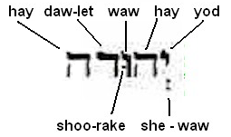

It is defined as; #3063 - Yehuwdah (yeh-hoo-daw'); from 3034; celebrated; Yehudah (or Judah).

Notice that the first two letters (“Yod” and “Hay”) are the same two letters that appear in the sacred name of “Yahh” (Yaw). This is because the “celebration” or “praise” being referred to by the word Yehudah, is in favor of “Yahh” (Yaw). Yehudah should have retained the vowel pointing of “Yahh” (Yaw), making this word Yawhudah. Instead, the scribes deliberately pointed the “Yod” with the vowel “e” (she-waw) changing the sound of the first syllable to “Ye.” This was also done with the names “Yehovah” and “Yehoshua.”

Yawhudah is derived from the root of word #3034, Yadah (shown below):

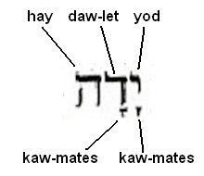

#3034; yadah (yaw-daw'); a primitive root (from #3027); to use or hold out the hand; especially to revere or worship (with extended hands). In other words, to praise.

“Yaw-daw” is derived from the two letter root word (#:3027) yad (yawd); a primitive word; a hand (the open one [indicating power, means, direction] shown below:

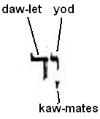

You can see how “Yaw” (in the three letter word of yaw-dah) maintained the vowel pointing of kawmates, found in the original two letter root word, “Yawd.” Subsequently, when forming the word five letter word, “Yehodah,” (a derivative of yawd and yaw-daw) the vowel point kawmates should have remained, making the word Yaw-hu-daw (shown below and read from right to left);

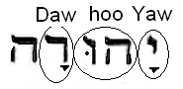

The problem is, the word Yawhudaw is too close to the sacred name which is being concealed. All someone has to do is remove the letter ”D” (containing the vowel “aw”) from Yaw-hu-daw, to see the name of the One they are praising (or celebrating):

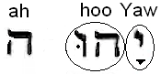

Chapter Two

I bring up the following point just so you’re aware of the controversy surrounding the Hebrew vowels points. This is not meant to be an expose’ of the differing opinions. In the chapters to follow, I will illustrate by use of the scriptures; that the original vowels were indeed part of the original text.

It is commonly thought among scholars that the Hebrew Scriptures did not contain vowel points, until the Masoretes (a Jewish Sect) invented the vowel pointing system. Other Bible scholars disagree. Peter Whitfield, an 18th Century Bible scholar supported and defended the position that the Hebrew vowel points were always present in the Hebrew language. Other scholars from the 17th, 18th, and 19th Century, such as Johann Buxtorf, John Owen, John Gill, and John Moncrieff also defended this position

Whitfield (in his book), “A Dissertation on the Hebrew Vowel-Points,” presents ten arguments and a conclusion, illustrating the point that they are so essential to the translation and interpretation they could not have been missing from the original text. Without vowels even simple pronunciations so necessary in learning a language are impossible. Hebrew grammar rules (especially vowel pointing); as well as exceptions, are so complicated that their correct and accurate transmission could not have been dependent upon an oral tradition.

While most scholars advocate the idea of a recent vowel pointing system (10th or 11th century) Whitfield argues that ancient writers, both Jew and Christian are silent about any type of recent origin (in their day). He points out that the Masoretes were so serious about preserving the original words, they included notes (in the margin) called, “qere” (what is said) and kethiv (what is written) when a questionable word arose in a manuscript. The pre-Christian antiquity of the Keri readings in the margin demands the pre-Masoretic antiquity of the vowel points.

John Gill 1767 (English Baptist Pastor, Bible Scholar, and Theologian) also considered it improbable that the Masotetes sect invented the vowel pointing system. I’ve copied three pages from his book (in the public domain) to illustrate his point of view. He starts off by asking the questions:

What is the Masorah?

(Which is a Hebrew word that means “tradition”).

Who are these Masoretes?

(They were a sect of Judaism credited with invented the vowel point system used in the Masoretic text).

]Be advised in the printing of this 18th century book, the lower case letter “s” looks more like an “f.”]

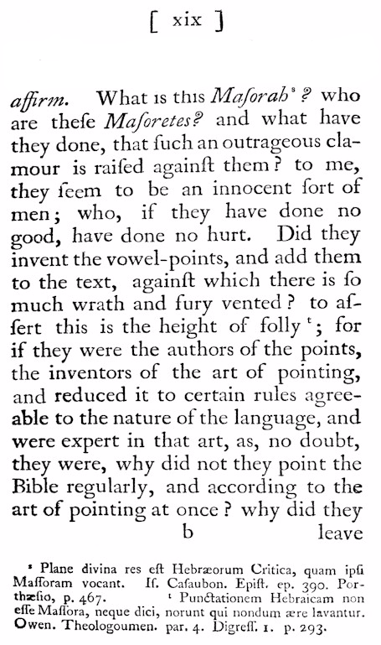

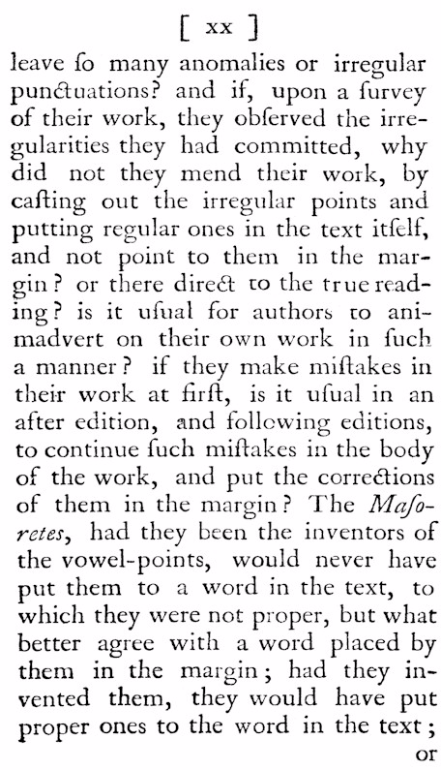

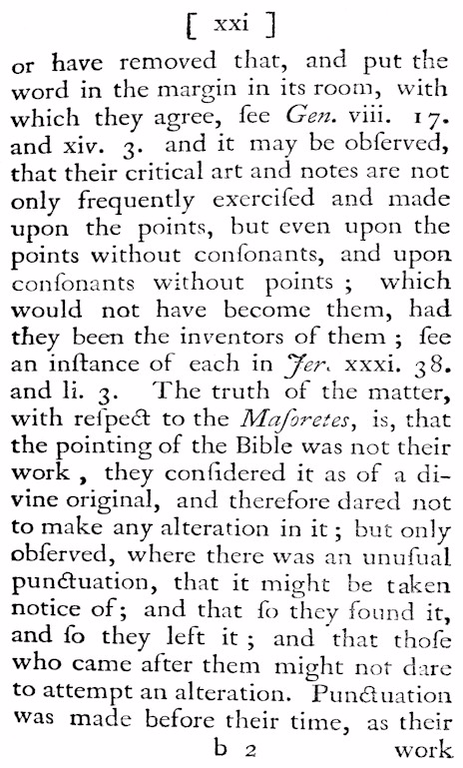

He raises a reasonable question; if the Masoretes had originated the pointing system, why did they use the margins to comment on their own pointing? I agree with John Gill’s conclusion; they must have inherited the pointing system, and considered it too Holy to be altered.

On the other side of this debate is the fact that none of the Dead Scrolls available to the public are pointed. So if vowel pointing was in existence, why wasn’t the earlier Dead Sea Scrolls marked with vowel points?

In fact, the consonants Y (yod), H (hay), W (Waw), and A (Aleph) have always served as consonants - and vowels (even in the Dead Sea Scrolls), depending upon their placement within a word. It could very well be that the Masoretes created a sort of short hand system for indicating vowel sounds. Their “points” took the place of inserting the full form of a consonantal letter. After all, this was the purpose behind creating the diacritical markings, such as the “dagesh forte,” and a “mappiq.” These marks serve to double certain letters simply by placing a dot within the letter (such as the example shown below, in the sacred name, Yhh” (#3050). The one and only “H” (Hay) receives a “mappiq,” effectively doubling the “H.”



Shown next is how the first words spoken by God into his creation appear in the ancient Hebrew letters (read from right to left);

“Exist Energy;” in the Hebrew “Yawhiy Ore”

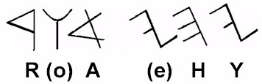

The first Yod (Y) receives its consonantal sound, but the second “Y” (appearing at the end of the word, produces the vowel sound of “e.” Y,H,W, and A are used as vowels throughout the Old Testament. Once the reader understood the grammar rules regarding their placement, and saw the word (in its context); there was no misunderstanding as to whether the letter was a “Y” or an “e.”

_______________

Chapter Three

Warning! Conspiracy theory!

It seems that the word "conspiracy" has been redefined in our day to include any and all thoughts that oppose the status quo. This is a perfect example of the term "doublespeak." This term comes from George Orwell’s book, “1984.” Doublespeak (by definition) deliberately disguises, distorts, or reverses the meaning of words. The word conspiracy is defined in the dictionary as a secret plan by a group (of 2 or more persons) to do something unlawful or harmful (that’s simple enough). In today's version of doublespeak, if you don't agree ideologically with the predominate school of thought, or you're suspicious of government (or even religion) you must be a conspiracy theorist. There’s no need to hear any evidence that might show otherwise. This is another way of controlling and manipulating others by defining the debate. The status quo is presumed to be the norm. It is not the Government or the majority you must worry about; their intentions are honorable and just. (After all, how could a majority of people be wrong?) It is the conspiracy theorist that lacks understanding and is therefore unnecessarily suspicious of the other group’s motives. In the minds of the manipulators, it is the conspiracy theorist who is maladjusted. Oh really? During the Constitutional Convention of 1787, James Madison and the other delegates used the word "conspiracy" so many times; that by today’s standards they would be considered conspiracy nut jobs. Their fear of conspiracies against the liberties of the people is the reason why they staggered the election terms for US Senators and Representatives. By changing the face of Congress every two years, they hoped to slow the momentum (their words) behind conspiracies aimed at disparaging the people’s rights. For some reason, it was normal among highly educated and religious men of the 18th Century to expect that some men would plot evil against their fellow countrymen. They hoped their efforts would “slow” the momentum of conspiracies, because they knew they couldn’t eradicate the threat all together. They based their assumptions on the tendencies of human nature; especially when it involves the pursuit of power. The most important ingredient that figured into their strategy for liberty was the American people themselves. They hoped that a certain percentage of the public would remain vigilant in the oversight of honest government. Historically, this also meant that Americans should be suspicious of Government, and any attempts made by the Government to advance their control (and subdue the people). You can see the difference between modern thinking and that of our ancestors, just by this one example. It is the difference between independent and dependent thinkers. An independent thinker has to convince themselves that the information being presented is true and correct. They use a method of critical thinking to process information and arrive at a logical conclusion. On the other hand, dependent thinkers accept what they are taught and rarely question information to see if it really makes sense. Totalitarian Governments use the media as well as social institutions to produce dependent thinking people. That same type of authoritarian mindset can also be found in religious institutions. Of course, not all religious leaders are corrupt or deceitful; but history is replete with examples of corruption in Judaism and Christianity. Religion is big business and there’s a lot of money being made. I am not categorically opposed to religion. I am opposed to certain teaching methods present in religion that produce dependent thinkers.

_______________

How did Jesus feel about religion?

Jesus said;

*But be not ye called Rabbi (teacher): for one is your Master, even Christ; and all ye are brethren. And call no man your father upon the earth: for one is your Father, which is in heaven. Neither be ye called masters (Adone): for one is your Master, even Christ. Matt 23:8-10 KJV*

The Apostle John makes this same point in his epistle, it is also a warning against being deceived by false teachers;

*But the anointing which you have received from Him abides in you, and you do not need that anyone teach you:...1 John 2:27NKJV*

God is truth, and there is power in the truth. There is also power in a lie. Lies have been used to subjugate people under a mechanical system of a religion.

Christian writer Lactantius (writing in the early fourth century) wrote that the word religion comes from the Latin root, “religare,” a verb meaning “to fasten or bind.” The Latin root “ligare” is where we get the English word “ligament” from (and meaning “to bind”).

Religion = re-binding.

God is not insulted by the independent thinker in their search for truth and confirmation. He calls it – reasoning (Isa 1:18).   
Christ died to make us free-e-e-e-e-e-e (in the fullest sense of the word). Then cometh the "religionist;" like the Pharisee of old, to remind us that; although you have complete freedom in Christ, you are not free to seek your own understanding. That sort of dangerous undertaking could lead to the questioning of historical dogma and doctrines of the established church. Even though you are lead by the Spirit of Truth, you need to “check in” with the authorities that God has placed between you and himself, to make sure you’re hearing correctly.

I have found, in the course of my studies; while some of the historical doctrines have a basis in truth, others are based in tradition.

Moses told the Hebrews, after God had given him the two tablets containing the Torah (or 10 Commandments);

"and he (God) added no more." (Duet 5:22)

He added no more to the 10 commandments.

Did God change his mind, or did someone add 603 additional “laws” (which are codified in the Talmud and Mishnah)? Could it have been the same ones who love to control the people and their wealth?

The Priestly Maxim of the Roman Catholic Church can be found above the doorway of the Abbey of Saint Victor in Paris, France (founded in 1108 A.D.); it reads (in Latin):

Disce primum quod credendum est.

Learn first of what is to be believed.

In other words, we will teach you, and train you, what to believe. There is no room left for reason, since the basic tenets are presented as undeniable truth, not to be questioned (sounds like dependent thinking). The purpose behind this method of teaching and administration is control. In the same spirit of control, we are told that vowel points did not exist in the Hebrew language before the Masoretic text was written.Even if we accept that; we have it on Rabbinical authority that the vowel points placed under Yhwh (in the Masoretic text) were not the correct ones needed to pronounce the Father's name.

The Masoretes scribes used the vowel points shewa (e) and cholem (o) and the reader was supposed to say “Adonai” (Lord) instead of the true name of God. If the vowels are read as they stand, they produce the name, Yehovah (which according to the Rabbis, is false).

We have already reviewed the so-called "contracted" version of the sacred name (#3050) which is Yahh (spelt with a k**aw**mates) and pronounced, Yaw.

[Bear in mind that most Hebrew scholars say the pronunciation of this name is "Yah," favoring the Aramaic “ah” sound.]

This is where the conspiracy mentioned at the beginning of this chapter comes into play. An in depth investigation of the Hebrew language reveals that not only has the name been hidden, but the vowel sound of the kawmates (which produces the “aw” sound) has been replaced in order to sever the link to its original sound. I mentioned earlier that several of the letters of the alephbet, have more recently been transformed from their original "aw" sound into that of another. Specifically, modern Hebrew has changed dawlet into dahlet, waw into vav, and taw into tav.

I purchased (and reviewed on line) a number of Hebrew language study courses. They teach that the vowel "kawmates" sounds the same as the vowel "patach" (which makes a short “a” sound, as in “father”). The question then becomes, why have two different vowels? I have found this to be a standard practice among Hebrew language courses, and also in the Messianic Congregations I’ve attended. I’m listing some of these courses here as a source for you to review while doing your own research.

1. Free online version by B'Nai Or; in Pueblo, Colorado (http://wn.com/bnaiorpueblo). Hebrew lesson No.2 the second vowel point, "kawmates,” has the same exact sound as "Patach"

2. The Hebrew language program "At Home With Hebrew" by Amerisoft ([www.amerisoftinc.com](http://www.amerisoftinc.com)) teaches that kawmates and patach have the same exact sound.

3. The Online study “Hebrew for Christians.” (<http://www.hebrew4christians.com/Grammar/Unit_Two/A-Type_Vowels/a-type_vowels.html>). This site teaches that patach and kawmates have the same sound.

The vowel points patach and kawmates cannot have the same sound. There are many Hebrew words spelt with the exact same consonants, but they have different meanings. The only difference in the spelling is, the vowel patach is exchanged for a kawmates. Here are some examples:

#1197 ba'ar [bayt-kawmates-ayin-patach-resh] (baw-ar) consumed by fire.

#1198 ba'ar [bayt-patach-ayin-patach-resh] (bah-ar) foot (of cattle) brutishness, stupid.

#3384 yarah [yod-kawmates-resh-kawmates-hay] (yaw-raw) to flow as water, teach.

#3415 yara [yod-kawmates-resh-patach-haymappiq] (yaw-rah) to be broken up, fear.

#7477 ra'al (raw-al) [with kawmates] to reel.

#7478 ra'al (rah-al) [with patach] reeling from intoxication.

#1961 hayah (haw-yaw) [with kawmates] to exist.

#1962 hayah (hah-yaw) [with patach] ruin.

#2449 chakam (khaw-kam) [with patach] to be wise.

#2450 chakam (khaw-kawm) [with kawmates] skillful.

#7460 ra'ad (raw-ad') [with kawmates] to shudder, tremble.

#7461 ra'ad (rah-ad) [with patach] a shudder or trembling.

#2511 challaq (khal-lawk'); [with kawmates] smooth(ness).

#2505 chalaq (khaw-lak'); [with patach] to be smooth

The fact that you can change one vowel among the same set of consonants and thereby change the entire meaning of the word, is not unique to kawmates and patach. It occurs throughout the entire language with other vowels also. In the example shown next, the vowel “a” that appears after the “s,” (in the word, chasaph) is changed to the vowel “e” (in chasiph). Changing this one vowel changes the entire meaning.

#2834 chasaph (khaw-saf'); spelt; chet (Ch), kawmates (aw), sin (s), patach (**a**), and peh (f); and means, a primitive root; to strip off, i.e. generally to make naked.

#2835 chasiph (khaw-seef'); spelt; chet (Ch), kawmates (aw), sin (s), chirek (**e**) and peh (f); and means, drawn off, separated; hence, a small company (as divided from the rest).

In the next word; the “e” in libbah is changed to an “a.”

3826 libbah (lib-baw'); spelt, lamed (l), chireck (e), bayt (b), bayt (b) kawmates (aw), and hay (h); which means, the heart.

3827 labbah (lab-baw'); spelt, lamed (l), patach (a), bayt (b), bayt (b), kawmates (aw), and hay (h); and means, flame.

In the next example, the “u” in “luwt” is changed to an “o.”

3874 luwt (loot); spelt; lamwd (l), waw (w), shurake (u), and tet (t); which means, a primitive root; to wrap up.

3875 lowt (lote); spelt; lamed (l), waw (w), cholem (o), and tet (t); which means, a veil.

There are numerous examples of other words whose definition is changed by replacing only one vowel of a different sound within the same set of consonants.

The question remains; how could patach and kawmates be interchangeable, when either vowel (placed in the same set of consonants) produces a word that has a different meaning?

Chaper Four

By researching the archaic (or primitive) root of each Hebrew letter, one can easily see that every letter of the aleph-bet (alphabet) actually backs up to an "aw" sound being produced by a kawmates. In reality, "aw" was the beginning sound of the first letter used in the Creation of all things. It is (so to say) the power source behind each letter, and by extension each word in which it appears. On page ten, I made an illustration showing the definition behind the letter, “Yawd,” which is the first letter of God’s sacred name. The “aw” means to grasp with the hand, in the sense of holding, preserving, and ownership. This is the sustaining **power** of God that maintains his creation. Is it any wonder that so many verbs contain this vowel? When placed within a word, “kawmates,” serves to indicate the power needed to perform the action being defined. In other words;

1254 bara' (b**aw**-r**aw**'); (power) to create.

6213 asah (**aw**-s**aw**'); (power) to do or make.

1129 banah (b**aw**-n**aw**'); (power) to build.

1697 dabar (d**aw**-b**aw**') (power) to speak a word (also daw-bar).

7200 ra'ah (r**aw**-**aw**'); (power) to see.

1980 halak (h**aw**-lak'); (power) to walk.

2421 chayah (kh**aw**-y**aw**'); (power) to live.

In the next example you can further see just how prevalent the lost (or hidden) sound of kawmates was throughout the ancient language. The archaic pronunciation of each letter (based on ancient words) would produce the following sounds (and alphabet):

Modern Archaic

1. Aleph aw

2. Bayt baw

3. Gimel gaw

4. Dalet daw

5. Hay haw

6. Waw waw

7. Zayin zaw

8. Chet chaw

9. Tet thaw

10. Yod yaw

11. Kaph kaw

12. Lamed law

13. Mem maw

14. Nun naw

15. Samek saw

16. Ayin a'w

17. Peh paw

18. Tsade tsaw

19. Qoph k'aw

20. Resh raw

21. Shin shaw

22. Taw taw

The following list of words illustrates how each of the modern letters of the Hebrew alphabet backs up (over time) to a single syllabic sound of "aw." (kawmates).

[The number in parenthesis following the letter is the numerical value of the letter. The numbers that appear before each Hebrew word is the Gesenius/Strong Concordance number.]

**1. Alef** (1) meaning side view of the eye, insight - 505 'eleph (eh'-lef); prop, the same as 504; hence; 'eleph (eh'-lef); **from 502**; a family; also (from the sense of yoking or taming) an ox or cow: **502** 'alph (**aw**-lof'); a primitive root, to associate with; hence, to learn (and causatively to teach).

Notice #502, the primitive root (oldest known form), is pronounced **aw**-lof. Therefore, the earliest sound of the alphabet letter “a” could not have originally been “eh,” but rather, it evolved into the form, “eh.” You can see a similar pattern in the rest of the words and alphabet letters that follow.

**2. Bayt** (2) meaning, house.  1004 bayith (bah'-yith); probably from 1129 abbreviated; a house (in the greatest variation of applications, especially family, etc.): 1129 banah (baw-naw'); a primitive root; to build (literally and figuratively).

**3. Gimel** (3) meaning, a camel. 1581 gamal (gaw-mawl'); apparently from 1580 (in the sense of labor or burden-bearing); a camel: 1580 gamal (gaw-mal'); a primitive root; to treat a person (well or ill).

**4. Daleth** (4) meaning, a door. 1817 deleth (deh'-leth);from 1802; something swinging, i.e. the valve of a door: 1802 dalah (daw-law'); a primitive root (compare 1809); properly, to dangle, i.e. to let down a bucket (for drawing out water); figuratively, to deliver.

**5. Hay** (5) window (also - Lo! - Look!- See!) 1888 he' (Aramaic) (hay);or ha' (Aramaic) (haw) (Hebrew).

**6. Waw** (6) nail or hook – 2055; this letter is spelt waw - kawmates – waw. Strong's Concordance translates the first "w" as a "vav," and the second "w" as a "waw;" But then reverses the order in the name, David; making the first “w” a "waw" and the second "w" a “vav.” [1732 David (daw-veed')] This is at the translators discretion, to soften the hard sound of two double-u’s placed together.

**7. Zayin** (or zay) (7) the letter represents a weapon or sword in shape, but the word "zay" or "Zayin" does not mean either weapon or sword. There are compound words with "zey" or "zay" as a prefix, that back up to "zaw;" (an archaic root). Samples shown below:

2143 zeker (zay'-ker); or zeker (zeh'-ker); from 2142; a memento, commemoration: 2142 zakar (zaw-kar'); a primitive root; properly, to mark (so as to be recognized), i.e. to remember; by implication, to mention; also (as denominative from 2145) to be male.

2169 zemer (zeh'-mer); apparently from 2167 or 2168; a gazelle (from its lightly touching the ground): 2167 zamar (zaw-mar'); a primitive root [perhaps ident. with 2168 through the idea of striking with the fingers]; properly, to touch the strings or parts of a musical instrument, i.e. play upon it; to make music, accompanied by the voice; hence to celebrate in song and music:

c) 2221 zeruwa` (zay-roo'-ah); from 2232; something sown, i.e. a plant: 2232 zara` (zaw-rah'); a primitive root; to sow; figuratively, to disseminate, plant, fructify.

d) 2225 zerach (zeh'-rakh); from 2224; a rising of light: 2224 zarach (zaw-rakh'); a primitive root; properly, to irradiate (or shoot forth beams), i.e. to rise (as the sun); specifically, to appear (as a symptom of leprosy): KJV-- arise, rise (up), as soon as it is up.

**8. Chet** (8) meaning hedge or fence; surround, gird - As with the letter and word meaning for "zayin," "chet" proper does not appear as a word that contains its meaning (shown above). The consonants that spell the the word “chet;” which are “ch” (chet) and “t” (taw) appear in the two words below, which both back up to word #**2865**; which is chathath (khaw-thath'); a primitive root; properly, to prostrate (also an “aw” word).

2844 chath (khath); and 2845 Cheth (khayth); from 2865; terror; Cheth, an aboriginal Canaanite: 2865 chathath (khaw-thath'); a primitive root; properly, to prostrate; hence, to break down, either (literally) by violence, or (figuratively) by confusion and fear.

**9. Teth** (9) a serpent. Twisted or rolled together. - Just as with Zayin, and Chet, "Teth itself is not part of a word. Many believe the root of Teth is from twisting together (as in) to spin.

2901 tavah (taw-vaw'); a primitive root; to spin:

**10. Yod** (10) a hand.- 3027 yad (yawd); a primitive word; a hand (the open one [indicating power, means, direction, etc.], in distinction from 3709, the closed one); used (as noun, adverb, etc.) in a great variety of applications, both literally and figuratively, both proximate and remote.

**11. Kaph** (20) #3709 kaph (kaf); from 3721; the hollow hand or palm (so of the paw of an animal, of the sole, and even of the bowl of a dish or sling, the handle of a bolt, the leaves of a palm-tree); figuratively, power. 3721 kaphaph (kaw-faf'); a primitive root; to curve.

**12. Lamed** (30) an ox goad; 3925 lamad (law-mad'); a primitive root; properly, to goad.

There are many words that begin with la (lah) that back up to "law." (such as:)

3931 la`ab (law-ab'); a primitive root; to deride:

3932 la`ag (law-ag'); a primitive root; to deride; by implication (as if imitating a foreigner) to speak unintelligibly:

3935 la`az (law-az'); a primitive root; to speak in a foreign tongue: -strange language.

3943 laphath (law-fath'); a primitive root; properly, to bend, i.e. (by implication) to clasp; also (reflexively) to turn around or aside:

**13. Mem** (40) water - *4475 memshalah (mem-shaw-law'); feminine of 4474; rule. 4474 mimshal (mim-shawl'); from 4910; a ruler or (abstractly) rule. 4910 mashal (maw-shal');a primitive root; to rule.

Words numbered 4493-4501,4506,4507,4513,4522,4523, begin with "maw." Some words that have a "man,"& "men" prefix, like 4516 "man’am" back up to 5279 "naw-ame."(or a "naw" prefix sound).

**14. Nun** (50) - 5125 nuwn (noon);a primitive root; to resprout. This letter has many words that back up to an "aw" root.

5144 nazar (naw-zar');a primitive root; to hold aloof, i.e. (intransitivey) abstain (from food and drink, from impurity, and even from divine worship

5148 nachah (naw-khaw'); a primitive root; to guide; by implication, to transport (into exile, or as colonists):

5157 nachal (naw-khal'); a primitive root; to inherit

5162 nacham (naw-kham'); a primitive root; properly, to sigh,

5193 nata` (naw-tah'); a primitive root; properly, to strike in,

**15. Samek** (60) a prop , support

5565 Cemakyahuw (sem-ak-yaw'-hoo); from 5564 and 3050; supported of Jah; Semakjah, an Israelite: KJV-- Semachiah.

5564 camak (saw-mak'); a primitive root; to prop (literally or figuratively); reflexively, to lean upon or take hold of (in a favorable or unfavorable sense):

**16. ayin** (70) While ayin is said to mean "the eye," it has also been called "a fort" because it resembles a fortification.

While I have not found ayin itself marked with the kawmates vowel point, the word "fortress" [4581 ma'owz] is from the word [5810] "azaz" (aw-zaz). It is spelt, ayin - kawmates - tsade - patach - tsade.

The earliest form of "ayin" was most likely, "ayin - kawmates," or "aw." This is not to be mistaken for the "aw" in "aw(leph)" the first letter. There is a difference between how the two letters aleph and ayin are aspirated. It is similar to the difference between hay and chet. The first letter (aleph) has a gentle "a" sound. Ayin has a more harsh guttural sound [from Gesenius' notes on ayin].

**17. Pe** (80) a mouth - The first word for the letter peh in the Hebrew lexicon is [#6284] pa'ah (paw-aw') and means, to puff, blow away, scatter into corners.

**18. Tsade** (90) pronounced tsah-dee.  - The closet word to "tsade" is 6654 tsad (tsad); contr. from an unused root meaning to sidle off; a side; figuratively, an adversary: [to sidle means, to move sideways, to advance in an unobtrusive, furtive, or coy way]

The oldest related word to "tsade" is 6658 tsadah (tsaw-daw'); a primitive root; to chase; by implication, to desolate:

**19. Koph** (100) Because of its archaic shape, it is said to mean, "the back of the head" or a "priest's cap." - While there is no word K(aw)f, there are numerous archaic words (classified as primitive or unused) that use the kawmates vowel point in the first syllable. Such as:

6915 qadad (kaw-dad'); a primitive root; to shrivel up, i.e. contract or bend the body (or neck) in deference:

6918 qadowsh (kaw-doshe'); or qadosh (kaw-doshe'); from OT:6942; sacred (ceremonially or morally); (as noun) God (by eminence), an angel, a saint, a sanctuary:

7033 qalah (kaw-law'); a primitive root [rather identical with OT:7034 through the idea of shrinkage by heat]; to toast, i.e. scorch partially or slowly:

7043 qalal (kaw-lal'); a primitive root; to be (causatively, make) light, literally (swift, small, sharp, etc.) or figuratively (easy, trifling, vile, etc.).

7059 qamat (kaw-mat'); a primitive root; to pluck, i.e. destroy.

7121 qara' (kaw-raw'); a primitive root [rather identical with OT:7122 through the idea of accosting a person met]; to call out to (i.e. properly, address by name.

7126 qarab (kaw-rab'); a primitive root; to approach (causatively, bring near) for whatever purpose.

7181 qashab (kaw-shab'); a primitive root; to prick up the ears, i.e. hearken: and many others.

Please Note:

You may be wondering; since Kaph has an archaic "kaw" sound, how can the letter Koph also have an archaic kaw sound. How would it be possible to distinguish between the two words? Gesenius notes (about koph); "its pronunciation differs from kaph, with or without dagesh, in that the sound of Koph is produced from the back part of the palete near the throat with more effort;..."

On a separate note, I find that the two letters do not overlap each other when forming words. Kaph and Koph do not accidentally form words that are spelt the same. For example

There is a (kaph) word #3513 kabad (kaw-bad'); a primitive root; to be heavy.  This word is spelt Kaph (kawmates) bayt (patach) dalet.

There is no (Koph) word spelt koph (kawmates) bayt (patach) dalet.

There is a (Koph) word, "qabal" [6901(kaw-bal'); a primitive root; to admit.  It is spelt, koph (kawmates) bayt (patach) lamed.

There is no (Kaph) word spelt kaph (kawmates) bayt (patach) lamed (that would sound like the word - “kabal”)

There is a (kaph) word 3516 kabah (kaw-baw'); a primitive root; to expire or to extinguish. It is spelt kaph (kawmates) bayt (kawmates) hay.

There are some (koph) words that are close like;

6896 qebah (kay-baw'); from OT:6895; the paunch (as a cavity) or first stomach of ruminants:

6897 qobah (ko'-baw); from OT:6895; the abdomen (as a cavity):

6906 qaba` (kaw-bah'); a primitive root; to cover, i.e. (figuratively) defraud:

But there is no (koph) word [for "kabah"] that would exactly duplicate the same "kaph" word.

**20. Resh** (200) Its archaic form denotes "the head" (or the mind). There is no word rawsh. But there are many words that have the primitive or unused root that contain "aw." (such as);

7493 ra`ash (raw-ash); a primitive root; to undulate (having a wavy surface, as the earth, the sky, etc.; also a field of grain).

7231 rabab (raw-bab'); a primitive root; properly, to cast together [compare OT:7241], i.e. increase.

7246 rabak (raw-bak'); a primitive root; to soak (bread in oil).

7264 ragaz (raw-gaz'); a primitive root; to quiver (with any violent emotion, especially anger or fear).

7286 radad (raw-dad'); a primitive root; to tread in pieces, i.e. (figuratively) to conquer, or (specifically) to overlay.

7290 radam (raw-dam'); a primitive root; to stun, i.e. stupefy (with sleep or death).

7329 razah (raw-zaw'); a primitive root; to emaciate, i.e. make (become) thin (literally or figuratively).

7353 rachel (raw-kale'); from an unused root meaning to journey.

**21. Shin** (300)  The same holds true for "sin" and "shin." The archaic (primitive or unused root) words contain the "aw" (kawmates)."

7579 sha'ab (shaw-ab'); a primitive root; to bale up water.

:7580 sha'ag (shaw-ag'); a primitive root; to rumble or moan.

7582 sha'ah (shaw-aw'); a primitive root; to rush; by implication, to desolate.

7586 Sha'uwl (shaw-ool'); passive participle of OT:7592; asked; Shaul.

7592 sha'al (shaw-al'); or sha'el (shaw-ale'); a primitive root; to inquire.

7599 sha'an (shaw-an'); a primitive root; to loll, i.e. be peaceful:

7601 sha'ac (shaw-as'); a primitive root; to plunder:

7602 sha'aph (shaw-af'); a primitive root; to inhale eagerly; figuratively, to cover; by implication, to be angry; also to hasten:

7604 sha'ar (shaw-ar'); a primitive root; properly, to swell up, i.e. be (causatively, make) redundant:

**22. Taw** (400) - Modern Hebrew has sought to eliminate the "aw" sound altogether, which includes changing the name of this letter to "tav" instead of "taw." The first letter in the Lexicon (a primitive root) under "t" is;

8372 ta' (taw); and (feminine) ta'ah (Ezek 40:12) (taw-aw'); from (the base of) OT:8376; a room (as circumscribed).

8376 ta'ah (taw-aw'); a primitive root; to mark off, i.e. (intensively) designate:

In summary; the letters a, b, g, d, h, w, y, k, l, m, p, tz, q, r, s, and t; conclusively back up to an earlier archaic “aw” sound. The letters Zay, Chet, Teth, Ayin, and Samek are somewhat speculative because they don’t have a precise traceable progression from an earlier form; but they do have an archaic form of words that are alike.

While the letter “zay” (zaw or zawn); and “Nun” (naw or nawn) could have had an archaic form that included the “uw” sound instead of the “aw.” (I mentioned the “uw” sound earlier). There is evidence in a number of words that these letters of the alphabet could have been named; “zuwn” and ‘nuwn.”

_______________

Let’s go back for a moment to the Conspiracy theory aspect of hiding the "aw" sound of the kawmates. Why has the title for our Creator [Ul (ool) meaning "Mighty One"] been replace by the name of the Canaanite deity "El?" Could it be because there is a certain significance found in the vowel points of Ul? That is the exact reason.

Look at the excerpt below from the Jewish Encyclopedia, found under the heading, "Names of God." You can find the webpage at the following link:

<http://www.jewishencyclopedia.com/view.jsp?artid=52&letter=N#ixzz1JYZ89YPF>

If you’re able to do this right now, open the page on your computer. As you read my explanation below, take special notice (on the webpage) that the authors have no objection to writing the Hebrew names of God and their corresponding English pronunciation.

Each name appears under a separate paragraph. Beginning with the third paragraph, the first name listed is YHWH (the Tetragrammaton), and they translate this name into the English word – Jehovah.  
   
The next name is Elohim, which means – God.

Then there is “El,” which also means God. Along with the compound names for God that include the name “El;” such as; El 'Elyon ("most high God"),El Shaddai ("God Almighty"), El 'Olam ("everlasting God"), El Ḥai ("living God"), El Ro'i ("God of seeing"), El Elohe Israel ("God, the God of Israel"), El Gibbor ("Hero God").

Also mentioned is Yahweh, Yahaweh, Ba'al, Zeba'ot (and others) all of which include their English translation- until you get to the word spelt:

**"aleph - waw- shurake – lamed."**

They do not print the phonetic sound for that spelling because it produces the word - Ul (ool) [Strong's #193] which also hides the true vowels of the Creators name.

This is what appears in the Jewish Encyclopedia under "Names of God," "El."

“The word El  (aleph-lamed)  appears in Assyrian (ilu) and Phenician, as well as in Hebrew, as an ordinary name of God. It is found also in the South-Arabian dialects, and in Aramaic, Arabic, and Ethiopic, as also in Hebrew, as an element in proper names. It is used in both the singular and plural, both for other gods and for the God of Israel. As a name of God, however, it is used chiefly in poetry and prophetic discourse, rarely in prose, and then usually with some epithet attached, as "a jealous God." Other examples of its use with some attribute or epithet are: El 'Elyon ("most high God"), El Shaddai ("God Almighty"), El 'Olam ("everlasting God"), El Ḥai ("living God"), El Ro'i ("God of seeing"), El Elohe Israel ("God, the God of Israel"), El Gibbor ("Hero God").

The commonly accepted derivation of this name from the Hebrew root  (aleph-waw-kawmates-lamed), "to be strong," is extremely doubtful. (Their words) A similar root has been explained from the Arabic as meaning "to be in front," "to be foremost," "to lead," "to rule," which would give the meaning "leader," "lord." But the fact that the e in El was originally short, as seen in such proper names as Elkanah, Elihu and in the Assyrian "ilu," is strong evidence against this derivation. As in the case of Elohim, it is necessary to admit that the original meaning is not certainly known.”

The author (or authors) of this article will not sound out the title those specific letters produce, namely, "Ool" (or Uwl).  
  
God, our Creator, has a sacred name. He also has a sacred title (reserved for Him alone); which is “Ul” or "THE MIGHTY ONE."   
  
Did they leave this out by accident? Or did they deliberately avoid pronouncing the Creator's sacred title, just as they avoid pronouncing His sacred name?

This is what I believe is being concealed. It is one of the pieces to the puzzle. Take the modern Aramaic block form of Uwl; which is spelt; aleph, waw, shurake, and lamed (shown below);

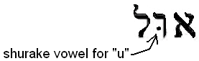

then convert it to its archaic (pre Babylonian) form;



Now reposition the first letter "aw" (modern aleph) to point down; fill it in, and then trim (as shown below):



This forms the sign of the vowel sound kaw-mates, which produces the sound “aw,” which is part of the sacred name, “Yaw,” and also the first sound ever uttered into God’s creation, “Yawhiy Oyr” (Exist energy). It is also the vowel used to indicate the power needed to perform an action – in primary verbs. Now place the vowels of "Uwl" under the sacred name Yhwh.

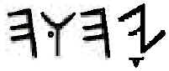

to spell;



Combine this name and correct title for:



Yaw Hu ah – Ul

A good example of the title “Ul” is preserved in the ancient name of Saul, Israel’s first King. From Strong’s Concordance:

7586 Sha'uwl (shaw-ool'); passive participle of 7592; asked; Shaul, the name of an Edomite and two Israelites: Gen 36:37

From Gesenius’ Hebrew Lexicon:

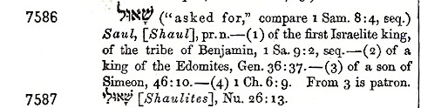

This is how Shaw Uwl is spelt (in both forms):

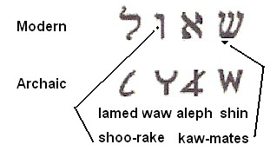

Sha’uwl literally means “asked for of God.” This name of course is related to the time when the nation of Israel asked God for a King, so they could be like the other nations of the world.

Yaw-hu is the same name that appears in seventy two of the ancient proper names that refer to God (shown on pages 25-30). The letter “hay” (h) means “life” (refer to the alphabet chart on pages 2-3). By adding the final “hay” (h) to Yaw-hu, you arrive at Yaw-hu-ah, which means “the self existent One” – who gives (breathes) life.”

The “Hu” in God’s name is the present consecutive conjugation of the verb "haw-yaw" which means "to exist."   
  
By pointing the sixth letter of the alphabet (waw) with a shurake vowel; this letter looses its consonantal sound and becomes a “u.”   
  
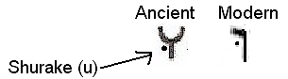  
Since this letter appears after the first “hay” (h) in God’s name, the “h” retains its consonantal sound and combined with shurake, the syllable “hu” is created. This grammar rule appears in many others words that use the present consecutive form (of “u”) to indicate “perpetuity.” For example; the saying from Psalms 122:6; “Pray for the Peace of Jerusalem,” should be rendered as: “Pray (continually) for the (perpetual) Peace of Jerusalem.” You can see in the text below (taken from Sovereign Grace Interlinear Bible) the use of the present consecutive indicated by the “waw” pointed with a shurake (u); is making the sound “lu” in the word “Sha-lu,” and the sound “ru” in the word “Yaw-ru-sha-laim.”

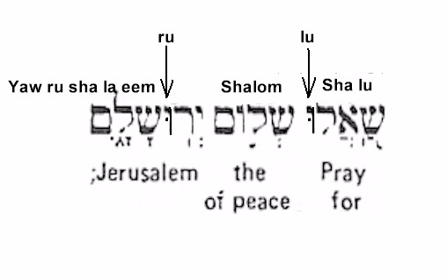This is the present consecutive tense, which means an incomplete ongoing action. Continually, always, in perpetuity; the same adjectives apply to the “hu” that appears in Yaw-hu-ah; perpetual existence.

_______________  
  
An explanation of the Hebrew Grammar rules applied to the consonants; Y, H, W, H., taken from Gesenius’ Book on Hebrew Grammar, page 56. [my comments in brackets]

1. A "hay" (h) in the middle of a word [such as in the second letter of Yaw-hu-ah] can never be a vowel. The "hay" retains it soft "h" consonantal sound.

2. The third letter "waw" has a sureq [or shurake] vowel point in the center of the letter, giving it the vowel sound "u," and making the second syllable "hoo." This "waw" cannot be a dages because there is no vowel before or after it, it must be a "u."

3. "Waw" in the center of a word (or proper name) always closes a syllable and begins another. Thus; giving the first three letters of the name the sound of "Yaw-Hu."

4. The final “hay” at the end of the name becomes quiescent (or silent) retaining its soft vowel sound of an exhaled – “ah.”

In further explanation of point #3 (above); as explained earlier, a dages is a doubling of the letter, which is indicated by a dot, like the dot place in the center of a “waw” to make the shurake (u) vowel point. As Gesenius points out, the “waw” in God’s name can not be a dages (or doubled “w”), because there is no vowel under the “h” that precedes the “waw,” neither is there a vowel under the “h” that follows the “waw.” This grammar rule has no exceptions. Therefore, to render the Creator’s name (as some do) as, “Yaw-hu-wah” or “Yahuwah” is incorrect.

Chapter Five

The Hebrew name of Jesus.

The name Jesus appears in the Greek Old Testament as Iesous (shown below):



It is spelt (in the Greek) Iota (I) eta I sigma (s) omicron (o) upsilon (u) and sigma (s); Iesous.

The Latin spelling is slightly different, and was used in the English Bible (printed in 1560 a.d.) before the letter “J” came into use. Jesus is spelt as Iesus (shown below);

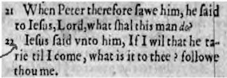

Strong’s defines the name of Jesus as follows:

*2424 Iesous (ee-ay-sooce’); of Hebrew origin [3091]; Jesus (i.e. Jehoshua), the name of our Lord and two (three) other Israelites:*

Next is the definition from Vine’s Expository Dictionary of Biblical Words:

*iesous (2424) is a transliteration of the Heb. “Joshua,” meaning “Jehovah is salvation,” i. e., “is the Savior,” “a common name among the Jews, e. g., <Ex. 17:9; Luke 3:29> (RV); <Col. 4:11>. It was given to the Son of God in Incarnation as His personal name, in obedience to the command of an angel to Joseph, the husband of His Mother, Mary, shortly before He was born, <Matt.1:21>.*

The name Jesus is a transliteration of the Hebrew name Joshua. You can see (below) that Joshua (or Yehoshua) is pointed in the exact same way as Yehovah. A “she-waw” (e) after the “Y” (or J), and a “cholem (o) after the "h.“

(from Gesenius’ Lexicon):

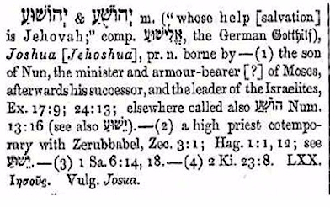

When the original ancient vowel points of Yaw, and Yaw-hu-ah are applied to the name Yehoshuah, the correct pronunciation becomes "Yaw-hu-shu-ah.” This means, “whose salvation is Yaw-hu”.

But is this the name of the Messiah of Israel? Yahushua (Y-H-W-shua) incorporates only three of the four letters found in God’s name (YHWH). The scriptures plainly say;  
  
*Wherefore Yawhuah also hath highly exalted him, and given him a name which is above every name: Phil 2:9 (KJV)*

"....above ever other name..." means NO ONE else has ever had that name, nor will any one ever have that name in the future. Strong, Gesenius, and Vine’s Concordance agree; not only have others had the name of Joshua (Yahushua), it was also a common name among the Jews. Jesus himself told the leaders in Israel;   
  
*"I have come in My Father's name, and you do not receive Me; ...” John 5:43 (NKJ)*

There is only one name that fits that requirement;

Yaw-Hu-ah-shua,

 [YHWHSWA]

incorporating all four letters of the Father's name and meaning;

**Yaw-the self existent one is salvation**.

NO ONE ELSE has ever had this name. 

I, even I, am Yawhuah (YHWH); and beside me there is no saviour. Isa 43:11 KJV

The true names in their Ancient and Modern forms:

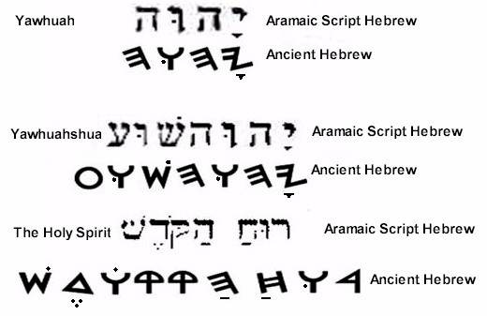

Footnotes:

1. By removing the shurake (u) vowel point, the true and unique title of our Creator “UL,” was changed into the name of the Canaanite deity “El.” Proof of this can be seen in the modern Hebrew calendar, that has been in effect since the Babylonian captivity (Definition below taken from Wikipedia);

*Elul (Hebrew: אֱלוּל) is the twelfth month of the Jewish civil year and the sixth month of the ecclesiastical year on the Hebrew calendar. It is a summer month of 29 days. Elul usually occurs in August–September on the Gregorian calendar. The name of the month, like the names of the rest of the Hebrew calendar months, was brought from the Babylonian Exile, and has originated from the Akkadian word for "Harvest". A similar month name was also used in Akkadian, in the form elūlu.*

The precise translation of El-UL is; “EL” (the chief deity of the Canaanite pantheon) is “Ul” (The Mighty One). This month of the calendar actually declares, “El is God.”

Applying what you just learned about the (waw) present consecutive tense (like hu, lu, and ru); that convey the idea of perpetuity; what do you think the “u” signifies at the end of the Akkadian form of elūlu? El is my Ul – for ever?

__________________

2. We discussed the meaning of the Hebrew words and verb forms used in God’s name, Yaw-hu-ah. In addition to this; the combined letters themselves (Y,H,W, and H) have a unique and special word meaning found in no other name. The Hebrew language uses male and female modifiers to add gender to a pronoun. The letter “Y” (Yod) serves as the male modifier, and the letter “H” (hay) is the female modifier. This is illustrated on the next page in the words used for man (iysh) and woman (ish-shaw).

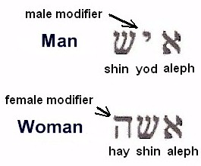

If you apply the word meaning for each letter (found on the alphabet chart on pages 2-3); they have a combined meaning of:

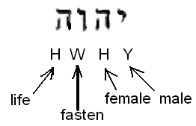

(Read from right to left) the male and female letters are fastened together giving life.

_______________

3. In the US, many (if not most) of the churches operate under IRS rules for a 501(c)3 Not For Profit Corporation. I have heard Pastors preach from the pulpit that they are not allowed by law to talk about Politics or Political candidates. You may also have heard that same statement. It is totally false, and I dare say, the ones who are using this excuse know it!

In 1954 Senator Lyndon B. Johnson had the IRS tax code changed to prohibit tax exempt organizations [like (501(c)3 Church Corporations] from endorsing or opposing political candidates. This amendment affected the tax code only, and tax exempt organizations only. The US Congress cannot pass a law forbidding the free exercise of Religion guaranteed in the first amendment of the US Constitution. Lyndon Johnson, on behalf of liberal Democrats in the Congress; had the tax code changed to silence the conservative religious leaders in our Country; and it worked! The liberal and academic social reformers knew from our history that church leadership has always been outspoken about American Political affairs, and how they relate to personal liberties. It only makes sense. Can there be freedom to worship if the other liberties we enjoy have been curtailed or eliminated?

Speaking about Political issues from the pulpit is a tradition that goes back to the American Revolution. God gave us Americans a Government of – self rule. God did not give us this form of Government, and then expect Christians to step back and let wicked and evil men run the Government. Quite the contrary; maintaining an honest and moral government is dependent upon men and women of faith taking an active role.

Churches should drop their 501(c)3 status, start paying taxes if they have to, and begin holding the Government accountable for its deeds. There are four aspects of life that affect every man, woman, and child in this Country; Religion, Politics, Economics, and Societal health and well being. What good is it to a people, if our religious organizations seek only to address our spiritual needs? If the righteous do not participate in Government, and the wicked are in charge of our financial and economic affairs, society will suffer as a whole. When we attend church, we should learn the truth about each one of the four aspects of life; and how they relate to our current state of affairs. In the end, not only is our well being at stake, but also the welfare of our children and grandchildren.

CREDITS

1. The Dean Burgon Society, Inc.

Box 354 - Collingswood, New Jersey 08108, U.S.A.

<http://www.deanburgonsociety.org/CriticalTexts/witfields>.

1. Dr. Clifford Wilson is an archaeologist, linguist and Bible scholar. He has a Ph.D. in Psycholinguistics from the University of South Carolina and is a member of the faculty at Monash University in Australia.

Some material is taken from Dr. Clifford Wilson's new book EBLA TABLETS: Secrets of a Forgotten City, published by Creation-Life Publishers, San Diego, CA 92115. (Publication date: April, 1977 - Price: $1.95)

1. The King James Bible, Thomas Nelson Publishers