Custom Express
1400 Industrial Dr.
Matthews, NC 28105
T 704.845.0900
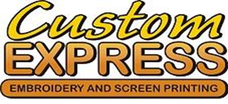

CREDIT CARD ON FILE AUTHORIZATION FORM
This form is for you to supply Custom Express with credit card information to keep on file for the payment of all services and fees when orders are shipped. A new form must be completed for each card kept on file. Custom Express accepts Visa, MasterCard, Discover and American Express.

CARDHOLDER INFORMATION

Name:

Billing Street Address:

Street Address (cont.):

City: State: Postal Code:

Country: Email

Address:

Direct Telephone: ( ) -

CREDIT CARD INFORMATION

Credit Card Type: □ MasterCard □ Visa □ American Express □ Discover Card

Number:

Expiration Month: Expiration Year:

Cardholder Signature X Date / /

Security Code:

accounting@yourcustomexpress.com | PO Box 1377, Matthews, NC 28106 | 704.845.0900

