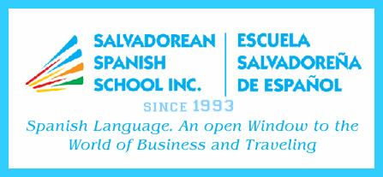 |  |  |  |  |  | SALVADOREAN SPANISH SCHOOL INC.  3706 Sherwood Drive, Regina, Sask. S4R 4A6  Tel. 306-543-6948 - Cell. 306-536-9610  E-mail ssschoolinc@sasktel.net  www.salvadoreanspanishschool.com
REGISTRATION FORM – SEPTEMBER 17 – DECEMBER 03, 2022
Student Name: |  |  |  |  |  |  |  |  |  | Date of Birth:
Regular School: |  |  |  |  |  |  |  |  |  |  |  |  | Grade:
Medical History:
 |  |  |  |  | (Anything you feel we must be aware of asthma, allergies, diabetes, etc.)
SATURDAY |  |  | TIME: 10:00 TO 11:45 AM
Fee: $100.00 – BOOK $25.00
Mother’s name: |  |  |  |  |  |  | Father’s name:
Address: |  |  |  |  |  |  |  |  |  |  | Postal code:
Telephone: |  |  |  |  |  |  | e-mail:
Classes for children are held at Balfour Collegiate – 1245 College Avenue (Tentative)
Special activities (Mother’s Day)
Classes start from the third week of September to the last week of November.
Balfour is closed on long weekends and when Language teachers have a workshop or a conference.
The kids have 15 minutes for recess. Please provide them some snacks. to in student and to be allowed to use the public school facilities.

SALVADOREAN SPANISH SCHOOL INC.
3706 Sherwood Drive, Regina, Sask. S4R 4A6
Tel. 306-543-6948 - Cell. 306-536-9610
E-mail ssschoolinc@sasktel.net
www.salvadoreanspanishschool.com
REGISTRATION FORM – SEPTEMBER 17 – DECEMBER 03, 2022
Student Name: |  |  |  |  |  |  |  |  |  | Date of Birth:
Regular School: |  |  |  |  |  |  |  |  |  |  |  |  | Grade:
Medical History:
 |  |  |  |  | (Anything you feel we must be aware of asthma, allergies, diabetes, etc.)
SATURDAY |  |  | TIME: 10:00 TO 11:45 AM
Fee: $100.00 – BOOK $25.00
Mother’s name: |  |  |  |  |  |  | Father’s name:
Address: |  |  |  |  |  |  |  |  |  |  | Postal code:
Telephone: |  |  |  |  |  |  | e-mail:
Classes for children are held at Balfour Collegiate – 1245 College Avenue (Tentative)
Special activities (Mother’s Day)
Classes start from the third week of September to the last week of November.
Balfour is closed on long weekends and when Language teachers have a workshop or a conference.
The kids have 15 minutes for recess. Please provide them some snacks.
re

