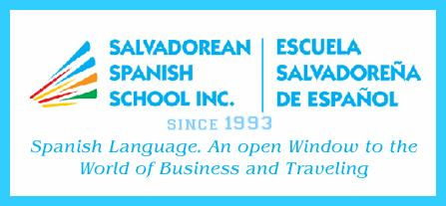 |  |  |  |  |  | SALVADOREAN SPANISH SCHOOL INC.  3706 Sherwood Drive, Regina, Sask. S4R 4A6  Tel. 306-536-9615 - Cell. 306-536-9610 - Landline 306-543-6948  E-mail ssschoolinc@sasktel.net  www.salvadoreanspanishschool.com
REGISTRATION FORM – Sept. 13 – Nov. 29, 2025
Student Name: |  |  |  |  |  |  |  |  |  | Date of Birth:
Regular School: |  |  |  |  |  |  |  |  |  |  |  |  | Grade:
Medical History:
 |  |  |  |  | (Anything you feel we must be aware of asthma, allergies, diabetes, etc.)
SATURDAY |  |  | TIME: 10:00 To 11:45 AM
Registration Fee: $125.00
Mother’s name: |  |  |  |  |  |  | Father’s name:
Address: |  |  |  |  |  |  |  |  |  |  | Postal code:
Telephone: |  |  |  |  |  |  | e-mail:
Payment by e-transfer or cash
Special activities (Mother’s Day)

SALVADOREAN SPANISH SCHOOL INC.
3706 Sherwood Drive, Regina, Sask. S4R 4A6
Tel. 306-536-9615 - Cell. 306-536-9610 – Landline 306-543-6948
E-mail ssschoolinc@sasktel.net
www.salvadoreanspanishschool.com
REGISTRATION FORM – Sept. 13 – Nov. 29, 2025
Student Name: |  |  |  |  |  |  |  |  |  | Date of Birth:
Regular School: |  |  |  |  |  |  |  |  |  |  |  |  | Grade:
Medical History:
 |  |  |  |  | (Anything you feel we must be aware of asthma, allergies, diabetes, etc.)
SATURDAY |  |  | TIME: 10:00 To 11:45 AM
Registration Fee: $125.00
Mother’s name: |  |  |  |  |  |  | Father’s name:
Address: |  |  |  |  |  |  |  |  |  |  | Postal code:
Telephone: |  |  |  |  |  |  | e-mail:
Payment by e-transfer or cash
Special activities (Mother’s Day)

