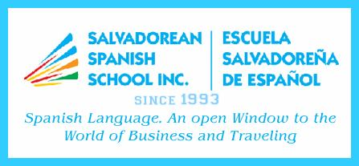 |  |  |  |  |  | SALVADOREAN SPANISH SCHOOL INC.  3706 Sherwood Drive, Regina, Sask. S4R 4A6  Tel. 306-536-9615 - Cell. 306-536-9610 - Landline 306-543-6948  E-mail ssschoolinc@sasktel.net  www.salvadoreanspanishschool.com
REGISTRATION FORM – January 11 – March 29, 2025
Student Name: |  |  |  |  |  |  |  |  |  | Date of Birth:
Regular School: |  |  |  |  |  |  |  |  |  |  |  |  | Grade:
Medical History:
 |  |  |  |  | (Anything you feel we must be aware of asthma, allergies, diabetes, etc.)
SATURDAY |  |  | TIME: 10:00 TO 11:45 AM
Fee: $125.00
Mother’s name: |  |  |  |  |  |  | Father’s name:
Address: |  |  |  |  |  |  |  |  |  |  | Postal code:
Telephone: |  |  |  |  |  |  | e-mail:
Payment by e-transfer or cash
Special activities (Mother’s Day)
The kids have 15 minutes for recess. Please provide them with some snacks.

SALVADOREAN SPANISH SCHOOL INC.
3706 Sherwood Drive, Regina, Sask. S4R 4A6
Tel. 306-536-9615 - Cell. 306-536-9610 – Landline 306-543-6948
E-mail ssschoolinc@sasktel.net
www.salvadoreanspanishschool.com
REGISTRATION FORM – January 11 – March 29, 2025
Student Name: |  |  |  |  |  |  |  |  |  | Date of Birth:
Regular School: |  |  |  |  |  |  |  |  |  |  |  |  | Grade:
Medical History:
 |  |  |  |  | (Anything you feel we must be aware of asthma, allergies, diabetes, etc.)
SATURDAY |  |  | TIME: 10:00 TO 11:45 AM
Fee: $125.00
Mother’s name: |  |  |  |  |  |  | Father’s name:
Address: |  |  |  |  |  |  |  |  |  |  | Postal code:
Telephone: |  |  |  |  |  |  | e-mail:
Payment by e-transfer or cash
Special activities (Mother’s Day)
The kids have 15 minutes for recess. Please provide them with some snacks.

