A SELECTION OF RESOURCES INDICATING HIGH MORTALITY & INJURIES ASSOCIATED WITH COVID VACCINATION

January 2021

https://stevekirsch.substack.com/p/incriminating-evidence

Incriminating evidence

Vaccine efficacy
These studies all show that the more you vaccinate, the worse the outcomes. Overall, the nations who vaccinate the most have the highest infection and death rates. That’s the opposite of what was promised. And the funny thing is that nobody can show an error in any of these studies. Do you think they are all wrong? Can you find the error in all of them?
- UK Government Data proves the Covid-19 Vaccines DOUBLE your chances of catching Covid-19. No age confounding on this one. This will be hard for anyone to explain.
- Scotland data clearly shows the vaccines are making things worse.
- New big data study of 145 countries show COVID vaccines makes things worse (cases and deaths)
- The Harvard study
- The German study
- The Denmark study (shows that against Omicron, we need to vaccinate people every 60 days or so and after that the vaccine efficacy goes negative). A Reuters fact check cannot change that fact.
- German government data (this is from The Expose and was based on the German government data at the time it was written. The German government then changed the data after the article revealed the problem which made the problem go away.
- 80% of the COVID deaths in the UK are vaccinated
- Lancet: 89% Of New UK COVID Cases Among Fully Vaxxed
- Official UK Government data suggests Fully Vaccinated Brits will develop Acquired Immunodeficiency Syndrome by the end of February 2022
- The Lyons-Weiler study
- Florida: Highest Rates of Infection Occurring in Counties with Highest Vaccination Rates
- Vaccine Failure - Across the Board. Negative efficacy in UK. The vaccines are not only failing to prevent infection, but they are making you more vulnerable to infection.
Pfizer’s own study showed that for 220M fully vaccinated people, we save at most 10,000 lives. Thus, we kill at least 15 people (all-cause mortality) for every person we save, which makes the vaccines nonsensical. See the previous section.
Here’s the kicker. The Denmark study was confirmed in an Israeli trial which concluded that a 4th dose is not enough. So basically they think that if you double vax and then triple boost someone that will do it. Five doses. That is unbelievable. There is no precedent for that. The Denmark study basically showed that the more you vaccinate, the easier it is for the virus to infect you. It’s crystal clear. They can give you infinite doses and it will not matter. Things will get worse and worse on each dose and the officials will still think that the solution is more doses. They’ll never figure out that early treatment is the better path. Insanity is doing the same thing over and over again and expecting a different result. This is actually worse than that: they are doing the same thing over and over again, each time getting a reduced result, and hoping it will just magically go the other way. Why are they doing these mass experiments on people? How is that ethical?

Vaccine risk-benefit analysis
Have you ever noticed that the Emperor has no Clothes?
We are told we should vaccinate to “protect others,” yet nobody has presented a risk-benefit analysis that justifies this.
Have you ever wondered “why is there no risk-benefit analysis?” If you have, you are probably a critical thinker and US CDC health guidelines requires you to immediately watch this helpful instructional video produced by Dr. Death that explains how people like you are a danger to society and what you can do about it.
On the other hand, we do have risk benefit analyses showing it is totally nonsensical for you to get the shot:
- VAERS risk benefit analysis shows vaccines make no sense for any age group
- Risk-benefit analysis shows we kill 117 kids for every child we might save from a COVID death
Ask yourself, would you voluntarily take a shot that has a 1% chance of killing or permanently disabling you in order to potentially save the life of someone else (likely an old person)?

https://stevekirsch.substack.com/p/we-will-kill-117-kids-to-save-one

We will kill 117 kids to save one child from dying from COVID in the 5 to 11 age range

That's according to a risk-benefit analysis done by risk-benefit expert Dr. Toby Rogers. His analysis has been viewed by over 22,000 readers. No mistakes were found. Nothing but praise.
 | Steve Kirsch
  Nov 4, 2021
  275 | 145
Dr. Toby Rogers writes a popular substack looking at risk benefit issues. His credentials are described here.
In a recent article that I hope everyone will read or at least skim, he concluded: “So, to put it simply, the Biden administration plan would kill 5,248 children via Pfizer mRNA shots in order to save 45 children from dying of coronavirus. For every one child saved by the shot, another 117 would be killed by the shot.”
That’s stunning. Read it again.

We kill 117 kids from the vaccine to save one kid from COVID.
This was not surprising to me.
What he did was super simple. He estimated the number of kids likely to die from COVID and assumed the shots would be 80% protective of all those deaths. He extrapolated the death rate from the vaccine from the 12-24 death data in VAERS using a conservative 41 under-reporting factor. It’s no more complicated than that. No rocket science required.
Dr. Roger’s results are consistent with the scientific peer-reviewed literature such as the Kostoff paper which concluded:
In plain English, people in the 65+ demographic are five times as likely to die from the inoculation as from COVID-19 under the most favorable assumptions! This demographic is the most vulnerable to adverse effects from COVID-19. As the age demographics go below about 35 years old, the chances of death from COVID-19 become very small, and when they go below 18, become negligible.
The Walach paper found the same thing. It has now been re-published in Science, Public Health Policy and the Law which is a peer-reviewed medical journal. The Walach paper appears in this issue along with a scathing editorial by the journal editor talking about how the paper authors were mistreated by the scientific community. James Lyons-Weiler wrote, “Either way, the authors of the latest paper in Science, Public Health Policy, & the Law (Walach et al.) have been caught, like grist in the mill, in a nonsensical, convoluted torture session in which their detractors have broken all logic and reason on the question of how society renders causal inference between vaccine exposure and serious illness or death.” James would love to debate anyone who disagrees with his editorial, but nobody wants to talk about it.
They don’t really care how many kids they kill from the vaccines. It just doesn’t matter. Their sole focus is on saving kids from dying from COVID, regardless of how many kids have to be killed from the drug. All-cause mortality is ignored entirely even though Pfizer’s own study showed 4X the deaths from cardiac arrest in the group that got the drug.
Even though there were 20 deaths in the group that got the vaccine vs. 14 deaths in the group that got the placebo, they can simply write that off as “not statistically significant.” In other words, the data does show that the drug does kill more people than it saves, but the study was never powered to measure that. So they can say “nobody knows” as long as they can keep fooling everyone to believe that the VAERS data is unreliable (which it isn’t which I address in detail here).
Over 22,000 people have read Toby’s analysis and nobody came up with a better estimate or a material error in his analysis. There were nothing but compliments on the quality of the analysis. In particular, nobody from the CDC or FDA pointed out any errors. Here’s the background…
On September 24, 2021, Toby posted this reasonable request on Twitter:
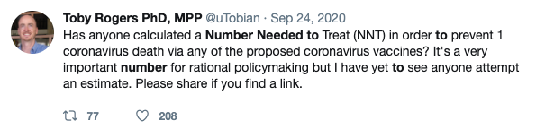
He did get a response, but not to the question he asked. He wrote, “Pharma sent a swarm of trolls in to attack me and Pharma goons published hits pieces on me outside of Twitter to punish me for even asking the question. Of course none of the Pharma trolls provided an estimate of the NNTV for COVID-19 shots. That tells us that we are exactly over the target.”
Since nobody, not even the trolls, responded with data, he started looking into it himself.
Next, he wrote a series of articles on what he found; the risk-benefit analysis for the current COVID vaccines. In particular, he examined the case for the 5 to 11 year cohort which was just approved by the FDA.
I like Toby because he doesn’t pull any punches when he writes. He calls a spade a spade. Here are a few “highlights” from his recent articles that I think everyone should know:
- “So then the NNTV to prevent a single fatality in this age group is 630,775 (28,384,878 / 45). But it’s a two dose regimen so if one wants to calculate the NNTV per injection the number doubles to 1,261,550. It’s literally the worst NNTV in the history of vaccination.” [ NNTV article ]
- “Where to even begin with the FDA’s preposterous risk-benefit analysis of Pfizer’s mRNA COVID-19 “vaccine” in children ages 5 to 11?” [Red flags article]
- “The FDA’s risk-benefit analysis in connection with Pfizer’s Emergency Use Authorization (EUA) application to inject children ages 5 to 11 with their COVID-19 vaccine is one of the shoddiest documents I’ve ever seen.” [Red flags article]
- “The CDC “Guidance” document describes 21 things that every health economics study in connection with vaccines must do and the FDA risk-benefit analysis violated at least half of them.” [ NNTV article ]
- “Pharma HATES talking about NNTV and they hate talking about NNTV even more when it comes to COVID-19 vaccines because the NNTV is so ridiculously high that this vaccine could not pass any honest risk-benefit analysis.” [ NNTV article ]
- “If the FDA or CDC want to calculate a different NNTV (and explain how they arrived at that number) I’m all ears. But we all know that the FDA refused to calculate an NNTV not because they forgot, but because they knew the number was so high that it would destroy the case for mRNA vaccines in children this age. Your move CDC — your own Guidance document states that you must provide this number.” [ NNTV article ]
- “So the Number Needed to Vaccinate in order to prevent a single hospitalization, ICU admission, or death, according to Pfizer’s own data, is infinity. ∞. Not the good kind of infinity as in God or love or time or the universe. This is the bad kind of infinity as in you could vaccinate every child age 5 to 11 in the U.S. and not prevent a single hospitalization, ICU admission, or death from coronavirus according to Pfizer’s own clinical trial data as submitted to the FDA. Of course Pfizer likes this kind of infinity because it means infinite profits.” [ NNTV article ]
- “I've studied corruption at the FDA & CDC for a while now (6 years) and I'm always shocked at how brazen and blatant it is.” [this is a comment Toby wrote in the NNTV article shown below ]
- “A funny thing happened this afternoon. Not funny as in “haha”. More like funny as in, “ohhhhh that’s how the FDA rigs the process.” [ NNTV article ]
- “I watched all 6+ hours of the ACIP meeting today. Here are my initial reactions. These people are batsh*t insane. They live in an alternative universe. As cartoonish as the FDA’s VRBPAC meeting was last week, this was even worse.” [ACIP article]
- “Pfizer learned their lesson with the adult trial and so when they conducted a trial of their mRNA vaccine in children ages 5 to 11 they intentionally made it too small (only 2,300 participants) and too short (only followed up for 2 months) in order to hide harms.” [ NNTV article ]

https://principia-scientific.com/lancet-89-of-new-uk-covid-cases-among-fully-vaxxed/

Lancet: 89% Of New UK COVID Cases Among Fully Vaxxed
Published on December 30, 2021
Written by The Lancet
High COVID-19 vaccination rates were expected to reduce transmission of SARS-CoV-2 in populations by reducing the number of possible sources for transmission and thereby to reduce the burden of COVID-19 disease.
Recent data, however, indicate that the epidemiological relevance of COVID-19 vaccinated individuals is increasing. In the UK it was described that secondary attack rates among household contacts exposed to fully vaccinated index cases was similar to household contacts exposed to unvaccinated index cases (25 percent for vaccinated vs 23 percent for unvaccinated).
12 of 31 infections in fully vaccinated household contacts (39 percent) arose from fully vaccinated epidemiologically linked index cases. Peak viral load did not differ by vaccination status or variant type [[1]]. In Germany, the rate of symptomatic COVID-19 cases among the fully vaccinated (“breakthrough infections”) is reported weekly since 21. July 2021 and was 16.9 percent at that time among patients of 60 years and older [[2]].
This proportion is increasing week by week and was 58.9 percent on 27. October 2021 (Figure 1) providing clear evidence of the increasing relevance of the fully vaccinated as a possible source of transmission. A similar situation was described for the UK. Between week 39 and 42, a total of 100,160 COVID-19 cases were reported among citizens of 60 years or older. 89,821 occurred among the fully vaccinated (89.7 percent), 3395 among the unvaccinated (3.4 percent) [[3]].
One week before, the COVID-19 case rate per 100.000 was higher among the subgroup of the vaccinated compared to the subgroup of the unvaccinated in all age groups of 30 years or more. In Israel a nosocomial outbreak was reported involving 16 healthcare workers, 23 exposed patients and two family members. The source was a fully vaccinated COVID-19 patient. The vaccination rate was 96.2 percent among all exposed individuals (151 healthcare workers and 97 patients).
Fourteen fully vaccinated patients became severely ill or died, the two unvaccinated patients developed mild disease [[4]]. The US Centres for Disease Control and Prevention (CDC) identifies four of the top five counties with the highest percentage of fully vaccinated population (99.9–84.3 percent) as “high” transmission counties [[5]].
Many decision makers assume that the vaccinated can be excluded as a source of transmission. It appears to be grossly negligent to ignore the vaccinated population as a possible and relevant source of transmission when deciding about public health control measures.
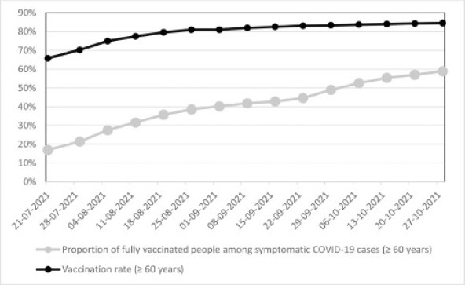
Figure 1. Vaccination rates and proportions of fully vaccinated people among symptomatic COVID-19 cases (≥ 60 years) in Germany between 21. July and 27. October 2021 based on the weekly reports from the Robert Koch-Institute [[2]].

References
- [1].
  - Singanayagam A, Hakki S, Dunning J, et al.
Community transmission and viral load kinetics of the SARS-CoV-2 delta (B.1.617.2) variant in vaccinated and unvaccinated individuals in the UK: a prospective, longitudinal, cohort study.
Lancet Infect Dis. 2021; https://doi.org/10.1016/S1473-3099(21)00648-4
- Robert Koch-Institut. Wöchentlicher Lagebericht des RKI zur Coronavirus-Krankheit-2019 (COVID-19). AKTUALISIERTER STAND FÜR DEUTSCHLAND 22. Juli 2021. https://www.rki.de/DE/Content/InfAZ/N/Neuartiges_Coronavirus/Situationsberichte/Wochenbericht/Wochenbericht_2021-07-22.pdf?__blob=publicationFile (accessed 28. September 2021).
- UK Health Security Agency. COVID-19 vaccine surveillance report. Week 4328. Oktober 2021. https://assets.publishing.service.gov.uk/government/uploads/system/uploads/attachment_data/file/1029606/Vaccine-surveillance-report-week-43.pdf (accessed 1. November 2021).
- Shitrit P, Zuckerman NS, Mor O, Gottesman BS, Chowers M.
Nosocomial outbreak caused by the SARS-CoV-2 Delta variant in a highly vaccinated population, Israel, July 2021.
Euro Surveill. 2021; 262100822https://doi.org/10.2807/1560-7917.ES.2021.26.39.2100822
- Subramanian SV, Kumar A.
Increases in COVID-19 are unrelated to levels of vaccination across 68 countries and 2947 counties in the United States.
Eur J Epidemiol. 2021; https://doi.org/10.1007/s10654-021-00808-7
See more here: thelancet.com

https://stevekirsch.substack.com/p/the-stunning-increase-in-myocarditis

The stunning increase in myocarditis rates after the vaccines rolled out

In just a few hours, my short tweet on myocarditis Google search rates went viral. Here's the reason why search rates skyrocketed (hint: it's because cases skyrocketed).
 | Steve Kirsch
  Jan 14
  567 | 543
I wrote this Tweet and it blew up really fast: over 100,000 views in the first 3 hours:
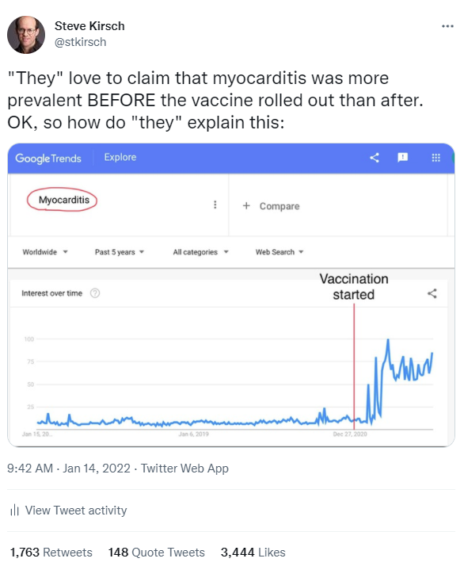
Of course, there were many people who wrote something to the effect of “Um. Those are Google searches. That means people searching about it. It doesn't mean anything.”
Really?!? Nothing?!? I disagree. I think it does mean something. It confirms every other piece of data I’ve seen.
A critical thinker might ask the question, “Why would people suddenly start searching about myocarditis shortly after the vaccines rolled out and not before?”
Vaccine-induced myocarditis started making headlines starting around June 14, 2021, but it wasn’t officially confirmed even then. So that doesn’t explain the increase before that time.
The answer seems obvious: clearly, interest in the topic increased a lot shortly after the vaccines rolled out. Is there a different explanation that is more likely?
Here are some of the reasons why the interest in myocarditis went up so much:
- VAERS data shows that the rates of myocarditis caused by the vaccine are far greater than the rates caused by COVID (see VaccineEssentials slide 48). According to this CDC MMWR report, “During 2020, the number of myocarditis inpatient encounters (4,560) was 42.3% higher than that during 2019 (3,205).” That’s why the bars in 2019 and 2020 below are about the same height. The incidence rate caused by the vaccine is way higher than for COVID (and it wasn’t caused by “over reporting” as I’ve explained many times before). There is no other way to explain this. This chart is from a published paper by Jessica Rose that was unethically retracted by the journal publisher because it goes against the narrative. If anyone wants to debate Jessica on this, bring it on! So you are never ever supposed to see this chart below. Nobody in mainstream medicine wants to talk about it either.
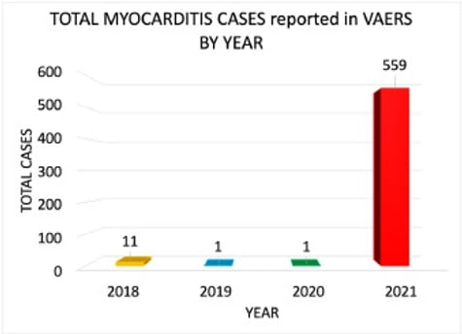
- UK data shows the rates of myocarditis increased after the vaccines (see VaccineEssentials slide 54).
- All of the cardiologists (people like Peter McCullough) I’ve talked to have confirmed that the rates of myocarditis have gone up after the vaccines have rolled out compared to pre-vaccine. Do you know of any cardiologists who claimed myocarditis cases went down after the vaccines rolled out?
- Young kids seem to be getting myocarditis regularly now whereas you’d pretty much never see these cases before the vaccines rolled out (see VaccineEssentials slide 50)
- At one private school near where I live, the rate of myocarditis after the vaccine roll out was greater than 1 in 100 teenage boys, which of course is far greater than the rate from COVID.
- The CDC doesn’t want to talk about vaccine-caused myocarditis as this story about the tragic death of 26-year-old Joseph Keating. Nobody wants to touch it.
- I’d love to get an explanation of this from mainstream medical doctors, but they refuse to talk to me because I don’t believe the vaccines are safe.

https://stevekirsch.substack.com/p/new-big-data-study-of-145-countries

New big data study of 145 countries show COVID vaccines makes things worse (cases and deaths)

I missed this study. So did the mainstream media for some reason. But this study is yet another independent analysis that is difficult to refute: we have been misled by the CDC, FDA, and NIH.
 | Steve Kirsch
  Jan 9
  890 | 622

At-a-Glance
- A new study by Kyle A. Beattie entitled “Worldwide Bayesian Causal Impact Analysis of Vaccine Administration on Deaths and Cases Associated with COVID-19: A Big Data Analysis of 145 Countries” concluded that vaccines are doing the opposite of what they were promised to do.
- Rather than helping us regain our freedoms, the vaccines are associated with higher rates of COVID-19 infections and higher rates of COVID-related deaths. In the US, the vaccines were associated with an increase of 38% in the number of COVID cases per million and an increase of 31% in the number of deaths per millions associated with COVID.
- Numerous other studies have independently reached the same conclusion. The more you vaccinate, the worse things get.
- Beattie concludes: “These results should encourage local policy makers to make decisions based on data, not narrative, and based on local conditions, not global or national mandates”. However, based on past performance it is not expected that health authorities will react to these results in a rational fashion. Rather they will continue pressing their vaccine mandate for all, regardless of age or medical history.
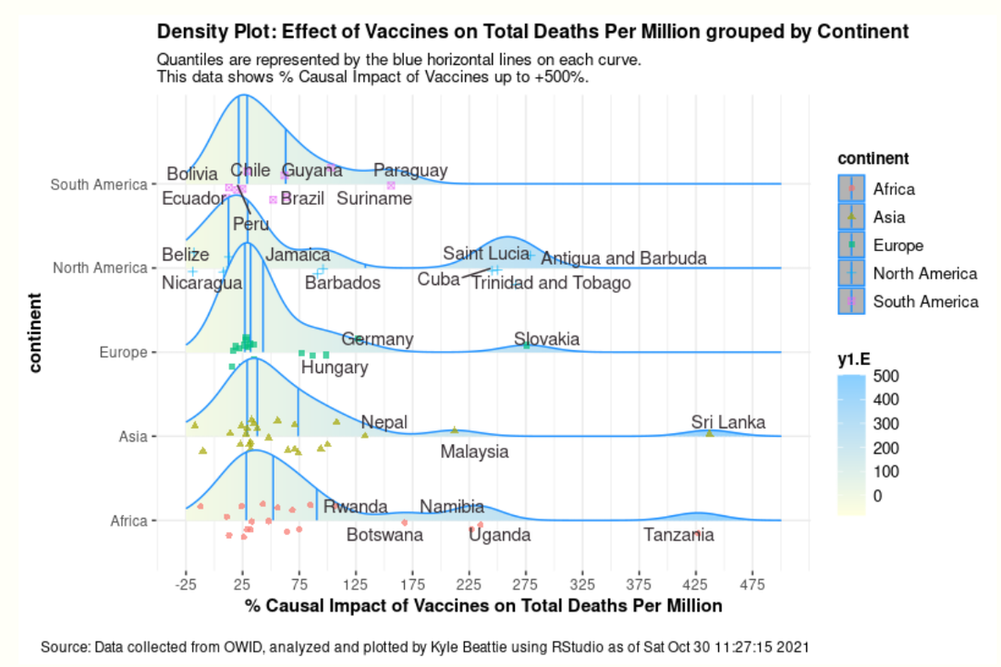
The next time you see you county health officer, President Biden, or Boris Johnson why not ask them if they can find a mistake in this study by Kyle A. Beattie entitled Worldwide Bayesian Causal Impact Analysis of Vaccine Administration on Deaths and Cases Associated with COVID-19: A BigData Analysis of 145 Countries (the PDF version is here).
The study found that the COVID vaccines cause more COVID cases per million (+38% in US) and more deaths per million associated with COVID (+31% in US).
The abstract says:
The statistically significant and overwhelmingly positive causal impact after vaccine deployment on the dependent variables total deaths and total cases per million should be highly worrisome for policy makers. They indicate a marked increase in both COVID-19 related cases and death due directly to a vaccine deployment that was originally sold to the public as the “key to gain back our freedoms.” The effect of vaccines on total cases per million and its low positive association with total vaccinations per hundred signifies a limited impact of vaccines on lowering COVID-19 associated cases.
These results should encourage local policy makers to make policy decisions based on data, not narrative, and based on local conditions, not global or national mandates. These results should also encourage policy makers to begin looking for other avenues out of the pandemic aside from mass vaccination campaigns.

In other words, we were lied to
The vaccines are making this worse, not better. This is why we are not getting ourselves out of the hole. Mandating vaccines are making this
This is hardly the first study to reach those conclusions. These studies, all done independently, found the same thing—the more you vaccinate, the worse things get.
- The Lyons-Weiler paper
- The Harvard study
- The German study
- The Denmark study (which shows Dr. James was right; you have to boost every 30 days to maintain protection.
- German government data (this is from The Expose)
- 80% of the COVID deaths in the UK are vaccinated
- Lancet: 89% Of New UK COVID Cases Among Fully Vaxxed

https://stevekirsch.substack.com/p/evidence-of-harm-in-children-caused

Evidence of harm in children caused by the vaccines

Dr. Robert Malone has asked me to help gather data for a paper he is preparing. I'm sending him everything I have, but you may have additional information.
 | Steve Kirsch
  Dec 28, 2021
  205 | 230

He is looking for papers he can cite showing any of the following:
- COVID-19 vaccines are not safe in children
- The risk-benefit ratio is completely upside down for children.
- More children will die from COVID-19 vaccines than will be saved
He already knows about:
- the Kostov paper
- the Toby Rogers risk-benefit analysis (my commentary; Toby’s analysis)
- my cost-benefit analysis,
- the fact that the 6 month Pfizer trial showed no death benefit whatsoever,
- the latest VAERS data (search result below),
- Myocarditis stats for kids with multiple anecdotes and more importantly, UCSF professor Vinay Prasad’s video showing the rate of myocarditis is higher from the vaccine than from COVID.
If you know of any similar sources in the peer reviewed literature or pre-print server (medrxiv, etc), please respond in the comments.
“Children” means 18 and younger.
He needs it today.

New articles suggested by readers:

Association of Myocarditis With BNT162b2 Messenger RNA COVID-19 Vaccine in a Case Series of Children
https://jamanetwork.com/journals/jamacardiology/article-abstract/2783052
Cardiovascular magnetic resonance findings in young adult patients with acute myocarditis following mRNA COVID-19 vaccination: a case series
https://jcmr-online.biomedcentral.com/track/pdf/10.1186/s12968-021-00795-4.pdf
Possible Association Between COVID-19 Vaccine and Myocarditis: Clinical and CMR Findings
https://www.sciencedirect.com/science/article/pii/S1936878X2100485X?via%3Dihub
2 case studies here were 16 year old male and 17 YO female
- The controversy surrounding vaccination of young people against COVID- 19
- https://theexpose.uk/2021/10/28/child-deaths-62-percent-higher-since-covid-19-vaccination-began/
- https://nationalfile.com/fda-committee-members-reviewing-pfizer-vaccine-for-children-have-worked-for-pfizer-have-big-pfizer-connections/
- https://theexpose.uk/2021/10/27/deaths-among-male-children-increased-by-89-percent-since-given-covid-19-vaccine/
- He needs to see Jessica Rose's long interview with Chris Masterjohn, PhD. Around the :56 minute mark she demonstrates the VAERS 5-11 children data and the UNDERREPORTING to the FDA committee by their medical adviser John Su.
Jessica Rose: VAERS, Myocarditis, COVID Vaccines, and So Much More |
- https://www.theepochtimes.com/mkt_morningbrief/lockdown-policies-and-mask-mandates-linked-with-lower-iq-in-children_4177711.html
- 1) SARS-CoV-2 mRNA Vaccination-Associated Myocarditis in Children Ages 12-17: A Stratified National Database Analysis
https://doi.org/10.1101/2021.08.30.21262866
https://www.medrxiv.org/content/10.1101/2021.08.30.21262866v1
2) https://t.me/robinmg/11261
https://health-infobase.canada.ca/covid-19/vaccine-safety/#a4
3) More links here: https://t.me/dailyexpose/3412
- https://drtrozzi.org/2021/12/28/vaers-mass-murder-update-and-sad-details-of-children-killed/
Dr. Trozzi has published a list of teenagers who died after the shot, taken from VAERS, that might serve the purpose.
- SARS-CoV-2 mRNA Vaccination-Associated Myocarditis in Children Ages 12-17: A Stratified National Database Analysis
Preprint
https://www.researchgate.net/publication/354465833_SARS-CoV-2_mRNA_Vaccination-Associated_Myocarditis_in_Children_Ages_12-17_A_Stratified_National_Database_Analysis
https://www.medrxiv.org/content/10.1101/2021.08.30.21262866v1.full.pdf
- There is the report made by Dr Jessica Rose and Dr Peter McCullough where they analyzed VAERS data of vaccination of children and that showed the harm and was peer-reviewed and published in all medial sites, but was suddenly removed 5 days prior FDAs decision on vaccinating children.
It's this one that she kept on her aubstack page:

The unforgivable sins of 2021
A Report on Myocarditis Adverse Events in the U.S. Vaccine Adverse Events Reporting System (VAERS) in Association with COVID-19 Injectable Biological Products
Abstract Following the global rollout and administration of the Pfizer Inc./BioNTech BNT162b2 and Moderna mRNA-1273 vaccines on December 17, 2020, in the United States, and of the Janssen Ad26.COV2.S product on April 1st, 2021, in an unprecedented manner, hundreds of thousands of individuals have reported adverse events (AEs) using the Vaccine Adverse Ev…
Read more
2 months ago · 37 likes · 36 comments · Jessica Rose

Here are six studies that make the case for not vaccinating children:
1. A 2020 Yale University report indicates children and adults display very diverse and different immune system responses to SARS-CoV-2 infection which explains why they have far less illness or mortality from COVID.
According to the study:
“Since the earliest days of the COVID-19 outbreak, scientists have observed that children infected with the virus tend to fare much better than adults … researchers reported that levels of two immune system molecules — interleukin 17A (IL-17A), which helps mobilize immune system response during early infection, and interferon gamma (INF-g), which combats viral replication — were strongly linked to the age of the patients. The younger the patient, the higher the levels of IL-17A and INF-g, the analysis showed…these two molecules are part of the innate immune system, a more primitive, non-specific type of response activated early after infection.”
2. Studies by Ankit B. Patel and Dr. Supinda Bunyavanich show the virus uses the ACE 2 receptor to gain entry to the host cell, and the ACE 2 receptor has limited (less) expression and presence in the nasal epithelium in young children (potentially in upper respiratory airways).
This partly explains why children are less likely to be infected in the first place, or spread it to other children or adults, or even get severely ill. The biological molecular apparatus is simply not there in the nasopharynx of children. By bypassing this natural protection (limited nasal ACE 2 receptors in young children) and entering the shoulder deltoid, this could release the vaccine, its mRNA and LNP content (e.g. PEG), and generated spikes into the circulation that could then damage the endothelial lining of the blood vessels (vasculature) and cause severe allergic reactions (e.g., here, here, here, here, here).
3. William Briggs reported on the n=542 children who died (0-17 years (crude rate of 0.00007 per 100 and under 1 year old n=132, CDC data) since January 2020 with a diagnosis of COVID linked to their death. This does not indicate whether, as Johns Hopkins’ Dr. Marty Makary has been clamoring, the death was “causal or incidental.” That said, from January 2020, 1,043 children 0-17 have died of pneumonia.
Briggs reported:
“There is no good vaccine for pneumonia. But it could be avoided by keeping kids socially distanced from each other — permanently. If one death is “too many,” then you must not allow kids to be within contact of any human being who has a disease that may be passed to them, from which they may acquire pneumonia. They must also not be allowed in any car … in one year, just about 3,091 kids 0-17 died in car crashes (435 from 0-4, 847 from 5-14, and 30% of 6,031 from 15-24). Multiply these 3,000 deaths in cars by about 1.75, since the COVID deaths are over a 21-month period. That makes about 5,250 kids dying in car crashes in the same period — 10 times as many as Covid.”
Briggs concluded: “there exists no justification based on any available evidence for mandatory vaccines for kids.”
4. Weisberg and Farber et al. suggest (and building on research work by Kumar and Farber) that the reason children can more easily neutralize the virus is that their T cells are relatively naïve. They argue that since children’s T cells are mostly untrained, they can thus immunologically respond (optimally differentiate) more rapidly and nimbly to novel viruses such as SARS-CoV-2 for an effective robust response.
5. Research published in August 2021 by J. Loske deepens our understanding of this natural type biological/molecular protection even further by showing that “pre-activated (primed) antiviral innate immunity in the upper airways of children work to control early SARS-CoV-2 infection … the airway immune cells in children are primed for virus sensing…resulting in a stronger early innate antiviral response to SARS-CoV-2 infection than in adults.”
6. When one is vaccinated or becomes infected naturally, this drives the formation, tissue distribution and clonal evolution of B cells, which is key to encoding humoral immune memory.
Research published in May 2021 showed that blood examined from children retrieved prior to COVID-19 pandemic have memory B cells that can bind to SARS-CoV-2, suggestive of the potent role of early childhood exposure to common cold coronaviruses (coronaviruses). This is supported by Mateus et al. who reported on T cell memory to prior coronaviruses that cause the common cold (cross-reactivity/cross-protection).
There is no data or evidence or science to justify any of the COVID-19 injections in children. Can the content of these vaccines cross the blood-brain barrier in children? We don’t know because it wasn’t studied.
There is no proper safety data. The focus rather has to be on early treatment and testing (sero antibody or T-cell) to establish who is a credible candidate for these injections, as it is dangerous to layer inoculation on top of existing COVID-recovered, naturally acquired immunity.
There is no benefit and only potential harm/adverse effects (here, here, here).

Please respond in the comments if you have something useful.
Here’s the death data from VAERS. 38*41=1,558 deaths approximately from the vaccine
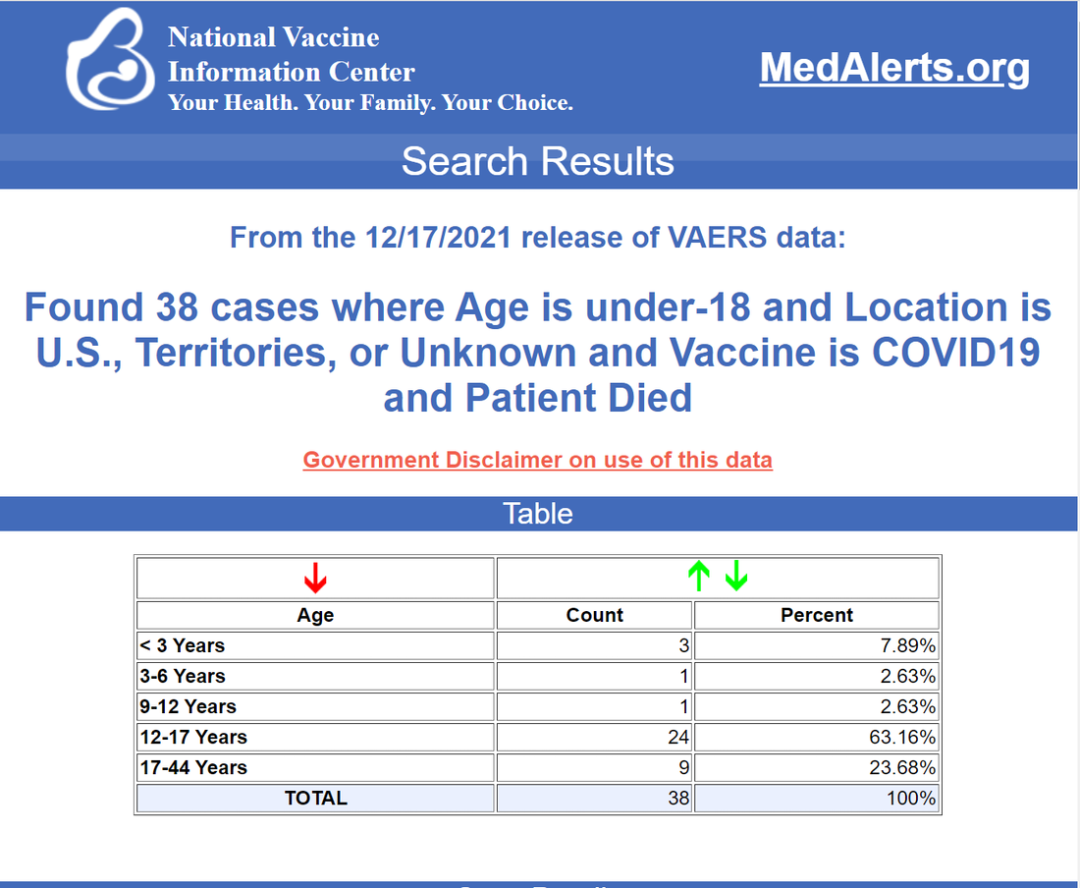
For disabled, there are 3.8 times as many as died. So 143*41=5,863 kids disabled. How does that compare with the number of teens disabled from COVID?
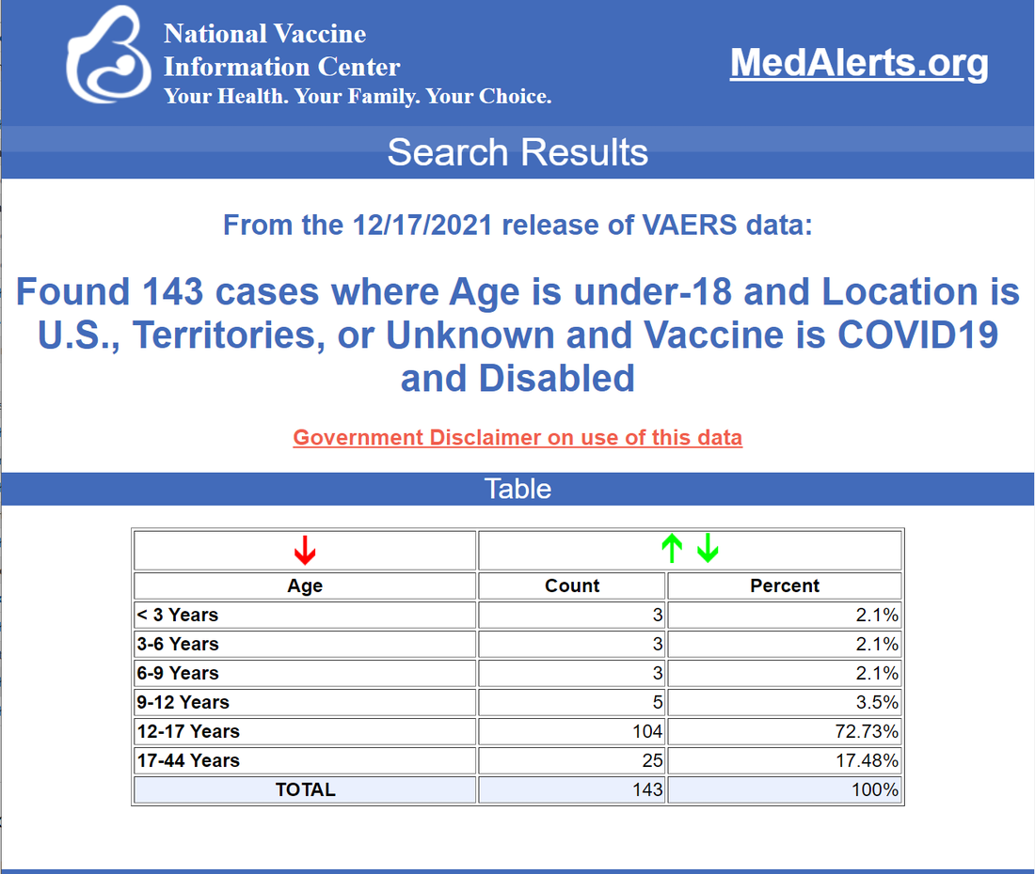

https://stevekirsch.substack.com/p/bhakdiburkhardt-pathology-results

Bhakdi/Burkhardt pathology results show 93% of people who died after being vaccinated were killed by the vaccine

The vaccine was implicated in 93% of the deaths in the patients they examined. What's troubling is the coroner didn't implicate the vaccine in any of those deaths.
Steve Kirsch
Dec 28, 2021

Summary
The vaccines are bad news. Fifteen bodies were examined (all died from 7 days to 6 months after vaccination; ages 28 to 95). The coroner or the public prosecutor didn’t associate the vaccine as the cause of death in any of the cases. However, further examination revealed that the vaccine was implicated in the deaths of 14 of the 15 cases. The most attacked organ was the heart (in all of the people who died), but other organs were attacked as well. The implications are potentially enormous resulting in millions of deaths. The vaccines should be immediately halted.
No need to worry. It is doubtful that anything will happen because the work wasn’t published in a peer-reviewed journal so will be ignored by the scientific community. That’s just the way it works.

The paper
I got an email recently from Mike Yeadon, former VP of Pfizer, who urged me to check out this video. He wrote me this email on 12/24/21:
https://www.bitchute.com/video/fHIT55iM4Zv9/
Steve,
This is about the worst 15min I’ve ever seen.
Mass covid19 vaccination is leading to mass murder.
Mike
The video references this paper, posted on December 10, 2021, On COVID vaccines: why they cannot work, and irrefutable evidence of their causative role in deaths after vaccination by Sucharit Bhakdi, MD and Arne Burkhardt, MD. It has been getting a lot of attention lately.
Check out the number of likes and retweets… just in the first 3 hours!!!!
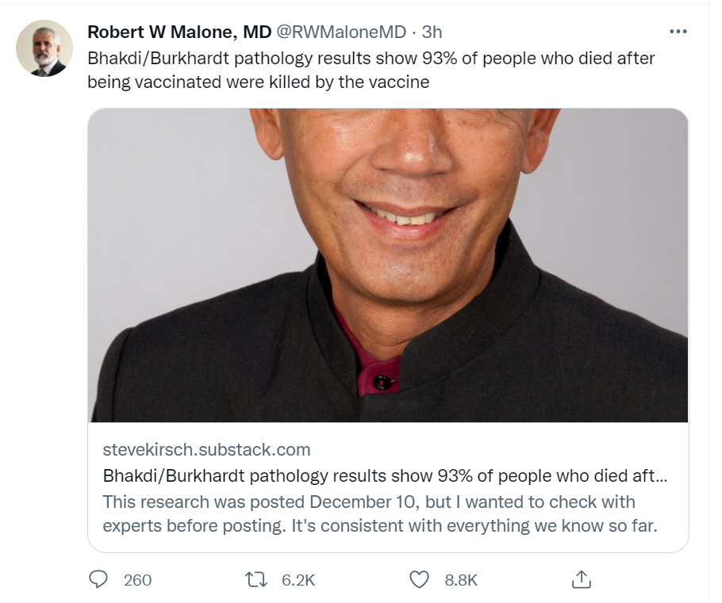
The authors did an autopsy in 15 patients who died (from 7 days to 6 months) after receiving the COVID vaccine. These were all cases where the coroner ruled as NOT being caused by the vaccine.
They discovered that in 14 of the 15 patients there was widespread evidence of the body attacking itself, something that is never seen before. The heart was attacked in all 14 cases.
A number of salient aspects dominated in all affected tissues of all cases:
- inflammatory events in small blood vessels (endotheliitis), characterized by an abundance of T-lymphocytes and sequestered, dead endothelial cells within the vessel lumen;
- the extensive perivascular accumulation of T-lymphocytes;
- a massive lymphocytic infiltration of surrounding non-lymphatic organs or tissue with T-lymphocytes.
Lymphocytic infiltration occasionally occurred in combination with intense lymphocytic activation and follicle formation. Where these were present, they were usually accompanied by tissue destruction.
Here's the video presentation of the results.
VAERS as well as other independent studies (e.g., see this vaccine injury paper) shows the vaccines are killing people and that cardiac events were highly elevated. This study is consistent with those results.
This work independently validates the analysis of Peter Schimacher who showed a minimum of 30% to 40% of the deaths after vaccine were caused by the vaccine.

Reactions from a level-headed scientist (name withheld to protect him from attack)
If the autopsy findings are confirmed by other pathologists with additional samples, and if they are combined with the findings of Dr. Hoffe (>60% inoculant recipients have elevated D-dimer tests and evidence of clotting) and Dr. Cole (increase in cancers after inoculation, including twenty-fold increase in uterine cancer), we are seeing a disaster of unimaginable proportions. The conclusion (if supported by further data) is that essentially EVERY inoculant recipient suffers damage, with more damage after each shot. Given the seriousness of the types of damage (autoimmune diseases, cancer, re-emergent dormant infections, clotting/strokes, cardiac damage, etc.), these effects will translate into lifespan reduction, which should be counted as deaths from the inoculations. So, in the USA, where ~200M people have been fully inoculated, the number of deaths will not be the 10,000 or so reported in VAERS, or the 150,000+ scaled-up deaths from VAERS, but could be closer to tens of millions when the inoculation effects play out!
What the above three findings (Burkhart, Hoffe, Cole, and I suspect many others who have not yet come forward) show is that the post-inoculation effects are not rare events (as reported by the media-gov't), but are in actuality frequent events. They may be, in fact, universal, with the severity and damage different for each recipient.
The question in my mind is whether it is possible to reverse these inoculation-based adverse events. Can the innate immune system be fully restored? Can the micro clotting be reversed? Can the autoimmunity be reversed? I have seen a wide spectrum of opinions on whether this is possible, none of which is overly convincing.
Are we headed for the situation where the ~30% unvaxxed will be devoting their lives to operating whatever is left of the economic infrastructure and serving as caretakers for the vaxxed?
I realize the above sounds extreme, and maybe when more data are gathered from myriad credible sources the results and conclusions may change, but right now the above data seem to synchronize with the demonstrated underlying mechanisms of damage. Additionally, we seem to be doubling down on inoculations, with fourth booster being proposed for Israel, and UK suggesting quarterly boosters.

Dr. Ryan Cole’s reaction
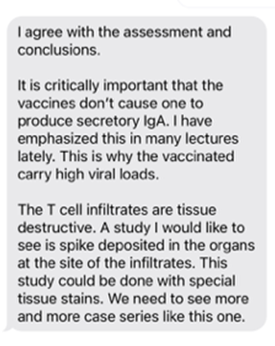

Background of two of the scientists behind the study
Dr. Bhakdi has spent his life practicing, teaching and researching medical microbiology and infectious diseases. He chaired the Institute of Medical Microbiology and Hygiene at the Johannes Gutenberg University of Mainz, Germany, from 1990 until his retirement in 2012. He has published over 300 research articles in the fields of immunology, bacteriology, virology and parasitology, and served from 1990 to 2012 as Editor-in-Chief of Medical Microbiology and Immunology, one of the first scientific journals of this field that was founded by Robert Koch in 1887.
Dr. Arne Burkhardt is a pathologist who has taught at the Universities of Hamburg, Berne and Tübingen. He was invited for visiting professorships/study visits in Japan (Nihon University), the United States (Brookhaven National Institute), Korea, Sweden, Malaysia and Turkey. He headed the Institute of Pathology in Reutlingen for 18 years. Subsequently, he worked as an independent practicing pathologist with consulting contracts with laboratories in the US. Burkhardt has published more than 150 scientific articles in German and international scientific journals as well as contributions to handbooks in German, English and Japanese. Over many years he has audited and certified institutes of pathology in Germany.

https://childrenshealthdefense.org/defender/physicians-scientists-kids-should-not-get-covid-vaccine/

16,000 Physicians and Scientists Agree Kids Shouldn’t Get COVID Vaccine
COVID vaccines are “irreversible and potentially permanently damaging,” says Dr. Robert Malone, who explains why 16,000 physicians and medical scientists around the world signed a declaration publicly declaring healthy children should not be vaccinated for COVID-19.
By
Robert W. Malone, M.D.
Before you vaccinate your child — which is irreversible and potentially permanently damaging — find out why 16,000 physicians and medical scientists around the world signed a declaration publicly declaring that healthy children should NOT be vaccinated for COVID-19.
On behalf of these M.D.s and Ph.D.s, I have published a clear statement outlining the scientific facts behind this decision:
My name is Robert Malone, and I am speaking to you as a parent, grandparent, physician and scientist. I don’t usually read from a prepared speech, but this is so important that I wanted to make sure that I get every single word and scientific fact correct.
I stand by this statement with a career dedicated to vaccine research and development. I’m vaccinated for COVID and I’m generally pro-vaccination.
I have devoted my entire career to developing safe and effective ways to prevent and treat infectious diseases.
After this, I will be posting the text of this statement so you can share it with your friends and family.
Before you inject your child — a decision that is irreversible — I wanted to let you know the scientific facts about this genetic vaccine, which is based on the mRNA vaccine technology I created:
There are three issues parents need to understand:
The first is that a viral gene will be injected into your children’s cells. This gene forces your child’s body to make toxic spike proteins. These proteins often cause permanent damage in children’s critical organs, including:

    - Their brain and nervous system.
    - Their heart and blood vessels, including blood clots.
    - Their reproductive system.
    - This vaccine can trigger fundamental changes to their immune system.
The most alarming point about this is that once these damages have occurred, they are irreparable:
    - You can’t fix the lesions within their brain.
    - You can’t repair heart tissue scarring.
    - You can’t repair a genetically reset immune system.
    - This vaccine can cause reproductive damage that could affect future generations of your family.
The second thing you need to know about is the fact that this novel technology has not been adequately tested.
    - We need at least 5 years of testing/research before we can really understand the risks.
    - Harms and risks from new medicines often become revealed many years later.
Ask yourself if you want your own child to be part of the most radical medical experiment in human history.
One final point: the reason they’re giving you to vaccinate your child is a lie.

    - Your children represent no danger to their parents or grandparents.
    - It’s actually the opposite. Their immunity, after getting COVID, is critical to save your family if not the world from this disease.
In summary: There is no benefit for your children or your family to be vaccinating your children against the small risks of the virus, given the known health risks of the vaccine that as a parent, you and your children may have to live with for the rest of their lives.
The risk/benefit analysis isn’t even close.
As a parent and grandparent, my recommendation to you is to resist and fight to protect your children.
RW Malone, M.D.
Chief Medical and Regulatory Officer, the Unity Project
President, International Alliance of Physicians and Medical Scientists
More on the twisted logic of vaccinating the children to protect the elderly

01/20/22
COVID › NEWS

40% Rise Nationwide in Excess Deaths Among 18- to 49-Year-Olds, CDC Data Show
Death certificate data from the Centers for Disease Control and Prevention show excess deaths increased by more than 40% among Americans 18 to 49 years old during a 12-month period ending in October of 2021, and that COVID caused only about 42% of those deaths.
By
Seth Hancock
Death certificate data from the Centers for Disease Control and Prevention (CDC) show excess deaths increased by more than 40% among Americans 18 to 49 years old during a 12-month period ending in October of 2021, and that COVID caused only about 42% of those deaths.
Excess deaths are defined as the difference between the observed number of deaths during a specific time frame and the expected number of deaths during that same period.
State-level data for the same 12-month period also show increases. For example, in Nevada, excess deaths were as high as 65%, with COVID accounting for only 36%.
The District of Columbia saw an even greater increase than Nevada — 72% — with COVID not being a factor in any of the deaths.
Bottom of Form
Increases in excess deaths were most noticeable in the Midwest and western and southern states, while states seeing the lowest increases were primarily from the Northeast.
On the low side, New Hampshire was the only state to see no increase in excess deaths for the 18 to 49 age group, nor did it record any COVID deaths among that group.
Other states on the high end include:
- Texas: 61% rise, 58% COVID-attributed
- Arizona: 57%, 37%
- Tennessee: 57%, 33%
- California: 55%, 42%
- New Mexico: 52%, 33%
- Florida: 51%, 48%
- Louisiana: 51%, 32%
States reporting a lower number of excess deaths were:
- Delaware: 10% rise, 0% COVID-attributed
- Massachusetts: 13%, 24%
- Maryland: 16%, 42%
- Connecticut: 17%, 23%
- Hawaii: 17%, 45%
- New Jersey: 17%, 58%
According to The Epoch Times, which investigated and reported on the CDC data:
“CDC data on the exact causes of those excess deaths aren’t yet available for 2021, aside from those involving COVID, pneumonia and influenza. There were close to 6,000 excess pneumonia deaths that didn’t involve COVID-19 in the 18-49 age group in the 12 months ending October 2021.
“Influenza was only involved in 50 deaths in this age group, down from 550 in the same period pre-pandemic. The flu death count didn’t exclude those that also involved COVID or pneumonia, the CDC noted.”
The CDC data also show an increase of 27% in excess deaths in the 50 to 84 age group and 12% for those 85 and older.
This data are in line with insurance data from Indiana, revealed last month by Scott Davison, CEO of Indianapolis-based insurance company OneAmerica.
During an online news conference, Davison said there was a 40% rise in the death rate among working-age people 18 to 64 years old in Indiana. He also said COVID was not the leading cause of those deaths.
Davison said he saw the rise in death rates starting in the third quarter of last year, continuing into the fourth quarter. He said it was “the highest … we have seen in the history of this business,” and he added that a “one-in-200-year catastrophe would be a 10% increase over pre-pandemic” excess deaths in that age group.
Some states investigating, while federal health officials remain silent
When The Epoch Times followed up on its initial investigation several states confirmed the data and said they are investigating.
Chris Van Deusen, head of media relations for the Texas Department of State Health Services, emailed The Epoch Times that his department was “looking at the data” and will “get back with you.”
Jeremy Redfern, Florida Department of Health spokesman, responded: “I am looking into it to see if there is some sort of correlation/causation.”
A Nevada official told The Epoch Times the data were submitted “for review.”
An Arizona official responded but would not comment because data were “not yet finalized,” and a DC official said they did not have proper experts to analyze the data.
The Epoch Times sought comment from the federal government, but as of its Jan. 18 reporting, no response has been provided. The newspaper reported:
“The Epoch Times repeatedly inquired with both the White House and the CDC about any steps they’re taking to examine the issue. They have yet to respond.”

What’s behind the rise in excess deaths?
Reports on excess deaths have spawned several theories about what’s driving the increase.
The Epoch Times suggested drug overdoses are at least partly to blame for the increases. Beyond the death certificate data, the newspaper reviewed the CDC’s overdose estimates which showed that during the 12-month period ending in June of 2021, overdose deaths rose from about 72,000 to more than 101,000.
Another theory is that COVID vaccines played a role in the increase, which has support from people on both sides of the vaccine debate.
Indiana’s Davison suggested the unvaccinated were partly to blame, saying the insurance industry was “starting to target and to add premium loads onto employers that are based in counties that have a low vaccination rate.”
Davison acknowledged, however, that the rise in excess deaths in the third and fourth quarters of last year followed well after Indiana’s mass vaccination program began.
According to WFYI, an NPR affiliate in Indianapolis, Davison also said:
“The challenge we have is that 84% of our people are vaccinated, and we have heard loud and clear from our vaccinated employees that they want no part of working in an open office environment with unvaccinated associates. And some of them made it very, very clear that if we try to comingle them with unvaccinated people, they’ll consider the workplace is unsafe.”
Steve Kirsch, executive director of the Vaccine Safety Research Foundation, disagreed, writing:
“So, the insurance companies had a wrong assumption and are blaming the wrong party perhaps because they didn’t have the data to see what was really behind the issue or they didn’t want to challenge the narrative and get in trouble. It could be a combination of the two reasons.”
Dr. Robert Malone argued the vaccine should be considered as the potential cause, adding:
“If this holds true, then the genetic vaccines so aggressively promoted have failed, and the clear federal campaign to prevent early treatment with lifesaving drugs has contributed to a massive, avoidable loss of life.”

https://twitter.com/stkirsch/status/1475655989361668097

Estimated 1 in 95 boys diagnosed with myocarditis in a California private school

This will blow your mind, I promise. I'm pretty sure that the rate of myocarditis is a LOT more than the CDC is telling people. I think the rate is ~100X higher than they claim. What do you think?
 | Steve Kirsch
  Dec 28, 2021
  387 | 418
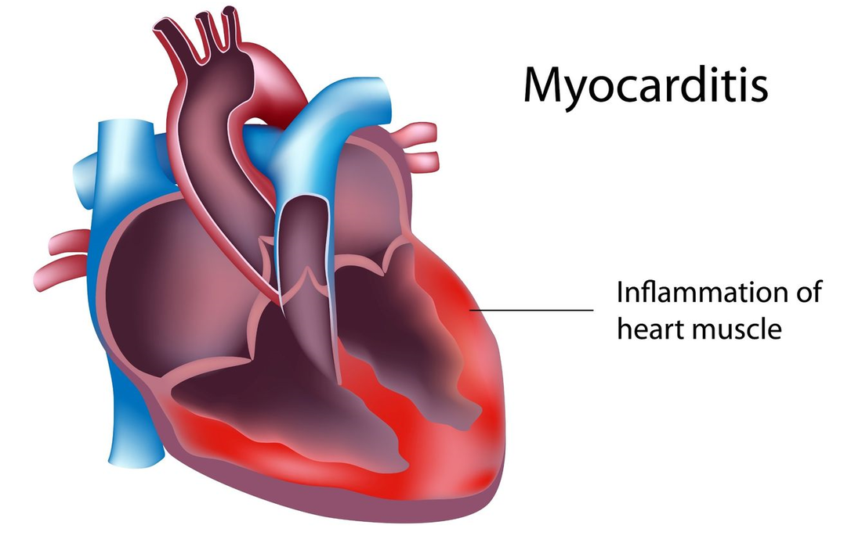
According to this Reuters Fact Check published a few days ago, Dr June Raine, chief executive of Britain’s Medicines and Healthcare products Regulatory Agency (MHRA), said that myocarditis and pericarditis remain a “very rare potential risk” with Pfizer and Moderna vaccines.
Seriously?!? A rare potential risk, eh? Are you kidding me?!?
Look, just because she said that doesn’t mean it is true.
For a long time, I’ve been on the record as saying that the rate of myocarditis is around 1 in 317 for teenage boys. That was a conservative estimate since it used a VAERS under-reporting factor (URF) of 41, which is reserved for only the most serious events.
Since the CDC calls this “mild” (even though every cardiologist I’ve asked says there is no such thing as “mild” myocarditis), we’d expect a URF of perhaps 80 or more since nobody died and most had a short hospital stay.
In short, a more “realistic” estimate is 1 in 150.
I didn’t want to use that in my original slide because 1 in 317 was already far from the CDC estimate of 1 in 13,000 which they said was “rare.” If I was more accurate, my work would be more likely to be ignored as ridiculously high. So I went with a very conservative URF=41. Here’s the slide I’ve been using up until today:
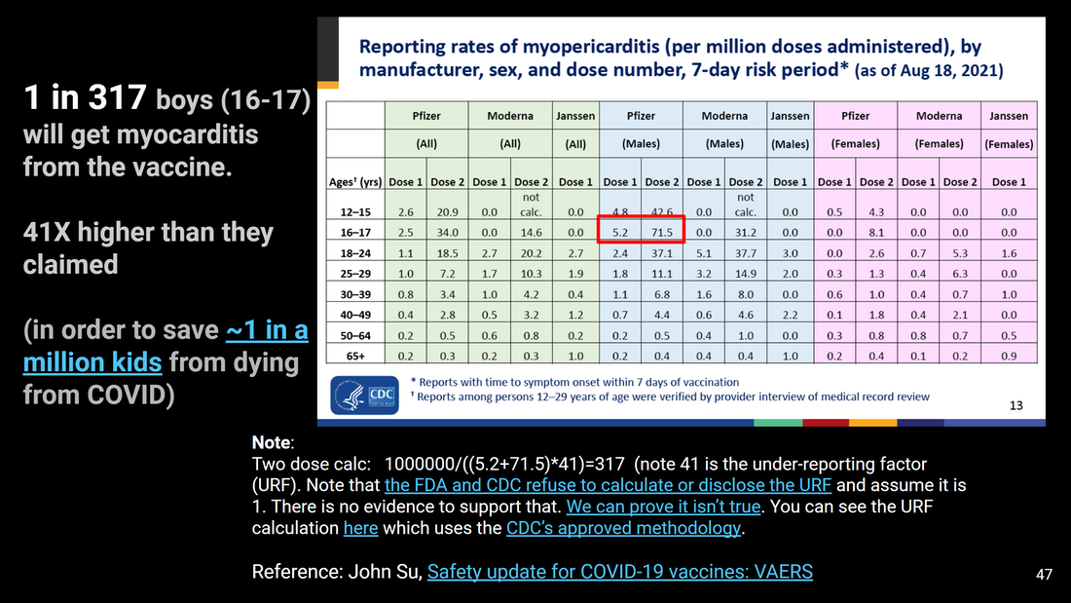

Finally, I heard some data from a private school that validates my estimate
Today, I heard from a parent of a child who attends Monte Vista Christian school that 3 children were diagnosed with myocarditis after they got the vaccine. The school has 855 kids. In autumn, the parent learned that 3 students had myocarditis.
Let’s do a little math.
The ratio of male to female rates of myocarditis is roughly 10:1 so it’s a good bet these were all boys. Roughly half the school are boys. There has never been a vaccine mandate at the school. So I’d estimate conservatively that 2/3 of the kids could have been vaccinated by then. So 855/2*2/3 = 285 vaccinated boys.
So the rate of myocarditis at the school by my estimate is 3/285 which is 1 in 95 boys.
This makes sense to me overall; it is not far from my 1 in 150 estimate.

1 in 95 boys with myocarditis is a train wreck
1 in 95 boys with myocarditis (which is never “mild”) should cause an immediate halt to the vaccines and an examination of how the CDC could possibly miss a safety signal this large.
But I also know what will happen next.
- The CDC will ignore this by writing it off as an unconfirmed anecdote.
- The “fact checkers” will call the school and the school spokesperson will simply say that they don’t comment on confidential health information of students. Otherwise the school would come under attack or people will lose their jobs. I can pretty much guarantee every “fact checker” will never go beyond calling the school, taking their word for it, and then rating this article “pants on fire false.” That’s the way the system works. Keeping information under wraps is essential.
- And of course, nobody outside of the school will be allowed to see the medical records since that is a HPPA violation.
So nobody will know for sure whether I am telling the truth. I know I am. A lot of the parents of course will know I am. But they aren’t going to speak out. I hope that they do, but I doubt it. Nobody wants to get their head chopped off.
The source who disclosed this information to me isn’t going to go public or obtain unassailable proof of this because that would get someone in trouble. I was requested to ensure all the details were scrubbed so that nobody could be identified other than the school.
Nikki Daniels, MVC’s Interim Head of School, responded to my inquiry: “Monte Vista Christian School does not disclose confidential health or diagnostic information regarding students.”
That’s totally understandable in today’s supercharged environment of intimidation where relationships can be damaged permanently when people speak out.
But there are going to be people who see exactly the same thing happening in their schools. And they will be afraid to speak out as well. But at least they will know they are not alone. That’s why I wrote this article, in the hopes that it will motivate someone who is not intimidated to speak out.
So this will be a statistic that we all know about and share amongst ourselves, but cannot talk about because we don’t want to get anyone in trouble.

Our kids will die unnecessarily because people are afraid to speak out
It’s really unfortunate that people are afraid to speak the truth. But this is the society we live in today. This is America where we value relationships over lives. It’s really sad.

Not cherry picking data
My stat isn’t cherry picked. This is the first statistic for a rate in myocarditis in a school that anyone has ever revealed to me. And even then, it was under condition of anonymity of all parties involved. But my source is extremely credible.
Most schools won’t ever say anything as to their stats on myocarditis so nobody will ever find out how dangerous the vaccines are.
Anyone who knows will not say anything or they get their head chopped off.
Someone revealed it to someone else thinking it wouldn’t go anywhere. That cycle repeated until it got to me. This is why I have so few data points to go on.
So I’m not cherry picking. I only had one cherry to pick from.

More confirmation
Here’s another stat I have from a physician in Canada. He doesn’t have a lot of young patients. He has older patients. He’s been in practice for 29 years and has 1,200 patients.
Here’s the amazing thing:
In 29 years, he’s never seen a case of pericarditis. This year, he’s seen 4 cases. So that is a rate of 1 in 300 in older people.
Weird huh?
Kinda like seeing all those athletes drop on the field this year after the vaccines rolled out.
Here are the details:
- All over age 20
- 3 male (oldest 57)
- 1 female (she’s 33, the worst case, was hospitalized and required multiple cardiologists)
- He didn’t see any cases until June, 2021 (i.e., after the vaccine rolled out)
- All of them happened between 1 and 2 weeks of vaccination and they all came in complaining of chest pain
- There were no cases reported in people who were not vaccinated
The authorities will reassure you that this is just a fluke and should be ignored. Whew. That’s a relief. What a great, credible explanation, supported by no evidence.
Next, they will try to find out who revealed this and have her medical license revoked. That’s why she can’t reveal her identity.
I’m glad I’m in such good hands and there are no intimidation techniques being used to silence doctors. I’m sure you feel the same way. These Medical Board are so responsible. And the best thing is that they are self-regulating. Got a complaint? They’ll handle it. It’s called “no accountability.”

Another anecdote
From my heathcare provider substack:
I am a Canadian nurse (for a few more days I will retain that designation) that lost my job over vaccine mandate. Placed on unpaid for 2 months, opted to retire (in my 60's) to at least have some income. It was probably 6-7 months before I'd planned to go. My union is fighting the mandate and there is perhaps a small hope that the several grievances will provide some payout to me in a year or two. I have no confirmations, but saw a couple of dialysis patients pass away having d dimers higher than I have ever seen in my career (10-20 times higher), and with stroke & cardiac symptoms as well. No one ever questioned ☹️. I was the only person in my unit to decline the shot. I'd had issues (up to requiring brain surgery) after my one & only flu shot, and have severe (anaphylactic) allergies. I received my first pension payment December 1 (after requesting early November!). All unvaxxed staff at my employer were fired December 2. (All had been on unpaid leave since mid-September. Canadian federal gov't changed rules in October so that no one who lost a job because of no jab could receive unemployment insurance. They (our feds) are *very* controlling and very petty.

One other thing…the CDC is also lying to us about the rate of vaccine-induced myocarditis compared to COVID induced myocarditis
Not only did the CDC likely get the rate wrong by a factor of 100, but this video, recorded by UCSF Professor Vinay Prasad, shows that the rates of myocarditis from the vaccines are much higher than those from COVID, particularly for the Moderna vaccine.
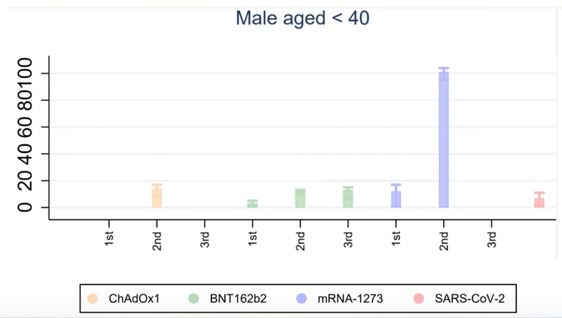
Whoops! The CDC screwed up on that too. All the members of the outside committee that reviews vaccines (ACIP), relied on a false representation by the CDC.

Don’t worry, be happy. The CDC says to shut up and take the vaccine.
OK, they got the myocarditis rate in teenage boys wrong by 100x. Nobody cares.
And they got it wrong about vaccine safety. The vaccines are way more deadly than COVID with respect to myocarditis. Nobody will pick up on that either. Too much cognitive dissonance to accept that.
But hey, we live in a world where facts like this simply do not matter. The attitude is “we don’t care how many kids we kill, just shut up and take the vaccine.”

Other independent data confirms that the COVID vaccines are a cardiovascular disaster of epic proportions
There are many other data points indicating the vaccines are super dangerous from a cardiac perspective. Here are three of them.
- VAERS statistics for these vaccines are off-the-charts for cardiac events, some elevated nearly 10,000X normal, yet the CDC doesn’t find a signal. If you want objective proof of corruption, you can’t beat this
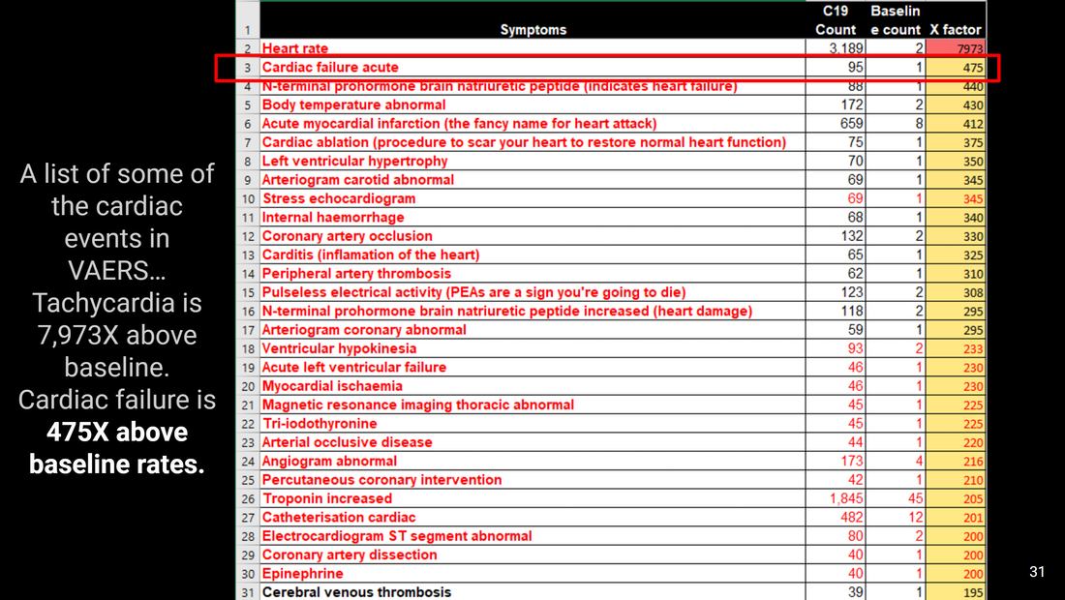
- Cardiac arrest in a 3-year-old just one day after vaccination is the new normal
- Heathcare workers are so pissed, they are breaking ranks and speaking out citing ‘Overwhelming’ Numbers of Heart Attacks, Clotting, Strokes.

https://dailyexpose.uk/2022/01/18/gov-data-suggests-covid-vaccines-killed-more-kids-than-covid/

Official Government data suggests the Covid-19 Vaccines have killed more Children than Covid-19
By The Exposé on January 18, 2022 • ( 8 Comments )

A huge amount of available official data suggests that the Covid-19 vaccines are responsible for causing more deaths among children than the alleged Covid-19 virus the injections are supposed to protect the recipient against.
The video below features Collette Martin, a practicing nurse who testified before a Louisiana Health and Welfare Committee hearing December 6, 2021. Martin claims she and her colleagues have witnessed “terrifying” reactions to the COVID shots among children — including blood clots, heart attacks, encephalopathy and arrhythmias — yet their concerns are simply dismissed.
By Dr Joseph Mercola
Among elderly patients, she’s noticed an uptick in falls and acute onset of confusion “without any known ideology.” Coworkers are also experiencing side effects, such as vision and cardiovascular problems.
Martin points out that few doctors or nurses are aware the U.S. Vaccine Adverse Events Reporting System (VAERS) even exists, so injury reports are not being filed. Hospitals also are not gathering data on COVID jab injuries in any other ways, so there’s no data to investigate even if you wanted to. According to Martin:
“We are not just seeing severe acute [short term] reactions with this vaccine, but we have zero idea what any long-term reactions are. Cancers, autoimmune [disorders], infertility. We just don’t know.
We are potentially sacrificing our children for fear of MAYBE dying, getting sick of a virus — a virus with a 99% survival rate. As of now, we have more children that died from the COVID vaccine than COVID itself.
And then, for the Health Department to come out and say the new variant [Omicron] has all the side effects of the vaccine reactions we’re currently seeing — it’s maddening, and I don’t understand why more people don’t see it. I think they do, but they fear speaking out and, even worse, being fired … Which side of history will you be on? I have to know that this madness will stop.”
Martin also states she believes the hospital treatment protocol is killing COVID patients. Doctors agree that it’s “not working,” but that “it’s all we have.” But “that’s simply not true,” she says. “It’s just what the CDC will allow us to give.”

What the VAERS data tell us about COVID jab risks
I recently interviewed Jessica Rose, Ph.D., a research fellow at the Institute for Pure and Applied Knowledge in Israel, about what the VAERS data tell us about the COVID jabs’ risks. As noted by Rose, the average number of adverse event reports following vaccination for the past 10 years has been about 39,000 annually, with an average of 155 deaths. That’s for all available vaccines combined.
The COVID jabs alone now account for 983,756 adverse event reports as of December 17, 2021, including 20,622 deaths — and this doesn’t include the underreporting factor, which we know is significant and likely ranges from five to 40 times higher than reported. Most doctors and nurses don’t even know what VAERS is and even if they do, they chose not to report the incidents.
You can’t even compare the COVID shots to other vaccines. They’re by far the most dangerous injections ever created, yet there doesn’t appear to be a cutoff for acceptable harm. No one within the CDC or Food and Drug Administration, which jointly run VAERS, has addressed these shocking numbers. Both agencies outrageously deny that a single death can be attributed to the COVID jabs, which is simply impossible. It’s not statistically plausible.
The FDA and CDC are also ignoring standard data analyses that can shed light on causation. It’s known as the Bradford Hill criteria — a set of 10 criteria that need to be satisfied in order to show strong evidence of causal relationship. One of the most important of these criteria is temporality, because one thing has to come before the other, and the shorter the duration between two events, the higher the likelihood of a causative effect.
Well, in the case of the COVID jabs, 50% of the deaths occur within 48 hours of injection. It’s simply not conceivable that 10,000 people died two days after their shot from something other than the shot. It cannot all be coincidence. Especially since so many of them are younger, with no underlying lethal conditions that threaten to take them out on any given day. A full 80% have died within one week of their jab, which is still incredibly close in terms of temporality.

Children risk permanent heart damage
Aside from the immediate risk of death, children are also at risk for potentially lifelong health problems from the jab. Myocarditis (heart inflammation) has emerged as one of the most common problems, especially among boys and young men.
In early September 2021, Tracy Beth Hoeg and colleagues posted an analysis of VAERS data on the preprint server medRxiv, showing that more than 86% of the children aged 12 to 17 who report symptoms of myocarditis were severe enough to require hospitalization.
Cases of myocarditis explode after the second shot, Hoeg found, and disproportionally affect boys. A full 90% of post-jab myocarditis reports are males, and 85% of reports occurred after the second dose. According to Hoeg et. al.:
“The estimated incidence of CAEs [cardiac adverse events] among boys aged 12-15 years following the second dose was 162 per million; the incidence among boys aged 16-17 years was 94 per million. The estimated incidence of CAEs among girls was 13 per million in both age groups.”
No doubt, doctors are seeing an increase in myocarditis, but few are willing to talk about it. In a recent Substack post, Steve Kirsch writes:
“I just read a comment on my private ‘healthcare providers only’ substack. An estimated 100X elevation in rate of myocarditis, but nobody will learn of it since cardiologists aren’t going to speak out for fear of retribution.
His comment was a private conversation he had with a pediatric cardiologist. The cardiologist is never going to say this in public, to the press, or have his name revealed since his first duty is to his family (keeping his job).
If a ‘fact checker’ called the cardiologist, he might either refuse to comment or say ‘I’m seeing somewhat more cases after the vaccine rolled out.’ Here’s the exact comment that was posted to the private substack:
‘Pre-jab, one or two cases per year of myocarditis. Now, half his waiting room. Tells parents they are ‘studying’ the causality. Refers them to infectious disease specialist for discussions on their other children.
Admits he and about 50% of his colleagues know what’s going on but are too terrified to speak out for fear of retaliation from hospitals and state licensing boards.
Other 50% don’t want to know, don’t care and/or are reveling in the cognitive dissonance (like Dr. Harvey [Cohen] at Stanford) and/or letting loose their authoritarian demon. Good luck with these former colleagues of mine. The stench is overpowering.’
… From 1 or 2 cases per year to ‘half his waiting room.’ I don’t know the size of his waiting room, but it’s at least two people since he said ‘half.’ So, the rate has increased by: 250 day per year open/1.5 avg cases per year=166X.”

Myocarditis is not a mild, inconsequential side effect
Together with Dr. Peter McCullough, in October 2021 Rose also submitted a paper on myocarditis cases in VAERS following the COVID jabs to the journal Current Problems in Cardiology. Everything was set for publication when, suddenly, the journal changed its mind and took it down.
You can still find the pre-proof on Rose’s website, though. The data clearly show that myocarditis is inversely correlated to age, so the risk gets higher the younger you are. The risk is also dose-dependent, with boys having a sixfold greater risk of myocarditis following the second dose.
While our health authorities are shrugging off this risk saying cases are “mild,” that’s a frightening lie. The damage to the heart is typically permanent, and the three- to five-year survival rate for myocarditis has historically ranged from 56% to 83%.
Patients with acute fulminant myocarditis (characterized by severe left ventricular systolic dysfunction requiring drug therapy or mechanical circulatory support) who survive the acute stage have a survival rate of 93% at 11 years, whereas those with acute nonfulminant myocarditis (left ventricular systolic dysfunction, but otherwise hemodynamically stable) have a survival rate of just 45% at 11 years.
This could mean that anywhere from 7% to 55% of the teens injured by these shots today might not survive into their late 20s or early 30s. Some might not even make it into their early 20s! How is this possibly an acceptable tradeoff for a virus you have practically zero risk of dying from as a child or adolescent?

Excess deaths are exploding, including among teens
Throughout the pandemic, the COVID jab was held out as the way back to normalcy. Yet, despite mass injections and boosters, excess deaths keep rising. For example, in the week ending November 12, 2021, the U.K. reported 2,047 more deaths than occurred during the same period between 2015 and 2019.
COVID-19 cannot be entirely to blame, as it was listed on the death certificates for only 1,197 people. Even more telling is the fact that, since July 2021, non-COVID deaths in the U.K. have been higher than the weekly average in the five years prior to the pandemic. Heart disease and strokes appear to be behind many of the excess deaths, and both are known side effects of the COVID jab.
In a November 28, 2021, Twitter post, Silicon Valley software engineer Ben M. (@USMortality) revealed that in the preceding 13 weeks, about 107,700 seniors died above the normal rate, despite a 98.7% vaccination rate. In another example, he used data from the CDC and census.gov to show excess deaths rising in Vermont even as the majority of adults have been injected.
“Vermont had 71% of their entire population vaccinated by June 1, 2021,” he tweeted. “That’s 83% of their adult population, yet they are seeing the most excess deaths now since the pandemic!”
Even more disturbing, British data show deaths among teenagers have spiked since that age group became eligible for the COVID shots. Between the week ending June 26 and the week ending September 18, 2020, 148 deaths were reported among 15- to 19-year-olds. Between the week ending June 25, 2021, and the week ending September 17, 2021, 217 deaths occurred in that age group. That’s an increase of 47%!
Deaths from COVID-19 also went up among 15- to 19-year-olds after the shots were rolled out for this age group. An investigation of Office for National Statistics data has revealed that since the Covid-19 vaccine began to be rolled-out to teenagers there has been a 53% rise in the number of deaths due to all-causes among males aged 15-19, and each spike in deaths correlates perfectly with a spike in administration of the first, second, and third doses of the Covid-19 injection to this age group.
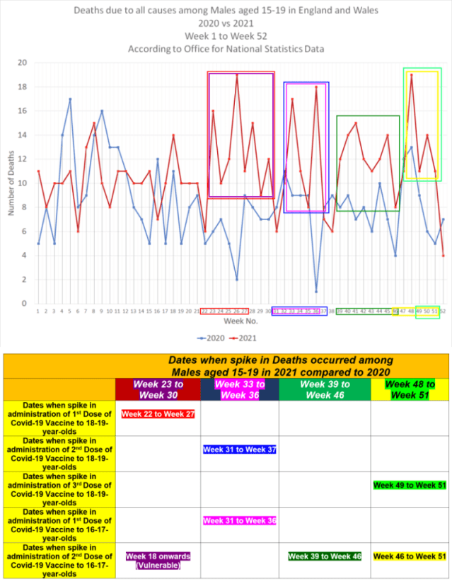Source - https://dailyexpose.uk/2022/01/16/male-teen-deaths-53-percent-higher-after-covid-vaccination-in-2021/
Significant concerns have been raised about the possibility that COVID-19 vaccines could worsen COVID-19 disease via antibody-dependent enhancement (ADE). Is that what’s going on here? As reported by The Exposé, which conducted the investigation:
“Correlation does not equal causation, but it is extremely concerning to see that deaths have increased by 47% among teens over the age of 15, and COVID-19 deaths have also increased among this age group since they started receiving the COVID-19 vaccine, and it is perhaps one coincidence too far.”

Omicron poses no risk to young people
As noted in a recent analysis by Dr. Robert Malone, (who recently got banned from Twitter but can be found on Substack), the risk-benefit ratio of the COVID shot is becoming even more inverted with the emergence of Omicron, as this variant produces far milder illness than previous variants, putting children at even lower risk of hospitalization or death from infection than they were before, and their risk was already negligible.
Malone is currently spearheading the second Physicians Declaration by the International Alliance of Physicians and Medical Scientists, which has been signed by more than 16,000 doctors and scientists, stating that “healthy children shall not be subjected to forced vaccination” as their clinical risk from SARS-CoV-2 infection is negligible and long term safety of the shots cannot be determined prior to such policies being enacted.
Not only are children at high risk for severe adverse events from the shots, but having healthy, unvaccinated children in the population is crucial to achieving herd immunity.

Shots double risk of acute coronary syndrome
Researchers have also found Pfizer and Moderna mRNA COVID-19 shots dramatically increase biomarkers associated with thrombosis, cardiomyopathy and other vascular events following injection.
People who had received two doses of the mRNA jab more than doubled their five-year risk of acute coronary syndrome (ACS), the researchers found, driving it from an average of 11% to 25%. ACS is an umbrella term that includes not only heart attacks, but also a range of other conditions involving abruptly reduced blood flow to your heart. In a November 21, 2021, tweet, cardiologist Dr. Aseem Malhotra wrote:
“Extraordinary, disturbing, upsetting. We now have evidence of a plausible biological mechanism of how mRNA vaccine may be contributing to increased cardiac events. The abstract is published in the highest impact cardiology journal so we must take these findings very seriously.”

AMA is a-OK with sacrificing children
Tragically, it’s not only the CDC and FDA that have been captured by the drug industry and who are sacrificing public health, including the health of our children, in order to further the technocratic Great Reset agenda.
Even the American Medical Association, which is supposed to lobby for physicians and medical students in the U.S. and promote medicine for the betterment of public health, has abandoned all semblance of ethics, transparency and honesty.
In a mid-November 2021 article on the AMA’s website, “COVID-19 Vaccine for Kids: How We Know It’s Safe,” contributing news writer Tanya Albert Henry cites data straight from Pfizer’s press release, and then goes on to claim we “know it’s safe” because “younger children see the same side effects as has been seen in adults and teens.” Based on the VAERS data, that should send shivers down parents’ backs.
“The American Academy of Pediatrics is on board with vaccinating this age group, along with the American Academy of Family Physicians and the Pediatrics Infectious Diseases Society, said Dr. Fryhofer, chair-elect the AMA Board of Trustees,” Henry writes.
“Dr. Fryhofer … noted that myocarditis has been a rare occurrence after the second dose of the mRNA vaccines. ‘The observed risk is highest in young males age 12 to 29, but COVID infection can also cause myocarditis,’ she pointed out. ‘For adolescents and young adults, the risk of myocarditis caused by COVID infection is much higher than after mRNA vaccination.’”
Really? Where did Fryhofer get that idea? I’ve not seen any data to back that up, and Henry doesn’t provide any.

What do the VAERS data show?
Research published in 2017 calculated the background rate of myocarditis in children and youth, showing it occurs at a rate of four cases per million per year. According to the U.S. Census Bureau, as of 2020 there were 73.1 million people under the age of 18 in the U.S. That means the background rate for myocarditis in adolescents (18 and younger) would be about 292 cases per year.
As of December 17, 2021, looking only at U.S. reports and excluding the international ones, VAERS had received:
308 cases of myocarditis among 18-year-olds | 252 cases among 17-year-olds
226 cases in 16-year-olds | 256 cases in 15-year-olds
193 in 14-year-olds | 132 in 13-year-olds
108 in 12-year-olds
In total, that’s 1,475 cases of myocarditis in teens aged 18 and younger — five times the background rate. And again, this does not take into account the underreporting rate, which has been calculated to be anywhere from five to 40.
Meanwhile, the CDC claims that, between March 2020 and January 2021, “the risk for myocarditis was 0.146% among patients diagnosed with COVID-19,” compared to a background rate of 0.009% among patients who did not have a diagnosis of COVID-19.
After adjusting for “patient and hospital characteristics,” COVID-19 patients between the ages of 16 and 39 were on average seven times more likely to develop myocarditis than those without COVID.
That said, the CDC stressed that “Overall, myocarditis was uncommon” among all patients, COVID or not. What’s more, only 23.7% of myocarditis patients between the ages of 16 and 24 had a history of COVID-19, so a majority of the cases in that age group were not due to COVID.
We’re also not talking about big numbers in terms of actual COVID infections. The weekly adolescent hospitalization rate peaked at 2.1 per 100,000 in early January 2021, declined to 0.6 per 100,000 in mid-March, and rose to 1.3 per 100,000 in April.
Using that peak hospitalization rate of 2.1 per 100,000 (or 21 per million) in this age group, and assuming the risk for myocarditis is 0.146% among COVID-positive patients, we get a myocarditis-from-COVID rate among adolescents of 0.03 per million. That’s a far cry from the normal background rate of four cases per million, so the risk of getting myocarditis from SARS-CoV-2 infection is probably quite small.
Now, assuming the COVID hospitalization rate for adolescents is 21 per million, and we have 73.1 million adolescents, we could expect there to be 1,535 hospitalizations for COVID in this age group in a year. If 0.146% of those 1,535 teens develop myocarditis, we could expect 2.2 cases of myocarditis to occur in this age group each year, among those who come down with COVID.
In summary, based on CDC statistics, we could expect just over two teens to contract myocarditis from COVID-19 infection. Meanwhile, we have 1,475 cases reported following the COVID jab in just six months (shots for 12- to 17-year-olds were authorized July 30, 2021).
Taking into account underreporting, the real number could be anywhere between 7,375 and 59,000 — again, in just six months! To estimate an annual rate, we’d have to double it, giving us anywhere from 14,750 to 118,000 cases of myocarditis. So, is it actually true that “For adolescents and young adults, the risk of myocarditis caused by COVID infection is much higher than after mRNA vaccination”? I doubt it.

https://healthimpactnews.com/covid-19-injection-casualties-list/

Government VAERS Data Reveal 15,600% Increase in Heart Disease Among Under 30 Year-Olds Following COVID-19 Vaccination (USA)
January 28, 2022

by Brian Shilhavy
Editor, Health Impact News
The U.S. Government’s Vaccine Adverse Events Reporting System (VAERS) released more data into the database maintained by the CDC and FDA today, and there are now 1,071,856 reports of deaths and injuries following COVID-19 “vaccines.” (Source.)
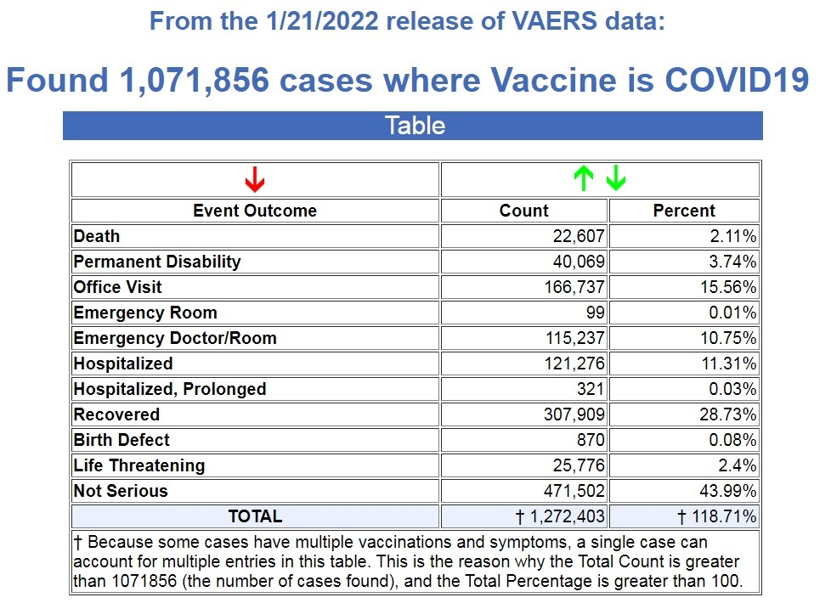
By way of contrast, prior to December of 2020 when the COVID-19 vaccines were issued emergency use authorization (EUA), there were a total of 915,813 reports of deaths and injuries following all FDA-approved vaccines for the previous 31 years. (Source.)
- 29,542 deaths and injuries per year following all FDA-approved vaccines
- 989,405 deaths and injuries per year following EUA COVID-19 vaccines
Therefore, following the first complete year of injecting the population with experimental COVID-19 injections that were given emergency use authorization, deaths and injuries have increased 3,250% compared to deaths and injuries reported following all FDA-approved vaccines for the previous 31 years.

CDC Admits Under 30 Year-Olds are Developing Heart Disease Following COVID-19 Vaccines
The CDC admits that as of January 20, 2022:
VAERS has received 2,132 preliminary reports of myocarditis or pericarditis among people ages 30 years and younger who received COVID-19 vaccines. (Source.)

The CDC calls this number “rare.” They have to say this, because they are funded and controlled by the pharmaceutical companies, and represent their interests, and not the interests of public health.
However, if we search VAERS for ALL types of myocarditis and pericarditis, instead of cherry picking only two types of “carditis,” and include all forms of “carditis” for heart disease, the number almost doubles to 3,912 cases. (Source.)
Using the exact same search for all cases of “carditis,” we find that prior to December, 2020, when the EUAs were issued to the experimental COVID-19 shots, there were a total of 725 cases of heart disease following all FDA-approved vaccines for the previous 31 years for young people under the age of 30. (Source.)
- 23 cases of heart disease per year for those under 30 following all FDA-approved vaccines
- 3611 cases of heart disease per year for those under 30 following EUA COVID-19 vaccines
That is a 15,600% increase of heart disease following COVID-19 EUA vaccines compared to FDA-approved vaccines for the previous 31 years. (Note: We now have 13 months of data on COVID-19 vaccines, so we divided the total number by 13 and then multiplied that number by 12 to derive the yearly number for the COVID-19 vaccine injury and deaths.)
Here are a few faces and stories of the victims to attach to these cold statistics that we have added to our continually-expanding list.

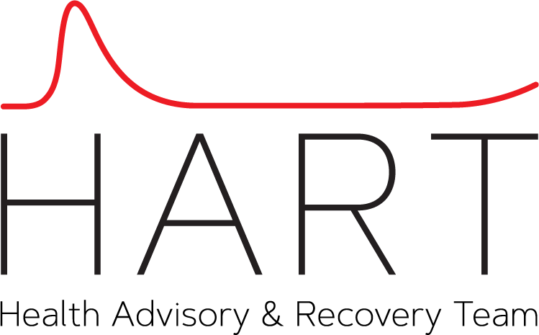

https://www.hartgroup.org/open-letter-to-the-mhra-regarding-child-death-data/

Open Letter to the MHRA Regarding Child Death Data
January 20, 2022
Signals that Covid-19 Vaccines may have caused death in children and young adults

Dated 19 January 2022
To:
- Dr June Raine, Chief Executive, MHRA
- Professor Lim, Chairman, JCVI COVID-19 subcommittee
- Hon Sajid Javid, Secretary of State for Health and Social Care
- Professor Sir Chris Whitty, Chief Medical Officer for England
- Sir Patrick Vallance, Government Chief Scientific Adviser
- Dr Jenny Harries OBE, Chief Executive, UKHSA
Dear Dr Raine, Professor Lim, Mr Javid, Professor Whitty, Sir Patrick Vallance & Dr Harries,

URGENT

RE: Signals that Covid-19 Vaccines may have caused death in children and young adults
We write to demand an immediate, urgent investigation to determine whether the Covid-19 vaccines are the cause of significant numbers of deaths seen recently in male children and young adults.
We also request that anonymised data and information known to be available, showing how many children have died following a Covid-19 vaccine and within how many days, be published for full transparency, in the public interest.
On Thursday 13th January 2022, at a hearing in the High Court[1] in London, evidence was presented showing a significant increase in the number of young male deaths following roll out of the Covid-19 vaccinations compared with the prior five-year average between 2015 and 2019. It is important to look at male deaths separately, given what is known about higher risks from myocarditis in young males.
Between 1st May to 24th December 2021 there were
- 402 registered deaths in 15–19-year-old males, 65 more than the 337 five-year average;
- by contrast, 163 registered deaths in females, 12 less than the 175 five-year average; and
- combining those, 565 deaths of males and females registered in total, 53 more than expected.
The Office for National Statistics has accepted that the increase in young male deaths is a statistically significant increase, with the mortality rate falling outside the expected confidence intervals from earlier years’ data.
Even more concerning is the fact that the actual number of deaths occurring of young males in this period is likely to be significantly higher than those registered. This is because the ONS estimates that owing to delays in registration, on average registered deaths in the period account for only 62% of actual deaths occurring. Any death where there was uncertainty about the cause will have been referred to the coroner and such deaths can take a long time to be registered. The fact that a signal is already evident in registered deaths is therefore a great concern.
Allowing for the ONS estimate, the 65 excess male deaths could represent 105 excess deaths of these young men, assuming the proportion of deaths that have been referred to the coroner is similar to previous years. If there have been more coroner’s referrals this year, the figure could be higher.
Since at least 13 October 2021, the Secretary of State and JCVI have been made aware of this increase in male deaths through their representation by the Government Legal Department in High Court proceedings. In addition, the ONS has itself now recognised that more work could be undertaken to examine the mortality rates of young people in 2021 and has confirmed in writing that it intends to undertake that work “when more reliable data are available.”

There are already signals of risk
The incidence of higher mortality in young males in 2021 coinciding with the roll out of Covid-19 vaccines cannot be dismissed as coincidental, since there have already been warning signals of serious adverse events in this age group. For this reason, the decision to offer the Covid-19 vaccine to under 18-year-olds has not been without controversy.
The JCVI previously declined to recommend that the Covid-19 vaccines be administered to healthy 12-15 year olds as the balance of benefit to risk was only marginal at best in the face of the very low risk to children of serious illness or death from Covid-19 disease, the considerable uncertainty of the potential harms of the Covid-19 vaccines, the known signals of harms from the vaccines already identified and the absence of complete and long term safety data in circumstances where the vaccines have been rapidly brought to market, long before the normal phase III clinical trials used to assess safety have been completed. On 3 September 2021 the JCVI said:
“Overall, the committee is of the opinion that the benefits from vaccination are marginally greater than the potential known harms (tables 1 to 4) but acknowledges that there is considerable uncertainty regarding the magnitude of the potential harms. The margin of benefit, based primarily on a health perspective, is considered too small to support advice on a universal programme of vaccination of otherwise healthy 12 to 15-year-old children at this time. As longer-term data on potential adverse reactions accrue, greater certainty may allow for a reconsideration of the benefits and harms. Such data may not be available for several months.”
The JCVI’s decision was overturned by the four chief medical officers of England, Wales, Scotland and Northern Ireland, not because they found there was a health benefit to children in respect of the Covid-19 vaccines but because, based on modelling analyses, they concluded that the Covid-19 vaccines were likely to reduce school absences. Notwithstanding that theoretically preventing a few days of absence for mild, cold-like symptoms could never reasonably be regarded as justification for administering vaccines with unknown long-term effects, this was the justification given for the vaccination of school-age children. Since then, data must have been obtainable and should have been collected and reviewed to determine whether vaccinations have in fact reduced school absences, and the extent to which absences have occurred by reason of (a) administration of the vaccination program and (b) adverse reactions to the vaccines.
In addition, on 4 August 2021 the JCVI initially recommended only one dose to healthy 16–17-year-olds, recognising that there was an enhanced risk in young males of myocarditis from the Covid-19 vaccines, especially following a second dose, as identified by the FDA in the U.S. and from data emerging in Israel. It is notable that when, in November 2021, the JCVI advised that 16–17-year-olds should be administered a second dose, it did so without including any express statement that it considered the benefits of the Covid-19 vaccine outweighed the risks in that age group. Instead, it recognised that information on the longer-term risks (months to years) of myocarditis was unclear and would only become available with the passage of time.
The risk:benefit concerning roll out of vaccines to under 18s had been said by the Secretary of State and those advising him to be finely balanced. Several months have passed and data as to registered deaths and school absences, together with the reduced risk from Omicron, must give cause to consider whether that fine balance must have tipped away from recommending vaccination in the young.

An investigation must be conducted
In light of the increase in deaths in young males and the known safety concerns, an investigation must be conducted. It is not suggested that the observed increase in mortality proves that the Covid-19 vaccines are causing death, whether via myocarditis or some other mechanism, but a connection cannot be excluded. The potential signal is strong enough that urgent investigations should commence immediately to rule out that possibility. Each recipient of this letter has a duty to investigate. It would be a grave dereliction of duty not to do so.
The JCVI has an ongoing duty to keep its advice under review with the emergence of new data. It has expressly stated on several occasions that more data is either needed or awaited.
The MHRA is tasked with responsibility for vaccine surveillance in real time and has a duty to monitor Covid-19 vaccine data for safety signals. It does this through the Yellow Card reporting system, but its role should not be confined to one passive surveillance system alone. It is accepted by the Commission on Human Medicines Expert Working Group, which was established to advise the MHRA on its safety monitoring strategy for Covid-19 vaccines, that passive surveillance relies on someone suspecting or ‘making a connection’ between the medicine or vaccine and an unexplained illness, and then reporting it, and that therefore it is important that other forms of vigilance are included to supplement the Yellow Card scheme.
It is therefore beyond doubt that the MHRA has a duty to investigate incidence of excess mortality in young males within ONS held data, regardless of whether or not Yellow Card reports have been submitted.
The Secretary of State, as the person responsible for the government’s vaccination programme, also has a paramount duty in the public interest to monitor the safety and effectiveness of the Covid-19 vaccines.

The data are available and can be readily examined
These concerns should not be difficult to investigate. The ONS has confirmed (to the Court) that it is able to provide precise anonymised data including the number of days between vaccination and death. No suggestion has been made that there is any difficulty in gathering or analysing the data. If, for example, the data reveal a concentration of deaths happening close in time to the date of vaccination, this may strengthen concerns of a positive causal link (e.g. under the Bradford Hill criteria) and further, more detailed investigations would be merited. Higher incidence of mortality in children after vaccination is a major cause for concern and could indicate a need to pause the vaccination program immediately. If no indication of causal connection is apparent, this may help to reassure the public as to safety of the vaccines.
Although a halt to the Covid-19 vaccination programme in children is what a High Court legal challenge has sought to achieve, so far the courts have taken the view that mass roll out to under 18s has been a political decision for the Secretary of State with which the Judiciary is unable to interfere. That view from the court, dealing with particular legal principles of judicial review, does not in any way hinder the investigation we demand. Indeed, the Honourable Mr Justice Jay remarked during one hearing, at which the Secretary of State was represented, that he expected the JCVI would be “clamouring for the data” relating to the incidence of death after vaccination.

Information has already been requested of and promised by the Secretary of State
This request for information relating to deaths following vaccination is not novel. On several occasions this issue has been raised in the House of Commons. For example, on 25 March 2021, in answer to questions from Mr William Wragg MP and Sir Christopher Chope MP about incidence of deaths within three weeks following Covid-19 vaccination, the then Secretary of State, Matt Hancock, assured Parliament that this was exactly the sort of thing he was looking at and that, if there was any data not published, he would look into publishing it because the government wanted to be completely open and transparent to reassure people that the risks are extremely low.
It is extremely worrisome that the data concerning deaths following Covid-19 vaccination does not appear to have been collected and analysed or, if it has been, a decision has been made not to publish it. Unfortunately, the impression given is not one of transparency, but rather that information is being hidden. The long-term impact on trust in elected representatives and in regulatory bodies that advise them cannot be understated. Neither can the potential significance of the data signals which are apparently emerging.

Our demand and request
In light of the above and in all the circumstances, please would you confirm the following by return:
- That each of you will investigate the increase in mortality over the period 1st May 2021 to 24th December 2021 (and beyond) in young males as recorded by the ONS, to determine the reason for the increase and whether causal connection to the Covid-19 vaccines can reasonably be excluded.
- What steps have been taken so far, if any, to conduct the investigation required and if such an investigation has already commenced please confirm when that investigation started, what is its scope, what stage it has reached and when it is due to be concluded. If no steps have yet been taken, please explain why not.
- That you will now seek to obtain from the ONS, without delay, the following data for all deaths aged 12-19 occurring on or after 1st May 2021 to date:
a. Age (whether in the 12-15 or 16-19 age group)
b. Sex
c. Whether the individual had dose 1 of a Covid-19 vaccine (and whether Moderna or Pfizer)
d. Whether the individual had dose 2 of a Covid-19 vaccine (and whether Moderna or Pfizer)
e. If applicable, the number of days death followed dose 1 (if dose 2 was not administered) or the number of days death followed dose 2 (if administered)
- That the Secretary of State will publish the data obtained or that he will procure that the ONS publishes such data.
- Whether you have concluded, and if so when, that a causative link to the Covid-19 vaccines may be ruled out or considered a negligible possibility, and on what basis.
- What you suggest might be the explanation for the statistically significant increase in deaths in young males in the period 1st May 2021 to 24th December 2021 other than a possible causative link to the Covid-19 vaccines.
- That you will supply the principal sources of evidence relied upon, in respect of any explanation provided, to support and explain why this increase was not also seen in other periods (for example, in 2020, when the pandemic arose and when deaths of young males were less than average).
Notwithstanding that we do not accept that the modelled data on absences could have justified the decision to rollout the vaccines to school-age children, please also confirm by return:
- That each of you will take steps to investigate the data available since decision of 13 September 2021 following the advice of the Chief Medical officers, as to (a) the level of school absences (b) whether the modelled benefit of avoiding school absences has been achieved and (c) the extent to which absence has been caused by each of (i) administration of the vaccination program and (ii) adverse reactions to the vaccination program.
- What steps have been taken so far, if any, to investigate the data relating to school absences since that decision of 13 September 2021 and, if such an investigation has already commenced, please confirm when that investigation started, what is its scope, what stage it has reached and when it is due to be concluded. If no steps have yet been taken, please explain why not.

Publishing of data
We do not see any bar to publishing the data requested. The ONS expressed concerns in court that publication of the data requested could be disclosive, in that it would allow for identification of the individuals concerned when associated with news reports and other information in the public domain. However, we do not understand how this would be even conceptually possible given the generalised nature of the data requested. We also note the regional and daily data published by the ONS in relation to deaths involving Covid-19.
No names, regional data, date of birth or date of death data are requested. With assistance of the ONS, please provide an example so that we and the public may understand why the data asked for could be withheld on grounds that it could be disclosive.

Paramount urgency
Finally, the government’s current message to children remains ‘get vaccinated’. It used to be ‘every life counts’. If likelihood of a causal connection were established between increased incidence of death and the Covid-19 vaccines, that would be a most serious matter. The death of even a single child from a Covid-19 vaccine would be a tragedy. It therefore stands to reason that an investigation is of paramount urgency.
It cannot be ignored that 65 deaths in young males above the normal average deaths equates to 2 deaths per week each week between 1st May and 24th December 2021. Taking account of the estimated 38% unregistered deaths, the actual figure could be at least 3 per week. This, of course, is only for the 15-19 age group. In the same period, there were just 2 deaths registered in the same age group recorded as ‘involving’ Covid.

We look forward to your substantive reply as soon as possible and in any event within 7 days.
This letter has been published openly and we hope it is shared widely along with any response.

Yours sincerely,
Dr Jonathan Engler, MBChB, LlB (hons), DipPharmMed and Dr Clare Craig, BM BCh FRCPath
Co-chairs of HART (Health Advisory & Recovery Team, www.hartgroup.org)

Signatories from HART:
- Professor Richard Ennos, MA, PhD. Honorary Professorial Fellow, University of Edinburgh
- John Collis, RN, Specialist Nurse Practitioner
- Dr Elizabeth Evans, MA, MBBS, DRCOG, retired doctor
- Dr John Flack, BPharm, PhD. Retired Director of Safety Evaluation at Beecham Pharmaceuticals 1980-1989 and Senior Vice-president for Drug Discovery 1990-92 SmithKline Beecham
- Dr Ali Haggett, Mental health community work, 3rd sector, former lecturer in the history of medicine
- Mr Anthony Hinton, MBChB, FRCS, Consultant ENT surgeon, London
- Dr Keith Johnson, BA, D.Phil (Oxon), IP Consultant for Diagnostic Testing
- Dr Rosamond Jones, MD, FRCPCH, retired consultant paediatrician
- Dr Tanya Klymenko, PhD, FHEA, FIBMS, Senior Lecturer in Biomedical Sciences
- Mr Malcolm Loudon, MB ChB, MD, FRCSEd, FRCS (Gen Surg), MIHM, VR. Consultant Surgeon
- Dr Alan Mordue, MBChB, FFPH (ret). Retired Consultant in Public Health Medicine & Epidemiology
- Sue Parker Hall, CTA, MSc (Counselling & Supervision), MBACP, EMDR. Psychotherapist
- Rev Dr William J U Philip MB ChB, MRCP, BD, Senior Minister The Tron Church, Glasgow, formerly physician specialising in cardiology
- Dr Gerry Quinn, PhD, Microbiologist
- Dr Jon Rogers, MB ChB (Bristol), Retired General Practitioner
- Natalie Stephenson, BSc (Hons) Paediatric Audiologist

Further signatories
- Professor Anthony J Brookes, Professor of Genomics & Health Data Science, University of Leicester
- Professor Angus Dalgleish, MD, FRCP, FRACP, FRCPath, FMedSci, Professor of Oncology, St George’s Hospital, London
- Professor John A Fairclough, BM BS, BMed Sci, FRCS, FFSEM(UK), Professor Emeritus, Honorary Consultant Orthopaedic Surgeon
- Professor Martin Neil, BSc PhD, Professor of Computer Science and Statistics
- Professor Keith Willison, PhD, Professor of Chemical Biology, Imperial, London
- Lord Moonie, MBChB, MRCPsych, MFCM, MSc, House of Lords, former parliamentary under-secretary of state 2001-2003, former consultant in Public Health Medicine
- Julie Annakin, RN, Immunisation Specialist Nurse
- Dr Michael Bazlinton, MBCHB MRCGP DCH
- Dr David Bell, MBBS, PhD, FRCP(UK)
- Dr Mark A Bell, MBChB, MRCP(UK), FRCEM, Consultant in Emergency Medicine, UK
- Dr Michael D Bell, MBChB, MRCGP, retired General Practitioner
- Dr Alan Black, MBBS, MSc, DipPharmMed, Retired Pharmaceutical Physician
- Dr David Bramble, MBChB, MRCPsych, MD. Consultant Psychiatrist
- Dr Emma Brierly, MBBS, MRCGP, General Practitioner
- Kim Bull, Foundation Degree in Paramedic Science, Paramedic
- Dr Elizabeth Burton, MB ChB, Retired General Practitioner
- Dr Peter Chan, BM, MRCS, MRCGP, NLP, General Practitioner, Functional Medicine Practitioner, GP Trainer
- Michael Cockayne MSc, PG Dip, SCPHNOH, BA, RN Occupational Health Practitioner
- Mr Ian F Comaish, MA, BM BCh, FRCOphth, FRANZCO, Consultant ophthalmologist
- James Cook, NHS Registered Nurse, Bachelor of Nursing (Hons), Master of Public Health (MPH)
- Dr Zac Cox, BDS, LCPH, Dentist
- Dr David Critchley, BSc, PhD, 32 years in pharmaceutical R&D as a clinical research scientist
- Dr Damien Downing, MBBS, MRSB, private physician
- Mr Christian Duncan, MB BCh, BAO, MPhil, FRCSI, FRCS (Plast), Consultant Plastic Surgeon
- Dr Chris Exley, PhD FRSB, retired professor in Bioinorganic Chemistry
- Dr Charles Forsyth, MBBS, BSEM, Independent Medical Practitioner
- Dr Jenny Goodman, MA, MBChB, Ecological Medicine
- Dr Catherine Hatton, MBChB, General Practitioner
- Dr Renee Hoenderkamp, General Practitioner
- Dr Andrew Isaac, MB BCh, Physician, retired
- Dr Pauline Jones MB BS retired general practitioner
- Dr Charles Lane, Molecular Biologist
- Dr Branko Latinkic, BSc, PhD, Molecular Biologist
- Dr Theresa Lawrie, MBBCh, PhD, Director, Evidence-Based Medicine Consultancy Ltd, Bath
- Dr Jason Lester, MRCP, FRCR, Consultant Clinical Oncologist
- Dr Felicity Lillingstone, IMD DHS PhD ANP, Doctor, Urgent Care, Research Fellow
- Katherine MacGilchrist, BSc (Hons) Pharmacology, MSc Epidemiology, CEO, Systematic Review Director, Epidemica Ltd
- Dr C Geoffrey Maidment, MD, FRCP, retired consultant physician
- Mr Ahmad K Malik, FRCS (Tr & Orth), Dip Med Sport, Consultant Trauma & Orthopaedic Surgeon
- Dr Kulvinder S. Manik MBChB, MRCGP, MA(Cantab), LLM, Gray’s Inn
- Dr Dee Marshall, MBBS, MFHom, Nutritional Medicine
- Dr Julie Maxwell, MBBCh, MRCPCH, Associate Specialist Community Paediatrician
- Dr S McBride, BSc(Hons) Medical Microbiology & Immunobiology, MBBCh BAO, MSc in Clinical Gerontology, MRCP(UK), FRCEM, FRCP(Edinburgh). NHS Emergency Medicine & geriatrics
- Mr Ian McDermott, MBBS, MS, FRCS(Tr&Orth), FFSEM(UK), Consultant Orthopaedic Surgeon
- Dr Niall McCrae RMN, PhD Mental Health Researcher and Officer of the Workers of England Union
- Dr Franziska Meuschel, MD, ND, PhD, LFHom, BSEM, Nutritional, Environmental & Integrated Medicine
- Dr. Scott Mitchell, MBChB, MRCS, Associate Specialist, Emergency Medicine
- Dr David Morris, MBChB, MRCP (UK), General Practitioner
- Dr Greta Mushet, retired Consultant Psychiatrist in Psychotherapy. MBChB, MRCPsych
- Dr Sarah Myhill, MBBS, Dip NM, Retired GP, Independent Naturopathic Physician
- Dr Christina Peers, MBBS, DRCOG, DFSRH, FFSRH, Menopause Specialist
- Anna Phillips, RSCN, BSc Hons, Clinical Lead Trainer Clinical Systems (Paediatric Intensive Care)
- Jessica Righart, BSc MSc, Senior Critical Care Scientist
- Mr Angus Robertson, BSc, MB ChB, FRCSEd (Tr & Orth), Consultant Orthopaedic Surgeon
- Dr Jessica Robinson, BSc(Hons), MBBS, MRCPsych, MFHom, Psychiatrist, Integrative Medicine Doctor
- Mr James Royle, MBChB, FRCS, MMedEd, Colorectal Surgeon
- Dr Rohaan Seth, Bsc (Hons), MBChB (Hons), MRCGP, Retired General Practitioner
- Dr Noel Thomas, MA, MBChB, DObsRCOG, DTM&H, MFHom, Retired Doctor
- Dr Julian Tompkins, MBChB, MRCGP, General Practitioner, GP trainer PCME
- Dr Livia Tossici-Bolt, PhD, NHS Clinical Scientist
- Dr Helen Westwood, MBChB (Hons), MRCGP, DCH, DRCOG, General Practitioner
- Dr Carmen Wheatley, DPhil, Orthomolecular Oncology
- Mr Lasantha Wijesinghe, FRCS, Consultant vascular surgeon
- Dr Ruth Wilde, MB BCh, MRCEM, AFMCP, Integrative & Functional Medicine Doctor
- Dr Stefanie Williams, Dermatologist
- Gordon Wolffe, BDS (Hons), MSc, FDSRCS, Consultant Periodontist (Retired), Director of Master’s Programme in Periodontology (Retired), University of Nijmegen the Netherlands.
- Dr Holly Young, BSc, MBChB, MRCP, Consultant Palliative Care Medicine

[1] In the matter of The Queen (on the application of AB and CD, by their mother and Litigation Friend EF) v The Secretary of State for Health and Social Care and The Joint Committee Vaccination and Immunisation, CO-3001-2021, a non-party application was made for provision by the ONS of disclosure of information as set out in this letter.

https://rairfoundation.com/revealed-uk-statisticians-find-massive-death-spike-during-covid-vaccine-campaigns/

REVEALED: UK Statisticians Find Massive Death Spike During Covid 'Vaccine' Campaigns
Renee Nal
January 22, 2022
2 comments
8 min read
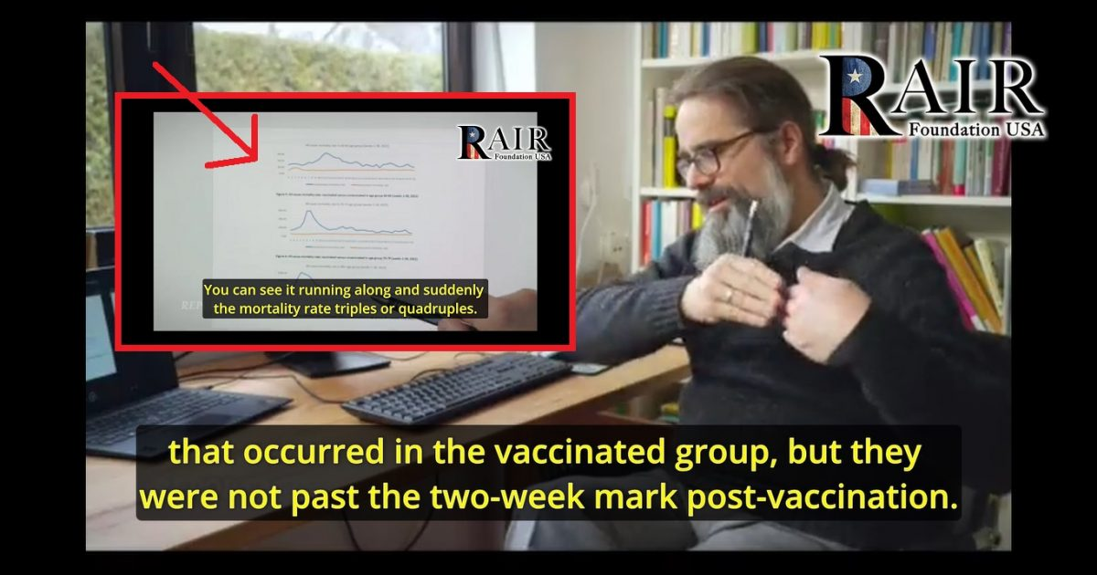
“…death spikes took place during vaccination campaigns, when people were not yet counted as ‘vaccinated’.”
Statististicians based in England were trying to get to the bottom of strange spikes in the death rates of unvaccinated people in certain age groups. They found that the death spikes took place during vaccination campaigns, when people were not yet counted as “vaccinated”.
The exclusively-translated clip presented to RAIR Foundation USA readers is from a larger German broadcast from January 18th. The short clip (less than three minutes) features Prof. Dr. Christof Kuhbandner of Universität Regensburg detailing the findings of the British study.
Kuhbandner explains in the report how the death spike of “unvaccinated” people in certain age groups is evident in the data, which was the subject of interest among the British statisticians:
The curve of the unvaccinated has a very peculiar peak. You can see it running along and suddenly the mortality rate triples or quadruples. It always happens at different times.
Then the English statisticians asked themselves what could be behind this?
See screenshot:

Prof. Dr. Christof Kuhbandner describes the charts:
First, it was mainly the over 80-year-olds that would be vaccinated. In this age group, the death curve reaches its peak at the end of January.
The 70-year-olds were vaccinated on average one month later.
Deaths reach maximum at the end of February. Finally, in March, the 60-year-olds were vaccinated, and in parallel there was a marked increase of deaths among the unvaccinated.
The British statisticians then found that the vaccination campaigns corresponded directly with the death spikes. “They then realized that vaccination campaign was taking place in England at exactly these times,” the Professor explains.
So the question becomes: “Why are the Covid vaccine campaigns affecting the unvaccinated?” It turns out that the “people who have received the first vaccination, but had not passed the two-week mark following the first vaccination — they were listed as unvaccinated.”
Therefore, the professor concludes that the high mortality rate (death spike) was from the so-called “partially” vaccinated population:
The tripling and quadrupling of the death rate actually comes from the deaths that occurred in the vaccinated group, but they were not past the two-week mark post-vaccination.
The findings are reminiscent of a dire warning by German physician and epidemiologist Dr. Wolfgang Wodarg, as exclusively translated at RAIR:
And when they say that people lying in the hospitals are all unvaccinated…you know, the ‘unvaccinated’ are also the people who have had their ‘vaccination’ injection within the last 14 days, and they are not yet counted as vaccinated. But it is precisely in these first 14 days that the acute and severe side effects occur, that is, many people are getting sick here, rendered ill by these injections, and they count as ‘unvaccinated’, which is of course totally wrong, and which is a deliberate blind flight that is being organized epidemiologically there.

https://childrenshealthdefense.org/defender/covid-vaccines-suppress-immune-system/
01/24/22

How COVID Vaccines Suppress the Immune System
In a preprint paper, Stephanie Seneff, Ph.D., described a mechanism of the COVID shots that results in the suppression of the innate immune system, and how that is leading to an increase in cancer cases in people who got the vaccines.
By Dr. Joseph Mercola
Story at-a-glance:
- In a non-peer-reviewed research paper last week, Stephanie Seneff, Ph.D., describes a mechanism of the COVID shots that results in the suppression of your innate immune system. It does this by inhibiting the type-1 interferon pathway.
- The COVID jab can cause neurons in your brain to produce toxic spike protein, or take up circulating spike protein, and the neurons try to eliminate the spike protein by transmitting them through exosomes. The exosomes are picked up by microglia, immune cells in your brain, which activate an inflammatory response, which can contribute to degenerative brain disorders.
- Two microRNAs, miR-148a and miR-590, are central in this process. These microRNAs — excreted in the exosomes along with the spike protein — significantly disrupt the type-1 interferon response in any cell, including immune cells.
- On average, there are twice as many reports of cancer following the COVID shots compared to all other vaccines combined over the last 31 years.
- The fact that the signal is that strong is even more remarkable when you consider that most people don’t think the COVID shot could be a variable in their cancer emergence, so they never report it.
In this interview, return guest Stephanie Seneff, Ph.D., a senior research scientist at MIT who has been at MIT for over five decades, discusses her latest paper, “Innate Immune Suppression by SARS-CoV-2 mRNA Vaccinations. The Role of G-quadruplexes, Exosomes and MicroRNAs,” co-written with Dr. Peter McCullough, along with two other authors, Dr. Greg Nigh and Dr. Anthony Kyriakopoulos.
Previously, Nigh and Seneff co-wrote an entire paper detailing the differences between the spike protein and the COVID jab spike protein.
In a non-peer-reviewed research paper published last week on the preprint service Authorea, they and their other co-authors delve deeply into the mechanisms of the COVID shots, showing how they absolutely, in no way, shape or form, are safe or effective. The shots actually suppress your innate immune system.
“I think McCullough is fantastic and I’m so happy to have him collaborate with me,” Seneff says. “I really hope we will be able to find a journal that is willing to publish it. We may have to seek some kind of alternative media to get it published.
“It’s really incredible the amount of censorship that’s going on right now. I’m in a state of shock all the time. I just keep thinking it’s not going to get any worse, and it’s truly going to get better, and it just seems to keep on getting worse and worse.
“I don’t know where the end is. It’s very discouraging … Pharma has so much money behind [them] and they’ve got it all set up to make sure that nothing gets past them …
“We’re hoping to put it up as a preprint, but … remarkably, they can reject it at the level of preprint as well. We’re working on that angle, but it’s not easy. When you’re writing something this radical, they really fight hard to keep it off the web.”
On Jan. 16, 2022, the pre-print service Authorea published this paper on its website, assigning it a Digital Object Identifier, thus making it official.
Exceptionally strong safety signals
As noted by Seneff, when you look at the various databases for adverse effects, you can see an exceptionally strong safety signal — and the COVID shot developers know that. “The numbers are out of sight,” Seneff says, and this goes for all levels of side effects, from mild to catastrophic.
Seneff has been looking at the cancer data, for example, and on average, there are twice as many reports of cancer following the COVID shots compared to all other vaccines combined over the last 31 years.
“It’s just amazing, because it’s overall two times [higher]. Breast cancer, for example, is three times [higher] for these vaccines in one year, as they are for all the other vaccines for 31 years. It’s a hugely strong signal,” Seneff says.
“Lymphoma is also showing up much more frequently with these [COVID shots]. There’s just an amazing signal there in VAERS [the U.S. Vaccine Adverse Events Reporting System].”
The fact that the signal is that strong is even more remarkable when you consider that most people don’t think the COVID shot could be a variable in their cancer emergence, so they never report it. “It puzzles me that they’re willing to do such damage to the health of the whole population of the world. I don’t understand that degree of evilness,” Seneff says.
Type-1 interferon disruption
The shots suppress your innate immune system by inhibiting type-1 interferon. One of the first studies to tip-off Seneff and McCullough to this was an Indian study, in which human cells grown in a culture were exposed to the DNA nanoparticles that instruct them to make SARS-CoV-2 spike protein, much like the COVID shots do.
The cell strain is called HEK-293. These are cells that were taken from the kidneys of an aborted fetus in the 1980s and are frequently used in research. While taken from the kidneys, these cells have neuron-like properties. When programmed to make spike protein, these cells release that spike protein inside exosomes — lipid nanoparticles inside which the spike protein is packaged.
Exosomes act as a communication network for cells. When a cell is under stress, it releases exosomes containing some of the molecules that are stressing it. So, in the case of the COVID shots, the exosomes contain spike protein and microRNA.
MicroRNAs are signaling molecules that are able to influence cell function. They cause the cell to change its behavior or metabolism. Typically, they do this by suppressing certain enzymes.
The Indian study found two specific microRNAs inside the exosomes released by these neuron-like cells: miR-148a and miR-590. The researchers then exposed microglia (immune cells in your brain) to these exosomes. So, as explained by Seneff, you’ve got neurons in your brain producing spike protein, or taking up spike protein that is in circulation and reacting to it by releasing exosomes.
The exosomes are then picked up by microglia, the immune cells in your brain. When the immune cells receive those exosomes, they turn on an inflammatory response. This is primarily a response to those microRNAs, the miR-148a and miR-590. Of course, you also have the toxic spike protein there.
Combined, they cause inflammation in the brain, which damages neurons. This inflammation, in turn, can contribute to a number of degenerative brain disorders. The lipid particles in the COVID shot, which contain the mRNA, are similar to exosomes, but not identical. They’re also very similar to low-density lipid (LDL) particles.
“I think the exosomes are probably quite a bit smaller. The vaccine particles are bigger. They’re more like an LDL particle. The vaccine particles have cholesterol in their membrane, and they have lipoprotein. So, they’re made to look like an LDL particle.
“But then they throw in this cationic lipid, which is really, really toxic — a synthetic cationic lipid that makes it positively charged. Experimentally, they’ve found that this lipid, when the particle is taken up by the cell, is released into the cytoplasm, [where] that mRNA then makes spike protein.
“[The COVID shots] are very cleverly designed, both in terms of protecting the RNA from getting broken down, and in terms of making the RNA be very efficient at making spike protein. It’s very different from the mRNA that the virus makes, even though it codes for the same protein.”
Seneff wrote an entire paper detailing the differences between the viral spike protein and the COVID jab spike protein, together with Greg Nigh, which was published in the International Journal of Vaccine Theory, Practice and Research in May 2021. It basically serves as a primer for understanding what we discuss here.
Getting back to the Indian paper cited above, they found that the microglia ended up producing inflammation in the brain, and the two microRNAs were central in this process. The miR-148a and miR-590 were put into those exosomes with the spike protein, and these two microRNAs are able to significantly disrupt the type-1 interferon response in any cell, including immune cells.
Type-1 interferon also keeps latent viruses like herpes and varicella (which causes shingles) viruses in check, so if your interferon pathway is suppressed, these latent viruses can also start to emerge. The VAERS database reveals many who have been jabbed do report these kinds of infections. Suppressed interferon also raises your risk of cancer and cardiovascular disease.
Type-1 interferon response is crucial in viral infections
As explained by Seneff, the type-1 interferon response is absolutely crucial as the first-stage response to a viral infection. When a cell is invaded by a virus, it releases type-1 interferon alpha and type-1 interferon beta. They act as signaling molecules that tell the cell that it’s been infected.
That, in turn, launches the immune response and gets it going early in the viral infection. It’s been shown that people who end up with severe SARS-CoV-2 infection have a compromised type-1 interferon response. As noted by Seneff:
“It’s ironic that the vaccines are being given to protect you from COVID, yet, they produce a situation where your immune cells are ill-equipped to fight SARS-CoV-2 if it gets into the cell. The trick is, the vaccine produces a tremendous antibody response, and that’s typical of severe disease.
“So, the [COVID shot] fools your immune system into thinking that you’ve had a severe case of COVID. It’s really interesting that way, because it’s gotten past the mucosal barrier of the lungs, it’s gotten past the vascular barrier of the blood, into the muscle. Also, it’s been disguised.
“The RNA doesn’t look like a virus RNA, it looks like a human RNA molecule. Part of the modifications [made to the mRNA in the jab] was to make it very sturdy, so it can’t be broken down. It’s also very good at making [spike] protein fast, which also has a problem because it leads to a lot of errors, which is another issue …
“The immune cells take up the nanoparticles and carry them through the lymph system into the spleen. Multiple studies have shown that it ends up in the spleen … the ovaries, the liver, the bone marrow … The spleen, of course, is very important for producing antibodies.”
Importantly, the antibody response you get from the COVID shot is exponentially higher than what you get from natural infection, and research has shown that the level of antibody response rises with disease severity.
So, the shot basically mimics severe infection. In mild infection, you may not produce any antibodies at all, because the innate immune cells are strong enough to fight off the infection without them.
It’s when your innate immune system is weak that you get into trouble, and part of that weakness is a suppressed type-1 interferon response. If your type-1 interferon response is deficient, your immune cells are not very capable of stopping the spread of the virus in your body.
According to Seneff, the reason type-1 interferon supplementation has not been recommended thus far is because you have to time it perfectly in order for the immune cascade to function properly. Type-1 interferon plays a definitive role only at the very earliest stage of the infection. Once you’ve entered a moderate or severe infection stage, it’s too late to use it.
COVID shots confuse your immune system
As noted by Seneff, the COVID shots are so unnatural that your immune system doesn’t quite know what to do anymore.
“My impression is that the immune cells don’t know what the hell’s going on. There’s this toxic protein being produced in massive amounts by the immune cells. That’s extremely unusual. There’s no sign of any kind of viral infection because these RNAs look like human RNAs.
“It’s as if the human immune cells suddenly decided to make a really toxic protein, and make lots of it — which is exactly what they’re doing — and the immune system is completely baffled by this. The immune cells have no clue what to do with it.
“Of course, these immune cells that are overloaded with all this spike protein, they say, ‘I’ve got to get rid of this stuff,’ so they ship it out as these exosomes. The microRNAs [in the exosomes] think that the recipient cells are going to need those particular signaling molecules to help it do whatever it needs to do to cope with this toxic load.
“So, you’re spreading the spike protein around to the rest of the body, just to dissipate the toxicity you’re coping with in the spleen, I think. Those exosomes are also very good for training antibodies. There was a nice paper that showed the exosomes being released [have] spike protein in their membrane, the exterior of the exosome.
“It’s quite cool that the spike protein is displayed there, because this allows the immune cells — the B-cells and the T-cells that need to get up close and personal to it — to figure out how to shape their antibodies. The antibodies get shaped to match the toxic protein that’s exposed on the surface of the exosomes.
“After something like 14 days of the second [jab], the exosomes induced an antibody response. [The researchers] felt the exosomes played a critical role in this extreme antibody response that was produced by the B-cells and the T-cells, the adaptive immune system.
“But I think the way the vaccine works is that there’s no game that you can choose other than to make antibodies. It’s the only way you can fight this. It’s a toxic protein that’s being produced and released by these immune cells, and the only thing you can do to stop it is to make antibodies.
“They try to make lots and lots of antibodies that will glue onto those toxic spike proteins and block them from being able to get in through the ACE2 receptor. That’s the job of the antibodies. They do a good job of it, initially … It’s true that they do protect you from disease. Unfortunately, the antibody levels drop pretty dramatically, pretty quickly.”
There are also antibodies that enhance disease rather than fight it, and the level of these antibodies declines at a slower pace than the protective antibodies. So, after a number of months you end up with a NEGATIVE immune response. In other words, you’re now more prone to infection than ever before. As explained by Seneff:
“There’s a crossover point at which the enhancing antibodies can be stronger than the protective antibodies, and that’s when you can get this antibody dependent enhancement (ADE) that people have seen in the past with [other] coronavirus vaccines. We’re still trying to see if that’s the case with [the COVID jabs]. There is some evidence here and there, but it’s not [conclusive yet].”
The importance of cytotoxic t-cells
After the India study tipped off Seneff and McCullough to the interferon problem, they came across a Chinese study that tracked the effect of the COVID jab on the immune system over time. Here, they discovered that the infection caused an increase in CD8+ T-cells, important cytotoxic T-cells that actually remove infected cells.
As noted by Seneff, the CD8+ cells are an important part of the defense against SARS-CoV-2. Importantly, CD8+ T-cells were enhanced in response to natural infection, but not in response to the COVID shot.
They too found type-1 interferon suppression post-jab. So, in the aftermath of the jab, not only is your first-line response depressed — the type-1 interferon response — but you’re also missing the part of the immune response that cleans away infected cells.
The microRNA that influences myocarditis risk
A third microRNA (mRNA) created by natural SARS-CoV-2 infection is miR-155, and it plays an important role in heart health. Early on in the pandemic, there were reports of COVID-19 causing heart problems.
Seneff suspects the miR-155-containing exosomes may also be present post-jab and may play a role in the heart damage that’s being reported. Specifically, miR-155 is associated with myocarditis.
As mentioned earlier, microRNA suppresses certain proteins that then cause a complicated cascade response. When a particular protein that is a critical player gets suppressed by a microRNA, then a whole different cascade takes place.
Why autoimmune problems may arise post-jab
The antibodies produced by the jab also have several short peptide sequences in them that have previously been found in several human cells that are related to autoimmune disease. Seneff explains:
“Kanduc has written a lot about this. She’s an expert on these antibodies … The [SARS-CoV-2] spike protein is very overlapped with human protein. That means when you build a really strong antibody response to the spike protein, those antibodies can get confused and they can attack a human protein that has a similar sequence.
“That’s a classic form of autoimmune disease. It’s called molecular mimicry. There were many different proteins that matched. It was quite surprising … It seems to be very well designed to induce autoimmune disease, if you produce antibodies to those sequences in the spike protein.”
Neurological problems in women
The shots are also tightly associated with neurological problems such as uncontrollable tremors and shaking. Curiously, this side effect disproportionally affects women. The mechanism here again involves the exosomes. Seneff explains:
“I feel there’s a very strong signal for the idea, which I’m pushing, that you have those immune cells in the spleen making spike protein and releasing it in exosomes. It’s been shown in studies on Parkinson’s disease that those exosomes travel along nerve fibers.
“They’ll go along the splanchnic nerve, they’ll hook up with the vagus nerve, they’ll go up to the brain and get into all these different nerves in the brain. When you look at the VAERS database, you see tremendous signals for all kinds of things that suggest different nerves are being inflamed.
“For example, there are 12,000 cases of tinnitus associated with the COVID-19 vaccine, and that’s only what’s reported. Tinnitus is a strong signal. Tinnitus is going to be inflammation of the auditory nerve. This means you have to go all the way from the spleen, up the vagus nerve, and then connect to the auditory nerve to cause tinnitus.
“Then you have Bell’s palsy, which is inflammation of the facial nerve. You have migraine headache. There are over 8,000 cases of migraine headache, which is linked to an inflammation of the trigeminal nerve.
“It probably also goes, I suspect, along the nerve fibers of the spinal column, which may be causing some of these cases where they’re finding paralysis. People have a lot of mobility issues connected with these vaccines.
“I see the possibility of causing a lot of disturbances to the myelin sheath, and we talk about that in the paper. It involves, again, complex signaling. You can get to the myelin sheath problem through the type-1 interferon disruption.
“That, again, involves something called interferon response factor 9 IRF9. This protein triggers the production of sulfatide in the liver, and this protein gets suppressed by these microRNAs that I mentioned earlier.”
Sulfatide, an important lipid carrier, is the only sulfonated lipid in the human body. Your liver makes most of the sulfatide, which is then carried by your platelets (blood cells) to other areas in your body. The myelin sheath contains high amounts of sulfatide. It’s part of what protects the myelin sheath. In demyelinating diseases, that sulfatide erodes, ultimately allowing the myelin to be attacked.
Seneff believes the COVID jab results in significant myelin damage, thanks to these inflammatory exosomes. This damage does not necessarily show up right away, although some jab recipients experience acutely devastating effects. It could take 10 years or more before a demyelinating disease sets in.
“I think we’re going to see people getting these neurodegenerative diseases earlier and earlier in life than they used to,” Seneff says, “and I think anybody who already has any of these diseases is going to have accelerated progression.”
We may soon see an explosion of Parkinson’s cases
Disturbingly, loss of smell and dysphagia, the inability to swallow, are both signs of Parkinson’s disease, and both of these conditions are being reported post-jab by the thousands. So, in years to come, we could be looking at an explosion of Parkinson’s.
“Parkinson’s studies have shown that you can get pathogens in the gut that produce a prion-like protein, which is what the spike protein is. The immune cells then take it up and take it to the spleen. This, of course, causes stress.
“A stressed immune cell in the spleen upregulates and produces more alpha-synuclein. Alpha-synuclein is a molecule that fights infection, and that’s the molecule that misfolds in association with Parkinson’s disease.
“I’m fascinated with all of these molecules that are prion-like. There’s the prion protein itself, which is associated with CJD, Creutzfeldt-Jakob disease, but then there’s the alpha-synuclein and amyloid beta, there’s TDP-43, which is associated with ALS.
“All of those diseases are overrepresented in the VAERS database for the COVID shots, compared to all the other vaccines combined over 31 years. It’s just completely out of line.
“There are 58 cases of Alzheimer’s in association with the COVID vaccines, and 13 in association with all the other vaccines over 31 years. That’s several times more — 58 versus 13.
“CJD (Creutzfeldt-Jakob disease) is also much more common. It’s almost seven times as common in the COVID vaccine cases. CJD is a terrible disease. You get very crippled and die after a few years. That’s the classic prion protein [disease]. It’s extremely rare. Only 1 in 1 million gets CJD.
“There was a person who contacted me from France whose wife got CJD just a few weeks after the second vaccine. He was absolutely convinced the vaccine caused it. There are actually 27 cases [of CJD] reported in VAERS for the COVID-19 vaccines, against only four cases over the entire history of all other vaccines combined.”
Health problems we can expect to see more of
In time, Seneff predicts we’ll see a dramatic increase in infections and cancers of all types, autoimmune diseases, neurodegenerative diseases and reproductive issues. As mentioned, research has demonstrated that the spike protein accumulates in the spleen and women’s ovaries.
Without doubt, inflammation in the ovaries is not a good thing. Men also report swollen testes, and that could be indicative of inflammation as well. Preliminary data show women who get the jab within the first 20 weeks of pregnancy have a miscarriage rate of 82% to 91%.5 There are also VAERS reports describing fetal damage. Of course, it could also impair future fertility.
As described earlier, some antibodies produced by the jab can react to human proteins. One protein that is similar to the spike protein that the antibodies attack is syncytin, which is essential for the fertilization of the egg. The concern is that the antibodies might attack and destroy syncytin, thereby disrupting and preventing implantation in the placenta.
Omicron — A blessing in disguise?
The jabs also perpetuate COVID, with ever-new variants of the virus.
“In the first paper that Greg and I wrote, we predicted the vaccines would cause an increased emergence of variants of spike protein, altered versions of the virus, under the pressure of the vaccine,” Seneff says.
“Indeed, it looks to me like that’s what’s happening. But I’m really hopeful with Omicron, because Omicron looks like it’s a milder virus, but incredibly infectious. It’ll flash through the population and give everybody, essentially, a vaccine. It’s kind of like a natural vaccine, I think.
“[Research] showed that … having had Omicron, you were protected, to some extent, from Delta. Delta’s disappearing anyway, because Omicron is chasing it out. It’s really great. I think Omicron is God’s gift from heaven.”
That blessing may be canceled out in those who have received multiple COVID jabs, however. Each dose erodes your immune response, such that it becomes increasingly compromised with each jab. Again, this has to do with the suppression of type-1 interferon, discussed earlier.
What catalyzes damage in athletes?
More than 400 cases of serious heart problems and death have also been reported among professional athletes, who are some of the healthiest people on the planet. What mechanism can account for this phenomenon? How is it that the COVID jabs can cause enough damage to take out young people with optimized biology?
Seneff suspects that being fit might cause you to have more ACE2 receptors in the heart, and the S1 portion of the SARS-CoV-2 spike protein binds to the ACE2 receptor. She believes the spike protein is being delivered to the heart via exosomes, by way of the vagus nerve, and, again, the miR-155 exosome is associated with heart problems.
Additionally, when the S1 spike protein binds to the ACE2 receptor, it disables the receptor. When you disable ACE2, you get an increase in ACE, which causes high blood pressure and elevates angiotensin 2.
When angiotensin 2 is overexpressed, you can get intense inflammation in the heart. If you’re engaging in intense exertion and your heart is inflamed, you can trigger cardiac arrest, which is what we see in many of these athlete cases. They’re collapsing on the field.
G-quadruplexes
Another focus of Seneff’s and McCullough’s paper is something called G4 or G-quadruplexes.
“G-quadruplexes are really fascinating, and I don’t have a handle on them at all,” Seneff says. “It’s hard biology, even harder than a lot of the other stuff that I’ve been reading …
“G4s are basically an arrangement of [guanines]. Guanines are one of the four nucleotides that make up DNA or RNA. Guanine is the G in the G4. What happens is that a sequence of nucleotides on a DNA or an RNA string can fold in on itself and form G-quadruplexes. It’s four guanines, at different places on the protein, winding back around and sticking together.
“There’s a metal in the middle — often potassium or calcium — that helps to stabilize these G4s. The interesting thing about them is that they make the water around them structured. They make gelled water [aka exclusion zone (EZ) water] …
“Those G4s can form in the DNA, and that actually keeps it from becoming active. [The DNA] doesn’t get converted into RNA, and it doesn’t make protein if it has those G4s. Probably, the EZ water doesn’t allow anything to get close. Think of it as being stuck in a gel.
“There are a lot of G4s in the promoter regions of these DNA sequences, and there are lots of proteins that have these G4s in their promoter region. Interestingly, there are certain proteins that can unravel them. There are proteins that can bind to them and cause the G4 to undo, and that activates or allows the protein to be expressed.
“It’s a regulatory element that controls which proteins get to be expressed from the DNA. Many of the proteins that have these G4s in their promoter are cancer oncogenes. As long as they stay gelled, they’re inactive, but if they become ungelled, they become active.
“It turns out that prion proteins … [are] made from RNA, and the RNA has these G4s. The protein can bind to the G4s in the RNA and both of them react. The theory is that the protein becomes prion-like. These prion proteins have two ways to be, one is safe and one is not safe, and the G4s increase the risk for prion protein misfolding.
“The presence of those G4s, and the meeting with those G4s, increases the risk of misfolding in the prion-like configuration. The interesting thing about that is that spike protein is a prion-like protein. The RNA they built for the [COVID jab], they did something called codon optimization, which involved putting a lot more guanines into the RNA than [found] in the original [virus]. They enhanced the guanine.
“Enhancing the guanine means increasing the number of G4s, which means increasing the risk of the spike protein misfolding into a prion like protein. I think that the G4s increase the risk, the danger of spike protein [acting] as a prion-like protein.
“But we don’t really know what the consequence of having all these G4 RNAs in the cytoplasm will be. We have massive numbers of these RNAs sitting there with their G4s. What is that going to do to the rest of the G4 regulatory process? We do not know. Nobody knows. Nobody has a clue.”

Summary
To summarize the central point of Seneff’s latest paper, the COVID jab causes alpha interferon suppression, which weakens your immune system. Indeed, regulators in the European Union are now warning that repeat COVID shots can weaken overall immunity.
The primary mechanism is the impairment of alpha interferon response, which is essential for the proper activation of your innate immune system, your cellular immunity, mostly your T-cells and killer cells. When functioning properly, the cell launches the type-1 interferon response as soon as it’s infected with a virus.
It triggers the immune cells to come in, kill the virus and remove the debris. This activates the humoral component of your immune system, the antibody production, which takes longer. (That’s why they say you are not protected until 14 days after the injection.)
How is type-1 interferon suppressed by the jab? It’s suppressed because type-1 interferon responds to viral RNA, and viral RNA is not present in the COVID shot. The RNA is modified to look like human RNA molecule, so the interferon pathway is not triggered.
Worse, the interferon pathway is actively suppressed by the large number of spike proteins produced from the mRNA in the shot and by the microRNAs in the exosomes released by the stressed immune cells.
Originally published by Mercola.
Please see also: Dr. Stephanie Seneff on Covid-19 Vaccines and Neurodegenerative Disease (video) https://rumble.com/vrylog-dr.-stephanie-seneff-on-covid-19-vaccines-and-neurodegenerative-disease.html

01/26/22
COVID › VIEWS

COVID Vaccines a Spectacular Failure, Data Show

Data analyses from multiple countries show a negative correlation between COVID vaccination rates and worsening infection rates and other health trends.
By
Dr. Joseph Mercola
Story at-a-glance:
- British data show the COVID shots are an abysmal failure, as COVID infection rates in the UK are higher among the “fully vaccinated” in all adult cohorts.
- Infection rates are also rising faster among the fully vaxxed than in unvaccinated cohorts of all ages. All in all, these data prove that vaccine passports and mandates are completely pointless.
- Data from Scotland show more of the same. Double-jabbed Scots are more likely to be admitted to the hospital for COVID than unvaccinated. Since Omicron became dominant, COVID case rates are also lower among the unvaccinated than among the single-, double- and even triple-jabbed.
- Internationally, journalists are now starting to try to switch the narrative away from cases, hospitalizations and deaths by pointing out how unreliable these data are. What they don’t admit is that “dangerous misinformants” have highlighted these problems for two years already.
- Omicron is blowing huge holes in the pandemic narrative, as it predominantly affects the vaxxed, thus proving mandates and vaccine passports are irrational and useless.
At this point, there is simply no question. The COVID shots are an abysmal failure in every way possible. Again and again, data analyses from around the world show a negative correlation between “vaccination” rates and worsening infection rates and other health trends.
There’s no rationale for passports and mandates
Among the latest data sets to show this are official statistics from the UK government. Its “National Flu and COVID-19 Surveillance Report: 13 January 2022 (Week 2)” shows COVID infection rates in the UK are higher among the “fully vaccinated” in all adult cohorts.
Infection growth rates are also rising faster among the fully vaxxed than in unvaccinated cohorts of all ages. All in all, these data prove that vaccine passports and mandates are completely pointless and nothing more than a coercion tool. In no way do they reduce infection rates, hospitalizations or deaths from COVID.
Regardless of how many shots a person has received, they’re still getting infected and transmitting it. Plus, we know the jabbed are veritable incubators for mutating strains. Everything about this mass vaccination campaign is detrimental to public health.

Far higher infection rates among the fully jabbed
Using UK government data, a Twitter user named Don Wolt created a series of helpful graphs that he posted Jan. 16. The graph below shows the differences in infection rates by age and vaccination status, and it is really telling.
Across the board, with the exception perhaps of the 80+ age group, the fully jabbed have significantly higher rates of COVID infection, completely decimating the myth that we’re in a “pandemic of the unvaccinated.” Clearly, that is not the case.
(Wolt clarifies that each bar in this graph represents four weeks of data, obtained from successive weekly UK Health Security Agency reports, and the chart illustrates the rates of infection — i.e., the number of infections per 100,000 people — not absolute numbers. “Vaxxed 2-doses” also includes those who have received a third booster.)
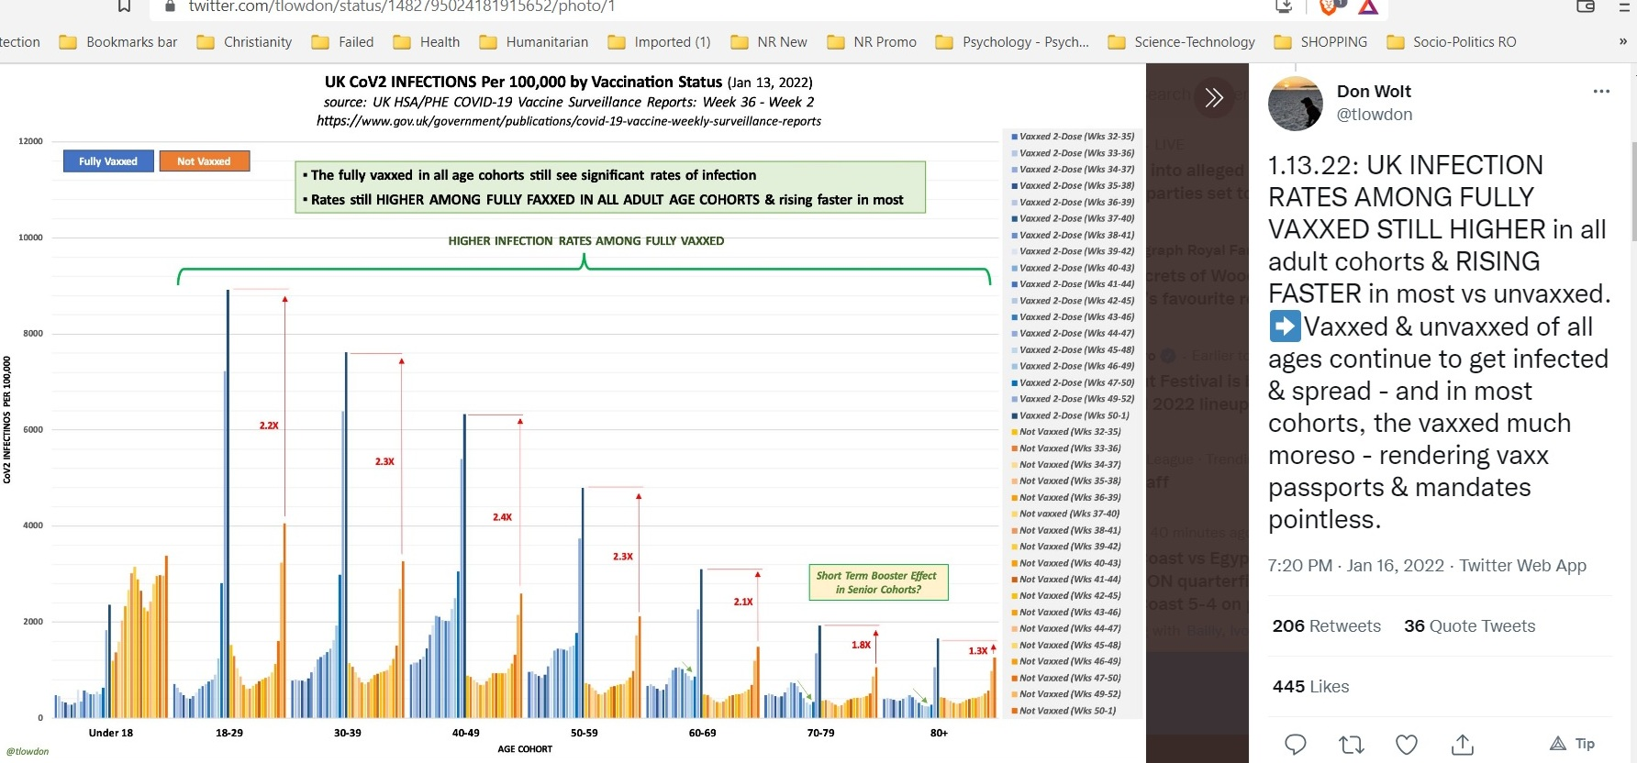

Infection rates rising faster among fully jabbed
In another graph, you can clearly see how infection rates are also rising faster in fully jabbed cohorts than in the unvaccinated — and this is not a result of higher vaccination rates.
Here, Wolt determined the growth of the infection rate for each age cohort by comparing the data of Week 1 against Week 2 in the surveillance report. As you can see by the orange graph bars, the growth rate of infection among the unvaccinated is relatively flat across age groups, whereas the infection growth rate among the fully jabbed keeps trending upward with age.
As noted by Wolt, this infection growth rate increase is not due to a tandem increase in the number of people getting a second or third jab. The data show that the greater an age cohort’s vaccination rate is, the higher its infection growth rate (i.e., the rate of increase from one week to the next).

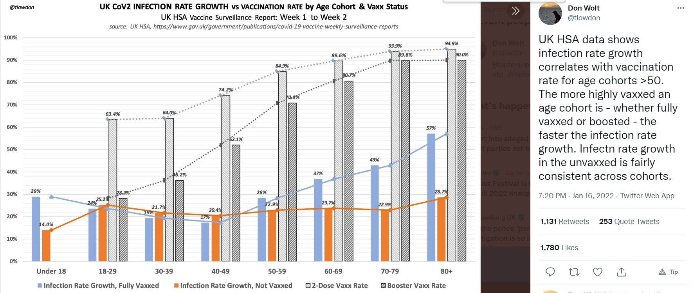

Risk of death is extremely low in under-50 age groups

The Jan. 13, UK COVID surveillance report does show that among those aged 50 and over, the COVID shots appear to lower hospitalization rates and death.
However, anyone under the age of 50 who tests positive for SARS-CoV-2 infection still has an exceptionally low risk of hospitalization or death, regardless of vaccination status. In those under the age of 30, the risk of being hospitalized or dying from COVID is “effectively zero,” Wolt notes, which, again, “makes mandated vaccination utterly unwarranted.”

Responding to detractors who point out that the report warns its raw data cannot be used to estimate vaccine effectiveness, Wolt points out that his graphs are not meant to illustrate vaccine effectiveness per se. They merely show rate trends between “vaccinated” and unvaccinated, and these trends clearly invalidate any perceived need for vaccine mandates. Data from Scotland show more of the same. As reported by The Herald, Jan 13:
“Double-jabbed Scots are now more likely to be admitted to hospital with COVID than the unvaccinated amid an increase in elderly people falling ill due to waning immunity.
“It comes amid ‘weird’ data showing that case rates have been lower in unvaccinated individuals than the single, double, or even triple-jabbed since Omicron became the dominant variant in Scotland.”
Omicron forces media to rethink what they report
The COVID pandemic has been all about social engineering, which of course cannot be done without the full complicity of the mainstream media. In a roundabout way, a Jan. 12, Associated Press (AP) News article admits this role:
“For two years, coronavirus case counts and hospitalizations have been widely used barometers of the pandemic’s march across the world. But the omicron wave is making a mess of the usual statistics, forcing news organizations to rethink the way they report such figures.
“It’s just a data disaster,’ said Katherine Wu, staff writer who covers COVID-19 for The Atlantic magazine. The number of case counts soared over the holidays, an expected development given the emergence of a variant more transmissible than its predecessors.
“Yet these counts only reflect what is reported by health authorities. They do not include most people who test themselves at home, or are infected without even knowing about it. Holidays and weekends also lead to lags in reported cases.
“If you could add all those numbers up — and you can’t — case counts would likely be substantially higher. For that reason, The Associated Press recently told its editors and reporters to avoid emphasizing case counts … Many news organizations are debating how best to use statistics now during the Omicron surge …
“Hospitalizations and death rates are considered by some to be a more reliable picture of COVID-19’s current impact on society. Yet even the usefulness of those numbers has been called into question in recent days. In many cases, hospitalizations are incidental: there are people being admitted for other reasons and are surprised to find they test positive for COVID.”
Narrative switch aimed at hiding failures
For those who have been “awake” to the censorship and misleading reporting over the past two years, this attempt at steering the narrative in a new direction is just laughable.
How could the AP possibly have missed the fact that it’s been a data disaster from the start? And intentionally so?
Case counts were always unreliable, considering the PCR test cannot diagnose an active infection, and excessive cycle thresholds guaranteed ridiculous amounts of false positives.
COVID hospitalization data were always unreliable, because anyone who tested positive for COVID was counted as a COVID hospitalization whether they were symptomatic or not. Nothing has changed in that regard.
The only thing that has changed is that now media are admitting it — pretending that this is a brand-new development, of course. The same goes for COVID death counts. They were vastly overcounted from the start, again, because of the reliance on faulty PCR testing.
Media now claim to be moving away from “unreliable” data such as case counts, hospitalizations and even deaths, and for all the reasons we’ve been highlighting for the past two years. For those who have paid attention all along, this is clearly an attempt to change the narrative without losing all credibility (which I think is near-impossible at this point).
The fact is that Omicron is making the holes in the narrative so much bigger, it’s all falling apart. They’re completely losing the rationale for vaccine passports and mandates for work, school and social events, as the higher the vaccination rate, the higher the infection rate.
To that end, UK Prime Minister Boris Johnson announced Jan. 19, that he was ending all remaining COVID restrictions in England, including mask mandates on public transportation and in schools, as well as vaccine passport requirements for public events.
This is the complete opposite of what the technocrats need in order to justify passports and mandates. To hide, as best as possible, this narrative-killing trend, media are now “explaining” why they won’t be discussing case counts or even hospitalizations or death rates anymore.
If they were, they’d have to admit that the pandemic response is resulting in an ever-growing disaster. So, don’t be surprised if fact checkers start debunking statistics proving what a disastrous failure the shots are by saying the data on cases, hospitalizations and deaths are simply too unreliable to use anymore.

New narrative doesn’t make sense either
The new narrative, according to AP News, will highlight things like hospitals running over capacity and general staff shortages.
The problem is, those don’t paint a true picture of COVID’s impact either, because hospitals have furloughed staff due to lack of patients (many have forgone routine medical treatments for fear of COVID), they’ve fired staff for not getting the jab, other staff have simply quit their jobs in the face of vaccine mandates and hospitals have shut down entire wings due to these staff cuts.
Of course, if patients start returning, they might rapidly find themselves with more patients than they can currently handle. What else can you expect when hospitals intentionally make these kinds of cuts?
General staff shortages in other industries are an equally flawed barometer of COVID’s impact. Many are still getting federal assistance and therefore don’t want to reenter the work force. Others are forced out due to vaccine mandates.
Others are too sick to work thanks to COVID jab injuries. As recently reported by OneAmerica, a national mutual life insurance company based in Indianapolis, in addition to a 40% increase in deaths among working age Americans (and they’re not dying from COVID), there’s also been a noticeable uptick in short-term and long-term disability claims in the third quarter of 2021 compared to prepandemic levels.
Working age Americans are getting too sick to work, and are dying at unprecedented levels, and it’s not because of COVID infection.
‘We failed,’ Danish media admit
The same attempt at switching the narrative can be seen in other countries. Danish media recently admitted they’ve failed the public by being “almost hypnotically preoccupied with the daily corona counts.” “We, the press, must … take count of our own efforts,” Danish journalist Brian Weichardt writes, “And we’ve failed.”
Weichardt admits that journalists failed to ask authorities for clear answers as to “what it meant in concrete terms that people are hospitalized with corona and not because of corona.” He also admits that this “makes a difference.” This, again, is precisely what many of us have been saying for the past two years, and all we got for the effort was a domestic terrorist label.
Weichardt, in this piece, tries to shift the blame from journalists to the authorities themselves. They’re to blame, he thinks. “The messages of the authorities and politicians to the people of this historic crisis leave much to be desired,” he writes, ignoring the fact that a journalist’s No. 1 duty is to actually investigate, to double-check and to question and not simply act as a two-legged parrot.
For two years straight, any dissenting opinion has been labeled as dangerous misinformation, even when completely accurate, because that’s how propaganda works. The fact that press members are now starting to backtrack in order to save what little credibility they have left does not change the fact that they have, nearly universally, acted as promoters of propaganda and nothing else.
Now that a majority of people are onto their spiel, they’re trying to pretend as though it were all a genuine mistake. Nice try. Let’s see how these pharma-backed propaganda jockeys fare when it comes to reporting the truth about COVID jab injuries. That will be where the rubber meets the road in terms of regaining credibility, as it will force them to bite the hand that feeds them — the drug industry.
The sad truth is, we’re likely facing an avalanche of serious chronic ailments going forward, among them, neurodegenerative diseases, as detailed by Stephanie Seneff, Ph.D., in her article “SARS-CoV-2 Vaccines and Neurodegenerative Disease.” A short summation of this article reads as follows:
“There are many reasons to be wary of the COVID-19 vaccines, which have been rushed to market with grossly inadequate evaluation and aggressively promoted to an uninformed public, with the potential for huge, irreversible, negative consequences.
“One potential consequence is to exhaust the finite supply of progenitor B cells in the bone marrow early in life, causing an inability to mount new antibodies to infectious agents. An even more worrisome possibility is that these vaccines, both the mRNA vaccines and the DNA vector vaccines, may be a pathway to crippling disease sometime in the future.
“Through the prion-like action of the spike protein, we will likely see an alarming increase in several major neurodegenerative diseases, including Parkinson’s disease, CKD, ALS and Alzheimer’s, and these diseases will show up with increasing prevalence among younger and younger populations, in years to come.
“Unfortunately, we won’t know whether the vaccines caused this increase, because there will usually be a long time separation between the vaccination event and the disease diagnosis.
“Very convenient for the vaccine manufacturers, who stand to make huge profits off of our misfortunes — both from the sale of the vaccines themselves and from the large medical cost of treating all these debilitating diseases.”
Originally published by Mercola.

Whistleblowers Share DOD Medical Data Thar Blows Vaccine Safety Debate Wide Open | Daniel Horowitz The Blaze (https://www.theblaze.com/op-ed/horowitz-whistleblowers-share-dod-medical-data-that-blows-vaccine-safety-debate-wide-open )
Data, transparency, and surveillance. That is what has been missing from the greatest experiment on humans of all time throughout this pandemic. Now, military medical whistleblowers have come forward with what they claim is perhaps the most accurate and revealing data set on vaccine safety one could possibly find.
On Monday, during Sen. Ron Johnson’s five-hour hearing on a “COVID-19: Second Opinion (https://rumble.com/vt62y6-covid-19-a-second-opinion.html),” Ohio attorney Thomas Renz, who has been representing clients suing the vaccine mandates, presented DOD medical billing data from the Defense Medical Epidemiology Database (DMED) that paints a shockingly disturbing picture of the health of our service members in 2021:
• Neurological issues: a 1,000% increase, from a baseline average of 82,000 to 863,000
• Cancer: an almost 300% increase in cancer diagnoses (from a five-year average of 38,700 per year to 114,645 in the first 11 months of 2021)
• Pulmonary embolisms: a 467% increase
• Myocardial infarction: a 269% increase
• Bell’s palsy: a 291% increase
• Miscarriages: a 300% increase in 2021 over the five-year average. The five-year average was 1,499 codes for miscarriages per year. During the first 10 months of 2021, it was 4,182.
• Congenital malformations (for children of military personnel): a 156% increase
• Female infertility: a 471% increase
DMED is quite literally an epidemiological surveillance program designed for the express purpose of detecting surges in illness and injury to make sure the military is combat-ready. It’s about national security even more than public health. Why would the military not have blown the whistle and warned the CDC right away about this data? On the military health system website (https://www.health.mil/Military-Health-Topics/Combat-Support/Armed-Forces-Health-Surveillance-Division), the Armed Forces Health Surveillance Division (AFHSD) is described as “the central epidemiologic resource for the U.S. Armed Forces, conducting medical surveillance to protect those who serve our nation in uniform and allies who are critical to our national security interests.”

COVID-19 Vaccines: Scientific Proof of Lethality
Post published: 5 January 2022 at https://www.saveusnow.org.uk/covid-vaccine-scientific-proof-lethal

Over One Thousand Scientific Studies Prove That the COVID-19 Vaccines Are Dangerous, and All Those Pushing This Agenda Are Committing the Indictable Crime of Gross Misconduct in Public Office
Just over 12 months from deployment of the COVID 19 emergency use experimental vaccines, scientific studies in the thousands, and reports of criminal complaints of assault and murder from the illegal, unlawful use of biochemical poisons made to police forces around the country, verify an assault on an unsuspecting UK population. Irrefutable science shows that the COVID 19 vaccine is not safe and not effective in limiting transmission or infection from the SARS-CoV-2, coronavirus pathogens.
The “safe and effective” false propaganda, put out by public officials who now are continuing to push this vaccine, is a clear breach of duty. A public office holder is subject to, and aware of, a duty to prevent death or serious injury that arises only by virtue of the functions of the public office.
Many have breached that duty and, in doing so, are recklessly causing a risk of death or serious injury, by carrying on regardless of the now-confirmed dangers associated with COVID 19 injections. Some of these risks are blood clotting, myocarditis, pericarditis, thrombosis, thrombocytopenia, anaphylaxis, Bell’s palsy, Guillain-Barre, cancer including deaths, etc.
All of these are confirmed in the following science-and-government-gathered data from the UK Health and Security agency on COVID 19 regarding vaccine damage.
The term “vaccine” was changed recently to incorporate this illegal, unlawful medical experiment to facilitate usage of mRNA technology that is demonstrably not a vaccine, and which contains biologically toxic nano-metamaterials associated with 5G urban data gathering capability.
Metal nanoparticulates are known in science to be genotoxic—a poison that can also cause sterilization. The dangers posed to the victims in the near term from this medical battery are now known. However, the long term lethality of this weapon is not as yet realized due to the debilitating effects it has on the immune system, causing Acquired Immunodeficiency Syndrome(AIDS).
We can now confirm the 2017 depopulation defence-intelligence documents, showing the planned murder of over 55 million across the United Kingdom by 2025 using this biochemical weapon.
The Medicines and Healthcare (products) Regulatory Agency (MHRA) had prior warning of the expected large numbers of adverse reactions before the deployment—confirming the premeditated nature of the crime and public conduct offences then and now.

See all this document comprising references to 1011 scientific studies published in prestigious papers to be found online – at https://www.saveusnow.org.uk/covid-vaccine-scientific-proof-lethal

https://dailyexpose.uk/2022/01/19/vaccines-double-chance-of-catching-covid/
https://palexander.substack.com/p/catastrophic-negative-efficacy-report
https://stevekirsch.substack.com/p/new-big-data-study-of-145-countries
https://stevekirsch.substack.com/p/the-more-we-vaccinate-the-higher
https://stevekirsch.substack.com/p/new-study-from-germany-confirms-higher
https://stevekirsch.substack.com/p/reuters-fact-check-of-the-denmark
https://dailyexpose.uk/2022/01/02/german-gov-data-suggests-fully-vaccinated-developing-ade/
https://dailyexpose.uk/
https://dailyexpose.uk/2022/01/08/bbc-forgot-to-tell-you-4-in-5-covid-deaths-triple-vaccinated/
https://principia-scientific.com/lancet-89-of-new-uk-covid-cases-among-fully-vaxxed/
https://dailyexpose.uk/category/breaking-news/
https://stevekirsch.substack.com/p/new-study-from-germany-confirms-higher
https://uncoverdc.com/2022/01/17/florida-highest-rates-of-infection-occurring-in-counties-with-highest-vaccination-rates/
https://paretos.substack.com/p/vaccine-failure-across-the-board
https://www.nejm.org/doi/full/10.1056/NEJMoa2110345
https://www.timesofisrael.com/israeli-trial-worlds-first-finds-4th-dose-not-good-enough-against-omicron/
https://www.youtube.com/watch?v=TNaT5A-1gHc
https://www.skirsch.com/covid/VCage.pdf
https://stevekirsch.substack.com/p/we-will-kill-117-kids-to-save-one
https://tobyrogers.substack.com/p/ten-red-flags-in-the-fdas-risk-benefit
https://tobyrogers.substack.com/p/what-is-the-number-needed-to-vaccinate
https://www.sciencedirect.com/science/article/pii/S221475002100161X
https://cf5e727d-d02d-4d71-89ff-9fe2d3ad957f.filesusr.com/ugd/adf864_8c97b2396c2842b3b05975bfbd8254cb.pdf
https://www.publichealthpolicyjournal.com/
https://www.publichealthpolicyjournal.com/general-5
https://www.nejm.org/doi/suppl/10.1056/NEJMoa2110345/suppl_file/nejmoa2110345_appendix.pdf
https://www.skirsch.com/covid/Deaths.pdf
https://tobyrogers.substack.com/p/what-is-the-number-needed-to-vaccinate
https://www.fda.gov/media/153447/download
https://tobyrogers.substack.com/p/ten-red-flags-in-the-fdas-risk-benefit
https://tobyrogers.substack.com/p/ten-red-flags-in-the-fdas-risk-benefit
https://tobyrogers.substack.com/p/what-is-the-number-needed-to-vaccinate
https://tobyrogers.substack.com/p/what-is-the-number-needed-to-vaccinate
https://tobyrogers.substack.com/p/what-is-the-number-needed-to-vaccinate
https://tobyrogers.substack.com/p/what-is-the-number-needed-to-vaccinate
https://tobyrogers.substack.com/p/what-is-the-number-needed-to-vaccinate
https://tobyrogers.substack.com/p/what-is-the-number-needed-to-vaccinate
https://tobyrogers.substack.com/p/some-thoughts-on-todays-acip-meeting
https://tobyrogers.substack.com/p/ten-red-flags-in-the-fdas-risk-benefit
https://tobyrogers.substack.com/p/what-is-the-number-needed-to-vaccinate
https://thehill.com/changing-america/well-being/prevention-cures/558321-cdc-says-vaccine-link-to-heart-inflammation-is
https://www.skirsch.com/covid/VaccineEssentials.pdf
https://www.cdc.gov/mmwr/volumes/70/wr/mm7035e5.htm
https://www.skirsch.com/covid/Deaths.pdf
https://jessicar.substack.com/p/a-report-on-myocarditis-adverse-events
https://jessicar.substack.com/p/censorship-update-record-keeping
https://www.skirsch.com/covid/VaccineEssentials.pdf
https://stevekirsch.substack.com/p/there-are-now-4-myocarditis-cases
https://childrenshealthdefense.org/defender/joseph-keating-autopsy-death-myocarditis-pfizer-covid-vaccine/?utm_source=salsa&eType=EmailBlastContent&eId=d8800cb1-6ca8-45e1-9766-b37231ff4113
https://vector-news.github.io/editorials/CausalAnalysisReport_html.html
https://stevekirsch.substack.com/p/the-more-we-vaccinate-the-higher
https://stevekirsch.substack.com/p/the-more-we-vaccinate-the-higher
https://stevekirsch.substack.com/p/new-study-from-germany-confirms-higher
https://stevekirsch.substack.com/p/new-study-shows-vaccines-must-be
https://dailyexpose.uk/2022/01/02/german-gov-data-suggests-fully-vaccinated-developing-ade/
https://dailyexpose.uk/
https://dailyexpose.uk/2022/01/08/bbc-forgot-to-tell-you-4-in-5-covid-deaths-triple-vaccinated/
https://principia-scientific.com/lancet-89-of-new-uk-covid-cases-among-fully-vaxxed/
https://pubmed.ncbi.nlm.nih.gov/34540594/
https://pubmed.ncbi.nlm.nih.gov/34540594/
https://tobyrogers.substack.com/p/what-is-the-number-needed-to-vaccinate
https://www.skirsch.com/covid/VCage.pdf
https://alexberenson.substack.com/p/more-people-died-in-the-key-clinical
https://stevekirsch.substack.com/p/estimated-1-in-95-boys-diagnosed
https://onlinelibrary.wiley.com/doi/pdf/10.1111/apa.16156
https://chrismasterjohnphd.com/covid-19/2021/12/27/jessica-rose-adverse-events-reporting-and-much-more
https://www.researchgate.net/publication/354465833_SARS-CoV-2_mRNA_Vaccination-Associated_Myocarditis_in_Children_Ages_12-17_A_Stratified_National_Database_Analysis
https://news.yale.edu/2020/09/21/childrens-immune-response-more-effective-against-covid-19
https://pubmed.ncbi.nlm.nih.gov/32432681/
https://jamanetwork.com/journals/jama/fullarticle/2766524
https://www.francesoir.fr/opinions-tribunes/pourquoi-la-proteine-spike-est-toxique-dans-le-covid-19-et-aussi-dans-les-vaccins
https://www.thelancet.com/journals/lancet/article/PIIS0140-6736(20)30937-5/fulltext
https://pubmed.ncbi.nlm.nih.gov/33360731/
https://pubmed.ncbi.nlm.nih.gov/34015087/
https://pubmed.ncbi.nlm.nih.gov/33784827/
https://wmbriggs.com/post/37874/
https://data.cdc.gov/NCHS/Provisional-COVID-19-Deaths-by-Sex-and-Age/9bhg-hcku
https://www.martymd.com/
https://www.msn.com/en-us/health/medical/dr-makary-says-natural-immunity-is-more-effective-then-vaccine-immunity/ar-AAMX3sM
https://injuryfacts.nsc.org/motor-vehicle/historical-fatality-trends/deaths-by-age-group/
https://wmbriggs.com/post/37874/
https://www.nature.com/articles/s41590-020-00826-9?campaign_id=154&emc=edit_cb_20201106&instance_id=23895&nl=coronavirus-briefing&regi_id=61609026&segment_id=43815&te=1&user_id=73aefc51739a420f3d188e5...
https://pubmed.ncbi.nlm.nih.gov/29466753/
https://www.nature.com/articles/s41587-021-01037-9
https://www.genengnews.com/news/kids-nose-cells-are-primed-to-fight-viruses-may-explain-milder-covid-19/?utm_medium=newsletter&utm_source=GEN+Daily+News+Highlights&utm_content=01&utm_campaign=GEN+Daily+News+Highlights_20210819&oly_enc_id=4125F3799801G1X
https://www.science.org/doi/10.1126/science.abf6648
https://pubmed.ncbi.nlm.nih.gov/32753554/
https://www.sciencedirect.com/science/article/pii/S221475002100161X
https://www.medrxiv.org/content/10.1101/2021.01.29.21250653v1
https://www.medrxiv.org/content/10.1101/2021.02.26.21252096v1
https://www.medrxiv.org/content/10.1101/2021.04.15.21252192v1
Dr. Sucharit Bhakdi: Organs of the dead vaccinated proves auto immune attack 22.12.22
https://doctors4covidethics.org/wp-content/uploads/2021/12/end-covax.pdf
https://www.bitchute.com/video/fHIT55iM4Zv9/
https://npojip.org/english/MedCheck/Med%20Check%20Tip-20-2021-08&12.pdf?fbclid=IwAR2oX2r4AGojcj3X5-uEMLo3gi6hn_cFthpyoGMg9VjfplVwHeynsHMY95E
https://theegg.house/covid-19-jab-is-cause-of-death-in-30-40-of-autopsies-of-recently-vaccinated-says-german-chief-pathologist/
https://www.pathologie-kaufbeuren.de/
https://childrenshealthdefense.org/authors/robert-w-malone-m-d/
https://doctorsandscientistsdeclaration.org/
https://childrenshealthdefense.org/defender_category/covid/
https://globalcovidsummit.org/news/live-stream-event-physicians-alerting-parents
https://globalcovidsummit.org/news/live-stream-event-physicians-alerting-parents
https://childrenshealthdefense.org/defender/covid-vaccine-spike-protein-travels-from-injection-site-organ-damage/
https://childrenshealthdefense.org/defender/dr-marty-makary-cdc-vaccine-mandates-children-natural-immunity/
https://globalcovidsummit.org/
https://www.cdc.gov/nchs/nvss/vsrr/covid_weekly/index.htm#SexAndAge
https://achi.net/newsroom/defining-covid-terms-excess-deaths/
https://www.theepochtimes.com/northeast-fares-best-amid-2021-prime-age-mortality-spike_4208797.html
https://childrenshealthdefense.org/defender/insurance-companies-report-increase-premature-deaths/
https://www.thecentersquare.com/indiana/indiana-life-insurance-ceo-says-deaths-are-up-40-among-people-ages-18-64/article_71473b12-6b1e-11ec-8641-5b2c06725e2c.html
https://www.theepochtimes.com/several-states-examine-2021-mortality-surge-in-americans-aged-18-49_4213438.html?utm_source=partner&utm_campaign=ZeroHedge
https://www.theepochtimes.com/biden-administration-mum-on-mortality-spike-in-americans-age-18-49_4221057.html?utm_source=ai&utm_medium=search
https://www.cdc.gov/nchs/nvss/vsrr/drug-overdose-data.htm
https://twitter.com/Mr_Mackei/status/1478008259474862081?s=20
https://www.wfyi.org/news/articles/insurance-death-rates-working-age-people-up-40-percent
https://www.vacsafety.org/
https://stevekirsch.substack.com/p/unprecedented-deaths-in-indiana-for?r=o7iqo
https://rwmalonemd.substack.com/p/what-if-the-largest-experiment-on
https://www.reuters.com/article/factcheck-coronavirus-sport/fact-check-list-of-108-fifa-soccer-players-is-not-proof-of-a-common-link-between-covid-19-vaccines-and-athlete-deaths-idUSL1N2T81NY
https://docs.google.com/presentation/d/11SqfJ5m_rvBfssP_wtgGEdgpUue6KH0WXxrfpNADp1c/edit#slide=id.g102944e166e_0_239
https://www.mvcs.org/
https://youtu.be/NR_ZVzrTeYk?t=45
https://breakingnews.exchange/investigation-has-launched-after-three-year-old-girl-dies-from-cardiac-arrest-one-day-after-receiving-covid-19-vaccine-in-argentina/
https://conejoguardian.org/2021/12/14/more-vc-nurses-blow-whistle-on-overwhelming-numbers-of-heart-attacks-clotting-strokes/
https://www.house.louisiana.gov/H_Video/2021/Dec2021
https://openvaers.com/
https://www.dareseektruth.com/dr-peter-mccullough/
https://www.medrxiv.org/content/10.1101/2021.08.30.21262866v1
https://i-do-not-consent.netlify.app/media/A%20Report%20on%20Myocarditis%20Adverse%20Events%20in%20the%20U.S.%20Vaccine%20AdverseEvents%20Reporting%20System%20%28VAERS%29%20in%20Association%20with%20COVID19%20Injectable%20Biological%20Products.pdf
https://www.ncbi.nlm.nih.gov/labs/pmc/articles/PMC2519249/
https://pubmed.ncbi.nlm.nih.gov/31319912/
https://www.ft.com/content/05e32f95-0e7e-4d2a-b408-6ec6035dea8e
https://twitter.com/USMortality/status/1463566908196802561
https://dailyexpose.uk/2022/01/16/male-teen-deaths-53-percent-higher-after-covid-vaccination-in-2021/
https://doctorsandscientistsdeclaration.org/
https://www.ahajournals.org/doi/10.1161/circ.144.suppl_1.10712
https://twitter.com/draseemmalhotra/status/1462363528065597440?s=21
https://www.ahajournals.org/doi/10.1161/JAHA.116.005306
https://www.census.gov/library/stories/2021/08/united-states-adult-population-grew-faster-than-nations-total-population-from-2010-to-2020.html
https://openvaers.com/covid-data/myo-pericarditis
https://www.cdc.gov/mmwr/volumes/70/wr/mm7035e5.htm
https://healthimpactnews.com/2022/government-vaers-data-reveal-15600-increase-in-heart-disease-among-under-30-year-olds-following-covid-19-vaccination/
https://www.youtube.com/watch?v=bcereQc4A-U
https://www.servustv.com/aktuelles/a/reportage-im-stich-gelassen-die-covid-impfopfer/201058/
https://rairfoundation.com/russian-roulette-famous-doctor-warns-batches-of-covid-vaccines-with-3000x-the-toxic-effect-released-video/
https://www.authorea.com/users/455597/articles/552937-innate-immune-suppression-by-sars-cov-2-mrna-vaccinations-the-role-of-g-quadruplexes-exosomes-and-micrornas
https://childrenshealthdefense.org/defender_category/covid/
https://www.authorea.com/users/455597/articles/552937-innate-immune-suppression-by-sars-cov-2-mrna-vaccinations-the-role-of-g-quadruplexes-exosomes-and-micrornas
https://www.authorea.com/
https://childrenshealthdefense.org/defender_category/big-pharma/
https://childrenshealthdefense.org/defender/vaers-cdc-olympic-sprinter-pericarditis-pfizer-booster/
https://vaers.hhs.gov/
https://www.frontiersin.org/articles/10.3389/fimmu.2021.656700/full
https://childrenshealthdefense.org/defender/mrna-technology-covid-vaccine-lipid-nanoparticles-accumulate-ovaries/
https://ijvtpr.com/index.php/IJVTPR/article/view/23
https://childrenshealthdefense.org/defender/pfizer-covid-vaccine-herpes-virus-shingles/
https://www.nature.com/articles/s41421-021-00329-3
https://www.ncbi.nlm.nih.gov/labs/pmc/articles/PMC3540844/
https://childrenshealthdefense.org/defender/mrna-technology-covid-vaccine-lipid-nanoparticles-accumulate-ovaries/
https://childrenshealthdefense.org/defender/pfizer-ceo-albert-bourla-variant-specific-covid-vaccine/
https://childrenshealthdefense.org/defender/theories-origin-omicron-variant-end-pandemic/
https://goodsciencing.com/covid/athletes-suffer-cardiac-arrest-die-after-covid-shot/
https://onlinelibrary.wiley.com/doi/pdf/10.1002/ejhf.2096
https://www.frontiersin.org/articles/10.3389/fimmu.2021.658428/full
https://www.ncbi.nlm.nih.gov/labs/pmc/articles/PMC4132711/
https://www.business-standard.com/article/international/covid-19-pandemic-frequent-boosters-can-weaken-immunity-says-eu-122011201707_1.html
https://childrenshealthdefense.org/defender_category/covid/
https://www.gov.uk/government/statistics/national-flu-and-covid-19-surveillance-reports-2021-to-2022-season
https://www.gov.uk/government/statistics/national-flu-and-covid-19-surveillance-reports-2021-to-2022-season
https://www.gov.uk/government/statistics/national-flu-and-covid-19-surveillance-reports-2021-to-2022-season
https://childrenshealthdefense.org/defender_category/covid/
https://childrenshealthdefense.org/defender_category/covid/
https://childrenshealthdefense.org/defender_category/covid/
https://childrenshealthdefense.org/defender/biden-predicts-winter-of-severe-illness-unvaccinated/
https://www.gov.uk/government/statistics/national-flu-and-covid-19-surveillance-reports-2021-to-2022-season
https://www.heraldscotland.com/news/19843315.covid-scotland-case-rates-lowest-unvaccinated-double-jabbed-elderly-drive-rise-hospital-admissions/
https://childrenshealthdefense.org/defender/omicron-decreased-lung-damage-death/
https://apnews.com/article/omicron-changing-news-outlets-covid-data-da9272f7c4c8a109c3bfb56bed9e9c76
https://childrenshealthdefense.org/defender/politics-cdc-u-turn-pandemic-narrative/
https://childrenshealthdefense.org/defender/pcr-testing-incorrect-use/
https://childrenshealthdefense.org/defender/uk-ends-vaccine-passports-mask-mandates/
https://www.nytimes.com/2022/01/19/world/uk-johnson-covid-rules.html
https://childrenshealthdefense.org/defender/facebook-admits-fact-checks-pure-opinion/
https://childrenshealthdefense.org/defender/vaers-cdc-olympic-sprinter-pericarditis-pfizer-booster/
https://www.thecentersquare.com/indiana/indiana-life-insurance-ceo-says-deaths-are-up-40-among-people-ages-18-64/article_71473b12-6b1e-11ec-8641-5b2c06725e2c.html?s=04&fbclid=IwAR2bDGdaAaTlAikGi6IlyXRx7J8bZXD2ieQjL1PytBqQSOYRoiSY9paXP40
https://childrenshealthdefense.org/defender/insurance-companies-report-increase-premature-deaths/
https://ekstrabladet.dk/nyheder/lederen/vi-fejlede/9072013
https://childrenshealthdefense.org/defender/jake-tapper-sold-soul-pharma-rfk-jr/
https://childrenshealthdefense.org/defender/mit-scientist-stephanie-seneff-neurodegenerative-disease-young-people-covid-shots/
https://rightsfreedoms.wordpress.com/2021/06/15/sars-cov-2-vaccines-and-neurodegenerative-disease/
https://childrenshealthdefense.org/defender/airfinity-pfizer-moderna-billions-covid-vaccine-sales/

