Open Letter to the JCVI: Pause vaccines for children pending urgent review
February 11, 2022
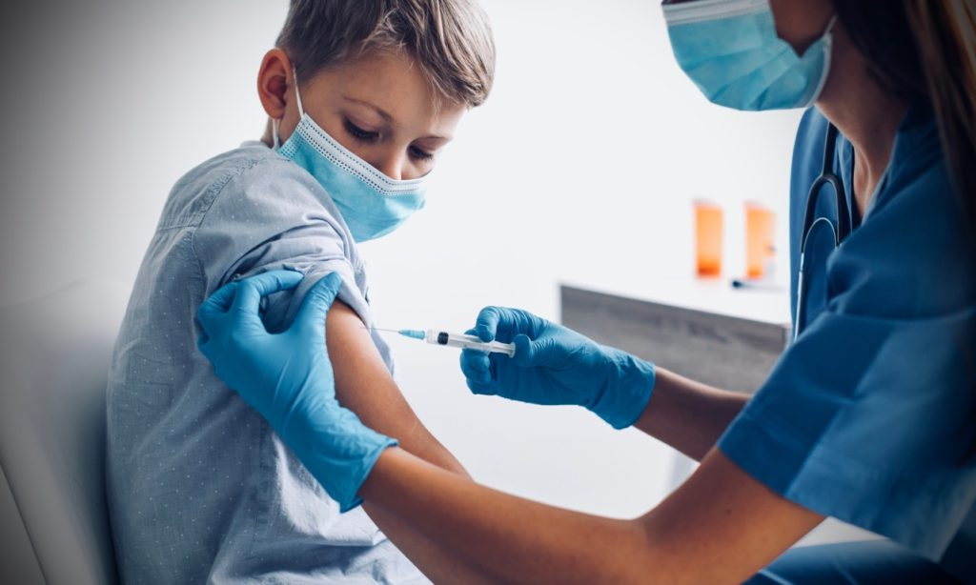
Increase in all-cause mortality in males aged 15-19 requires immediate investigation

https://www.hartgroup.org/open-letter-to-the-jcvi-pause-vaccines-for-children-pending-urgent-review/

Thursday, 10th February 2022

To:

Professor Wei, JCVI

Professor Sir Chris Whitty, CMO

Sajid Javid, Secretary of State, DHSC
Dear Professor Wei, Professor Whitty and Mr Javid,
We wrote to you and also the MHRA last month regarding urgent investigation of the acknowledged increase in all cause mortality in males aged 15-19 since the Pfizer covid vaccine rollout commenced in this age group in May 2021. ONS have acknowledged in the High Court in London, that the figure of 402 excess deaths is significantly higher than the previous 5 year average of 337 deaths. Indeed they stated it is probably an underestimate because of delays for coroners’ cases. This equates to at least one additional teenage boy dying each week. It is thus very disappointing not to have received any response.
We are writing further to ask you to pause the vaccines for children while you undertake and publish an urgent review of the risk/benefit analysis. In August 2021 you concluded that there was no medical justification for vaccinating healthy 12-15-year-olds, with the authorisation based on an aim to reduce school closures. But this new safety signal and the impact of this uncertainty must affect your assessment of the risk to benefits.
Since that date, much has changed. The latest omicron variant has been shown to have a much lower risk of serious illness, hospitalisations and deaths than the previous alpha and delta variants circulating at the time of the decision. This is true for children as well as adults, so given the extremely low risk for children in previous waves, any potential for benefit must surely have dwindled to virtually zero. Also, in your analysis you failed to take due regard to naturally-acquired immunity, now demonstrated and widely accepted to be superior to vaccine acquired immunity. Children have had high rates of infection throughout recent weeks with at least 80% now estimated to be immune. In addition, the efficacy of Pfizer against omicron compared to previous variants is reduced to the point where infection rates are now higher in the vaccinated than the unvaccinated removing any potential indirect benefit to immune-compromised family members and perversely creating an increased risk to contacts of the vaccinated.
On the risks side of the balance sheet, we have further information regarding myocarditis, with an occurrence rate of 1/2680 young men in Hong Kong, where unlike the UK, this was sought systematically from the start of their rollout. Indeed they paused their second dose, just as the UK moved from one to two doses. Data from the US also confirm high rates of 1/9443 in males aged 16-17 after their second dose. We still have no follow-up data on the increasing number of children reported from the US with significant abnormalities on their cardiac MRI scans. We also have worrying information on all-cause mortality by vaccination status, which even from the original adult Pfizer trial showed a higher mortality for the vaccinated group. Side effects are higher when vaccinating those already immune. Other side effects such as increased blood clots will all be playing a part in this balance of risk. Non-fatal adverse events, particularly neurological, have the potential to blight the lives of affected children.
The latest information from the CDC is extremely worrying, that of 4149 children, 100 (2.41%) had a serious adverse event, 15/4149 (0.36%) had increased troponin (12 confirmed to be myocarditis), 12/4149 (0.29%) had seizures, 2/4149 (0.048%) died (being evaluated). This in itself is a reason to review.
Furthermore, there is increasing evidence of impairment of immune function particularly following multiple doses of vaccine. Israel is now seeing serious illness and death after the fourth vaccine dose. There is also new bio-distribution data showing that mRNA and spike protein, far from being eliminated within a few days, are still persisting for 60 days or more. We have no knowledge of the long-term implications of vaccinating children against what is now acknowledged to be a very mild illness for them, indeed with 50% having no symptoms whatsoever.
With the arrival of omicron, SARS-CoV-2 has moved from pandemic to endemic. If the current situation had existed six months ago, there would have been no case made for commencing routine rollout for healthy children. Now, it is proposed that even those testing positive for omicron do not need to isolate. If omicron is no risk to others, why vaccinate? The prospect now of widening the coverage to 5-11s would be all the more ludicrous. We should, like Norway & Sweden, make clear that vaccination for this age group is simply not necessary.
The time has now come to pause and acknowledge that there is no emergency for children and that for them the balance of benefit and risk now clearly favours natural immunity. On that basis the routine programme could and should be halted. Failure to act will lay you open to liability for ongoing harms.
We would like to meet with you urgently, in order to support you in taking stock of all of the pertinent new and emerging data.
Yours sincerely,
- Dr Rosamond Jones, MD, FRCPCH, retired consultant paediatrician
- Professor Keith Willison, PhD, Professor of Chemical Biology, Imperial, London
- Professor David Livermore, BSc, PhD, Professor of Medical Microbiology, University of East Anglia
- Professor Anthony J Brookes, Professor of Genomics and Health Data Science, University of Leicester
- Professor Richard Ennos, MA, PhD. Honorary Professorial Fellow, University of Edinburgh
- Professor Angus Dalgleish, MD, FRCP, FRACP, FRCPath, FMed Sci, Professor of Oncology, St Georges Hospital, London
- Professor John Fairclough FRCS FFSEM retired Honorary Consultant Surgeon
- Professor Norman Fenton, CEng, CMath, PhD, FBCS, MIET, Professor of Risk Information Management, Queen Mary University of London
- Professor Anthony Fryer, PhD FRCPath, Professor of Clinical Biochemistry
- Lord Moonie, MBChB, MRCPsych, MFCM, MSc, House of Lords, former parliamentary under-secretary of state 2001-2003, former consultant in Public Health Medicine
- Dr Theresa Lawrie, MBBCh, PhD, Director, Evidence-Based Medicine Consultancy Ltd, Bath
- Dr John Flack, BPharm, PhD. Retired Director of Safety Evaluation, Beecham Pharmaceuticals 1980-1989 and Senior Vice-president for Drug Discovery 1990-92 SmithKline Beecham
- Professor Anthony J Brookes, Professor of Genomics & Health Data Science, University of Leicester
- Dr Alan Mordue, MBChB, FFPH. Retired Consultant in Public Health Medicine & Epidemiology
- Dr Roland Salmon, MB BS, MRCGP, FFPH, Former Director, Communicable Disease Surveillance Centre Wales
- Dr Gerry Quinn, PhD. Postdoctoral researcher in microbiology and immunology
- Katherine MacGilchrist, BSc (Hons), MSc, CEO/Systematic Review Director, Epidemica Ltd.
- Mr James Royle, MBChB, FRCS, MMedEd, Colorectal surgeon
- Dr Livia Tossici-Bolt, PhD, Clinical Scientist
- Dr Elizabeth Evans MA(Cantab), MBBS, DRCOG, Retired Doctor
- Dr Rohaan Seth, Bsc (hons), MBChB (hons), MRCGP, Retired General Practitioner
- Dr Emma Brierly, MRCGP, General Practitioner
- Dr Geoffrey Maidment, MD, FRCP, retired consultant physician
- Mr Malcolm Loudon, MBChB, MD, FRCSEd, FRCS(Gen Surg), MIHM,VR, Consultant Surgeon
- Dr Alan Black, MBBS, MSc, DipPharmMed, retired pharmaceutical physician
- Dr David Cartland, MBChB, BMedSci, General practitioner
- Dr Peter Chan, BM, MRCS, MRCGP, NLP, General Practitioner, Functional medicine practitioner
- Dr Greta Mushet, MBChB, MRCPsych, retired Consultant Psychiatrist in Psychotherapy
- Dr Samuel McBride, MBBCh, BAO, BSc, MSc, MRCP (UK) FRCEM, FRCP (Edinburgh), NHS Emergency Medicine & geriatrics
- Mr Ian F Comaish, MA, BM BCh, FRCOphth, FRANZCO, Consultant ophthalmologist
- Dr Branko Latinkic, BSc, PhD, Reader in Biosciences
- Dr Helen Westwood MBChB MRCGP DCH DRCOG, General Practitioner
- Michael Cockayne, MSc, PGDip, SCPHNOH, BA, RN, Occupational Health Practitioner
- Mr Anthony Hinton, MBChB, FRCS, Consultant ENT surgeon, London
- Dr Tanya Klymenko, PhD, FHEA, FIBMS, Senior lecturer in Biomedical Sciences
- Michael Cockayne, MSc, PGDip, SCPHNOH, BA, RN, Occupational Health Practitioner
- Dr Carmen Wheatley, DPhil, Orthomolecular Oncology
- Dr Charles Lane OBE, Molecular Biologist
- Mr Angus Robertson BSc (Med. Sci.) MB ChB FRCS(Ed) FFSEM(UK) Consultant Orthopaedic Surgeon
- Dr Michael D Bell, MBChB MRCGP Retired General Practitioner
- Dr Jayne LM Donegan, MBBS, DRCOG, DCH, DFFP, MRCGP, General Practitioner
- Dr David Critchley, BSc, PhD in Pharmacology, 32 years’ experience in Pharmaceutical R&D
- Dr Keith Johnson, BA, D.Phil (Oxon), IP Consultant for Diagnostic Testing
- Julie Annakin, RN, Immunisation Specialist Nurse
- Rev Dr William J U Philip MB ChB, MRCP, BD, Senior Minister The Tron Church, Glasgow, formerly physician specialising in cardiology
- Dr Jonathan Rogers MBChB (Bristol) MRCGP DRCOG Retired NHS General Practitioner
- Dr Pauline Jones, MB BS, Retired General Practitioner
- Dr Emma Brierly, MBBS, MRCGP, General Practitioner
- Dr Elizabeth Burton, MB ChB, Retired General Practitioner
- Dr Franziska Meuschel, MD, ND, PhD, LFHom, BSEM, Nutritional, Environmental and Integrated Medicine
- Dr Michael Bazlinton, MBCHB MRCGP DCH
- Dr Holly Young, BSc, MBChB, MRCP, Consultant Palliative Care Medicine
- Dr Julian Tomkinson, MBChB, MRCGP, General Practitioner, GP Trainer, PCME
- Dr David Bramble, MBChB, MRCPsych, MD, Consultant Psychiatrist
- Dr Christina Peers, MBBS, DRCOG, DFSRH, FFSRH, Menopause Specialist
- Dr Chris Newton, PhD, Biochemist working in immuno-metabolism
- Dr Christopher Exley, PhD, FRSB, Bioinoganic Chemist
- Dr Sarah Myhill, MBBS, Retired General Practitioner
- Jessica Righart, Senior Critical Care Scientist
- Dr Michael D Bell, MBChB, MRCGP, retired General Practitioner
- Dr Angharad Powell, MBChB, General Practitioner
- Dr Stephen Ting, MB CHB, MRCP, PhD, Consultant Physician
- Mr Ahmad K Malik, FRCS (Tr & Orth), Dip Med Sport, Consultant Trauma & Orthopaedic Surgeon
- Dr Catherine Hatton, MBChB, General Practitioner
- Dr Kulvinder S. Manik MBChB, MRCGP, MA(Cantab), LLM, Gray’s Inn
- Dr Stefanie Williams, MD, Dermatologist
- Kim Bull, Foundation Degree in Paramedic Science, Paramedic
- Margaret Moss, MA (Cantab), CBiol, MRSB, Director, The Nutrition and Allergy Clinic, Cheshire
- Dr Haleema Sheikh, MRCGP, General Practitioner
- James Cook, NHS Registered Nurse, Bachelor of Nursing (Hons), Master of Public Health (MPH)
- Dr Jonathan Engler, MBChB, LlB (Hons), DipPharmMed
- Dr Clare Craig, BMBCh, FRCPath, Pathologist
- Dr David Bell, MBBS, PhD, FRCP(UK), Public Health Physician
- Dr Ruth Wilde, MB BCh, MRCEM, AFMCP, Integrative & Functional Medicine Doctor
- John Collis, RN, Specialist Nurse Practitioner
- Dr Damien Downing, MBBS, MRSB, private physician
- Mr Lasantha Wijesinghe, FRCS, Consultant Vascular Surgeon
- Dr Claire Mottram, BSc Hons, MBChB, Doctor in General Practice
- Dr Ali Haggett, Mental health community work, 3rd sector, former lecturer in the history of medicine
- Dr Jenny Goodman, MA, MBChB, Ecological Medicine
- Suzanne Tomkinson BSc MSc CSci FIBMS Senior Biomedical Scientist (Clinical Biochemistry)
- Dr Felicity Lillingstone, IMD DHS PhD ANP, Doctor, Urgent Care, Research Fellow
- Dr Marco Chiesa, MD, FRCPsych, Consultant Psychiatrist & Visiting Professor, UCL
- Anna Phillips, RSCN, BSc Hons, Clinical Lead Trainer Clinical Systems (Paediatric Intensive Care)

