Greater Glasgow and Clyde NHS Board
JB Russell House
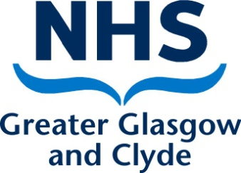
Gartnavel Royal Hospital
1055 Great Western Road
GLASGOW
G12 0XH

Tel. 0141-201-4444
Fax. 0141-201-4601
Textphone: 0141-201-4479
www.nhsggc.org.uk

Date: 5th February 2021
Our Ref: CK/EF

Enquiries to: Public Affairs
E-mail: PublicAffairs@ggc.scot.nhs.uk

Email: psimonel@gmail.com

Dear Mr Panaitescu

Re: Information regarding the COVID-19 vaccine

Thank you for your email of 5th February 2021 and for your interest in the COVID-19 vaccination programme. You have clearly invested a lot of time and effort in the email you have circulated to a variety of public services.

I can advise you that NHS Greater Glasgow and Clyde (NHSGGC) are following the guidance on the pioritisation of key groups for the vaccination which is determined by advice provided by the Joint Committee on Vaccination and Immunisation (JCVI). Nationally agreed priority groups have been identified and this determines the sequence that has and will be followed. The principles underlying the sequencing have been to prioritise the most vulnerable patients and staff groups based on potential risk.

The programme will continue as directed and the rollout is going as planned

Yours sincerely

Catriona Kent
On behalf of Public Affairs
NHS Greater Glasgow and Clyde

