NOTICE OF LIABILITY
ADDRESSED TO HEADTEACHERS & TEACHERS
CONCERNING THE HEALTH & SAFETY
OF CHILDREN IN SCHOOL

We, the members of the civic group ‘Unite for Truth’, feel compelled to address you in matters of the utmost importance that we think should be of great concern to you, as an educator, you have full liability for the health & safety of all the children present on the premises of the school during their hours of study.
We will first inform you about the general situation of covid vaccination according to recent data coming from official sources and experts, so you can fully understand the potential consequences of allowing the children under your supervision to be vaccinated against covid-19.
Despite the official messages that are repeated non-stop in the mainstream media, according to the opinion of expert doctors, these EXPERIMENTAL VACCINES AGAINST COVID appear NOT to significantly prevent infection or transmission of the disease. Since the introduction of these covid-vaccines in December, in less than two months. more than 7 million people have been vaccinated in the UK (10.79 of 100), which at a global level, amongst the more populated countries, was surpassed only by UAE (27.07) and Israel (47.9). The sharpest increase in covid deaths immediately followed: between 26 Nov 2020 and 26 Jan 2021 the number of covid deaths almost TRIPLED, which also amounts for THE GREATEST INCREASE IN BIWEEKLY DEATHS in the world.
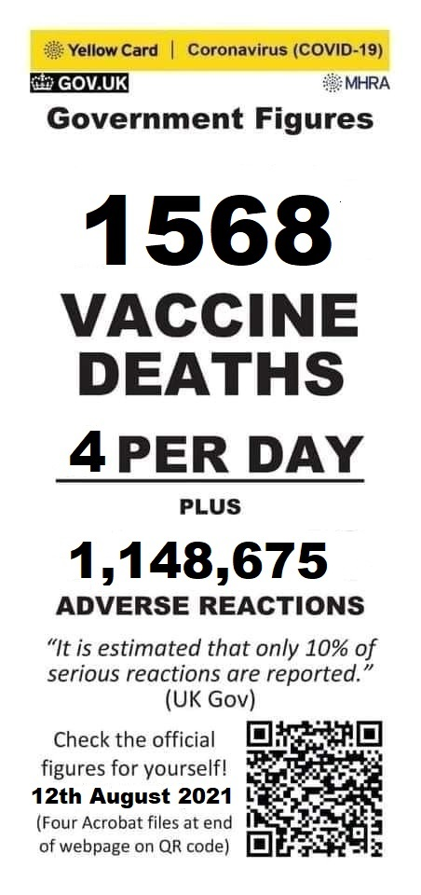
Public Health England (in the paper ‘SARS-CoV2 variants of concern and variants under investigation in England’ - 9 July 2021) revealed that with the Delta variant 68% of covid deaths in the people over 50’s were among the vaccinated and that, in fact, double vaccination increased the chances of death almost 10 fold! At the end of July, American CDC has admitted the reality of fully vaccinated people spreading the Delta variant.
Stunning rates of infection and hospitalization among vaccinated (breakthrough cases) are also confirmed by data coming from countries and states with even higher rate of vaccination that the UK, such as Israel, Gibraltar, Iceland, Singapore, California & Massachusetts, and also Bahrain, Seychelles, Maldives and Chile. Beginning of August 2021, 12 out of 13 countries on Johns Hopkins list of the most vaccinated are currently listed by the CDC as 'high' or 'very high' COVID-19 travel risk. A recent British article, using official data, shows that this year, despite the expectations related to the rollout of the vaccines, or rather proportional with it, in Scotland Covid-19 deaths are 44 times higher in July this year comparative to July 2020 and three quarters of the fatalities are among the vaccinated population.
So if the vaccines seem not to do very well in preventing covid infections and especially in reducing the risk of hospitalization and death, what they are however, really doing, is causing a huge wave of death, disability and sickness wherever they are deployed. Consider that the data recorded in the official databases MHRA (UK), VAERS (US) and EudraVigilance (Europe) - see pictures - admittedly represent just 1-10% of the real life events.

Again, despite the huge and unlawful censorship on both social and mainstream media, there are websites and groups which reveal the truth about the horrific reality of the covid-vaccines damage, some even among healthcare professionals. Most regrettably, due to the unjustifiable so-called emergency, this damage, no matter how severe and extended, incurs no liability for the vaccines producers or for any of the healthcare providers involved in vaccination.
The widespread vaccine damage, with the exception of myocarditis occurring mostly in young people and thrombocytopenia/ thrombosis (blood clots), has been officially ignored by the medical establishment, although whistleblowers and healthcare professionals are very much aware of it.

Now, the government pressures the British public towards the acceptance of kids’ vaccination, despite the fact that CHILDREN HAVE PRACTICALLY ZERO CHANCES OF DYING FROM COVID-19; in fact, to date, no healthy children have died of covid-19 and it is highly unlikely that they spread the disease. Moreover, according to experts’ opinions they have much more chances to be harmed by these new vaccines than the other age groups . Despite these strong arguments, articles in the mainstream press show a huge percentage of the people want to vaccinate their children, which is not only disputable, as it is much more than the percentage of all adults of parental age that have been vaccinated, but also constitute in itself, an argument for vaccination. Now, the 16 and 17 year olds can be already vaccinated without parental consent, as for the rest of the children a most immoral and unlawful plan has been put in place so to vaccinate them with or without parental consent, based on the inappropriate Gillick Competency concept. It is obvious that the absolute majority of the adults alive today in the UK and the world, including the healthcare professionals, have no competency in matters of experimental mRNA vaccines and have not been given the information necessary for an informed consent. How much less can the children have any competency on this issue?
Reality is that countless people have taken and are still taking the vaccines because of NOT BEING AWARE THAT THEY ARE PARTICIPATING IN A MEDICAL EXPERIMENT, A RUSSIAN ROULETTE that in just six months has killed much more than (the officially recorded)+ 34,000 people in the UK, US and EU, has injured and disabled millions and, according to the warnings of experts, is undoubtedly leading to a true pandemic of neurological, cardiovascular, auto-immune and reproductive diseases.
The VAERS database belonging to CDC in the US has recorded TWICE more deaths in the 7 months after the introduction of these experimental covid vaccines than from all the vaccines ever given to the American people in the last 30 years since its creation!
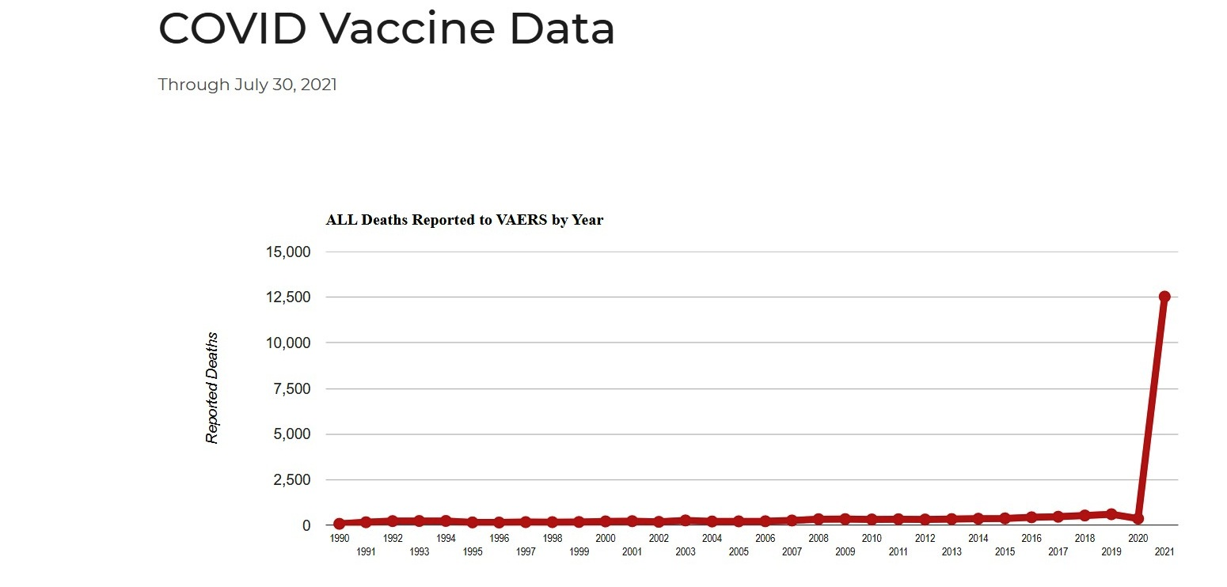
In Scotland as of 1st of August (thus during the last 17 months of pandemic) there have been a total of 10,370 deaths of covid (respectively, in less than a month since they had a positive covid test). According to a FOI request there have been 5,522 deaths within 28 days of having a Covid-19 vaccine during 6 months ending June 23, 2021. Consequently we have 152% more deaths/first month after vaccination than after a covid diagnosis.
In the UK, as revealed by a FOI request made to the MHRA, the number of deaths due to the Covid-19 jabs in the period December 2020 – June 2021 is over 5 times higher than what have been reported in relationship to all other vaccines in the UK since 2010, and the corresponding vaccine adverse reaction are more than 17 times higher than those resulting from all vaccinations in this period.
Shockingly though there is such an explosion of mortality after the covid vaccination, autopsies are not performed in such cases. However when such a most common medical procedure is allowed to happen, the results are more than concerning. As Daily Expose related on the 4th of August, “Researchers from Germany conducted the world’s first-ever postmortem study on a corpse that had been vaccinated against Covid-19 prior to their death. They discovered that every single organ of the deceased person’s body had become infested with spike proteins as a result of the vaccine”

EUROPE
USA
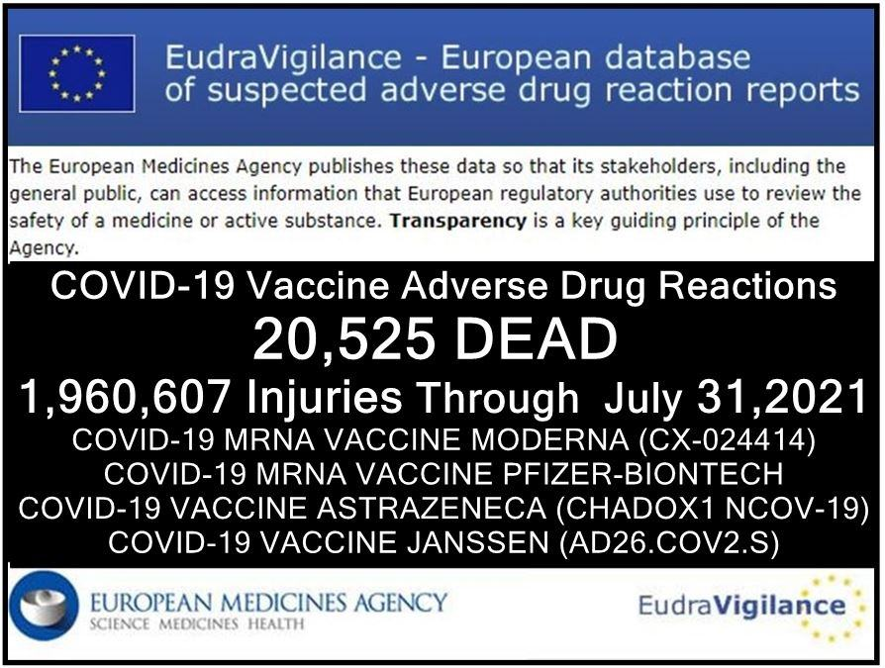
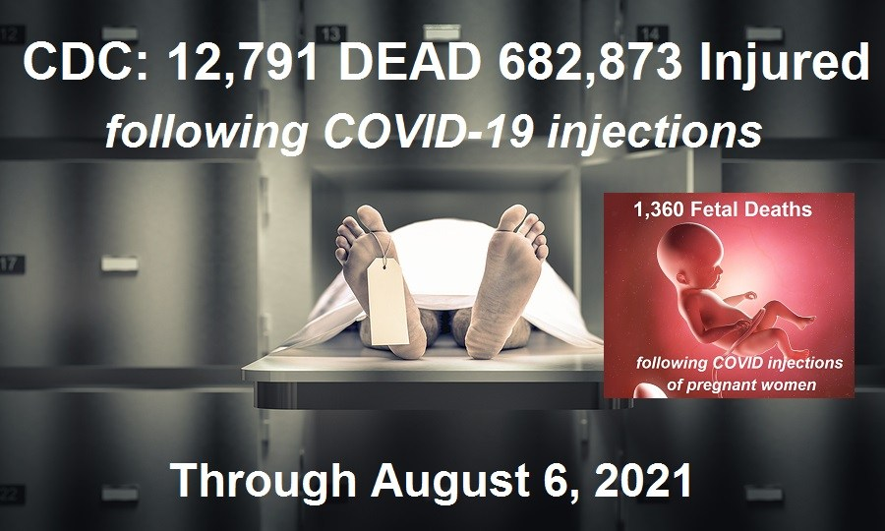
Not only that thousands of unborn children have died due to these shots being administered to their pregnant mothers, but according to the data presented by a study published in New England Journal of Medicine 86% of the pregnant ladies who got an mRNA shot (Moderna or Pfizer) in the first two trimesters of pregnancy have lost their unborn baby. Incredibly, UK and US are still advising pregnant women to take the shot despite these horrific statistics and the fact that no peer reviewed clinical study supports the safety of the immunization.

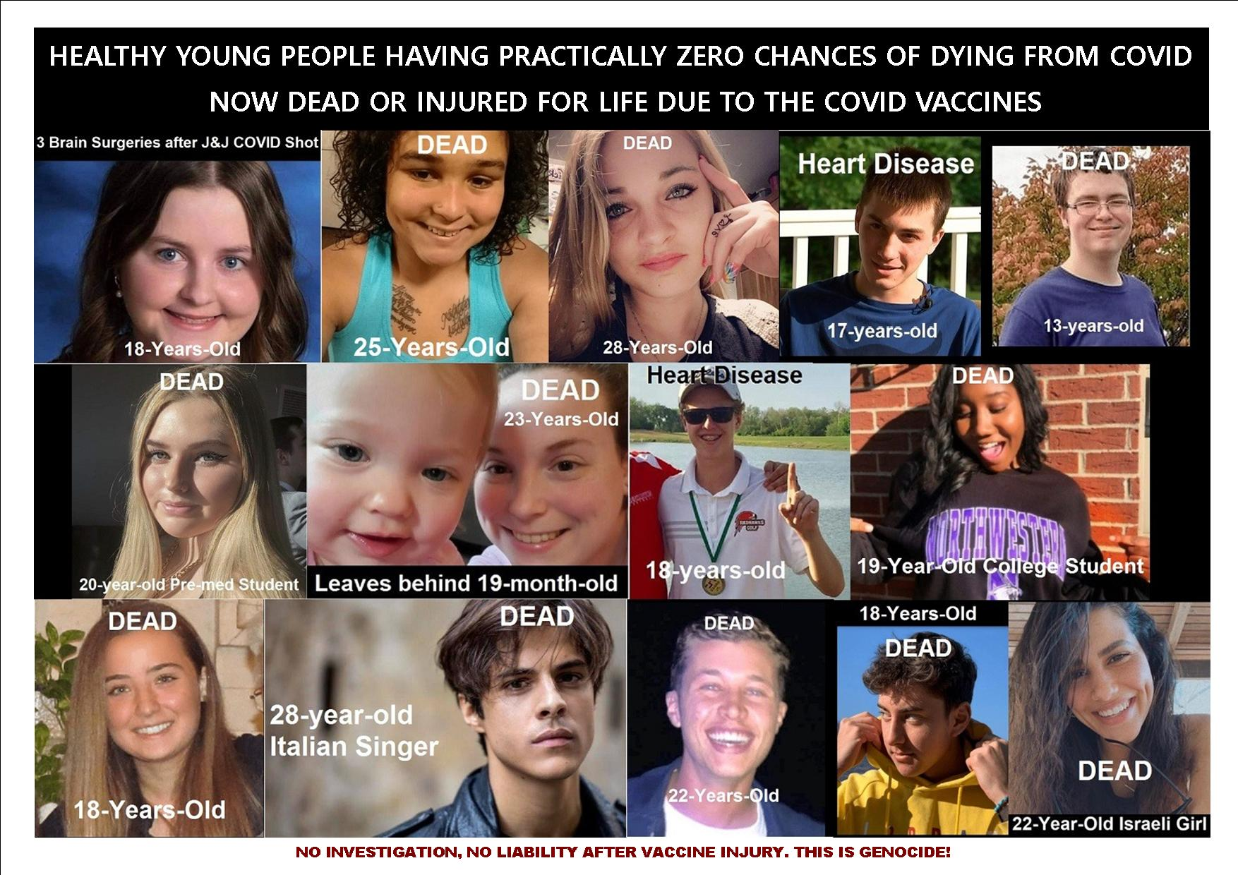

Eminent scientists and experts in microbiology, virology, vaccinology and medicine have raised their voices and severely warned against the roll-out of these vaccines, despite the global censorship of all covid vaccines’ criticism.Please look out for the following names of some of them on the independent platforms bitchute.com, rumble.com, odysee.com, healthimpactnews.com, highwire.com, mercola.com, naturalnews.com, childrenshealthdefense.com, lifesitenews.com, greenmedinfo.com, truthaboutcancer.com, ukcolumn.org, dailyexpose.com and you will be able to see their various critical testimonies and acknowledge their dire warnings concerning the dangers of these experimental vaccines.

DR. MIKE YEADON, ex-Pfizer head of respiratory research (“Look out the window, and think, “why is my government lying to me about something so fundamental?” Because, I think the answer is, they are going to kill you using this method. They’re going to kill you and your family,”) ’
DR. WOLFGANG WODARD, lung specialist and former head of the Public Health Department (“There is no indication whether antibodies against spike proteins of SARS viruses would also act like anti-Syncytin-1 antibodies. However, if this were to be the case this would then also prevent the formation of a placenta which would result in vaccinated women essentially becoming infertile.”)
Dr. Geerd Vanden Bossche, Vaccine Research Expert, worked for GAVI (“I am EXTREMELY CONCERNED ABOUT THE IMPACT CURRENT Covid-19 vaccines will have when increasingly deployed in mass vaccination campaigns conducted in the heat of a pandemic. Read my global WARNING & scientific evidence”: bit.ly/3q89hWZ)

Dr. Robert Malone, mRNA vaccines inventor (“I don't think the benefits outweigh the risks in that cohort,' said Malone, referring to people in the 18 to 22 age bracket, 'but unfortunately the risk-benefit analysis is not being done[…] these are experimental vaccines.” )

DR. Byram Bridle, viral immunologist, & associate professor (“We made a big mistake creating the covid vaccines”; “We have known for a long time that the spike protein is a pathogenic protein. It is a toxin. It can cause damage in our body if it gets into circulation.”)

Dr. Richard Fleming Physicist—Nuclear Cardiologist (“Doctors, if you are participating in this, you are violating the AMA Code of Ethics. Informed consent is not provided”)

DR. ROGER HODKINSON pathologist, expert in infectious disease, virology and evidence-based medicine (“Let me just paint the big picture here for the contrast between vaccinations and other forms of therapies. If in fact this is an emergency as they claim, which I contest, but let’s take their word for it, they are using it to vaccinate people without an appropriately tested vaccine. If you accept that a potentially dangerous vaccine, for which there is growing evidence of danger, contrast that with the prohibition of physicians to prescribe Ivermectin, or vitamin D for that matter.”)

PROF. LUC MONTAGNIER virologist, 2008 Nobel Prize for his discovery of HIV (“We’re in unknown territory and proclaim mandatory vaccines for everyone. It’s insanity. It’s vaccination insanity that I absolutely condemn”.)

PROF. JAMES LYONS-WEILER PHD, founder of the "Institute for Pure and Applied Knowledge, microbiologist and genetician (“The public needs to understand that tens of thousands and, soon, hundreds of thousands of medical doctors around the world are going to join me and others in condemning the politicization of coronavirus and public health, in general, including vaccines.”)

Dr. FRANK SHALLENBERGER, MD, HMD ‘The Nevada Center of Alternative and Anti-Aging Medicine (“Absolutely no long term safety studies will have been done to ensure that any of these vaccines don’t cause the cancer, seizures, heart disease, allergies, and autoimmune diseases seen with other vaccines. If you ever wanted to be guinea pig for Big Pharma, now is your golden opportunity” )

PROF. DOLORES CAHILL, microbiologist, founder and president of World Freedom Alliance (“I have said if you paid me £10 million I would not take [a vaccine], and if anyone forcibly injected me like they can potentially try to do in Australia, I would sue someone for attempted murder.”)

Dr. MARK TROZZI, ER medic, Advanced Trauma Life Support , professor— College of Surgeons of America (“With many people falling ill and dying after the injection, the criminal covid enterprise, consistent with their strategies so far, may use propaganda and deceive people so they do not realize that the injections, not covid, are the real danger. Instead, they are fooled into thinking that there is more covid, that covid not the shots are the danger, and that there are more dangerous variants causing all the sickness and death. The MSM propaganda will preach that there are “more cases and deaths”, and that will cause more unsuspecting victims to run for the injections.
Meanwhile, like all the experimental animals in the past, the injected people will get very sick and have high death rates from coronaviruses, thanks to antibody dependent enhancement.”)

Dr. Judy Mikovitz PhD, virologist, author of the bestseller ‘Plague of Corruption’, no 1 on Amazon charts (“Most people don’t realize the vaccines do not prevent infection. You’re injecting the blueprint of the virus and letting a compromised system try to deal with it. And worse, it doesn’t go in the cells that a natural infection would, that have lock and key receptors, gatekeepers, so that only certain cells can be infected, like the upper respiratory tract for a coronavirus. Now you’re making it in a nanoparticle which means it can go in every cell without that receptor. So, can you imagine the damage of bypassing God’s natural immunity and allowing the blueprint for coronavirus that also has components of HIV in some strains, meaning you can infect your white blood cells. So now you’re going to inject an agent into every cell of the body. I just can’t even imagine a recipe for anything other than what I would consider mass murder on a scale where 50 million people will die in America from the vaccine.”)

DR. ROBERT YOUNG, expert in cellular nutrition, biochemistry and microbiology (“Currently, over 70 percent of adolescents, ages 12 to 17 are being hospitalized for heart inflammation directly related to the experimental mRNA Pfizer and Moderna inoculations.”)

Dr. Peter McCullough, Internist, Cardiologist, Epidemiologist (““We have now a whistleblower inside the CMS, and we have two whistleblowers in the CDC[…]We think we have 50,000 dead Americans. Fifty thousand deaths. So we actually have more deaths due to the vaccine per day than certainly the viral illness by far. It’s basically propagandized bioterrorism by injection.”)

DR. LEE MERRITT, military doctor and bioweapons expert, former head of the American Association of Physicians and Surgeons (“I’m just shocked that people who wouldn’t buy the first edition of a new car line […] are willing to get into this and have an experimental vaccine with an agent that they know nothing about – it’s not even a vaccine, really, is an experimental unapproved genetic agent they know nothing about it, their doctor doesn’t really know about it, in fact nobody except the people on the top of the research know what’s in it, because there has been no independent analysis and… the animals died in the animal studies…I mean… it should be a clue also that you cannot have this thing at the pharmacy, you have to go some place where you can be resuscitated…”)

DR. JOSEPH MERCOLA, osteopathic physician, bestselling medical author (“Even if vaccinating children were found to reduce infection among adults, it would be unethical and against regulations to do so, because the FDA can only authorize the use of a medical product in a given population if the benefit outweighs the risk in that same population, and in children the benefits do not outweigh the risks”)

PROF. CHRISTIAN PERRONNE, Professor of Infectious and Tropical Diseases at the Faculty of Medicine of Paris-Ile de France-Ouest, chief of a Department of Infectious Diseases at the Raymond Poincaré University Hospital, past vice-president of the European Advisory Group of Experts on Immunisation (“It’s not actually a vaccine. There is deception here. This is a vaccine like Moderna and Pfizer which is not a vaccine. This is actually a product of Ribonucleic Acid (RNA) gene therapy. What does this mean? In other words, they inject you with a type of Ribonucleic Acid called “messenger” RNA. This messenger RNA will encode your cells for the corona virus fragment.
Here we are playing a wizard apprentice game, because this technique is only used for vegetables, genetically modified organisms, just like tomatoes and corn. However, this has never even been tested on animals on a large scale, so humans have become the first mouse in the lab with this type of technology on earth.
It may be effective, but it was completed hastily in 2 months. If your cells, based on your genetic status, produce much more virus particles than expected, it may cause catastrophic consequences in your body” – December 2021)

Dr. IGOR SHEPHERD, Russian expert in biowarfare, ex-manager Wyoming’ State Public Health Department/Preparedness Unit, Covid response team (“Corona Virus Vaccination is a BIOLOGICAL WEAPON OF MASS DESTRUCTION. I call it the 3G: GLOBAL GENETIC GENOCIDE. And this is coming. Not only to the United States, but to the whole world.”)

DR. SUCHARIT BHAKDI, award-winning doctor and scientist, former head of the Institute of Medical Microbiology and Hygiene, co- author of the best-seller “Corona, False Alarm” (“Not only the second shot, but any shot thereafter is gonna place your life in danger, that is I am convinced of now.”)

Dr. GÉRARD DELÉPINE, Oncologist, Orthopedic Surgeon, and Statistician at the Raymond Poincaré Hospital (“Since this period, vaccination campaigns have spread worldwide even to countries where covid was not present. And everywhere they have been followed by a dramatic rise in new infections and mortality for several weeks or months”)

DR. HEINRICH FIECHTNER, haematologist and oncologist, member of the state parliament in Baden-Württemberg (“I’ve said it before: it’s a killer vaccine. It’s a pharmaceutical product for which there isn’t even a toxicology report. It’s just going to be given to people. There’s a possibility that it may cause infertility in women, severe allergic reactions, and you want to inflict this unreasonable imposition upon citizens. That’s right, and you will, because you made them afraid beforehand. You are putting the lives of citizens at risk. You’re putting existences at risk.”)

DR, SHERRY TENNPENNY, osteopathic medical doctor, board certified in three medical specialties, vaccine expert (“The end result is to create a spike protein in your body, which is a foreign protein – there’s billions of particles of spike proteins that we know have caused direct harm. Once that process has been started is like having an on button with no off button.”)

DR. CARRIE MADEJ, osteopathic internal medicine physician, ex-medical director of three private clinics (Why we’re not allowed to know everything inside there, that’s being injected inside a person and how can we help with any negative side effects that are happening if we don’t have any knowledge about this? These are crimes against humanity… So once we understand what we’re dealing with, yes there’s always a solution, but don’t get any more injections if we don’t know what we’re putting in people! This is crazy!”)

DR. LARRY PALEVSKY, paediatrician (“What’s in the shot is not meant to protect us againt SARS-Cov2 infection. Now, when we look at the literature from 2020 and we see that people were getting illnesses of blood disorders, lack of oxygen –hipoxia, lung disease, clotting disease, strokes, hypertension, hypotension, loss of taste, loss of smell, neurological issues… this was not a viral illness, this was the clinical presentation of a poisoning of the blood and all of the literature shows that the spike protein of this so-called virus was responsible for causing all of these symptoms […] This spike protein is not a naturally occurring thing, is a man-made weapon.[…] So why, in God’s name, are we ok with injecting something into the body that’s going to cause all of us to make spike protein?”)

DR. CHRISTIANE NORTHRUP OB-GYN, medical bestseller author and leading authority in the field of women’s health and wellness (“It has never been a vaccine like this. It’s an RNA vaccine, it’s what’s called ‘transinfection’, It will fundamentally change people’s DNA and what I don’t like about it even more than the usual thing about the toxic metals that are in vaccines and make our bodies literally into an antenna – with 5G, this one has the usual non-human DNA, like you know, monkeys, maybe foetal cells, pigs whatever, so it begins to make us what’s called chimeras…”[…] this vaccines will have nanoparticles that are in fact, actually, little robots, like little antennas and they will have the ability to take your biometric data, not only your vaccine record, but your breathing, your heart rate, your activity, sexual activity, these drugs that you’re taking, where you travel, all of that and then take that data and store it in the cloud…”)

DR. ANGELINA FARELLA, AFLDS Pediatric Medical Director (“We’ve never seen this level of side effects for any vaccine without the FDA taking action. The Rotavirus vaccine was pulled for 15 cases of non-lethal side effects and the Swine Flu vaccine was pulled for 25 deaths. But now, by the CDC’s own data, we are seeing a 12,000 percent increase in deaths with these vaccines and they’re still talking about giving this to our kids.”)

DR. TESS LAWRIE, Director of the Evidence-based Medicine Consultancy Ltd and EbMC Squared CiC (“The Existing Yellow Card data covering just under a five-month period indicate that the extent of morbidity and mortality associated with the COVID-19 vaccines is unprecedented.[…] In addition, urgent independent expert evaluation and discussion is required to assess whether the novel vaccines may be causing gene mutations among recipients, as suggested by the occurrence of usually extremely rare genetic disorders, such as Paroxysmal Extreme Pain Disorder (PEPD)”)
DR. JANE RUBY, medical professional and a pharmaceutical drug development expert, health economist at Ruby Health Consulting (“These graphene sheets that investigators found in the Pfizer vial, when they get into your system and when they start to penetrate your cells – which they have a lipid nanoparticle that pushes them into your cells – you get oxidative stress…
It destroys literally everything inside the cell. It explodes the mitochondria. It creates a situation where the body is on a 10-Alarm fire truck and inflammation, cytokines, chemokines. This incredibly violent… inflammatory storm comes in and it has particular affinity for creating acute inflammation of the lungs, it creates an inflammatory storm in cardiac tissue and in brain tissue. […] this is going to tie directly to strokes, to the heart attacks – and we’re giving this to pregnant mothers and babies?”)

SENATE COMMITTEE ON STATE AFFAIRS – US (“In the four months of 2021 we had more covid-19 experimental vaccines deaths than all the vaccine deaths for the 15 year period between 1997 and 2013 plus almost a hundred heart attacks and over 8 thousand hospitalizations[…] In 1976 45 million people were vaccinated for swain flu. A mere 53 people died, and I don’t say that lightly because any death is very regrettable, but the program was immediately halted because it was considered too risky…. 53 death… and we are approaching 4000 with the covid vaccines.” (May 2021))

For a compilation of medical testimonies, see also: DOCTORS AROUND THE WORLD ISSUE DIRE WARNING: DO NOT GET THE COVID VACCINE!!

Most people that have received these covid vaccines do not know that they all are still in their experimental phase (until 2023) and that they have not been licensed, but have just emergency use authorisation. In order for this authorisation to be given, there should be no other available, safe and effective treatments for covid-19 and the lethality of SARS-Cov2 should justify the declared global pandemic.
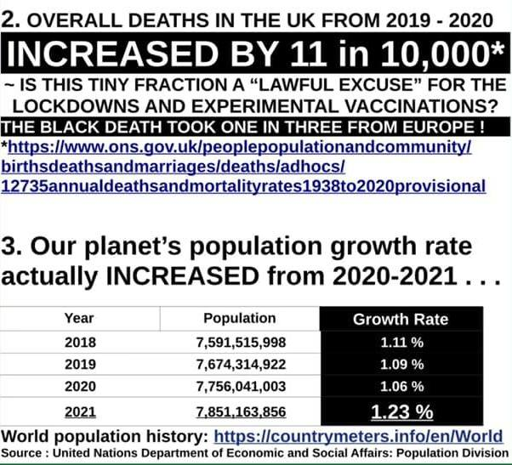
However, starting with February 2020 (in the case of China) there have been medical treatments in place that have saved many thousands of lives such as IV Vit. C, HCQ protocols, IVERMECTINE, CHLORINE DIOXIDE, Budenisode (corticosteroids), Vit. D/ Caldifediol etc, but these have been forbidden in the UK, USA and other Western countries by political decree and the consequent unlawful and inhumane suppression of the freedom of speech and practice of the healthcare professionals.

As far as the pandemic is concerned, it is most relevant to observe that in 2020 there were no notable excess deaths in the UK and, generally speaking, in the world

According to a British Medical Journal study, in 2020 there were more deaths per 100,000 population than in the previous 17 years, but less than in all years before 2003; there was also less age standardised death rate per 100,000 population than in all years from 1943 to 2008.
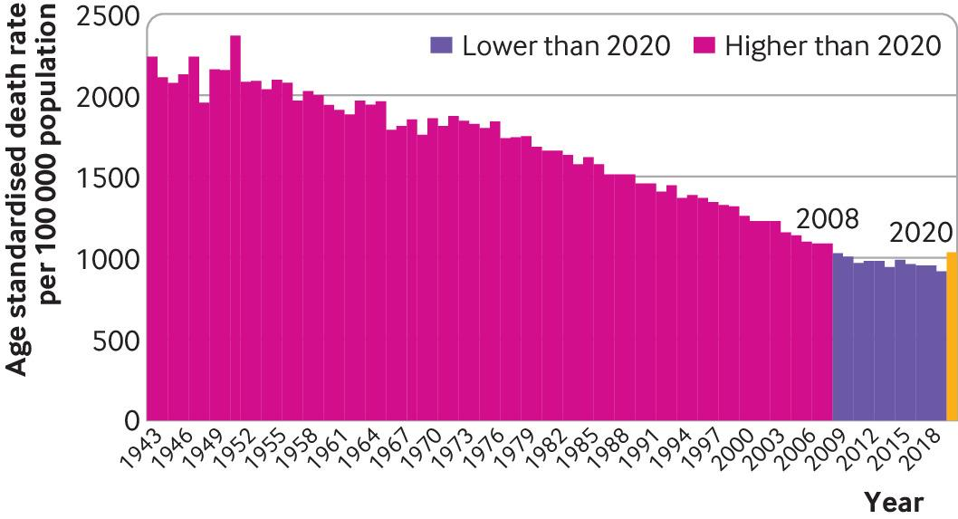

Cancer for example is many times more of a killer pandemic than covid-19 and we never shut down our society due to it.
The entire pandemic construct has been based on the extremely disputable use of the PCR test for the detection of SARS-Cov2, which has been invalidated by its own inventor, Nobel Prize winner dr. Karry Mullis and by numerous other medical authorities, not to mention the US - FDA manual of the test itself.
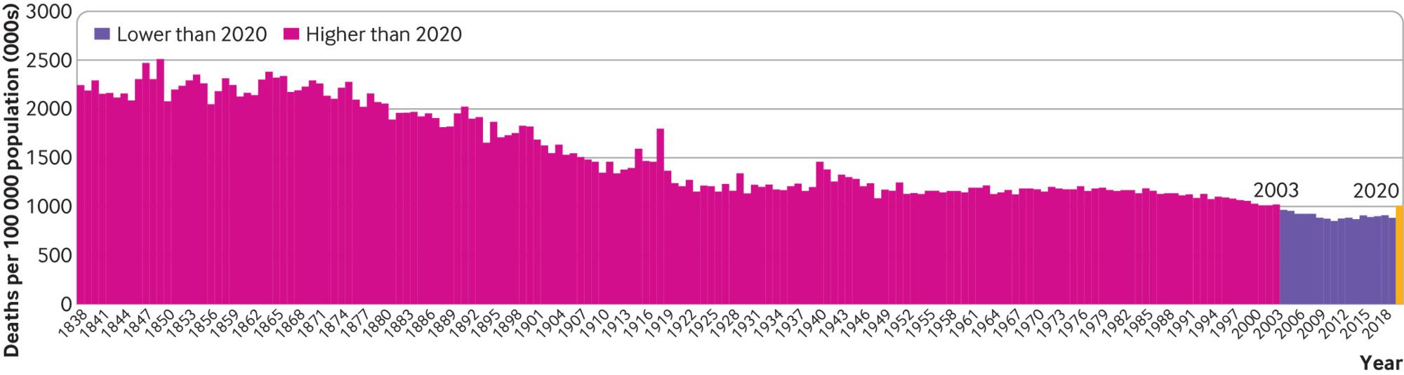
In this light, the government imposed lockdowns, covid legislation and regulations appear unfortunately as immoral, tyrannical means that have uselessly deprived countless people of their basic human rights and indiscriminately destroyed numerous lives.
The necessity and efficacy of all these truly draconian measures have been fundamentally challenged by thousands of doctors and experts world-wide, despite an extreme censorship and repressive professional policies. Please have a look at the open letter of the World Doctors Alliance, The Great Barrington Declaration (signed now by almost 58,500 Healthcare Professionals and experts and almost 800,000 citizen) and the multidisciplinary experts group PANDA Protocol for Re-opening Society
The impact of these pandemic-related measures on the population is in itself genocidal at a global scale. Never before in human history have been healthy people forced into quarantine; putting entire nations in lockdown has never been even conceivable. Moreover the pathogen known as SARS-Cov2 was surely not the black death. The majority of the people diagnosed as covid positive had been asymptomatic, therefore not having any recognizable symptoms, while the majority of the symptomatic had only mild symptoms not necessitating hospitalization; according to reliable studies and sources, with few if any exceptions, the asymptomatic appear not to have spread the disease either.

It is undeniable that many people have died as covid positive and a part of them with specific severe symptoms of the disease, with the absolute majority elderly persons, above the age of 80. However it is also undeniable that the lack of any meaningful medical intervention, especially in care homes, combined with shocking end-of-life protocols and the widespread, almost always fatal use of ventilators have greatly contributed to this. We can also observe that according to governmental reports in Scotland, UK and US, the absolute majority of the people who died with a covid diagnosis have been elderly, having also underlying conditions which in themselves could have been a cause of death. CDC admitted that only 6% of the Covid deaths were, as recorded on the death certificates, only due to covid. In the UK covid only - deaths were just 5% of all reported ones, and in Scotland, according to FOI and governmental stats, covid only - deaths were less than 4%. According to the best estimate of CDC, IFR for covid-19 last year wass less than 0.5% for the ones aged below 70 and 5.4% for the ones above 70
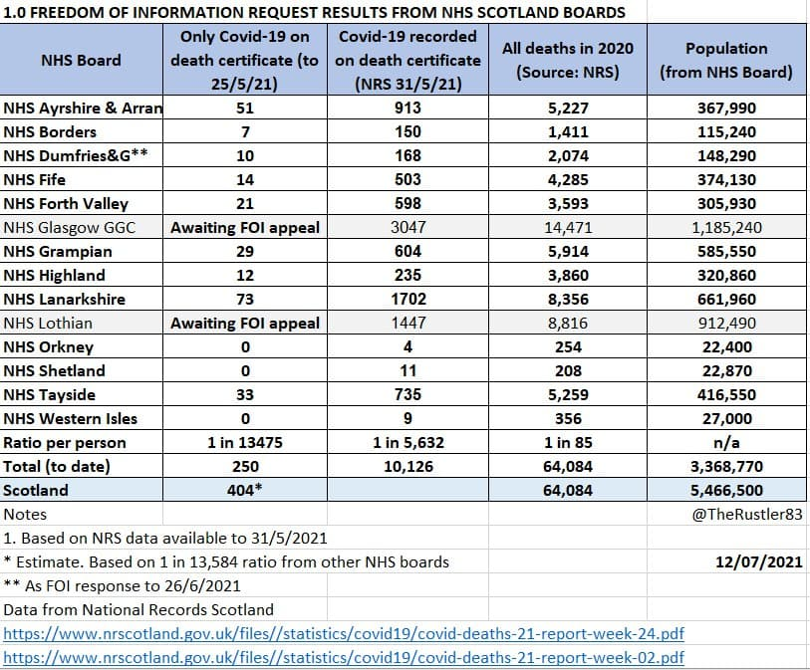
The following arguments dealing with international and national conventions on human rights, bioethics, ethics in medicine etc add up to the case of genocide and crimes against humanity committed against the British people via experimental vaccination and associated propaganda.

TRESSPASSES OF INTERNATIONAL LAWS AND REGULATIONS

First, let’s note that the official (NIH, MSM) recognition of the experimental character of these new covid vaccines, which according to their own documents, are running the phase III of their trials in 2023, already confirms the case for the TRESPASSING OF ALL NUREMBERG CODE PROVISIONS.

“1. The voluntary consent of the human subject is absolutely essential.” – this is lacking as no recipients of the vaccines are informed of the deaths and injuries recorded in the official databases (MHRA – UK, EudraVigilance-EU, VAERS-US) and not even of the predicted adverse events according to previous official assessments such as the FDA Safety Surveillance of COVID Vaccines from 22 October 2020 by Steve Anderson PhD which listed among the possible adverse effects death, anaphylaxis, severe neurological and cardio-vascular conditions, autoimmune diseases, vaccine enhanced diseases etc. Let’s note also that until today FDA, same as all other state regulators have not licensed these experimental shots – they all have just an emergency use authorisation, which is justified by the humanitarian crisis create by the pandemic (contradicted however by the lack of notable excess death for 2020) and the lack of alternative safe and effective treatments (contradicted by the existence of the above mentioned viable treatments that have already saved hundreds of thousands of lives worldwide)

“2. The experiment should be such as to yield fruitful results for the good of society, unprocurable by other methods or means of study, and not random and unnecessary in nature.”
Recipients are generally unaware that the products are unlicensed and have only emergency use authorisation. Nor are they aware that there are safe and efficacious treatments that if allowed, would have made impossible any continuation of the state of emergency.

“3. The experiment should be so designed and based on the results of animal experimentation and a knowledge of the natural history of the disease or other problem under study that the anticipated results will justify the performance of the experiment.”
No animals studies have been published, as confirmed by America’s Frontline Doctors and numerous other experts. The Governments, while introducing and greatly promoting these vaccines to the public, have not provided any example of published (not to mention peer-reviewed) animal studies. Moreover, as publicly affirmed in a Texas Senate Committee by experts and also by several independent doctors, there have been such trials for covid vaccines on mice and rats, but most of the animals died.

4. The experiment should be so conducted as to avoid all unnecessary physical and mental suffering and injury.

5. No experiment should be conducted where there is an a priori reason to believe that death or disabling injury will occur; except, perhaps, in those experiments where the experimental physicians also serve as subjects.
These two, maybe the most important provisions of the Nuremberg Code have been fatally trespassed by the rollout of these experimental covid vaccines, which have left behind a trail of death and injury like no other medical products in history. At the end of July 2021, as shown above, more than 33,982 deaths and millions of injuries were officially recorded in the governmental databases of UK (MHRA), EU (EudraVigilance) and US (VAERS) without the companies or anybody else involved in their rollout and delivery to be held liable for this. Despite criminal censorship on social media (FB, YT, Instagram, Google, Twitter, Vimeo etc) which has taken down countless testimonies of covid vaccine injuries, now thousands of them can be found on alternative platforms and we provided some references in this letter.

6.The degree of risk to be taken should never exceed that determined by the humanitarian importance of the problem to be solved by the experiment.
The humanitarian aspect of the so-called pandemic has never been a matter of concern for the authorities, or else they would not have been promoting censorship, not have interfered with the practice of medical profession (like never before in history), not have persecuted and gagged numerous healthcare professionals who simply tried to do their job and help their patients and not have forbidden treatments that have been proven by science and medical practice to work and save lives (thus trespassing The Declaration of Helsinki II 1, 6) Also let’s state again that due to the lack of excess death and misdiagnosing covid-19 with the flawed PCR test, it appears that there has never been a humanitarian medical emergency nor at the national neither international scale. For more reference, on the side of expert opinions in matters of virology and microbiology, please see dr. Sucharit Bhakdi and dr. Karina Reiss bestseller: “Corona? False Alarm”, Dr. Mikovitz’s bestseller Plague of Corruption: Restoring Faith in the Promise of Science (Children’s Health Defense) and the soon coming Ending Plague: A Scholar's Obligation in an Age of Corruption (Children’s Health Defense)

7. Proper preparations should be made and adequate facilities provided to protect the experimental subject against even remote possibilities of injury, disability, or death.
As very well known by the public, people have not been provided with any particular protection beyond their brief period of participating in vaccination (and eventually another half an hour after meant to supervise their condition for any possible allergic reactions). People have been sent home without being given any notice that they can expect severe pain, injury, disability or death, as these possibilities have been permanently denied by governmental officials and medical authorities, though they appeared even in the trials’ papers . No mention of these is put out on the NHS website. MHRA chief, June Rainey, while publishing weekly the horrific reports of such events following covid vaccination in the UK, has persistently denied that there is a correlation between these and the vaccinations; however, no medical assessments or autopsies have been performed to back her claims up despite pressure coming from experts. Maybe the fact that MHRA has been sponsored by Bill & Melinda Gates Foundation, the no 1 supporter of vaccination worldwide and that the Government has also been partnering with them could explain the obvious bias.

8. The experiment should be conducted only by scientifically qualified persons. The highest degree of skill and care should be required through all stages of the experiment of those who conduct or engage in the experiment.
Obviously, in no case has this imposition been fulfilled outside of the official trials for covid vaccination. None of the other vaccinations performed on people world-wide have involved scientists’ oversight or scientific evaluations of the cases. In fact, in UK’s case, none of the people in authority involved in the roll-out of these vaccinations, starting with the prime minister, advisors and ministers, MPs, JCVI, MHRA, NHS staff, GP’s, healthcare practitioners, vaccinators etc has got any scientific expertise in mRNA or DNA vaccination, therefore no understanding of the risks-benefits associated with this experiment, nor the knowledge required to remediate any possible injuries induced by it.

9. During the course of the experiment the human subject should be at liberty to bring the experiment to an end if he has reached the physical or mental state where continuation of the experiment seems to him to be impossible.
Obviously, the experiment refers not only to what is unfolding during the short duration of vaccination in itself, but also in regards to what this causes in the human body on a short, medium and even long term. Once vaccination is performed, the recipients have no means to stop the adverse reactions, unless specific medical assistance that can deal with such issues is offered to them – and as said before, this medical knowledge of treating spike protein/ mRNA, DNA vaccines damage was not acknowledged as existing by the officials in the medical establishment, who went so far as to indoctrinate the healthcare professionals that the milder adverse reactions vaccinated people reported should be deemed positive signs that ‘the immune system is working’. However, experts such as dr. Sucharit Bhakdi, dr. Peter Mc Cullough, dr. Sherry Tennpenny, dr. James Lyons-Weiler, dr. Lee Merritt, dr. Arvind Joshi and many others have shown that these symptoms are also signs of potentially severe damage, especially when dealing with the brain and the circulatory system, and that they should have required immediate medical intervention.

10. During the course of the experiment the scientist in charge must be prepared to terminate the experiment at any stage, if he has probable cause to believe, in the exercise of the good faith, superior skill and careful judgment required of him that a continuation of the experiment is likely to result in injury, disability, or death to the experimental subject.”
Again (see number 8), with these experimental vaccines forced on an unsuspecting population lacking informed consent, same as most of the health care professionals involved in this rollout, there was no scientific supervision of the vaccination and the effects of it and not even an honest reporting and investigation of them, in order to prevent further harm.

Now that we made clear that NO voluntary consent that is also an informed one has been facilitated for the tens of millions of the recipients of these experimental products in the UK, let’s also show that this is obviously in breach of the provisions of the International Covenant on Civil and Political Rights (ICCPR Treaty on Human Experimentation ), the Universal Declaration of Human Rights, the Declaration of Helsinki 1964 concerning the International Research Ethics, the WMA International Code of Medical Ethics, Patients Charter England, NHS Constitution England, The Charter of Patient Rights and Responsibilities (NHS Scotland) and the UK Supreme Court ruling in Montgomery case (2015) as follows:

INTERNATIONAL COVENANT ON CIVIL AND POLITICAL RIGHTS (ICCPR Treaty on Human Experimentation) – Art. 7: “No one shall be subjected to torture or cruel, inhuman or degrading treatment and punishment (also common with THE UNIVERSAL DECLARATION OF HUMAN RIGHTS Art.5). In particular, no one shall be subjected without his free consent to medical or scientific experimentation.”

DECLARATION OF HELSINKI 1964: A Set of Ethical Principles for Conducting Human Research -
All the Basic Principles of Biomedical research involving human subjects (as this is definitely the case with these unlicensed experimental vaccines) are trespassed. The most obvious are the following:
- 3. Biomedical research involving human subjects should be conducted only by scientifically qualified persons and under the supervision of a clinically competent medical person. The responsibility for the human subject must always rest with a medically qualified person and never rest on the subject of the research, even though the subject has given his or her consent.
- 4. Biomedical research involving human subjects cannot legitimately be carried out unless the importance of the objective is in proportion to the inherent risk to the subject (N.B: this risk which for example, in matters of sensitivities to the components of the vaccines is admitted in the papers for Healthcare providers and patients – Ex. Reg 174, Pfizer – is not individually assessed as necessary, Furthermore, the risk of death and severe disability or disease as seen with these vaccines cannot be justified by the 99.9% risk of death in the case of covid-19 for people younger than 70 and 94.6 for the rest)
- 5. Every biomedical research project involving human subjects should be preceded by careful assessment of predictable risks in comparison with foreseeable benefits to the subject or to others. Concern for the interests of the subject must always prevail over the interests of science and society.
- 6. The right of the research subject to safeguard his or her integrity must always be respected. Every precaution should be taken to respect the privacy of the subject and to minimize the impact of the study on the subject's physical and mental integrity and on the personality of the subject.
- 7. Physicians should abstain from engaging in research projects involving human subjects unless they are satisfied that the hazards involved are believed to be predictable. Physicians should cease any investigation if the hazards are found to outweigh the potential benefits.
- 9. In any research on human beings, each potential subject mus be adequately informed of the aims, methods, anticipated benefits and potential hazards of the study and the discomfort it may entail. He or she should be informed that he or she is at liberty to abstain from participation in the study and that he or she is free to withdraw visor her consent to participation at any time. The physician should then obtain the subject's freely given informed consent, preferably inheriting.
- 10. When obtaining informed consent for the research project the physician should be particularly cautious if the subject is in dependent relationship to him or her or may consent under duress. In that case the informed consent should be obtained by a physician who isn't engaged in the investigation and who is completely independent of this official relationship.
- 11. In case of legal incompetence, informed consent should be obtained from the legal guardian in accordance with national legislation. Where physical or mental incapacity makes it impossible to obtain informed consent, or when the subject is a minor, permission from the responsible relative replaces that of the subject in accordance with national legislation. Whenever the minor child is in fact able to give a consent, the minor's consent must be obtained in addition to the consent of the minor's legal guardian.

WMA INTERNATIONAL CODE OF MEDICAL ETHICS
“A physician shall act in the patient’s best interest when providing medical care, owing his/her patients complete loyalty and all the scientific resources available to him/her. Whenever an examination or treatment is beyond the physician’s capacity, he/she should consult with or refer to another physician who has the necessary ability.”

PATIENTS CHARTER ENGLAND: “You have the right to: have any proposed treatment, including any risks involved in that treatment and any alternatives, clearly explained to you before you decide whether to agree to it”
NHS CONSTITUTION ENGLAND: “You have the right to accept or refuse treatment that is offered to you, and not to be given any physical examination or treatment unless you have given valid consent. If you do not have the capacity to do so, consent must be obtained from a person legally able to act on your behalf, or the treatment must be in your best interests”
THE CHARTER OF PATIENT RIGHTS AND RESPONSIBILITIES from NHS SCOTLAND (page 3): “your rights to have a say about your treatment or care and to have any concerns and complaints dealt with.” and at page 13: " I have the right to accept or refuse any advice, care or treatment, examination, test or screening procedure that is offered to me, or to take part in research. To accept or refuse any of these, I must understand the information I have been given and I must be capable of making a decision for myself. If I refuse any care and treatment, this will not change the way I access or receive care and treatment from NHS staff in future”.
Health professionals are also under OBLIGATION to comply with the MONTGOMERY JUDGEMENT passed back in 2015 in the UK Supreme Court .
“The argument in this appeal was that is not appropriate to use the accepted practice of a body of reasonable medical practitioners when consent is considered. It should be viewed differently from the process of diagnosis or treatment. The relevant guidance from the GMC was reviewed and this supported the argument that it was the doctor’s role to provide a patient with all the information to allow them to make a balanced judgment between different options.”

Summarizing all the above, healthcare professionals are LEGALLY required to discuss the 'risks and benefits' of any medical intervention and even if the person lacks capacity (as many of the residents living in care homes or in other healthcare settings do), they need to inform the legal guardian or person having the power of attorney and in case there is no such person, they have to be able to demonstrate that the medical procedure was in the best interest of the patient. Of course with these rushed experimental vaccines, supported by a technology never used on humans before, and according to the producers’ own documents, having unknown long term risks, geno-toxic risks, auto-immunity risks, risks of interfering with other vaccines and medication etc no such discussion targeting an informed consent was even possible.
Also considering the millions upon millions of recorded severe adverse reactions that consist or are accompanied by great, sometime permanent pain: the most various temporary and permanent diseases and disabilities, not to mention the often agonizing deaths, these vaccines can be correctly identified as means of bodily harm or cruel and inhuman treatment that are absolutely forbidden according to the Human Rights Act 1998 in the UK, and internationally, the United Nations Convention against Torture. Any such means inflicting cruel and inhuman treatment or torture on people, be they even a minority of those confronting with these means, cannot be called MEDICAL, BENEFICIAL and THERAPEUTIC and need to be absolutely prohibited.
According to the Human Rights Act 1998, every person’s body is ‘inviolate’, and an individual cannot be considered as consenting to bodily harm; any consent given to vaccination in the absence of relevant information concerning its potential dangers and in the presence of deceitful promotion of its advantages or under duress, through unlawful economic, social and psychological harassment is in itself just the consequence of a crime perpetrated against the individual. Moreover, as far as mandatory vaccination is considered, any unrequited intervention on a person’s body (interference) pertains to ‘the offence of common assault and the tort of battery.
The Equality Act 2010 confirms every person’s right to hold on to their religious and philosophical beliefs. The belief that all these fundamental conventions and laws we mentioned above are not only compelling but also very necessary and good for the individual and the society, needing to be preserved at all time, cannot be legitimately refuted. This is a belief that at the core of all good conventions and laws stands the innate human conscience testifying of the fundamental love and care for the fellow human, which is forever incompatible with any form of deceit, manipulation and infliction of pain, suffering and death.

Finally, speaking about the associated means of propaganda, respectively deceit and manipulation, let’s add here the critical arguments leading to moral caution, that the main companies (Pfizer, Astrazeneca) our government is relying on saving the lives of (in majority healthy) people from the PCR diagnosed Covid-19, have got a very disturbing record of legal violations , Moderna has never produced a vaccine before and all covid vaccines producers have no liability for any damage produced by these experimental products.

In consequence we want to assure you that any medical intervention such as vaccination upon our children inside your school will immediately call all legal and criminal liability for the consequences of this on our children’s health and lives to fall on your shoulders, as a person responsible with caring for their health and safety while they are present on the premises of the school.

Similarly, we are holding you and all the other teachers in the school legally and criminally liable for the very real and severe consequences for our children’s health and lives that derived from the imposition of mandatory wearing of the face masks (which can lead to bacterial pneumonia, severe respiratory issues, increase the risks of cancer, autoimmune and neurological diseases, which impede the normal neurological and psychological development of children ) as also for the very critical impact of the high frequency WI-FI/ 5G radiation in the classrooms, that can unfortunately produce symptoms entirely resembling those of covid-19.

All these issues (covid vaccination, face mask wearing, EMF radiation exposure) affect all of us, but have an especially critical importance when dealing with the much more sensible and frail bodies of CHILDREN and although many parents and teachers are not aware of the risks, it is, definitely, a moral duty of the more knowledgeable among us to help them as much as possible, in the spirit of fraternity.

In matters of EMF radiation, it is known that insurance companies have refused to cover WiFi/5G human health damage, due to the overwhelming, scientific, peer reviewed and published, uncontested studies proving biological health effects. However here we have our children exposed to this non-ionised radiation for up to 6 hours per day in school, exceeding the ICNIRP’s own 6 minute exposure “guidelines”. Consider also that these are are indeed guidelines only and not to be relied upon, as stated on their website; moreover, not only are these guidelines inadequate but they look at thermal effects only. No industry study has ever looked at the biological effects of wireless radiation, which we know have extremely detrimental effects on human biology at a genetic and molecular level. There are thousands of peer reviewed and published, uncontested scientific studies proving otherwise from reputable independent scientists, and the scientific consensus is that microwaves cause important biological effects, particularly in the case of children whose thinner skulls allow their brains to absorb at least 60% more radiation in comparison with the adults.
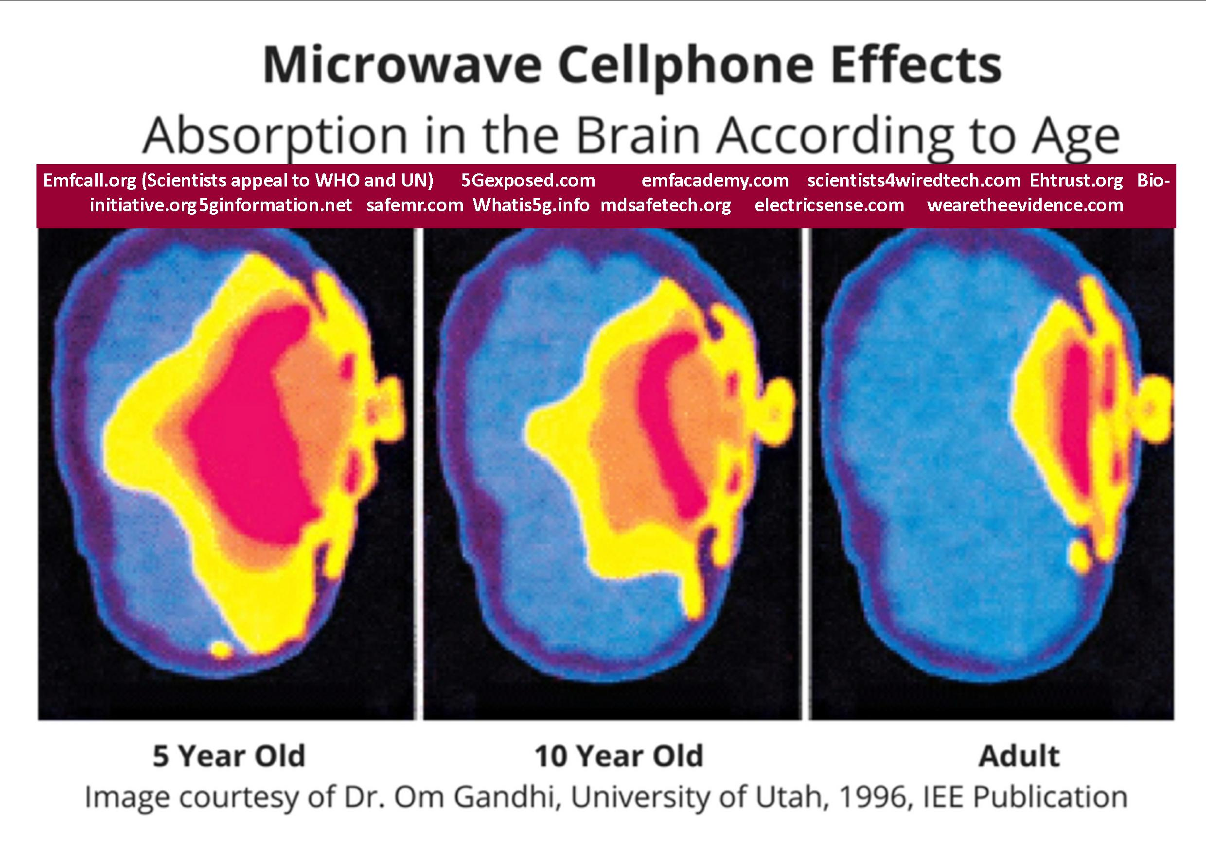
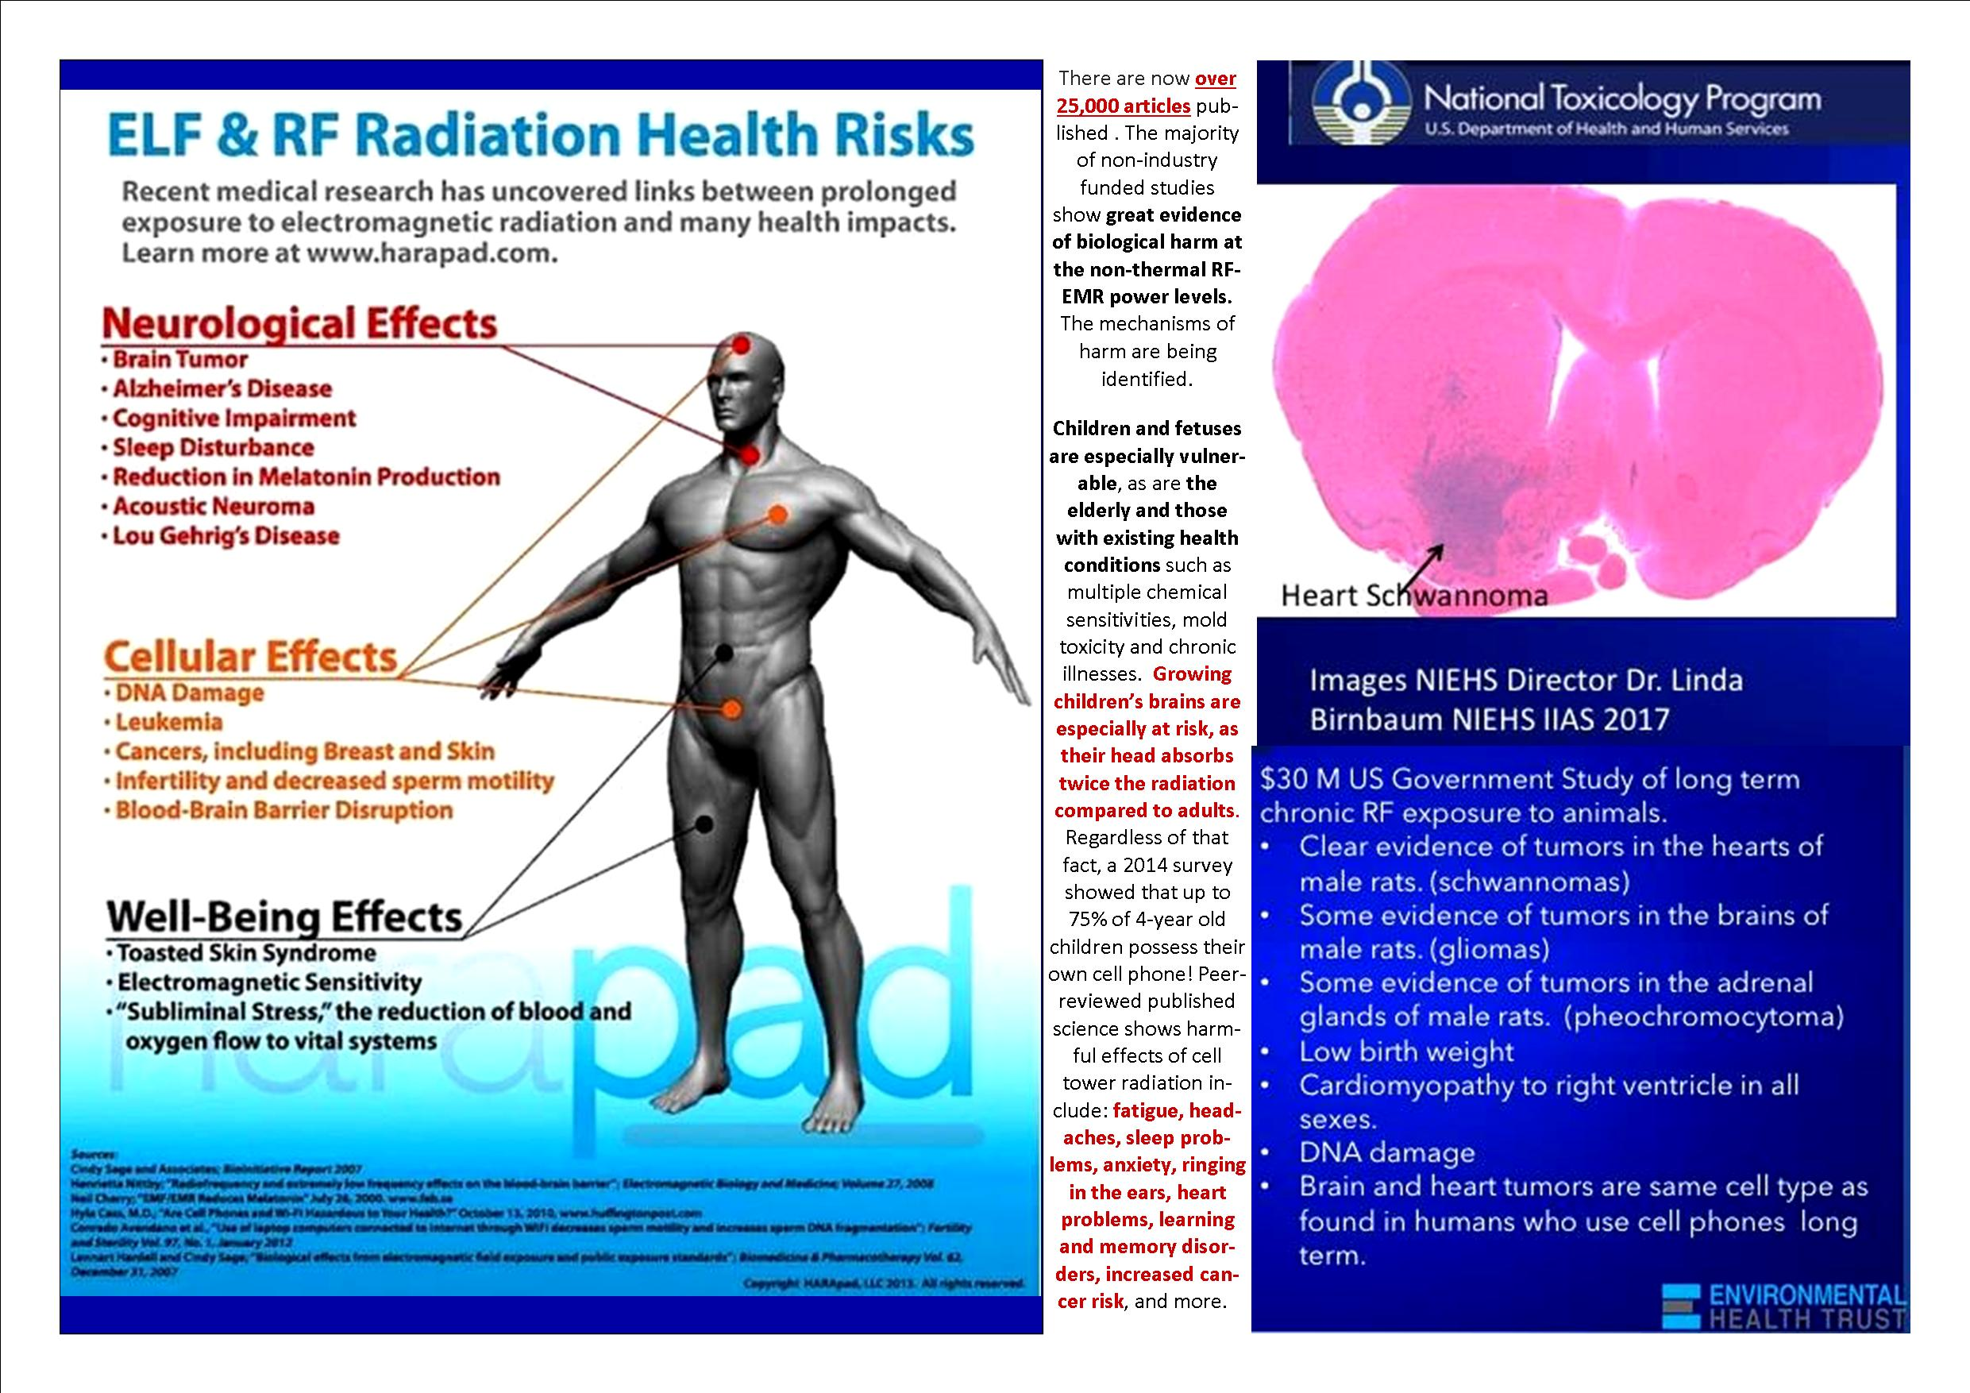

Since 2018, we have clear evidence of microwave radiation causing cancer, from two complementary and mutually supportive long term research studies: the US Government’s National Toxicology Programme and the Italian independent Institute Ramazzini Study on Cell Phone Radiation, which has helped to lead the way in large scale animal carcinogenicity testing for the last 50 years. The longer term effects, as per these studies, now include strong evidence of cancer in humans, notably for glioma (brain) tumours and acoustic neuromas.
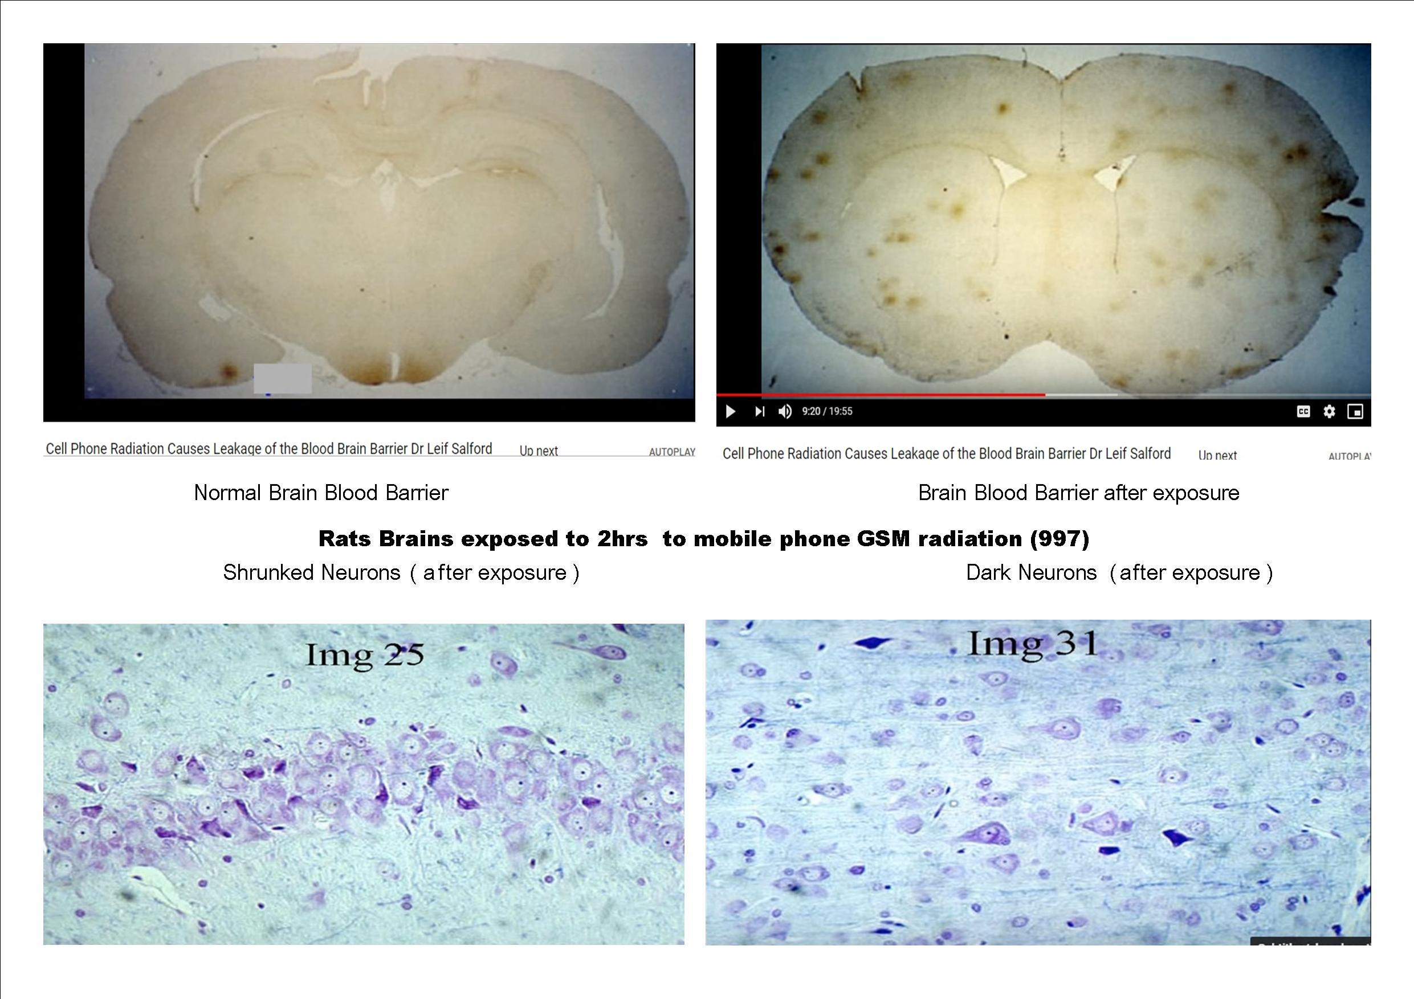
Above, critical images presented by Dr. Leif Salford, neurologist – this is what 2 hours exposure to 915 MHZ GSM radiation does to the brains of rats: leakage of the essential Blood-Brain-Barrier and neuronal damage (https://www.cellphonetaskforce.org/the-work-of-leif-salford/ )

Senior experts from within the Biophysics and electromagnetism field, such as Professors James Lin and Frank Barnes, Martin Pall, Devra Davis and many others are questioning the ability of the ICNIRP exposure limits for RF to fully protect public health, particularly in children. They, and many other EMF experts are recommending the ALARA principle (ie to keep exposures “as low as reasonably achievable”) which has been long used in the radiation field to protect the public and sensitive sub groups from radiation. Resolution 1815 of the European Parliament (2011) specifically states that governments should “reconsider the scientific basis for the present standards on exposure to electromagnetic fields set by the International Commission on Non-Ionising Radiation Protection, which have serious limitations, and apply ALARA [as low as reasonably achievable], covering both thermal effects and the athermic or biological effects of electromagnetic emissions or radiation.”
Campaigning doctors from groups such as PHIRE Medical (http://phiremedical.org) and SSITA (Safe Schools Information Technology Alliance, https://ssita.org.uk) have stated that this is a public health emergency. PHE is currently the object of written complaints from campaigning doctors and is under investigation from the PHSO ombudsman. Legal cases against PHE are being prepared and the UK government and the PHE EMR advisors are now on legal notice over their ‘advice.’

The more recent evidence means that the current classification of the cancer risk from RF from mobile phones by the International Agency for Research on Cancer (IARC/WHO,2011), as a “possible” human carcinogen, will certainly be re-evaluated to at least a “probable” and possibly a “proven” human carcinogen when IARC comes to re-evaluate the RFR evidence which is expected in the next 1-2 years. For a couple of important scientific reviews of the Wi-Fi effects on human health and the necessary standards in matters of emitted radiation, please see the independent collaborative work of 29 renown scientists THE BIOINITIATIVE HUMANITY AT THE BRINK , as also
THE AMMENDED DECLARATION OF BARRIE TROWER CONCERNING THE USE OF WIFI IN SCHOOLS
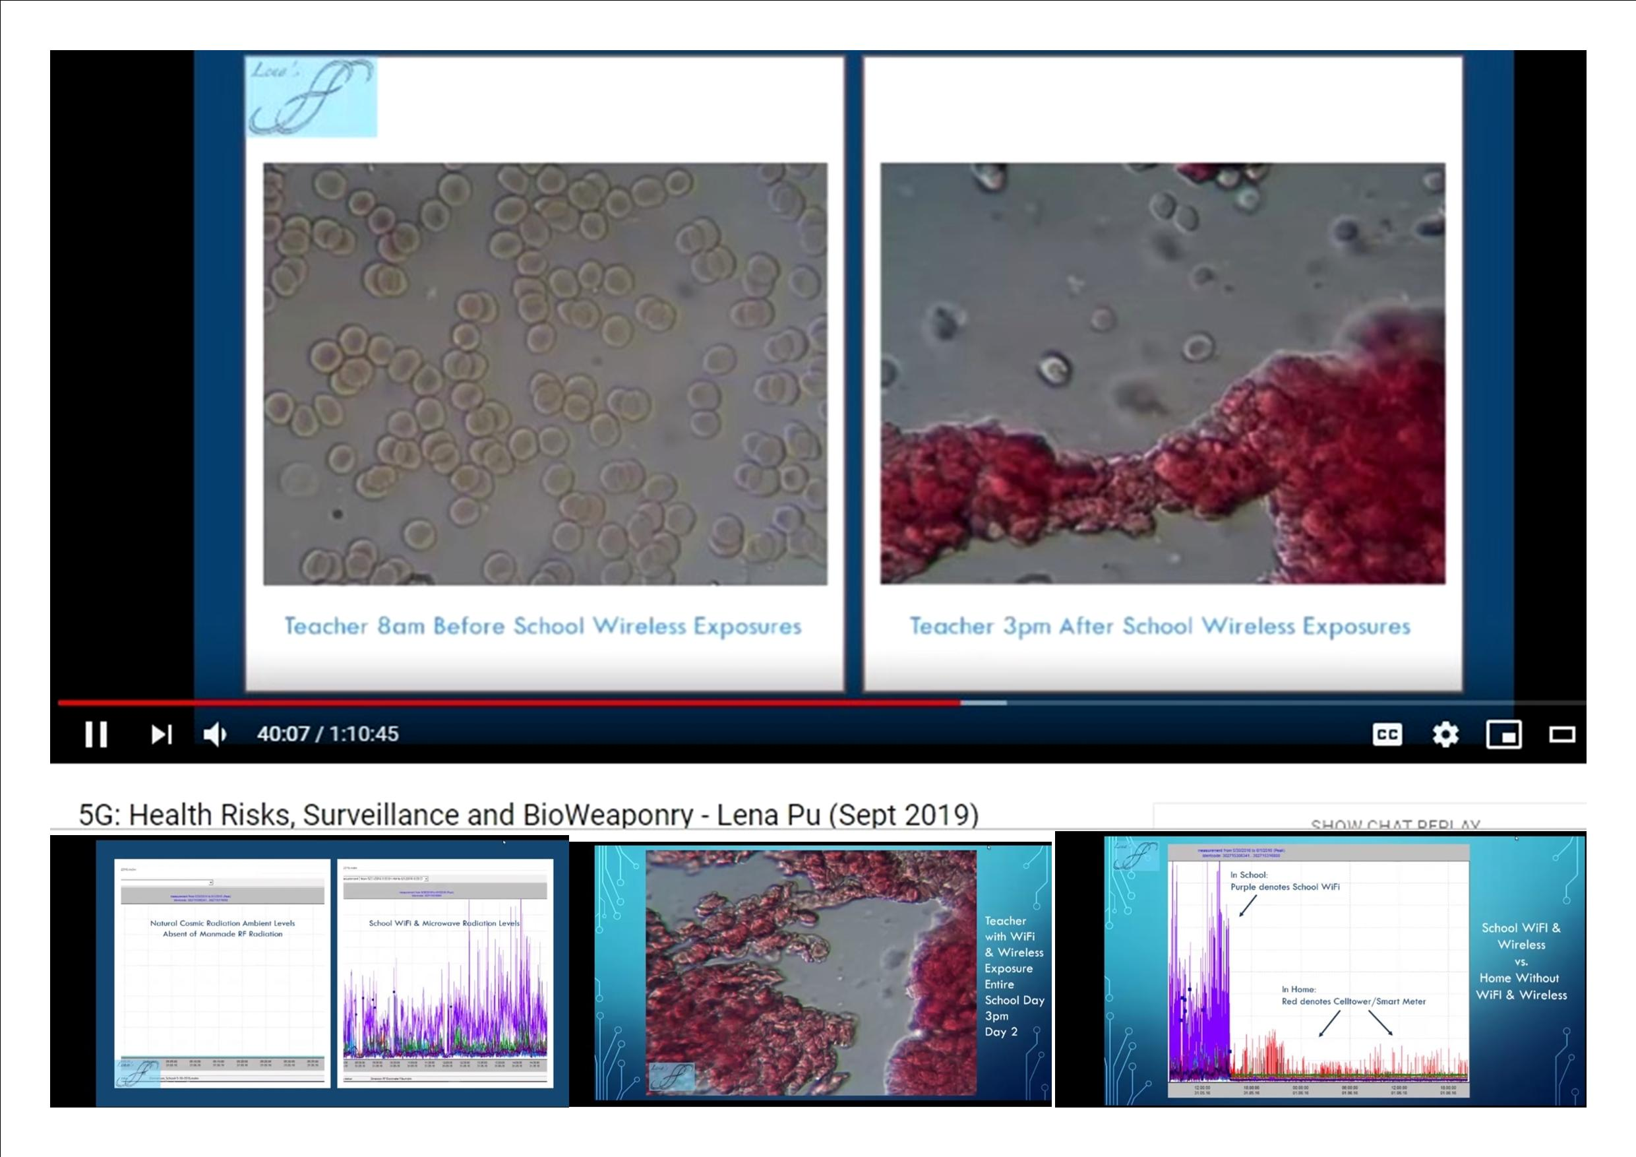
Images proving the abnormal coagulation of the blood’s red cells (Roulleaux formations) after a day of exposure to WiFi in school – in a healthy young teacher – Lena Pu research
Chronic EMF exposure is particularly linked to infertility, leukaemia, brain and cardiovascular damage, cancer and is exceedingly harmful to children.

Please consider also that WiFi is already removed from schools worldwide. For ex., CYPRUS, FRANCE, BELGIUM, ISRAEL, GERMANY, AUSTRALIA and RUSSIA, as also THE STATES OF MARYLAND, OHIO, ONTARIO CANADA HAVE BANNED WIFI IN CLASSROOMS AND/OR REDUCED EMF RADIATION EXPOSURE
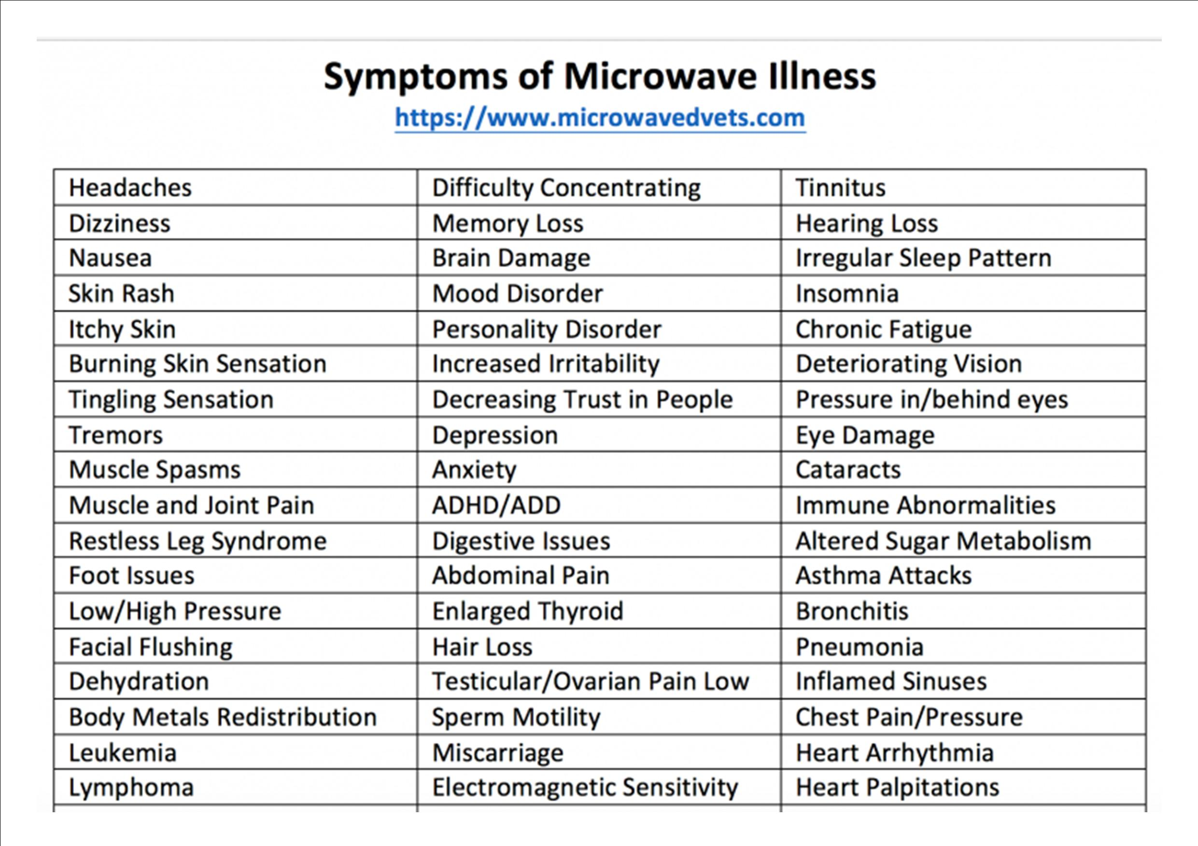
In light of this emerging evidence and the already widespread and increasing public and environmental exposures to non-ionising radiation from industrial grade WiFi rooters installed throughout classrooms, we consider that the safe way to connect to the Internet is hardwired, with cables and definitely oppose any upgraded, untested 5G- 60Ghz (WiGIG) in classrooms, which is also now being proposed to be installed throughout schools. Also a matter of high importance for health is the potential exposure to cell towers that may be found in the close neighbourhood of the school and this needs also a careful consideration for the benefit of all, children and staff.
We expect Health & Safety Risk Assessments determining the risks and the appropriate measures to be put in place in order to protect the children and the staff, according with the legislation in place concerning all three important issues discussed in this letter. In matters of EMF exposure, the school can refer to the control of the electromagnetic fields at work and to the examples of good practice offered in the annex of this letter. Finally, it appears to us as a matter of both common sense and common law that by simply receiving this our letter, in virtue of your social duty and authority, you also receive an appropriate responsibility and liability towards your students, in all critical matters mentioned above.
It is definitely a lot to research and investigate, but we appeal to you to use all necessary means and support in order to assess these issues and act accordingly and with a sense of urgency, because time is of the essence and our families and our children are truly facing destruction, if the trend of these concerted attacks to our health and lives is not stopped as soon as possible and reversed. And yes, we do believe that, although it may not appear to be always the case, we all, including you and all your dear ones are in this together.
Thank you very much and all the best,
UNITE FOR TRUTH
SCOTLAND
unitefortruth.online
REFERENCES:

Best estimate CDC Scenario: https://www.cdc.gov/coronavirus/2019-ncov/hcp/planning-scenarios.html
The New Moderna covid-19 vaccine is called experimental by NIH: Experimental coronavirus vaccine highly effective https://www.nih.gov/news-events/nih-research-matters/experimental-coronavirus-vaccine-highly-effective They are also called “experimental” in the Daily Mail, as quoting the creator of the mRNA technology, dr. Robert Malone: 'The government is not being transparent about the risks': Inventor of MRNA vaccines says people should not be forced to take experimental COVID vaccines because risks aren't known and under 18s and those who’ve had virus shouldn’t take it https://www.dailymail.co.uk/news/article-9719891/Inventor-mRNA-vaccines-says-young-adults-teens-not-forced-COVID-vaccine.html In effect, all these new so-called vaccines trials will end their clinical trials in 2023, as explained in America’s Frontline Doctors White Paper On Experimental Vaccines For COVID-19 https://img1.wsimg.com/blobby/go/99d35b02-a5cb-41e6-ad80-a070f8a5ee17/SMDwhitepaper.pdf Moreover, these trials have not been conclusive in matters of efficacy and safety: Covid-19 vaccine trials cannot tell us if they will save lives (BMJ) https://www.bmj.com/company/newsroom/covid-19-vaccine-trials-cannot-tell-us-if-they-will-save-lives/ How COVID-19 Vaccine Trials Are Rigged (Dr. Mercola, Oct 2020) https://articles.mercola.com/sites/articles/archive/2020/10/27/covid-vaccine-trials.aspx ......................................................................................................................................
160+ experts slam COVID vaccines as ‘unnecessary, ineffective and unsafe’ in powerful letter (May 2021) 'In short, the available evidence and science indicate that COVID-19 vaccines are unnecessary, ineffective and unsafe. https://www.lifesitenews.com/news/160-experts-slam-covid-vaccines-as-unnecessary-ineffective-and-unsafe-in-powerful-letter?utm_source=LifeSiteNews.com&utm_campaign=a6b3c2feea-Daily%20Headlines%20-%20U.S._COPY_1042&utm_medium=email&utm_term=0_12387f0e3e-a6b3c2feea-402348069 CDC says fully vaccinated people spread the Delta variant and should wear masks: 'This new science is worrisome' (27 July 2021 ) https://www.businessinsider.com/cdc-fully-vaccinated-people-can-spread-delta-variant-2021-7 …………………………………………………………………………………………………………………………
https://ourworldindata.org/grapher/covid-vaccination-doses-per-capita …………………………………………………………………………………………………………………..
https://coronavirus.data.gov.uk/details/deaths?areaType=nation&areaName=England https://ourworldindata.org/grapher/biweekly-covid-deaths?tab=table&time=2020-11-26..latest https://ourworldindata.org/grapher/covid-deaths-daily-vs-total-per-million?tab=table&stackMode=absolute&time=2020-11-10..2021-01-26&country=&region=World …………………………………………………………………………………………………………………….
Whilst you’ve been distracted by England making the final, PHE released a report showing 68% of Covid Deaths in the over 50’s were people who’d been vaccinated https://dailyexpose.co.uk/2021/07/09/whilst-youve-been-distracted-by-england-making-the-final-phe-released-a-report-showing-68-of-covid-deaths-in-the-over-50s-were-people-whod-been-vaccinated/ “Well, of the 257 alleged Covid deaths in all age groups to have occurred since the 1st February, a huge 63.4% of them were people who had received at least one dose of a Covid-19 vaccine.But yet again the majority were not people who had only received one dose, 72.3% of those who had died with Covid-19 after having at least one dose of the Covid-19 jab were in fact fully vaccinated. A further 27% of those who’d had at least one dose had received their first dose at least 21 days prior to their death. The number of unvaccinated people in all age groups to have allegedly died of the Delta variant accounted for just 35% of all alleged Covid deaths according to PHE data.[…] Fully vaccinated people have a 990% higher chance of death due to Covid-19 than people who are unvaccinated according to latest Public Health England data https://dailyexpose.co.uk/2021/07/09/fully-vaccinated-people-have-a-990-higher-chance-of-death-due-to-covid-19-than-people-who-are-unvaccinated-according-to-latest-public-health-england-data/ “The above table shows that of the 71,932 alleged cases of the Delta variant in people who are unvaccinated, just 92 sadly died. This translates to 0.1% of cases. The above table also shows that of the 10,834 alleged cases of the Delta Covid variant in people who are fully vaccinated, 118 people sadly died. This translates to 1.09% of cases. The means the data published by Public Health England shows us that people who have received two doses of a Covid-19 vaccine have a 990% higher chance of dying due to the Delta Covid variant than people who are unvaccinated.” REFERENCE: ‘SARS-CoV-2 variants of concern and variants under investigation in England’ https://assets.publishing.service.gov.uk/government/uploads/system/uploads/attachment_data/file/1001009/Variants_of_Concern_VOC_Technical_Briefing_18.pdf ………………………………………………………………………………………………………………
CDC says fully vaccinated people spread the Delta variant and should wear masks: 'This new science is worrisome' https://www.businessinsider.com/cdc-fully-vaccinated-people-can-spread-delta-variant-2021-7?r=US&IR=T SARS-CoV-2 "Just a Few Mutations" Away From Evading COVID-19 Vaccines, CDC Director Warns https://t.me/COVID19Up/10393)) The CDC now advises that vaccinated people be tested for SARS-CoV-2 if they come into contact with someone with COVID-19, even if they have no symptoms. https://www.nytimes.com/2021/07/28/health/cdc-covid-testing-vaccine.html Previously, it only recommended vaccinated people get tested if they were experiencing COVID-19 symptoms. COVID-19 Vaccines Could Be Making Coronavirus Deadlier, New Research Shows https://covid19up.org/covid-19-vaccines-making-coronavirus-deadlier/ ……………………………………………………………………………………………………………………….
Vaccinated people now make up almost 47% of all new Covid cases (MSN/ Daily Mail) https://www.msn.com/en-gb/health/medical/symptom-tracking-app-claims-covid-cases-are-falling/ar-AAMbAz3 As for the vaccine at least preventing hospitalization and death if not infection (as claimed in this article), this is really contradicted by the previous references to Public Health England data ………………………………………………………………………………………………………………………………
Israel reported that 55% of the new covid infections are in vaccinated people (July 4, 2021) https://www.bloomberg.com/news/articles/2021-07-05/israel-sees-decline-in-pfizer-vaccine-efficacy-rate-ynet-says Israel data 'preliminary signal' Delta variant can bypass vaccine: expert (July 5, 2021) https://medicalxpress.com/news/2021-07-israel-preliminary-delta-variant-bypass.html COVID in Israel: New Cases Top 2,000 for Third Day as Delta Spreads (29 July 2021) https://www.haaretz.com/israel-news/covid-in-israel-coronavirus-spreads-steadily-experts-debate-3rd-shot-1.10050533 95% of the severe patients are vaccinated". "85-90% of the hospitalizations are in fully vaccinated people." "We are opening more and more COVID wards." "The effectiveness of the vaccine is waning/fading out" (Dr. Kobi Haviv, Aug 5 on Chanel 13 @newsisrael13 https://twitter.com/RanIsraeli/status/1423322271503028228
By June 1, over 99% of Gibraltar's population was fully vaccinated. Since that time, new COVID cases per day have increased more than 2500%. (29 July 2021) https://twitter.com/MichaelPSenger/status/1420812757427908610
Cases in Iceland are still rising, now up 44,275% since the New Yorker described in detail how Iceland “beat the coronavirus" (5 Aug 2021) https://twitter.com/ianmSC/status/1423334160588959747
Vaccinated people make up 75% of recent COVID-19 cases in Singapore, but few fall ill (Reuters 23 July 2021) https://www.reuters.com/world/asia-pacific/vaccinated-people-singapore-make-up-three-quarters-recent-covid-19-cases-2021-07-23/
COVID spreading fast in well-vaccinated California counties (24 July 2021) https://www.mercurynews.com/2021/07/24/covid-spreading-fast-in-well-vaccinated-california-counties/ California ‘Epsilon’ strain of COVID-19 could evade vaccines, study says https://nypost.com/2021/07/07/california-epsilon-strain-of-covid-19-could-evade-vaccines-study/ A new study has found that COVID-19 vaccines may be somewhat vulnerable to California's Epsilon variant of SARS-CoV-2. The variant has three spike protein mutations it uses to weaken current vaccines by up to 70%, according to researchers from University of Washington and the San Fransisco-based lab Vir Biotechnology. The strain’s mutations break down neutralized antibodies, which are produced by vaccines such as Pfizer and Moderna and protect against infection, according to the study. A federal investigation into a COVID-19 outbreak this month in a Massachusetts county found that 74% of the 469 infections were among fully vaccinated people, a finding that raises questions (https://www.marketwatch.com/story/cdc-data-shows-that-74-of-people-who-tested-positive-for-the-virus-in-massachusetts-outbreak-were-fully-vaccinated-11627665558) about the prevalence of breakthrough infections. The research (https://www.cdc.gov/mmwr/volumes/70/wr/mm7031e2.htm?s_cid=mm7031e2_w), published Friday (July 30) afternoon by the CDC, is the latest indication that people who are fully vaccinated are not as protected against SARS-CoV-2 as they were told. 79% of the fully vaccinated people who tested positive for SARS-CoV-2 were symptomatic. Out of the 133 specimens that were sequenced in this outbreak, 89% were Delta variant. 4 of the 5 people who were hospitalized were vaccinated. No one died. Of the people who reported breakthrough infections, 46% had gotten the Pfizer injection, 38% had received the Moderna shot, and 16% had been administered the Johnson & Johnson vaccine. Earlier this week, the CDC revealed for the first time that people who are vaccinated and test positive for SARS-CoV-2 can carry the same viral load as people who are unvaccinated and test positive for SARS-CoV-2. …………………………………………………………………………………………………………………..
https://ourworldindata.org/explorers/coronavirus-data-explorer?zoomToSelection=true&pickerSort=asc&pickerMetric=location&hideControls=true&Metric=Confirmed+cases&Interval=7-day+rolling+average&Relative+to+Population=true&Align+outbreaks=false&country=SYC~MDV~BHR~CHL~GBR Six vaccinated countries have high Covid infection rates. Five of them rely on Chinese vaccines (CNBC, 7 July 2021) https://www.cnbc.com/2021/07/08/five-vaccinated-countries-with-high-covid-rates-rely-on-china-vaccines.html (UAE, Seychelles, Chile UK, Uruguay, Mongolia) …………………………………………………………………………………………………………………..
Very High: Malta, United Arab Emirates, Seychelles, Chile, Uruguay, Bahrain, Mongolia High: Iceland, Qatar, Belgium, Canada, Israel Low: Singapore Unavailable: Bahrain, Bhutan Why does the CDC's data show that the greatest risk of catching COVID-19 is in the most vaccinated countries in the world❓ CDC Travel Risk: https://www.cdc.gov/coronavirus/2019-ncov/travelers/map-and-travel-notices.html Johns Hopkins Vaccinations: https://coronavirus.jhu.edu/vaccines/international …………………………………………………………………………………………………………..
If the Covid-19 vaccines work, then why are Covid-19 deaths 44 times higher than this time last year, and why are 75% of those deaths people who were vaccinated (12 August 2021) https://dailyexpose.co.uk/2021/08/12/if-the-covid-19-vaccines-work-then-why-are-covid-19-deaths-44-times-higher-than-this-time-last-year-and-why-are-75-of-those-deaths-people-who-were-vaccinated/ ………………………………………………………………………………………………………………..
Health Impact News https://healthimpactnews.com/ The Pfizer mRNA vaccine: pharmacokinetics and toxicity Michael Palmer, MD and Sucharit Bhakdi, MD https://doctors4covidethics.org/wp-content/uploads/2021/07/Pfizer-pharmacokinetics-and-toxicity.pdf ……………………………………………………………………………………………………………..
Children’s Health Defense https://childrenshealthdefense.org/defender/329-deaths-9516-other-injuries-reported-following-covid-vaccine-cdc/?fbclid=IwAR3WrGnvBgG1qd5R6acEQd7xWki_KkkoRwG5nzkwnFlTlKh2JfcixBxpo90 ……………………………………………………………………………………………………………..
DOCTORS CONCERNS ABOUT THE COVID VACCINES (Medscape) https://www.medscape.com/sites/public/covid-19/vaccine-insights/how-concerned-are-you-about-vaccine-related-adverse-events VAX LONGHAULERS – We Want To Be Heard https://www.vaxlonghaulers.com/ FB: Neuro V Long-Haulers Covid Vaccine - Long Haul Support Group Our Letter: https://www.vaxlonghaulers.com/uploads/1/3/8/1/138180543/our_letter_for_the_landing_page.pdf Covid19 Vaccine Victims and Families https://www.facebook.com/groups/616637409732910/?multi_permalinks=661233681939949&notif_id=1625872617108891&notif_t=group_highlights&ref=notif COVID VACCINE GROUPS ON TELEGRAM: https://t.me/covidvaccinevictims https://t.me/vaccineawareness https://t.me/DrTenpenny https://t.me/worlddoctorsalliance https://t.me/ukvacinfo https://t.me/AdverseReactionsAustralia https://t.me/vaccinechoiceaustralia https://t.me/NoVaccineCoercion https://t.me/CovidVaxTruths https://t.me/VaksinMalaysia https://t.me/covidvaccineadveffect https://t.me/covid_vaccine_injuries https://t.me/avninformedchoice https://t.me/cv19vaccine_reactions https://t.me/CovidVaccineWORLD https://t.me/cv19VaccineDeathInjuryTricks https://t.me/cv19vaccineinjured https://t.me/TheTruthAboutCancer_Vaccines https://t.me/CovidVaxTruths https://t.me/vaccineawareness https://t.me/avninformedchoice https://t.me/Vaccinedeath https://t.me/Covid_Vaccine_Deaths_Worldwide Tens of Thousands of COVID-19 “Vaccine” Injured in the U.S. Begging for Help as the Medical Community Turns Their Back on Them (July 7, 2021) https://healthimpactnews.com/2021/tens-of-thousands-of-covid-19-vaccine-injured-in-the-u-s-begging-for-help-as-the-medical-community-turns-their-back-on-them/ What is the probability of having members of the same family injured or dead shortly after the covid vaccination? – just two examples among many: 18 Year Old University Of Arizona Student Hospitalized After Johnson Johnson Vaccine, As His Mom Is Hospitalized From Pfizer Reaction https://theempoweror.com/2021/06/27/18-year-old-university-of-arizona-student-hospitalized-after-johnson-johnson-vaccine-as-his-mom-is-hospitalized-from-pfizer-reaction/ Father And Daughter Died Four Days Apart Despite Taking Different Brands Of Covid Vaccines https://theempoweror.com/2021/07/01/father-and-daughter-died-four-days-apart-despite-taking-different-brands-of-covid-vaccines/ ………………………………………………………………………………………………..
Heart Inflammation After COVID-19 Vaccinations Higher-Than-Expected in Study of U.S. Military (SOURCE (https://t.me/COVID19Up/9896)) — Members of the U.S. military who were vaccinated against COVID-19 showed higher-than-expected rates of heart inflammation. …………………………………………………………………………………………….
Clinical Features of Vaccine-Induced Immune Thrombocytopenia and Thrombosis https://www.nejm.org/doi/full/10.1056/NEJMoa2109908 “Overall mortality was 22%[…] The high mortality associated with VITT was highest among patients with a low platelet count and intracranial hemorrhage.” ………………………………………………………………………………………………………
54% of Doctors say they are aware of patients suffering severe adverse reactions to the Covid-19 vaccines in survey (July 7, 2021) https://dailyexpose.co.uk/2021/07/07/54-of-doctors-say-they-are-aware-of-patients-suffering-severe-adverse-reactions-to-the-covid-19-vaccines-in-survey/ DOCTORS CONCERNS ABOUT THE COVID VACCINES (Medscape) https://www.medscape.com/sites/public/covid-19/vaccine-insights/how-concerned-are-you-about-vaccine-related-adverse-events ………………………………………………………………………………………………….
Children face just a one in 500,000 risk of dying from Covid, studies show amid growing row over whether youngsters should be given vaccines - In England, 25 under-18s died from Covid, equating to two per million https://www.dailymail.co.uk/news/article-9769283/Children-face-one-500-000-risk-dying-Covid-amid-row-kids-vaccinated.html COVID-19: Only 0.005% of COVID infections among children have led to deaths - so vaccine would have to be 'very low risk' (Sky, 2 July 2021) https://news.sky.com/story/covid-19-only-0-005-of-covid-deaths-have-been-children-so-vaccine-would-have-to-be-very-low-risk-12351975 “The chances of children dying from coronavirus are so low that vaccines would need to be proven to be "very low risk" before they were given jabs, according to child health experts. Their warning follows research that shows only 25 children and young people in England died from COVID-19 during the first year of the pandemic - just 0.005% of those who were infected with the virus. Nineteen of the deaths were in children with an underlying health condition, with complex neurodisability accounting for 13 of them, according to results from three studies conducted by academics from universities around the country.” Infectivity of severe acute respiratory syndrome coronavirus 2 in children compared with adults (April 2021) https://www.cmaj.ca/content/193/17/E601 “Compared with adults, children with nasopharyngeal swabs that tested positive for SARS-CoV-2 were less likely to grow virus in culture, and had higher cycle thresholds and lower viral concentrations, suggesting that children are not the main drivers of SARS-CoV-2 transmission.” ………………………………………………………………………………………………………
Ex-Pfizer VP Yeadon Warns: Children 50 Times More Likely to Die From Vaccine Than Virus https://rumble.com/viaz6n-ex-pfizer-vp-yeadon-warns-children-50-times-more-likely-to-die-from-vaccine.html Frontline doctors file motion to stop FDA authorization of COVID vaccines for children With a ‘12,000 percent increase in deaths with these vaccines’ and ‘statistically zero risk’ of children dying from COVID-19, plaintiffs argue there is no justification for such injections. https://www.lifesitenews.com/news/frontline-doctors-file-motion-to-stop-fda-authorization-of-covid-vaccines-for-children ............................................................................................................
Doctors for COVID Ethics: Halt Use of Pfizer COVID Vaccines in Adolescents ‘Immediately’ In a 20-page report, three doctors who are all founding members of Doctors for COVID Ethics outline in detail the compelling argument for why COVID vaccines are not only unnecessary and ineffective, but also dangerous for children and adolescents. (15.07.21) "In addition to submitting three admonitory letters to the EMA — on March 10, April 1 and April 20 — Doctors for COVID Ethics on May 18 served Notices of Liability to all members of the European Parliament for COVID-vaccine-related harms and deaths to children. (https://doctors4covidethics.org/notice-of-liability-for-harm-and-death-to-children-served-on-all-members-of-the-european-parliament/) Now, three of the group’s founding signatories — Dr. Michael Palmer (Canada), Dr. Sucharit Bhakdi, (Germany) and Stefan Hockertz, Ph.D. (Germany) — have assembled in one document powerful expert evidence (https://doctors4covidethics.org/expert-evidence-regarding-comirnaty-covid-19-mrna-vaccine-for-children/ ) showing COVID vaccines are not only unnecessary and ineffective but also dangerous for children and adolescents. Tell Schools/Universities No Vaccine Mandates for Children/Young Adults! On July 3, Italian lawyer Renate Holzeisen submitted the expert document (https://childrenshealthdefense.org/wp-content/uploads/expert-evidence-pfizer-children.pdf) to the European General Court as part of a lawsuit (https://doctors4covidethics.org/expert-evidence-regarding-comirnaty-covid-19-mrna-vaccine-for-children/)challenging the EMA’s late-May decision to extend emergency use of Pfizer’s vaccine for 12- to 15-year-olds. [...] The most alarming section of the report is Palmer’s, Bhakdi’s and Hockertz’s discussion of the Pfizer vaccine’s “catastrophically bad” safety profile in both adults and adolescents. The Pfizer injection’s destructive impact is readily discernible by anyone with the patience to pore through the vaccine injury reports submitted to the Vaccine Adverse Event Reporting System (VAERS) in the U.S. or the EudraVigilance database in Europe. For 12- to 17-year-old Americans receiving a COVID shot, VAERS received more than 13,000 reports of adverse events by July 2, including more than 1,909 reports (Pfizer alone) of anaphylaxis, 343 reports (Pfizer alone) of heart problems, 56 reports (Pfizer alone) of blood clotting disorders and 14 deaths, of which 13 were reported after a Pfizer vaccine." COVID Vaccines: Hypothetical Benefits to Adults Don’t Outweigh Risks to Children (16.07.21) (https://childrenshealthdefense.org/defender/covid-vaccines-hypothetical-benefits-adults-risks-children/ ) Given the very low incidence of COVID-19 in children, an extremely high number would need to be vaccinated in order to prevent one severe case. Meanwhile, a large number of children with very low risk for severe disease would be exposed to vaccine risks, known and unknown. First, the disease in children is commonly mild, and serious sequelae remain rare. Despite “long COVID” recently garnering increased attention, two large studies in children show that prolonged symptoms are uncommon and overall similar or milder in children testing positive for SARS-CoV-2 compared to those with symptoms from other respiratory viruses. The U.S. Center for Disease Control and Prevention (CDC) estimates put the infection fatality rate from COVID-19 among children 0 to 17 years old at 20 per 1,000,000. Hospitalization rates are also very low, and have likely been overestimated. Furthermore, a large proportion of children have already been infected with SARS-CoV-2. The CDC estimates 42% of U.S. children aged 5 to 17 years have been infected by March 2021. Given that SARS-CoV-2 infection induces a robust immune response in the majority of individuals, the implication is that the risks COVID-19 poses to the pediatric population may be even lower than generally appreciated HART - An open letter from UK doctors to Dr June Raine, Chief Executive, MHRA - COVID-19 child vaccination: safety and ethical concerns (March 2021) https://www.hartgroup.org/open-letter-child-vaccination/ (final) “We conclude that it is irresponsible, unethical and indeed, unnecessary, to include children under 18 years in the national COVID-19 vaccine rollout. Clinical trials in children also pose huge ethical dilemmas, in light of the lack of potential benefit to trial participants and the unknown risks. The end of the current Phase 3 trials should be awaited as well as several years of safety data in adults, to rule out, or quantify, all potential adverse effects. We call upon our governments and the regulators not to repeat mistakes from history, and to reject the calls to vaccinate children against COVID-19. Extreme caution has been exercised over many aspects of the pandemic, but surely now is the most important time to exercise true caution – we must not be the generation of adults that, through unnecessary haste and fear, risks the health of children.” UKMFA Urgent Open Letter to the MHRA re Emergency Authorisation of the Pfizer Covid-19 vaccine for Children (08/06/21) (https://www.ukmedfreedom.org/open-letters/ukmfa-urgent-open-letter-to-the-mhra-re-emergency-authorisation-of-the-pfizer-covid-19-vaccine-for-children?fbclid=IwAR0lfNW-62rfbvO9xhPlCetKacEWQ8nBztGYXFi2Hhq5dCfi02LQrVAqb2E ) UKMFA has sent an Open Letter to the the MHRA in which we raise grave concerns about this emergency authorisation, citing evidence of known and potential harms to children that may result and the serious ethical issues this decision raises. Given that these vaccines will have virtually no benefit to the children themselves, it is profoundly unethical and indefensible to vaccinate children, especially with an experimental vaccine using novel technology, in what appears to be a misguided attempt to protect adults and achieve herd immunity. We call on the MHRA to exercise caution and immediately reverse their decision. Arguments: The benefits of Covid-19 vaccines for children are close to zero, yet they carry known and unknown risks. Experts are stating that vaccinating children is neither necessary nor justified: • The minutes of the Joint Committee on Vaccination and Immunisation (JCVI) dated 16 February 2021 note “little impact of vaccinating children once all other adults were offered vaccine” and “that modelling results on the impact of vaccinating children were considered highly uncertain” xv. • Other experts have argued that “Covid-19 vaccines for children should not get emergency use authorization” xvi and that this would be “hard to justify right now for most children in most countries” xvii • Professor of Paediatrics and member of the JCVI, Adam Finn, said in an interview on the 20 May 2021 that it was “an open question as to whether we need to immunise children at all” and “if we can control this virus without immunising children, we shouldn’t immunise children as a matter of principle”xviii 5. Below, we set out specific issuesregarding Covid-19 vaccines in children – each sufficient to justify not proceeding any further with this proposal. a. The risk of Covid-19 to children is miniscule. The infection fatality rate in this age group is close to zero, and most remain asymptomatic or experience mild symptoms only xix xx xxi xxii This has been reiterated by the Government xxiii and by Professor of Paediatrics, Adam Finn xviii Even the low records of children hospitalized with Covid-19, may be an over-estimate, according to a recent study xxiv . The number of children and teens under the age of 20 without pre-existing conditions who have died in England with a positive Covid- 19 test, as of 13 May 2021, is in single figures xxv Mortality in children in the UK in 2020/21 has in fact been significantly lower than in previous years xxvi xxvii As the emergency does not, therefore, apply to children, there can be no justification to authorize any product for emergency use in the paediatric population. b. The absolute risk reduction by Covid-19 vaccines is around 1% (0.84-1.3%)xxviii This applies to the healthy adult trial participants and cannot be extrapolated to children,who are already at extremely low risk from the disease. The potential benefit to an individual child of receiving a Covid-19 vaccine is statistically zero. c. Children play an insignificant role in transmission of Covid-19ix xviii xxix Living with children may even reduce the risks of the disease xxx Transmission in schools has not been significant xxxi xxxii xxxiii Trials have not demonstrated whether Covid-19 vaccines reduce asymptomatic infection or transmission xxxiv There is therefore no demonstrable benefit to the wider society in vaccinating children. d. In a population cohort at minimal risk of severe disease, such as young people and children, acquiring natural immunity will serve a better purpose, as this will be more comprehensive, longer lasting, and cover a broad range of virus variants. Vaccine-induced immunity does not cover the full spectrum of protection (mucosal immunity, IgA, and T-cell immunity to the whole virus) and may only be short-lived. Acquiring natural immunity will therefore also benefit the wider population, contributing to herd immunity xxxv xxxvi xxxvii xxxviii xxxix .e. All Covid-19 vaccines used in the UK are based on completely new gene-based technologies (mRNA / DNA vector technology)xl , that have never received full regulatory approval for mass rollout in humans. They have not been licensed and remain experimental until Phase 3 trials have been completed xli Thus, we cannot infer long- term safety without observing the impact on human health in those who have received the vaccines over the next few years. f. There is currently no data to indicate whether dose adjustment may be necessary in children. This would appear relevant as side-effects in initial phase 1 dose-escalation trials were more significant with higher dosage xlii g. Covid-19 vaccines work completely differently to established childhood vaccines. Traditional, live vaccines work using attenuated virus strains to prompt antibody development. Covid-19 vaccines introduce a synthetic gene which induces the recipient’s own cells to produce spike proteins. Spike proteins appear to contribute significantly to the pathogenicity of SARS-CoV-2, and there are studies suggesting that they have the potential to cause pathology on their own xliii xliv It is unknown how much spike protein will be produced by an individual, and it is plausible that younger, healthier people may produce higher quantities, potentially increasing the risk of side-effects. The safety of this approach needs to be thoroughly investigated and firmly established prior to full licensure in adults and prior to any use in children. h. At this stage, medium- and long-term effects of Covid-19 vaccines are completely unknown and unpredictable, due to the short duration of the Phase 3 safety trials, which are ongoing and not due to complete until 2023. This is most relevant for young people and children. Before giving Covid-19 vaccines to children, potential adverse, long-term, effects on fertility, carcinogenesis, and children’s developing neurological and immune systems MUST be completely ruled out, as is done with other drugs and vaccines. This may take years or decades to fully establish. i. Serious adverse events and vaccine-related deaths have been reported in the UK xlv , theUS xlvi and Europe xlvii In the report published by the MHRA on 13 May 2021, there were 822,078 adverse reactions in the UK, including seizures, paralysis, blindness, strokes, blood clots and acute cardiac events. There were 1178 reports of fatalities. j. Some life-threatening effects, such as blood clots xlviii and myocarditis xlix , have been reported specifically in children and young adultsl li . Government advice has recently been amended to avoid the AstraZeneca vaccine in young people due to a concern regarding the risk of rare blood clots (now considered to be around 1:100,000). The new term “vaccine-induced immune thrombotic thrombocytopenia” acknowledges the causality of the vaccine in these events, often presenting as ischemic strokes lii . It is possible that this reaction could be a class effect caused by spike proteins and therefore not specific or limited to the AstraZeneca vaccine liii . Of the 4347 events of thrombosis and embolism reported to the MHRA as of 13 May 2021, 770 occurred following the Pizer-BioNTech vaccine xlv. According to the US VAERS reporting system, several children under the age of 18 have died following a Covid-19 vaccine liv k. Vaccine manufacturers have requested and been granted complete exemption from liability for any injuries or deaths resulting from their productslv lvi . A spokesperson for AstraZeneca acknowledged the potential for unexpected long-term side-effects, stating that as a company, they “simply cannot take the risk if in ... four years the vaccine is showing side-effects” lvii . If the risk is significant enough for manufacturers to anticipate economic loss, children must not be expected to take the same risk to their long-term health. ……………………………………………………………………………………………………….
Nine in 10 parents in England approve of Covid jabs for children, survey finds ONS survey comes as member of Sage suggests there is not enough evidence to back vaccinating children https://www.theguardian.com/society/2021/jul/01/not-enough-evidence-to-back-covid-jabs-for-children-says-uk-expert?fbclid=IwAR179hQS-oJPS1e9XWAknHRdYBUwjsvVy56EJeGZQoefMJC-6W1V5aQfkik ………………………………………………………………………………………………………….
Covid-19 Vaccines Will be Offered to all 16 and 17-Year-Olds in UK – No Parental Consent Required https://dailyexpose.co.uk/2021/08/12/covid-19-vaccines-will-be-offered-to-all-16-and-17-year-olds-in-uk-no-parental-consent-required/ …………………………………………………………………………………………………….
From Mark Sexton’s letter to the police: CRIME REPORT FORM & EVIDENCE COMBINED (July 2021) https://img1.wsimg.com/blobby/go/71801b8c-fda3-43cc-86e2-e2e50ff2f191/downloads/CRIME%20REPORT%20FORM%20%26%20EVIDENCE%20COMBINED.pdf?ver=1628807576928 The NHS has provided the Patient Information Leaflet to some patients who are being vaccinated. That Patient Information Leaflet does not present the material risks and the material benefits of the vaccination in an adequate way: 1. The Patient Information Leaflet does not make clear that the vaccines are still in clinical trial. 2. The Patient Information Leaflet does not make any reference to alternatives to vaccination. 3. The Patient Information Leaflet does not make clear that the mRNA vaccines are experimental in that these vaccines have never been used before and there is no data on medium term to long term safety. […] 4. The Patient Information Leaflet does not make clear that the clinical trials being run to show the safety and efficacy of the vaccine did not include particular cohorts of people including pregnant women and the very elderly. There is therefore no evidence available to show that they are safe and efficacious for those cohorts. 5. The Patient Information Leaflet does not make clear that the clinical trials are only using people who have not been infected with covid. There is therefore no data on safety and efficacy for vaccination of those who have been infected. Many people who have been infected with coronavirus are also being vaccinated. 6. The Patient Information Leaflet does not set out the difference between the absolute risk and the relative risk from coronavirus infection. 7. By being vaccinated each individual is reducing their absolute risk of being infected and dying from covid by 1%. https://pubmed.ncbi.nlm.nih.gov/33652582/ Montgomery Guidelines: Risks of Vaccination: 1. At none of the press conferences have the risks of vaccination been presented. 2. The advertising campaigns infer that the vaccines are safe. 3. […] 4. Serious adverse event data is being collected by the MHRA. But is not being disseminated to news outlets or via the press conferences https://www.gov.uk/government/publications/coronavirus-covid-19-vaccine-adversereactions/coronavirus-vaccine-summary-of-yellow-card-reporting 5. That serious adverse event data is not being presented by Government or the NHS in its Patient Information Leaflet. 6. Data from deaths falling within 28 days of vaccination is not being collected, let alone communicated. 7. The Salk Institute has found that the spike protein, a constituent component in the vaccine or the vaccine’s mode of action, is a toxin. https://www.salk.edu/news-release/the-novel-coronavirus-spike-protein-plays-additionalkey-role-in-illness/ 8. The Japanese medicine regulator has found that those who have been vaccinated have a concentration of spike proteins in every organ of their body, in particular the ovaries https://regenerativemc.com/biodistribution-of-pfizer-covid-19-vaccine/ . This study is a called a bio-distribution study. 9. The NHS does not appear to have done any bio-distribution study of those who have been vaccinated. 10. The MHRA has not required a bio-distribution study to be conducted to check the safety of vaccination and if there has been a bio-distribution study conducted it has not been communicated to the public. 11. A number of regulators around the world have required health authorities to stop using the vaccine on health grounds. 12. The last UK emergency vaccine after swine flu was also suspended on safety grounds after 50 deaths. 13. The material risks from vaccination known to date are: a. Death in extreme cases. Over 1300 deaths reported on the yellow card system. (N.B.: 1536 deaths reported up to 28th of July 2021) https://www.gov.uk/government/publications/coronavirus-covid-19-vaccine-adversereactions/coronavirus-vaccine-summary-of-yellow-card-reporting b. Bells Palsy. c. Thrombo-embolic events with low platelets. d. Capillary Leak Syndrome. e. Menstrual disorder and extreme bleeding. f. Myocarditis and Pericarditis. g. Antibody dependant enhancement. 14. The public is not able to give informed consent to vaccination as the data on the material risks on vaccination is being inadequately collated and the data that is collected is then not communicated to the public at any Press Conference. 15. The public is being informed that the vaccination is a public health benefit, the risks of vaccination are not being communicated in as systematic way as coronavirus infections and deaths are communicated. ………………………………………………………………
VAXLONGHAULERS – VACCINE REACTION PUBLISHES CASE STUDIES (1) https://www.vaxlonghaulers.com/uploads/1/3/8/1/138180543/vaccine_reaction_published_case_studies_1.pdf .............................................................................................................
STUDY: Pfizer vaccine causes catastrophic damage to every system of your body (Israel May 2021) https://pandemic.news/2021-05-10-pfizer-vaccine-catastrophic-damage-every-body-system.html Mechanisms of COVID-19 Vaccine Induced Injuries/Deaths (Maggie Zhou, PhD – May 2021) http://stateofthenation.co/?p=66454 20 Mechanisms of Injuries (MOI) – Dr.Sherry Tennpenny – May5, 2021) https://rense.com/general96/20-mechanisms-of-injury.php?fbclid=IwAR3F4zruY30hizywtH0wDjQo5WWkhJG_tNqrw6ndUONR2cP5df6NzA4F2nM The Covid Vaccine Can Make You Very Sick And Now We Know Why (May 28, 2021) https://jansiebenga.medium.com/the-covid-vaccine-can-make-you-very-sick-and-now-we-know-why-140bfba72154 ............................................................................................................................
CDC: 11,940 DEAD 618,648 Injuries and 1,175 Unborn Babies DEAD Following COVID-19 Shots (1 Aug 2021) https://healthimpactnews.com/2021/cdc-11940-dead-618648-injuries-and-1175-unborn-babies-dead-following-covid-19-shots/ ………………………………………………………………………………………………………………………
Freedom of Information Request Reveals 5,522 People have Died Within 28 Days of Receiving COVID-19 Vaccines in Scotland https://healthimpactnews.com/2021/freedom-of-information-request-reveals-5522-people-have-died-within-28-days-of-receiving-covid-19-vaccines-in-scotland/ …………………………………………………………………………………………………………………….
Deaths involving coronavirus (COVID-19) in Scotland https://www.nrscotland.gov.uk/statistics-and-data/statistics/statistics-by-theme/vital-events/general-publications/weekly-and-monthly-data-on-births-and-deaths/deaths-involving-coronavirus-covid-19-in-scotland .........................................................................................................................
FACT – Deaths due to the Covid Vaccines in the UK after 6 months are 407% higher than deaths due to all other Vaccines combined in the past 11 years (July 11, 2021 ) https://dailyexpose.co.uk/2021/07/11/fact-deaths-due-to-the-covid-vaccines-in-the-uk-after-6-months-are-407-higher-than-deaths-due-to-all-other-vaccines-combined-in-the-past-11-years/ …………………………………………………………………………………………………………………..
First Autopsy of Dead Person Vaccinated for Covid Found to Contain Spike Proteins in Every Organ of Body https://dailyexpose.co.uk/2021/08/04/first-autopsy-of-dead-person-vaccinated-for-covid-found-to-contain-spike-proteins-in-every-organ-of-body/ Let’s note that the Salk Institute has found that the spike protein, which is officially the key component in the covid vaccines is a pathogen, creating illness in the body. https://www.salk.edu/news-release/the-novel-coronavirus-spike-protein-plays-additionalkey-role-in-illness/ ……………………………………………………………………………………………………………
mRNA Covid-19 Vaccine Safety in Pregnant Woman https://vaccinesvictims.blogspot.com/2021/07/cdc-manipulated-study-data-to-show.html ………………………………………………………………………………………………………………..
Pregnant women are being pressured to get the Covid-19 jab based on a study that has ‘NOT been peer-reviewed and should NOT be used to guide clinical practice’ https://dailyexpose.co.uk/2021/08/08/pregnant-women-are-being-pressured-to-get-the-covid-19-jab-based-on-a-study-that-has-not-been-peer-reviewed-and-should-not-be-used-to-guide-clinical-practice/ CDC officially recommends COVID-19 vaccine for anyone who is pregnant (August 2021) https://thehill.com/policy/healthcare/567385-cdc-officially-recommends-covid-vaccine-for-anyone-who-is-pregnant …………………………………………………………………………………………………………..
Doctors warned that they could lose their license for contradicting CDC info on COVID treatments and vaccines (9 August 2021) https://reclaimthenet.org/doctors-warned-that-they-could-lose-their-license-for-contradicting-cdc-info-on-covid-treatments-and-vaccines/ ……………………………………………………………………………………………………………..
EXCLUSIVE - Former Pfizer VP: ‘Your government is lying to you in a way that could lead to your death.’ https://www.lifesitenews.com/news/exclusive-former-pfizer-vp-your-government-is-lying-to-you-in-a-way-that-could-lead-to-your-death …………………………………………………………………………………………………………………….
Doctors Including Former Pfizer Respiratory VP & Chief Scientific Advisor File Petition – Covid Vaccine Could Be Linked to Infertility https://newsrescue.com/doctors-former-pfizer-respiratory-vp-chief-scientific-advisor-file-petition-covid-vaccine-could-be-linked-to-infertility/ …………………………………………………………………………………………………………………….
Halt All Covid-19 Mass Vaccination Immediately (Open Letter to the WHO) — Vaccine Research Expert https://dryburgh.com/geert-vanden-bossche-open-letter-to-who-halt-all-covid-19-mass-vaccination/
'The government is not being transparent about the risks': Inventor of MRNA vaccines says people should not be forced to take experimental COVID vaccines because risks aren't known and under 18s and those who’ve had virus shouldn’t take it (June 24, 2021) https://www.dailymail.co.uk/news/article-9719891/Inventor-mRNA-vaccines-says-young-adults-teens-not-forced-COVID-vaccine.html …………………………………………………………………………………………………………………….
Dr. Byram Briddle: We made a big mistake creating the “covid-19 vaccines” – May 2021”https://www.bitchute.com/video/tDviHlA52Uyr/ ………………………………………………………………………………………………………………………
Researcher: 'We Made a Big Mistake' on COVID-19 Vaccine https://articles.mercola.com/sites/articles/archive/2021/06/14/covid-19-vaccine-mistake.aspx ……………………………………………………………………………………………………………………
The Covid-19 Experimental Drug Vaccines are DANGEROUS - The Call for a Second Nuremberg Trial https://rumble.com/vfnwc1-the-covid-19-experimental-drug-vaccines-are-dangerous-the-call-for-a-second.html .............................................................................................................................
An exclusive interview with Dr Roger Hodkinson – “When the history of this madness is written, reputations will be slaughtered and there will be blood in the gutter “ https://dailyexpose.co.uk/2021/05/23/an-exclusive-interview-with-dr-roger-hodkinson-when-the-history-of-this-madness-is-written-reputations-will-be-slaughtered-and-there-will-be-blood-in-the-gutter/ …………………………………………………………………………………………………………………….
Nobel Laureate Luc Montagnier Warns Covid Vaccine May Lead to ‘Neurodegenerative Illness’ (Video) https://undercurrents723949620.wordpress.com/2021/06/13/nobel-laureate-luc-montagnier-warns-covid-vaccine-may-lead-to-neurodegenerative-illness-video/ …………………………………………………………………………………………………………………….
James Lyons-Weiler — Pathogenic Priming: Coronavirus Vaccine Safety Warning http://stateofthenation.co/?p=40694 …………………………………………………………………………………………………………………….
Dr. Shallenberger’s Letter to His Patients Regarding the Covid 19 Vaccine https://visionlaunch.com/dr-shallenbergers-letter-to-his-patients-regarding-the-covid-19-vaccine/ …………………………………………………………………………………………………………………
Prof. Dolores Cahill – I would sue for murder if someone forcibly injected me with the vaccine! https://www.bitchute.com/video/8yu61kifD2UL/ …………………………………………………………………………………………………………………..
Covid "Vaccines"; How Dangerous are They? https://drtrozzi.com/2021/06/covid-vaccines-how-dangerous-are-they/ …………………………………………………………………………………………………………………….
Dr Judy Mikovits: “COVID vaccine will kill 50 million Americans.” https://z3news.com/w/dr-judy-mikovits-50-million-people-die-america-vaccine/ ………………………………………………………………………………………………………………….
Does the 'JAB' Cause Myocarditis in Children and Adults? https://www.drrobertyoung.com/post/does-the-jab-cause-myocarditis ......................................................................................................................
Dr. Peter McCullough – COVID Vaccines Have Already Killed 50,000 Americans https://tapnewswire.com/2021/06/dr-peter-mccullough-covid-vaccines-have-already-killed-50000-americans/ ………………………………………………………………………………………………………………..
TEXAS SENATE HEARING: COVID VACCINES DID HAVE ANIMAL TRIALS, ALL WERE HALTED BECAUSE THEY KEPT DYING https://www.bitchute.com/video/j58eeKr4HJT7/ ……………………………………………………………………………………………………………………
COVID Vaccine Shedding Hurting Unvaxed? Dr. Lee Merritt Explains https://rumble.com/vh8swd-lee-merrit-interview.html ………………………………………………………………………………………………………………..
Why Children Should Not Receive the COVID Shot https://articles.mercola.com/sites/articles/archive/2021/06/29/children-covid-vaccine.aspx ...................................................................................................................
REVEAL – NOT A VACCINE https://reveal666.weebly.com/not-a-vaccine.html ...................................................................................................................
Dr. Igor Shepherd warns that Covid vaccines are BIOLOGICAL WEAPONS & “GLOBAL GENETIC GENOCIDE.” https://www.bitchute.com/video/IGDWOdrXiZRz/ …………………………………………………………………………………………………………………..
"Proof that puts an end to the Sars-CoV-2 Narrative" | Professor Sucharit Bhakdi, M.D. https://www.youtube.com/watch?v=xf18fwAHVFA ………………………………………………………………………………………………………………….
Covid-19 Vaccinations Lead to New Infections and Mortality: The Evidence is Overwhelming https://stuartbramhall.wordpress.com/2021/05/28/covid-19-vaccinations-lead-to-new-infections-and-mortality-the-evidence-is-overwhelming/ ………………………………………………………………………………………………………………….
Doctor Heinrich Fiechtner Warns: ‘It’s a Killer Vaccination’ https://foreignaffairsintelligencecouncil.wordpress.com/2021/02/02/doctor-heinrich-fiechtner-warns-its-a-killer-vaccination/ …………………………………………………………………………………………………………………..
Dr. Tenpenny: Covid Shots Have No Off Button* https://www.brighteon.com/f26b26b2-1c3a-4c06-9f35-9059dae7efac .......................................................................................................................
Dr. Carrie Madej Exposes Covid Vaccine https://steverotter.com/dr-carrie-madej-exposes-covid-vaccine/ …………………………………………………………………………………
The spike proteins are a bioweapon - Dr Larry Palevski blows the lid off the covid hoax (ugetube.com by ‘Dust in the Wind’) ……………………………………………………………………………………………………………………..
Dr. Christiane Northrup – Covid-19 MRNA Vaccines are deadly murder weapons that will change your DNA https://www.bitchute.com/video/7rMcCm61z65t/ ……………………………………………………………………………………………………………………
Frontline doctors file motion to stop FDA authorization of COVID vaccines for children https://www.lifesitenews.com/news/frontline-doctors-file-motion-to-stop-fda-authorization-of-covid-vaccines-for-children ......................................................................................................................
Dr. Tess Lawrie demands Chief Exec of MHRA halts the Covid Vaccine programme immediately due to severe Adverse Reactions and Deaths https://dailyexpose.co.uk/2021/06/10/dr-tess-lawrie-demands-dr-june-raine-the-chief-exec-of-mhra-halts-the-covid-vaccine-programme-immediately-due-to-severe-adverse-reactions-and-deaths/ UK Research Group Concludes Covid-19 Vaccines are “Unsafe for Humans” due to Adverse Reactions https://dailyexpose.co.uk/2021/07/12/uk-research-group-concludes-covid-19-vaccines-are-unsafe-for-humans-due-to-adverse-reactions/ …………………………………………………………………………………………………………………
The actual contents inside Pfizer vaccine exposed! (July 20210) https://forbiddenknowledgetv.net/the-actual-contents-inside-pfizer-vials-exposed/ Toxic nanoparticles used to amplify MRNA in Covid vaccines (July 2021) https://www.bitchute.com/video/Qzu7JMNWzu3z/ - More about GRAPHENE OXIDE found in covid vaccines by researchers of Almera University Spain at: LA QUINTA COLUMNA https://www.laquintacolumna.net/ (please use a google browser and translate the pages from Spanish to English) An entire literature on the topic of using graphene (oxide) nanoparticles as an interface between brain and computer can be found on the internet. Just one example: Fuzzy graphene for neuron control https://www.nature.com/articles/s42254-020-0202-8 ………………………………………………………………………………………………………………..
Bombshell testimony on 30 people a day dying from vaccine,4k reported to have died so far (May 2021) – US Senate https://rumble.com/vhdbbx-bombshell-testimony-on-30-people-a-day-dying-from-vaccine4k-reported-to-hav.html?fbclid=IwAR38V9RqtMkPotCyi98TfPfugGzLU4KaGz2MdGEKhjQ6Yv9Xuxmmp93_CE0 …………………………………………………………………………………………………………………….
DOCTORS AROUND THE WORLD ISSUE DIRE WARNING: DO NOT GET THE COVID VACCINE https://forbiddenknowledgetv.net/doctors-around-the-world-issue-dire-warning-do-not-get-the-covid-vaccine/ 160 DOCTORS FROM ALL OVER THE WORLD – LONDON REAL, July 2020 https://www.bitchute.com/video/CvNkX8DDQLSO/ WORLD DOCTOR ALLIANCE- DIRE WARNING CONCERNING THE COVID VACCINE https://www.bitchute.com/video/H4cRqcIMlWQp/ ………………………………………………………………………………………………………………………
Just a few examples: US doctors claim that Trump's controversial hydroxychloroquine drug DOES help 91% of coronavirus patients and argue we should not wait for 'controlled trials' https://www.dailymail.co.uk/health/article-8266737/amp/Doctors-group-claims-hydroxychloroquine-helps-91-coronavirus-patients.html?__twitter_impression=true https://vladimirzelenkomd.com/zelenko-prophylaxis-protocol/ Ivermectine for Prevention and Treatment of Covid-19 Infection https://journals.lww.com/americantherapeutics/Fulltext/2021/08000/Ivermectin_for_Prevention_and_Treatment_of.7.aspx Contradictory Meta-Analysis Sparks Ivermectin Debate on Social Media (June 2021) https://covid19up.org/contradictory-meta-analysis-sparks-ivermectin-debate-on-social-media/ The Deadly Censorship of Ivermectin https://articles.mercola.com/sites/articles/archive/2021/07/10/the-deadly-censorship-of-ivermectin.aspx Covid-19: Budesonide shortens recovery time in patients not admitted to hospital, study finds https://www.bmj.com/content/373/bmj.n957 The Cure We Are Not Allowed To Talk About In Some Countries https://rumble.com/ve1lrp-the-cure-we-are-not-allowed-to-talk-about-in-some-countries.html ; COMUSAV – Coalicion Mundial Salud Y Vida https://www.comusav.com/videoteca/ More references at NATURAL HEALTH – UNITE FOR TRUTH https://unitefortruth.online/natural-health …………………………………………………………………………………………………..
UK deaths in 2020: how do they compare with previous years? https://www.bmj.com/content/373/bmj.n896.full
How 12 times more people are dying from cancer than Covid - as experts warn treatment backlog will become 'collateral damage' of the pandemic (April 2021) https://www.dailymail.co.uk/health/article-9457599/How-12-times-people-dying-cancer-Covid.html ……………………………………………………………………………………………………………………..
The PCR tests, as described in their FDA manual (https://www.fda.gov/media/134922/download?fbclid=IwAR2dpjGwxTHwFBkHEf5LgbEF6l3nidYJJpkOzRt-_FLekaCAiqQY13mbHvY ), are not, in fact fit for purpose, because: • DETECTION OF VIRAL RNA MAY NOT INDICATE THE PRESENCE OF INFECTIOUS VIRUS OR THAT 2019-NCOV IS THE CAUSATIVE AGENT FOR CLINICAL SYMPTOMS. • THE PERFORMANCE OF THIS TEST HAS NOT BEEN ESTABLISHED FOR MONITORING TREATMENT OF 2019-NCOV INFECTION. • THIS TEST CANNOT RULE OUT DISEASES CAUSED BY OTHER BACTERIAL OR VIRAL PATHOGENs." More references: “Though the whole world relies on RT-PCR to “diagnose” Sars-Cov-2 infection, the science is clear: they are not fit for purpose” – Bulgarian Pathology Association https://bpa-pathology.com/covid19-pcr-tests-are-scientifically-meaningless/?fbclid=IwAR1A1FAwIwzHPaKrxVSC8Msw1ZmShY3EI9UoVY7VFSyudEZ6VnWzhvWyeTM ; also expanded in Off Guardian article: “Covid-19 PCR Tests are Scientifically Meaningless”: https://off-guardian.org/2020/06/27/covid19-pcr-tests-are-scientifically-meaningless/ and in Review report Corman-Drosten et al. Eurosurveillance 2020 https://cormandrostenreview.com/report/ See even more references on covid-19 testing at https://unitefortruth.online/covid-tests-tracing ........................................................................................................
All the following fundamental human rights have been infringed upon by governmental orders during the claimed coronavirus pandemic: the right to free acting in agreement to personal reason and conscience in a spirit of brotherhood (Art.1), the right to liberty (Art. 3), the right to live free of cruel, inhuman or degrading treatment (as seen with the vulnerable patients and residents throughout this period in hospitals, care homes, residential centers, but also with the majority of the population and especially with the children forced to wear face masks https://unitefortruth.online/face-masks ) (Art. 5), the right to freedom from arbitrary interference with privacy and family life (Art. 12), the right to the freedom of movement (Art. 13), the right to (uncensored) freedom of thought and conscience (Art. 18), the right to (uncensored) freedom of opinion and expression (Art. 19), the right to work (Art. 23), the right to leisure (Art. 24), the right to an adequate standard of living (Art. 25), the right to education (Art. 26), the right to participate in the cultural life of the community - Universal Declaration of Human Rights | United Nations https://www.bing.com/search?q=human+rights+declaration&qs=n&form=QBRE&sp=-1&pq=human+rights+declaration&sc=8-24&sk=&cvid=BE94FF45D6874E2989D39B0D98BBD8D0 Countries wich in 2020 have imposed none of the extreme measures seen in the UK (such as Sweden, South Korea, Taiwan, Japan, Iceland Belarus) have seen less or much less deaths of covid, a fact that has never been admitted by the government as it would have completely invalidated their strategy Ref: - Countries That DIDN’T Lockdown Got It Right: https://indianexpress.com/article/explained/explained-the-countries-that-have-not-imposed-lockdown-and-why-6389003/?fbclid=IwAR1ziht6r1i__q3GO4dqVaiB7c45oVBCxirMi3JPhNTlOPOpoV1rgg8mIZE - Epidemiologist Dr Knut Wittkowski: ‘Lockdown Has No Benefit, Only Negative Effects’https://21stcenturywire.com/2020/05/01/coronavirus-epidemiologist-dr-knut-wittkowski-lockdown-has-no-benefit-only-negative-effects/?fbclid=IwAR3kB-Xa8wgweVE8I8-9x28spuk2VLD5FNnw1Za9Wjf4GWiNGJgF8yQ0j-I - It’s now looking like the lockdowns may have been a huge mistake (NEW YORK TIME, September 2020) https://nypost.com/2020/09/06/its-now-looking-like-the-lockdowns-may-have-been-a-huge-mistake/ - Proof: Lockdowns Did Not Reduce Deaths https://www.primarydoctor.org/public-health-lockdowns The governor of South Dakota refusing to lockdown, resulted in 11 times less fatalities per 10,000 people than the state of New York!!... - Gov. Noem explains how South Dakota kept COVID cases low without locking down: https://www.youtube.com/watch?v=wlUkKPcwc0k A similar story in the case of the governor of Mississipi : - Rigid Lockdowns vs. Relative Freedom: A Tale of Two Southern Governors: https://fee.org/articles/rigid-lockdowns-vs-relative-freedom-a-tale-of-two-southern-governors/ …………………………………………………………………………………………
World Doctors Alliance (Open letter to the UK Government, Governments of the World and the Citizens of the World) https://worlddoctorsalliance.com/ ………………………………………………………………………………………………….
The Great Barrington Declaration https://gbdeclaration.org/view-signatures/
PANDA Protocol for Re-opening Society https://www.pandata.org/about/protocol-for-reopening-society/ ……………………………………………………………………………………………
- 150,000 Brits will die an 'avoidable death' during coronavirus pandemic through depression, domestic violence and suicideshttps://www.dailymail.co.uk/news/article-8207783/150-000-Brits-die-coronavirus-pandemic-domestic-violence-suicides.html?fbclid=IwAR23ZOQ70wsjtQ_dxXUkKQcqxwEcRmQHFczMME-Q74cLOBs4_BUnFrcodL4 - The Impacts of the Draconian Lockdowns: 1.1 Billion People At Risk of Starvation. Dr. John Ioannidis: https://www.globalresearch.ca/300-million-people-may-infected-covid-19-stanford-guru-john-ioannidis-says/5717660?fbclid=IwAR1DFjXZg5ylLn-FmW_2QgCTO5VmU_XAS4Ok__eTaVIV1WxnJsA8MMo36nc - By the end of 2020 more people will have died from hunger, despair and suicide than from the corona disease. We, the world, is facing a famine-pandemic of biblical proportions": https://www.globalresearch.ca/corona-tyranny-death-famine/5711942 Although even some MSM and financial think-thanks also eventually admited that lockdowns are genocidal... - Lockdowns failed to alter the course of pandemic and are now destroying millions of livelihoods worldwide, JP Morgan study claims: https://www.dailymail.co.uk/news/article-8347635/Lockdowns-failed-alter-course-pandemic-JP-Morgan-study-claims.html?fbclid=IwAR3QuNLIUQKjKmq4R0ttPqbkPSUZuxda3r1BFvN6tz4T9fg4VJrBD_h0SRM & Israeli Study Suggests Lockdown Has No Effect On Coronavirus Timeline, Says Israeli Space Agency Chair https://www.dailywire.com/news/israeli-study-suggests-lockdown-has-no-effect-on-coronavirus-timeline-say-israeli-space-agency-chair. ………………………………………………………………………………………………………………
Asymptomatic transmission of COVID-19 didn’t occur at all, study of 10 million finds https://www.lifesitenews.com/mobile/news/asymptomatic-transmission-of-covid-19-didnt-occur-at-all-study-of-10-million-finds?__twitter_impression=true&fbclid=IwAR1ZjgSU003_1Qsxhd5x3OOiu28bfh3mENsVrPy3LNp4L5oyIFzAGKJM6Ao “WUHAN, China, December 23, 2020 (LifeSiteNews) – A study of almost 10 million people in Wuhan, China, found that asymptomatic spread of COVID-19 did not occur at all, thus undermining the need for lockdowns, which are built on the premise of the virus being unwittingly spread by infectious, asymptomatic people. Published in November in the scientific journal Nature Communications, the paper was compiled by 19 scientists, mainly from the Huazhong University of Science and Technology in Wuhan, but also from scientific institutions across China as well as in the U.K. and Australia. It focused on the residents of Wuhan, ground zero for COVID-19,” Has the Evidence of Asymptomatic Spread of COVID-19 been Significantly Overstated? https://lockdownsceptics.org/has-the-evidence-of-asymptomatic-spread-of-covid-19-been-significantly-overstated-2/?fbclid=IwAR0pXSoMpGJUH9ZOeU2VnLfEo5L-wBjX2oI0yx8EnU2X06vM35nd_gDah7o “The existence of transmission of SARS-CoV-2 from asymptomatic individuals has become an accepted truth but the evidence for this phenomenon being anything other than mistaken interpretation of false positive test results is weak. Examination of the underlying data from the most frequently-cited such meta-analyses reveals that the conclusions are based on a surprisingly small number of cases (six in total globally) and, moreover, the possibility that they are all coincidental contacts with false positive results cannot be ruled out. Transmission which is pre-symptomatic is rare and represents a negligible risk to the population. ” Asymptomatic spread of coronavirus is ‘very rare,’ WHO says (June 2020) https://www.cnbc.com/2020/06/08/asymptomatic-coronavirus-patients-arent-spreading-new-infections-who-says.html “From the data we have, it still seems to be rare that an asymptomatic person actually transmits onward to a secondary individual,” Dr. Maria Van Kerkhove, head of WHO’s emerging diseases and zoonosis unit, said at a news briefing from the United Nations agency’s Geneva headquarters. “It’s very rare.” CDC says asymptomatic people don't need testing, draws criticism from experts (Aug 2020) https://thehill.com/policy/healthcare/513704-cdc-says-asymptomatic-people-dont-need-testing-draws-criticism-from-experts?fbclid=IwAR1gG0lqEqpxDI1dYTR3JbcX78-znxA3TqHN9_Q-6c0oqU8f2kPMjJm_W6k “The guidance now states: “If you have been in close contact (within 6 feet) of a person with a COVID-19 infection for at least 15 minutes but do not have symptoms: You do not necessarily need a test unless you are a vulnerable individual or your health care provider or State or local public health officials recommend you take one.” ……………………………………………………………………………………………………………………..
The Evidence – ‘You stayed at home, to protect the NHS, but they gave Midazolam to the Elderly and told you they were Covid Deaths’ https://dailyexpose.co.uk/2021/06/13/stay-at-home-protect-the-nhs-give-midazolam-to-the-elderly-and-tell-you-they-are-covid-deaths/ ……………………………………………………………………………………………………..
Are Ventilators Killing More People Than They’re Saving?? https://www.globalresearch.ca/are-ventilators-killing-more-people-than-saving/5709562?utm_campaign=magnet&utm_source=article_page&utm_medium=related_articles Is this proof 'life-saving' ventilators are actually deathtraps? Their success rate is appalling and medics are increasingly worried they may do more harm than good, disturbing report reveals https://www.dailymail.co.uk/news/article-8230775/Is-proof-live-saving-ventilators-actually-deathtraps.html?fbclid=IwAR1V-zC49NRD3pnhSmugb128vJMXttcAeL4XmBbSIvNLdp2cfzhjzNmIQuc Covid death rates dropped as doctors reject ventilators https://www.telegraph.co.uk/news/2020/09/03/covid-death-rates-dropped-doctors-rejected-ventilators/ …………………………………………………………………………………………………………
CDC Admits That 94 Percent of “COVID-19 Deaths” Had Other Causes/Conditions (Aug 2021) https://greatgameindia.com/cdc-inflated-fatality-1600/?fbclid=IwAR2nbfbMrBg53nJ3ZY9sVX-njBujW0U8ivU0zjuvu1FTiinCf3Ux6aS6s0c REPORT: CDC Inflated COVID-19 Fatality Rates By 1600% (Feb 2021) https://greatgameindia.com/cdc-inflated-fatality-1600/?fbclid=IwAR2nbfbMrBg53nJ3ZY9sVX-njBujW0U8ivU0zjuvu1FTiinCf3Ux6aS6s0c …………………………………………………………………………………………………………………..
Covid TRUTHS: Covid stats revealed: 95% of deaths had underlying health conditions and ICU hospital beds lower than 5-year average (The Sun , Nov 21, 2020) https://www.thesun.co.uk/news/13260175/covid-stats-revealed-deaths-icu-hospital-beds/ ……………………………………………………………………………………………………………….
See also, another assessment from prof. Ioannidis: “For people <70 years old, IFR for covi-19 across 40 location with available data ranged from 0.00 to 0.21% (median 0.05%) - Infection fatality rate of COVID-19 inferred from seroprevalence data” https://www.who.int/bulletin/online_first/BLT.20.265892.pdf ……………………………………………………………………………………………………………………….
INTERNATIONAL CRIMINAL COURT ACT 2001, SCHEDULE 8: ARTICLE 6 - GENOCIDE AND ARTICLE 7 – CRIMES AGAINST HUMANITY https://www.legislation.gov.uk/ukpga/2001/17/contents …………………………………………………………………………………………….
10,000 Doctors & 1000 Lawyers sue WHO, CDC & DAVOS Group; Maricopa County leaked audit results https://www.bitchute.com/video/Sqac8ITxOWSP/ …………………………………………………………………………………………………………
Vaccines and Related Biological Products Advisory Committee October 22, 2020 Meeting Presentation https://www.fda.gov/media/143557/download ......................................................................................................................
Texas Senate Hearing; Covid Vaccines did have animal trials, all were halted because they kept dying https://www.bitchute.com/video/XzF5GqnKGqW3/ …………………………………………………………………………………………………………..
1. “In the treatment of the sick person, the physician must be free to use a new diagnostic and therapeutic measure, if in his or her judgement it offers hope of saving life, re-establishing health or alleviating suffering.” 6. The physician can combine medical research with professional care, the objective being the acquisition of new medical knowledge,only to the extent that medical research is justified by its potential diagnostic or therapeutic value for the patient. http://www.cirp.org/library/ethics/helsinki/ ………………………………………………………………………………………………………………..
“Corona? False Alarm” https://www.amazon.co.uk/Corona-False-Alarm-International-Bestseller-ebook/dp/B08JCDV25M
Plague of Corruption: Restoring Faith in the Promise of Science (Children’s Health Defense) https://www.amazon.co.uk/Plague-Corruption-Restoring-Promise-Science-ebook/dp/B07SNV4GNR/ref=sr_1_1?dchild=1&keywords=judy+mikovits&qid=1626200865&s=digital-text&sr=1-1
Ending Plague: A Scholar's Obligation in an Age of Corruption (Children’s Health Defense) https://www.amazon.co.uk/Ending-Plague-Obligation-Corruption-Childrens-ebook/dp/B08FJHJ2Q5/ref=sr_1_4?dchild=1&keywords=judy+mikovits&qid=1626200865&s=digital-text&sr=1-4 ………………………………………………………………………………………………………………………..
https://www.fda.gov/media/144337/download (Pfizer trials)
Coronavirus (COVID-19) vaccine adverse reactions https://www.gov.uk/government/publications/coronavirus-covid-19-vaccine-adverse-reactions ……………………………………………………………………………………………………………………..
Renowned German Pathologist Urges More Autopsies of Vaccinated People Due to High Rate of Vaccine-related Deaths https://thenewamerican.com/renowned-german-pathologist-urges-more-autopsies-of-vaccinated-people-due-to-high-rate-of-vaccine-related-deaths/?fbclid=IwAR3g7MhycUbxynk0i1CxBHyc3bybRB-iUoqjwcu9mdEed1Xl9n_bQB1FqcQ …………………………………………………………………………………………………………………….
MHRA awarded over £980,000 for collaboration with the Bill and Melinda Gates Foundation and the World Health Organisation https://www.gov.uk/government/news/mhra-awarded-over-980000-for-collaboration-with-the-bill-and-melinda-gates-foundation-and-the-world-health-organisation?fbclid=IwAR0EfgYaQ7JwJkcK3cyKk6SiFq2NKm74w-YwymN5vq2zND6ePk37zKsneXQ On the 5th of February, after UK has seen the sharp increase of deaths in care home residents after the introduction of vaccines, MHRA was referred to in a BBC article as claiming that Covid vaccines extremely safe, finds UK regulator https://www.bbc.com/news/health-55946912 “Side effects do occur, but overwhelmingly, are mild. They are not the disease itself, but the body's response to the vaccine. They usually get better within a couple of days, says the Medicines and Healthcare products Regulatory Agency.” The Government itself, found no better way to deal with the pandemic but by cooperating with Bill and Melinda Gates and invest hundreds of millions of people money in new vaccines, at a time when safe and effective medicines against Covid such IV Vit C, HBQ and Ivermectine had been already used successfully in the China, France, US, Australia etc Boris Johnson to discuss coronavirus vaccine efforts with Bill and Melinda Gates (May 19, 2020) https://www.itv.com/news/2020-05-19/boris-johnson-bill-gates-melinda-gates?fbclid=IwAR0zwIGGl1EGHeC7i7Rz9CHnjiz60fmxFSFk10XcF5KXwBTUUE0jhJbbXU8 ………………………………………………………………………………………………………………………….
http://www.cirp.org/library/ethics/helsinki/ ……………………………………………………………………………………………………………………………
Best estimate CDC Scenario: https://www.cdc.gov/coronavirus/2019-ncov/hcp/planning-scenarios.html See also, another assessment from prof. Ioannidis: “For people <70 years old, IFR for covi-19 across 40 location with available data ranged from 0.00 to 0.21% (median 0.05%) - Infection fatality rate of COVID-19 inferred from seroprevalence data” https://www.who.int/bulletin/online_first/BLT.20.265892.pdf …………………………………………………………………………………………………………………………..
Any motivation to get the vaccine outside of health considerations, such as this being required for work, travel, ability to visit family, access benefits, shopping, leisure, access to education, access to health services or generally for ‘the world to return to normal’ is a consequence of coercion strategies such as KUBARK technique ‘Alice in Wonderland’ known to generate compliance. https://web.archive.org/web/20080227144830/http://www.dia.mil/college/3866.pdf (pag 129) ………………………………………………………………………………………………………….
https://www.wma.net/policies-post/wma-international-code-of-medical-ethics/
http://www.tgmeds.org.uk/patientscharter.html
https://www.gov.uk/government/publications/the-nhs-constitution-for-england/the-nhs-constitution-for-england
https://www.nhsggc.org.uk/media/254912/sg-charter-patient-rights-responsibilities-revised-june-2019.pdf
https://rcpsg.ac.uk/college/this-is-what-we-stand-for/policy/consent/the-montgomery-case?fbclid=IwAR2Jws4eL5cIog7TSsagcGCm-W4DU8EJBG8p2BhoPiv9aGnlV3ZXnOb-IuA ………………………………………………………………………………………………………………
THE VACCINE TRANSPARENCY MANIFESTO https://www.anhinternational.org/resources/documents/uk-vaccine-transparency-manifesto/ from the Alliance for Natural Health Intl is a very important document that clarifies the conditions for informed consent. One can also find a guideline for officially obtaining an informed consent from a doctor, before participating in a research/ experiment at: INFORMED CONSENT: YOU HAVE THE RIGHT TO KNOW https://ahrp.org/informed-consent-the-subjects-right-to-know/ (Alliance From Human Research Protection) ………………………………………………………………………………………………………..
https://en.wikipedia.org/wiki/United_Nations_Convention_against_Torture#Definition_of_torture
https://en.wikipedia.org/wiki/Human_rights_in_the_United_Kingdom#cite_note-FOOTNOTEClaytonTomlinson2009para._8.03-301 …………………………………………………………………………………………………………..
https://en.wikipedia.org/wiki/Human_rights_in_the_United_Kingdom#cite_note-FOOTNOTEClaytonTomlinson2009para._8.03-301 ……………………………………………………………………………………………………………
https://www.legislation.gov.uk/ukpga/2010/15/section/10 ..................................................................................................................
Violations Tracker Pfizer: https://violationtracker.goodjobsfirst.org/parent/pfizer https://www.drugwatch.com/manufacturers/pfizer/ https://youtu.be/al-SZ7cii-g https://www.theguardian.com/business/2009/sep/02/pfizer-drugs-us-criminal-fine?fbclid=IwAR0yAML1B1lPAbN6duP6-bt__2SHYHGV9hXYe51Hks_zKw5Rz0Cp1azKKp0 (2009) Note that the company has been sued for even higher compensation than the total amount it had to pay for all its violations, though it paid only a fraction. An example : (2007 ) Nigerian Government sued Pfizer for $7blillion over illegal trials of anti-meningitis drug that killed 11 children and caused brain damage and paralysis in several hundreds in 1996 https://www.theguardian.com/world/2007/jun/05/health.healthandwellbeing1?fbclid=IwAR1P8qF9k3kXBnX9Va-JNCjtkCyPCK6tQ-2CNrue1rVMcPN6IShlB2C16nQ And https://nimedhealth.com.ng/2020/05/05/history-the-failed-trovan-drug-trial-by-pfizer-in-kano-that-killed-and-maimed-nigerians/ Violations Tracker AstraZeneca: https://violationtracker.goodjobsfirst.org/prog.php?parent=astrazeneca …………………………………………………………………………………………………………………..
FACE MASKS WEARING CRITICAL REFERENCES: FACE MASKS HAVE A VERY LOW EFFICIENCY IF ANY IN PROTECTING THE WEARER FROM RESPIRATORY VIRUSES INCL. COVID-19 Study on the CDC website which reviewed ten different randomized clinical trials, world-wide, reviewing highly infectious respiratory virus transmission which found “no significant reduction” in “transmission with the use of face masks.” https://wwwnc.cdc.gov/eid/article/26/5/19-0994_article Nonpharmaceutical Measures for Pandemic Influenza in Nonhealthcare Settings—Personal Protective and Environmental Measures, Jingyi Xiao1, Eunice Y. C. Shiu1, Huizhi Gao, Jessica Y. Wong, Min W. Fong, Sukhyun Ryu, and Benjamin J. Cowling (Volume 26, Number 5, May of 2020). World Health Organization states there “is no evidence wearing a mask by a healthy person in a community setting can prevent infection with respiratory viruses, including COVID-19” and further concludes “universal community masking” is ineffective at preventing “infection from respiratory viruses, including COVID-19.” The WHO recommended against wearing medical masks as they “may create a false sense of security” against COVID-19, while it further went out of its way to reiterate that there is “no evidence available on a [mask’s] usefulness to protect non-sick persons.” https://apps.who.int/iris/bitstream/handle/10665/331693/WHO-2019-nCov-IPC_Masks-2020.3-eng.pdf?sequence=1&isAllowed=y Advice on the Use of Masks in the Context of COVID-19 – Guidance, World Health Organization (April 6, 2020) Even at the end of March 2020, during the peak of the epidemic in Europe… WHO stands by recommendation to not wear masks if you are not sick or not caring for someone who is sick: https://edition.cnn.com/2020/03/30/world/coronavirus-who-masks-recommendation-trnd/index.html?fbclid=IwAR0LHhez6ASIv6BsS9ZbJwRS3z0tuyd_BAeDdP6qDH0HZCB8LKJ4fmI31Mo WHO emergencies chief Dr. Michael Ryan said “… there is no specific evidence to suggest that the wearing of masks by the mass population has any particular benefit – in fact, there’s some evidence to suggest the opposite,” WHO says there is no need for healthy people to wear face masks, days after the CDC told all Americans to cover their faces (Apr 7, 2020): https://www.businessinsider.com/who-no-need-for-healthy-people-to-wear-face-masks-2020-4?fbclid=IwAR2H8MleINAK9t-BoKqbXAe5_1x7xSHvhBkSca7O_56F5ExANQQfzwPFby4&r=US&IR=T New England Journal of Medicine,written my several doctors and public health officials with the title, “Universal Masking in Hospitals in the Covid-19 Era,”: We know that wearing a mask outside health care facilities offers little, if any, protection from infection. Public health authorities define a significant exposure to Covid-19 as face-to-face contact within 6 feet with a patient with symptomatic Covid-19 that is sustained for at least a few minutes (and some say more than 10 minutes or even 30 minutes). The chance of catching Covid-19 from a passing interaction in a public space is therefore minimal. In many cases, the desire for widespread masking is a reflexive reaction to anxiety over the pandemic. Public Health Canada: Masks worn by ill individuals may protect uninfected individuals from virus transmission, but little evidence exists that mask use by well individuals avoids infection. - Public health measures: Canadian Pandemic Influenza Preparedness: Planning Guidance for the Health Sector: https://www.canada.ca/en/public-health/services/flu-influenza/canadian-pandemic-influenza-preparedness-planning-guidance-health-sector/public-health-measures.html#a352 Effectiveness of Surgical and Cotton Masks in Blocking SARS–CoV-2: A Controlled Comparison in 4 Patients: https://www.acpjournals.org/doi/10.7326/M20-1342?fbclid=IwAR3cZA2YUZhV_w9VJfiOozK5VNGM8d9XW9W2Wxa-N-CjfGSwWLoooJZ3ZUA "In conclusion, both surgical and cotton masks seem to be ineffective in preventing the dissemination of SARS–CoV-2 from the coughs of patients with COVID-19 to the environment and external mask surface." Unmasking the surgeons: the evidence base behind the use of facemasks in surgery: https://www.ncbi.nlm.nih.gov/pmc/articles/PMC4480558/?fbclid=IwAR0Jonaftzo_vuykmb5_3L-RWfBwC5OLROj_ylcF7Zx4qiQeTD3humkR9z4 An increasingly prevalent belief, in favour of mask usage, is the idea that they also confer some degree of protection to the operating staff from patient-derived infectious material.18 Most obviously, they can act as a physical barrier against blood and bodily fluid splashes during surgery. […]Despite clear evidence that facemasks act to protect the theatre staff from macroscopic facial contamination, there are studies to suggest that they fail to protect surgeons from potentially hazardous sub-micrometre contaminants.21 This corresponds roughly to the size range of infectious bacteria while viruses are even smaller. Masks Are Neither Effective Nor Safe: A Summary Of The Science https://www.technocracy.news/masks-are-neither-effective-nor-safe-a-summary-of-the-science/?fbclid=IwAR1gflyHWyuuPyeoILty1JGtrXchl5hJ7QH9ETU4duoXVejjlhMJfNv3Ec0 Several meta analyses and studies (4 of them from 2020) concerning mask wearing against flu like diseases, particularly Covid -19, show no discernable benefit for the users.... " The use of face masks, whether cloth, surgical or N95, creates a poor obstacle to aerosolized pathogens as we can see from the meta-analyses and other studies in this paper, allowing both transmission of aerosolized pathogens to others in various directions, as well as self-contamination. It must also be considered that masks impede the necessary volume of air intake required for adequate oxygen exchange, which results in observed physiological effects that may be undesirable. Even 6- minute walks, let alone more strenuous activity, resulted in dyspnea. The volume of unobstructed oxygen in a typical breath is about 100 ml, used for normal physiological processes. 100 ml O2 greatly exceeds the volume of a pathogen required for transmission. The foregoing data show that masks serve more as instruments of obstruction of normal breathing, rather than as effective barriers to pathogens. Therefore, masks should not be used by the general public, either by adults or children, and their limitations as prophylaxis against pathogens should also be considered in medical settings." Aee also: The science behiund WHY face masks don't work (Ben Swann) USE OF MASKS (SURGICAL) CAUSES HYPOXIA Studies show that headaches in medical professionals are commonly found as a result of mask-wearing, which is a sign of hypoxia: Just under 10% of the healthcare workers in one study experienced such severe symptoms that they were forced to take, on average, two full days of sick leave from their healthcare jobs, while 60% of these healthcare professionals “required use of abortive analgesics because of headache.” Headaches and the N95 Face-Mask Amongst Healthcare Providers. Lim EC1, Seet RC, Lee KH, Wilder-Smith EP, Chuah BY, Ong BK, Acta Neurologica Scandinavica, 28 Feb 2006, 113(3):199-202. A more recent study involving 159 healthcare workers aged 21 to 35 years of age found that 81% developed headaches from wearing a face mask – which is a sign of dangerously low levels of oxygenation – and ALL healthcare workers felt like the headaches affected their work performance. Ong JJY et al. Headaches associated with personal protective equipment- A cross-sectional study among frontline healthcare workers during COVID-19. Headache 2020;60(5):864-877. In this study, researchers examined the blood oxygen levels in 53 surgeons. They measured blood oxygenation before surgery as well as at the end of surgeries. The researchers found that the mask reduced the blood oxygen levels significantly. The longer the duration of wearing the mask, the greater the fall in blood oxygen levels. Bader A et al. Preliminary report on surgical mask induced deoxygenation during major surgery. Neurocirugia 2008;19:12-126. DR. RUSELL BLAYLOCK CONCERNING THE EFFECTS OF HYPOXIA Blaylock: Face Masks Pose Serious Risks To The Healthy https://www.citizensforfreespeech.org/blaylock_face_masks_pose_serious_risks_to_the_healthy “The immunity of the mask wearer – and his or her subsequent ability to fight off COVID-19 or any other harmful infection – is actually harmed by wearing a mask. The drop in oxygen levels (hypoxia) noted in many studies is directly associated with an impairment in immunity. In terms of the biological effects, what the studies have shown is that the lowered rate of oxygen (hypoxia) in turn inhibits the production of the type of primary immune cells that our bodies use to fight viral infections (known as the CD4+ T-lymphocyte). Functionally speaking, what happens inside our bodies is that the decrease in oxygen causes a spike in the level of a compound called hypoxia-inducible-factor-1 (HIF-1). Once that compound spikes, it in turn inhibits the production of T-lymphocytes we need for our bodies to fight off invaders and infections. Yet worse, the lack of oxygen stimulates a powerful inhibitor of the immune system (a cell called the Tregs), which in turn makes one’s body ripe for contracting a COVID-19 infection and experiencing said illness more severely: “This sets the stage for contracting any infection, including COVID-19, and making the consequences of that infection much graver. In essence, your mask may very well put you at an increased risk of infections and if so, having a much worse outcome.” Russell Blaylock, Id. (quoting Shehade H et al. Cutting edge: Hypoxia-Inducible Factor-1 negatively regulates Th1 function. J Immunol 2015;195:1372-1376. See also: Westendorf AM et al. Hypoxia enhances immunosuppression by inhibiting CD4+ effector T cell function and promoting Treg activity. Cell Physiol Biochem 2017;41:1271-84. See further: Sceneay J et al. Hypoxia-driven immunosuppression contributes to the pre-metastatic niche. Oncoimmunology 2013;2:1 e22355. People with cancer may be at a further risk from hypoxia – as cancer cells grow best in a bodily environment that is low in oxygen. Low oxygen also promotes systemic inflammation which, in turn, promotes “the growth, invasion and spread of cancers.” Aggarwal BB. Nucler factor-kappaB: The enemy within. Cancer Cell 2004;6:203-208, and Blaylock RL. Immunoexcitatory mechanisms in glioma proliferation, invasion and occasional metastasis. Surg Neurol Inter 2013;4:15. Repeated episodes of low oxygen – known as intermittent hypoxia – also “causes atherosclerosis” and hence increases “all cardiovascular events” such as heart attacks – as well as adverse cerebral events like stroke. Blaylock, quoting Savransky V et al. Chronic intermittent hypoxia induces atherosclerosis. Am J Resp Crit Care Med 2007;175:1290-1297. It appears the virus may be able to enter the brain. According to those who practice neurosurgery, in most instances where the virus enters the brain, it does so by way of the olfactory nerves (smell nerves) – and accordingly – by wearing a mask “the exhaled viruses will not be able to escape, and will concentrate in the nasal passages, enter the olfactory nerves and travel into the brain.’’ Blaylock, reviewing Baig AM et al. Evidence of the COVID-19 virus targeting the CNS: Tissue distribution, host-virus interaction, and proposed neurotropic mechanisms. ACS Chem Neurosci 2020;11:7:995-998. Wu Y et al. Nervous system involvement after infection with COVID-19 and other coronaviruses. Brain Behavior, and Immunity. Perlman S et al. Spread of a neurotropic murine coronavirus into the CNS via the trigeminal and olfactory nerves. Virology 1989;170:556-560. Dr. Jenny Harries, England’s deputy chief medical officer, has warned that it was not a good idea for the public to wear facemasks as the virus can get trapped in the material and causes infection when the wearer breathes in. “For the average member of the public walking down a street, it is not a good idea,” Dr. Harries said. https://www.news-medical.net/news/20200315/Wearing-masks-may-increase-your-risk-of-coronavirus-infection-expert-says.aspx A study found respiratory infection was much higher among healthcare workers wearing cloth masks, with the penetration of cloth masks by particles at almost 97% compared to medical masks with 44%. https://globalbiodefense.com/2015/04/28/cloth-masks-increase-infection-risk-for-healthcare-workers (However, medical masks could be treated with harmful chemicals) The source of bacterial contamination in SMs (surgical masks) was the body surface of the surgeons rather than the OR environment. Moreover, we recommend that surgeons should change the mask after each operation, especially those beyond 2 hours. https://www.ncbi.nlm.nih.gov/pmc/articles/PMC6037910 “There’s no evidence that wearing masks on healthy people will protect them,” Perencevich said, the publication reported. “They wear them incorrectly, and they can increase the risk of infection because they’re touching their face more often,” says Dr. Eli Perencevich, a professor of medicine and epidemiology at the University of Iowa’s College of Medicine, according to Forbes. https://www.sacbee.com/news/nation-world/national/article240780786.html. Surgeon General Doubles Down: Masks Increase Virus Risk: https://www.newsmax.com/t/newsmax/article/960679?section=us&keywords=surgeon-general-adams-masks&year=2020&month=03&date=31&id=960679&oref=m.facebook.com&fbclid=IwAR1AGRsfD7bZwNOM9PZlOcNqdPXn-Sd2EUOQ2acZzTARnRyCPhwPl25BxQY What the World Health Organization and the CDC have reaffirmed in the last few days is that they do not recommend the general public wear masks," Adams told Fox News' "Fox and Friends." "There was a study in 2015 looking at medical students. And medical students wearing surgical masks touch their faces on average 23 times. We know a major way that you can get respiratory diseases like coronavirus is by touching a surface and then touching your face."" USE OF MASKS STRICTLY FORBIDDEN FOR CHILDREN “Use of these masks by the general public may impose pressure on the user’s respiratory system and may cause respiratory diseases among its users. THE USE OF THESE MASKS IS ALSO STRICTLY FORBIDDEN FOR CHILDREN,” said Dr Adil Al Sajwani, https://ke.linkedin.com/in/dr-adil-sajwani a family medicine specialist and Ministry of Health and Prevention official, United Arab Emirates (UAE), in a video on Twitter. https://www.thenational.ae/uae/health/coronavirus-face-masks-may-do-more-harm-than-good-emirati-health-ministry-says-1.986379 " For children, masks are an absolute no no. Children and adolescents have an extremely active and adaptive immune system…Their brain is also insanely active and has so much to learn…The youth brain is thirsting for oxygen…In children…every organ is metabolically active, to deprive a child’s brain of oxygen, or even just to restrict this is absolutely criminal…The damage because of it cannot be reversed…We don’t need a clinical study for that, it is simple simple indisputable physiology…Conscious and purposefully induced oxygen deficiency is a deliberate…health hazard and an absolute medical contraindication….This therapy, this method, this measure should not be used, should not be allowed to be used. To use an absolute medical contraindication…by force…there must be definitely and serious reasons and they must be presented to competent in-disciplinary independent bodies to authorize this…" One of Europe’s Leading Neurologists Claims Masks Are Dangerous & Explains Why ( Dr. Margareta Griesz-Brisson, MD, PhD (see also: Masks are destroying your brain and is worse for the kids (video) See more at: https://unitefortruth.online/face-masks ……………………………………………………………………………………………
Lloyds Of London refuse coverage - https://principia-scientific.org/lloyds-insurers-refuse-to-cover-5g-wi-fi-illnesses/ In February 2015 Lloyd’s of London informed schools that it was excluding liability coverage for injuries resulting from or contributed to by microwave radiation and electromagnetic fields. School boards therefore become liable: http://parentsforasafeschool.blogspot.com/2015/02/school-boards-left-on-hook-for-wi-fi.html …………………………………………………………………………………………..
POWERWATCH– Peer-reviewed scientific studies on EMF related subjects https://www.powerwatch.org.uk/science/studies.asp …………………………………………………………………………………………..
Dr Devra Davis: Wireless Devices: what we know; what we do not know; what we can do now https://www.youtube.com/watch?v=EwS-aHB-zHk Why children absorb more microwave radiation than adults: The consequences. https://www.sciencedirect.com/science/article/pii/S2213879X14000583 ………………………………………………………………………………………..
NTP CELL PHONE RADIATION STUDY (Final Reports) https://www.saferemr.com/2018/11/NTP-final-reports31.html ………………………………………………………………………………………..
RAMAZZINI INSTITUTE STUDY https://www.saferemr.com/2018/03/RI-study-on-cell-phone.html ………………………………………………………………………………………..
PACE Resolution 1815 (2011) https://assembly.coe.int/nw/xml/XRef/Xref-XML2HTML-en.asp?fileid=17994&fbclid=IwAR0d4rrRbTtVYe2bSBseMlHKVPWPWBzPTeb6HrkOO8JL63cHkw08y_0mC18 ………………………………………………………………………………………..
Trower Report https://rense.com/general96/trower.html …………………………………………………………………………………………
Amended Declaration of Barry Trower https://www.wirelesswatchblog.org/wp-content/uploads/2001/11/20-Amended-Declaration-of-Barry-Trower.pdf
EXPERT PANEL DISCUSSION ON CHILDREN AND WIRELESS FOR PARENTS: https://ehtrust.org/science/key-scientific-lectures/expert-panel-discussion-on-children-and-wireless-for-parents/?fbclid=IwAR33pssQqY7bzv91198q7qJvh56rqdUyOm_F7mTgFKAT-70jRGQ45hJMFbk Evidence-base for the link between adverse childhood experiences and long-term negative outcomes https://cdn.website-editor.net/2479f24c54de4c7598d60987e3d81157/files/uploaded/Early_Years_Inquiry_EY10062.pdf Studies showing harm to children from smartphones and Wi-Fi https://www.radiationresearch.org/wp-content/uploads/2019/10/On-the-Clear-Evidence-of-the-Risks-to-Children-from-Smartphone-and-WiFi-Radio-Frequency-Radiation-Final-2019.pdf Damage from just minutes of exposure Includes calls to wire Wi-Fi in schools https://stopsmartmeters.org.uk/uk-medical-doctors-call-for-immediate-action-against-wireless-technologies/?fbclid=IwAR1pUP2pvS1CcKc0-e_F5kBEbA52svyfgO6Sm7RyQ_yxZOhRH6dU7nnKgyY …………………………………………………………………………………………………………..
WiFi Being Removed from Schools Worldwide (April 2019) http://stateofthenation2012.com/?p=121005 Russian Government Recommends Banning Wi-Fi and Cell Phones in Primary Schools: https://childrenshealthdefense.org/child-health-topics/known-culprit/5g-electromagnetic/russian-government-bans-wi-fi-and-cell-phones-in-primary-schools/?fbclid=IwAR33pssQqY7bzv91198q7qJvh56rqdUyOm_F7mTgFKAT-70jRGQ45hJMFbk ……………………………………………………………………………………………………….
Cancer clusters in neighbourhoods and schools due to 5G masts - https://youtu.be/ psDrvMwbq48 Pittsfield cell tower could cause harmful health effects, experts say https://spectrumnews1.com/ma/worcester/news/2021/06/03/pittsfield-cell-tower-concerns?fbclid=IwAR2I3dbNADSXHwBGxW9qWzynmCLVM9Ol4onkv78OACrpa8lQckle2HhtW0U ………………………………………………………………………………………………………
Control of Electromagnetic Fields at Work Regulations 2016 & related https://www.hse.gov.uk/radiation/nonionising/emf.htm

