#STOP5G RELATED ACTIVISM: LOS ANGELES FIREFIGHTERS STOPS 86 CELL TOWERS!
Posted June 1st, 2018 by admin & filed under 5G Cancer, 5G Cover Up, 5G Crisis, 5G Health Risk Assessment, 5G Health Risks, 5G Liability, 5G News, 5G Safety Code, Anti-5G-Protest, EMF Technology, Microwave Radiation, Mobile Phone Hazard, news, Solutions, Stop5G, Stop5G Activism, Stop5G News, Stop5G Related!, Stop5G.net, Surveillance Society, WiFi Radiation.
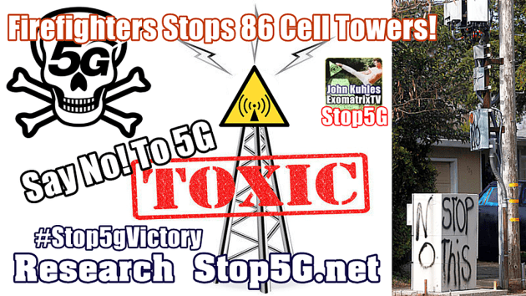
SayNo!To5G-Stop5G.net

LOS ANGELES FIREFIGHTERS STOPS 86 CELL TOWERS!
https://www.youtube.com/watch?v=Xk4vpSzyCKY
LA County firefighters called for support in stopping 86 cell towers on fire stations. County supervisors voted to suspend the construction at the hearing on Tuesday.
Firefighters used social media, radio and video to get their message out to the community. This radio ad ran for three days:
Audio Player
“This is fire captain Lew Currier. Los Angeles County is installing cell towers on 86 fire stations near you. The radiation generated by these seven story eye sores can cause debilitating health effects. Studies suggest nearby families could get sick too, yet the board of supervisors is erecting these toxic towers without public hearings or required studies. This time, be there for us, your firefighters. Call the Board of Supervisors at 213-974-1411. Tell them to stop the cell towers, NOW. This message is brought to you by Los Angeles County firefighters local 1014.”
Los Angeles County firefighters are in immediate danger of having their fire stations used as cell tower sites. You can help them by calling, and attending the hearing which will be held on Tuesday, March 24; 9:30 am at the LA County Board of Supervisors Hearing Room, 500 West Temple Street, Los Angeles.
http://stopcellphonetowers.com
3/24/2015: UPDATE: County suspends decision to construct the towers! Congratulations local 1014!
http://abc7.com/news/la-supervisors-stop-cell-tower-construction-at-fire-stations/571612/
Source Article Above

LA COUNTY FIREFIGHTERS LOCAL 1014 FIGHTING CELL TOWERS
Posted by Robert Daniel on 3/31/2015 to Wireless
Original Source
Update, March 24, 2015: LOS ANGELES (KABC) – Construction on giant cell towers needed to make Los Angeles County’s emergency communication system work has been halted until radiation concerns can be addressed. Dozens of firefighters came to the Los Angeles County Board of Supervisors meeting Tuesday to let them know they do not want cell towers where they work.
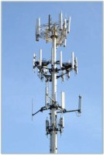
The Los Angeles Regional Interoperable Communications System (LA-RICS) is spending hundreds of millions of taxpayer dollars to install hundreds of new microwave radiation-producing cell towers throughout the County, including at County-owned and leased fire stations and lifeguard facilities.
“As firefighters and paramedics, we live in these firehouses. What effect will these towers have on us? What are the risks to our neighbors? It’s a no-brainer that LA County should at least have done a proper study before putting 200-foot high-power microwave antennas on top of our heads.”
– Dave Gillotte, Active Duty Fire Captain
President, LA County Firefighters Local 1014
“This is fire captain Lew Currier. Los Angeles County is installing cell towers on 86 fire stations near you. The radiation generated by these seven story eye sores can cause debilitating health effects. Studies suggest nearby families could get sick too, yet the board of supervisors is erecting these toxic towers without public hearings or required studies. This time, be there for us, your firefighters. Call the Board of Supervisors at 213-974-1411. Tell them to stop the cell towers, NOW. This message is brought to you by Los Angeles County firefighters local 1014.”
From the Firefighters Local 1014 website:
“We’re not talking about driving down the freeway past a cell tower that looks like a fake tree. We’re talking about having antennas practically on top of our heads day in and day out, irradiating us with radiofrequency (RF) radiation every second we’re in the stations.”
SkyVision Solutions supports the efforts of the firefighters in Los Angeles. We would hate to see anyone having to live or work within about 200 to 300 meters of a cell tower [1].
For more information on this specific issue in LA County, refer to: “Cell Tower Message to our Members,” at: http://local1014.org/index.cfm?zone=/unionactive/view_article.cfm&HomeID=482795
The following link may also be of interest: “Position on the Health Effects from Radio Frequency/Microwave (RF/MW) Radiation in Fire Department Facilities from Base Stations for Antennas and Towers for the Conduction of Cell Phone Transmissions,” at:
http://www.iaff.org/hs/Facts/CellTowerFinal.asp
Update, March 24, 2015: Here is a new article on the subject: “A new hurdle for L.A. County emergency-radio effort: cell tower fears,” at
http://www.latimes.com/local/countygovernment/la-me-disaster-radios-20150324-story.html. Quoting the article:
“If the data system isn’t completed by the end of September, local officials will have to return any unspent federal money. To help keep to its schedule, the authority decided to build its cell towers on publicly owned sites, including county fire stations, and got them exempted from state environmental review requirements.
But the firefighter union contended that the towers’ radio frequency emissions would pose health hazards to them and neighboring residents. And community activists got angry when they saw the towers — some with monopoles as high as 70 feet — going up without notice. Some cities refused to allow the towers, reducing their planned numbers from 232 to 177.”
[1] Cited Study for Basis of Distance Factor
The chart shown below is derived from data found in the following article: “Study of the Health of People Living in the Vicinity of Mobile Phone Base Stations: [Part 1] Influence of Distance and Sex”; Santini R, Santini P, Danze JM.; Pathol Biol (Paris) 2002; 50: S369–73.
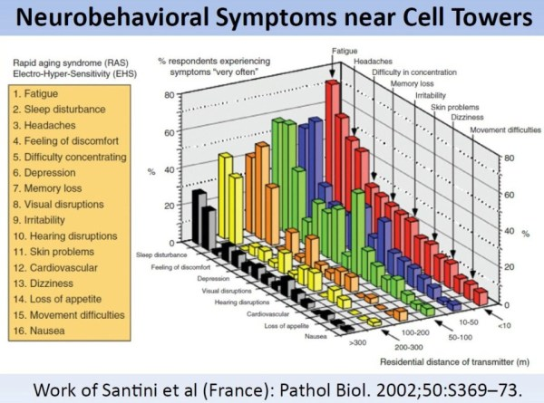
Santini 2002 Symptoms Near Cellular Base Stations
Discussion and conclusions of the published report include:
“This study gives evidence of the fact that bioeffects are reported by people exposed at up to 300 m from base stations.”
“The significant increase in the frequency of complaints in relation to the reference group (people exposed at > 300 m or not exposed) leads toward the observation found in the Australian governmental report indicating that at 200 m from a base station, some people exposed in their homes are complaining of chronic fatigue and sleep disruption.”
“From these results and in applying the precautionary principle, it is advisable that mobile phone base stations not be sited closer than 300 meters to populations and most significantly because exposed people can have different sensitivities related particularly to their sex.”
Reference: http://www.ncbi.nlm.nih.gov/pubmed/12168254

HOW TO OPPOSE “SMALL CELL” 5G TOWERS
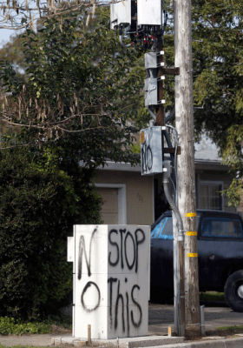“small cell” tower in Santa Rosa CA.
The telecom industry has switched from primarily installing large, macro cell towers to deploying “small cell” towers (5G). The following information is focused on the “small cell”, but the “how to oppose” can apply to larger towers too.
The Federal Communications Commission and the federal government have been promoting and supporting rapid expansion of 5G. Some states have already passed laws forcing them onto communities. However people are pushing back and defeating installations. In Hillsborough California 16 cell towers were denied. In California SB649, which would have restricted cities ability to regulate 5G, was vetoed by Governor Jerry Brown.
The industry vision for 5G is to enable the Internet of Things, Smart Communities, driverless cars (and more), where roads and appliances (even baby diapers!) are embedded with wireless radiation transmitters that connect to cell phones, smart meters and the internet. The industry wants wireless everywhere with “small cell” towers every couple hundred feet apart! That means cell towers in our neighborhoods, near schools and parks, where we live, work and play.
5G would use a combination of microwaves and millimeter waves, which are scientifically shown to harm people and nature. For more information on 5G see What is 5G?
Artwork by Shelley Masters
We strongly urge people to oppose 5G! The following information has been compiled to help you stop 5G to protect your neighborhood, community, people, pets, and environment.
- Keep a watch on your [city or county] planning or permit department for applications for “small cell” towers. You’ll need to call the city or county to find out who handles the telecommunications applications. Note they will likely deny the “small cell” is 5G.
- Educate and engage the community about EMF/wireless health risks. Here is a brochure about EMFs you can use to start a conversation. Legally a city cannot deny an application based on health effects, however it is important to educate decision makers on the science of harm, because this will motivate them to find another way to deny the application. People can also argue aesthetics, location, loss of property value and no significant coverage gap. (see legal letter below)
- If you live in California: Read and present this legal letter from Best Best and Krieger, which outlines what a California community can do to legally deny “small cell” towers in the public rights of way. April 24 2018 Letter to EMF Safety Network re small cells. If you don’t live in CA you can still present this letter and urge them to research and understand their legal rights.
- Speak at public comments at city meetings. Speak to those issues with the strongest science, boil it down to basic terms and concepts, and document the claims you make. For example: Peer-reviewed published science shows harmful effects of cell tower radiation include: fatigue, headaches, sleep problems, anxiety, ringing in the ears, heart problems, learning and memory disorders, increased cancer risk, and more. Children, the ill and the elderly are more vulnerable. This Letter to Sebastopol 5G includes studies and quotes you can use. See also: Biological Effects from Radiofrequency Radiation and www.emfscientist.org Peer reviewed published studies found radiation harms trees, birds, bees and insects. Studies of radiation impacts on wild birds documented nest abandonment, plumage deterioration and death. https://www.ntia.doc.gov/files/ntia/us_doi_comments.pdf Peer reviewed published science shows millimeter waves adversely affect health. https://goo.gl/gbBKHL More studies here. See also: EU 5G Appeal. International Society of Doctors for Environment 5G Appeal
Santa Rosa on Link Lane, this one is partly dismantled due to resident protests and the city halting the installation.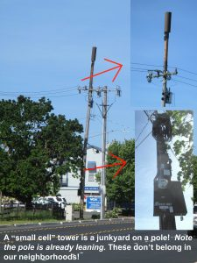Santa Rosa on Sebastopol Road.
- “Small cell” tower is a junkyard on a pole! In reality these often do not look like the representational drawings the industry presents. Click on the photos to the left for a closer look.
- Share important news: Democracy Now reported on an investigation by The Nation “How Big Wireless Made Us Think That Cell Phones Are Safe.” and “How Big Wireless War-Gamed the Science on Risks, While Making Customers Addicted to Their Phones”
- When there is an application pending: Send a letter by mail and email to the decision makers and go to the public meetings to speak out and oppose. Gather others to go to the meeting to also speak out. Please note: decision makers are often volunteers and they need to be educated about complex EMF science and laws. While some people feel aggressive tactics is the only way to get them to understand, practicing courtesy is also effective. You may want to ask the city to hire an independent RF specialist to prove there is a coverage gap. Here is an independent RF firm: http://www.emfservices.com/cell-towers.htm
- Create a flyer to circulate to let people know what’s happening and where to complain. See this sample flyer to adapt and create your own.
- Donate! Your donation will help support and expand this important work. To donate via Paypal (or credit card) click on the yellow button below. For more information on how to donate by check or for non-profit donations click here.

9. Sign up with EMF Safety Network to stay informed. click here
Further suggestions:

  - Make posters of Shelley Masters 5G Artwork (see image above) and ask shop owners to put them up. To obtain a higher resolution file for reproduction contact emfsafe at sonic.net.
  - Make use of social media, online community bulletin boards to warn others about where the towers are planned and where to complain.
  - Circulate a petition.
  - Send letters to the editor of your local newspapers.
  - Table at a farmers market, or simply go to a farmers market and hand out flyers.
  - Take Action to Oppose 5G and Federal Wireless Expansion: click here
Thank you for your support and let us know the outcome of your action!
(http://stop5g-resistance.whynotnews.eu/5g-cancer/related-stop5g-activism-los-angeles-firefighters-stops-86-cell-towers/)

