Subject : Notice of critical information and liability - sent to UK, Scottish Parliament, MHRA, JCVI, NHS England, NHS Scotland on 6.02.2021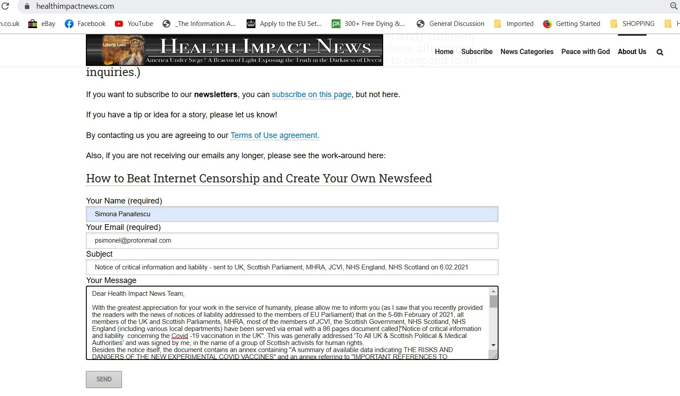

Dear Health Impact News Team,

With the greatest appreciation for your work in the service of humanity, please allow me to inform you (as I saw that you recently provided the readers with the news of notices of liability addressed to the members of EU Parliament) that on the 5-6th February of 2021, all members of the UK and Scottish Parliaments, MHRA, most of the members of JCVI, the Scottish Government, NHS Scotland, NHS England (including various local departments) have been served via email with a 86 pages document called "Notice of critical information and liability concerning the Covid -19 vaccination in the UK". This was generally addressed 'To All UK & Scottish Political & Medical Authorities' and was signed by me, in the name of a group of Scottish activists for human rights.
Besides the notice itself, the document contains an annex containing "A summary of available data indicating THE RISKS AND DANGERS OF THE NEW EXPERIMENTAL COVID VACCINES" and an annex referring to "IMPORTANT REFERENCES TO
CENSORED TREATMENTS FOR COVID-19"

You can find the document here: https://img1.wsimg.com/blobby/go/71801b8c-fda3-43cc-86e2-e2e50ff2f191/downloads/Notice%20of%20Critical%20Information%20and%20Liability%20c.pdf?ver=1619362847787

and some screenshots of the sent messages here: https://img1.wsimg.com/blobby/go/71801b8c-fda3-43cc-86e2-e2e50ff2f191/downloads/Notice%20of%20Critical%20Information%20and%20Liability%20%E2%80%93.doc?ver=1619365838133

I have also received two answers from the Scottish Govt and NHS Scotland which can be found here: https://img1.wsimg.com/blobby/go/71801b8c-fda3-43cc-86e2-e2e50ff2f191/downloads/Response-202100154891%20-%20to%20Notice%20of%20Critical%20.pdf?ver=1619364049128

and here: https://img1.wsimg.com/blobby/go/71801b8c-fda3-43cc-86e2-e2e50ff2f191/downloads/Mr%20Panaitescu%20(Response%20to%20Notice%20of%20Critical.docx?ver=1619364049128

This is in case you find this information of any relevance. Again, a huge thank you for all your great efforts and dedication. I will gladly continue to share most of the essential information you provide on your website.

God bless and strengthen you and all your dear ones!
Simona
psychologist, author
Cumbernauld, Scotland
07749 428 272

https://communityawarescotland.info/

