UK researchers have calculated that if the entire UK population started using disposable masks daily, it would create a significant environmental hazard, namely 42,000 tonnes of potentially contaminated and unrecyclable plastic waste per year.
Here are some other reasons NOT to wear a mask
- Flu season is over
- Covid-19 is NOT transmitted through the air but in droplets – and ONLY from someone with FULL-BLOWN SYMPTOMS of Covid-19
- European Pathologists have reported NO; ZERO; ZILCH; NADA; HEE HAW deaths from Covid-19: NONE. NOT ONE.
Source: https://www.marktaliano.net/no-one-has-died-from-the-coronavirus-important-revelations-shared-by-dr-stoian-alexov-president-of-the-bulgarian-pathology-association-by-rosemary-frei-and-patrick-corbett-offguar/
- An A&E Consultant in Surrey gave an interview in which he stated, “In my opinion, and that of many of my colleagues, there has been no Covid-19 Pandemic, certainly not in the Surrey region and I have heard from other colleagues this picture is the same throughout the country”.
Here is the source of this doctor’s statement: please check it for yourself: https://www.facebook.com/jill.kirk999/posts/10217051238625100
- It is scientifically proven that paper or cloth facemasks against Covid-19 (which is 3 microns in size; that’s a miniscule 0.003 mm) do NOT work: the masks we are being told to wear have pore sizes of between 80 and 500 microns, so 27 to 167 individual virus particles could link arms and march RIGHT through your mask, up your nose.

- Wearing a facemask if you are healthy is scientifically proven NONSENSE.
Use the one on the left for shops and the one on the right for public transport: cut them out, pop them in a lanyard and show at the door instead of perpetuating this myth. For more info’ go to www.MeWe.com and join the group called “Red Pill”
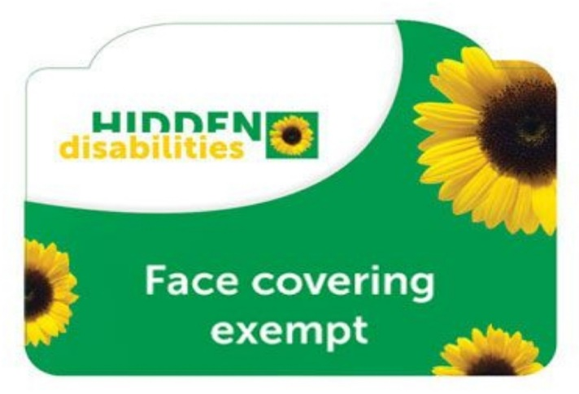 | 