December 7, 2019
Print This Post

New 5G Cell Towers and Smart Meters to Increase Microwave Radiation – Invade Privacy
Join The Discussion(11)
32

6

42
Share

2
Share

0

98

4

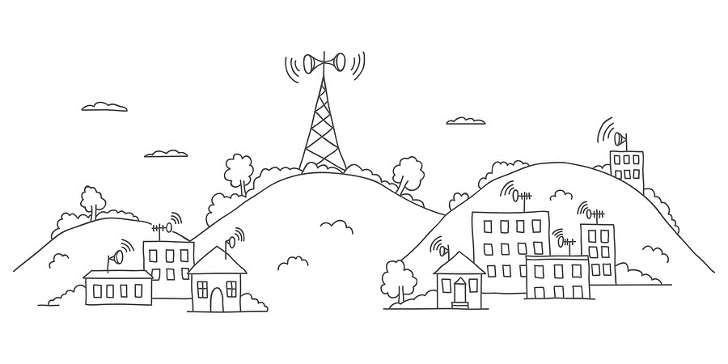

Telecom Companies are Going Green, but Their Version of Green will cause Illness and Death
by John P. Thomas
Health Impact News
When the Federal Communication Commission (FCC) approved the use of 5-G microwave communication technology in 2016 and approved the use of microwave frequencies in the 30 Ghz range, [1], they opened the door to even higher levels of human illness and severe disability for American children and adults.
Microwave radiation such as that currently being used in cell phones, Wi-Fi routers, and smart meters has already been linked to numerous health effects.
The introduction of even more intense levels of microwave exposure at higher frequencies will push many people into life-threatening chronic illness. High frequency microwave radiation is often overlooked as a causative factor in illness, because most conventional healthcare providers, government regulators, telecom companies, and electric utilities believe microwave radiation used in communication technology is harmless. [2]
Despite the warnings being raised by scientists, well informed healthcare providers, and grassroots organizations about existing and future microwave hazards, [3, 4, 5] telecom companies are planning to implement 5G technology throughout every urban area in America. They are already testing this new generation wireless telecommunication infrastructure in Boston, Austin, Palo Alto, and Mountain View California. [6, 7]
In a January 2017 announcement, AT&T described their plan for future technology deployment. The announcement stated:
Our 5G Evolution plans will pave the way to the next-generation of higher speeds for customers. We’re not waiting until the final standards are set to lay the foundation for our evolution to 5G. We’re executing now,” said John Donovan, chief strategy officer and group president, Technology and Operations. [8] [emphasis added]

The Battle to Implement 5G has begun in California
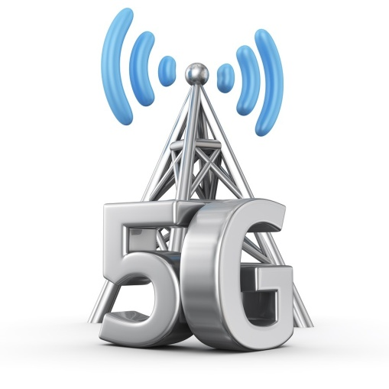
Proposed legislation in California would permit telecom companies to erect 50,000 new microwave antennas in residential and commercial areas without municipal approval.
The 5G microwave antennas would be placed on top of existing utility poles or on public infrastructure such as schools, libraries, bus shelters, and in public parks. The placement of this equipment will be at the discretion of the telecom companies. [9, 10, 11]

Health Dangers of Microwave Radiation have been Well Documented
The symptoms of microwave radiation exposure include fatigue, headaches, heart palpitations, high pitched ringing in the ears, dizziness, disturbed sleep at night, sleepiness in daytime, moodiness, irritability, unsociability, feelings of fear, anxiety, nervous tension, mental depression, memory impairment, pain in muscles, pain in the region of the heart, and breathing difficulties, to name a few.
Inflammation (caused by excess histamine in the blood), oxidative stress, autoimmune responses, reduced blood flow to the region of the thalamus, pathologic leakage of the blood-brain barrier, and a deficit in melatonin metabolic availability have all been observed.
There is evidence that existing and new frequencies of microwave radiation are associated with cancer, heart disease, neurological dysfunction, immune system suppression, cataracts of the eyes, and sperm malformation. [12, 13]

5G Microwaves have Harmful Biological Effects
In her testimony before the California legislature, Dr. Ann Lee, M.D., indicated that there are 20,000 well established scientific studies on the bio-effects of radio frequency radiation.
She confirmed that microwave radiation such as that from the proposed 5G wireless facilities that would be deployed in California has been shown to cause neurological damage, cardiac dysfunction, reproductive harm, immune compromises, and cancer. [14]
Dr. Ronald Powell, Ph.D., expands upon these concerns. Dr. Powell received his doctorate in Applied Physics from Harvard University in 1975, and has worked for the National Science Foundation and the National Institute of Standards on energy policy research and R&D program evaluation.
He is uniquely qualified to interpret the junction between the physics of electromagnetic fields and the biological effects these fields produce. [15]
In a letter to the FCC, Dr. Ronald Powell stated:
It would greatly extend FCC’s current policy of the mandatory irradiation of the public without adequate prior study of the potential health impact and assurance of safety. It would irradiate everyone, including the most vulnerable to harm from radio frequency radiation: pregnant women, unborn children, young children, teenagers, men of reproductive age, the elderly, the disabled, and the chronically ill. [16]

AT&T: Let Us Install Microwave Transmitter on Your Home or Lose Service
Now that more than 50% of homes are wireless, telecom companies plan to abandon copper phone lines used for their phone service and create a wireless phone system. For example, Michigan has passed a law permitting this, and AT&T is working with all 21 states in its service territory to bring this about. [17, 18, 19]
As an alternative to the wired system, telecom companies plan to install wireless microwave transmitters on homes as a method of providing traditional phone service. In the case of AT&T customers, the only way you will be able to prevent them from installing such devices on your home is to remove AT&T as your service provider. [20]
In addition, telecom companies plan to install microwave antennas on top of electrical power poles near homes and businesses, and on top of public buildings throughout every urban area and in every neighborhood.

California Legislators Consider Bill to Allow More Microwave Radiation
But this is not just about offensive looking antennas!
Nina Beety described the situation in the article she wrote for StopSmartMeters.org. She is the moderator of the Wireless Radiation Alert Network and distributes her research about the harmful effects of electromagnetic fields and the dangers of smart meters on her website, SmartMeterHarm.org.
Nina Beety stated:
Spaced approximately every 10-20 homes, cell antennas will hang in one or more clusters on utility or light poles. Equipment cabinets the size of refrigerators, with cooling fans and back-up generators, will sit on sidewalks. Towers will be located in the public right of way a few feet from bedroom windows, offices, schools, hospitals and nursing homes.
Called “small cells,” there is little difference in size for many of these antennas; the chief difference is the location on utility poles versus large towers. Measurements of these cell towers recently taken in Palo Alto found high levels of radiation on the sidewalk below them — levels higher than those associated in research with breaches in the blood-brain barrier, free radical formation, DNA damage, cancer and tumors, and heart rhythm disturbances. [21]
Nina Beety is specifically describing the proposed system that would be implemented in California if the telecom companies get their way. Currently, a bill permitting the establishment of the 5G system has been passed by the California Senate. A legislative committee will be considering the bill on July 12, 2017. A rally at the State House in Sacramento is planned for July 12th. Please see the following urgent call for action and related links for the details.

Urgent Call to Action for Californians
The announcement from StopSmartMeters.org states:
The Assembly Local Government Committee voted 6-1 to approve SB 649 on Wednesday June 28th (even after hearing the below testimony). It goes next to the Communications and Conveyance Committee at 1:30pm on July 12th. People are coming from all over the state to be there on this day to speak out against SB 649, including mayors, and regular people opposed to the bill. Will you be one of them? [23]
More details about SB 649 and the rally in Sacramento can be found here.
Dr. Ann Lee, M.D., testifies about the Dangers of the Proposed 5G Network:
10-Year Old Child Testifies about how Wireless Communications Equipment Affects His Heart:
Nina Beety’s Testimony about the Proposed 5G System from the Perspective of an EMF Disabled Person:

Why do Telecom Companies Want a 5G Network? The Merging of Telecommunications with Electric Utilities
Telecom giants plan to take their 5G technology nationwide. It is part of a long-term plan to integrate telecom activities with electrical service providers. A 2015 white paper written by telecom companies, electric utilities, and technology developers published in the European Union describes their vision for the future.
As I interpret the images that these European visionaries are creating, I believe they are foreseeing a day when electrical power production and distribution will be controlled by the 5G network.
In this future vision, large-scale power production facilities will be replaced by hundreds of thousands of small power producers, which could even include personal power production in our homes from solar and wind.

Centralized Power and Control
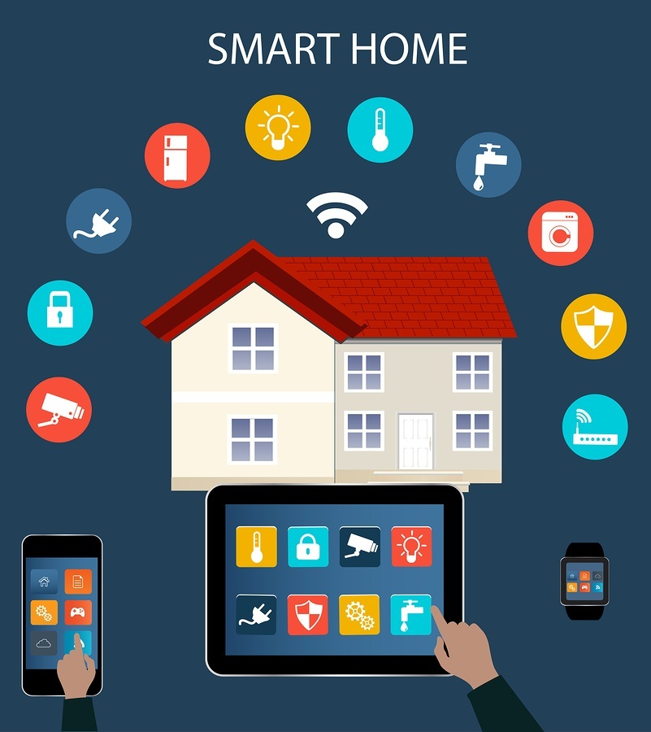
Wireless technology allows you more control of your home, but at what cost?
The 5G system will monitor not just consumption of power, but will monitor and control the redistribution of electrical power across the entire electrical grid.
The 5G network will be the nerves and sense organs of a massive organism that has a central brain somewhere, which controls all forms of information exchange and electric utilization/production.
Electricity will be used for all aspects of household and business activities, and the 5G network and its centralized brain will control everything. [24]
In the beginning, the speed of the 5G network will be marketed to consumers and businesses who want super-fast internet service. This will allow for instant access to videos and webpages with as little as a 5-millisecond delay from the moment a start button is pressed.
Transmission speeds will be hundreds of times faster than current internet connections. It will be so fast that it will be able to instantaneously project images on the lenses of smart enabled eye glasses to create virtual reality images that blend with the environment.
People will be able to watch videos or even read email simply by looking through the lenses of their glasses. The speed will be so phenomenal that it will make available self-driving cars, which can safely drive passengers to their destinations. [25]
Ultimately, the greatest benefit of the 5G system will be for utility companies. It will give them the ability to take total control of electric production, distribution, and consumption.

Smart Meters and Smart Appliances: Your Home is no Longer Private
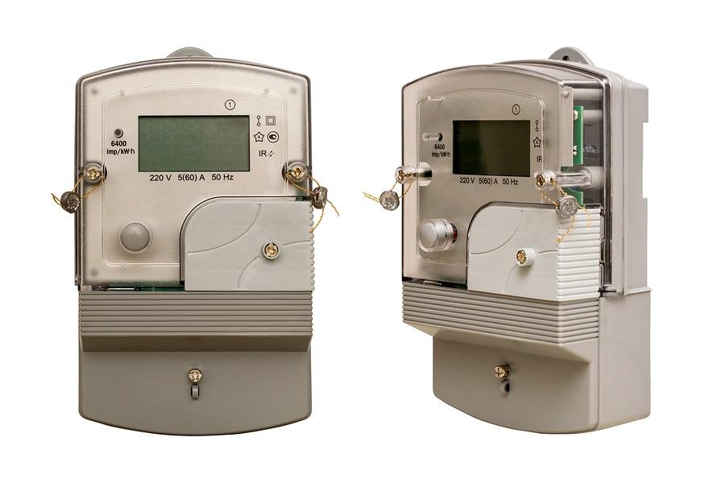
New Smart Meters.
The smart meters that electric utilities are now installing throughout the U.S. are the nerve endings for what will become a highly complex centrally controlled information and energy exchange system.
The 5G network will use the smart meter system (being implemented throughout the U.S.) and the new generation of smart appliances to reach into our homes and make decisions for us.
Current smart meter technology enables electric utilities to read electric meters without sending a human being to physically read the meters.
Electric providers have been quietly installing these smart meters throughout the U.S. They insist that these meters are harmless even though they broadcast intense bursts of high frequency microwave radiation several times per minute 24-hours per day every day.
Currently, smart meters record electric consumption and transmit the information to the utility company for billing and electric distribution purposes.
The bursts of microwaves are used to communicate with other smart meters in the neighborhood and with wireless routers mounted on top of electric poles. The routers send even more powerful microwave signals several thousand times per hour to the utility company.
Smart appliances such as heating/cooling equipment, washers/dryers, refrigerators/freezers, stoves/microwave ovens, dishwashers, hot water heaters, and even electric coffee makers will each be able to broadcast and receive microwave signals.
These appliances and our smart meters will constantly communicate with one another all day long and all night long – they will never stop transmitting microwave radiation.
Everything that uses electricity will be potentially monitored and controlled by the power companies.
If desired, the electric providers can even independently turn off any appliance they wish whenever they wish to conserve energy consumption. [26, 27]
The need for smart appliances will be a boon for appliance manufacturers and microwave technology producers. The fusion of 5G with the electrical grid will require everyone to buy new appliances that are smart meter enabled or have our existing appliances retrofitted with microwave transmitters.

Is it Green or Just a Way for Corporations to Make More Money and Control Our Lives?
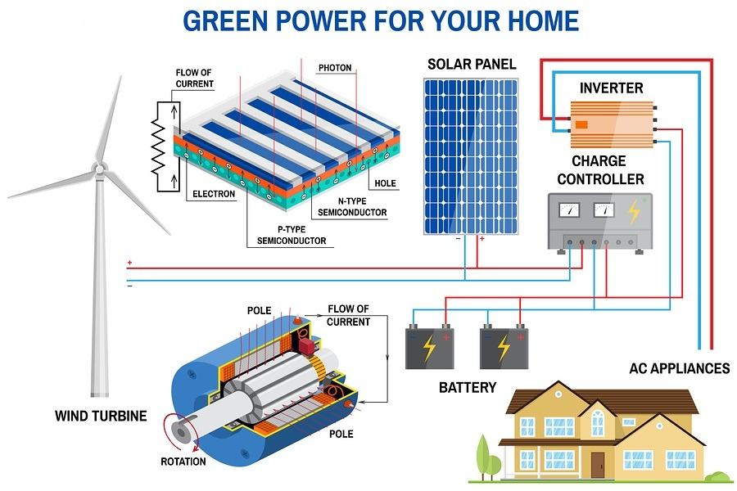
The 5G system goes hand-in-hand with the smart meter system. Together, these systems will be used to create “smart cities.”
These cities will be blanketed in high frequency microwave radiation and will provide the means for enabling a wide variety of new technology.
It is considered to be part of the green revolution. It is part of national technology priorities that were established at the beginning of the first Obama administration. [28]
It is green, because the technology will allow utility providers to closely control energy usage and implement billing systems that will benefit those who reduce energy consumption.
During times of peak energy usage, they will be able to control our appliances and even cut off certain appliances, so that available energy can be directed to high priority uses.
Such a system would supposedly prevent the need for building additional power production facilities, thus avoiding additional fossil fuel emissions or the creation of additional nuclear waste.
It is green, because telecom companies will no longer need to maintain thousands of miles of copper phone lines and switching equipment. Even though the telecom companies will discontinue the network of copper wire, they will still be using fiber optics for some activities.

There are Serious Health Risks Beyond the 5G Hype
As exciting as a future of blended telecommunications and electrical service technology might be for corporations and some consumers, there are very serious health risks, which the FDA and corporations are ignoring.
They believe that microwave technology used for communication does not affect human health. They believe that it doesn’t matter how much microwave radiation is put into the air and what frequencies are used to transmit information.
It doesn’t matter, because the single criterion that they use to judge safety is not affected by the new 5G system.
The criterion that is of interest to regulators is heating. Does the technology cause the human body to heat up and is that heating excessive? [29]
Almost anyone who has spoken on a cell phone pressed against their ear for a long phone call will notice that their ear and even the side of their head will feel warm by the time they end the call.
This is the heating effect of microwaves. This is why iPhones come with a warning to keep the phone 15 mm away from the body. [30]

Microwave Radiation Produces Cellular Disruption Even if it is Not Felt
At the beginning of this article, I mentioned a long list of health effects, medical conditions, and chronic illnesses that are associated with microwave exposure.
I plan to look at this research in more detail in my next article. I will address the effect of microwave radiation on heart function and nerve function, and examine the reality of electromagnetic hypersensitivity, which is already disabling hundreds of thousands of people in the U.S. even before the 5G network is implemented.
At this point, I want to finish up with a powerful quote from a recent article on anxiety disorders prepared by Dr. Joseph Mercola, D.O.
In part, the article mentioned microwave exposure as being a potential contributing factor for anxiety disorders. These comments offer additional evidence that the health effects of microwave exposure are profound and are being completely overlooked by regulators.
Dr. Mercola’s article stated:
Due to the pioneering work of Dr. Martin Pall, we know that voltage gated calcium channels are over 7 million times more sensitive to microwave radiation than the charged particles inside and outside our cells. This means that the safety standards for this exposure are off by a factor of 7 million.
When the EMF from the above listed devices [cellphones and cordless phones, Wi-Fi routers, baby monitors, smart meters and cellphone towers] hit your voltage gated calcium channels, nearly 1 million calcium ions per second are released into the cell, which then causes the cell to release excessive nitric oxide that then combines with superoxide to form peroxynitrate, which then forms the dangerous hydroxyl free radical that causes massive mitochondrial dysfunction.
Guess which tissues have the greatest density of voltage gated calcium channels? Your nerves and tissues, like the pacemaker in your heart and, of course, your brain. When the channels in the brain are activated, it causes a major disruption in neurotransmitter and hormonal balance that can radically increase the risk for not only anxiety and depression but arrhythmias, autism and Alzheimer’s. [31]

Final Question: Is the Technology Worth the Harm to Our Health and Loss of Privacy?
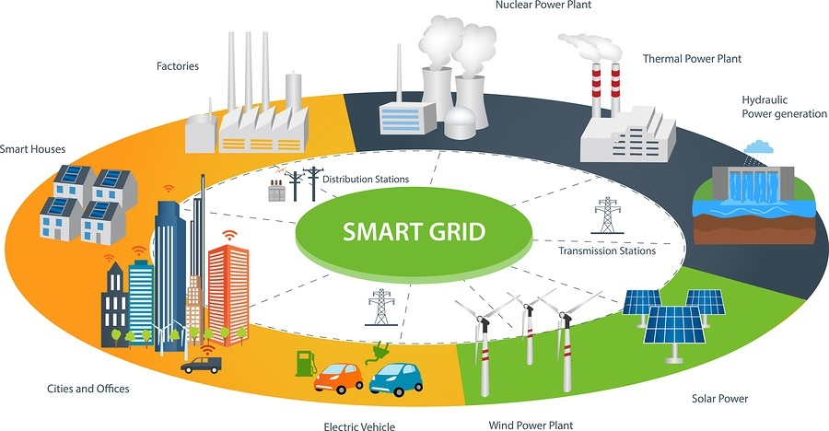
There is a very basic question that we must all consider.
Are the dreams of mega-corporations to create smart cities saturated in high frequency microwave electromagnetic fields worth the harm that this technology will create for the people who live in those cities?
In smart cities, no one will be exempt from microwave exposure. We won’t be able to opt out, because the 5G microwave system is designed to reach every space in a city.
Those who experience microwave related illness and disability will have few options. They will either stay in the smart city and stay sick or they will need to try to find a place to live in some sparsely populated off the grid location where the 5G system does not reach.
Which future do you want for America? Super-fast internet and corporate control of every aspect of your life, or good health and longevity?

About the Author
John P. Thomas is a health writer for Health Impact News. He holds a B.A. in Psychology from the University of Michigan, and a Master of Science in Public Health (M.S.P.H.) from the School of Public Health, Department of Health Administration, at the University of North Carolina at Chapel Hill.

Resources
[1] “FCC approves spectrum for 5G advances,” Mike Snider, USA TODAY, 7/14/2016. https://www.usatoday.com/story/tech/news/2016/07/14/fcc-approves-spectrum-5g-advances/87081242/
[2] “A 5G Wireless Future: Will it give us a Smart Nation or Contribute to an Unhealthy One?” Dr. Cindy Russell, MD, Retrieved 6/5/2017. http://www.sccma-mcms.org/Portals/19/assets/docs/17ZZ-PDF.pdf?ver=2017-05-10-133815-897
[3] “Smart Meter Resources from Ronald Powell Ph.D.,” Stop Smart Meters!, Retrieved 6/5/2017. https://stopsmartmeters.org/2016/03/04/smart-meter-resources-from-ronald-powell-ph-d/
[4] Dr. Cindy Russell, op. cit.
[5] Stop Smart Meters! Fighting for health, privacy, and safety. http://stopsmartmeters.org/
[6] Dr. Cindy Russell, op. cit.
[7] “AT&T Details 5G Evolution,” News provided by AT&T Inc., 1/4/2017. http://www.prnewswire.com/news-releases/att-details-5g-evolution-300385196.html
[8] Ibid.
[9] Stop Smart Meters! Fighting for health, privacy, and safety. http://stopsmartmeters.org/
[10] “Opinion: Turning California utility poles into cell towers,” Nina Beety, Stop Smart Meters!, 6/12/2017. https://stopsmartmeters.org/2017/06/12/opinion-bill-would-turn-california-utility-poles-into-cell-towers/
[11] “Plan To Install 50,000 Cell Towers In California Faces Opposition,” Phil Matier, CBS San Francisco, 6/28/2017. http://sanfrancisco.cbslocal.com/2017/06/28/plan-install-50000-cell-towers-california-opposition/
[12] Dr. Cindy Russell, op. cit.
[13] “Smart Meter Resources from Ronald Powell Ph.D.,” Stop Smart Meters!, Retrieved 6/5/2017. https://stopsmartmeters.org/2016/03/04/smart-meter-resources-from-ronald-powell-ph-d/
[14] Dr. Ann Lee, MD, Testifies about the dangers of the proposed 5G network. https://www.youtube.com/watch?v=ARTBx8osdds
[15] “Smart Meter Resources from Ronald Powell Ph.D.,” Stop Smart Meters!, Retrieved 6/5/2017. https://stopsmartmeters.org/2016/03/04/smart-meter-resources-from-ronald-powell-ph-d/
[16] Dr. Cindy Russell, op. cit.
[17] “6 things to know now about the landline phone bill signed by Gov. Rick Snyder,” MLive.com, Melissa Anders, 3/26/2014. http://www.mlive.com/lansing-news/index.ssf/2014/03/6_things_to_know_now_about_the.html
[18] “AT&T wants out of Illinois-wide mandate to run landline phones,” Amina Elahi, Chicago Tribune, 3/21/2017. http://www.chicagotribune.com/bluesky/…/ct-illinois-telecom-bill-att-bsi-20170321-story.html
[19] “AT&T ready to hang up on traditional landline phone service in Illinois,” Robert Channick, Chicago Tribune, 5/4/2017. http://www.chicagotribune.com/business/ct-att-landline-phone-service-0507-biz-20170503-story.html
[20] “Opinion: Bill would Turn California Utility Poles into Cell Towers,” Nina Beety, op. cit.
[21] Ibid.
[22] Also see Nina Beety’s research about Smart Meter overbilling, fires, health problems, inaccuracy, hacking & cybersecurity, interference, privacy loss, and more on her website. https://smartmeterharm.org/
[23] ““Microwave Radiation has been Shown to Cause Neurological Damage”– Physicians and Other SB 649,” Stop Smart Meters!. https://stopsmartmeters.org/2017/06/23/stop-smart-meters-letter-to-the-california-assembly-local-
[24] “5G PPP White Paper on Energy Vertical Sector,” 9/30/2015. https://5g-ppp.eu/wp-content/uploads/2014/02/5G-PPP-White_Paper-on-Energy-Vertical-Sector.pdf
[25] “AT&T Details 5G Evolution,” News provided by AT&T Inc., 1/4/2017. http://www.prnewswire.com/news-releases/att-details-5g-evolution-300385196.html
[26] “The Truth About Smart Meters,” YouTube. https://www.youtube.com/watch?v=v4HsxNG2-4M
[27] “Smart Grid Sensibility? Audio Interview with B. Blake Levitt and Duncan Campbell, Esq. by ElectromagneticHealth.org.” http://electromagnetichealth.org/electromagnetic-health-blog/smart-grid-sensibility-audio-interview-with-b-blake-levitt-and-duncan-campbell-esq-by-electromagnetichealth-org-founder-camilla-rees/
[28] IBID.
[29] “RF Safety FAQ,” Federal Communications Commission, Retrieved 7/6/2017. https://www.fcc.gov/engineering-technology/electromagnetic-compatibility-division/radio-frequency-safety/faq/rf-safety
[30] “iPhone 6 Bendgate: Apple’s Instructions Say Not to Keep Your Phone in Your Pocket Anyway,” Zoë Schlanger, News Week, 9/26/2014. http://www.newsweek.com/iphone-6-bendgate-apple-says-your-iphone-shouldnt-go-your-pocket-avoid-273313
[31] “Anxiety Overtakes Depression as No. 1 Mental Health Problem,” Dr. Joseph Mercola, Mercola.com, 6/29/2017. http://articles.mercola.com/sites/articles/archive/2017/06/29/anxiety-overtakes-depression.aspx?utm_source=dnl&utm_medium=email&utm_content=art1&utm_campaign=20170629Z1&et_cid=DM148831&et_rid=2061336581
Published on July 7, 201
(https://healthimpactnews.com/2017/new-5g-cell-towers-and-smart-meters-to-increase-microwave-radiation-invade-privacy/)

