Here is a letter / email drawn up in response to Rachel Elnaugh’s video. Please share far and wide so we can flood these bastards with correspondence and remind them that they serve we the people.
For postal addresses of the various subjects to target, please reference Rachel Elnaugh’s YouTube video from 9 min 40 secs in: https://youtu.be/T3DNV7v5i74 otherwise titles / email addresses here:
State FAO + the NAME of the person in the SUBJECT line:
FAO NADHIM ZAHAWI , in his capacity as Minister for Vaccine Deployment: by an annoying online form here: https://contactus.dhsc.gov.uk/ but you could also try him at his constituents contact email here: constituents@zahawi.com
BoJo as PM also has an annoying online form here: https://email.number10.gov.uk/
NB. Online forms: you won’t be able to include the reference to the graph or include the graph but everything else should be OK.
This one’s for Dr. Vernon Coleman:
FAO DAVID LAMMY MP lammyd@parliament.uk
FAO SIR SIMON STEPHENS, Chief Exec NHS: England.contactus@nhs.net
FAO AMANDA PRICHARD, Chief Operating Officer NHS: England.contactus@nhs.net
FAO DR JUNE RAINE CBE, MHRA: info@mhra.gov.uk
FAO MATT HANDCOCK, Secretary of State, DHSS: matt.hancock.mp@parliament.uk
FAO BORIS JOHNSON : boris.johnson.mp@parliament.uk
And, of course, your own MP.
Dear …….,
21st Century Nuremberg trials: as a servant of the public, you are being called to account
The Nuremberg Code (1947) and the Declaration of Helsinki (2000) are in place for the protection of all humanity from unethical experimentation. The UK population is being coerced into taking DNA-modifying operating systems (genetic engineering) which are being falsely promoted as vaccines. As a result, the Helsinki and Nuremberg Codes are being violated.
The official human trials on Covid-19 “vaccines” do not finish until 2023, doctors and scientists are being brutally censored, open debate has been quashed and it is now evident that these toxic systems are causing neurological damage and death in the UK population.
Within days of the first “vaccine” doses being administered, a steady rise in deaths became evident. Elders who have been forced into isolation for months; far from relatives and any “virus” are being inhumanely murdered via experimental genetic engineering. This is now clearly in breach of the Nuremberg Code.
These deaths are graphically depicted in the chart below which has been compiled from UK Government figures:
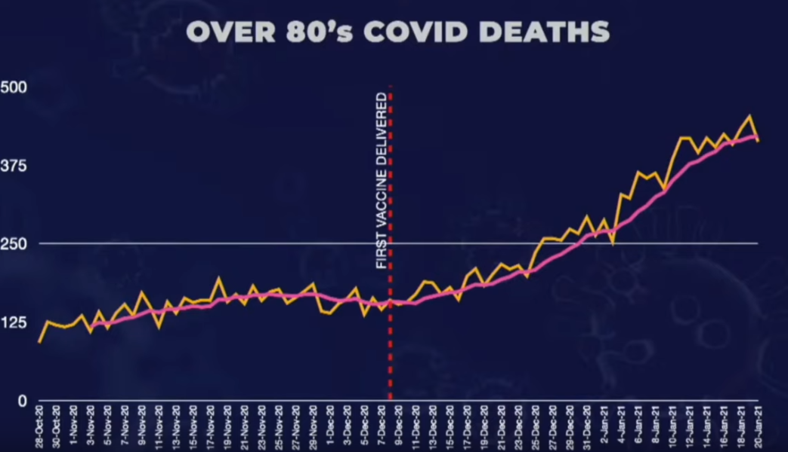
21st Century Nuremberg-style trials must be held for what is taking place in 2021. You are public servants: You serve US and We the people demand action; we demand transparency and we demand an immediate cessation of this experimental genetic engineering injection programme.
We the people want inquests to be held for the deaths of every UK citizen that has happened within a minimum 28-day period of “vaccination” injection. We want reparations for the damage caused to all entities, including through medical injury, psychological damage, loss of livelihood and to all lives and businesses that have been lost as a result of Lockdowns. In short, all damages that have been created by this government and all of the official agencies that have gone along with it since March 2020.
Unless you take action personally to stop the genocide that is happening on your watch, you will be held personally accountable for the part you are playing in this atrocity.
As with those tried at Nuremberg, now as in 1945 and 1946, “I was only following orders/doing my job/ I didn’t know” is no defence.
As a servant of the people, will you ensure these demands are met?

Regards,

…………………………………
Member of the UK people whom you have pledged to serve

