Registration
Register top, right for
occasional updates.

Mission Statement
We aggregate news, offer commentary & provide original content. Our news is largely political & we currently lean right due to the happenings in D.C.
We are interested in all points of view, but our goal is to counteract the spin that is eroding freedom of the press, and we often do it satirically.

Subscribe to RSS Feed

Recent Comments
- Dennis Clark on Colorado Woman Gang-Raped by Iraqi Muslims
- Chris on Colorado Woman Gang-Raped by Iraqi Muslims
- Dell's Bottom Line on U.S. Marine Jon Hammar Has Been Left Behind in a Mexican Prison
- RYAN on U.S. Marine Jon Hammar Has Been Left Behind in a Mexican Prison
- Dell's Bottom Line on We Won! Watchers of Weasels Is Best Blog-Ring!
- Sara Noble on We Won! Watchers of Weasels Is Best Blog-Ring!
- Dell's Bottom Line on We Won! Watchers of Weasels Is Best Blog-Ring!
- TaterSalad on Bland Benghazi Report Blames the State Department & Reprimands No One
- robert on Small Arms Treaty of 2012 – Elimination of the Second Amendment
- robert on Small Arms Treaty of 2012 – Elimination of the Second Amendment
- Sara Noble on Tim Scott, Historic Appointment to the US Senate
- Sara Noble on President Obama, Wayne LaPierre Issue Statements on Gun Control December 21 – Videos

Submissions
Submit articles for publication to: sara@ independentsentinel.com All points of view are welcomed!

Archive

Obama’s Seizure of the Heartland, Executive Order 13575, Laying the Groundwork for Agenda 21
February 4, 2012
By Sara Noble


“We need to get some broad based support, to capture the public’s imagination… So we have to offer up scary scenarios, make simplified, dramatic statements and make little mention of any doubts… Each of us has to decide what the right balance is between being effective and being honest.”
~ Prof. Stephen Schneider,
Stanford Professor of Climatology, lead author of many IPCC reports
Agenda 21 is a blueprint for sustainable development using global warming as the motivator. ICLEI is an offshoot of Agenda 21. Simply put, ICLEI is local governments for sustainability. The UN sees Agenda 21 succeeding by infiltrating the smallest levels of government, thus ICLEI is a means to an end.
If you are wondering why you keep hearing so much about sustainable development, smart growth, open spaces, environmental justice, social equity, TDR’s, population control, Eminent Domain, and redistribution of the wealth [which includes land not simply money], it is because the Obama administration is infiltrating every aspect of our society with it via executive orders and agencies. It’s been around for twenty years, but he put it on steroids.
A good example is Obama’s executive order 13575 which pushes Agenda 21 into every aspect of rural America. It cedes U.S. agriculture to international guidelines under the authorship of the UN. Obama in effect is signing the Kyoto treaty without a physical signing. He is ceding U.S. agriculture to the U.N.
Obama’s 86th Executive Order 13575, signed in 2011, mandates government control over 16% of the rural lands in America, but it will extend outward into every aspect of our lives. It represents a massive & organized infiltration of Agenda 21 into the United States societal fabric.
The first paragraph of the order reads:
Section 1. Policy. Sixteen percent of the American population lives in rural counties. Strong, sustainable rural communities are essential to winning the future and ensuring American competitiveness in the years ahead. These communities supply our food, fiber, and energy, safeguard our natural resources, and are essential in the development of science and innovation. Though rural communities face numerous challenges, they also present enormous economic potential. The Federal Government has an important role to play in order to expand access to the capital necessary for economic growth, promote innovation, improve access to health care and education, and expand outdoor recreational activities on public lands.
As the Executive Order references “sustainable rural communities,” it uses one of the key phrases found in the UN plan for sustainable development known as Agenda 21. The order admits that it intends to seize greater power over “food, fiber, and energy,” items that are key to human existence.
The mission and function of the White House Rural Council, according to the Executive Order, is as follows:
“The Council shall work across executive departments, agencies, and offices to coordinate development of policy recommendations to promote economic prosperity and quality of life in rural America, and shall coordinate my Administration’s engagement with rural communities.”
This video presents a good discussion. Caroline Heldman of far left Occidental College, who takes the government’s side. is as far left as anyone I have heard on TV.
Here is a quick summary of the terms for those who are unfamiliar with them -
Sustainable development, according to its authors, is purposed to integrate economic, social and environmental policies in order to achieve reduced consumption, social equity, and the preservation and restoration of biodiversity.
Sustainablistas insist that every societal decision be based on environmental impact, focusing on three components; global land use, global education, and global population control and reduction.
Social Equity (Social injustice) is described as the right and opportunity of all people “to benefit equally from the resources afforded us by society and the environment.”
Redistribution of wealth – private property is a social injustice since not everyone can build wealth from it. National sovereignty is a social injustice.
Agenda 21 policy includes Economic Prosperity Public Private Partnerships (PPP), special dealings between government and certain, chosen corporations which get tax breaks, grants and the government’s power of Eminent Domain to implement sustainable policy which are government-sanctioned monopolies aka crony socialism.
Read background information here: EO 13575 Update and here: Taking over land and oceans
http://www.independentsentinel.com/2012/02/obamas-seizure-of-the-heartland-executive-order-13575-laying-the-groundwork-for-agenda-21/

Executive Order 13575 – Rural Lands Takeover, Update 8/15
August 13, 2011
By Sara Noble
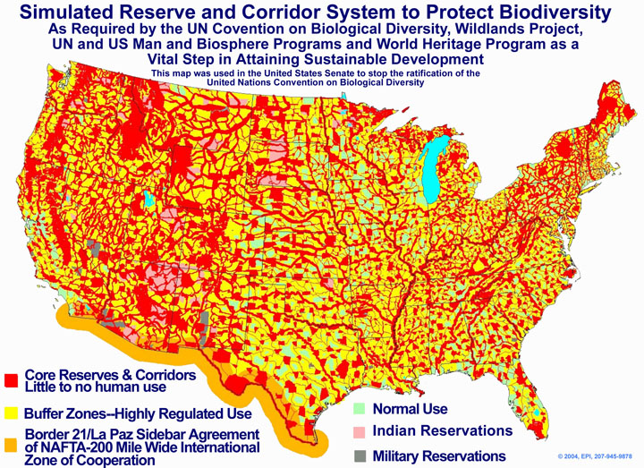

Update: – The following video provides a good overview of what this Executive Order actually means to us. This Executive Order gives the government control over 16% of our rural lands. For what reason? Are the rural lands doing badly? Did the farmers ask for this? How much power can the Executive Branch grab in a Republic? The balance of power is being diminished with the improper use of Executive Orders. Don’t forget that the Center for American Progress, under Podesta, believes Obama should circumvent Congress by using Executive Orders, and Obama is doing just that.
Original Story: - Recently, we reported on Executive Order 13575 which allows the President to develop “sustainable communities, something for which the government has no constitutional authority. It is in complete agreement with the UN’s Agenda 21 Read here: The UN’s View on Property Rights – Straight From the Marxist Manual
Last month, Obama created the WH Rural Council, which will be chaired by the Secretary of Agriculture. It will include 25 Cabinet secretaries (oh goody, more bureaucrats). Their mission, which will cover every government everything, is to promote prosperity and quality of life in rural USA.
This is a complete takeover of rural lands and it won’t matter who owns them. The Amish won’t be able to breathe as they try to farm in the old ways. Since when do we need the government to provide this prosperity and equality? The answer is – ever since the redistributionists took over.
From Trevor Loudon: “…Obama’s ultimate goal is to assure that government has ultimate control of every square inch of land, every business activity, the curriculum in every school and, ultimately, the information that may be conveyed on the public airways.
This is the goal of Agenda 21. Its recommendations are designed to produce this outcome. The program is called “Sustainable Development,” which means in real terms “government-approved” development. Every recommendation in Agenda 21 requires government enforcement. Any activity that is preceded by the word “Sustainable,” should be recognized as a “government-controlled” activity.
Sustainable Development brings the concept of “Amortization of Non-Conforming Uses.” This means that, over time, the right of private landowners to occupy their houses will automatically be extinguished, and owners will be forced to leave their property without just compensation. This is happening in both urban and rural areas of the country. One of the more blatant examples was revealed in an article published by the LA Weekly News, June 23: “L.A. County’s Private Property War.”
Countless L.A. County property owners have been victimized by armed NATs (Nuisance Abatement Teams) issuing citations for ‘living on the land illegally’ and other equally ridiculous code violations. This is on land the victim owns. The code violations arise from new codes that comply with Agenda 21. These codes did not exist when the homes in Antelope Valley were built 20 and 30 years ago. Owners have had the time since the new codes were adopted, until recently, to bring their structures up to code. Those who failed to do so have now effectively lost their property to the county – without compensation. The fact that the land owners had no idea these ridiculous codes had been adopted is no excuse. This is ‘Amortization of Non-Conforming Uses.’” Read here: Rural land takeover
Global governance, sustainable development, Agenda 21 (UN) are very real and they are being implemented in the United States by our current administration. The belief is that our world must be fair and all manner of existence must be equalized. Who is to do this? The elites of course. Read here: Global Governance

Rural Land & Oceans Are In Danger From Crazed Scientists & Government Control Freaks (Repost)
August 8, 2011
By Sara Noble
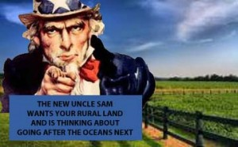

Not long ago, in the Health & Science section, Newsday reported the latest sustainable development folderol* straight from a London workshop held at Oxford University.
The report, currently being blasted around the world, claims the oceans are dying (I’m sure they eventually will). The report stems from a workshop (that would be a measly workshop) at a London conference (just to put things in perspective). The hyperbolic language alone should tag their entire report as “nuts.” Why don’t we start preparing for the sun burning out since it only has about 5 billion years to go. And what about the earth’s rotation slowing down – maybe windmills should be eliminated because they will slow the earth’s rotation.
The earthy rant in this report came from far left international scientists who said, “Oceans in urgent danger.“ They further warned, ” … that the world’s oceans are degenerating far faster than predicted and marine life is facing extinction due to human impacts.” (Where do they want us humans to go anyway?)
The report rages about the cumulative impact of “severe individual stresses.” Stresses include global warming, overfishing, acid water, and so on.”Coral reefs could disappear,” they say, “could” being the operative word. “Something must be done immediately,” they scream. “Urgent” measures must be taken (editor’s note – and here is the bottom line) such as cutting carbon emissions, reducing overfishing, shutting unsustainable fisheries, creating protected areas in the seas and cutting pollutions.
No doubt, we can do plenty of things better, but do people really think that one crazy report from one workshop merits the instilling of terror in our international hearts?
It is important to note here, as an aside, that the United States is not culpable in the overfishing debacle. Almost every other country in the world is however. In the Mediterranean, for example, they are wiping out Blue Fin Tuna. No doubt in my mind that the only ones who will be cutting the emissions and limiting freedoms will be the United States because that is how it has gone so far in the name of setting a good example to the very people who seek our demise.
More from the report – “The findings are shocking,” said Alex Rogers, scientific director of the International Programme on the State of the Ocean (editor’s note – looney name, isn’t it?), which convened the panel with the International Union for Conservation of Nature. “The World’s leading experts on oceans are surprised by the rate and magnitude of changes we are seeing,” said Dan Laffoley, the co-author of the report.
This report is typical of Agenda 21/sustainable development histrionics.
That takes me to rural lands in the USA - In our country, we see this extreme reaction taking shape via government agencies and Executive Orders. President Obama just signed Executive Order 13575 to circumvent Congress and to push the UN’s Agenda 21. This Order sets the stage for government control over almost all aspects of 16 % of American’s lives.
Here is one para that supports my claim and should give one pause - Section 1. Policy. Sixteen percent of the American population lives in rural counties. Strong, sustainable rural communities are essential to winning the future and ensuring American competitiveness in the years ahead. These communities supply our food, fiber, and energy, safeguard our natural resources, and are essential in the development of science and innovation. Though rural communities face numerous challenges, they also present enormous economic potential. The Federal Government has an important role to play in order to expand access to the capital necessary for economic growth, promote innovation, improve access to health care and education, and expand outdoor recreational activities on public lands.
It further states - The mission and function of the White House Rural Council, according to the Executive Order, is as follows: “The Council shall work across executive departments, agencies, and offices to coordinate development of policy recommendations to promote economic prosperity and quality of life in rural America, and shall coordinate my Administration’s engagement with rural communities.” Read here: Executive Order 13575
The government wants control of our rural communities and that can’t be a good thing for freedom loving Americans.
*Sustainable development is an offshoot of the UN Agenda 21 mantra. I have a link to a previous article here which provides information about the UN Agenda 21 and sustainable development - The UN Moving In On The Earth

