Dear Pastor and Brother in Christ,

We, the Christian people of the civic group ‘United for Truth’, feel compelled to address you in matters of the utmost importance for our nation, that we think should be of great concern to any of us.

As we do not know what your personal position is towards what is happening today in our society, we would like to present to you some critical facts that, in our view, justify conclusively the most urgent necessity of all anointed people of God to stand up and fight as true shepherds from God, for the natural and spiritual life of their congregation, community and nation.
For the last 15 months we lived a life of most unusual restrictions and control over almost all aspects of our lives, with dire consequences for the economic, moral and mental state of many of our fellowmen, under the noble justification of saving lives from the threat of the global covid pandemic. As known, until the end of March 2021, when the Government has been defeated in Court by 27 church leaders , there has been no freedom for the congregations of God to assembly, and even now, regulations concerning social distancing, masks etc are put in place. All these draconian measures have been challenged again by UK church leaders (health passports introduction), as well by thousands of doctors, health-care providers and experts world-wide, despite censorship and repressive professional policies. The following example coming from World Doctors Alliance is just one of the many.
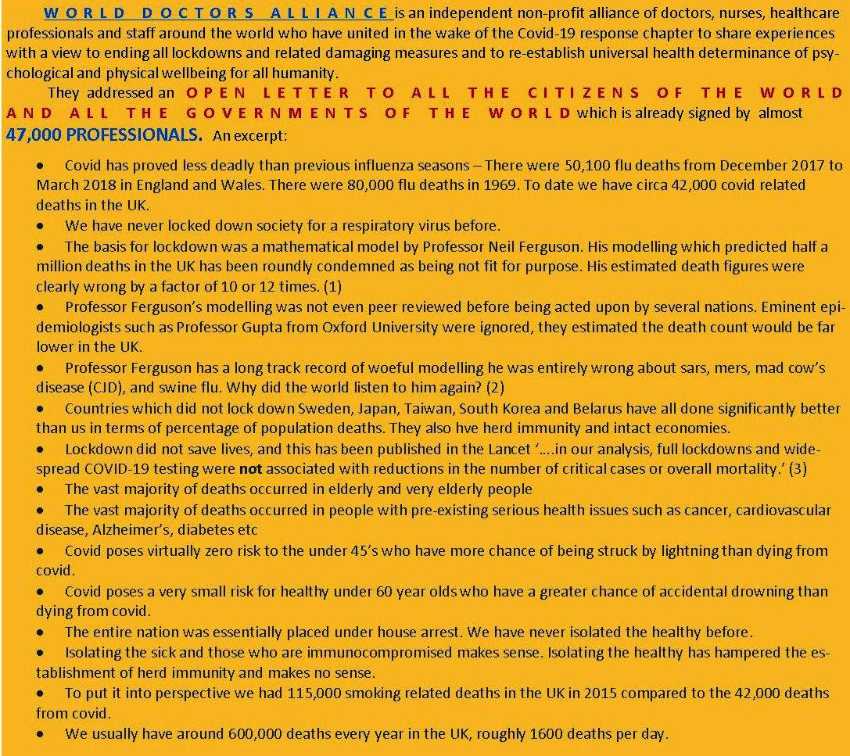
Let’s also note that the National Institutes of Health (NIH US) revealed in January 2021 that people who had covid-19 experience lasting immunity. Moreover, the majority of the affected were asymptomatic, therefore not having any recognizable symptoms, while the majority of the symptomatic had only mild symptoms not necessitating hospitalization; according to reliable studies and sources, with few if any exceptions, they appear not to spread the disease either. In fact, despite the WHO declaration of the pandemic, in 2020 there were no notable excess deaths in the UK and, generally speaking, in the world. According to a British Medical Journal study, in 2020 there were more deaths per 100 000 population than in the previous 17 years, but less than in all years before 2003; there was also less age standardised death rate per 100 000 population than in all years from 1943 to 2008. Cancer for example is many times more of a killer pandemic than covid-19 and we never shut down our society due to it.
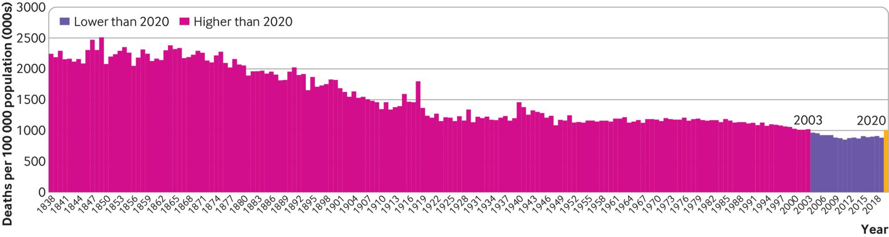
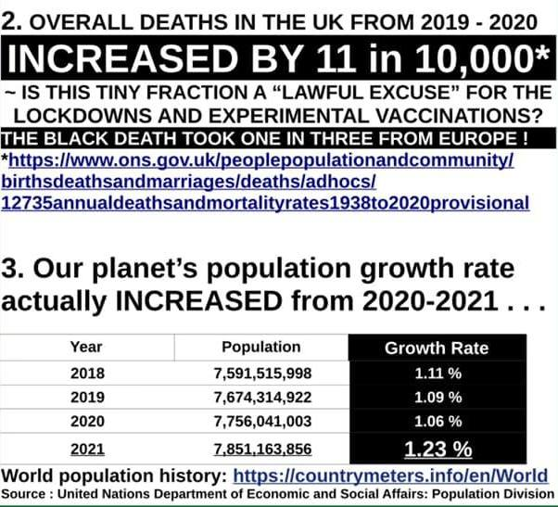
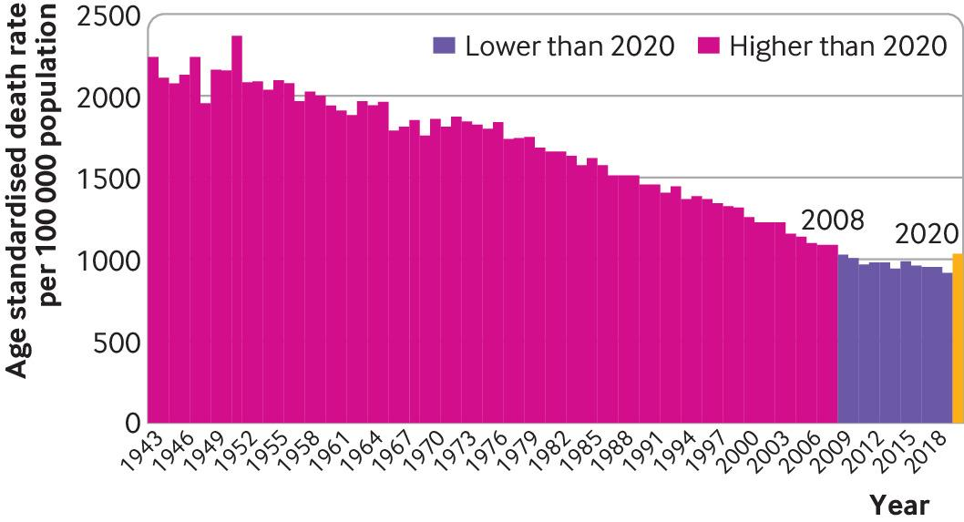
The entire pandemic construct has been based on the extremely disputable use of the PCR test for the detection of SARS-Cov2, which has been invalidated by its own inventor, Nobel Prize winner dr. Karry Mullis and by numerous other medical authorities, not to mention the US - FDA manual of the test itself.

It is undeniable that many people have died as covid positive and a part of them with specific severe symptoms of the disease, with the absolute majority elderly persons, above the age of 80. However it is undeniable that the lack of any meaningful medical intervention, especially in care homes, combined with shocking end-of-life protocols and the widespread, almost always fatal use of ventilators have greatly contributed to this.
Even more shocking, beginning with February 2020 (in the case of China) there have been medical treatments in place that have saved many thousands of lives such as IV Vit. C, HCQ protocols, IVERMECTINE, CHLORINE DIOXIDE, Budenisode, Vit. D/ Caldifediol etc, but these have been forbidden in the UK, USA and other Western countries by political decree and the consequent unlawful and inhumane suppression of the freedom of speech and practice of the healthcare professionals. It appears that there are also potential safe treatments of covid vaccine damage (some common with those for covid-19); this widespread damage, with the exception of myocarditis occurring mostly in young people, is officially ignored by the medical establishment, although whistleblowers and healthcare professionals are very much aware of it.

These EXPERIMENTAL VACCINES AGAINST COVID appear not to significantly prevent infection or transmission. . Since the introduction of these covid-vaccines in December, in less than two months. more than 7 million people have been vaccinated in the UK (10.79 of 100), which at a global level was surpassed only by UAE (27.07) and Israel (47.9). The sharpest increase in covid deaths immediately followed: between 26 Nov 2020 and 26 Jan 2021 the number of covid deaths almost TRIPLED, which also amounts for THE GREATEST INCREASE IN BIWEEKLY DEATHS in the world. Public Health England (in ‘SARS-CoC2 variants of concern and variants under investigation in England’ - 9 July 2021) revealed at the beginning of July that with the Delta variant 68% of covid deaths in the people over 50’s were among the vaccinated and that, in fact, double vaccination increased the chances of death almost 10 fold! Stunning rates of infection and hospitalization among vaccinated (breakthrough cases) are also confirmed by data coming from countries and areas with even higher rate of vaccination that the UK, such as Israel, Gibraltar, Iceland, Singapore, California, and also Bahrain, Seychelles, Maldives and Chile.
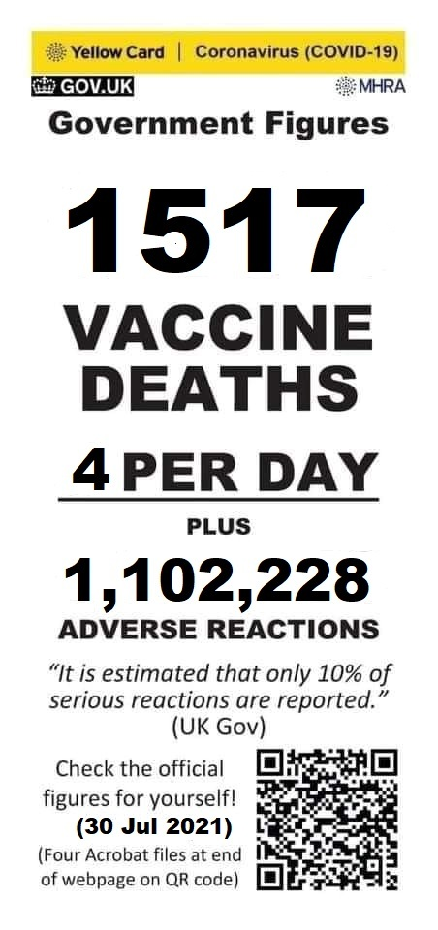
So if the vaccines seem not to do very well in preventing covid infections and especially in reducing the risk of hospitalization and death of covid, what they are however, really doing, is to cause a huge wave of death, disability and sickness wherever they are deployed. Consider that the data recorded in the official databases MHRA (UK), VAERS (US) and EudraVigilance (Europe) - see pictures - admittedly represent just 1-10% of the real life events.
Despite the huge censorhip in the MSM, there are websites and groups which reveal the truth about the horrific reality of the covid-vaccines damage. Most regrettably, due to the unjustifiable so-called emergency, this damage, no matter how severe and extended, incurs no liability for the vaccines producers or for any of the healthcare providers involved in vaccination.

Now, the government pressures the British public towards the acceptance of kids’ vaccination, despite the fact that CHILDREN HAVE PRACTICALLY ZERO CHANCES OF DYING FROM COVID-19; in fact, to date, no healthy children have died of covid-19 and it is highly unlikely that they spread the disease. Moreover, according to experts’ public letters and appeals, the children and teenagers have much more chances to be harmed by these new vaccines than the other age groups . Despite these strong arguments, articles in the press show a huge percentage of the people want to vaccinate their children, which is not only disputable, as it is much more than the percentage of all adults of parental age that have been vaccinated, but also constitute in itself, an argument for vaccination. Added to this, a most immoral and unlawful plan has been put in place so to vaccinate the children even without parental consent, based on the inappropriate Gillick Competency concept. It is obvious that the absolute majority of the adults alive in the UK and the world, including the healthcare professionals, have no competency in matters of experimental mRNA/ DNA vaccines and have not been given the information necessary for an informed consent. How much less can the children have any competency on this issue?

Reality is that countless people have taken and are still taking the vaccines because of NOT BEING AWARE AWARE THAT THEY ARE PARTICIPATING IN A MEDICAL EXPERIMENT, A RUSSIAN ROULETTE that in just six months has killed much more than (the recorded) 34,000 people in the UK, US and EU, has injured and disabled millions and, according to the warnings of experts, is undoubtedly leading to a true pandemic of neurological, cardiovascular, auto-immune and reproductive diseases. The VAERS database belonging to CDC in the US has recorded TWICE more deaths in 7 months after the introduction of these experimental covid vaccines than from all the vaccines ever given to the American people in the last 29 years since its creation! In Scotland as of the 1st of August (thus during the last 17 months) there have been a total of 10,370 deaths of covid (respectively, in less than a month since they had a positive covid test). According to a FOI there have been recorded 5,522 deaths within 28 days of having a Covid-19 vaccine during 6 months ending June 23, 2021. Consequently there have been in average 152% more deaths/first month after vaccination than after a covid diagnosis.
EUROPE
USA
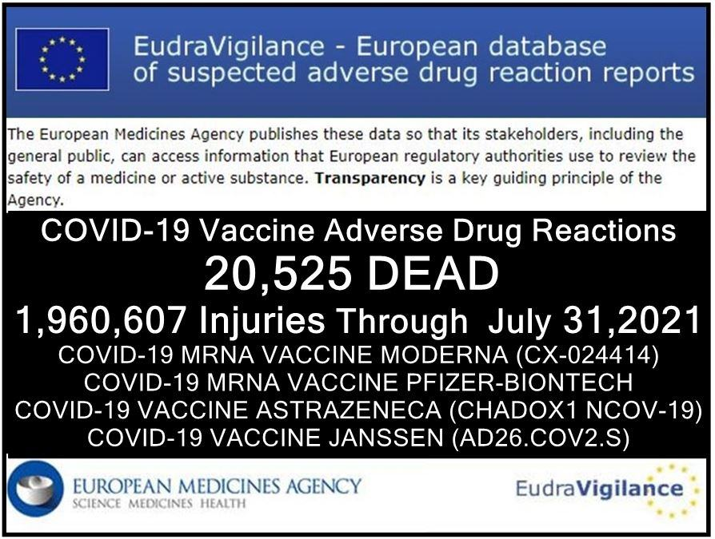
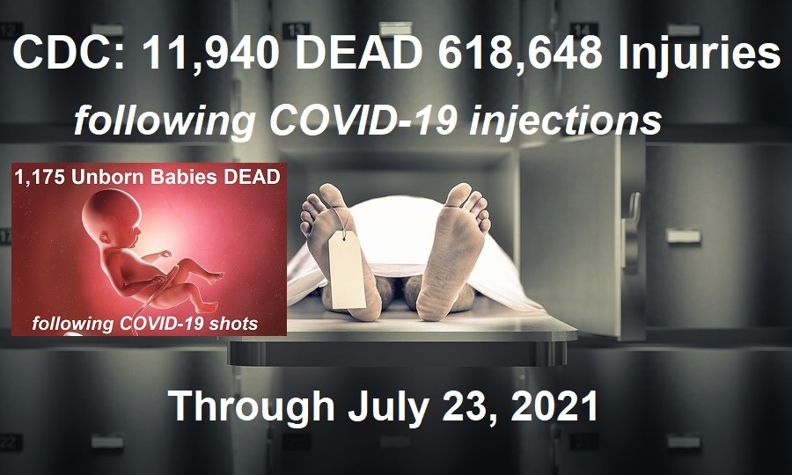
Not only that thousands of unborn children have died due to these shots being administered to their pregnant mothers, but, according to their own documents, some of them (Astrazeneca) have been cultivated in genetically modified human embryonic kidney (foetal cells). Does your Christian ethic agree with the use of unborn children for industrial purposes and the incorporation of their cells via injection in the bodies of other human beings?

Eminent scientists and experts in microbiology, virology, vaccinology and medicine have raised their voices and severely warned against the roll-out of these vaccines, despite the global censorship of all covid vaccines’ criticism. Please, look out for the following names of some of these experts on the independent platforms bitchute.com, rumble.com, odysee.com, healthimpactnews.com, highwire.com, mercola.com, naturalnews.com, childrenshealthdefense.com, lifesitenews.com, greenmedinfo.com, truthaboutcancer.com, ukcolumn.org, dailyexpose.com and you will be able to see their various critical testimonies and acknowledge their dire warnings concerning the dangers of these experimental vaccines.

DR. MIKE YEADON, ex-Pfizer head of respiratory research (“Look out the window, and think, “why is my government lying to me about something so fundamental?” Because, I think the answer is, they are going to kill you using this method. They’re going to kill you and your family,”) ’
DR. WOLFGANG WODARD, lung specialist and former head of the Public Health Department (“There is no indication whether antibodies against spike proteins of SARS viruses would also act like anti-Syncytin-1 antibodies. However, if this were to be the case this would then also prevent the formation of a placenta which would result in vaccinated women essentially becoming infertile.”)
Dr. Geerd Vanden Bossche, Vaccine Research Expert, worked for GAVI (“I am EXTREMELY CONCERNED ABOUT THE IMPACT CURRENT Covid-19 vaccines will have when increasingly deployed in mass vaccination campaigns conducted in the heat of a pandemic. Read my global WARNING & scientific evidence”: bit.ly/3q89hWZ)

Dr. Robert Malone, mRNA vaccines inventor (“I don't think the benefits outweigh the risks in that cohort,' said Malone, referring to people in the 18 to 22 age bracket, 'but unfortunately the risk-benefit analysis is not being done[…] these are experimental vaccines.” )

DR. Byram Bridle, viral immunologist, & associate professor (“We made a big mistake creating the covid vaccines”; “We have known for a long time that the spike protein is a pathogenic protein. It is a toxin. It can cause damage in our body if it gets into circulation.”)

Dr. Richard Fleming Physicist—Nuclear Cardiologist (“Doctors, if you are participating in this, you are violating the AMA Code of Ethics. Informed consent is not provided”)

DR. ROGER HODKINSON pathologist, expert in infectious disease, virology and evidence-based medicine (“Let me just paint the big picture here for the contrast between vaccinations and other forms of therapies. If in fact this is an emergency as they claim, which I contest, but let’s take their word for it, they are using it to vaccinate people without an appropriately tested vaccine. If you accept that a potentially dangerous vaccine, for which there is growing evidence of danger, contrast that with the prohibition of physicians to prescribe Ivermectin, or vitamin D for that matter.”)

PROF. LUC MONTAGNIER virologist, 2008 Nobel Prize for his discovery of HIV (“We’re in unknown territory and proclaim mandatory vaccines for everyone. It’s insanity. It’s vaccination insanity that I absolutely condemn”.)

PROF. JAMES LYONS-WEILER PHD, founder of the "Institute for Pure and Applied Knowledge, microbiologist and genetician (“The public needs to understand that tens of thousands and, soon, hundreds of thousands of medical doctors around the world are going to join me and others in condemning the politicization of coronavirus and public health, in general, including vaccines.”)

Dr. FRANK SHALLENBERGER, MD, HMD ‘The Nevada Center of Alternative and Anti-Aging Medicine (“Absolutely no long term safety studies will have been done to ensure that any of these vaccines don’t cause the cancer, seizures, heart disease, allergies, and autoimmune diseases seen with other vaccines. If you ever wanted to be guinea pig for Big Pharma, now is your golden opportunity” )

PROF. DOLORES CAHILL, microbiologist, founder and president of World Freedom Alliance (“I have said if you paid me £10 million I would not take [a vaccine], and if anyone forcibly injected me like they can potentially try to do in Australia, I would sue someone for attempted murder.”)

Dr. MARK TROZZI, ER medic, Advanced Trauma Life Support , professor— College of Surgeons of America (“With many people falling ill and dying after the injection, the criminal covid enterprise, consistent with their strategies so far, may use propaganda and deceive people so they do not realize that the injections, not covid, are the real danger. Instead, they are fooled into thinking that there is more covid, that covid not the shots are the danger, and that there are more dangerous variants causing all the sickness and death. The MSM propaganda will preach that there are “more cases and deaths”, and that will cause more unsuspecting victims to run for the injections.
Meanwhile, like all the experimental animals in the past, the injected people will get very sick and have high death rates from coronaviruses, thanks to antibody dependent enhancement.”)

Dr. Judy Mikovitz PhD, virologist, author of the bestseller ‘Plague of Corruption’, no 1 on Amazon charts (“Most people don’t realize the vaccines do not prevent infection. You’re injecting the blueprint of the virus and letting a compromised system try to deal with it. And worse, it doesn’t go in the cells that a natural infection would, that have lock and key receptors, gatekeepers, so that only certain cells can be infected, like the upper respiratory tract for a coronavirus. Now you’re making it in a nanoparticle which means it can go in every cell without that receptor. So, can you imagine the damage of bypassing God’s natural immunity and allowing the blueprint for coronavirus that also has components of HIV in some strains, meaning you can infect your white blood cells. So now you’re going to inject an agent into every cell of the body. I just can’t even imagine a recipe for anything other than what I would consider mass murder on a scale where 50 million people will die in America from the vaccine.”)

DR. ROBERT YOUNG, expert in cellular nutrition, biochemistry and microbiology (“Currently, over 70 percent of adolescents, ages 12 to 17 are being hospitalized for heart inflammation directly related to the experimental mRNA Pfizer and Moderna inoculations.”)

Dr. Peter McCullough, Internist, Cardiologist, Epidemiologist (““We have now a whistleblower inside the CMS, and we have two whistleblowers in the CDC[…]We think we have 50,000 dead Americans. Fifty thousand deaths. So we actually have more deaths due to the vaccine per day than certainly the viral illness by far. It’s basically propagandized bioterrorism by injection.”)

DR. LEE MERRITT, military doctor and bioweapons expert, former head of the American Association of Physicians and Surgeons (“I’m just shocked that people who wouldn’t buy the first edition of a new car line […] are willing to get into this and have an experimental vaccine with an agent that they know nothing about – it’s not even a vaccine, really, is an experimental unapproved genetic agent they know nothing about it, their doctor doesn’t really know about it, in fact nobody except the people on the top of the research know what’s in it, because there has been no independent analysis and… the animals died in the animal studies…I mean… it should be a clue also that you cannot have this thing at the pharmacy, you have to go some place where you can be resuscitated…”)

DR. JOSEPH MERCOLA, osteopathic physician, bestselling medical author (“Even if vaccinating children were found to reduce infection among adults, it would be unethical and against regulations to do so, because the FDA can only authorize the use of a medical product in a given population if the benefit outweighs the risk in that same population, and in children the benefits do not outweigh the risks”)

PROF. CHRISTIAN PERRONNE, Professor of Infectious and Tropical Diseases at the Faculty of Medicine of Paris-Ile de France-Ouest, chief of a Department of Infectious Diseases at the Raymond Poincaré University Hospital, past vice-president of the European Advisory Group of Experts on Immunisation (“It’s not actually a vaccine. There is deception here. This is a vaccine like Moderna and Pfizer which is not a vaccine. This is actually a product of Ribonucleic Acid (RNA) gene therapy. What does this mean? In other words, they inject you with a type of Ribonucleic Acid called “messenger” RNA. This messenger RNA will encode your cells for the corona virus fragment.
Here we are playing a wizard apprentice game, because this technique is only used for vegetables, genetically modified organisms, just like tomatoes and corn. However, this has never even been tested on animals on a large scale, so humans have become the first mouse in the lab with this type of technology on earth.
It may be effective, but it was completed hastily in 2 months. If your cells, based on your genetic status, produce much more virus particles than expected, it may cause catastrophic consequences in your body” – December 2021)

Dr. IGOR SHEPHERD, Russian expert in biowarfare, ex-manager Wyoming’ State Public Health Department/Preparedness Unit, Covid response team (“Corona Virus Vaccination is a BIOLOGICAL WEAPON OF MASS DESTRUCTION. I call it the 3G: GLOBAL GENETIC GENOCIDE. And this is coming. Not only to the United States, but to the whole world.”)

DR. SUCHARIT BHAKDI, award-winning doctor and scientist, former head of the Institute of Medical Microbiology and Hygiene, co- author of the best-seller “Corona, False Alarm” (“Not only the second shot, but any shot thereafter is gonna place your life in danger, that is I am convinced of now.”)

Dr. GÉRARD DELÉPINE, Oncologist, Orthopedic Surgeon, and Statistician at the Raymond Poincaré Hospital (“Since this period, vaccination campaigns have spread worldwide even to countries where covid was not present. And everywhere they have been followed by a dramatic rise in new infections and mortality for several weeks or months”)

DR. HEINRICH FIECHTNER, haematologist and oncologist, member of the state parliament in Baden-Württemberg (“I’ve said it before: it’s a killer vaccine. It’s a pharmaceutical product for which there isn’t even a toxicology report. It’s just going to be given to people. There’s a possibility that it may cause infertility in women, severe allergic reactions, and you want to inflict this unreasonable imposition upon citizens. That’s right, and you will, because you made them afraid beforehand. You are putting the lives of citizens at risk. You’re putting existences at risk.”)

DR, SHERRY TENNPENNY, osteopathic medical doctor, board certified in three medical specialties, vaccine expert (“The end result is to create a spike protein in your body, which is a foreign protein – there’s billions of particles of spike proteins that we know have caused direct harm. Once that process has been started is like having an on button with no off button.”)

DR. CARRIE MADEJ, osteopathic internal medicine physician, ex-medical director of three private clinics (Why we’re not allowed to know everything inside there, that’s being injected inside a person and how can we help with any negative side effects that are happening if we don’t have any knowledge about this? These are crimes against humanity… So once we understand what we’re dealing with, yes there’s always a solution, but don’t get any more injections if we don’t know what we’re putting in people! This is crazy!”)

DR. LARRY PALEVSKY, paediatrician (“What’s in the shot is not meant to protect us againt SARS-Cov2 infection. Now, when we look at the literature from 2020 and we see that people were getting illnesses of blood disorders, lack of oxygen –hipoxia, lung disease, clotting disease, strokes, hypertension, hypotension, loss of taste, loss of smell, neurological issues… this was not a viral illness, this was the clinical presentation of a poisoning of the blood and all of the literature shows that the spike protein of this so-called virus was responsible for causing all of these symptoms […] This spike protein is not a naturally occurring thing, is a man-made weapon.[…] So why, in God’s name, are we ok with injecting something into the body that’s going to cause all of us to make spike protein?”)

DR. CHRISTIANE NORTHRUP OB-GYN, medical bestseller author and leading authority in the field of women’s health and wellness (“It has never been a vaccine like this. It’s an RNA vaccine, it’s what’s called ‘transinfection’, It will fundamentally change people’s DNA and what I don’t like about it even more than the usual thing about the toxic metals that are in vaccines and make our bodies literally into an antenna – with 5G, this one has the usual non-human DNA, like you know, monkeys, maybe foetal cells, pigs whatever, so it begins to make us what’s called chimeras…”[…] this vaccines will have nanoparticles that are in fact, actually, little robots, like little antennas and they will have the ability to take your biometric data, not only your vaccine record, but your breathing, your heart rate, your activity, sexual activity, these drugs that you’re taking, where you travel, all of that and then take that data and store it in the cloud…”)

DR. ANGELINA FARELLA, AFLDS Pediatric Medical Director (“We’ve never seen this level of side effects for any vaccine without the FDA taking action. The Rotavirus vaccine was pulled for 15 cases of non-lethal side effects and the Swine Flu vaccine was pulled for 25 deaths. But now, by the CDC’s own data, we are seeing a 12,000 percent increase in deaths with these vaccines and they’re still talking about giving this to our kids.”)

DR. TESS LAWRIE, Director of the Evidence-based Medicine Consultancy Ltd and EbMC Squared CiC (“The Existing Yellow Card data covering just under a five-month period indicate that the extent of morbidity and mortality associated with the COVID-19 vaccines is unprecedented.[…] In addition, urgent independent expert evaluation and discussion is required to assess whether the novel vaccines may be causing gene mutations among recipients, as suggested by the occurrence of usually extremely rare genetic disorders, such as Paroxysmal Extreme Pain Disorder (PEPD)”)

DR. JANE RUBY, medical professional and a pharmaceutical drug development expert, health economist at Ruby Health Consulting (“These graphene sheets that investigators found in the Pfizer vial, when they get into your system and when they start to penetrate your cells – which they have a lipid nanoparticle that pushes them into your cells – you get oxidative stress…
It destroys literally everything inside the cell. It explodes the mitochondria. It creates a situation where the body is on a 10-Alarm fire truck and inflammation, cytokines, chemokines. This incredibly violent… inflammatory storm comes in and it has particular affinity for creating acute inflammation of the lungs, it creates an inflammatory storm in cardiac tissue and in brain tissue. […] this is going to tie directly to strokes, to the heart attacks – and we’re giving this to pregnant mothers and babies?”)

SENATE COMMITTEE ON STATE AFFAIRS – US (“In the four months of 2021 we had more covid-19 experimental vaccines deaths than all the vaccine deaths for the 15 year period between 1997 and 2013 plus almost a hundred heart attacks and over 8 thousand hospitalizations[…] In 1976 45 million people were vaccinated for swain flu. A mere 53 people died, and I don’t say that lightly because any death is very regrettable, but the program was immediately halted because it was considered too risky…. 53 death… and we are approaching 4000 with the covid vaccines.” (May 2021))

DOCTORS AROUND THE WORLD ISSUE DIRE WARNING: DO NOT GET THE COVID VACCINE!!

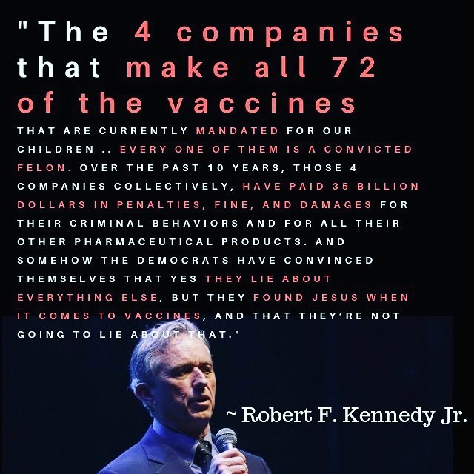
Let’s add to all the above the moral argument that the main companies (Pfizer, Astrazeneca) our government is relying on saving the lives of (in majority healthy) people from the PCR diagnosed Covid-19, have got a very disturbing record of legal violations , Moderna has never produced a vaccine before and all covid vaccines producers have no liability for any damage produced by these experimental products.

As Christians, we are aware that we all have been commended to humbly obey our leaders, but also that these ought to be those authorities who watch over our souls (Heb 3:17), the caring watchmen set up by the Lord into our communities (Ezek 3:17) speaking to us the word of God (Heb 13:7) and, of course, in neighbourly love, also acting accordingly so to help with our physical preservation and spiritual life. But surely, our God who is the only Lord of all Love, Life and Truth cannot expect us to unquestionably surrender to powers which trespass His very commandments, which systematically lie to the people or hide from them essential facts necessary for their survival, while diligently pushing them, and especially the innocent children, towards the precipice of physical and spiritual destruction. Such are authorities that have only been given power by the world and by worldy means, not by God; we, the people confirm and accept their dominion as long as we can trust their legitimate rights and interests inside the society are secured by these individuals. However our souls’ well-being are definitely of no concern for these political and economic leaders who, sadly, do not appear to take any responsibility before God or their conscience for the critical effects of their official actions on our lives.

As a man of God and an anointed guide for other brothers and sisters in Christ, you are one standing before our Lord as a shepherd and watchman of your congregation, also partaking these roles with the other local pastors at the level of the community. Therefore, if you see some of the people of this, your community (and among these, any political, economic, scientific or other worldly authority) committing wicked deeds aiming at the destruction of the people, it is your holy duty to rebuke and warn them in view of their certain damnation, or else their judgment will fall upon you too (Ezek 3:17-20; 33:6-12). It is also your foremost duty to warn your congregation and community so they do not fall pray to the schemes of the evil ones and to encourage all your followers to act against them. For surely, we Christians, have not been put into this world to live as silent witnesses and accomplices to all abominations, as partakers to the fruitless works of darkness, but as true warriors of truth and love, who dare to boldly expose them (Ephes 5:11), that are inspired by evil spiritual powers (Ephes 6:12) and manifest in lies, deceit, depravity, jealousy, robbery, tyranny and murder.

We, as children of God, carrying His holy name, are called to be the salt of the earth, carriers of His eternal love and truth into this dark world. If people of other faiths or no faith at all, despite having the law written in their hearts and minds, may still not understand that strong morals and conscience should be the guidelines of every day life, we, having the living seal and guidance of God, have absolutely no justification in taking the path of the world and choosing the yoke of sin once again.

Therefore, in all brotherly seriousness, we are urging you, as a pastor of souls and brother in Christ, to investigate the facts we presented here and to stand up in active love for the survival of our congregations and communities, most especially for the PHYSICAL SALVATION OF OUR INNOCENT CHILDREN, who are severely threatened by the roll-out of these COVID VACCINES, which can bring absolutely no benefit, but only great harm to them. Their health and lives are also under attack by the deployment of high frequency WI-FI in their schools, and by MASK WEARING which leads to an extremely dangerous synergy of toxicity.

We have the utmost certitude that if we fail this task and come to see even the death and maiming of the most helpless and innocent children of God that have been entrusted to us, His judgment will also not fail to bring destruction over the entire nation and especially over the elected who, by acting or remaining silent, contributed to the genocide.
The official plan of the Great Reset to ‘augment’ and ‘digitalize’ the remaining sterilized humanity, God’s supreme creation, by merging them with lifeless, loveless machines and thus eliminate human free will, free feeling and free thinking is indeed the abomination of desolation, the most murderous active denial of the existence of the soul and the spiritual nature of creation, the great judgment that will be forced on us all, by a tyranny such as the world has never seen before. We think that with these experimental so-called vaccines, we are already seeing inflicted upon the people a plague like the one predicted in Rev 9:6, and we most sadly expect many people will indeed come to envy the dead, for they “ will seek death but will not find it; will long to die, but death will elude them.”

In the name of the Holy God that paid with His blood for our salvation, we urge you to not reject knowledge and not fear the world, but to bravely stand up and fight for our spiritual dignity and for the sacred life that He has given us. Come out while you still can, warn your followers and call for these estranged and blind people to turn from their wicked ways and seek His face, so He, the only true Doctor and Saviour, would listen to our prayers and heal our land (2 Chron 7:14). Pray for the Lord to give you and your people the loving strength to endure scarcity and persecution and to receive the gift of healing in His name. For this is the last struggle of this blind beast of tyranny that tears apart the entire world at the command of the dragon… and no human power will be able to turn back this tide of destruction. It will be as at the time of Noah. The only hope for us all is the Lord Himself and we know that without Him we can do nothing, but with Him everything. Therefore, we need to get ready for Him and the oil of our love for our fellowmen should not be forgotten.
Please come, Lord Jesus!

May Our Father bless you and keep you, dear brother in Christ, your congregation and all your loved ones,

Faithfully Yours,
The Christian Activists of
UNITE FOR TRUTH
Scotland
www.unitefortruth.online

(Please see references with the entire letter, by downloading the document template at: https://img1.wsimg.com/blobby/go/71801b8c-fda3-43cc-86e2-e2e50ff2f191/downloads/Pastors_%20letter%20-%20covid%20vaccines%20children%20to%20d.doc?ver=1628429224392
This can be found on the page https://unitefortruth.online/covid-vaxx-children as an attached filed called Pastors' letter - covid vaccines children to download (template))

Church leaders win legal battle against Scot Govt in church closures case (24 Mar 2021) https://www.christian.org.uk/news/church-leaders-win-legal-battle-against-scot-govt-in-church-closures-case/ ………………………………………………………………………………………………………
‘Medical apartheid’: UK Christian leaders urge Boris Johnson to reject vaccine passports (13 Apr 2021) https://www.lifesitenews.com/news/medical-apartheid-uk-christian-leaders-urge-boris-johnson-to-reject-vaccine-passports/ ………………………………………………………………………………………………..
World Doctors Alliance https://worlddoctorsalliance.com/ ………………………………………………………………………………………………….
Lasting immunity found after recovery from COVID-19 https://www.nih.gov/news-events/nih-research-matters/lasting-immunity-found-after-recovery-covid-19 Coronavirus Immunity May Last Years, Possibly Even Decades https://www.forbes.com/sites/tommybeer/2020/11/17/coronavirus-immunity-may-last-years-possibly-even-decades-study-suggests/?fbclid=IwAR2QTk4Ke7s-OdUOqE9o-Ey6f6Xr0nuxXQbt9Z4QwfZB9yo8PgyZNKMo-6I&sh=36d379bc4185 …………………………………………………………………………………………………
Asymptomatic transmission of COVID-19 didn’t occur at all, study of 10 million finds https://www.lifesitenews.com/mobile/news/asymptomatic-transmission-of-covid-19-didnt-occur-at-all-study-of-10-million-finds?__twitter_impression=true&fbclid=IwAR1ZjgSU003_1Qsxhd5x3OOiu28bfh3mENsVrPy3LNp4L5oyIFzAGKJM6Ao “WUHAN, China, December 23, 2020 (LifeSiteNews) – A study of almost 10 million people in Wuhan, China, found that asymptomatic spread of COVID-19 did not occur at all, thus undermining the need for lockdowns, which are built on the premise of the virus being unwittingly spread by infectious, asymptomatic people. Published in November in the scientific journal Nature Communications, the paper was compiled by 19 scientists, mainly from the Huazhong University of Science and Technology in Wuhan, but also from scientific institutions across China as well as in the U.K. and Australia. It focused on the residents of Wuhan, ground zero for COVID-19,” Has the Evidence of Asymptomatic Spread of COVID-19 been Significantly Overstated? https://lockdownsceptics.org/has-the-evidence-of-asymptomatic-spread-of-covid-19-been-significantly-overstated-2/?fbclid=IwAR0pXSoMpGJUH9ZOeU2VnLfEo5L-wBjX2oI0yx8EnU2X06vM35nd_gDah7o “The existence of transmission of SARS-CoV-2 from asymptomatic individuals has become an accepted truth but the evidence for this phenomenon being anything other than mistaken interpretation of false positive test results is weak. Examination of the underlying data from the most frequently-cited such meta-analyses reveals that the conclusions are based on a surprisingly small number of cases (six in total globally) and, moreover, the possibility that they are all coincidental contacts with false positive results cannot be ruled out. Transmission which is pre-symptomatic is rare and represents a negligible risk to the population. ” Asymptomatic spread of coronavirus is ‘very rare,’ WHO says (June 2020) https://www.cnbc.com/2020/06/08/asymptomatic-coronavirus-patients-arent-spreading-new-infections-who-says.html “From the data we have, it still seems to be rare that an asymptomatic person actually transmits onward to a secondary individual,” Dr. Maria Van Kerkhove, head of WHO’s emerging diseases and zoonosis unit, said at a news briefing from the United Nations agency’s Geneva headquarters. “It’s very rare.” CDC says asymptomatic people don't need testing, draws criticism from experts (Aug 2020) https://thehill.com/policy/healthcare/513704-cdc-says-asymptomatic-people-dont-need-testing-draws-criticism-from-experts?fbclid=IwAR1gG0lqEqpxDI1dYTR3JbcX78-znxA3TqHN9_Q-6c0oqU8f2kPMjJm_W6k “The guidance now states: “If you have been in close contact (within 6 feet) of a person with a COVID-19 infection for at least 15 minutes but do not have symptoms: You do not necessarily need a test unless you are a vulnerable individual or your health care provider or State or local public health officials recommend you take one.” ……………………………………………………………………………………………………………………..
UK deaths in 2020: how do they compare with previous years? https://www.bmj.com/content/373/bmj.n896.full
How 12 times more people are dying from cancer than Covid - as experts warn treatment backlog will become 'collateral damage' of the pandemic (April 2021) https://www.dailymail.co.uk/health/article-9457599/How-12-times-people-dying-cancer-Covid.html ……………………………………………………………………………………………………………………..
The PCR tests, as described in their FDA manual (https://www.fda.gov/media/134922/download?fbclid=IwAR2dpjGwxTHwFBkHEf5LgbEF6l3nidYJJpkOzRt-_FLekaCAiqQY13mbHvY ), are not, in fact fit for purpose, because: • DETECTION OF VIRAL RNA MAY NOT INDICATE THE PRESENCE OF INFECTIOUS VIRUS OR THAT 2019-NCOV IS THE CAUSATIVE AGENT FOR CLINICAL SYMPTOMS. • THE PERFORMANCE OF THIS TEST HAS NOT BEEN ESTABLISHED FOR MONITORING TREATMENT OF 2019-NCOV INFECTION. • THIS TEST CANNOT RULE OUT DISEASES CAUSED BY OTHER BACTERIAL OR VIRAL PATHOGENs." More references: “Though the whole world relies on RT-PCR to “diagnose” Sars-Cov-2 infection, the science is clear: they are not fit for purpose” – Bulgarian Pathology Association https://bpa-pathology.com/covid19-pcr-tests-are-scientifically-meaningless/?fbclid=IwAR1A1FAwIwzHPaKrxVSC8Msw1ZmShY3EI9UoVY7VFSyudEZ6VnWzhvWyeTM ; also expanded in Off Guardian article: “Covid-19 PCR Tests are Scientifically Meaningless”: https://off-guardian.org/2020/06/27/covid19-pcr-tests-are-scientifically-meaningless/ See even more references on covid-19 testing at https://unitefortruth.online/covid-tests-tracing ........................................................................................................
The Evidence – ‘You stayed at home, to protect the NHS, but they gave Midazolam to the Elderly and told you they were Covid Deaths’ https://dailyexpose.co.uk/2021/06/13/stay-at-home-protect-the-nhs-give-midazolam-to-the-elderly-and-tell-you-they-are-covid-deaths/ ……………………………………………………………………………………………………..
Are Ventilators Killing More People Than They’re Saving?? https://www.globalresearch.ca/are-ventilators-killing-more-people-than-saving/5709562?utm_campaign=magnet&utm_source=article_page&utm_medium=related_articles Is this proof 'life-saving' ventilators are actually deathtraps? Their success rate is appalling and medics are increasingly worried they may do more harm than good, disturbing report reveals https://www.dailymail.co.uk/news/article-8230775/Is-proof-live-saving-ventilators-actually-deathtraps.html?fbclid=IwAR1V-zC49NRD3pnhSmugb128vJMXttcAeL4XmBbSIvNLdp2cfzhjzNmIQuc Covid death rates dropped as doctors reject ventilators https://www.telegraph.co.uk/news/2020/09/03/covid-death-rates-dropped-doctors-rejected-ventilators/ …………………………………………………………………………………………………………
Just a few examples: US doctors claim that Trump's controversial hydroxychloroquine drug DOES help 91% of coronavirus patients and argue we should not wait for 'controlled trials' https://www.dailymail.co.uk/health/article-8266737/amp/Doctors-group-claims-hydroxychloroquine-helps-91-coronavirus-patients.html?__twitter_impression=true The Deadly Censorship of Ivermectin https://articles.mercola.com/sites/articles/archive/2021/07/10/the-deadly-censorship-of-ivermectin.aspx The Cure We Are Not Allowed To Talk About In Some Countries https://rumble.com/ve1lrp-the-cure-we-are-not-allowed-to-talk-about-in-some-countries.html ; COMUSAV – Coalicion Mundial Salud Y Vida https://www.comusav.com/videoteca/ More references at NATURAL HEALTH – UNITE FOR TRUTH https://unitefortruth.online/natural-health …………………………………………………………………………………………………..
Pine Tea possible antidote for spike protein transmission: https://ambassadorlove.wordpress.com/2021/05/06/pine-tea-possible-antidote-for-spike-protein-transmission/ Antidote for Spike Proteins and COVID19 Vaccination? FENNEL SEEDS, shikimic acid, Pine Tree Needle Oil, Turpentine +NANO SOMA* https://www.survivethenews.com/antidote-spike-proteins-covid19-vaccination-fennel-star-anise-pine-needle-tea-turpentine-nano-soma/ How to Neutralize Potential Damage from mRNA Vaccines https://thetruthaboutvaccines.com/stop-damage-mrna-vaccines/ Biocompatible N-acetyl cysteine reduces graphene oxide and persists at the surface as a green radical scavenger https://pubmed.ncbi.nlm.nih.gov/30892320/ RESEARCH: Dandelion leaf extract blocks spike proteins from binding to the ACE2 cell surface receptor https://thetruthaboutvaccines.com/research-dandelion-leaf-extract-blocks-spike-proteins-binding-ace2-cell-surface-receptor/ Ivermectin, medicine to kill parasites can also kill DARPA Hydrogel with nano-parasites in COVID Vaccine https://spacetravelinalabama.com/2021/05/19/ivermectin-medicine-to-kill-parasites-can-also-kill-darpa-hydrogel-with-nano-parasites/ Chlorine Dioxide against grapheme oxide in La Quinta Columna explains what exactly is the 'brain tsunami' that the never isolated SARS-CoV-2 will cause https://www.orwell.city/2021/07/brain-tsunami.html ………………………………………………………………………………………………..
54% of Doctors say they are aware of patients suffering severe adverse reactions to the Covid-19 vaccines in survey (July 7, 2021) https://dailyexpose.co.uk/2021/07/07/54-of-doctors-say-they-are-aware-of-patients-suffering-severe-adverse-reactions-to-the-covid-19-vaccines-in-survey/ ………………………………………………………………………………………………….
The New Moderna covid-19 vaccine is called experimental by NIH: Experimental coronavirus vaccine highly effective https://www.nih.gov/news-events/nih-research-matters/experimental-coronavirus-vaccine-highly-effective They are also called “experimental” in the Daily Mail, as quoting the creator of the mRNA technology, dr. Robert Malone: 'The government is not being transparent about the risks': Inventor of MRNA vaccines says people should not be forced to take experimental COVID vaccines because risks aren't known and under 18s and those who’ve had virus shouldn’t take it https://www.dailymail.co.uk/news/article-9719891/Inventor-mRNA-vaccines-says-young-adults-teens-not-forced-COVID-vaccine.html In effect, all these new so-called vaccines trials will end their clinical trials in 2023, as explained in America’s Frontline Doctors White Paper On Experimental Vaccines For COVID-19 https://img1.wsimg.com/blobby/go/99d35b02-a5cb-41e6-ad80-a070f8a5ee17/SMDwhitepaper.pdf Moreover, these trials have not been conclusive in matters of efficacy and safety: Covid-19 vaccine trials cannot tell us if they will save lives (BMJ) https://www.bmj.com/company/newsroom/covid-19-vaccine-trials-cannot-tell-us-if-they-will-save-lives/ How COVID-19 Vaccine Trials Are Rigged (Dr. Mercola, Oct 2020) https://articles.mercola.com/sites/articles/archive/2020/10/27/covid-vaccine-trials.aspx ......................................................................................................................................
160+ experts slam COVID vaccines as ‘unnecessary, ineffective and unsafe’ in powerful letter (May 2021) 'In short, the available evidence and science indicate that COVID-19 vaccines are unnecessary, ineffective and unsafe. https://www.lifesitenews.com/news/160-experts-slam-covid-vaccines-as-unnecessary-ineffective-and-unsafe-in-powerful-letter?utm_source=LifeSiteNews.com&utm_campaign=a6b3c2feea-Daily%20Headlines%20-%20U.S._COPY_1042&utm_medium=email&utm_term=0_12387f0e3e-a6b3c2feea-402348069 …………………………………………………………………………………………………………………………
https://ourworldindata.org/grapher/covid-vaccination-doses-per-capita …………………………………………………………………………………………………………………..
https://coronavirus.data.gov.uk/details/deaths?areaType=nation&areaName=England https://ourworldindata.org/grapher/biweekly-covid-deaths?tab=table&time=2020-11-26..latest https://ourworldindata.org/grapher/covid-deaths-daily-vs-total-per-million?tab=table&stackMode=absolute&time=2020-11-10..2021-01-26&country=&region=World …………………………………………………………………………………………………………………….
Whilst you’ve been distracted by England making the final, PHE released a report showing 68% of Covid Deaths in the over 50’s were people who’d been vaccinated https://dailyexpose.co.uk/2021/07/09/whilst-youve-been-distracted-by-england-making-the-final-phe-released-a-report-showing-68-of-covid-deaths-in-the-over-50s-were-people-whod-been-vaccinated/ “Well, of the 257 alleged Covid deaths in all age groups to have occurred since the 1st February, a huge 63.4% of them were people who had received at least one dose of a Covid-19 vaccine.But yet again the majority were not people who had only received one dose, 72.3% of those who had died with Covid-19 after having at least one dose of the Covid-19 jab were in fact fully vaccinated. A further 27% of those who’d had at least one dose had received their first dose at least 21 days prior to their death. The number of unvaccinated people in all age groups to have allegedly died of the Delta variant accounted for just 35% of all alleged Covid deaths according to PHE data.[…] Fully vaccinated people have a 990% higher chance of death due to Covid-19 than people who are unvaccinated according to latest Public Health England data https://dailyexpose.co.uk/2021/07/09/fully-vaccinated-people-have-a-990-higher-chance-of-death-due-to-covid-19-than-people-who-are-unvaccinated-according-to-latest-public-health-england-data/ “The above table shows that of the 71,932 alleged cases of the Delta variant in people who are unvaccinated, just 92 sadly died. This translates to 0.1% of cases. The above table also shows that of the 10,834 alleged cases of the Delta Covid variant in people who are fully vaccinated, 118 people sadly died. This translates to 1.09% of cases. The means the data published by Public Health England shows us that people who have received two doses of a Covid-19 vaccine have a 990% higher chance of dying due to the Delta Covid variant than people who are unvaccinated.” REFERENCE: ‘SARS-CoV-2 variants of concern and variants under investigation in England’ https://assets.publishing.service.gov.uk/government/uploads/system/uploads/attachment_data/file/1001009/Variants_of_Concern_VOC_Technical_Briefing_18.pdf ………………………………………………………………………………………………………………
Israel reported that 55% of the new covid infections are in vaccinated people (July 4, 2021) https://www.bloomberg.com/news/articles/2021-07-05/israel-sees-decline-in-pfizer-vaccine-efficacy-rate-ynet-says COVID in Israel: New Cases Top 2,000 for Third Day as Delta Spreads (29 July 2021) https://www.haaretz.com/israel-news/covid-in-israel-coronavirus-spreads-steadily-experts-debate-3rd-shot-1.10050533 95% of the severe patients are vaccinated". "85-90% of the hospitalizations are in fully vaccinated people." "We are opening more and more COVID wards." "The effectiveness of the vaccine is waning/fading out" (Dr. Kobi Haviv, Aug 5 on Chanel 13 @newsisrael13 https://twitter.com/RanIsraeli/status/1423322271503028228
By June 1, over 99% of Gibraltar's population was fully vaccinated. Since that time, new COVID cases per day have increased more than 2500%. (29 July 2021) https://twitter.com/MichaelPSenger/status/1420812757427908610
Cases in Iceland are still rising, now up 44,275% since the New Yorker described in detail how Iceland “beat the coronavirus" (5 Aug 2021) https://twitter.com/ianmSC/status/1423334160588959747
Vaccinated people make up 75% of recent COVID-19 cases in Singapore, but few fall ill (Reuters 23 July 2021) https://www.reuters.com/world/asia-pacific/vaccinated-people-singapore-make-up-three-quarters-recent-covid-19-cases-2021-07-23/
COVID spreading fast in well-vaccinated California counties (24 July 2021) https://www.mercurynews.com/2021/07/24/covid-spreading-fast-in-well-vaccinated-california-counties/ ……………………………………….
https://ourworldindata.org/explorers/coronavirus-data-explorer?zoomToSelection=true&pickerSort=asc&pickerMetric=location&hideControls=true&Metric=Confirmed+cases&Interval=7-day+rolling+average&Relative+to+Population=true&Align+outbreaks=false&country=SYC~MDV~BHR~CHL~GBR …………………………………………………………………………………………………………………..
Health Impact News https://healthimpactnews.com/ ……………………………………………………………………………………………………………..
Children’s Health Defense https://childrenshealthdefense.org/defender/329-deaths-9516-other-injuries-reported-following-covid-vaccine-cdc/?fbclid=IwAR3WrGnvBgG1qd5R6acEQd7xWki_KkkoRwG5nzkwnFlTlKh2JfcixBxpo90 ……………………………………………………………………………………………………………..
VAX LONGHAULERS – We Want To Be Heard https://www.vaxlonghaulers.com/ Our Letter: https://www.vaxlonghaulers.com/uploads/1/3/8/1/138180543/our_letter_for_the_landing_page.pdf COVID VACCINE GROUPS ON TELEGRAM: https://t.me/covidvaccinevictims https://t.me/vaccineawareness https://t.me/DrTenpenny https://t.me/worlddoctorsalliance https://t.me/ukvacinfo https://t.me/AdverseReactionsAustralia https://t.me/vaccinechoiceaustralia https://t.me/NoVaccineCoercion https://t.me/CovidVaxTruths https://t.me/VaksinMalaysia https://t.me/covidvaccineadveffect https://t.me/covid_vaccine_injuries https://t.me/avninformedchoice https://t.me/cv19vaccine_reactions https://t.me/CovidVaccineWORLD https://t.me/cv19VaccineDeathInjuryTricks https://t.me/cv19vaccineinjured https://t.me/TheTruthAboutCancer_Vaccines https://t.me/CovidVaxTruths https://t.me/vaccineawareness https://t.me/avninformedchoice https://t.me/Vaccinedeath https://t.me/Covid_Vaccine_Deaths_Worldwide Tens of Thousands of COVID-19 “Vaccine” Injured in the U.S. Begging for Help as the Medical Community Turns Their Back on Them (July 7, 2021) https://healthimpactnews.com/2021/tens-of-thousands-of-covid-19-vaccine-injured-in-the-u-s-begging-for-help-as-the-medical-community-turns-their-back-on-them/ What is the probability of having members of the same family injured or dead shortly after the covid vaccination? – just two examples among many: 18 Year Old University Of Arizona Student Hospitalized After Johnson Johnson Vaccine, As His Mom Is Hospitalized From Pfizer Reaction https://theempoweror.com/2021/06/27/18-year-old-university-of-arizona-student-hospitalized-after-johnson-johnson-vaccine-as-his-mom-is-hospitalized-from-pfizer-reaction/ Father And Daughter Died Four Days Apart Despite Taking Different Brands Of Covid Vaccines https://theempoweror.com/2021/07/01/father-and-daughter-died-four-days-apart-despite-taking-different-brands-of-covid-vaccines/ ………………………………………………………………………………………………..
Children face just a one in 500,000 risk of dying from Covid, studies show amid growing row over whether youngsters should be given vaccines - In England, 25 under-18s died from Covid, equating to two per million https://www.dailymail.co.uk/news/article-9769283/Children-face-one-500-000-risk-dying-Covid-amid-row-kids-vaccinated.html Frontline doctors file motion to stop FDA authorization of COVID vaccines for children With a ‘12,000 percent increase in deaths with these vaccines’ and ‘statistically zero risk’ of children dying from COVID-19, plaintiffs argue there is no justification for such injections. https://www.lifesitenews.com/news/frontline-doctors-file-motion-to-stop-fda-authorization-of-covid-vaccines-for-children BMJ – Covid-19: Asymptomatic cases may not be infectious, Wuhan study indicates https://www.bmj.com/content/371/bmj.m4695 ………………………………………………………………………………………………………
Ex-Pfizer VP Yeadon Warns: Children 50 Times More Likely to Die From Vaccine Than Virus https://rumble.com/viaz6n-ex-pfizer-vp-yeadon-warns-children-50-times-more-likely-to-die-from-vaccine.html Attorney Thomas Renz: “MORE Than 45,000 People Have Died From the Covid-19 Vaccines Within 3 Days of Vaccination” https://dailyexpose.co.uk/2021/08/05/attorney-thomas-renz-more-than-45000-people-have-died-from-the-covid-19-vaccines-within-3-days-of-vaccination/ Renz said: “Based on our statistical analysis if you are under 30 the ‘vaccine’ is more likely to kill you than save you.” ............................................................................................................
Doctors for COVID Ethics: Halt Use of Pfizer COVID Vaccines in Adolescents ‘Immediately’ In a 20-page report, three doctors who are all founding members of Doctors for COVID Ethics outline in detail the compelling argument for why COVID vaccines are not only unnecessary and ineffective, but also dangerous for children and adolescents. (15.07.21) "In addition to submitting three admonitory letters to the EMA — on March 10, April 1 and April 20 — Doctors for COVID Ethics on May 18 served Notices of Liability to all members of the European Parliament for COVID-vaccine-related harms and deaths to children. (https://doctors4covidethics.org/notice-of-liability-for-harm-and-death-to-children-served-on-all-members-of-the-european-parliament/) Now, three of the group’s founding signatories — Dr. Michael Palmer (Canada), Dr. Sucharit Bhakdi, (Germany) and Stefan Hockertz, Ph.D. (Germany) — have assembled in one document powerful expert evidence (https://doctors4covidethics.org/expert-evidence-regarding-comirnaty-covid-19-mrna-vaccine-for-children/ ) showing COVID vaccines are not only unnecessary and ineffective but also dangerous for children and adolescents. Tell Schools/Universities No Vaccine Mandates for Children/Young Adults! On July 3, Italian lawyer Renate Holzeisen submitted the expert document (https://childrenshealthdefense.org/wp-content/uploads/expert-evidence-pfizer-children.pdf) to the European General Court as part of a lawsuit (https://doctors4covidethics.org/expert-evidence-regarding-comirnaty-covid-19-mrna-vaccine-for-children/)challenging the EMA’s late-May decision to extend emergency use of Pfizer’s vaccine for 12- to 15-year-olds. [...] The most alarming section of the report is Palmer’s, Bhakdi’s and Hockertz’s discussion of the Pfizer vaccine’s “catastrophically bad” safety profile in both adults and adolescents. The Pfizer injection’s destructive impact is readily discernible by anyone with the patience to pore through the vaccine injury reports submitted to the Vaccine Adverse Event Reporting System (VAERS) in the U.S. or the EudraVigilance database in Europe. For 12- to 17-year-old Americans receiving a COVID shot, VAERS received more than 13,000 reports of adverse events by July 2, including more than 1,909 reports (Pfizer alone) of anaphylaxis, 343 reports (Pfizer alone) of heart problems, 56 reports (Pfizer alone) of blood clotting disorders and 14 deaths, of which 13 were reported after a Pfizer vaccine." COVID Vaccines: Hypothetical Benefits to Adults Don’t Outweigh Risks to Children (16.07.21) (https://childrenshealthdefense.org/defender/covid-vaccines-hypothetical-benefits-adults-risks-children/ ) Given the very low incidence of COVID-19 in children, an extremely high number would need to be vaccinated in order to prevent one severe case. Meanwhile, a large number of children with very low risk for severe disease would be exposed to vaccine risks, known and unknown. First, the disease in children is commonly mild, and serious sequelae remain rare. Despite “long COVID” recently garnering increased attention, two large studies in children show that prolonged symptoms are uncommon and overall similar or milder in children testing positive for SARS-CoV-2 compared to those with symptoms from other respiratory viruses. The U.S. Center for Disease Control and Prevention (CDC) estimates put the infection fatality rate from COVID-19 among children 0 to 17 years old at 20 per 1,000,000. Hospitalization rates are also very low, and have likely been overestimated. Furthermore, a large proportion of children have already been infected with SARS-CoV-2. The CDC estimates 42% of U.S. children aged 5 to 17 years have been infected by March 2021. Given that SARS-CoV-2 infection induces a robust immune response in the majority of individuals, the implication is that the risks COVID-19 poses to the pediatric population may be even lower than generally appreciated UKMFA Urgent Open Letter to the MHRA re Emergency Authorisation of the Pfizer Covid-19 vaccine for Children (08/06/21) (https://www.ukmedfreedom.org/open-letters/ukmfa-urgent-open-letter-to-the-mhra-re-emergency-authorisation-of-the-pfizer-covid-19-vaccine-for-children?fbclid=IwAR0lfNW-62rfbvO9xhPlCetKacEWQ8nBztGYXFi2Hhq5dCfi02LQrVAqb2E ) UKMFA has sent an Open Letter to the the MHRA in which we raise grave concerns about this emergency authorisation, citing evidence of known and potential harms to children that may result and the serious ethical issues this decision raises. Given that these vaccines will have virtually no benefit to the children themselves, it is profoundly unethical and indefensible to vaccinate children, especially with an experimental vaccine using novel technology, in what appears to be a misguided attempt to protect adults and achieve herd immunity. We call on the MHRA to exercise caution and immediately reverse their decision. Arguments: The benefits of Covid-19 vaccines for children are close to zero, yet they carry known and unknown risks. Experts are stating that vaccinating children is neither necessary nor justified: • The minutes of the Joint Committee on Vaccination and Immunisation (JCVI) dated 16 February 2021 note “little impact of vaccinating children once all other adults were offered vaccine” and “that modelling results on the impact of vaccinating children were considered highly uncertain” xv. • Other experts have argued that “Covid-19 vaccines for children should not get emergency use authorization” xvi and that this would be “hard to justify right now for most children in most countries” xvii • Professor of Paediatrics and member of the JCVI, Adam Finn, said in an interview on the 20 May 2021 that it was “an open question as to whether we need to immunise children at all” and “if we can control this virus without immunising children, we shouldn’t immunise children as a matter of principle”xviii 5. Below, we set out specific issuesregarding Covid-19 vaccines in children – each sufficient to justify not proceeding any further with this proposal. a. The risk of Covid-19 to children is miniscule. The infection fatality rate in this age group is close to zero, and most remain asymptomatic or experience mild symptoms only xix xx xxi xxii . This has been reiterated by the Government xxiii and by Professor of Paediatrics, Adam Finn xviii Even the low records of children hospitalized with Covid-19, may be an over-estimate, according to a recent study xxiv . The number of children and teens under the age of 20 without pre-existing conditions who have died in England with a positive Covid- 19 test, as of 13 May 2021, is in single figures xxv Mortality in children in the UK in 2020/21 has in fact been significantly lower than in previous years xxvi xxvii As the emergency does not, therefore, apply to children, there can be no justification to authorize any product for emergency use in the paediatric population. b. The absolute risk reduction by Covid-19 vaccines is around 1% (0.84-1.3%)xxviii This applies to the healthy adult trial participants and cannot be extrapolated to children,who are already at extremely low risk from the disease. The potential benefit to an individual child of receiving a Covid-19 vaccine is statistically zero. c. Children play an insignificant role in transmission of Covid-19ix xviii xxix Living with children may even reduce the risks of the disease xxx Transmission in schools has not been significant xxxi xxxii xxxiii Trials have not demonstrated whether Covid-19 vaccines reduce asymptomatic infection or transmission xxxiv There is therefore no demonstrable benefit to the wider society in vaccinating children. d. In a population cohort at minimal risk of severe disease, such as young people and children, acquiring natural immunity will serve a better purpose, as this will be more comprehensive, longer lasting, and cover a broad range of virus variants. Vaccine-induced immunity does not cover the full spectrum of protection (mucosal immunity, IgA, and T-cell immunity to the whole virus) and may only be short-lived. Acquiring natural immunity will therefore also benefit the wider population, contributing to herd immunity xxxv xxxvi xxxvii xxxviii xxxix .e. All Covid-19 vaccines used in the UK are based on completely new gene-based technologies (mRNA / DNA vector technology)xl , that have never received full regulatory approval for mass rollout in humans. They have not been licensed and remain experimental until Phase 3 trials have been completed xli Thus, we cannot infer long- term safety without observing the impact on human health in those who have received the vaccines over the next few years. f. There is currently no data to indicate whether dose adjustment may be necessary in children. This would appear relevant as side-effects in initial phase 1 dose-escalation trials were more significant with higher dosage xlii g. Covid-19 vaccines work completely differently to established childhood vaccines. Traditional, live vaccines work using attenuated virus strains to prompt antibody development. Covid-19 vaccines introduce a synthetic gene which induces the recipient’s own cells to produce spike proteins. Spike proteins appear to contribute significantly to the pathogenicity of SARS-CoV-2, and there are studies suggesting that they have the potential to cause pathology on their own xliii xliv It is unknown how much spike protein will be produced by an individual, and it is plausible that younger, healthier people may produce higher quantities, potentially increasing the risk of side-effects. The safety of this approach needs to be thoroughly investigated and firmly established prior to full licensure in adults and prior to any use in children. h. At this stage, medium- and long-term effects of Covid-19 vaccines are completely unknown and unpredictable, due to the short duration of the Phase 3 safety trials, which are ongoing and not due to complete until 2023. This is most relevant for young people and children. Before giving Covid-19 vaccines to children, potential adverse, long-term, effects on fertility, carcinogenesis, and children’s developing neurological and immune systems MUST be completely ruled out, as is done with other drugs and vaccines. This may take years or decades to fully establish. i. Serious adverse events and vaccine-related deaths have been reported in the UK xlv , theUS xlvi and Europe xlvii In the report published by the MHRA on 13 May 2021, there were 822,078 adverse reactions in the UK, including seizures, paralysis, blindness, strokes, blood clots and acute cardiac events. There were 1178 reports of fatalities. j. Some life-threatening effects, such as blood clots xlviii and myocarditis xlix , have been reported specifically in children and young adultsl li . Government advice has recently been amended to avoid the AstraZeneca vaccine in young people due to a concern regarding the risk of rare blood clots (now considered to be around 1:100,000). The new term “vaccine-induced immune thrombotic thrombocytopenia” acknowledges the causality of the vaccine in these events, often presenting as ischemic strokes lii . It is possible that this reaction could be a class effect caused by spike proteins and therefore not specific or limited to the AstraZeneca vaccine liii . Of the 4347 events of thrombosis and embolism reported to the MHRA as of 13 May 2021, 770 occurred following the Pizer-BioNTech vaccine xlv. According to the US VAERS reporting system, several children under the age of 18 have died following a Covid-19 vaccine liv k. Vaccine manufacturers have requested and been granted complete exemption from liability for any injuries or deaths resulting from their productslv lvi . A spokesperson for AstraZeneca acknowledged the potential for unexpected long-term side-effects, stating that as a company, they “simply cannot take the risk if in ... four years the vaccine is showing side-effects” lvii . If the risk is significant enough for manufacturers to anticipate economic loss, children must not be expected to take the same risk to their long-term health. …………………………………………………………………………………………………….
Nine in 10 parents in England approve of Covid jabs for children, survey finds ONS survey comes as member of Sage suggests there is not enough evidence to back vaccinating children https://www.theguardian.com/society/2021/jul/01/not-enough-evidence-to-back-covid-jabs-for-children-says-uk-expert?fbclid=IwAR179hQS-oJPS1e9XWAknHRdYBUwjsvVy56EJeGZQoefMJC-6W1V5aQfkik ………………………………………………………………………………………………………….
VAXLONGHAULERS – VACCINE REACTION PUBLISHES CASE STUDIES (1) https://www.vaxlonghaulers.com/uploads/1/3/8/1/138180543/vaccine_reaction_published_case_studies_1.pdf .............................................................................................................
STUDY: Pfizer vaccine causes catastrophic damage to every system of your body (Israel May 2021) https://pandemic.news/2021-05-10-pfizer-vaccine-catastrophic-damage-every-body-system.html Mechanisms of COVID-19 Vaccine Induced Injuries/Deaths (Maggie Zhou, PhD – May 2021) http://stateofthenation.co/?p=66454 20 Mechanisms of Injuries (MOI) – Dr.Sherry Tennpenny – May5, 2021) https://rense.com/general96/20-mechanisms-of-injury.php?fbclid=IwAR3F4zruY30hizywtH0wDjQo5WWkhJG_tNqrw6ndUONR2cP5df6NzA4F2nM The Covid Vaccine Can Make You Very Sick And Now We Know Why (May 28, 2021) https://jansiebenga.medium.com/the-covid-vaccine-can-make-you-very-sick-and-now-we-know-why-140bfba72154 ............................................................................................................................
CDC: 11,940 DEAD 618,648 Injuries and 1,175 Unborn Babies DEAD Following COVID-19 Shots (1 Aug 2021) https://healthimpactnews.com/2021/cdc-11940-dead-618648-injuries-and-1175-unborn-babies-dead-following-covid-19-shots/ ………………………………………………………………………………………………………………………
Freedom of Information Request Reveals 5,522 People have Died Within 28 Days of Receiving COVID-19 Vaccines in Scotland https://healthimpactnews.com/2021/freedom-of-information-request-reveals-5522-people-have-died-within-28-days-of-receiving-covid-19-vaccines-in-scotland/ …………………………………………………………………………………………………………………….
Deaths involving coronavirus (COVID-19) in Scotland https://www.nrscotland.gov.uk/statistics-and-data/statistics/statistics-by-theme/vital-events/general-publications/weekly-and-monthly-data-on-births-and-deaths/deaths-involving-coronavirus-covid-19-in-scotland .........................................................................................................................
mRNA Covid-19 Vaccine Safety in Pregnant Woman https://vaccinesvictims.blogspot.com/2021/07/cdc-manipulated-study-data-to-show.html (study publish in New England Journal of Medicine shows that 86% of the ladies who got an mRNA shot (Moderna or Pfizer) have lost their unborn baby) ………………………………………………………………………………………………………………..
REG 174 INFORMATION FOR UK HEALTHCARE PROFESSIONALS https://assets.publishing.service.gov.uk/government/uploads/system/uploads/attachment_data/file/1003565/uk-clean-spc-covid-19-vaccine-astrazeneca-reg174_16July_1_.pdf (page 2) …………………………………………………………………………………………………………………
EXCLUSIVE - Former Pfizer VP: ‘Your government is lying to you in a way that could lead to your death.’ https://www.lifesitenews.com/news/exclusive-former-pfizer-vp-your-government-is-lying-to-you-in-a-way-that-could-lead-to-your-death …………………………………………………………………………………………………………………….
Doctors Including Former Pfizer Respiratory VP & Chief Scientific Advisor File Petition – Covid Vaccine Could Be Linked to Infertility https://newsrescue.com/doctors-former-pfizer-respiratory-vp-chief-scientific-advisor-file-petition-covid-vaccine-could-be-linked-to-infertility/ …………………………………………………………………………………………………………………….
Halt All Covid-19 Mass Vaccination Immediately (Open Letter to the WHO) — Vaccine Research Expert https://dryburgh.com/geert-vanden-bossche-open-letter-to-who-halt-all-covid-19-mass-vaccination/
'The government is not being transparent about the risks': Inventor of MRNA vaccines says people should not be forced to take experimental COVID vaccines because risks aren't known and under 18s and those who’ve had virus shouldn’t take it (June 24, 2021) https://www.dailymail.co.uk/news/article-9719891/Inventor-mRNA-vaccines-says-young-adults-teens-not-forced-COVID-vaccine.html …………………………………………………………………………………………………………………….
Dr. Byram Briddle: We made a big mistake creating the “covid-19 vaccines” – May 2021”https://www.bitchute.com/video/tDviHlA52Uyr/ ………………………………………………………………………………………………………………………
Researcher: 'We Made a Big Mistake' on COVID-19 Vaccine https://articles.mercola.com/sites/articles/archive/2021/06/14/covid-19-vaccine-mistake.aspx ……………………………………………………………………………………………………………………
The Covid-19 Experimental Drug Vaccines are DANGEROUS - The Call for a Second Nuremberg Trial https://rumble.com/vfnwc1-the-covid-19-experimental-drug-vaccines-are-dangerous-the-call-for-a-second.html .............................................................................................................................
An exclusive interview with Dr Roger Hodkinson – “When the history of this madness is written, reputations will be slaughtered and there will be blood in the gutter “ https://dailyexpose.co.uk/2021/05/23/an-exclusive-interview-with-dr-roger-hodkinson-when-the-history-of-this-madness-is-written-reputations-will-be-slaughtered-and-there-will-be-blood-in-the-gutter/ …………………………………………………………………………………………………………………….
Nobel Laureate Luc Montagnier Warns Covid Vaccine May Lead to ‘Neurodegenerative Illness’ (Video) https://undercurrents723949620.wordpress.com/2021/06/13/nobel-laureate-luc-montagnier-warns-covid-vaccine-may-lead-to-neurodegenerative-illness-video/ …………………………………………………………………………………………………………………….
James Lyons-Weiler — Pathogenic Priming: Coronavirus Vaccine Safety Warning http://stateofthenation.co/?p=40694 …………………………………………………………………………………………………………………….
Dr. Shallenberger’s Letter to His Patients Regarding the Covid 19 Vaccine https://visionlaunch.com/dr-shallenbergers-letter-to-his-patients-regarding-the-covid-19-vaccine/ …………………………………………………………………………………………………………………
Prof. Dolores Cahill – I would sue for murder if someone forcibly injected me with the vaccine! https://www.bitchute.com/video/8yu61kifD2UL/ …………………………………………………………………………………………………………………..
Covid "Vaccines"; How Dangerous are They? https://drtrozzi.com/2021/06/covid-vaccines-how-dangerous-are-they/ …………………………………………………………………………………………………………………….
Dr Judy Mikovits: “COVID vaccine will kill 50 million Americans.” https://z3news.com/w/dr-judy-mikovits-50-million-people-die-america-vaccine/ ………………………………………………………………………………………………………………….
Does the 'JAB' Cause Myocarditis in Children and Adults? https://www.drrobertyoung.com/post/does-the-jab-cause-myocarditis ......................................................................................................................
Dr. Peter McCullough – COVID Vaccines Have Already Killed 50,000 Americans https://tapnewswire.com/2021/06/dr-peter-mccullough-covid-vaccines-have-already-killed-50000-americans/ ………………………………………………………………………………………………………………..
TEXAS SENATE HEARING: COVID VACCINES DID HAVE ANIMAL TRIALS, ALL WERE HALTED BECAUSE THEY KEPT DYING https://www.bitchute.com/video/j58eeKr4HJT7/ ……………………………………………………………………………………………………………………
COVID Vaccine Shedding Hurting Unvaxed? Dr. Lee Merritt Explains https://rumble.com/vh8swd-lee-merrit-interview.html ………………………………………………………………………………………………………………..
Why Children Should Not Receive the COVID Shot https://articles.mercola.com/sites/articles/archive/2021/06/29/children-covid-vaccine.aspx ...................................................................................................................
REVEAL – NOT A VACCINE https://reveal666.weebly.com/not-a-vaccine.html ...................................................................................................................
Dr. Igor Shepherd warns that Covid vaccines are BIOLOGICAL WEAPONS & “GLOBAL GENETIC GENOCIDE.” https://www.bitchute.com/video/IGDWOdrXiZRz/ …………………………………………………………………………………………………………………..
"Proof that puts an end to the Sars-CoV-2 Narrative" | Professor Sucharit Bhakdi, M.D. https://www.youtube.com/watch?v=xf18fwAHVFA ………………………………………………………………………………………………………………….
Covid-19 Vaccinations Lead to New Infections and Mortality: The Evidence is Overwhelming https://stuartbramhall.wordpress.com/2021/05/28/covid-19-vaccinations-lead-to-new-infections-and-mortality-the-evidence-is-overwhelming/ ………………………………………………………………………………………………………………….
Doctor Heinrich Fiechtner Warns: ‘It’s a Killer Vaccination’ https://foreignaffairsintelligencecouncil.wordpress.com/2021/02/02/doctor-heinrich-fiechtner-warns-its-a-killer-vaccination/ …………………………………………………………………………………………………………………..
Dr. Tenpenny: Covid Shots Have No Off Button* https://www.brighteon.com/f26b26b2-1c3a-4c06-9f35-9059dae7efac .......................................................................................................................
Dr. Carrie Madej Exposes Covid Vaccine https://steverotter.com/dr-carrie-madej-exposes-covid-vaccine/ …………………………………………………………………………………
The spike proteins are a bioweapon - Dr Larry Palevski blows the lid off the covid hoax (ugetube.com by ‘Dust in the Wind’) ……………………………………………………………………………………………………………………..
Dr. Christiane Northrup – Covid-19 MRNA Vaccines are deadly murder weapons that will change your DNA https://www.bitchute.com/video/7rMcCm61z65t/ ……………………………………………………………………………………………………………………
Frontline doctors file motion to stop FDA authorization of COVID vaccines for children https://www.lifesitenews.com/news/frontline-doctors-file-motion-to-stop-fda-authorization-of-covid-vaccines-for-children ......................................................................................................................
Chief Exec of MHRA halts the Covid Vaccine programme immediately due to severe Adverse Reactions and Deaths https://dailyexpose.co.uk/2021/06/10/dr-tess-lawrie-demands-dr-june-raine-the-chief-exec-of-mhra-halts-the-covid-vaccine-programme-immediately-due-to-severe-adverse-reactions-and-deaths/ …………………………………………………………………………………………………………………
The actual contents inside Pfizer vaccine exposed! (July 20210) https://forbiddenknowledgetv.net/the-actual-contents-inside-pfizer-vials-exposed/ Toxic nanoparticles used to amplify MRNA in Covid vaccines (July 2021) https://www.bitchute.com/video/Qzu7JMNWzu3z/ - More about GRAPHENE OXIDE found in covid vaccines by researchers of Almera University Spain at: LA QUINTA COLUMNA https://www.laquintacolumna.net/ (please use a google browser and translate the pages from Spanish to English) An entire literature on the topic of using graphene (oxide) nanoparticles as an interface between brain and computer can be found on the internet. Just one example: Fuzzy graphene for neuron control https://www.nature.com/articles/s42254-020-0202-8 ………………………………………………………………………………………………………………..
Bombshell testimony on 30 people a day dying from vaccine,4k reported to have died so far (May 2021) – US Senate https://rumble.com/vhdbbx-bombshell-testimony-on-30-people-a-day-dying-from-vaccine4k-reported-to-hav.html?fbclid=IwAR38V9RqtMkPotCyi98TfPfugGzLU4KaGz2MdGEKhjQ6Yv9Xuxmmp93_CE0 …………………………………………………………………………………………………………………….
DOCTORS AROUND THE WORLD ISSUE DIRE WARNING: DO NOT GET THE COVID VACCINE https://forbiddenknowledgetv.net/doctors-around-the-world-issue-dire-warning-do-not-get-the-covid-vaccine/ 160 DOCTORS FROM ALL OVER THE WORLD – LONDON REAL, July 2020 https://www.bitchute.com/video/CvNkX8DDQLSO/ () WORLD DOCTOR ALLIANCE- DIRE WARNING CONCERNING THE COVID VACCINE https://www.bitchute.com/video/H4cRqcIMlWQp/ ………………………………………………………………………………………………………………………
Violations Tracker Pfizer: https://violationtracker.goodjobsfirst.org/parent/pfizer https://www.drugwatch.com/manufacturers/pfizer/ https://youtu.be/al-SZ7cii-g https://www.theguardian.com/business/2009/sep/02/pfizer-drugs-us-criminal-fine?fbclid=IwAR0yAML1B1lPAbN6duP6-bt__2SHYHGV9hXYe51Hks_zKw5Rz0Cp1azKKp0 (2009) Note that the company has been sued for even higher compensation than the total amount it had to pay for all its violations, though it paid only a fraction. An example : (2007 ) Nigerian Government sued Pfizer for $7blillion over illegal trials of anti-meningitis drug that killed 11 children and caused brain damage and paralysis in several hundreds in 1996 https://www.theguardian.com/world/2007/jun/05/health.healthandwellbeing1?fbclid=IwAR1P8qF9k3kXBnX9Va-JNCjtkCyPCK6tQ-2CNrue1rVMcPN6IShlB2C16nQ And https://nimedhealth.com.ng/2020/05/05/history-the-failed-trovan-drug-trial-by-pfizer-in-kano-that-killed-and-maimed-nigerians/ Violations Tracker AstraZeneca: https://violationtracker.goodjobsfirst.org/prog.php?parent=astrazeneca …………………………………………………………………………………………………………………..
The Extreme Dangers of EMF/WIFI RADIATION https://unitefortruth.online/wifi%2F-5g-issues SCHOOL’S DANGERS https://unitefortruth.online/schools-dangers .....................................................................................................................
FACE MASK WEARING https://unitefortruth.online/face-masks .......................................................................................................................
CONVERGENCE OF TOXICITY https://unitefortruth.online/convergence-of-toxicity ....................................................................................................................
Klaus Schwab: Great Reset Will “Lead To Fusion Of Our Physical, Digital, & Biological Identity” (Nov 2020) https://www.algora.com/Algora_blog/2020/11/17/klaus-schwab-great-reset-will-lead-to-fusion-of-our-physical-digital-biological-identity?fbclid=IwAR0SkGuH9TG4Dc_4qY9zKPi5JAJbbdi5PUDtJv51OM4_ua0EbCm3x_C7ODk Humans of the GREAT RESET: What the future MIGHT look like in 2021 – if the controlling elites have their way https://www.rt.com/news/510860-great-reset-future-society-predictions/?fbclid=IwAR3oOCU60bunShbyJz5xJCpr6sW41aOyBdzpCkLqDsxeexn64js1IPVzBhA TUCKER CARLSON: THE ELITES WANT COVID-19 LOCKDOWNS TO USHER IN A ‘GREAT RESET’ AND THAT SHOULD TERRIFY YOU https://theirishsentinel.com/2020/11/18/tucker-carlson-the-elites-want-covid-19-lockdowns-to-usher-in-a-great-reset-and-that-should-terrify-you/ The Evil Twins Of Transhumanism And Technocracy https://www.activistpost.com/2021/07/the-evil-twins-of-transhumanism-and-technocracy.html?utm_source=feedburner&utm_medium=feed&utm_campaign=Feed%3A+ActivistPost+%28Activist+Post%29 THE ‘GREAT RESET’ MEETS THE INTERNET OF BODIES: MANIPULATING HUMAN BEHAVIOR WITH AUTHORITARIAN SURVEILLANCE https://sociable.co/technology/great-reset-meets-internet-of-bodies-manipulating-human-behavior-authoritarian-surveillance/?fbclid=IwAR0km-eMkRTfocXo40cy_JEllI2wIgH2imuZCk8ELrWC55OQG2z7Jv1Ys2I#comments Neural lace Technology – Next Boom in Artificial Intelligence https://www.cuelogic.com/blog/neural-lace-technology-next-boom-in-artificial-intelligence Wireless Electrophysiology with Ultrasonic Neural Dust https://www.youtube.com/watch?v=XtICxWfZ3Ag Engineering Sensors That Listen to Brain Cells https://www.youtube.com/watch?v=rAOKLGKWa5I&t=1894s Designing Humans for Fun and Profit (Corbett Report) https://www.corbettreport.com/humandesign/ Human Augmentation strategic implications project (UK Govt – Ministry of Defense) https://assets.publishing.service.gov.uk/government/uploads/system/uploads/attachment_data/file/986301/Human_Augmentation_SIP_access2.pdf#:~:text=Human%20Augmentation%20%E2%80%93%20The%20Dawn%20of%20a%20New,be%20relevant%20to%20those%20involved%20in%3A%20policy%20and

