Dear ______ [Headteachers name] ,acting in capacity of headmistress/headmaster at ______ [school name]

It is with great concern and urgency that I am contacting you today. I represent a considerable number of parents from across Scotland who have concerns over the EMF/ EMR (electromagnetic field/ radiation) via WiFi that our children are being exposed to in school. You have been contacted in the capacity of school representative in relation to health & safety and it is recommended for your own benefit, that of all your colleagues and especially that of your pupils, that you read this e-mail in full, as parents can and will definitely hold you personally liable for the health and safety of their children from WiFi and (eventual) cell tower exposure.
It is known that insurance companies have refused to cover WiFi/5G human health damage, due to the overwhelming, scientific, peer reviewed and published, uncontested studies proving biological health effects, but here we have our children exposed to this non-ionised radiation for up to 6 hours per day in school, exceeding the ICNIRP’s own 6 minute exposure “guidelines”. Consider also that these are are indeed guidelines only and not to be relied upon, as stated on their website. Moreover, not only are these guidelines inadequate but they look at thermal effects only. No industry study has ever looked at the biological effects of wireless radiation, which we know have extremely detrimental effects on human biology at a genetic and molecular level. There are thousands of peer reviewed and published, uncontested scientific studies proving otherwise from reputable independent scientists, and the scientific consensus is that microwaves cause important biological effects, particularly in the case of children whose thinner skulls allow their brains to absorb at least 60% more radiation in comparison with the adults.
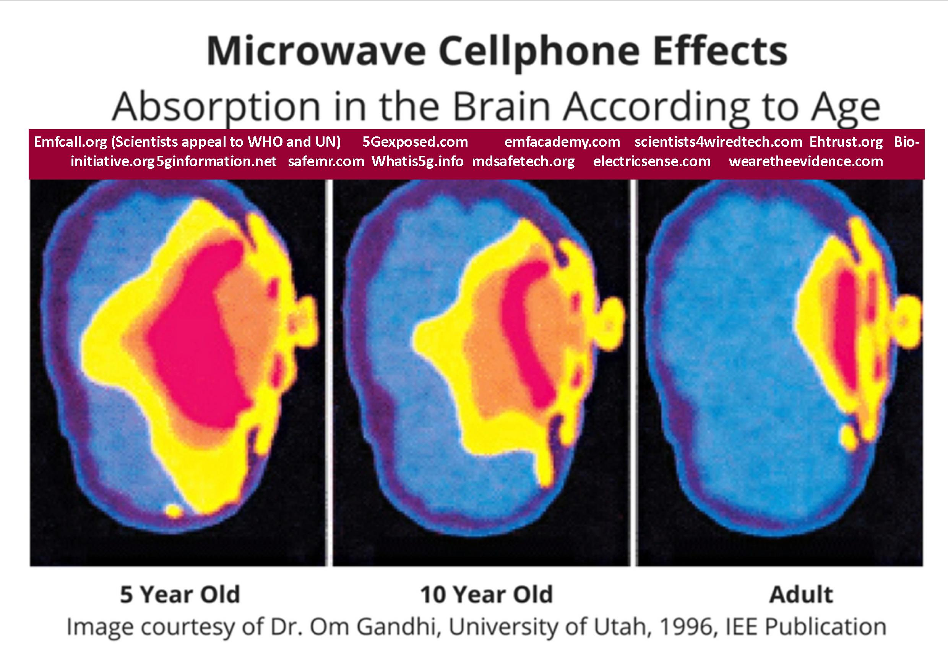
Since 2018, we have clear evidence of microwave radiation causing cancer, from two complementary and mutually supportive long term research studies: the US Government’s National Toxicology Programme and the Italian independent Institute Ramazzini Study on Cell Phone Radiation, which has helped to lead the way in large scale animal carcinogenicity testing for the last 50 years. The longer term effects, as per these studies, now include strong evidence of cancer in humans, notably for glioma (brain) tumours and acoustic neuromas.
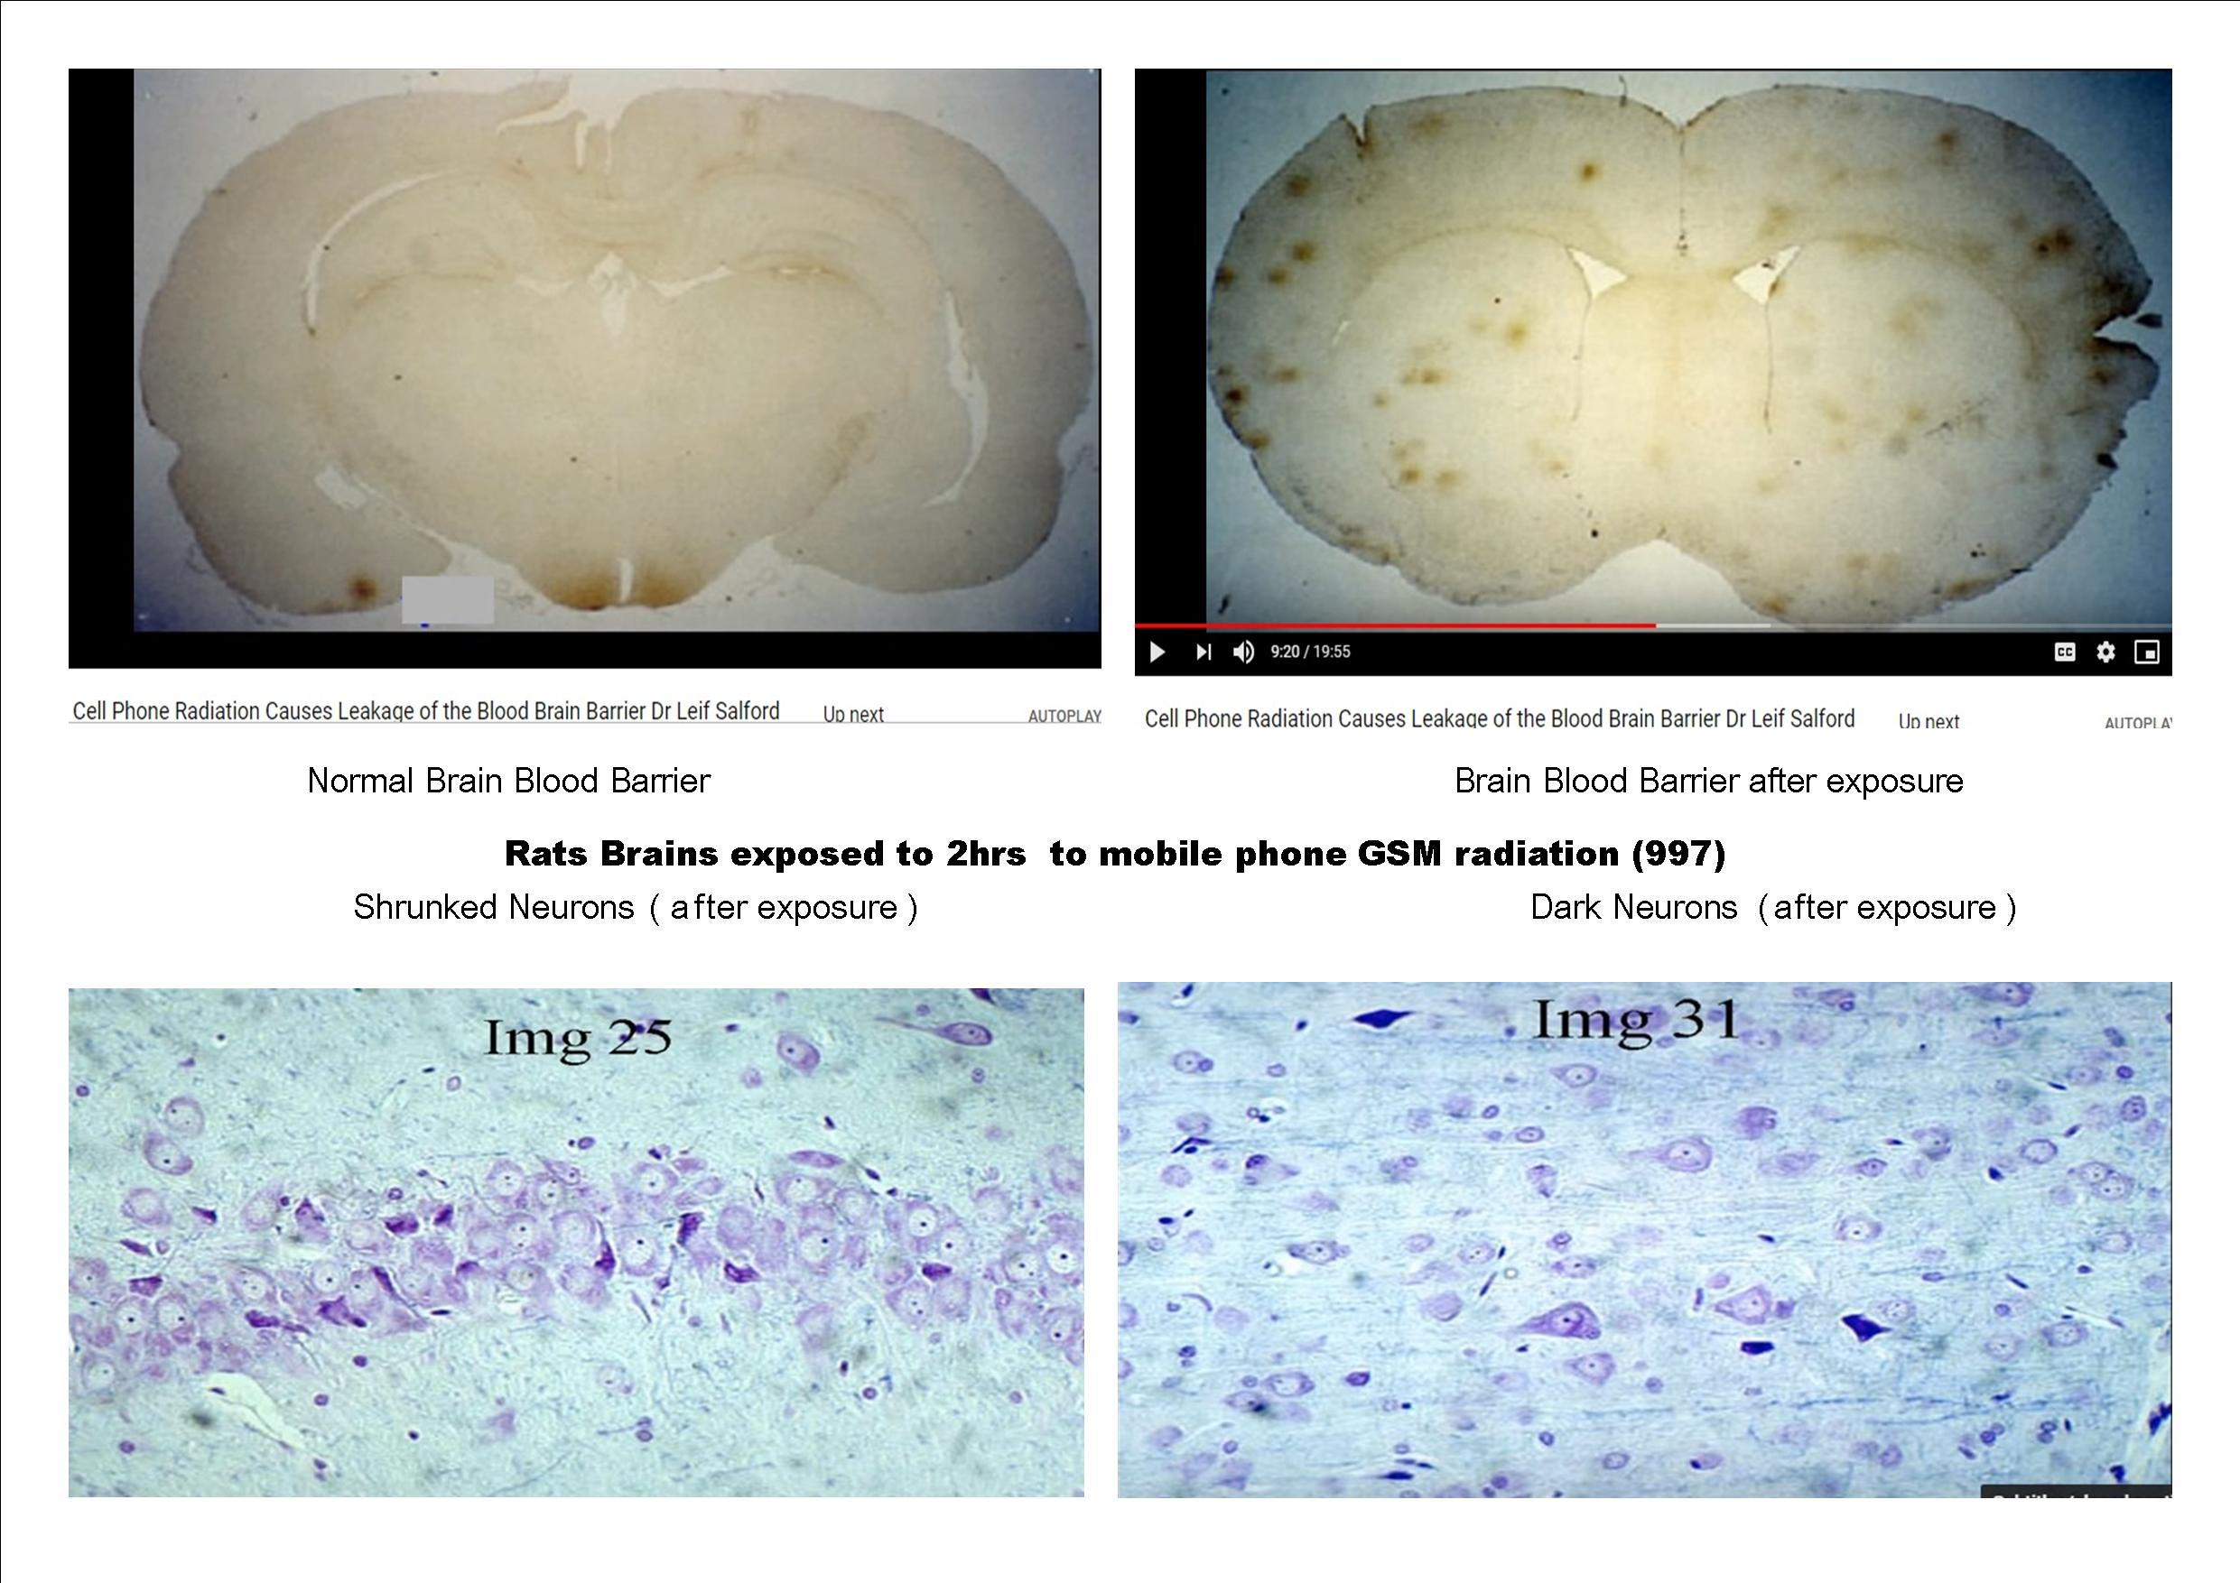
Above, critical images presented by Dr. Leif Salford, neurologist – this is what 2 hours exposure to 915 MHZ GSM radiation does to the brains of rats: leakage of the essential Blood-Brain-Barrier and neuronal damage (https://www.cellphonetaskforce.org/the-work-of-leif-salford/ )

Senior experts from within the Biophysics and electromagnetism field, such as Professors James Lin and Frank Barnes, Martin Pall, Devra Davis and many others are questioning the ability of the ICNIRP exposure limits for RF to fully protect public health, particularly in children. They, and many other EMF experts are recommending the ALARA principle (ie to keep exposures “as low as reasonably achievable”) which has been long used in the radiation field to protect the public and sensitive sub groups from radiation. Resolution 1815 of the European Parliament (2011) specifically states that governments should “reconsider the scientific basis for the present standards on exposure to electromagnetic fields set by the International Commission on Non-Ionising Radiation Protection, which have serious limitations, and apply ALARA [as low as reasonably achievable], covering both thermal effects and the athermic or biological effects of electromagnetic emissions or radiation.”
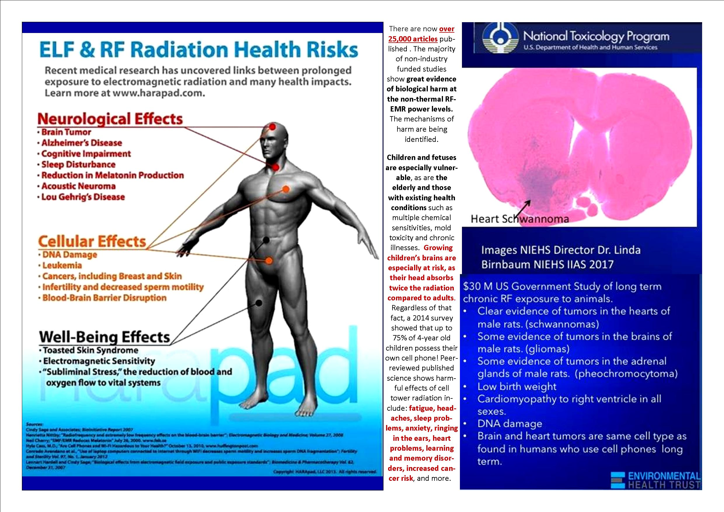
Campaigning doctors from groups such as PHIRE Medical (http://phiremedical.org) and SSITA (Safe Schools Information Technology Alliance, https://ssita.org.uk) have stated that this is a public health emergency. PHE is currently the object of written complaints from campaigning doctors and is under investigation from the PHSO ombudsman. Legal cases against PHE are being prepared and the UK government and the PHE EMR advisors are now on legal notice over their ‘advice.’

The more recent evidence means that the current classification of the cancer risk from RF from mobile phones by the International Agency for Research on Cancer (IARC/WHO,2011), as a “possible” human carcinogen, will certainly be re-evaluated to at least a “probable” and possibly a “proven” human carcinogen when IARC comes to re-evaluate the RFR evidence which is expected in the next 1-2 years. For a couple of important scientific reviews of the Wi-Fi effects on human health and the necessary standards in matters of emitted radiation, please see the independent collaborative work of 29 renown scientists THE BIOINITIATIVE HUMANITY AT THE BRINK , as also

Images proving the abnormal coagulation of the blood’s red cells (Roulleaux formations) after a day of exposure to WiFi in school – in a healthy young teacher – Lena Pu research
THE AMMENDED DECLARATION OF BARRIE TROWER CONCERNING THE USE OF WIFI IN SCHOOLS
Chronic EMF exposure is particularly linked to infertility, leukaemia, brain and cardiovascular damage, cancer and is exceedingly harmful to children.
Please consider also that WiFi is already removed from schools worldwide. For ex., CYPRUS, FRANCE, BELGIUM, ISRAEL, GERMANY, AUSTRALIA and RUSSIA, as also tHE STATES OF MARYLAND, OHIO, ONTARIO CANADA HAVE BANNED WIFI IN CLASSROOMS AND/OR REDUCED EMF RADIATION EXPOSURE
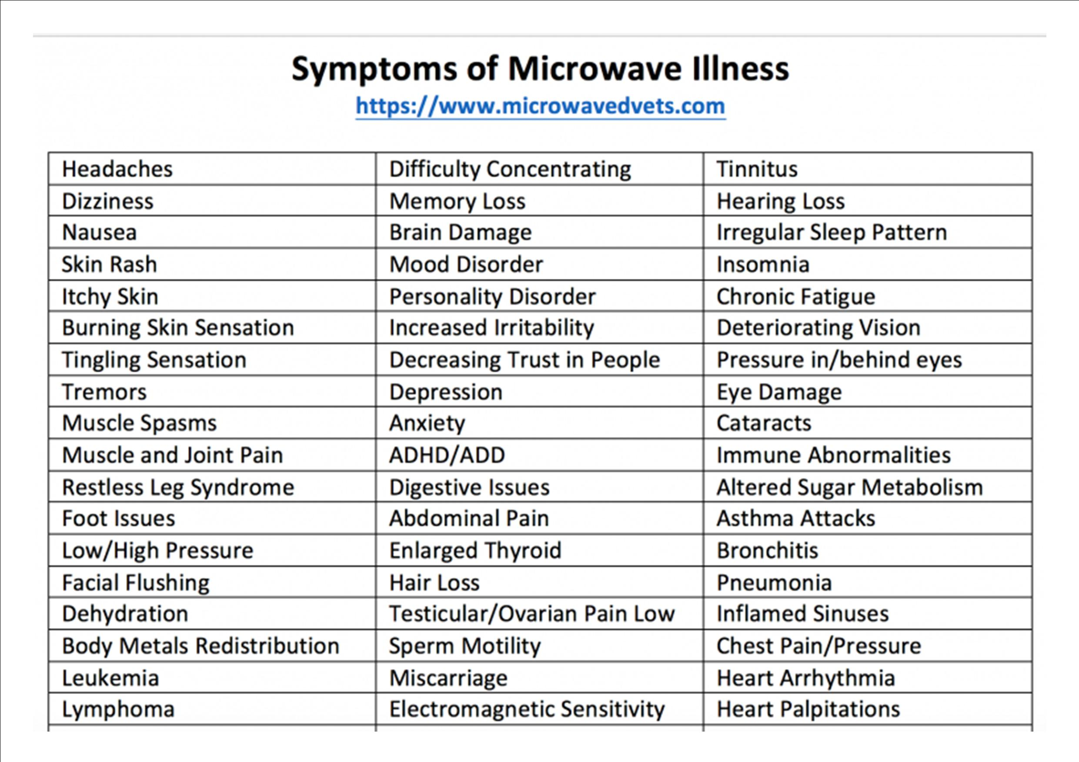
In light of this emerging evidence and the already widespread and increasing public and environmental exposures to non-ionising radiation from industrial grade WiFi rooters installed throughout classrooms, powering multiple devices (which will, in general, be exacerbated by the roll out of 5G), we consider it would be a retrograde and unwise move to increase the EMF exposure even beyond the limits recommended by ICNIRP.
We, the concerned parents fully support equal access to technology for all pupils. The safe way to connect to the internet is hardwired, with cables. I hope I can trust that you will review the literature and take the necessary steps to reduce the WiFi exposure in classrooms and definitely oppose any upgraded, untested 5G- 60Ghz (WiGIG) in classrooms, which is also now being proposed to be installed throughout schools. Also a matter of high importance for health is the potential exposure to cell towers that may be found in the close neighbourhood of the school and this needs also a careful consideration for the benefit of all, children and staff. As the highest authority at my child’s school, you also have the highest responsibility in matters of protecting the health and lives of the children and staff during the time they attend school and will be held liable from now on for your decisions and actions in this area. I expect Health& Safety Risk Assessments determining the risks and the appropriate measures to be put in place in order to protect the children and the staff, according with the legislation in place concerning the control of the electromagnetic fields at work and to the examples of good practice offered in the annex of this letter.

Thank you for taking the time to read this e-mail and I look forward to hearing from you about your decisions and actions in this matter of great importance.

Kind regards,
______ [ Name ]
______ [City/Town]
______ [Phone No]
______ [Email Address]

______ [ Date}

ANNEX

TWO EXAMPLES OF GOOD PRACTICE
State of Maryland (which advises against Wi-Fi in schools:
https://phpa.health.maryland.gov/OEHFP/EH/Shared%20Documents/CEHPAC/MD_CEHPAC_SchoolWiFi_022017_final.pdf?fbclid=IwAR2tZok8_UQnKDPBJYnQY3S32phKyo1m0-rTk6-U8zUfAkrKmZJ0qvgZ7jA )
Maryland Dept of Education guidelines for safer Wi-Fi in schools:
The Maryland State Department of Education should recommend that local school systems:
○Consider using wired devices.
■Where classrooms have internet access with a wireless connection,
WiFi can be turned off and wired local area network (LAN) can provide a reliable and secure form of networking for as many wireless devices as necessary without any microwave electromagnetic field exposure.
■If a new classroom is to be built, or electrical work is to be carried out in an existing classroom, network cables can be added at the same time, providing wired network access with minimal extra cost and time.
○Have children place devices on desks to serve as barrier between the device and children’s bodies.
○Locate laptops in the classroom in a way that keeps pupil heads as far away from the laptop screens (where the antennas are) as practicable.
○Consider using screens designed to reduce eyestrain.
○Consider using a switch to shut down the router when it is not in use.

Wifi in Schools Australia: Reducing EMR. http://www.WiFi-in-schools-australia.org/p/blog-page_13.html
WiFi Radiation in Schools December 13, 2016 Page 9
○Teach children to turn off WiFi when not in use.
○Consider placing routers as far away from students as possible.
○Share this document with teachers and parents.
●The General Assembly should consider funding education and research on electromagnetic radiation and health as schools add WiFi to classrooms.
●The Maryland Department of Health and Mental Hygiene should provide suggestions to the public on ways to reduce exposure:
○Sit away from WiFi routers, especially when people are using it to access the internet.
○Turn off the wireless on your laptop when you are not using it.
○Turn off WiFi on smartphones and tablets when not surfing the web.
○Switch tablets to airplane mode to play games or watch videos stored on
the device.

OTHER IMPORTANT RESOURCES:
Actions for schools to reduce risks
Safe Schools Information Technology Alliance
https://ssita.org.uk
https://ssita.org.uk/children/
PHIRE doctors
phiremedical.org
http://phiremedical.org/vulnerability-in-children/
Dr Erica Mallory-Blythe’s talk on EMR and children: https://www.youtube.com/watch?v=sNFdZVeXw7M
Excellent resource for schools:
https://ehtrust.org/take-action/schools-programs/
Information from the Environmental Health Trust (EH Trust) (Dr Devra Davis & colleagues)
https://ehtrust.org/wp-content/uploads/WiFi-in-Schools-Toolkit-EHT.pdf

Schools and families course: https://www.wirelesseducation.org/store/l2/
SafeG wired connections
Wi-Fi routers are often vastly overpowered https://safeg.net/home/?fbclid=IwAR3xGA5vIKTOmx7uVwVpeOPN2zaDbfQ4oPrau3_Th3Djo_1qhmqsEIlDjYc

Schools and families course: https://www.wirelesseducation.org/store/l2/

Wired child: http://wiredchild.org/home.html

Safer internet solutions https://ehtrust.org/key-issues/cell-phoneswireless/wifi-in-schools/
Working for Safe Technologies for Nurseries, Schools and Colleges
http://www.wifiinschools.org.uk
Wi-Fi router guards can be used to block signal if router cannot be turned on and off https://www.radiationhealthrisks.com/wifi-radiation-protection-items/
Checklist on reducing EMR in classrooms
https://ehtrust.org/wp-content/uploads/Reducing-EMF-in-School-Classrooms-EHT-.pdf
The Collaborative for High Performance Schools
The US-based Collaborative for High Performance Schools has developed Best Practices for LOW EMF classrooms which includes using corded, not cordless phones, using ethernet connected, not wireless computers in the classroom.
https://ehtrust.org/wp-content/uploads/US-CHPS__Criteria_2014_Low-EMF-Low-ELF-Criteria102314_VA-1-copy-2.pdf

Cece Doucette, comms professional https://sites.google.com/site/understandingemfs/contact
Generation Zapped – multi award winning documentary 2017
https://vimeo.com/ondemand/generationzapped

Talk by doctor, EMR expert and campaigner Dr Erica Mallory-Blythe - https://www.youtube.com/watch?v=7hQKFPQL6gI&feature=youtu.be

Wi-Fi in schools proven dangerous- documentary
http://www.electrosmogprevention.org/public-health-alert/wifi-dangers/wifi-in-schools-proven-dangerous/?fbclid=IwAR1DwUr5HUWnI95hmIzR0lA5Rg3_rz2lIfEf5mcnGkp5stR9oYNex23r6_8
Powerful Wi-Fi in schools causes symptoms & linked with cancer/lower limits in some countries (video from Australia)
https://www.youtube.com/watch?v=YF5XeQAHtQE&list=PLT6DbkXhTGoDuG9AjOwvPaWLSk8mYyeyK
Is WiFi making your child ill? Article with info from Dr Erica Mallory-Blythe:
https://www.telegraph.co.uk/health-fitness/body/wifi-internet-family-dangerous-health/

THE EXTREME DANGERS OF EMF/WIFI RADIATION https://unitefortruth.online/wifi%2F-5g-issues

Lloyds Of London refuse coverage - https://principia-scientific.org/lloyds-insurers-refuse-to-cover-5g-wi-fi-illnesses/ In February 2015 Lloyd’s of London informed schools that it was excluding liability coverage for injuries resulting from or contributed to by microwave radiation and electromagnetic fields. School boards therefore become liable: http://parentsforasafeschool.blogspot.com/2015/02/school-boards-left-on-hook-for-wi-fi.html Swiss Re “ EMR High Risk Category” - https://www.jrseco.com/insurer-swiss-re-electromagnetic-radiation-highest-risk-category/
POWERWATCH– Peer-reviewed scientific studies on EMF related subjects https://www.powerwatch.org.uk/science/studies.asp
Dr Devra Davis: Wireless Devices: what we know; what we do not know; what we can do now https://www.youtube.com/watch?v=EwS-aHB-zHk Why children absorb more microwave radiation than adults: The consequences. https://www.sciencedirect.com/science/article/pii/S2213879X14000583
NTP CELL PHONE RADIATION STUDY (Final Reports) https://www.saferemr.com/2018/11/NTP-final-reports31.html
RAMAZZINI INSTITUTE STUDY https://www.saferemr.com/2018/03/RI-study-on-cell-phone.html
PACE Resolution 1815 (2011) https://assembly.coe.int/nw/xml/XRef/Xref-XML2HTML-en.asp?fileid=17994&fbclid=IwAR0d4rrRbTtVYe2bSBseMlHKVPWPWBzPTeb6HrkOO8JL63cHkw08y_0mC18
Trower Report https://rense.com/general96/trower.html
Amended Declaration of Barry Trower https://www.wirelesswatchblog.org/wp-content/uploads/2001/11/20-Amended-Declaration-of-Barry-Trower.pdf
EXPERT PANEL DISCUSSION ON CHILDREN AND WIRELESS FOR PARENTS: https://ehtrust.org/science/key-scientific-lectures/expert-panel-discussion-on-children-and-wireless-for-parents/?fbclid=IwAR33pssQqY7bzv91198q7qJvh56rqdUyOm_F7mTgFKAT-70jRGQ45hJMFbk Evidence-base for the link between adverse childhood experiences and long-term negative outcomes https://cdn.website-editor.net/2479f24c54de4c7598d60987e3d81157/files/uploaded/Early_Years_Inquiry_EY10062.pdf Studies showing harm to children from smartphones and Wi-Fi https://www.radiationresearch.org/wp-content/uploads/2019/10/On-the-Clear-Evidence-of-the-Risks-to-Children-from-Smartphone-and-WiFi-Radio-Frequency-Radiation-Final-2019.pdf Damage from just minutes of exposure Includes calls to wire Wi-Fi in schools https://stopsmartmeters.org.uk/uk-medical-doctors-call-for-immediate-action-against-wireless-technologies/?fbclid=IwAR1pUP2pvS1CcKc0-e_F5kBEbA52svyfgO6Sm7RyQ_yxZOhRH6dU7nnKgyY
WiFi Being Removed from Schools Worldwide (April 2019) http://stateofthenation2012.com/?p=121005 Russian Government Recommends Banning Wi-Fi and Cell Phones in Primary Schools: https://childrenshealthdefense.org/child-health-topics/known-culprit/5g-electromagnetic/russian-government-bans-wi-fi-and-cell-phones-in-primary-schools/?fbclid=IwAR33pssQqY7bzv91198q7qJvh56rqdUyOm_F7mTgFKAT-70jRGQ45hJMFbk SCHOOLS PROGRAMS (EHT) https://ehtrust.org/take-action/schools-programs/
Cancer clusters in neighbourhoods and schools due to 5G masts - https://youtu.be/ psDrvMwbq48 Pittsfield cell tower could cause harmful health effects, experts say https://spectrumnews1.com/ma/worcester/news/2021/06/03/pittsfield-cell-tower-concerns?fbclid=IwAR2I3dbNADSXHwBGxW9qWzynmCLVM9Ol4onkv78OACrpa8lQckle2HhtW0U
Control of Electromagnetic Fields at Work Regulations 2016 & related https://www.hse.gov.uk/radiation/nonionising/emf.htm

