Smart Meters: Countdown to a National Crisis of Illness and Death
Join The Discussion(11)
436

29

8
Share

11
Share

15

320

0


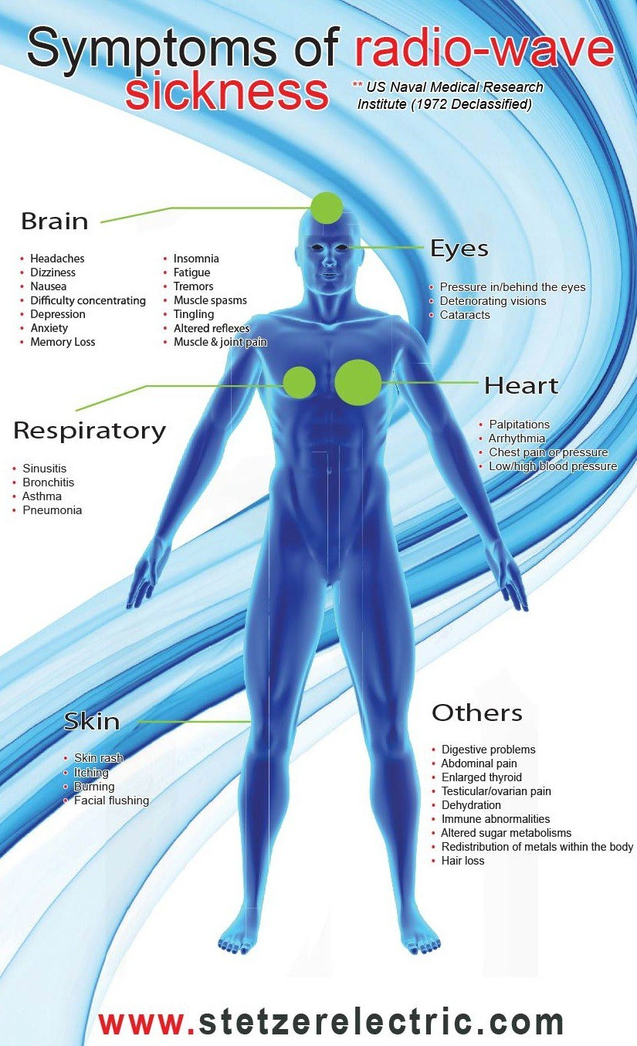
by John P. Thomas
Health Impact News
Electric utility companies are in the process of installing smart meters at all of their customer locations, which are making thousands of their customers sick. These meters emit microwave radiation in the 900+ megahertz frequency band, which is known to cause weakness, fatigue, sleep disturbances, heart palpitations, ringing in the ears, pain, and immune system disruption. These smart meters broadcast intense bursts of microwave radiation through the air many times per minute, 24-hours a day. [1, 2, 3, 4]
Smart meters also add high frequency electromagnetic radiation in the kilohertz frequency band to the electrical wiring of every building where they are attached. This electromagnetic radiation is also harmful. It turns the electric wiring in buildings into giant antennas that fill the interior spaces with radiation frequencies that are known to alter human biological functioning. These same frequencies are used in medical research to block the activity of nerves. [5]
The nationwide installation of smart meters is like a time bomb ticking, because the harmful effects are cumulative — it can take 5 or 10 years of exposure to evoke a life-threatening illness.
At some point, it will not be thousands who suffer from electromagnetic radiation sickness, but there will be an explosion of illness. There will be millions of people who are experiencing chronic disability and fatal illness from exposure that spanned many decades. [6]
The current epidemics of cancer, heart disease, diabetes and even autism will intensify until very few of us will be able to escape these devastating illnesses. Others will suffer for decades with chronic fatigue, unexplained anxiety, and attention deficits until a life-threatening illness makes its ugly appearance.
It is true that the majority of people feel nothing when exposed to electromagnetic radiation such as microwave transmissions from smart meters and cell phones. Even if people can’t identify reactions to this exposure, proteins within their cells are being permanently altered. [7]
At present, very few healthcare providers in the conventional medical system consider electromagnetic exposure to be causative for the diseases they treat. They are either unaware of the scientific research on electromagnetic radiation and illness or they are skeptics who don’t believe that unseen and unfelt electromagnetic radiation can have an effect upon the bodies and minds of their patients.
Most continue to use pharmaceuticals designed to eliminate acute symptoms, when their patients are actually suffering from chronic illnesses linked to electromagnetic radiation exposure, which can only be fixed by reducing exposure.
It is estimated that 80% of modern chronic illnesses are caused by or influenced by long-term exposure to sources of electromagnetic radiation such as cell phones, cell towers, Wi-Fi routers, baby monitors, cordless phone base stations, Bluetooth devices, smart meters, and dozens of other wireless devices that are used every day by Americans.
By far, smart meters are the worst offenders in this list. The combined electromagnetic radiation from these devices is evoking modern illnesses and disabling us at a level that has never been seen before, because these levels of exposure have never been experienced by human beings before. [8]

Smart Meters are Coming to Every Neighborhood in America
The previous article in this series described the relationship between the roll out of smart meters by utility companies and the roll out of the 5G cellular communication network that telecom companies are planning to install throughout the United States.
If you don’t currently have one or more smart meters on your home, then be aware that plans are being made to change that situation for you. Please use this link to read the first article.

New 5G Cell Towers and Smart Meters to Increase Microwave Radiation – Invade Privacy

Tested for the presence of glyphosate!

Which Utility Companies Use Smart Meters?
In addition to smart meters collecting information for electric utilities, they may soon be used by natural gas providers and public water districts.
Thus, some homes may eventually have three smart meters broadcasting electromagnetic radiation 24-hours a day.

Utility Companies are Lying about how often Smart Meters Broadcast Microwaves

Utility companies want us to believe that their smart meters only broadcast information once a day or only once every 4 hours.
This simply is not true. They actually broadcast intense levels of microwave radiation several times per minute – they never stop – up to 190,000 times per day. [9]
The following video by Warren Woodward records the constant pulsing broadcasts of a smart meter owned by Navopache Electric Cooperative in Arizona.
I am not targeting this electric provider – they just happened to be the owner of the smart meter that appears in the following video.
This is typical for all smart meter performance, though some are reported to have much higher levels of transmission.
As you will see, microwave bursts are frequent and unpredictable.
Navopache Caught Lying – YouTube (1 minute 41 seconds)

Smart Meters More Dangerous than Cell Towers and other Devices
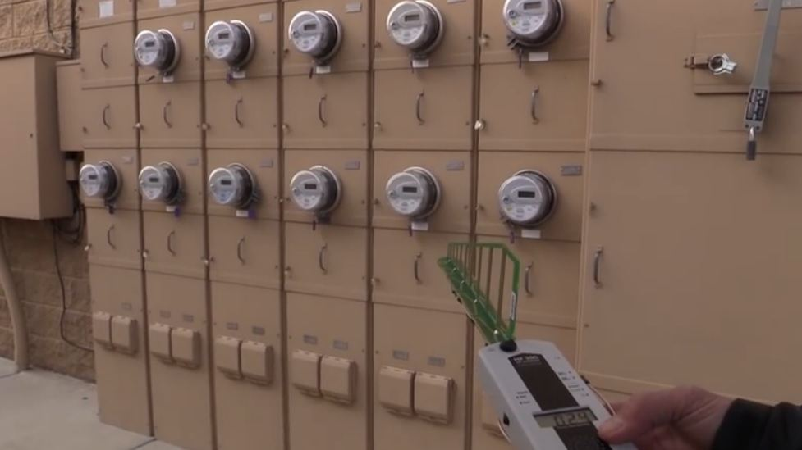
In the following video clip, Warren Woodward measures the density of microwave radiation from cell towers and compares the measurement to microwave radiation from smart meters.
The constant activity of cell towers had a reading of 1,800 microwatts per meter squared, while the bank of smart meters that he measured had bursts of microwave radiation with density readings ranging from 15,000 to 38,900 microwatts per meter squared. (Measurements were taken on smart meters owned by Arizona Public Service Electric Company, APS.)
APS Caught Lying – YouTube
The term “density” describes the amount of electromagnetic radiation that passes through a square centimeter or square meter.
The density is primarily determined by two factors: (1) the distance between a person and the source of the electromagnetic transmission and (2) the strength of the transmission at the source.
This means that if a person is exposed to microwave radiation from two sources that have the same transmitting strength, but one source is close and the other is far away, then the nearer source will have much higher density.
The higher the density – the higher the exposure. The higher the exposure, the higher the risks of harm to human health. Of course, the length of exposure is also important as is the specific frequency of the transmission. There are risks associated with both long-term continuous exposure at low levels and short-term high levels of exposure.
The preceding video clearly demonstrates that, based on proximity, the smart meters produce much higher microwave density than cell towers. People who have smart meters, for example, on their homes or even worse on the wall of a bedroom, are at serious risk, because the density of their microwave radiation exposure is much higher than from distant cell towers.


Real World Examples of Illness Caused by Smart Meters
Dr. Darren Schmidt, a chiropractor from Ann Arbor, Michigan, has worked with patients with numerous health problems. [10] He specializes in using nutritional approaches to help people with their healing. His work with electromagnetic radiation exposure began with helping people who are exposed to electromagnetic fields and frequencies from the computer equipment they use. Eventually he came to understand that smart meters are an even greater concern.
Dr. Schmidt stated:
I started using our testing procedures and sure enough I found that people who spend more than 4 hours per day in front of a computer are tired because of it. The brain gets tired, their eyes get tired –this takes energy out of the body. For about three years I looked for supplements that would fix this – and there are none. There are no supplements that fix hypersensitivity to EMF and radio frequencies. I found supplements that would work for three months, maybe, but then the problem would come back.
But I did discover that there are underlying conditions that can be addressed over the course of 6 months to a year. I am specifically talking about heavy metal toxicity. So, if you have [metal] fillings in your teeth or have heavy metals stuck in your body, those metals in your organs such as mercury and aluminum … act as an antenna which attract EMFs to the body. [11]
In the following video, Dr. Schmidt presents several case studies and experiments that highlight the specific effects of microwave exposure on the parasympathetic and sympathetic nervous system, diabetes, blood pressure, cancer, asthma, and heart rate. His entire presentation is interesting if you are willing to take the time to watch the 22 minute presentation. You could begin watching at 9 minutes and 40 seconds to just hear about his case studies.
Dr. Darren Schmidt, How Smart Meters Affect Your Body, YouTube

Let’s Take a Closer Look at How Smart Meters Affect the Human Heart
An experiment was set up where the heart activity of two test subjects was monitored by an EKG machine. The subjects (a male and a female) were positioned 10 feet from a smart meter while their heart activity and the activity of the microwave bursts of the smart meter were recorded. The subjects were unaware of when the smart meter was transmitting. [12]
The results were decisive. Each time the smart meter broadcasted microwave radiation there was an instantaneous disruption in normal heart activity. Neither subject had a physical sensation of the disruption. The doctor who cleared the subjects for the test and who observed the EKG activity for the two subjects decided to cancel the test for the female before it was complete, because of the severity of the heart disruption.
The following video shows the test results. You can watch the entire 21 minute video or focus on the analysis of the results which begin at 9 minutes and 11 seconds.
EKG Proof that Smart Meters Affect the Human Heart, Part II, YouTube

Smart Meters Radiate into Both the Air and into Electrical Wiring
Thus far the discussion has focused on how smart meters broadcast intense bursts of microwave radiation into the air. These bursts of electromagnetic radiation contain information that is sent to other smart meters and to utility company routers, which pass it on to the utility provider. Utility company routers broadcast bursts of microwave radiation thousands of times per hour. However, there is another, even darker, side to these devices.
Smart meters also add other frequencies of electromagnetic radiation to the electric wiring of buildings. This radiation is in the 2 kilohertz to 50 kilohertz frequency band. Radiation of this type has been studied by scientists and physicians for its ability to alter cellular activity. [13]
For example, researchers are trying to use kilohertz frequencies in this radiation band as a form of anesthetic. If they are able to block the experience of pain by administering kilohertz frequencies to a patient, then it would be unnecessary to use anesthetics. [14, 15, 16, 17, 18, 19, 20, 21, 22, 23]
We must wonder why the frequencies used in medical research to block nerve activity are also being added to electrical wiring by smart meters. Is it coincidence?
The insertion of these kilohertz frequencies by smart meters into household wiring radiates into the environment as much as 6 to 8 feet from electric wires. This means that in a typical home, it is impossible to remove oneself from their effects.
The following picture compares the electrical signal that comes through the old-fashioned analog electrical meter to the electrical signal coming through a smart meter. The smart meter adds a large number of kilohertz frequencies to the standard 60 Hz frequency that is normally present in household wiring.
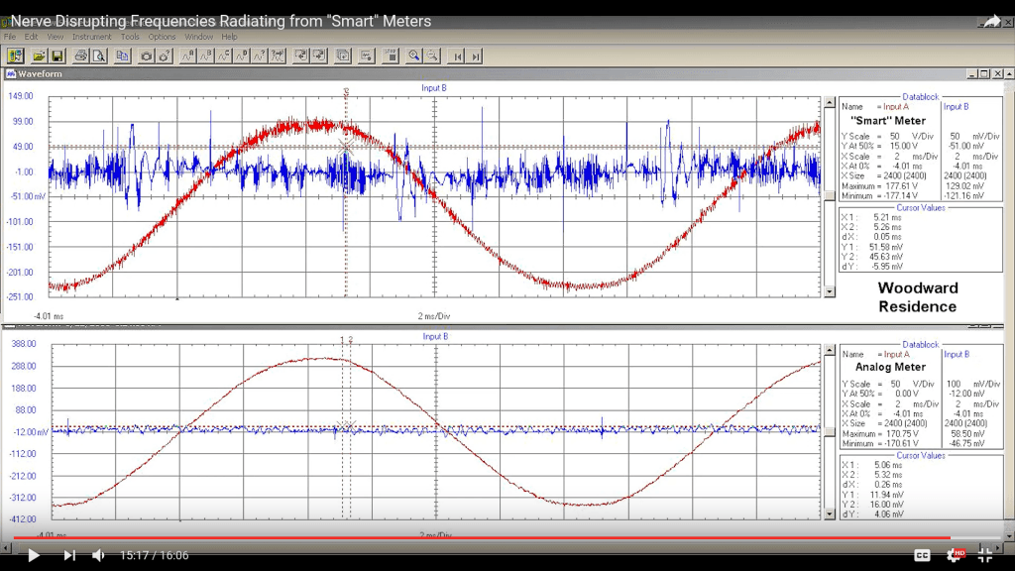
Taken from “Nerve Disrupting Frequencies Radiating from Smart Meters”
You may wish to watch the above video to see the actual experiment that compared the performance of analog meters and smart meters, and how smart meters produce “dirty electricity.”

Smart Meters Can Push People Over the Top to Electromagnetic Radiation Illness
Often people who experience illness from smart meters were not bothered by their use of cell phones or Wi-Fi routers. However, once a smart meter was installed on the wall of their home, they became seriously disabled; and they were no longer able to tolerate microwave radiation from a cell phone or Wi-Fi router. Once they were pushed off the cliff into electromagnetic radiation illness, they found it very difficult to regain their health even after limiting their exposure to these frequencies of radiation.
I do want to make quick reference to the fact that the kilohertz frequencies that smart meters add to electrical wiring can be removed with filters.
Unfortunately, protecting ourselves from microwave radiation that travels through the air is much more difficult. Please watch this video to see how frequencies radiate off electrical wiring. The video also discusses the use of Graham-Stetzer filters for removing these frequencies, which are also called “dirty electricity.” The images of radiation produced by dirty electrical wiring begins at 5 minutes and 20 seconds.
See also:

“Dirty” Electricity is a National Problem Affecting Everyone’s Health in the United States
Dirty Electricity Explained – YouTube (8 minutes 21 seconds)

How Do Frequencies Harm Health and Why isn’t Everyone Sick?
Dr. Dietrich Klinghardt, M.D., Ph.D., answers this question. Dr. Klinghardt founded the Sophia Health Institute and sees patients in Seattle, Washington. The institute specializes in the treatment of chronic illness. [24]
The typical patient that he and his colleagues treat has been seen by 23 other physicians before coming to his clinic. They have found that the foundational causes of illness are now quite different than they were thirty or forty years ago.
He explains that electromagnetic radiation such as microwave radiation permanently destroys and alters the manufacturing of proteins within the cells. “Meaning this completely changes the human organism permanently!” [25]
These are a few of the important points made by Dr. Klinghardt in a video entitled, “SMART METERS & EMF RADIATION ➜ The Health Crisis of Our Time!” (His remarks have been slightly edited for brevity.)
Dr. Klinghardt stated:
From a medical perspective, there are two kinds of illnesses. There are the illnesses that have a name, traditional illnesses such as diabetes, hypertension, fractures, and appendicitis. And then there is the much larger amount of illness that goes without a name, where people feel they have lost their zest, they lost their enthusiasm, they lost their sex drive, they have lost their joy – they don’t dance any more, they don’t sing any more. They are still living, but they are sort of living a half-life. This fits every patient we see.
About 80% of health problems that we see now are caused or contributed to by the exposure to man-made electromagnetic fields … all the studies that were correctly done show that they are not safe.
We know cancer rates are going up. There was a famous study in Germany – the Niehler Study – which showed cancer rates in a community where there was no cell phone tower. When the cell phone industry came in, there was no increase in cancer rates for 5 years. After 5 years the cancer rate goes up. After 10 years it’s about 4-fold [higher]. This has now been confirmed by other studies.
The difference between people being more or less electrosensitive is explained by the antenna function of the human body. [Sensitivity is determined by] the composition of minerals, the density of minerals, electrolytes, water content of the system, and even the body size. It has been shown that people with bigger bodies tend to be more electrosensitive. Smaller people are likely to be less sensitive. The most severe electro-allergic (electrosensitive) people that I have seen were large people.
The primary strategy we have used for the last twenty years to move people out of [their condition] is to detox them for heavy metals – to reduce the amount of mercury, lead, nickel, and cadmium that is in the bone marrow and in the fascia membranes and in the connective tissue – to remove as much of that as possible. This has been very successful.
And then there is part two. The shielding of the electric wiring in the body is the myelin sheath around the nerves. This is greatly diminished in chronic infections – especially in Lyme’s. The surface of the Lyme’s spirochete has the same surface markers as the myelin. So, when the immune system looks for the Lyme’s spirochete it also attacks the person’s own myelin and nibbles away at it, so the insulation wears thin. The chronic Lyme’s patients are the same as electrosensitive people. If someone watches this video and you are highly electrosensitive, then please have yourself checked out for Lyme’s disease, because most likely you are positive.
The treatment begins by successfully treating the chronic infection. The second step is to rebuild the myelin.
The set of procedures that we do also involves the use of fungal products. The mushroom extracts have a unique property for protecting people from electrosensitivity. Why this is we don’t know exactly, but we do know that mushrooms thrive in electrically polluted environments. [26]

Healing from Microwave Radiation – Success with Autism
Dr. Klinghardt requires his patients to take three steps to clean up their living spaces.
1. Get rid of cordless phones – replace with corded phones.
2. Get rid of wireless Wi-Fi routers – replace with wired ethernet connections and a wired router.
3. Measure the density of microwave radiation in the bedroom. If the density is above 5, then look for a sleeping location in the house where there is microwave density at or below this level.
If this cannot be found, then protection will need to be installed to prevent microwaves from entering the sleeping space.
About half of Dr. Klinghardt’s patients are autistic children. He describes the requirements for their successful treatment.
Dr. Klinghardt stated:
There are two kinds of autistic kids – the ones that recover and the ones that don’t recover. The ones that recover are the ones that follow exactly this set of instructions. [the 3 points summarized above – eliminating cordless phones and Wi-Fi routers, and sleeping in a low microwave density bedroom]
[Recovery] is hardly done with the vitamins and the other things we do with behavioral therapies. [These things] have a minor effect. The moment we protect the sleeping location of autistic children, the children start recovering. [27]
I highly recommend listening to Dr. Klinghardt’s presentation for all the details about the preceding comments. Specific information about the importance of preventing smart meter installation is in the second half of his presentation.
SMART METERS & EMF RADIATION ➜ The Health Crisis of Our Time! – YouTube (43 minutes)

Conclusion: Smart Meters are a Huge Threat to Our Lives
Smart meters are one of the most invasive technologies invented thus far.
They invade our health by exposing us to radiation that we cannot avoid, and they literally threaten our long-term survival.
They invade our privacy, because when they are fully implemented along with smart appliances, they will essentially be monitoring everything we do.
They are invasive, because they can be used to control our use of electrical power and make choices for us, or be used to deny us access to electric power to “encourage” us to submit and conform to the plans that major corporations and government are making for us.
Every analog meter that remains in place stands as a beacon of freedom for those who are concerned about their health and wish to preserve independent thinking.
Yes, the smart meter system is that serious of a matter!

About the Author
John P. Thomas is a health writer for Health Impact News. He holds a B.A. in Psychology from the University of Michigan, and a Master of Science in Public Health (M.S.P.H.) from the School of Public Health, Department of Health Administration, at the University of North Carolina at Chapel Hill.

References
[1] “FAQ: Radio-Frequency Radiation Issues,” Stop Smart Meters!. https://stopsmartmeters.org/frequently-asked-questions/radio-frequency-radiation-issues/
[2] “Microwave and Radio Frequency Radiation,” Communications Workers of America, Retrieved 7/15/2017. https://www.cwa-union.org/national-issues/health-and-safety/health-and-safety-fact-sheets/microwave-and-radio-frequency
[3] “The Science,” Stop Smart Meters! https://stopsmartmeters.org/the-science/
[4] “SMART METERS & EMF RADIATION ➜ The Health Crisis of Our Time!” Dr. Dietrich Klinghardt, MD, PhD, YouTube. https://www.youtube.com/watch?v=8RP7vmFeo0k
[5] “Nerve Disrupting Frequencies Radiating from Smart Meters,” YouTube. https://www.youtube.com/watch?v=4NTSejgsjTc
[6] Dr. Dietrich Klinghardt, op cit.
[7] Fragopoulou AF, Samara A, Antonelou MH, Xanthopoulou A, Papadopoulou A, Vougas K, Koutsogiannopoulou E, Anastasiadou E, Stravopodis DJ, Tsangaris GT, Margaritis LH; “Brain proteome response following whole body exposure of mice to mobile phone or wireless DECT base radiation,” Electromagn Biol Med, 12/31/2012, PMID 22263702.
[8] Dr. Dietrich Klinghardt, op cit.
[9] “FAQ: Radio-Frequency Radiation Issues,” Stop Smart Meters!. https://stopsmartmeters.org/frequently-asked-questions/radio-frequency-radiation-issues/
[10] The Nutritional Healing Center of Ann Arbor, About Us. http://thenutritionalhealingcenter.com/about-us/
[11] “How Smart Meters Affect Your Body,” Dr. Darren Schmidt DC, YouTube. https://www.youtube.com/watch?v=z2Mt00xY8eU
[12] “EKG Proof That “Smart” Meters Affect the Human Heart, Part II,” Warren Woodward, 5/31/2017. https://www.youtube.com/watch?v=UIobFr3m8kk
[13] Nerve Disrupting Frequencies Radiating from “Smart” Meters, YouTube. https://www.youtube.com/watch?v=4NTSejgsjTc
[14] “Mechanism of nerve conduction block induced by high-frequency biphasic electrical currents,” (Frequency: 165 kHz). https://www.ncbi.nlm.nih.gov/pubmed/17153201
[15] “Modulation of axonal excitability by high-frequency biphasic electrical current.” https://www.ncbi.nlm.nih.gov/pubmed/19389692
[16] “The role of slow potassium current in nerve conduction block induced by high-frequency biphasic electrical current.” https://www.ncbi.nlm.nih.gov/pubmed/19224727
[17] “Effects of ramped amplitude waveforms on the onset response of high-frequency mammalian nerve block,” (Frequency: 3125 Hz to 40 kHz). https://www.ncbi.nlm.nih.gov/pubmed/18057506
[18] “Conduction block in myelinated axons induced by high-frequency kHz non-symmetric biphasic stimulation,” (Frequency 10 to 300 kHz). https://www.ncbi.nlm.nih.gov/pmc/articles/PMC4491630/
[19] “Conduction block in myelinated axons induced by high-frequency (kHz) non-symmetric biphasic stimulation,” (Frequency: 10 to 300 kHz). https://www.ncbi.nlm.nih.gov/pmc/articles/PMC4491630/
[20] “Electrical Conduction Block in Large Nerves: High Frequency Current Delivery in the Nonhuman Primate.” https://www.ncbi.nlm.nih.gov/pmc/articles/PMC3101373/
[21] “High-frequency electrical conduction block of mammalian peripheral motor nerve,” (Frequency: 10 to 30 kHz). https://www.ncbi.nlm.nih.gov/pubmed/16124008
[22] “Transcutaneously coupled, high-frequency electrical stimulation of the pudendal nerve blocks external urethral sphincter contractions,” (Frequency 1 to 10 kHz). https://www.ncbi.nlm.nih.gov/pubmed/19109445
[23] Links to related articles on PubMed. https://www.ncbi.nlm.nih.gov/pubmed?cmd=link&linkname=pubmed_pubmed&uid=25475345&log$=relatedarticles&logdbfrom=pmc and https://www.ncbi.nlm.nih.gov/pubmed?linkname=pubmed_pubmed&from_uid=16041996
[24] Dietrich Klinghardt, MD, PhD – Sophia Health Institute. http://www.sophiahi.com/meet-the-team/dietrich-klinghardt-md-phd/
[25] “SMART METERS & EMF RADIATION ➜ The Health Crisis of Our Time!” YouTube. https://www.youtube.com/watch?v=8RP7vmFeo0k
[26] IBID.
[27] IBID.
(https://healthimpactnews.com/2017/smart-meters-countdown-to-a-national-crisis-of-illness-and-death/)

