covid pandemic — covid vaccines
did you know that…
1. .......THE PCR TEST (covid infection diagnosis tool used throughout 2020) is not able to identify and differentiate between various viral infections according to its own manual, to its inventor, Nobel prize laureate, Karry Mullis and to many other specialists?
2. .......in 2020, the year of the pandemic, there were fewer DEATHS IN THE UK AND SCOTLAND than in several other years since 1990 on?
3. .......SWEDEN who imposed no lockdown, no mask wearing and no social distancing measures had less deaths of covid than the UK who imposed all these measures?
4. .......the various SYMPTOMS OF COVID all match the symptoms of microwave radiation sickness, and partially the symptoms of flu, which, coincidentally has seemingly almost disappeared in the UK, US, Scotland and many other countries since the start of this pandemic?
5. .......FACE MASK WEARING has not been definitely proven effective in preventing infection or transmission of viruses, nor safe, but on the contrary, very dangerous for health, especially in the case of children?
6. ......there are cheap, very effective, medically and scientifically proven TREATMENTS for the disease identified as covid-19, that have been totally SUPPRESSED in the UK, while the doctors, scientists, professionals and members of the public who spoke out against the official narrative or in support of these treatments have been heavily CENSORED throughout the social and mainstream media?
7. ......the covid vaccines that have been released for the public are UNLICENSED and still in their EXPERIMENTAL phase and, that these typed of genetically engineered vaccines have never been used before?
8. .....there have been plenty of OFFICIAL WARNINGS towards UK using these rushed vaccines without a clear assessment of their safety and efficacy?
9. ......there are doctors and scientists who spoke out pointing towards actual scientific literature showing the mechanisms through which they can and will cause SEVERE DISABILITY, NEUROLOGICAL DAMAGE, INFERTILITY AND MISCARRIAGES, AUTO-IMMUNE DISEASES, CANCER AND DEATH?
10. ….VAERS, an American public database presenting Vaccines Adverse Reactions, which has been previously assessed as reporting no more than 1% of the real-life cases, shows in February 2021 almost 1000 PEOPLE DEAD AFTER THE VACCINATION, ONE THIRD OF THEM IN THE FIRST 48 HOURS?
11. …..MHRA published in February 2021 a summary of the reports of adverse reactions until Jan 31, that include 173 DEATHS and more thand 70,000 serious adverse reactions?
12. ….there have been CLUSTERS OF DEATHS IN CARE HOMES OCCURRING SOON AFTER VACCINATION WORLDWIDE, which were generally attributed to coincidentally sudden outbreaks of covid (these deaths, of course, not being recorded in VAERS or MHRA files)?
13. ….several European nations (Germany, France, Spain, Italy, Belgium, Switzerland) STOPPED THE USE OF ASTRAZENECA COVID VACCINES FOR THE OVER 55 OR ALL?.
14. ….numerous REPORTS OF UNEXPECTED DEATHS AND SEVERE INJURIES AFTER VACCINATION have surfaced in the social media, some of them referring to doctors, nurses or young people with no previous health issues?

childrenshealthdefense.org vaccineimpact.com dailyexpose.co.uk thelightpaper.co.uk www.ukcolumn.org vaccines.news www.mercola.com off-guardian.org communityawarescotland.info

did you know that…

15. ….the first people that have been prioritized for vaccination – the residents of the care homes have also received shameful DNR (DO NOT REUSCITATE) ORDERS in 2020 and have also been highly exposed to infection, as hospitals have discharged untested patients in care homes?
16. ....none of the professionals advising the government on the rollout of these vaccines has any EXPERTISE IN SYNTHETIC BIOLOGY/ GENETIC ENGINEERING OR MRNA/DNA VACCINES, and similarly, none of the healthcare professionals (GP’s, nurses) that the government deems able to advise you in matters of covid vaccination and obtain from you an informed consent?
17. ....the producers of these experimental vaccines have BEEN DISCHARGED OF ANY LIABILITY FOR THE EVENTUAL INJURIES AND DEATHS PRODUCED BY THEM, although Pfizer has a record track of violations of 4 billion USD, Astrazeneca of and Moderna has never produced any other medicine before?
18. ...Government advisors like Sir Patrick Vallance and Chris Witty have VESTED INTERESTED IN THE VACCINE INDUSTRY?
19. ...UK SCIENTISTS HAVE REPEATEDLY BREACHED THE PUBLIC TRUST during the post-war period by experimenting with airborne pathogens on the unaware British population and the MATHEMATICAL MODELS used by the government for the pandemic as also for other previous epidemics have been proved utterly wrong?
20. ...Boris Johnson, Bill Gates and Henry Kissinger, who are all greatly supporting this global vaccination campaign, have all publicly stated that OVERPOPULATION is the greatest problem of our times and that DEMOCIDE (death by government) and not war was the greatest cause of death at a global level in the XXth century?
MORE DETAILS AT: https://communityawarescotland.info/did-you-know-that

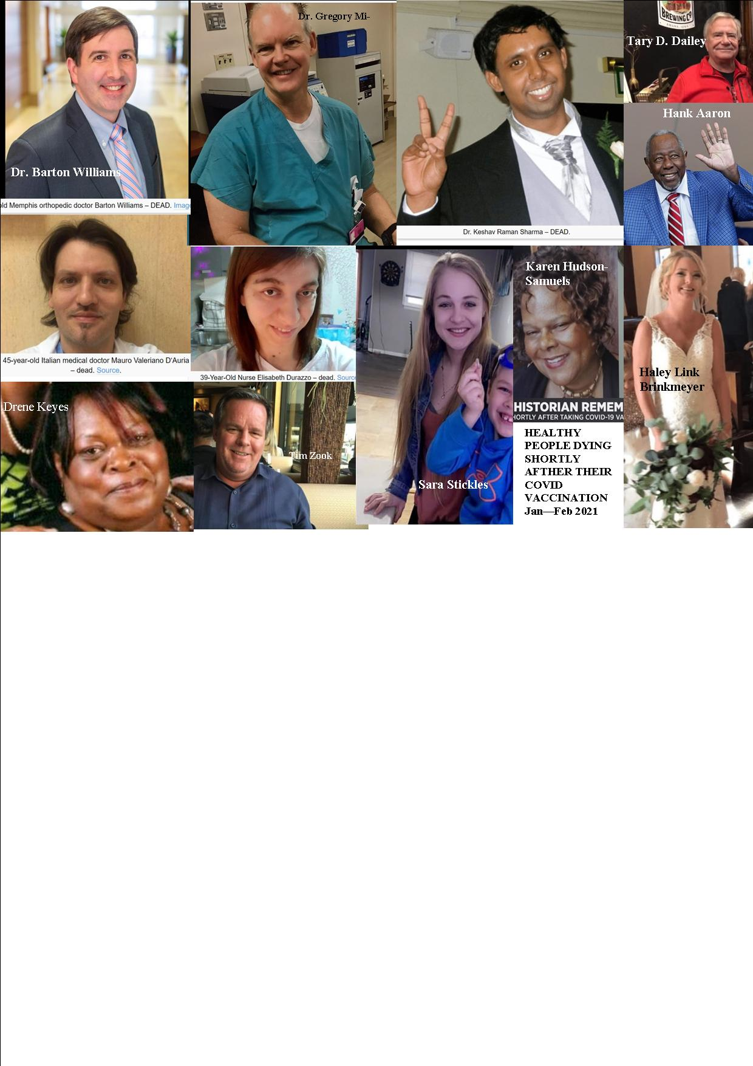
T
H
I
N
K

T
W
I
C
E!

There have been many clusters of deaths in UK care homes (in just 2 months since the vaccination campaign started: ‘weekly Covid deaths in care homes nearly TRIPLED in a fortnight with 1,705 residents dying in England and Wales’ (Jan 22), ‘the rate of covid deaths with the over 60 has quadrupled in London’ (Jan 8), ‘the Covid related deaths in English care homes jumped by 46%’ (Jan 19) etc; the reality is that these sudden outbreaks coinciding with vaccination are a convenient way to dismiss the possibility of vaccine damage that has been admitted by the FDA & other agencies. Please see the very documented UK Column: “Why Is There A Correlation Between The Vaccine Rollout And Increased COVID–19 Mortality?’ and google ‘rushed vaccines’…

https://childrenshealthdefense.org https://vaccineimpact.com/ https://www.mercola.com/ https://www.ukcolumn.org/

A FEW OF THE VERY MANY VICTIMS OF THE NEW EXPERIMENTAL VACCINES
- BECAUSE THEIR LIVES ALSO MATTERED! -

