covid pandemic — covid vaccines
did you know that…
1. .......THE PCR TEST (covid infection diagnosis tool used throughout 2020) is NOT able to identify and differentiate between various viral infections according to its own manual, to its inventor, Nobel prize laureate, Karry Mullis and to many other specialists?
2. .......in 2020, the year of the pandemic, there were fewer DEATHS/ POPULATION IN THE UK AND SCOTLAND than in several other years since 1990 on?
3. .......SWEDEN who imposed no lockdown, no mask wearing and no social distancing measures had less deaths of covid than the UK who imposed all these measures?
4. .......the various SYMPTOMS OF COVID could match the symptoms of microwave radiation sickness, and partially the symptoms of flu, which, coincidentally has seemingly almost disappeared in the UK, US, Scotland and many other countries since the start of this pandemic?
5. .......FACE MASK WEARING has not been definitely proven effective in preventing infection or transmission of viruses, nor safe by any study or risk assessment, but on the contrary, very dangerous for health, especially in the case of children?
6. ......there are cheap, very effective, medically and scientifically proven TREATMENTS for the disease identified as covid-19, that have been totally SUPPRESSED in the UK, while the doctors, scientists, professionals and members of the public who spoke out against the official narrative or in support of these treatments have been heavily CENSORED throughout the social and mainstream media?
7. ......the covid vaccines that have been released for the public are UNLICENSED and still in their EXPERIMENTAL phase and, that these types of genetically engineered vaccines have never been used before in the history of medicine on humans?
8. .....there have been plenty of OFFICIAL WARNINGS towards UK using these rushed vaccines without a clear assessment of their safety and efficacy?
9. ......there are doctors and scientists who spoke out pointing towards actual scientific literature showing the mechanisms through which they can and will cause SEVERE DISABILITY, NEUROLOGICAL AND CARDIOVASCULAR DAMAGE, INFERTILITY AND MISCARRIAGES, AUTO-IMMUNE DISEASES, CANCER AND DEATH?
10. ….VAERS – US public database, which has been previously assessed by Harvard study as reporting no more than 1-10% of the real-life cases, shows on May 28, 2021, 4863 DEATHS & 262,521 INJURIES? Also that Eudravigilance-EU database shows on June 5, 2021, 13,867 DEATHS & 1,354,336 INJURIES?
11. …..MHRA published on May 26, 2021 a summary of the reports of covid vaccine adverse reactions for the UK, that include 1,253 DEATHS and 888,196 INJURIES?
12. ….there have been CLUSTERS OF DEATHS IN CARE HOMES OCCURRING SOON AFTER VACCINATION WORLDWIDE, which were generally attributed to coincidentally sudden outbreaks of covid (these deaths, generally, not being recorded in VAERS, Eudravigilance or MHRA databases)?
13. …Starting February more than 20 countries (including Italy, Spain, France, Germany, Belgium, Greece, Denmark, The Netherlands, Sweden, Poland, Austria, Norway, Canada & Switzerland) HAVE partially or totally STOPPED the use of Astrazeneca Vaccines’. 75% of the US MILITARY refused the covid vaccination, and millions of people in all Western nations. Numerous healthcare professionals refused it also, despite the pressure.
14. ….REPORTS OF UNEXPECTED DEATHS AND SEVERE INJURIES AFTER VACCINATION, though severely censored, have surfaced in the social media, referring especially to doctors, nurses, teachers with no known health issues?

childrenshealthdefense.org mercola.com dailyexpose.co.uk thelightpaper.co.uk ukcolumn.org www.grenmedinfo.com healthimpactnews.com off-guardian.org thelightpaper.co.uk vaccinenews.com

did you know that…

15. ….the first people that have been PRIORITIZED for vaccination – the residents of the care homes - have also received shameful DNR (DO NOT REUSCITATE) ORDERS in 2020 have also been DELIBATERATELY EXPOSED TO INFECTION, as hospitals have discharged untested patients in care homes, and have been sedated and treated with END-OF-LIFE DRUGS SUCH AS MIDAZOLAM FOR COVID?
16. ....NONE of the professionals advising the government on the rollout of these vaccines has got any EXPERTISE IN SYNTHETIC BIOLOGY/ GENETIC ENGINEERING OR MRNA/DNA VACCINES, and similarly, none of the healthcare professionals (GP’s, nurses) that the government deems able to advise you in matters of covid vaccination so to offer you an INFORMED CONSENT?
17. ....the producers of these experimental vaccines have BEEN DISCHARGED OF ANY LIABILITY FOR THE EVENTUAL INJURIES AND DEATHS PRODUCED BY THEM, although Pfizer has got a record penalties for violations of 4.7 billion USD, Astrazeneca of 1.5 billions and Moderna has never produced any other medicine before?
18. ...Government advisors like Sir Patrick Vallance, Chris Witty and others have VESTED INTERESTED IN THE VACCINE INDUSTRY or ties with GATES FOUNDATION? Also, Pfizer, AstraZeneca & J&J are companies with a huge criminal record, paying billions in court?
19. ...UK SCIENTISTS HAVE REPEATEDLY BREACHED THE PUBLIC TRUST during the post-war period by experimenting with airborne pathogens on the unaware British population and the MATHEMATICAL MODELS provided by them to the government for the pandemic as also for other previous epidemics have been proved utterly wrong?
20. ...Boris Johnson, Bill Gates and Henry Kissinger, who are all greatly supporting this global vaccination campaign, have all publicly stated that OVERPOPULATION is the greatest problem of our times? Are you aware that DEMOCIDE (death by government) and not war was the greatest cause of death at a global level in the XXth century?
Find more at: https://unitefortruth.online/did-you-know-that

There have been many clusters of deaths in UK care homes (in just 2 months since the vaccination campaign started: ‘weekly Covid deaths in care homes nearly TRIPLED in a fortnight with 1,705 residents dying in England and Wales’ (Jan 22), ‘the rate of covid deaths with the over 60 has quadrupled in London’ (Jan 8), ‘the Covid related deaths in English care homes jumped by 46%’ (Jan 19) etc; the reality is that these sudden outbreaks coinciding with vaccination are a convenient way to dismiss the possibility of vaccine damage that has been admitted by the FDA & other agencies. Please see the very documented UK Column: “Why Is There A Correlation Between The Vaccine Rollout And Increased COVID–19 Mortality?’ and google ‘rushed vaccines’…

https://childrenshealthdefense.org https://vaccineimpact.com/ https://www.mercola.com/ https://www.ukcolumn.org/

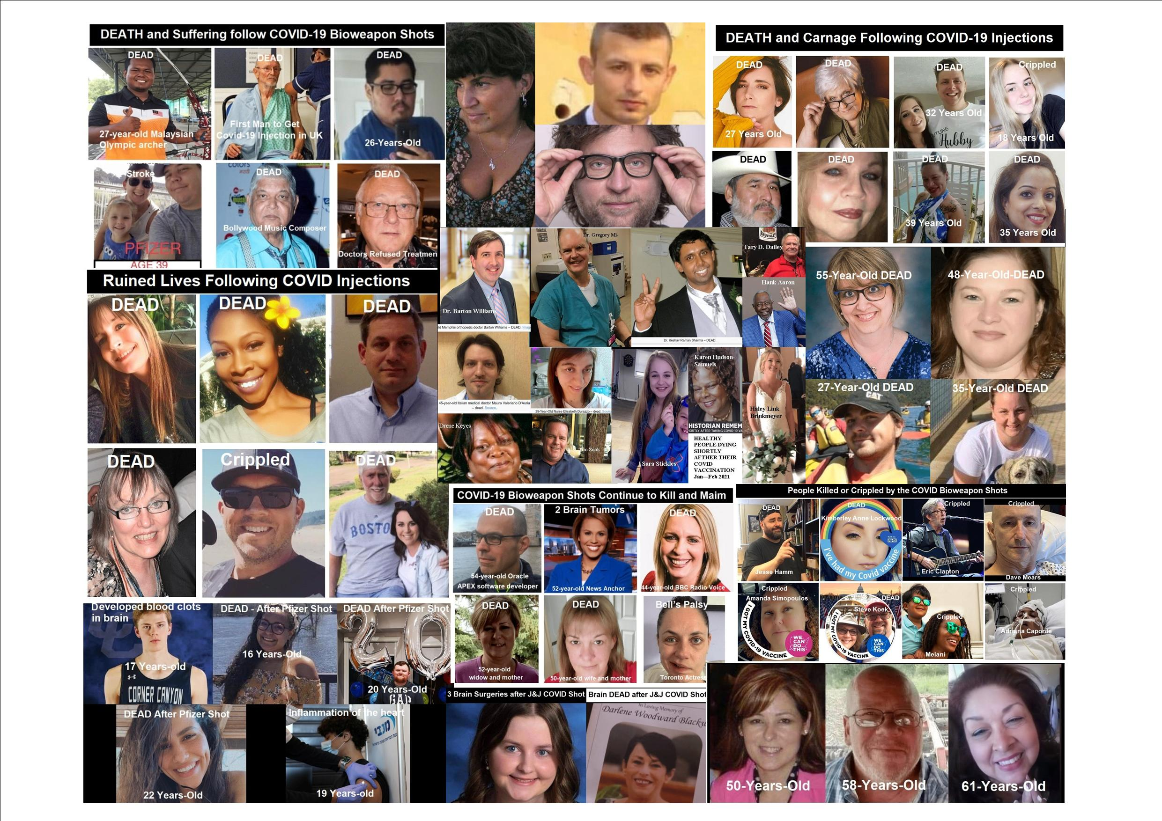
A FEW OF THE MANY
VICTIMS OF THE NEW COVID
VACCINES

HOWEVER
SAME AS WITH
COVID-19
THERE ARE
SOLUTIONS

PLEASE LOOK ON:
unitefortruth.online/
natural-health

