covid vaccines DANGERS: leave our children alone !
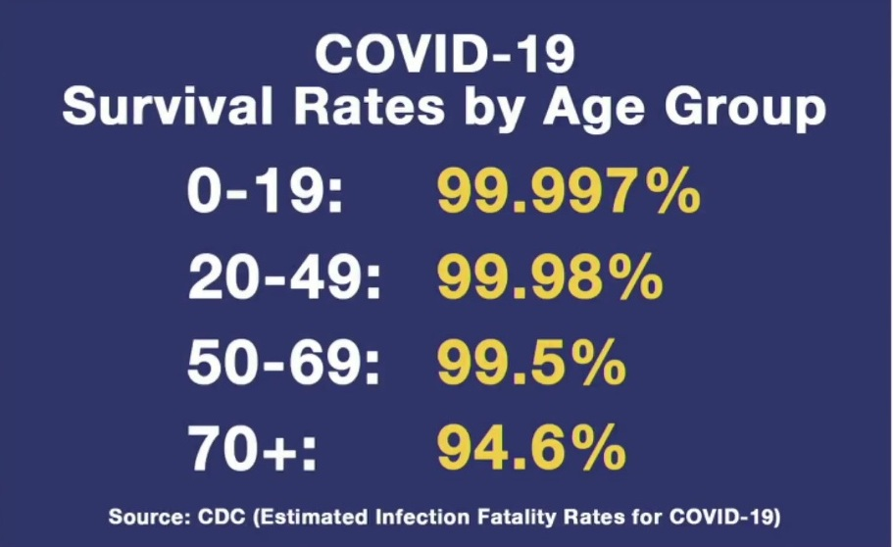
Independent scientists and medics showed the SPIKE PROTEIN from the covid ‘vaccines’ is a PATHOGEN that can cause inflammation of the heart, blood clots, neurological damage. CHILDREN & TEENAGERS have almost zero risk of dying from covid-19 and are not spreaders. Thousands of Doctors, Nurses and Scientists question the SAFETY of these

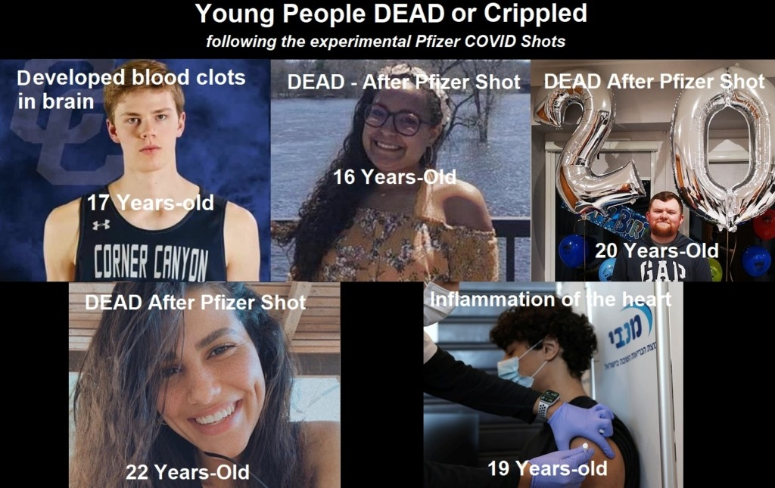
EXPERIMENTAL SHOTS, as of July 2021, more than 25,000 DEATHS & MILLIONS of injuries are recorded in official databases (MHRA, VAERS, EudraVigilance)
The HART Goup, Doctors for Covid Ethics, America’s Frontline Doctors etc warned about the high risks of these products for children &youth.

If you had the jab or have covid symptoms please have a look at: unitefortruth.online/
natural-health

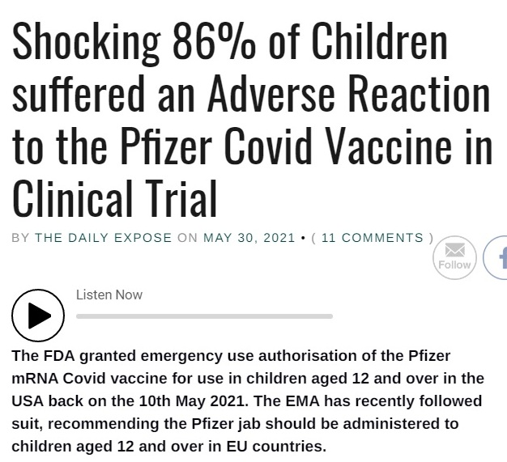

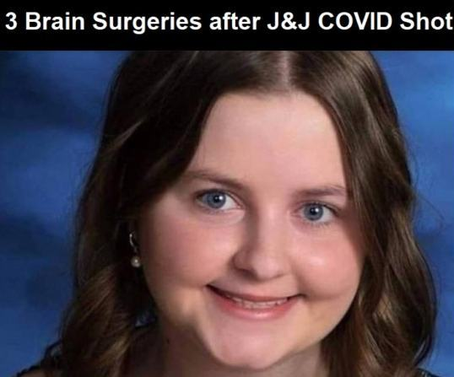
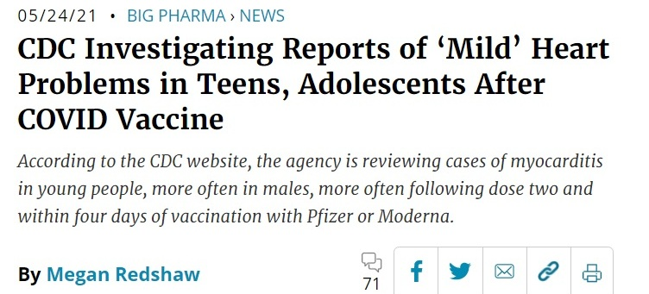

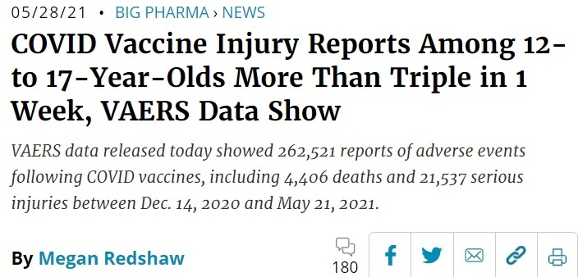

childrenshealthdefense.org vaccinenews.com www.mercola.com ukcolumn.org greenmedinfo.com

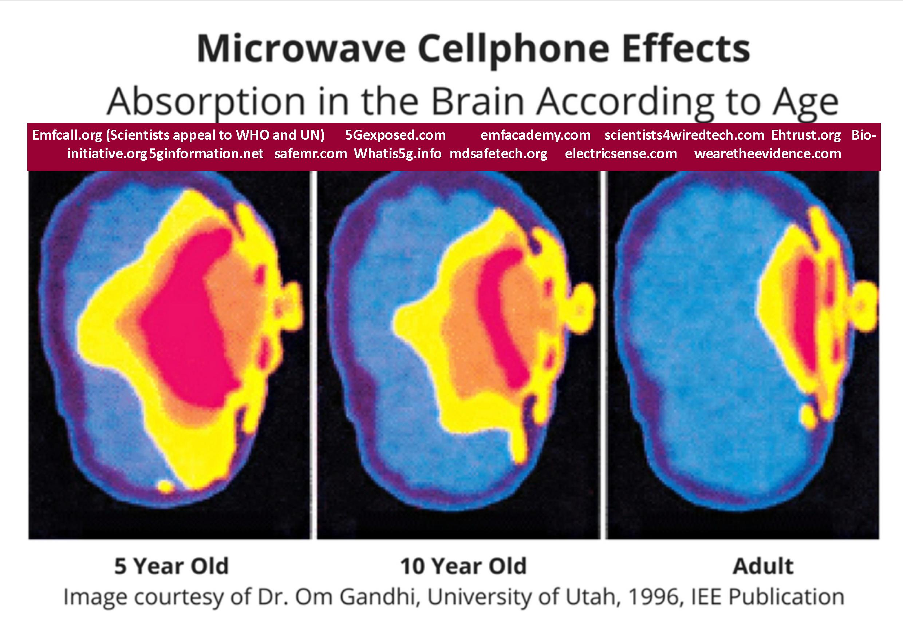
There are thousands of peer reviewed and published, uncontested scientific studies from reputable independent scientists, proving that microwaves & millimeter waves (5G) cause dangerous biological effects, particularly in the case of children whose thinner skulls allow their brains to absorb at least 60% more radiation in comparison with the adults.
WiFi is already removed from schools worldwide. For ex., CYPRUS, FRANCE, BELGIUM, ISRAEL, GERMANY, AUSTRALIA and RUSSIA, as also THE STATES OF MARYLAND, OHIO, ONTARIO CANADA have banned WIFI in the classrooms and/or reduced EMF radiation exposure (mainly through hardwire).

wifiinschools.org.uk
ehtrust.org/take-action/schools-programs/
ssita.org.uk/children/
www.wirelesseducation.org
electrosmogprevention.org
Wifi/5g DANGERS: protect our children in schools !

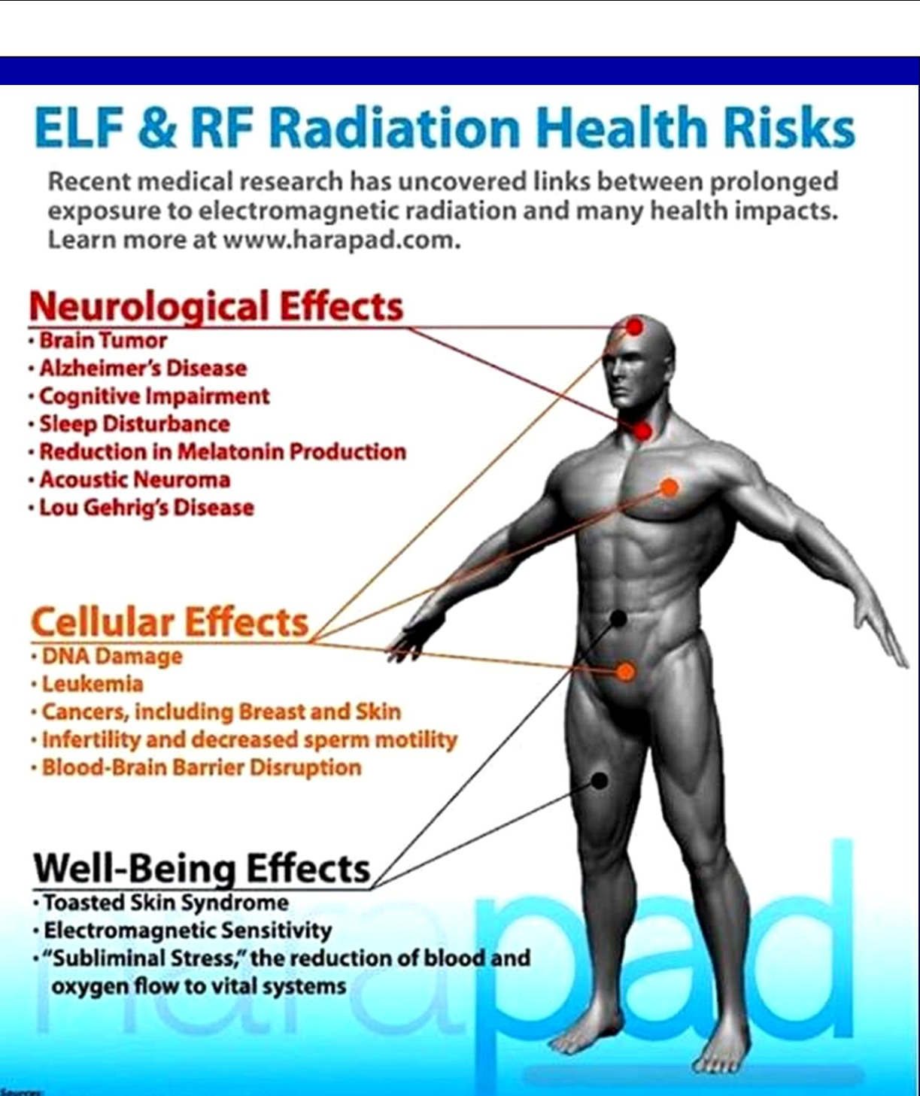

BE AWARE & USE TECHNOLOGY SAFELY !

healthimpactnews.com thelightpaper.co.uk off-guardian.org dailyexpose.co.uk unitefortruth.online

