covid vaccines DANGERS: leave our children alone !
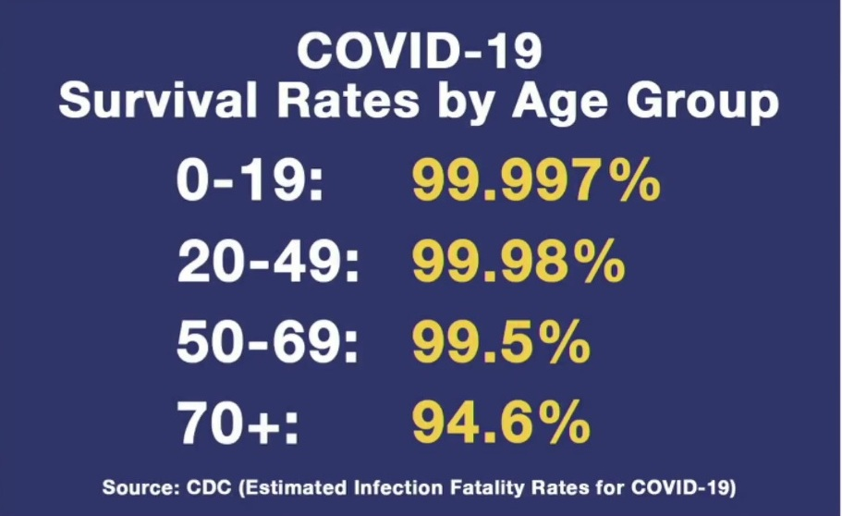
Dear Parents,
You have the legal right to INFORMED CONSENT before any medical intervention. This means you must be told potential risks before allowing your child to take a RUSHED EXPERIMENTAL SYNTHETIC ‘VACCINE’.

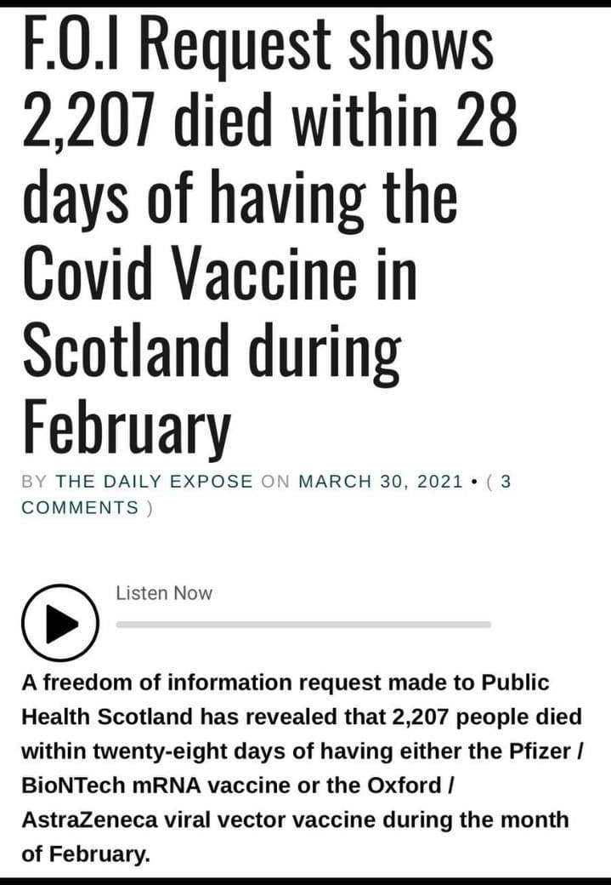
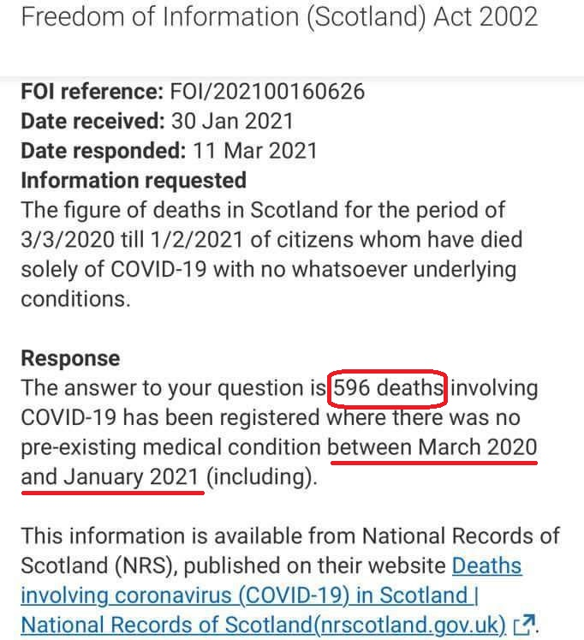
Here are some FACTS YOU ought to know. 1000’s of Doctors, Nurses and Scientists question the SAFETY of these EXPERIMENTAL ‘vaccine’
There is no long term safety data to guarantee your child will not be harmed.

Independent scientists and medics showed the ‘spike protein’ from the ‘vaccine’ is a pathogen that can cause inflammation of the heart, blood clots, neurological damage. This while children and teenagers have almost ZERO chance of dying from covid-19 and do not spread the disease as proved by several studies and by the low infection rates amongst the teachers.
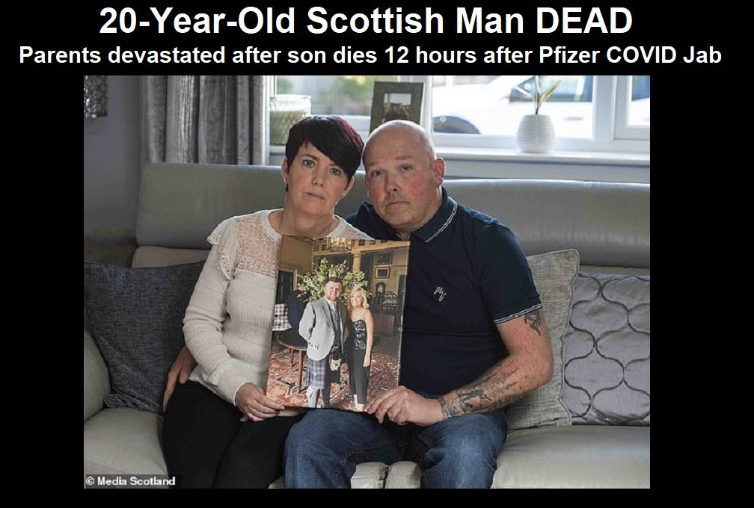


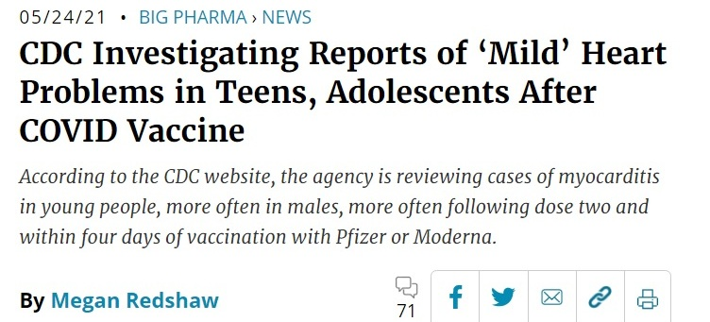

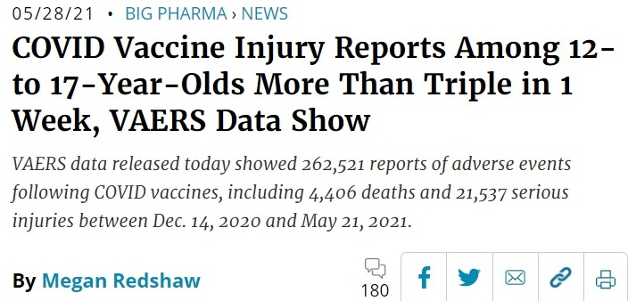

childrenshealthdefense.org vaccinenews.com www.mercola.com ukcolumn.org greenmedinfo.com

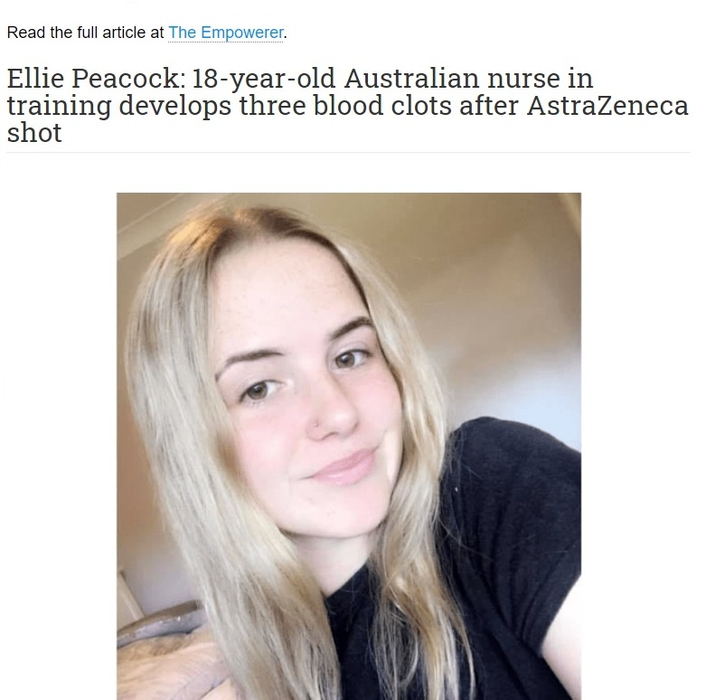
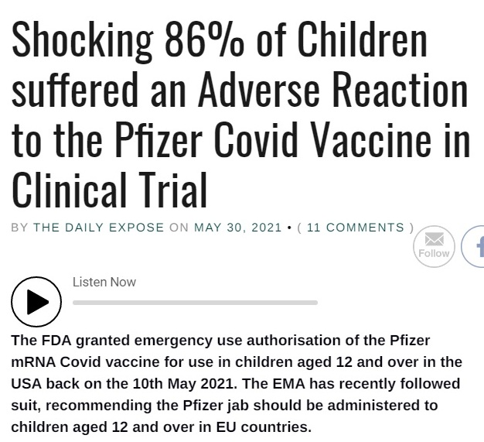

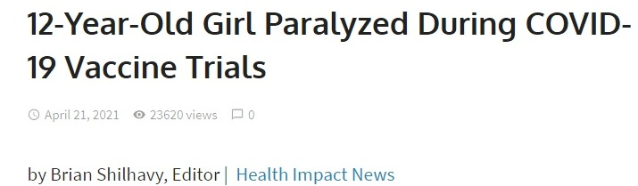
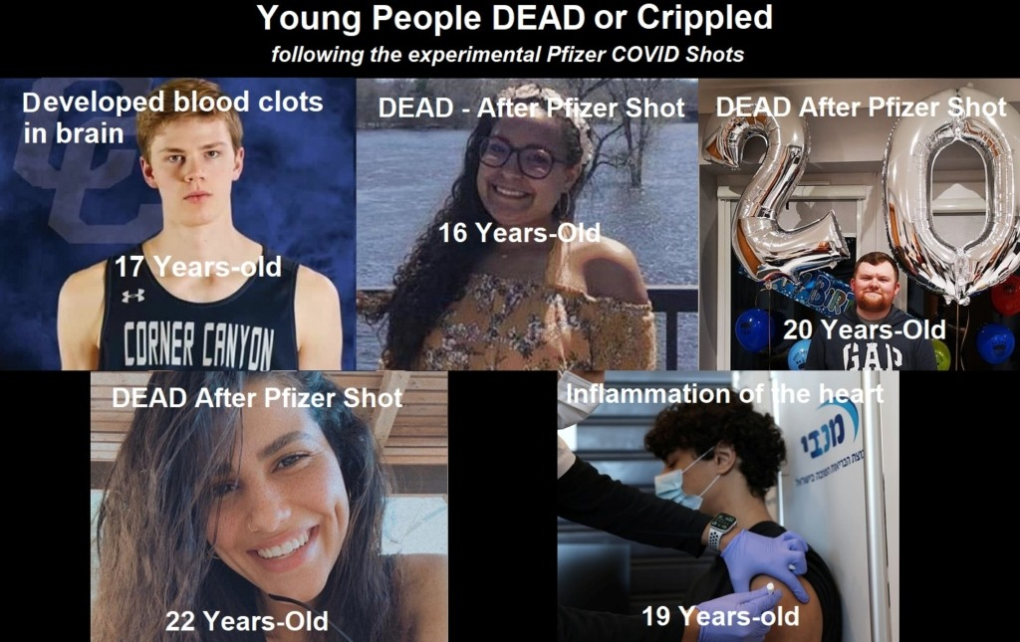
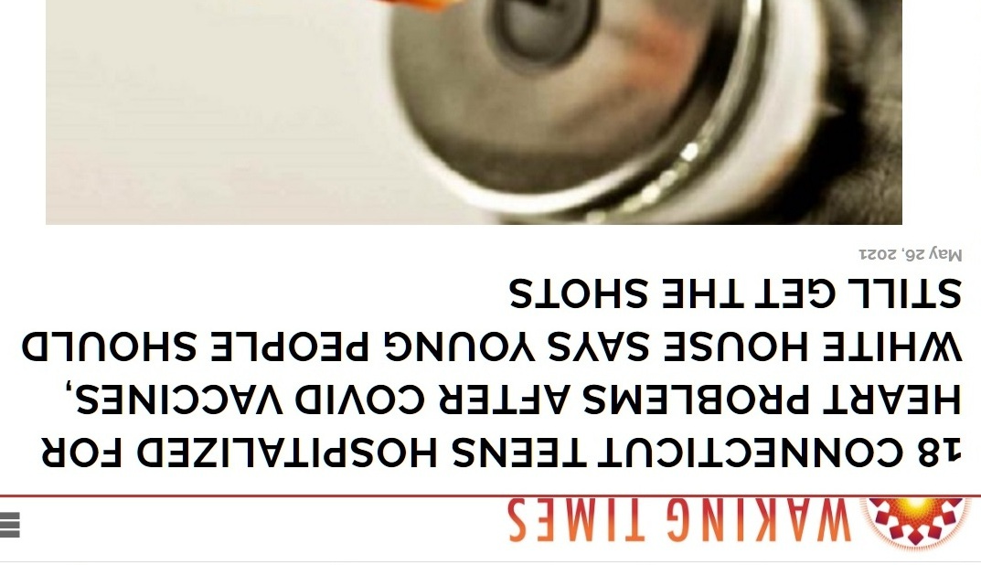

Many 1000’s of people have died after taking the jab. At the beginning of July 2021, in the UK, the governmental MHRA database reported over 1,403 deaths and over 1,007,253 adverse events after covid vaccination. In the EU, end of June have been reported over 15,473 deaths and 1,509,266 injuries (EudraVigilance) and in the US 6,985 deaths and 489,098 injuries (CDC – VAERS) which is more than all deaths recorded in relationship to all given vaccines in the last 29 years. Science and statistics show now that the jab is definitely more of a risk to children and youth than the disease.

If you had the jab or have covid symptoms please have a look at: unitefortruth.online/
natural-health

Doctors, Nurses, Consultants, Teachers and all officials who did not provide INFORMED CONSENT to the parents of injured children will one day be personally held liable in court for the health damages and deaths occurring as a result of the experimental ‘vaccine’, but the loss of a child will surely never be compensated.
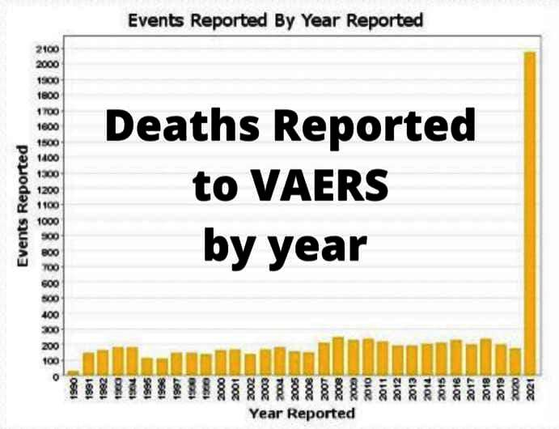

healthimpactnews.com thelightpaper.co.uk off-guardian.org dailyexpose.co.uk unitefortruth.online

