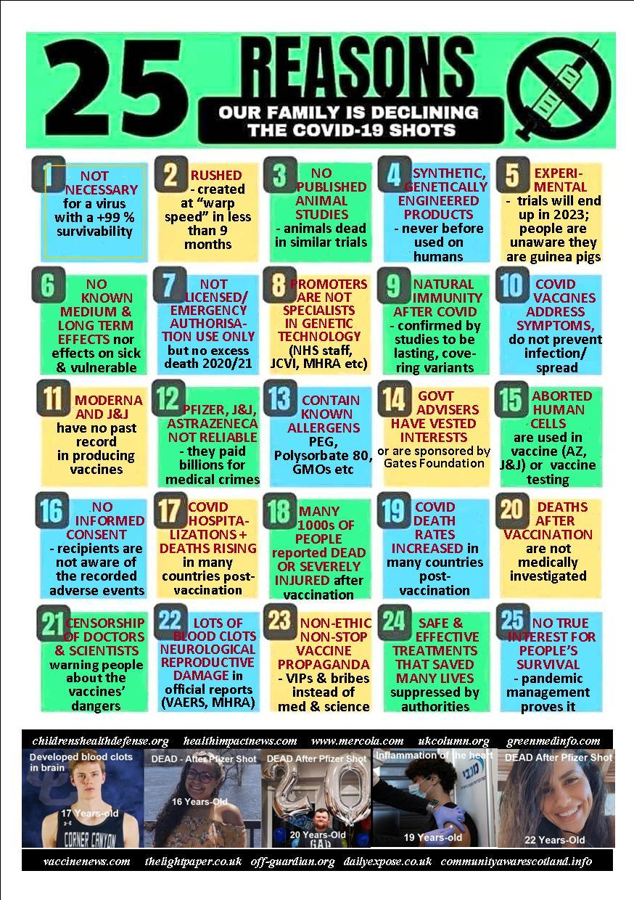
Your life and your children’s lives are in your hands. You may want to do your research before putting them at risk !
Vaccinenews.com thelightpaper.co.uk off-guardian.org dailyexpose.co.uk unitefortruth.online
Childrenshealtdefense.com healthimpactnews.com mercola.com ukcolumn.org greenmedinfo.com lifesitenews.com

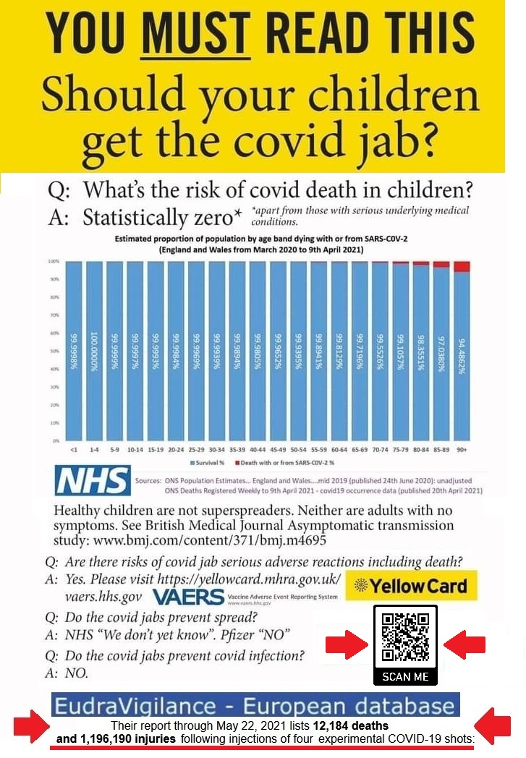
At the beginning of July MHRA database reported over 1,470 deaths and over 493,162 after covid vaccination. In the EU, have been reported over 17,503 deaths and 1,687,527 injuries (EudraVigilance) and in the US (July 9) 10,991 deaths and 551,172 injuries (CDC – VAERS) which is more than all deaths recorded in relationship to all given vaccines in the last 29 years. SCIENCE AND STATISTICS SHOW NOW THAT THE JAB IS DEFINITELY MORE OF A RISK TO CHILDREN AND YOUTH THAN THE DISEASE.

If you had the jab or have covid symptoms please have a look at: unitefortruth.online/
natural-health
: unitefortruth.online/
natural-health

[Type a quote from the document or the summary of an interesting point. You can position the text box anywhere in the document. Use the Text Box Tools tab to change the formatting of the pull quote text box.]

