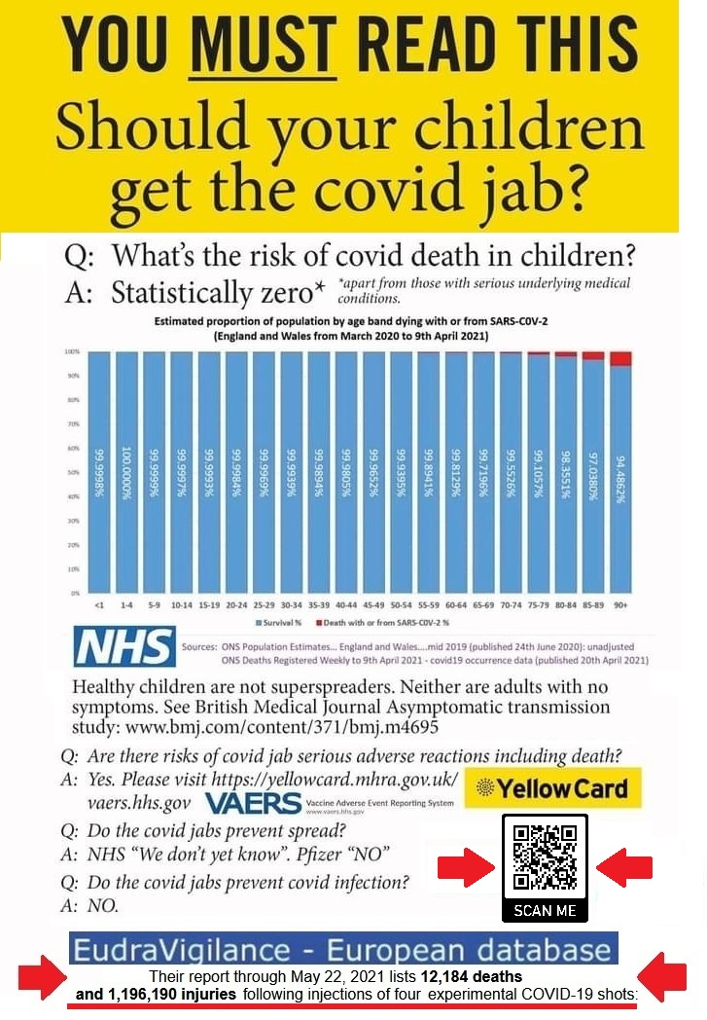

If you had the jab or have covid symptoms please have a look at: unitefortruth.online/
natural-health
: unitefortruth.online/
natural-health

MHRA database (July 1) reported over 1,403 deaths and over 1,007,253 injuries after covid vaccination. In the EU, end of June have been reported over 15,473 deaths and 1,509,266 injuries (EudraVigilance) and in the US 6,985 deaths and 489,098 injuries (CDC – VAERS) which is more than all deaths recorded in relationship to all given vaccines in the last 29 years. SCIENCE AND STATISTICS SHOW NOW THAT THE JAB IS DEFINITELY MORE OF A RISK TO CHILDREN AND YOUTH THAN THE DISEASE.

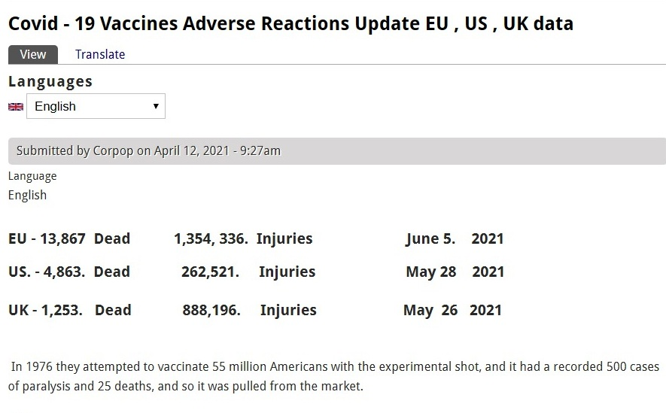
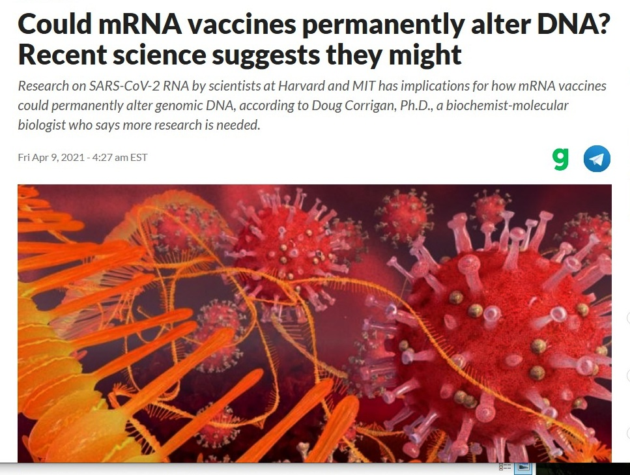
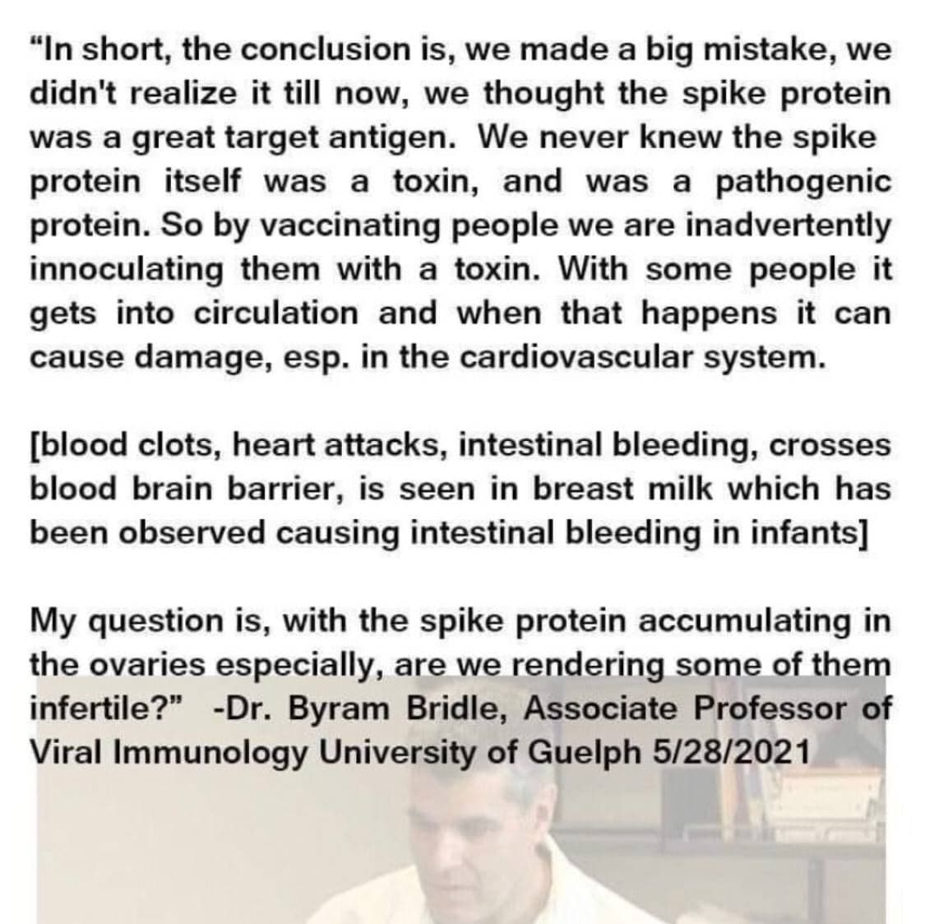
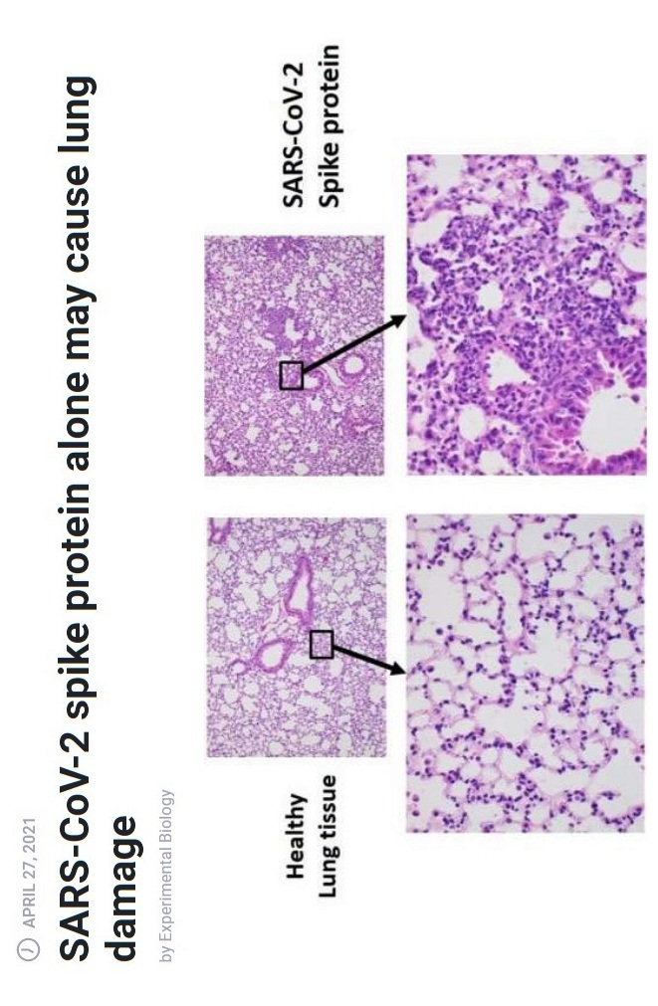
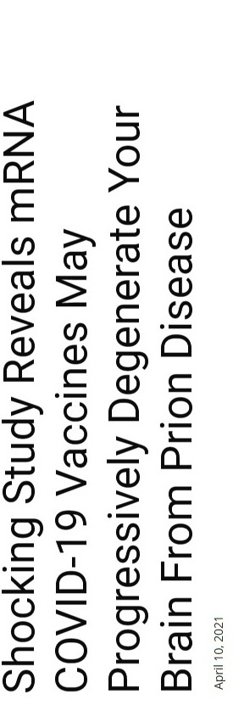

Doctors For
COVID Ethics

doctors4covidethics.org
[Type a quote from the document or the summary of an interesting point. You can position the text box anywhere in the document. Use the Text Box Tools tab to change the formatting of the pull quote text box.]
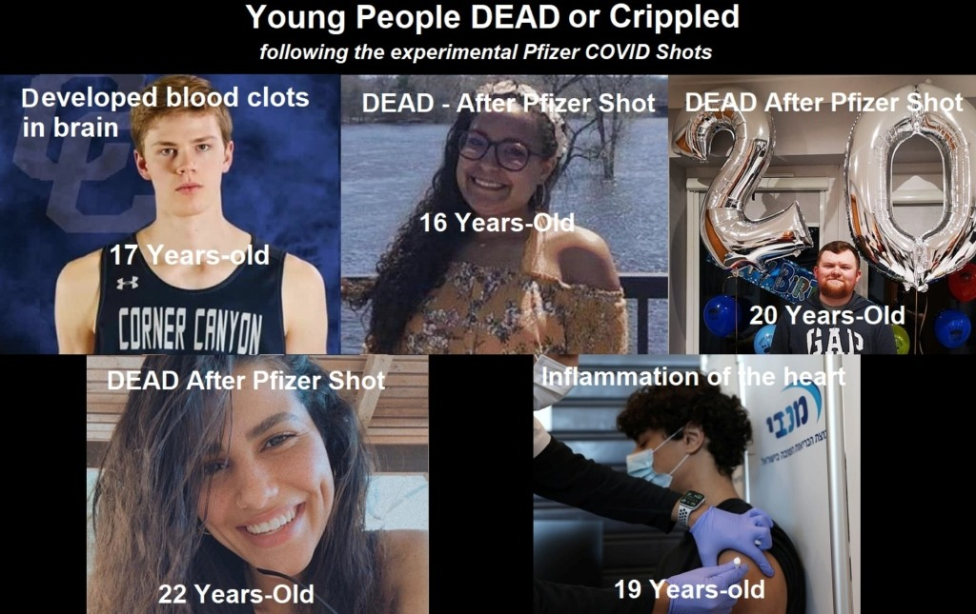
childrenshealthdefense.org vaccinenews.com www.mercola.com ukcolumn.org greenmedinfo.com healthimpactnews.com thelightpaper.co.uk off-guardian.org dailyexpose.co.uk unitefortruth.online

