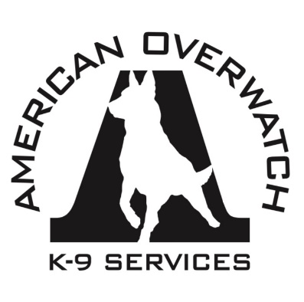
Hotel Information:
Hampton Inn
327 Ed Schmidt Blvd
Hutto, Texas 78634
(512) 846-2992
Govt. Rate $93/night

Mailing Address:
American Overwatch K-9 Services
313 W. Garden Cove Circle
Davie, FL. 33325
(If mailing check and/or registration)

Advanced K-9 Development for Real World Deployments

American Overwatch K-9 Services Class Registration for:

Hutto, Texas November 13-15th, 2019

To register please print or type your information below and email completed forms to: AmericanOverwatchK9@yahoo.com or above mailing address
Please select one: ☐ K-9 Handler ($475) ☐ Decoy ($250) ☐ Supervisor ($250) ☐Observer ($250)
Last Name: |  | First Name:
Rank/Title: |  | # of Years in K-9 or Law Enforcement:
Cellphone #: ( ) |  | Email:
K-9 Partner Name: |  | Breed & Age:
Agency Name: |  | Agency Phone #: ( )
Agency Address: City, State, Zip:
Supervisor’s Name: |  | Supervisor’s Phone#: ( )
Emergency Contact:  (Name/Relationship) |  | Emergency Contact#: ( )

*Please note that class size is limited and you are not considered registered for the course until you receive confirmation via email and payment has been made*
Payment Information:
Tuition Cost: $475 per K-9 handler and $250 per decoy, supervisor (no dog), observer.
Please make checks payable to: American Overwatch K-9 Services
To pay by Credit Card please visit our website and click the link to register (top right) and follow PayPal prompt at bottom of page or contact us for a digital invoice or pay by phone
*No registration refunds within 60 days of seminar*

For more information please visit us at
www.AmericanOverwatchK9.com
Instagram: @AmericanOverwatchK9
Facebook: American Overwatch K9 Services
Email: AmericanOverwatchK9@yahoo.com
Call or Text us at 954-817-9899 or 941-809-4304

