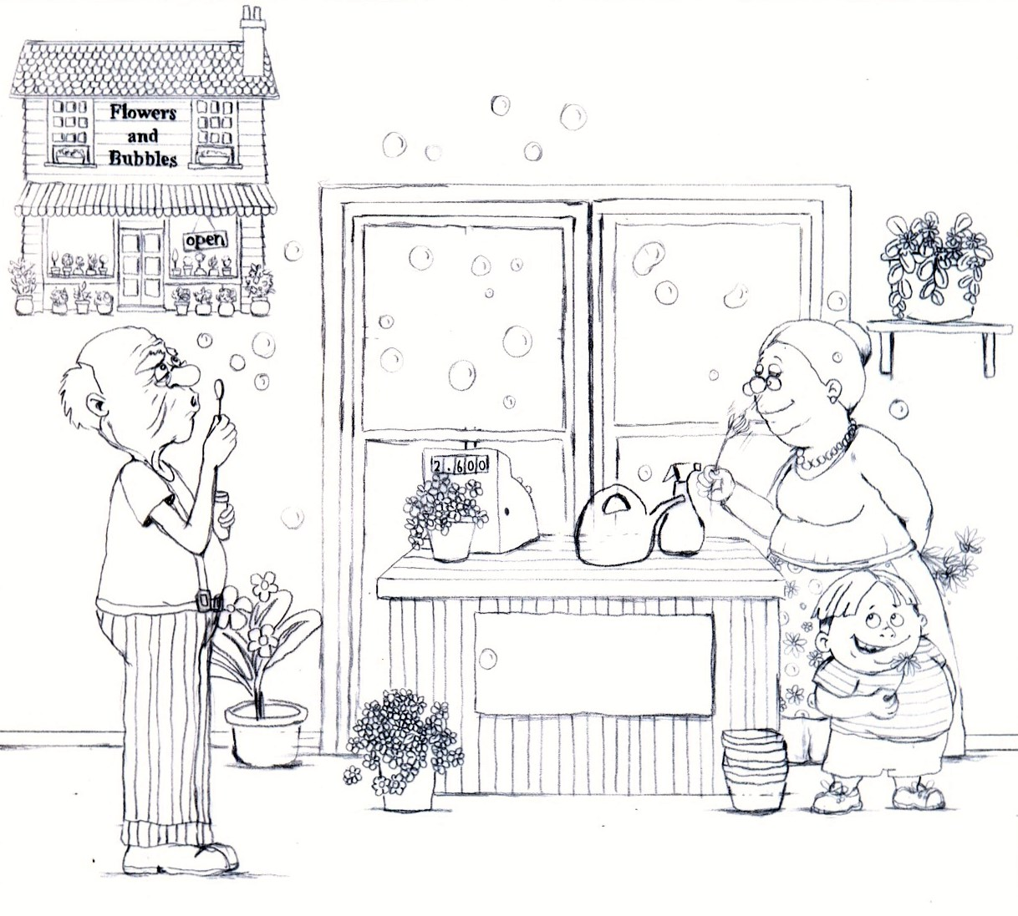
Flowers and Bubbles: A Story About Coping with Anger and Frustration
Written By: Allison C. Siegel, L.M.S.W
Illustrated By: Lizette Duvenage

