Public Notification of WIC Services in Caldwell County for 2020
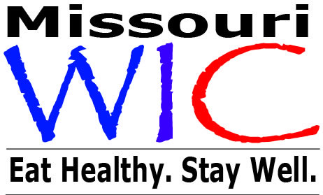
The Caldwell County Health Department has announced that a contract to continue to provide WIC services for federal fiscal year 2020 has been signed with the Missouri Department of Health and Senior Services. Under the terms of the contract, the Caldwell County Health Department will be able to serve 178 persons eligible for WIC every month.

Women, Infants and Children (WIC) is a special supplemental nutrition program providing services to pregnant women, new mothers, infants and children up to their 5th birthday based on nutritional risk and income eligibility. The primary services provided are health screenings, risk assessment, nutrition education and counseling, breastfeeding promotion and referrals to health care. Nutritious supplemental food is provided at no cost to participants. To be eligible for WIC applicants must have an income of less than or equal to 185% of the poverty level and be determined by a health professional to be at nutritional risk. Migrant families are also eligible.

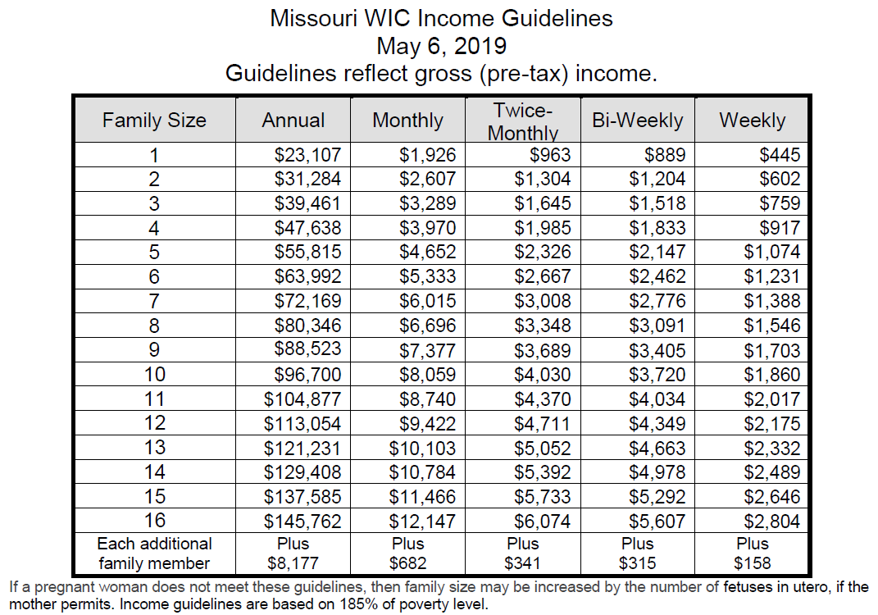

WIC supplemental food packages are specially chosen to provide foods high in protein, iron, calcium, and vitamins A and C. Eligible women and children receive fortified milk and cheese, eggs, whole grain bread products and hot or cold cereals, 100% fruit juices and fresh or frozen fruits and vegetables. The WIC program recommends breastfeeding, provides breastfeeding support, baby foods and infant cereal. For women who cannot or choose not to breastfeed, infants may receive supplemental iron fortified formula. WIC participants obtain their foods by redeeming food checks for specific items at local grocery stores and pharmacies.
Studies confirm that pregnant women who enroll in WIC during the early months of pregnancy have fewer low birth weight babies, experience fewer infant deaths, see the doctor earlier in pregnancy and eat healthier.

WIC is administered in Caldwell County by the Caldwell County Health Department. Persons interested in applying or who are in need of more information should contact the Caldwell County Health Department at 816-586-2311.

WIC clinics are offered at:

Caldwell County Health Department
255 W Main
Kingston, MO 64650
1st Thursday of each month 8:30a-12p and 12:30p-4:30p
2nd Thursday of each month 8:30a-12p
3rd Thursday of each month 8:30a-12p

Braymer City Hall
108 E 2nd Street
Braymer, MO 64624
2nd Wednesday of each month 1p-4p

Hamilton United Methodist Church
104 W Samuel Street
Hamilton, MO 64644
4th Wednesday of each month 12p-5p

In accordance with Federal civil rights law and U.S. Department of Agriculture (USDA) civil rights regulations and policies, the USDA, its Agencies, offices, and employees, and institutions participating in or administering USDA programs are prohibited from discriminating based on race, color, national origin, sex, disability, age, or reprisal or retaliation for prior civil rights activity in any program or activity conducted or funded by USDA.
Persons with disabilities who require alternative means of communication for program information (e.g. Braille, large print, audiotape, American Sign Language, etc.), should contact the Agency (State or local) where they applied for benefits. Individuals who are deaf, hard of hearing or have speech disabilities may contact USDA through the Federal Relay Service at (800) 877-8339. Additionally, program information may be made available in languages other than English. To file a program complaint of discrimination, complete the USDA Program Discrimination Complaint FormPDF Document, (AD-3027) found online at: http://www.ascr.usda.gov/complaint_filing_cust.html, and at any USDA office, or write a letter addressed to USDA and provide in the letter all of the information requested in the form. To request a copy of the complaint form, call (866) 632-9992. Submit your completed form or letter to USDA by:
- Mail: U.S. Department of Agriculture
Office of the Assistant Secretary for Civil Rights
1400 Independence Avenue, SW
Washington, D.C. 20250-9410;
- Fax: (202) 690-7442; or
- Email: program.intake@usda.gov.
This institution is an equal opportunity provider.

