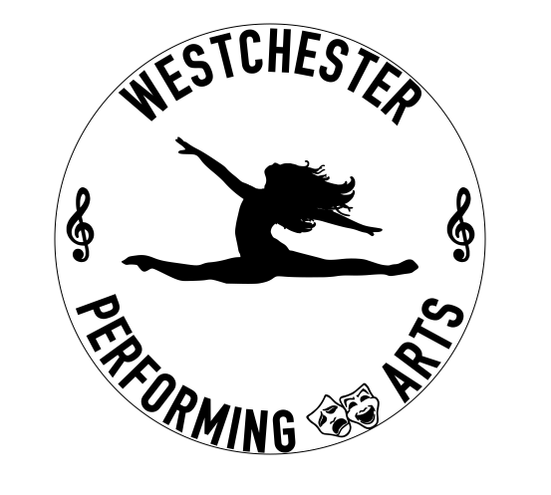
REGISTRATION FORM
WESTCHESTER PERFORMING ARTS STUDIO
875 Saw Mill River Road
Ardsley, New York 10502
914-222-3858 / WPAS875@gmail.com

Today’s Date ______________
Student Name First _________________ Last ______________________________
Mother or Guardian First _________________ Last ______________________________
Father or Guardian First _________________ Last ______________________________
Address ____________________________________________________
City _____________________ State _________ Zip __________
Home # (____) _____________________ Student Cell # (____) ____________________
Mother Work # (____) _______________ Father Work # (____) _____________________
Cell #1 (____) ______________________ Cell #2 (____) ___________________________
E-Mail Address _____________________________________________________________
Student’s Birthdate __________________________________ Age ___________________
Dance Experience ___________________________________________________________
How did you hear about us? ___________________________________________________
Interested in: (Circle all that apply)
Pre-School: 1.Tiny Toes 2.Hip Hop & Tumbling 3.Creative Movement 4.Creative Movement w/ Tap
Primary: 1.Ballet/Tap 2.Tap/Jazz 3.Ballet/Jazz 4.Hip Hop 5.Acro 6.Musical Theater
Level A: 1.Ballet 2.Tap 3.Jazz 4.Acro 5.Lyrical 6.Hip-Hop 7.Musical Theater 8.Ballet/Tap 9.Boys Crew
Level B: 1.Ballet 2.Tap 3.Jazz 4.Acro 5.Contemporary 6.Hip-Hop 7.Technique 8.Musical Theater 9.Pointe 10.Boys Crew
Competition Classes: 1.Ballet* 2.Tap 3.Jazz 4.Contemporary 5.Production* 6.Hip-Hop 7.Acro* 8.Technique* 9.Musical Theater 10.Pointe // Classes marked with * are mandatory for competition
Unlimited Class Package//Adult classes//Other_____________________________________
===========================================================================For School Use Only: Registration Fee Paid: Yes No $___________________
Class 1 ________________________________ Day _____________ Time ____________
Class 2 ________________________________ Day _____________ Time ____________
Class 3 ________________________________ Day _____________ Time ____________
Class 4 ________________________________ Day _____________ Time ____________
Class 5 ________________________________ Day _____________ Time ____________
===========================================================================I, undersigned, understand that dancing is a physical activity that carries certain risks. I do hereby agree to hold harmless the Westchester Performing Arts Studio, Ardsley, NY, its Agents, Director or Employees.
Please state any allergies/medical condition the student has that WPAS should be aware of:
_______________________________________________________________________________________ I have read and agree to the policies set for by WPAS. I understand that tuition payments are drafted monthly and payments made after the due date will be subject to a $15 late fee. I hereby grant WPAS permission to use at any time, a photograph or video tape of this student in connection with any WPAS activity. If there is any conflict due to religious beliefs, please let us know.
Signature: __________________________________________ Date: ____________________

