Order your bees early
Rusch Farms, LLC
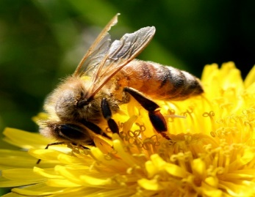
Four frame nucs with new queen.
May delivery date.
$150.00 plus sales tax per nuc
Call Wayne at 320-583-0041 with questions
Mail form and payment to
Wayne Rusch
22094 Yacht Ave
Hutchinson, MN 55350
Order by February 1, 2019 to guarantee delivery
Name:
Phone:
Email:
Address
Number of Nucs:
Number |  | $150 ea |  | Total
11.06 per nuc |  | Sales Tax multiply by .0737
 |  |  |  | Total
 |  |  | Total sent

Queens guaranteed for 30 days

