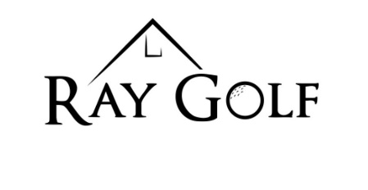

2025 Membership Form
Name:___________________________________________________________________
Mailing Address:__________________________________________________________
___________________________________________________________
Phone #:_________________________________________________________________
Membership Type:
- Family - $599.50 (family with children 18 years and younger)
- Couple - $490.50
- Single - $436.00
- Social - $109.00
- College (ages 18-21) - $109.00
- High School (grades 7-12) - $54.50
Cart Barn:
- Gas Spot #______ $150.00
- Electric Spot # ______ $200.00
**Cart Barn rent MUST be paid by May 31st or you will forfeit your spot. *If you would like to add your name to our waiting list, please talk with clubhouse attendant.
Total amount paid: _________________ Date: ____________
Payment Type: Cash Card Check #______ Gift Certificate
Employee Initials: _______

Mailing Address: P.O. Box 332, Ray, ND 58849

