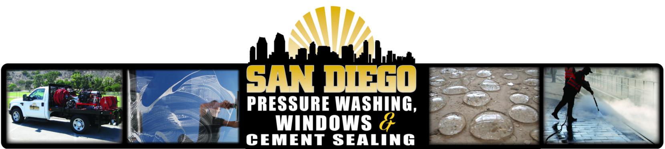

**Company Name:**  San Diego Pressure Washing Professionals “Plus”

“San Diego P.W.P.”

**Business Mailing Address:** P.O. Box 600595

San Diego, Ca 92160

**Phone:** (619) 405-7274 **E-Mail:** [Douglas@SanDiegoPWP.com](mailto:Douglas@SanDiegoPWP.com)

**Contractor’s License #:** 734652 **Federal Tax I.D. #:** 45-5512691

**Type of Business or Services Provided:** *Pressure Washing*

*Window Washing*

*Solar Panel Cleaning*

*Concrete/Paver Sealing*

*Rain Gutter Cleaning*

_______________________________________________________________________________________________

P.O. Box 600595 San Diego, Ca 92160 / 619-405-7274 / Email- Douglas@SanDiegoPWP.com

TWO Web sites: WWW.SanDiegoPWP.com -or- WWW.SanDiegoPS.com

FREE Estimates & Free Demonstrations / License #734652 / $2,000,000 Liability insured