DISHES AND THEIR ALLERGEN CONTENT
(Note – Please state the name of the cereal(s) containing gluten** in that column AND/OR the name of the nut(s)* in that column)
DISHES | 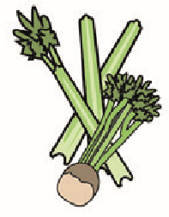 |  | 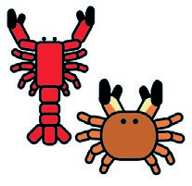 |  |  | 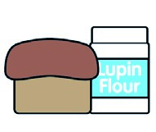 |  |  | 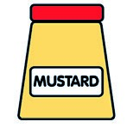 |  |  |  |  | 
 | Celery | Cereals containing gluten** | Crustaceans | Eggs | Fish | Lupin | Milk | Molluscs | Mustard | Nuts* | Peanuts | Sesame seeds | Soya | Sulphur dioxide
CAPRESE |  |  |  |  |  |  | ✓ |  |  |  |  |  |  | ✓
GRILLED GOATS CHEESE | ✓ |  |  |  |  |  | ✓ |  |  |  | ✓ |  |  | ✓
GRILLED OCTOPUS |  |  |  |  | ✓ |  |  | ✓
ARANCINI |  | ✓ |  | ✓ |  | ✓ | ✓ |  |  |  |  |  |  | ✓
BURRATA |  |  |  |  |  |  | ✓ |  |  |  |  |  |  | ✓
GAMBERONI LA VILLA VERDE |  | ✓ | ✓ |  |  | ✓ |  |  |  |  |  |  |  | ✓
ANTIPASTO ITALIANO |  | ✓ |  |  |  | ✓ |  |  |  |  |  |  |  | ✓
PORTOFINO |  | ✓ | ✓ |  |  | ✓ | ✓ | ✓
Linguine branzino |  | ✓ | ✓ |  | ✓ | ✓ |  |  |  |  |  |  |  | ✓
Review date: Reviewed by:You can find this template, including more information at www.food.gov.uk/allergy

