DISHES AND THEIR ALLERGEN CONTENT
(Note – Please state the name of the cereal(s) containing gluten** in that column AND/OR the name of the nut(s)* in that column)
DISHES | 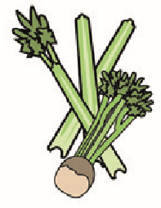 | 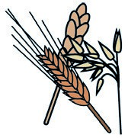 | 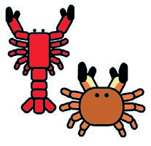 |  |  | 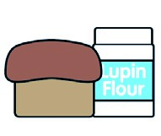 |  |  | 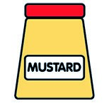 |  | 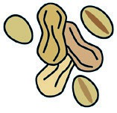 | 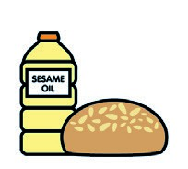 |  | 
 | Celery | Cereals containing gluten** | Crustaceans | Eggs | Fish | Lupin | Milk | Molluscs | Mustard | Nuts* | Peanuts | Sesame seeds | Soya | Sulphur dioxide
PENNE POLLO GAMBERET |  | ✓ | ✓ | ✓ |  | ✓ | ✓ |  |  |  |  |  |  | ✓
LINGUINE BRANZINO |  | ✓ |  | ✓ | ✓ | ✓ | ✓ |  |  |  |  |  |  | ✓
RIGATONI RAGU | ✓ | ✓ |  | ✓ |  | ✓ | ✓ |  |  |  |  |  |  | ✓
STINCO D’AGNELLO | ✓ | ✓ |  |  |  | ✓ | ✓ |  |  |  |  |  |  | ✓
COSTOLETTE D’AGNELLO | ✓ | ✓ |  |  |  | ✓ | ✓ |  |  |  |  |  |  | ✓
POLLO PROSCIUTTO |  | ✓ |  |  |  | ✓ | ✓ |  |  |  |  |  |  | ✓
POLLO PRINCIPESSA |  | ✓ |  |  |  | ✓ | ✓ |  |  |  |  |  |  | ✓
SIRLOIN STEAK |  |  |  |  |  |  | ✓ |  |  |  |  |  |  | ✓
FILLET STEAK |  |  |  |  |  |  | ✓ |  |  |  |  |  |  | ✓
TOMAHAWK STEAK |  |  |  |  |  |  | ✓ |  |  |  |  |  |  | ✓
Review date: Reviewed by:You can find this template, including more information at www.food.gov.uk/allergy

