DISHES AND THEIR ALLERGEN CONTENT
(Note – Please state the name of the cereal(s) containing gluten** in that column AND/OR the name of the nut(s)* in that column)
DISHES | 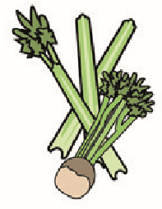 |  | 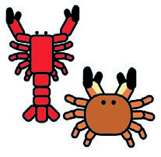 | 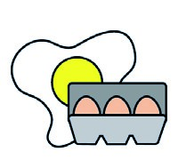 |  | 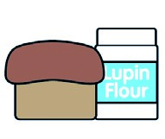 |  |  | 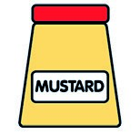 |  |  |  |  | 
 | Celery | Cereals containing gluten** | Crustaceans | Eggs | Fish | Lupin | Milk | Molluscs | Mustard | Nuts* | Peanuts | Sesame seeds | Soya | Sulphur dioxide
PENNE ARRABBIATA | ✓ | ✓ |  | ✓ |  | ✓ |  |  |  |  |  |  |  | ✓
SPAGHETTI BOLOGNESE | ✓ | ✓ |  | ✓ |  | ✓ |  |  |  |  |  |  |  | ✓
SPAGHETTI CARBONARA |  | ✓ |  | ✓ |  | ✓ | ✓
SPAGHETTI PESTO&BURRATA |  | ✓ |  | ✓ |  | ✓ | ✓ |  |  | ✓ | ✓
PENNE AL FORNO |  | ✓ |  | ✓ |  | ✓ | ✓ |  |  |  |  |  |  | ✓
LASAGNE | ✓ | ✓ |  | ✓ |  | ✓ | ✓ |  |  |  |  |  |  | ✓
GNOCCHI GORGONZOLA | ✓ | ✓ |  | ✓ |  | ✓ | ✓ |  |  |  |  |  |  | ✓
CANNELLONI | ✓ | ✓ |  | ✓ |  | ✓ | ✓ |  |  |  |  |  |  | ✓
RAVIOLI LOBSTER | ✓ | ✓ | ✓ | ✓ | ✓ | ✓ | ✓ |  | ✓ |  |  |  |  | ✓
LINGUINE ALLA MARINARA | ✓ | ✓ | ✓ | ✓ | ✓ | ✓ |  | ✓ |  |  |  |  |  | ✓
Review date: Reviewed by:You can find this template, including more information at www.food.gov.uk/allergy

