|  |
| --- |
| f |
| S |



828.551.8225 [kevin@MTSecological.com](mailto:kevin@MTSecological.com)

PO Box 255 Barnardsville NC 28709

# Mountains-to-Sea Ecological

Fox Creek Park Wetland Delineation Report

Sept-OCT 2022

### **FOX CREEK PARK WETLAND DELINEATION**

#### INTRODUCTION

At the request of the Allen Dye of the Swannanoa Community Council, Inc. (“SCC”), MTS Ecological delineated wetlands of the 2.35-acre “Fox Creek Park” property in the Grovemont community in Swannanoa, NC (Figure 1, p2). The delineation was performed to demarcate wetlands 1) to property location future trail or bridge construction activities; 2) avoid and minimize wetland impacts, and 3) aid in potential future wetland and stream restoration efforts per requirements by the US Army Corps of Engineers (USACE).

The site is in central Grovement between W. Charleston and Hawthorn Avenues, Summer Street, and Ivanhoe Drive and is bounded by small private tracts on all sides. It sits in the central upper region of a tributary referred by residents locally as “Fox Creek.” Fox Creek headwaters originate 0.3-0.4 miles north of the park at the toe slopes of Four Brothers Knobs (mountain). Fox Creek drains south/southwest from the park into the Swannanoa River after passing through industrial / commercial zones near Hwy 70 and I-40, where Fox Creek is ditched and not apparent. In the early 1900’s, E.W. Grove owned the property and developed” a small pond which was drained or abandoned in the 1960’s. A small portion of this former pond is currently a wetland, and one primary stream channel with two small tributaries occurs onsite.

#### METHODOLOGY

Delineations were performed on October 1 and 25, 2022 by Kevin Caldwell and Bob Gale. Delineation timing was based on rainfall to observe the highest water table possible. Prior to delineation, relevant information and data for the site was reviewed including previous reports, National Wetland Inventory (NWI), the 2022 Natural Heritage Program (NCNHP) “Element Occurrence” database, USDA Natural Resources Conservation Service (NRCS) soils data, and other relevant GIS data. Field methodology followed the United States Army Corp of Engineers (USACE) 1987 manual served as the delineation basis with using the USACE 2012 Regional Supplement and the 2020 National Wetland Plant List (NWPL).

Site review for wetlands occurred within obvious wetlands and upland zones, with soil samples collected to document wetland or upland status. Streams internal and external to wetlands were mapped at their centerlines using handheld GPS and aerial imagery.

Note that the wetland vegetation inventory occurred within a single plot and is not comprehensive to the entire wetland due to time of year. Spring 2023 vegetation inventories will focus on location of additional (and upland) species composition for future educational and restoration purposes onsite.

Soils were sampled by Bob Gale using a post-hole digger in two locations, reviewing hydric soil characteristics and presence of water within twenty inches. Soils were documented using the Munsell Soil Chart for wetland and upland soil Identification.

Data collection sheets from the 2012 Regional Supplement and the 2016 Regional Hydric Plants List were used to document wetland (W1) and upland (U2) plots as depicted in Figure 2 (p.4). Data and mapping for wetlands, streams, and soil-sample locations were collected using handheld GPS and processed in Quantum GIS (QGIS). Acreage and linear footage calculations were processed in QGIS.

#### SUMMARY OF FINDINGS

One area-based jurisdictional wetland and two jurisdictional streams occur within the property (Figure 2). The wetland comprises ~0.39 acres (~16% of property acreage). Four stream sections comprising ~415 linear feet occur onsite. Only “normal” wetland conditions exist onsite and no difficult wetland situations exist.

Wetlands are forested and dominated by native wetland Obligate (OBL) and Facultative Wetland (FACW) plants. The wetland zone is naturally occurring and is dominated by native plants, and hydric soils, and it may be relict and bordering or consisting of historical pond shallows after impoundment.

Streams are described as follows:

1. Primary tributary (~190 linear ft); defines the western park boundary.
2. Springhouse tributary (~40 linear ft); contains a former headwater spring or seepage that was modified into a springhouse historically, and which intersections the primary channel in the northwestern region.
3. Secondary tributary (~164 linear ft); defines the eastern boundary and bounds the eastern wetland edge, with headwaters in the northeastern park corner. It intersects the primary stream channel at the dam and southern boundary.
4. Northeastern tributary (~30 linear feet); intersects the secondary tributary from the northern boundary where its headwaters are covered by fill on the adjacent private lot.

The former lake-bed is filled with sediment from a combination of stream sedimentation and colluvium, flooding, and/or fill material placement following pond abandonment and thus wetland conditions do not exist in this park region.

No federal Threatened and Endangered (T&E) species were observed.

#### WETLAND & UPLAND COMMUNITY DESCRIPTIONS

Typical area-based small wetlands comprise the central-eastern region, while impaired streams comprise most of the eastern and western property boundaries as low gradient, small-cobble, small streams draining north to south. Boggy, hydric soil conditions comprise much of the forested wetland along the stream interface. Sphagnum moss, indicative of true bog conditions was not observed. Streams onsite are typical of developed, residential areas in the region.

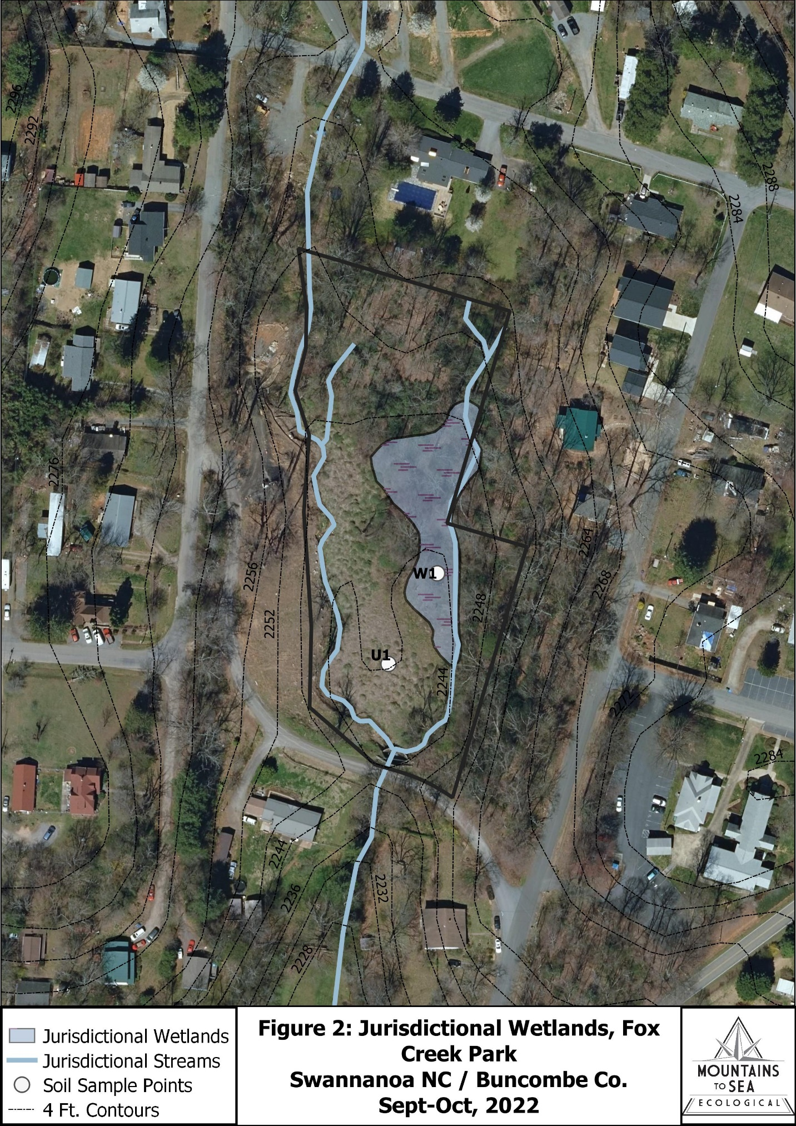

**Table 2: Wetland Cover Types at Fox Creek Park**

|  |  |
| --- | --- |
| **Cover Type** | **NWI Classification Code** |
| Swamp Forest | PFO1 |
| Perennial Streams | R2SB2 / R2SB3 / R2SB5 |
| Meadow / Early Successional | None |
| Montane Oak-Hickory Forest | None |

These two wetland cover types are based on Wetland Subcommittee Federal Geographic Data (WSFGD, 2013) classification criteria and USACE (2012).

Wetlands consist only of Forested Wetland and perennial streams. Vegetation Indicator species in all strata are entirely OBL and FACW wetland plant species, with just a few FAC (facultative) species and readily suggestive of wetlands in tandem with wetland soils and hydrology.

**Wetland Natural Communities**

Forested Wetland (i.e., Swamp Forest)

*Hydrological Indicators:* Though open water was not observed, the water table was high and saturated, sitting within 5-6 inches of the soil surface at time of assessment. Mucky conditions dominate, particularly adjacent to the stream channel region and less so near the perimeters. Other hydrological indicators included water-stained leaves, true aquatic plants, and drift / sediment deposits.

The morphology of the Fox Creek Park floodplain influences current area-based wetlands, forcing water to accumulate in low-lying toe-slope areas bunkered on the eastern boundary, and it is likely that most of the lowest elevations of the property included this original wetland community prior to lake development.

*Vegetation:* 23 of 27 plant species detected are OBL and FACW species with most wetland species being common or dominant throughout (11 OBL and 16 FACW species; See Table 1 below). The canopy is tall and mature, comprised of Red Maple (*Acer rubrum*) and Tulip Poplar (*Liriodendron tulipifera).* River Birch (*Betula nigra*), Black Willow (*Salix nigra)* and Sycamore (*Platanus occidentalis)* are scattered*.* One large diameter stem of the rare Shingle Oak (*Quercus imbricaria)* occurs adjacent to the modified seep. All trees demonstrate characteristic prop roots due to high water tables, shallow topsoil, and hydric soils. Understory trees and shrubs are Black Alder (*Alnus serrulatus),* Winterberry (*Ilex verticillata),* and Elderberry (*Sambucus canadensis),* Arrowwood (*Viburnum recognita*), Doghobble (*Leucothoe fontansiana),* and Spicebush (*Lindera benzoin*).

Herbs are lush and dense with numerous wetland obligate species though Sedge species tend to dominate. Typical plants are Bladder / Shallow / Fringed Sedges (*Carex intumescens / lurida / crinita*), Arrow Arum (*Peltandra virginica),* Wood Reed (*Cinna arundinaceum),* Purple-stem Aster (*Symphyotrichum puniceum),* Jewelweed (*Impatiens capensis),* Cowbane (*Oxypolis rigidior),* Tearthumb (*Persicaria sagittata),* Three-way Grass (*Dulichium arundinaceum),* Mannagrass (*Glyceria melicaria),* Marchflower (*Packera aureus),* and Jack-in-the-Pulpit (*Arisaema triphyllum).*

**Table 1: Wetland Plant Species, Fox Creek Park 2022**

*\*Plants are listed by OBL-FACU (wet to dry) status*

|  |  |  |  |  |
| --- | --- | --- | --- | --- |
| FORM | COMMON NAME | *SCIENTIFIC NAME* | INDICATOR STATUS | CODE - COE |
| Tree | Black Willow | *Salix nigra* | OBL | 1 |
| Tree | River Birch | *Betula nigra* | FACW | 2 |
| Tree | Sycamore | *Platanus occidentalis* | FACW | 2 |
| Tree | Red Maple | *Acer rubrum* | FAC | 3 |
| Tree | American Holly | *Ilex opaca* | FACU | 5 |
| Tree | Tulip Poplar | *Liriodendron tulipifera* | FACU | 5 |
| Shrub | Black Alder | *Alnus serrulata* | OBL | 1 |
| Shrub | Doghobble | *Leucothoe fontanesiana* | FACW | 2 |
| Shrub | Elderberry | *Sambucus canadensis* | FACW | 2 |
| Shrub | Smooth Arrowwood | *Viburnum recognitum* | FACW | 2 |
| Shrub | Winterberry | *Ilex verticillata* | FACW | 2 |
| Shrub | Spicebush | *Lindera benzoin* | FAC | 3 |
| Vine | Swamp Rose | *Rosa palustris* | OBL | 1 |
| Vine | Multiflora Rose | *Rosa multiflora* | FACU | 5 |
| Herb | Arrow Arum | *Peltandra virginica* | OBL | 1 |
| Herb | Cowbane | *Oxypolis rigidior* | OBL | 1 |
| Herb | Purple-stem Aster | *Symphyotrichum puniceum* | OBL | 1 |
| Herb | Tearthumb | *Persicaria sagittata* | OBL | 1 |
| Herb | Golden Ragwort | *Packera aurea* | FACW | 2 |
| Herb | Jack-in-the-pulpit | *Arisaema triphyllum* | FACW | 2 |
| Herb | Jewelweed | *Impatiens capensis* | FACW | 2 |
| Grass | Slender Manna Grass | *Glyceria melicaria* | OBL | 1 |
| Grass | Wood Reed-grass | *Cinna arundinacea* | FACW | 2 |
| Sedge | Fringed Sedge | *Carex crinita* | OBL | 1 |
| Sedge | Shallow Sedge | *Carex lurida* | OBL | 1 |
| Sedge | Three-way Sedge | *Dulichium arundinaceum* | OBL | 1 |
| Sedge | Bladder Sedge | *Carex intumescens* | FACW | 2 |

*Soils:* Wetland soils occur throughout the entire soil column including 10YR 2/1 and 4/1 color soils from 0-12 inches and 12-20+ inches, respectively. Throughout, coated sand grains (10YR 7/4, very pale brown), with 50% 10YR 3/2 very dark brown grayish mottles. Iron concretions present throughout. Sandy mucky mineral (S1) and dark surface (S7) seen throughout. Duff was not present and organic soils comprise the surface. Oxidized rhizospheres are seen throughout.

According to NRCS (2018) data for the Fox Creek Park floodplain only one soil series occurs onsite: *Tate loam, basin, 2 to 8 percent slopes.* This soil series is common in small-stream alluvial floodplains and terraces in western NC. While it is not a hydric soil series, the 0.39-acre wetland onsite is likely too small or was previous considered part of pond to have been included in previous NRCS soil mapping. However, the wetland soil profile is natural rather than anthropogenic or altered, comprising soil structure, color, reduced oxygen, and other hydric soil requirements as required by USCOE.

Perennial Streams

Approximately 415 linear feet of perennial streams occur in four sections onsite.

Stream conditions are a mixture of fair to poor conditions, and all are low gradient, gently flowing channels. Embankment and substrate structure and integrity, sinuosity, hydrology, sedimentation, and vegetation cover are poor to absent on the main channel and fair to good on the tributaries. Steep eroding embankments need stabilization along the primary channel though most wetland herbs onsite can be found in and along stream edges in patches.

Stream substrates consist of mud, sediment, small-cobbles and rock, and extensive sedimentation dominate the primary stream channel, reducing its quality. Streambanks, which have been (and appear to be continuously) incised downward via stream-flow cutting through pond fill provide ongoing sediment to the primary stream channel, though secondary stream tributaries are mostly vegetated and intact. The springhouse tributary, headed by a modified seep, is in fair condition having been historically converted from a floodplain seepage to a springhouse. Its confluence at the primary stream channel is damaged and partly buried from having been smothered with flood-deposited or historic fill material.

**Upland Natural Communities**

The adjacent uplands include both full sun open “meadow” / early successional habitat and mature Montane Oak-Hickory Forest. Kudzu, in process of removal, dominates meadow habitat while a variety of Oak and Hickory species and invasive and native shrubs dominate upland forests. Comprehensive inventories of each upland community will take place in 2023, however, the sites were observed, and basic information was collected to determine these are not wetland communities.

Meadow / Early Successional Habitat – this area includes most of the former lake-bed region and it is currently dominated by Kudzu (Pueraria montana) and miscellaneous full sun plants such as Kudzu, Elderberry, Tearthumb, Crabgrass (*Digitaria glomerata),* New York Fern (*Athyrium thelyptris),* Jewelweed (Impatiens capensis), Pokeweed (Phytolacca americana), Buttercup (Ranunculus sp.), Flat-sedge (*Cyperus strigosus),* Carolina Cranesbill (*Geranium carolinianum)* and many other species. Because moderate density of the wetland obligate Tearthumb occur west of and bordering Swamp Forest, soils and hydrology were reviewed in this area to determine if wetland conditions remain, but these occur lower than twenty inches at present.

Montane Oak-Hickory Forest – Oak-Hickory Forests are typical of the Blue Ridge, and these can often extend down into small stream ecotones. No plots were performed here due to lack of wetlands and comprehensive inventory was not performed for the wetland delineation Here, Oaks and Hickories co-dominate along with other hardwoods such as White Oak (*Quercus alba*), Northern Red Oak (Quercus rubra), Tulip Poplar (*Lireodendron tulipifera),* Black Oak (*Quercus velutina),* Red Maple (Acer rubrum), Black Gum (Nyssa sylvatica), and Sourwood (*Oxydendron arborea).*

The shrub zone is dominated by the invasive Japanese Holly (*Ilex crenata)* and Japanese Maple (*Acer palmatum)* but also contains native shrubs like Witch Hazel (Hamamelis virginiana), Mountain Laurel (*Kalmia latifolia*), and Strawberry-Bush (*Euonymus americanus).* Typical herbs where English Ivy (*Hedera helix)* and Periwinkle do not dominate are Galax (*G. urceolata),* Toadshade Trillium (*T. cuneatum),* New York Fern (*Amauropeltum noveboracensis),* Wood Violet (*Viola sororia),* Trout Lily (*Erythronium americanum).*

#### THREATENED AND ENDANGERED SPECIES REVIEW

NCNHP statewide and county EO data (2022) for Buncombe County and a 3-mile radius of the property were reviewed to determine potential T&E wetland species that might occur in wetlands onsite. Among 18 federal T&E species known in the county, two Endangered wildlife species – Rusty Patch Bumblebee (*Bombas affinis*) and Gray Bat (*Myotis grisescens*) – have historical records (>20 years) within 3 miles of the park. Neither have suitable habitat breeding habitat in wetlands onsite.

Three wetland plants – Bunched Arrowhead (*Sagittaria fasciculata*), Mountain Sweet Pitcherplant (*Sarracenia jonesii),* and Virginia Spiraea (*Spiraea virginiana)* – are known from Buncombe County. These species do not occur onsite. While the Arrowhead has marginal habitat onsite and could thrive if introduced, the Pitcherplant and Spiraea do not have suitable habitat to colonize or persist of introduced.

#### REFERENCES

Munsell Soil Color Charts: with Genuine Munsell Color Chips. Grand Rapids, MI; Munsell Color, 2010. MLA. Munsell Color (Firm).

National Wetlands Inventory Wetlands Mapper (2022). https://fwsprimary.wim.usgs.gov/wetlands/apps/wetlands-mapper/

Natural Resources Conservation Service (NRCS) Web Soil Survey. (Oct 1, 2022) https://websoilsurvey.sc.egov.usda.gov/App/WebSoilSurvey.aspx

North Carolina Natural Heritage Program (2022). Element Occurrence (EO) Database. Accessed in GIS for project review.

North Carolina Natural Heritage Program (2022). Federal Threatened & Endangered Species by County. https://www.ncnhp.org/data/speciescommunity-search

US Army Corp of Engineers Environmental Laboratory. 1987. Environmental Laboratory. Corps of Engineers Wetlands Delineation Manual. Technical Report Y-87-1, U. S. Army Engineer Waterways Experiment Station. Vicksburg, Mississippi.

US Army Corp of Engineers. April 2012. Regional Supplement to the Corps of Engineers Wetland Delineation Manual: Eastern Mountains and Piedmont Region (Version 2.0)

US Army Corp of Engineers. 2016. Regional Plant List for the Eastern Mountains and Piedmont Region.

Weakley, Alan S. Flora of the Southern and Mid-Atlantic States, Working Draft of 21 May 2015. University of North Carolina Herbarium (NCU). North Carolina Botanical Garden. University of North Carolina at Chapel Hill. Campus Box 3280. Chapel Hill NC 27599-3280.

Wetlands Subcommittee Federal Geographic Data (WSFGD). 2013. Classification of Wetlands and Deepwater Habitats of the United States. Adapted from Cowardin, Carter, Golet and LaRoe (1979).