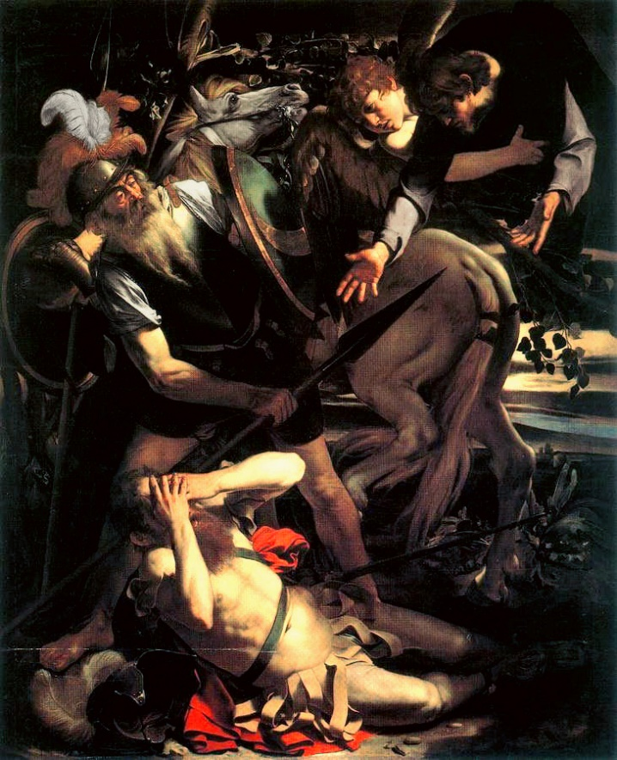 |  | St. Paul’s Church  - 422 Market St.  - Box 1551, Camden, New Jersey 08101
Conversions

One of the deepest tensions I find in my life as a cleric is in the reliance I place on the rhythm of the church year and the awareness of new things happening around and among us. In January, chief among these new things is the education program we are beginning for the parish. There will indeed be a place for everyone, from the youngest of our communicants and our pre-teens/teens to a Bible study for adults. “Formation” is the language the church often uses but if we are talking about the creation and nurture of disciples, it will mean simultaneously looking at the stories from scripture and being able to see that work of God made manifest in the people around us. We have our own stories too, and I believe it is the meeting of our stories with God’s story that we learn what discipleship means.
For the adults, our encounter with scripture will be deeply informed by our own experience; in my view, it is especially important in our work with those on the margins, as well as in our workplaces. With our youngest, it will mean meeting this Jesus for the first time in the Bible and understanding how these stories of transformation are repeated at home, in school and among those we serve at St. Paul’s. The early teen years may be the most difficult ( I say this with some experience as a teacher and parent), with the pressures of school, hormones, and conflicting tensions about friendships and choices to make in and out of school. I’m profoundly grateful for Clare Gutwein, Mitchell Morgan and all the people who have agreed to take on this task; in many ways, it is the most important work we do and will help us listen for the “still, small voice of God” in the decisions we make, large and small.
The other major event for us will be the annual meeting after our celebration of the Conversion of St. Paul on January 26. Having worked in other churches named after our patron saint, I have always been grateful that “conversion” will be at the center of the day; doubtless, others have spoken about this happy fact. It is a time to take stock of our life together, to elect new members to the vestry and, God willing, to present a budget ratified by our vestry. I believe it is important that we look at how we spend our resources, at the mutual ministry with others in our convocation that has defined our work for many years, and our hopes for the future. Conversion is an especially appropriate context for this year’s meeting; I believe that God is doing a new thing among us and our job is to listen to that voice I described and to act on it in a world of competing choices, not all of them healthy or helpful to our mission.
As I have said in other contexts, St. Paul’s is a jewel and it is a privilege to serve here. It was the overwhelming impression I had at the installation last month and it continues each Sunday we are together. Many places talk about “radical hospitality”: St. Paul’s practices it with a sincerity of commitment that, in my experience, is exceedingly rare. At the same time, I think it is providential that we are gathering in the season after the Epiphany to talk about our collective life. God is continually calling us into conversion, to think about our lives together in new ways and to reflect on how we can serve our selves, our community and the kingdom of which we are part. I hope you will join me in being part of the conversation.

In This Issue
Epiphany and Uncertainty
Page 2
Come and See
Page 3
Other News Items page 4

Epiphany and the Gift of Uncertainty

One of my confessions about the church year is the wonderful variety I find in the different character of the seasons. If you are like me, we feel the unbridled joy of Christmas as a single event, the coming of an incarnate Lord among us, God made human so that we might become divine, as the early church fathers put it. So strong is the pull of this joy that it reaches, for most of us, beyond the reports of retail sales, the list of cards to send that grows like a weed every year, all the things we do to both celebrate and control this event of a “God with us”. At some level, we know that we do not have to understand it; we simply accept this event that comes unbidden into our lives and the depth of the love of God that it reflects for each of us.
But Epiphany and the season that follows it make us work harder. Older than Christmas, Epiphany compels us to search out what this God-with skin-on means in each of our circumstances, among the poor and the lonely, the heartbreak and the hope that are fused into our lives, the sense that we are journeying with the disciples to try to make sense of why the world feels so different. It begins with a baptism, one in which the heavens are opened, the Spirit descends like a dove, and a voice cries out that, “This is my Son, the Beloved; with you I am well-pleased”. But most of us, as wonderful as our baptisms are, spend our lives trying to determine what that event means. Embedded in this life-changing gift is the hard work of determining the meaning of this manifestation of the love of God and proclaiming it by word and example, as our prayer book has it. What it means is uncertainty, and in a time when we make idols of our ability to determine the trajectory of everything from the weather to our stock portfolios, that uncertainty can be deeply unsettling.
The challenge of Epiphany is this uncertainty, the hard work that we do to see God made manifest in the smallest events in our lives. When I was asked recently by one of the young people of a parish I had served, “Why do we let Jesus into our hearts?”, my response was that we let him in because that is where he lives, and we would not deny him a home. The hard part, however, is being able see the face of this Christ among us, in the stranger and among those we say we love.
Embedded in this challenge, however, is an opportunity to know that the love of God is greater than any of our attempts to measure or quantify it. What it demands is a kind of ability to be attuned to the presence of God made manifest while understanding that our own view of this world will always be incomplete. Just as our salvation is dependent on one another, so is the knowledge that we are playing a small but irreplaceable in that salvation, a part whose effects we may never know. As Esther de Waal puts it in one of her collections from the ancient desert mothers and fathers:
Let us live with uncertainty
as with a friend
to feel certain
means feeling secure
to feel safe is unreal
a delusion of self
knowing we do not know is
the only certainty
letting the self be lost into Christ.

My hope is that Epiphany and the weeks following will draw you from the things we think we know and toward the mystery of the Christ made manifest in all the unexpected corners of our lives.

Come and See.

Philip found Nathaniel and said to him, “We have found him about whom Moses in the law and also the prophets wrote, Jesus son of Joseph from Nazareth.” Nathaniel said to him, “Can anything good come out of Nazareth?” Philip said to him, “Come and see.”

Philip's response to Nathaniel runs through all our lives, but never so fiercely as in the season of Epiphany. Without even considering what is happening overseas, it is practically impossible to turn on the radio without hearing the stories about conflict over budgets, job consolidations, people having to make choices about paying the light or the phone bill this month.
The great gift of the season of Epiphany is to look at the work that comes out of Philip's invitation. It is natural to ask, “Can anything good come out of Nazareth,” or anywhere else, but the invitation is to look in places that contradict what we see in the television and newspapers, maybe even in the places where we work or go to school. God is never so present as in the particular; a child being taught, a family fed, a parish with a unique relationship with a wonderful mission toward service to the community. Epiphany, the revealing of God, is defined by the specific, and the great joy of the work we do is seeing it in the time we spend giving our time, our resources and ourselves to the work we do and then inviting the world to come and see, to look at a world where the kingdom of God is obvious to anyone with the eyes and the courage to see it.
To be sure, hunger is a national problem, but the gift of living in our time and place is to be able to serve the Christ we see coming through our own doors and to minister to him, offering what we can in our own time and resources. It will be an opportunity to supplement the work we do at The Breakfast Club and our Sunday Night Suppers.
Come and see. Living in this time and this place, I have never been so proud to belong to a community that takes Nathaniel's invitation seriously. St. Paul’s is a place that we all know, but it is the specific people who make it what it is. I am proud to belong to such a people, people who take the gospel so seriously; they are people who, in encounters large and small, help us to come and see the living God walking among us. I cannot help but be proud to belong to such a people, whose care for the needy and marginalized, the particular in each of us, could not be more deep or more loving.

Annual Meeting
Please join us on January 26 following the 11:00 mass for our annual meeting. We will have vestry elections for three new members, hear reports from those responsible for different parts of our life together and have a look at a proposed budget for next year. There is also a proposed revision of the by-laws from last year that will need a ratification vote if it is to be implemented; copies of the old by-laws and the revision are on the back table and can be consulted after the 11:00 mass.
Be there if you can. The best way to move a church forward is through an informed body; we need your wisdom to be the best advocate for the kingdom we can be!
Sunday School
Beginning January 12, we are starting a program of Christian education, with offerings available for all members of St. Paul’s. Our youngest will meet in the vestry room and the pre-teens-teens will be in the chapel; adults will meet for Bible study in Fr. Mark’s office. We will begin at 12:30 and will conclude at 1:15. As I indicated above, we are all very excited about this venture and welcome your input and comments. Come and see—and bring the kids.
From the Diocese of New Jersey:
MLK Day—January 20
Dubbed "A Day On, Not Off," the diocese honors the legacy of Dr. King through worship, learning, and service. The diocese is making a special liturgy available to be used in churches and at home. We're working with local convocations and with Jubilee ministries around the state to present volunteer opportunities to help those in need.
The day (Monday, Jan. 20) begins with worship at the Cathedral and at churches around the diocese. The service will be livestreamed via Zoom and social media platforms.
At the cathedral, young people will read selection's from King's seminal work on the civil rights movement, "Letter from Birmingham Jail," written after King was arrested in 1963 for protesting the treatment of blacks in Birmingham.
Planned Sites for MLK Day of Service Events
(tentative)

Convocation Host Church Time

Atlantic Saint Mark's and All Saint's / Galloway 10:00 a.m
Burlington 2nd Baptist Church Mount Holly Jan. 19, 4:00 p.m.
Burlington Quaker Meeting House Mt. Holly Jan. 20, 11:00 a.m.
Camden Grace Church Haddonfield 10:00 a.m
Monmouth St. Mark's Keansburg 10:00 a.m
Trenton Trinity Cathedral Trenton 10:00 a.m
Woodbury St. Thomas Glassboro 9:00 a.m.

