Greetings, SPRING HAS SPRUNG!
- The City requires sidewalks to be free from weeds and grass, protruding shrubs, trees, and other debris.
- Clean up any trash or fallen debris in the yard. Pull weeds in garden beds.
- Don’t forget to apply for Architectural Review Committee approval before starting any major projects that affect the appearance of your home or yard.” Please access documents at http://vuemont.org/Documents.htm

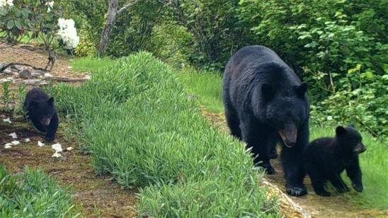
Responsible Wildlife Management
Among the unique benefits of living in our neighborhood are frequent opportunities to view wildlife. Bald eagles, deer, bobcats, bears…and of course, coyotes, are regular visitors to our yards. We share a duty to be responsible stewards, however, and to ensure that our furry friends don’t lose their natural fear of humans.

As a reminder:

- Please do not feed wild animals of any type.
- Please do not leave pet food or water out for your own pets.
- Please do not provide water in the form of bird baths or fountains.
- Please do not put bird seed out.
- Please do not put food scraps in compost piles.
- Please pick up all fruit that falls from trees.
- Please secure your garbage so wild animals can’t get to it.
Private Contracts with USDA
Some of you may have attended the USDA presentation late last year regarding coyote encounters. While the HOA is taking no official stance on the issue, and does not make any endorsement, there is a private group of individuals discussing contracting directly with USDA to address the issue in our neighborhood. Those interested are invited to email SaveCougarMtnPets@gmail.com
Thank you!

Vuemont Homeowners Association
4957 Lakemont Blvd. SE
Suite C-4, PMB 383
Bellevue, WA 980006

