JAYBE-EL ASSOCIATES
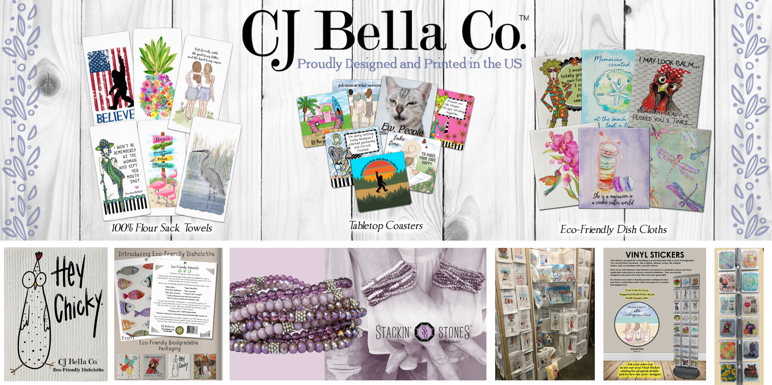
Links to CJ Bella Co. 2025 Catalogs

CJ Bella Co.: https://bit.ly/CJBellaCo2025
Dolly Mama: https://bit.ly/DollyMama2025
Rose Hill Beach: https://bit.ly/RoseHillBeach2025
Rose Hill Everyday: https://bit.ly/RoseHilEveryday2025
Tracey Gurley: https://bit.ly/TraceyGurley2025
