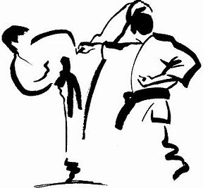

COMPETITION TRAINING

Informational Meeting: May 12th at 12:00
TRAINING BEGINS: June 2nd, 12:00-1:00

Competition Training:
Although Peak Performance has always focused on development of character through training, I think it is time to incorporate “Sport Karate”. A student can learn a great deal in the tournament arena and it can be a lot of fun. On May 12th there will be an informational meeting at the dojo, starting at 12:00, for students and parents to get an idea of what competition karate is about. We will begin the actual classes June 2nd on Saturdays at 12:00 for 1 hour (the regular morning class will now only be 1 hour: 11:00 – 12:00).
There is a spring and fall tournament season so we will be preparing for the fall season. However, I am working to arrange a shiai (informal tournament) with a dojo in south Minneapolis for July. Tournaments include Kate competitions and Kumite (partner or sparring) events. Karateka from Peak will be encouraged to participate in both events.
Since it is important to me that students have a good experience at competitions it will be important for students to commit to this training. Although I know schedules won’t permit every Saturday I highly recommend no less than three Saturdays a month. If a student is not prepared for a tournament I will discourage participation.
There will be no additional charge for this class since it is part of Peak’s programing. However, there are usually fees for tournaments and I will keep everyone informed of those cost.
NOTE: competition training cannot replace normal training classes and MUST be considered an additional class. Please come and enjoy.

Oss!
Sensei Chris

