Connection to the Earth
Greg Sullivan

I have found the strength in a technique starts with a proper foundation that provides a connection to the earth (the ground). This connection comes from stances that provide a solid foundation below the waist, that allow you to have a connecting pressure that I like to refer to as torque. Techniques of moving, blocking, striking and kicking are strongest when you have a solid foundation stance that provides a full body connection. That same full body connection also comes into play when you employ manipulations of an opponent with takedowns, locks & throws.
This full body connection requires that the Karateka have a solid stance. The stance requires proper foot placement. This proper foot placement is where the torque is generated, and if the feet are moved even slightly off line, then the torque can be lost.
In the following text, I will explain how the Karateka can generate torque that is gained and lost through foot placement.
Zenkutsu Dachi (Front Stance)
We are taught at white belt to obtain a solid Zenkutsu Dachi (front stance), by placing the feet are about 1 to 1-1/2 shoulder widths wide, and about 2 shoulder widths long. The weight shift is about 60 percent front leg, and 40 percent rear leg.
We are taught at white belt how to move forward, backwards, and make turns using this stance. This stance allows us to block, strike, kick, and move out of the way.
To deliver a strike such as an Oi Zuki (lunge punch), we are taught to step forward, and punch at the end of the step, striving to be able to stop the punch and forward step at approximately the same time.
What I have found is that if you time your movement so that the punch and your step will stop at approximately the same time, you can generate a very strong punch. The strongest of the punches I have seen is where the punch is delivered when the Karateka has a full body connection that is pushing from the rear leg and foot’s connection to the ground. If the rear foot is positioned on the ground with the foot rotated as much forward as the person can do, this will allow them to push from the full foot, with an emphasis starting from the heel, and then drive the punching side hip forward in a driving type push. By pushing the hip forward from the rear heel’s connection to the ground, you can drive the hip forward and create an isometric tensioning of the pelvic area and opposite side hip, resulting in a Gyaku Hanmi type feeling.
If the Karateka can get proper feet positioning, then they obtain a solid connection to the ground, and this connection can be used to create a torque. This torque can be used for an entire body connection to block, strike, kick, and move.
The proper positioning of the feet can slightly differ between each person’s own body capabilities of what their body allows them to do. Both feet need to be placed so that they work together, meaning that the back foot and front foot work in unison.
Let’s start by viewing each foot separately, and then how they work together.
Zenkutsu Dachi Front Foot Position
If the front foot is placed so that the instep is 90-degrees, there may not be any connection to create torque. | 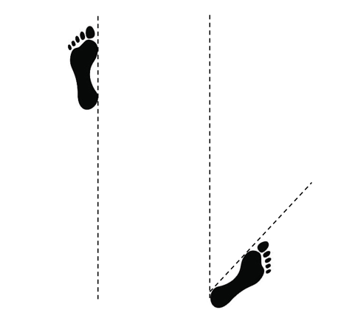
If the front foot is placed so that the middle toe is placed at 90-degrees, you will be able to obtain a connection to the ground. | 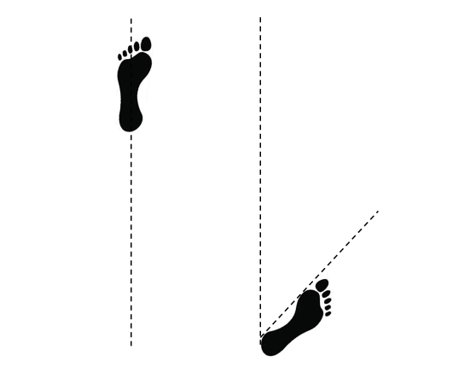
If the front foot is placed so that outside edge of the foot is placed at 90-degrees, you will gain a greater connection to the ground. This connection of the front foot will allow you to move in all directions. | 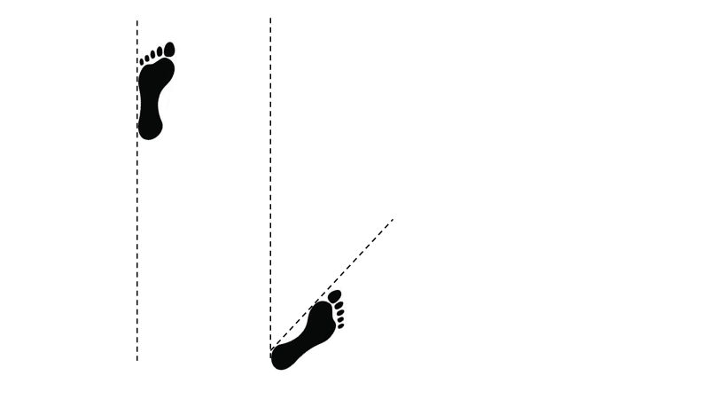

Zenkutsu Dachi Back Foot position
The back foot needs to be placed so that the foot is at a position of at least 45-degrees forward. If the Karateka can place the rear foot at a position of at least 45-degrees forward on the back foot or more, this will create an outward pressure between both feet that I like to refer as torque. If the rear foot is placed with the instep at 45-degrees, you will be able to obtain a connection to the ground.

If the rear foot is placed so the middle toe is at 45-degrees, you will be able to create more torque between the feet. | 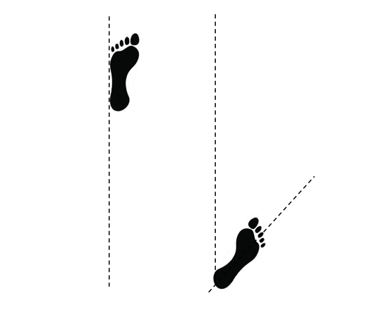
If the rear foot is placed so that the outside edge of the foot is at 45-degrees or more forward, you will obtain even more torque between the feet. | 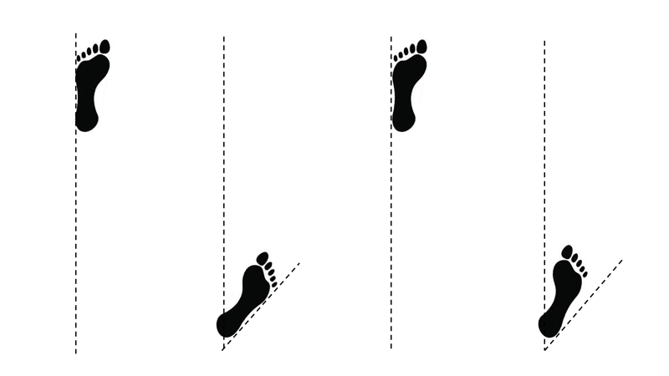
A common mistake is to place the rear foot outward more than 45-degrees. We see this often in lower belts. By allowing the rear foot to turn more outward, all the torque is allowed to escape, resulting in all connection to the earth being lost and the Karateka is only be able to block or strike with arm power, and not the entire body connection. | 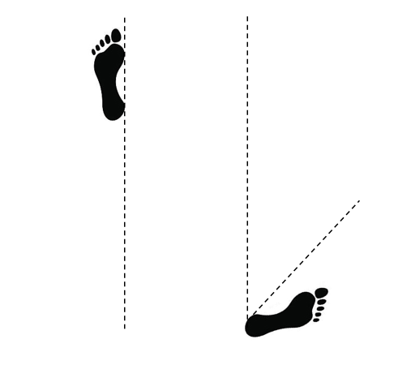

When both feet are properly placed with the rear foot placed at 45-degrees or more forward, and the front foot at 90-degrees or slightly inward, the Karateka will create a natural outward pressure between the feet, which results in a torque connection of the lower half of the body below the waist. This torque of the lower half of the body allows the Karateka to then connect the upper half of the body, what is above the waist, for an entire body connection for the greatest strength for blocks, strikes, and kicks.
The torque pressure from the foot connection to the ground allows you to create a natural drive for moving forward and backwards. For example, if you start to move the rear foot forward towards the front foot and come to center, the pressure connection allows you to push off the rear foot, as the legs are contracted and pulled together to center. Then the pressure and weight shift will change from the rear foot to the front foot, as the rear foot becomes the forward moving foot as you expand the feet and legs apart to obtain the next stance with outward pressure and the feet are placed so the floor connection is obtained once again.
To move rearward, the Karateka has to move the front foot back towards their center. If the front foot is properly placed with the outside edge of the foot at 90 degrees to obtain outward torque pressure, this torque creates a natural rearward push so the Karateka can contract the front foot rearward towards their center. Then as the front foot comes to center the Karateka can then decide to continue rearward or move off line to the side or rearward.
If the front foot is placed so the instep is at 90 degrees so no natural torque pressure is obtained, then the rearward movement of the front foot will be slower.
From the Zenkutsu Dachi stance with the feet properly placed so the outward pressure torque is obtained, if the Karateka lifts their front foot off the ground to kick, the torque from the rear foot being positioned at 45 degrees or more forward will propel the Karateka forward for a full body connection to the ground for the kick being delivered.
If the rear foot is turned outwards more than 45 degrees, and the Karateka lifts the front foot to kick, there is no outward torque on the rear foot to propel you forward, and the Karateka will most times have to shift their body rearward in order to kick. This rearward shift will force the Karateka to have no body connection, resulting in a kick that is only leg power, which is much weaker than a full body connection. This rearward shift will also give a visual clue to your opponent that you are going to kick.
Kokutsu Dachi (Back Stance)
As lower belts we are taught Kokutsu-Dachi (back stance) is where the heels of the feet are placed on the same line, with the front foot straight forward at 90 degrees, and the rear foot to the side at 0 degrees, with the feet about 2 shoulder widths apart. Then the weight shift is about 70 percent on the rear leg, and 30 percent on the front leg.
What I have found is that the front foot can be placed with the middle toe of the foot straight forward at 90 degrees or slightly inwards so the outside of the foot is at 90 degrees, then a pressure is created to give a torque connection to the ground.
Kokutsu Dachi
The rear foot if placed so that the instep of the foot is at 0 degrees, then there is not much outward torque pressure created between the feet. If the feet are in this position, and you try and move the rear foot forward, there is no push forward from the rear foot so the movement is often times slower. | 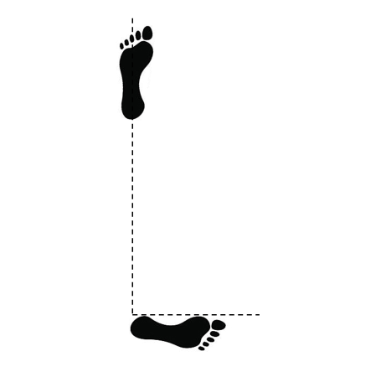
If the rear foot is placed so that the middle toe is at 0 degrees, an outward pressure between the feet and legs is created, which results in a torque. If you try and move the rear foot towards your center, the rear foot is naturally pushing forward. | 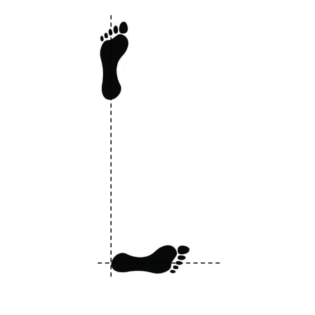
If the rear foot is placed so the outside of the foot is at 0 degrees or slightly more forward, there will be more outward pressure created between the feet and legs, resulting in lots more torque. This torque that is created below the waist in the legs, allows the Karateka to then use the upper body techniques of blocks and strikes to be tied together for a full body connection of the entire technique so it is rooted to the ground. | 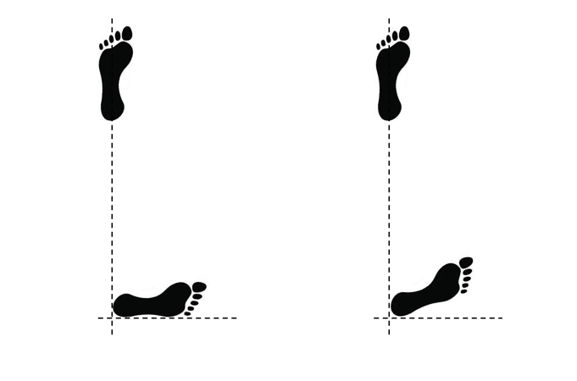

A common mistake is to allow the back foot to go outward to the rear more than 90 degrees in angle between the feet, because this releases all connection to the ground. If the rear foot is allowed to go rearward with no ground connection, then all strikes and blocks are performed only with arm power. If the Karateka lifts their front leg in order to kick, they will have to shift all their weight rearward by pushing their torso over their back leg, resulting in the possibility of being off balance or easily pushed rearward.
By obtaining more torque with the outside of the rear foot at 0 degrees or turned more forward, the outward torque that is created can be used for movement and kicks. If the Karateka moves forwards towards their center, the torque on the rear foot is already creating a forward push, which allows the Karateka to contact the legs together, often resulting in a quicker movement.
When kicking off the front foot in Kokutsu-Dachi, if the instep of the back foot is at 0 degrees, when the front leg is lifted off the ground, the Karateka will most often times have to shift their weight rearward onto their rear leg, resulting in the kick only being powered by the leg.
If the rear foot is placed so the middle toe is at 0 degrees, when the front foot is lifted off the ground a slight forward push from the rear foot starts to happen.
If the rear foot is placed so the outside of the foot is at 0 degrees or even slightly more forward to create the maximum amount of torque, then as the front foot is lifted to kick, the torque pressure that is being created by the rear foot will naturally push your torso forward, resulting in a stronger kick, because there is an entire body connection of delivering a kick that is now rooted to the ground.

Kiba-Dachi (Horse Stance)
The Kiba-Dachi stance is often referred to as a horse stance. This horse stance reference paints a mental image of how you sit on a horse. You place your feet about 2 shoulder widths apart, with the knees pushing outward like you are sitting on a horse, and the feet should be parallel to each other. The weight distribution is equal, with 50 percent on each side.
Kiba-Dachi
Foot placement in Kiba-Dachi is also important. If the feet are placed so the feet are outwards of 90 degrees from forward, there is no outward pressure created, resulting in no torque. This lack of torque to the ground results in all blocks, strikes and kicks being done with arm or leg power only.

If the feet are placed so that the instep is at 90 degrees facing forward, there will be a slightly outward push between the feet from the feet being about 2 shoulder widths apart. But there is still no body connection of the lower and upper half of the body being connected together.

If the feet are placed so that the middle toe of each foot is placed at 90 degrees facing forward, then there is an outward pressure created between the feet and legs, resulting in torque starting to develop.

If the feet are placed so the outside of the foot is at 90 degrees forward or slightly inwards, there will be a much larger outward pressure created between the feet and legs, resulting in maximum torque in the lower half of the body. All techniques above and below the waist can then be tied together, resulting in a full body connection to deliver the strongest blocks, strikes, and kicks from the Kiba-Dachi position.

When the maximum torque is created by properly placing the feet, when the foot is lifted to deliver a Yoko Kekomi Geri (side thrust kick), like in Niju-Shiho Kata, when the kicking leg is lifted, the outward pressure torque on the support leg that is created from the stance, helps push the entire bodies’ pressure into the kick, resulting in a full body connection of great strength in the technique.
When performing a Nami Ashi Geri (Sweeping Leg Kick), such as in Tekki Shodan kata, when the kicking foot is lifted off the ground, the outward torque pressure on the support leg will keep the knee pushed outward, resulting in a strong foundation and delivering a kick that is rooted to the ground with a full body connection. If the support foot is turned forward or slightly outwards, when the kicking foot is lifted off the ground, the support leg knee will not have the outward torque, resulting in the support leg knee collapsing inwards, which is a weak technique.
Conclusion
A full body connection that starts from the ground allows the Karateka to deliver the strongest blocks, strikes, and kicks. This connection starts with proper foot placement so that an outward pressure is created to obtain torque. This torque creates a lower body connection, which then ties the upper body above the waist with the lower body below the waist, resulting in a full body connection for the strongest blocks, strikes and kicks. This torque in the stance also allows for a stronger and more efficient movement between stances.
If the feet are placed so there is no natural torque created, then the Karateka is only blocking, striking or kicking with the arm or leg, and doesn’t have a full body connection. If the feet are placed so not torque is created, then the Karateka will be slower when trying to move between stances and maximum power is lost.

